CHAPTER 1: INTRODUCTION
1.1 Background
Natural disasters such as floods, earthquakes, cyclones, landslides, fires, and severe storms can cause significant loss of life, infrastructure, and property. During such emergencies, the effectiveness of disaster management depends heavily on how quickly incidents are reported, verified, prioritized, and responded to. However, disaster response operations may involve multiple stakeholders such as citizens, disaster management officers, volunteers, hospitals, shelters, and administrators. When information is handled through disconnected systems, phone calls, messages, spreadsheets, or manual coordination, important information can be delayed, duplicated, or difficult to track.
A major challenge in disaster response is obtaining a clear and timely understanding of the situation. A citizen may report an incident with a location, description, and supporting evidence, but emergency authorities still need to verify the report and determine its severity and priority. They also need to identify appropriate resources such as rescue personnel, vehicles, equipment, hospitals, and shelters. Managing these activities manually becomes increasingly difficult when multiple incidents occur simultaneously.
The proposed AI-Rescue: Intelligent Disaster Response & Resource Coordination Platform is designed to provide a centralized web-based system for managing these activities. The platform allows citizens to report disaster incidents and enables authorized disaster management officers to review and verify the submitted information. Once an incident is verified, the system can use AI-assisted decision-support capabilities to assess its severity, recommend a priority level, and suggest the types of resources that may be required.
The platform also supports resource coordination, emergency communication, incident status tracking, dashboards, and report generation. Volunteers or responders can receive relevant assignments and notifications, while hospitals and shelters can provide availability information required for emergency coordination.
The system follows a human-in-the-loop approach. AI recommendations are intended to assist authorized officers rather than replace human decision-making. This allows the platform to combine automated analysis with human verification and operational judgment.
The proposed solution is intended as an academic project with an industry-oriented architecture. Its modular design provides a foundation for future integration with technologies such as live geographic information, IoT-based monitoring, weather services, mobile applications, external emergency-service systems, and advanced predictive analytics.

1.2 Objectives
The main objectives of the AI-Rescue platform are:
- To provide centralized disaster incident reporting through which citizens can submit disaster-related information, location details, and supporting evidence.
- To improve incident verification and management by enabling authorized disaster management officers to review submitted incidents and update their status.
- To provide AI-assisted decision support for assessing incident severity, recommending priority levels, and suggesting required resource types.
- To improve emergency resource coordination by managing available resources, vehicles, equipment, responders, hospitals, and shelters.
- To facilitate emergency communication by providing relevant notifications and updates to citizens, responders, hospitals, shelters, and other authorized users.
- To support real-time operational monitoring through dashboards containing incident, resource, and response information.
- To maintain records and accountability through reporting and audit-related information.
- To provide a scalable foundation for future integration with IoT devices, mapping services, mobile applications, external emergency systems, and advanced AI capabilities.

1.3 Purpose, Scope, and Applicability
This section defines what the proposed AI-Rescue system is intended to achieve, what functions are included in the project, and where the system can be applied.
1.3.1 Purpose
The purpose of the AI-Rescue platform is to improve the organization and coordination of disaster response activities through a centralized digital system.
The platform aims to reduce delays caused by fragmented information and manual coordination by bringing incident reporting, verification, AI-assisted prioritization, resource coordination, emergency communication, response tracking, and reporting into a single system.
The system is designed to assist disaster management authorities in making informed decisions while maintaining human control over important operational decisions.

1.3.2 Scope
The scope of the proposed system includes:
- User registration and authentication.
- Role-based access for different categories of users.
- Disaster incident reporting by citizens.
- Collection of incident location, description, and supporting evidence.
- Incident validation and verification by authorized officers.
- Incident status management.
- AI-assisted severity assessment.
- AI-assisted priority recommendation.
- AI-assisted resource recommendation.
- Resource availability management.
- Vehicle and equipment management.
- Resource assignment to incidents.
- Volunteer/responder coordination.
- Hospital and shelter availability management.
- Emergency notifications.
- Incident response tracking.
- Operational dashboards.
- Report generation.
- Audit and system activity recording.
The initial project focuses on developing the core software platform and decision-support functionality. Advanced features such as physical IoT deployment, drone integration, large-scale government integration, and fully autonomous emergency decision-making are outside the initial implementation scope.

1.3.3 Applicability
The AI-Rescue platform can be applied in environments where multiple stakeholders need to coordinate disaster-related incidents and emergency resources.
Potential application areas include:
- District-level disaster management operations.
- Municipal or local emergency management.
- Flood response.
- Cyclone and storm response.
- Earthquake-related emergency coordination.
- Fire and rescue coordination.
- Landslide response.
- Community-level disaster reporting.
- Emergency shelter coordination.
- Hospital emergency-capacity coordination.
The system can be adapted according to the requirements of a particular geographical region or disaster-management organization.
For the academic implementation, the platform serves as a prototype demonstrating how digital systems and AI-assisted decision support can improve disaster-response coordination rather than claiming to replace existing government emergency infrastructure.

1.4 Achievements
Since this is a proposed academic project, we should be careful with this section.
We should not falsely claim that the system has already reduced response time or successfully handled real disasters.
Instead, document the achievements of the project/design work:
- Designed a centralized disaster-response management platform.
- Defined multiple user roles and role-based access requirements.
- Designed the complete disaster incident lifecycle from reporting to closure.
- Designed AI-assisted severity, priority, and resource recommendation functionality.
- Designed a structured relational database for managing project information.
- Defined system modules for incident management, AI analysis, resource coordination, emergency services, notifications, reporting, and auditing.
- Developed conceptual and system-design models including system flowcharts, ER diagrams, DFDs, use-case diagrams, and sequence diagrams.
- Defined security, data-integrity, and audit requirements.
- Established a modular architecture that can support future extensions.

CHAPTER 2: SURVEY OF TECHNOLOGIES
This chapter explains the technologies considered for developing the AI-Rescue: Intelligent Disaster Response & Resource Coordination Platform. The selected technologies are based on the functional requirements, scalability, security, database requirements, AI integration, and feasibility of implementation.
The project uses a combination of web development, backend programming, relational database management, and AI/ML technologies. Each technology has a specific role in the proposed system.

2.1 Frontend Technologies
2.1.1 HTML5
HTML5 is used to create the basic structure of the web application. It provides elements for forms, tables, navigation menus, dashboards, buttons, input fields, and other interface components.
In the AI-Rescue platform, HTML5 can be used for:
- User registration and login forms.
- Disaster incident reporting forms.
- Resource management interfaces.
- Hospital and shelter information pages.
- Officer dashboards.
- Report and notification interfaces.
HTML5 provides the structural foundation of the application's user interface.

2.1.2 CSS3
CSS3 is used to control the visual appearance and layout of the web application.
It can be used for:
- Responsive page layouts.
- Dashboard design.
- Forms and buttons.
- Navigation menus.
- Tables and cards.
- Status indicators.
- Mobile-friendly interfaces.
CSS allows the system to maintain a consistent and user-friendly interface across different screen sizes.

2.1.3 JavaScript
JavaScript provides client-side interactivity and dynamic behaviour.
In the AI-Rescue platform, JavaScript can be used for:
- Client-side Form validation.
- Interactive dashboard components.
- Dynamic incident information.
- Notification interfaces.
- Asynchronous requests to backend services.
- Interactive maps and location-related features.
- Updating information without unnecessarily reloading the entire page.
JavaScript therefore complements HTML and CSS by providing interactive functionality.

2.2 Backend Technologies
2.2.1 Java
Java is considered as the primary backend programming language for the system because of its object-oriented architecture, security features, portability, extensive libraries, and suitability for enterprise-level web applications.
Java can handle:
- Business logic.
- User authentication.
- Role-based access control.
- Incident processing.
- Resource management.
- Database communication.
- API development.
- Notification processing.
Java also provides a structured environment for developing a modular backend.

2.2.2 Spring Boot
Spring Boot can be used as the backend application framework for the proposed platform.
It simplifies the development of Java-based web applications and REST APIs by providing configuration and infrastructure required for application development.
For AI-Rescue, Spring Boot can manage:
- REST APIs.
- Authentication and authorization.
- Incident management services.
- Resource management services.
- Notification services.
- Database connectivity.
- Communication with the AI/ML service.
The use of Spring Boot also makes it easier to separate the application into independent modules.

2.3 Database Technology
2.3.1 PostgreSQL
PostgreSQL is selected as the relational database management system for the AI-Rescue platform.
The system handles structured and interconnected information such as users, roles, incidents, disaster types, resources, vehicles, equipment, assignments, hospitals, shelters, notifications, reports, audit records, and system settings. A relational database is therefore appropriate for maintaining consistency and relationships between these entities.
PostgreSQL provides features such as:
- Primary keys.
- Foreign keys.
- Unique constraints.
- Check constraints.
- Transactions.
- Referential integrity.
- Structured SQL queries.
- Support for complex relational data.
The database design of the project consists of the finalized 16-table V1 schema.
The major tables include:
- ROLE
- USER
- DISASTER_TYPE
- INCIDENT
- INCIDENT_MEDIA
- AI_RECOMMENDATION
- RESOURCE
- VEHICLE
- EQUIPMENT
- RESOURCE_ASSIGNMENT
- HOSPITAL
- SHELTER
- NOTIFICATION
- REPORT_LOG
- AUDIT_LOG
- SYSTEM_SETTINGS
The database will serve as the primary persistent storage layer of the application.

2.4 AI and Machine Learning Technologies
2.4.1 Python
Python is suitable for implementing the AI/ML component because of its extensive machine-learning ecosystem and relatively simple syntax.
Python can be used as a separate AI service responsible for processing verified incident information.
Possible inputs include:
- Disaster type.
- Incident description.
- Number of people affected.
- Location-related information.
- Reported severity indicators.
- Other structured incident attributes.
The AI component can then provide decision-support outputs such as:
- Severity assessment.
- Priority recommendation.
- Required resource recommendation.
- Confidence score.

2.4.2 Machine Learning Libraries
Python-based machine-learning libraries such as scikit-learn can be considered for implementing the initial AI component.
For the academic V1 system, the AI functionality should remain practical rather than pretending to have a sophisticated real-world disaster prediction model.
The AI module can initially demonstrate classification or scoring-based decision support using a suitable dataset or controlled project dataset.
The output is then sent back to the Java backend for officer review.

AI architecture
Verified Incident
↓
Java Backend
↓
Python AI Service
↓
AI Analysis
↓
Severity / Priority /
Resource Recommendation
↓
Java Backend
↓
Officer Review
↓
Operational Decision

This is a much more defensible architecture in your viva than saying "AI automatically decides what emergency teams should do."

2.5 API Technology
2.5.1 REST API
REST (Representational State Transfer) APIs are used as the communication mechanism between the major components of the proposed system.
The basic communication structure can be represented as:
Web Frontend
|
| REST API
↓
Java / Spring Boot Backend
|
| SQL / Database Access
↓
PostgreSQL Database
The AI component communicates separately with the backend:
Java / Spring Boot Backend
|
| REST API
↓
Python AI Service
|
↓
AI Recommendation
|
↓
Java Backend
This approach keeps the AI component separate from the main application logic and allows the AI service to be improved independently.

2.6 System Modelling and Design Tools
2.6.1 Visual Paradigm
Visual Paradigm is used as a system modelling and diagram-design tool.
It can be used to create:
- Entity Relationship Diagrams.
- Use Case Diagrams.
- Sequence Diagrams.
- Data Flow Diagrams.
- System design models.
- UML diagrams.
Using standard diagram components and notation is important for presenting the system design clearly in the project documentation.

2.6.2 PostgreSQL Database Modelling Tools
Database modelling tools can be used to represent the PostgreSQL database structure and relationships between tables.
The database design will be based on the finalized 16-table schema, including primary keys, foreign keys, attributes, and integrity constraints.
The ER diagram will represent the logical relationships between the entities, while the actual PostgreSQL database will be used during implementation.

2.7 Version Control Technology
2.7.1 Git
Git is a distributed version-control system used to track changes made to the project source code and documentation.
It allows developers to:
- Maintain version history.
- Track modifications.
- Restore previous versions.
- Work on different development stages.
- Manage project files systematically.

2.7.2 GitHub
GitHub can be used as the remote repository for storing and managing the project's source code and documentation.
It provides:
- Remote source-code storage.
- Version history.
- Project collaboration.
- Backup.
- Documentation management.
The project repository can contain source code, database scripts, diagrams, documentation, and other project-related files.

2.8 Technology Architecture
The selected technologies can be organized into the following logical architecture:
┌────────────────────────────────────────┐
│ USER LAYER │
│ Citizen • Officer • Admin • Volunteer │
└───────────────────┬───────────────────┘
│
↓
┌────────────────────────────────────────┐
│ PRESENTATION LAYER │
│ HTML5 • CSS3 • JavaScript │
└───────────────────┬───────────────────┘
│
REST API
│
↓
┌─────────────────────────────────────────┐
│ APPLICATION LAYER │
│ Java • Spring Boot │
│ Authentication • Incidents • │
│ Resources • Notifications • Reports │
└───────────────┬─────────────────────┬─┘
│ │
│ │ REST API
│ ↓
│ ┌──────────────────┐
│ │ AI/ML LAYER │
│ │ Python │
│ │ Scikit-learn │
│ └──────────────────┘
│
↓
┌───────────────────────────────────────┐
│ DATA LAYER │
│ PostgreSQL │
│ 16 V1 Tables │
└───────────────────────────────────────┘
This architecture separates the user interface, application logic, AI functionality, and data storage, making the system easier to maintain and extend.

2.9 Technology Selection Summary
Technology | Purpose
HTML5 | Structure of the web interface
CSS3 | Styling, layout and responsive design
JavaScript | Client-side interaction and dynamic functionality
Java | Backend programming and business logic
Spring Boot | Backend framework and REST API development
PostgreSQL | Relational database management
Python | AI/ML service development
Scikit-learn | Machine-learning implementation
REST API | Communication between system components
Visual Paradigm | UML, ERD, DFD and system modelling
Git | Version control
GitHub | Remote repository and project management

2.10 Justification of Technology Selection
The selected technology stack provides a practical combination of technologies for implementing the AI-Rescue platform.
HTML5, CSS3, and JavaScript provide the foundation for the web interface. Java and Spring Boot provide a structured and modular backend capable of implementing authentication, business logic, REST APIs, incident management, resource coordination, and notifications.
PostgreSQL is selected as the relational database because the project contains multiple interconnected entities requiring primary keys, foreign keys, constraints, transactions, and referential integrity.
Python and scikit-learn provide a suitable environment for developing the AI-assisted decision-support component. Keeping the AI component as a separate service allows it to communicate with the Java backend without tightly coupling the two technologies.
REST APIs provide standardized communication between the frontend, backend, and AI service. Visual Paradigm supports the creation of the project's system-design diagrams, while Git and GitHub support version control and project management.
Overall, the selected technologies provide a balance between functionality, maintainability, scalability, security, modularity, and academic feasibility.

CHAPTER 3: REQUIREMENTS AND ANALYSIS
This chapter defines the problem addressed by the AI-Rescue: Intelligent Disaster Response & Resource Coordination Platform, identifies the functional and non-functional requirements, describes the project planning and scheduling, specifies the required hardware and software environment, and presents the preliminary description and conceptual models of the proposed system.

3.1 Problem Definition
Natural disasters such as floods, earthquakes, cyclones, landslides, fires, and severe storms can affect large populations within a short period of time. During such situations, emergency authorities need accurate information about incidents, affected people, available resources, rescue teams, hospitals, and shelters.
A major challenge in disaster response is the coordination of information and resources. Incident reports may arrive from different sources, while emergency personnel may need to manually verify reports, determine their priority, identify available resources, and coordinate the response. This can result in delays, inefficient resource utilization, duplicate efforts, and difficulty in maintaining a centralized view of ongoing incidents.
The proposed AI-Rescue platform addresses this problem by providing a centralized web-based system for disaster incident reporting, incident verification, resource management, emergency coordination, notifications, and reporting.
The system also incorporates an AI-assisted decision-support component. After an incident has been verified by an authorized officer, the AI component analyzes relevant incident information and provides recommendations regarding severity, priority, and required resources. These recommendations are reviewed by the authorized officer before operational action is taken.
Therefore, the primary problem addressed by the project is:
To develop a centralized and intelligent disaster-response platform that improves incident management, resource coordination, communication, and decision support while reducing delays in emergency response operations.

3.2 Requirements Specification
The requirements of the AI-Rescue platform are divided into functional requirements and non-functional requirements.
3.2.1 Functional Requirements
FR-01: User Registration
The system shall allow new users to register by providing the required personal and account information.
FR-02: User Authentication
The system shall authenticate users using valid login credentials.
FR-03: Role-Based Access
The system shall provide different access permissions according to the user's assigned role.
Possible roles include:
- Citizen
- Volunteer / Support User
- Officer
- Administrator
FR-04: Disaster Incident Reporting
The system shall allow authorized users, particularly citizens, to submit disaster incident reports.
An incident report may contain:
- Disaster type.
- Incident title.
- Description.
- Location.
- Latitude and longitude.
- Number of people affected.
- Severity-related information.
- Supporting evidence.
FR-05: Incident Validation
The system shall validate the information entered during incident submission before storing the incident.
FR-06: Incident Verification
The system shall allow an authorized officer to review submitted incidents and determine whether an incident is genuine/valid.
Invalid incidents can be rejected and the relevant user can be notified.
FR-07: Incident Management
The system shall maintain the status and lifecycle of incidents from reporting through resolution.
FR-08: AI-Assisted Analysis
After an incident has been verified, the system shall send relevant incident information to the AI component for analysis.
The AI component shall provide decision-support information such as:
- Severity assessment.
- Priority recommendation.
- Required resource recommendation.
- Confidence score.
The AI output shall be treated as a recommendation, not as an automatic operational decision.
FR-09: AI Recommendation Review
The authorized officer shall be able to review the AI-generated recommendations before taking operational action.
FR-10: Resource Management
The system shall maintain information about available emergency resources.
Resources may include:
- Rescue resources.
- Vehicles.
- Equipment.
- Other response assets.
FR-11: Resource Availability
The system shall allow authorized users to check the availability and status of response resources.
FR-12: Resource Assignment
The system shall allow authorized officers or administrators to assign available resources to verified incidents.
The assignment may include vehicles, equipment, and other resources.
FR-13: Emergency Service Information
The system shall maintain information related to emergency facilities such as hospitals and shelters.
Hospital information may include emergency capacity and available beds, while shelter information may include capacity and current occupancy.
FR-14: Notifications
The system shall generate notifications for relevant users regarding important incident and operational events.
Examples include:
- New incident notification.
- Incident verification result.
- Resource assignment notification.
- Response-status update.
- Other emergency notifications.
FR-15: Incident Status Management
The system shall allow authorized users to update the status of an incident during the response process.
Possible states may include:
Reported
↓
Under Review
↓
Verified
↓
Response Initiated
↓
In Progress
↓
Resolved
↓
Closed
FR-16: Dashboard
The system shall provide dashboards for authorized users to monitor relevant disaster-response information.
The dashboard may display:
- Active incidents.
- Incident priorities.
- Resource availability.
- Response status.
- Notifications.
- Summary information.
FR-17: Report Generation
The system shall allow authorized users to generate reports based on stored system information.
FR-18: Audit Logging
The system shall record important system activities for traceability and accountability.
FR-19: System Settings
The administrator shall be able to manage relevant system configuration settings.

3.2.2 Non-Functional Requirements
NFR-01: Security
The system should protect user accounts and sensitive operational information through authentication, authorization, secure password storage, and role-based access control.
NFR-02: Performance
The system should respond to normal user requests within a reasonable time and should efficiently handle incident and resource data.
NFR-03: Reliability
The system should maintain data consistency and minimize failures during normal operation.
NFR-04: Usability
The interface should be simple and understandable so that users can perform required operations without unnecessary complexity.
NFR-05: Scalability
The architecture should allow additional users, incidents, resources, and future services to be incorporated without major changes to the overall design.
NFR-06: Maintainability
The application should use a modular architecture so that individual components can be modified or enhanced independently.
NFR-07: Data Integrity
The database should maintain accurate and consistent information using primary keys, foreign keys, constraints, and appropriate validation.
NFR-08: Availability
The system should be designed to remain accessible during normal operational periods and should support recovery from common application or database failures.
NFR-09: Extensibility
The architecture should allow future integration with technologies such as IoT devices, weather services, mapping services, mobile applications, and external emergency systems.

3.3 Planning and Scheduling
The development of AI-Rescue is divided into several stages to ensure that the system is developed systematically.
Table 3.1: Work Breakdown Structure & Execution Timeline (June 2026 – February 2027)
ID | Work Package / Activity | Start Date | End Date | Days | Category | Key Deliverable
01 | Project Inception, Scope & Feasibility | 23 Jun 2026 | 28 Jun 2026 | 6d | Planning & Initiation | Project Charter
02 | Requirement Gathering & Tech Survey | 29 Jun 2026 | 09 Jul 2026 | 11d | Planning & Analysis | Survey Report
03 | Software Requirements Specification (SRS) | 10 Jul 2026 | 19 Jul 2026 | 10d | Requirements Analysis | SRS Document
04 | System Architecture & High-Level Design | 20 Jul 2026 | 29 Jul 2026 | 10d | System Architecture | Architecture Blueprint
05 | Database Design & ER Modeling (Master ERD) | 30 Jul 2026 | 08 Aug 2026 | 10d | Database Engineering | ER Diagrams & DDL
06 | Data Flow Diagrams (DFD Level 0 & Level 1) | 09 Aug 2026 | 16 Aug 2026 | 8d | Process Modeling | DFD Specifications
07 | UML Modeling (Use Case & Sequence Diagrams) | 17 Aug 2026 | 25 Aug 2026 | 9d | Object-Oriented Design | UML Diagrams
08 | System Flowchart & Module Logic Diagrams | 26 Aug 2026 | 03 Sep 2026 | 9d | Procedural Design | Logic Flowcharts
09 | UI/UX Wireframes & AI Architecture Spec | 04 Sep 2026 | 12 Sep 2026 | 9d | Interface & AI Design | UI Prototypes
10 | Phase 1 Documentation (Chapters 1 to 4) | 23 Jun 2026 | 18 Sep 2026 | 88d | Academic Documentation | Draft Chapters 1–4
11 | Review, Diagram Verification & Corrections | 19 Sep 2026 | 24 Sep 2026 | 6d | Quality Assurance | Review Sign-off
12 | Phase 1 Final Interim Submission & Freeze | 25 Sep 2026 | 25 Sep 2026 | 1d | Milestone 1 | Interim Report Submission
13 | Dev Setup, Scaffolding & DB Migration | 26 Sep 2026 | 08 Oct 2026 | 13d | Core Full-Stack Dev | Dev Environment & Baseline
14 | Backend Services & REST APIs (Spring Boot) | 09 Oct 2026 | 02 Nov 2026 | 25d | Backend Engineering | REST API Endpoints
15 | Frontend Web & Mobile Portal (React.js UI) | 24 Oct 2026 | 20 Nov 2026 | 28d | Frontend Engineering | Responsive UI Views
16 | AI Decision-Support & Severity Index Engine | 15 Nov 2026 | 10 Dec 2026 | 26d | AI & NLP Services | Triage & Ranking Model
17 | GIS Interactive Mapping & Resource Dispatch | 01 Dec 2026 | 24 Dec 2026 | 24d | Geo-Spatial & Dispatch | GIS Map & Routing
18 | Shelter, Hospital & Notification Services | 18 Dec 2026 | 08 Jan 2027 | 22d | Integration Services | Alert & Capacity Engines
19 | System Integration & End-to-End Testing | 05 Jan 2027 | 25 Jan 2027 | 21d | Quality Assurance | Test Case Execution Report
20 | User Acceptance Testing & Cloud Deployment | 22 Jan 2027 | 08 Feb 2027 | 18d | Deployment & Hosting | Production Cloud URL
21 | Phase 2 Documentation (Chapters 5, 6 & 7) | 15 Jan 2027 | 18 Feb 2027 | 35d | Academic Documentation | Final Chapters 5–7
22 | Final Project Submission & Degree Defense | 26 Feb 2027 | 28 Feb 2027 | 3d | Milestone 2 | Project Defense / Viva
The project schedule was prepared using a Gantt chart to organize the major activities of the AI-Rescue project from initial planning through final documentation and submission.
The project schedule was prepared using an academic Gantt chart to organize and track the major work packages of the AI-Rescue platform across both Phase 1 (Planning, Requirement Analysis, Architecture & System Design) and Phase 2 (Full-Stack Implementation, AI Priority Engine, GIS Services, Quality Assurance, Cloud Deployment, Final Documentation and Viva Defense).
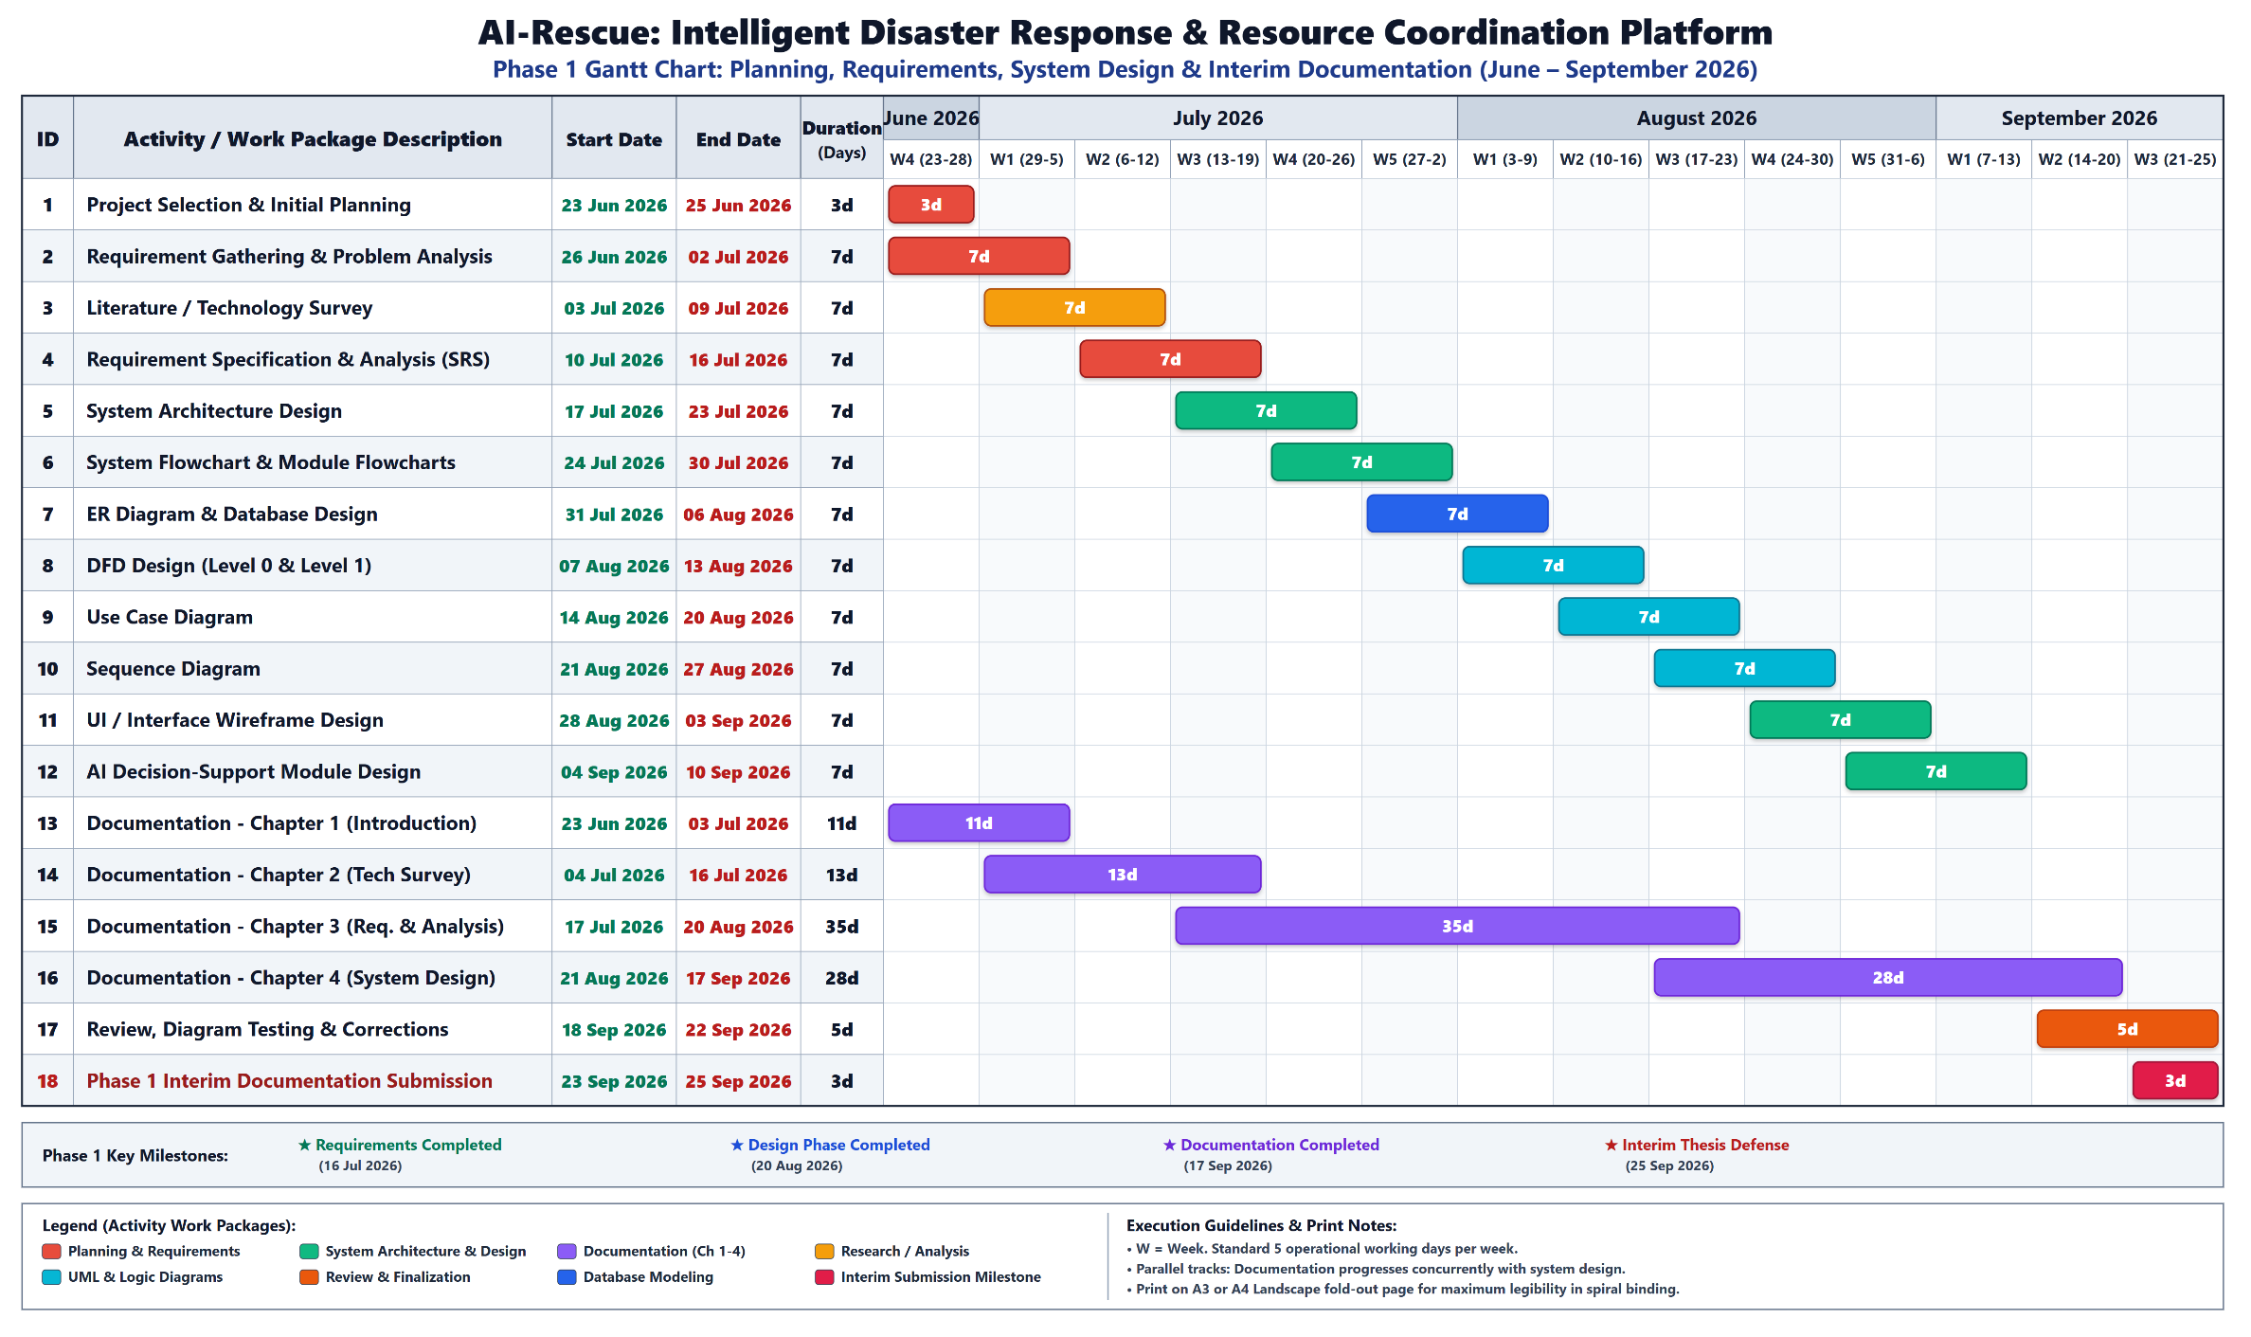
Figure 3.1: Gantt Chart – Phase 1: Planning, Requirements, System Design & Interim Documentation (June 2026 – September 2026)
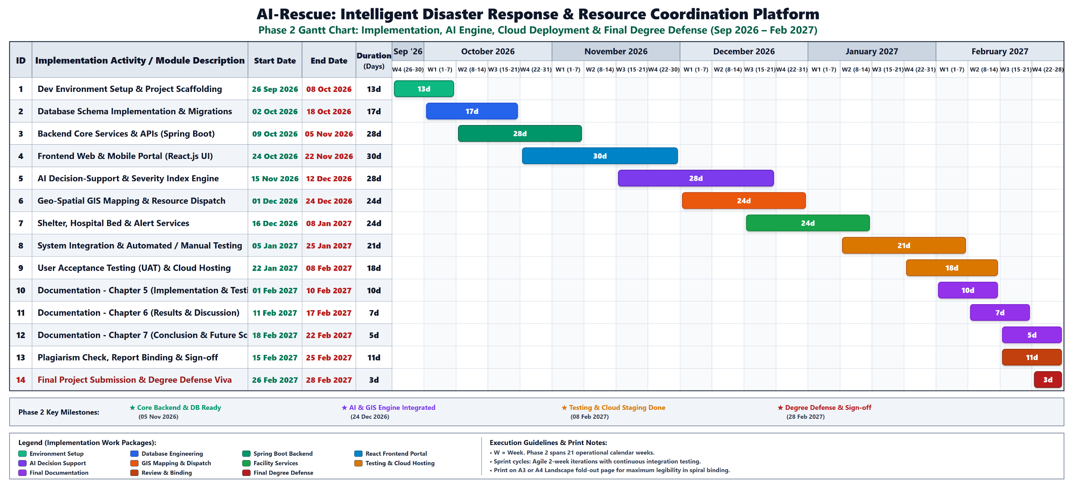
Figure 3.2: Gantt Chart – Phase 2: Core Full-Stack Development, AI Engine, Testing, Cloud & Final Defense (September 2026 – February 2027)
The project schedule is structured into two standalone execution phases. Phase 1 (Figure 3.1) encompasses initial problem definition, requirements engineering, SRS specification, architectural modeling (DFDs, ERDs, UML diagrams), and Chapters 1–4 interim documentation, concluding on 25 September 2026. Phase 2 (Figure 3.2) initiates immediately on 26 September 2026 without interruption, covering core Spring Boot backend services, PostgreSQL database schema migrations, React web portal development, AI decision-support algorithms, GIS routing, automated testing, cloud deployment, and final thesis defense by 28 February 2027.
The Gantt chart shows the planned timeline and duration of each major project activity. Activities are arranged according to their dependencies, with overlapping tasks where appropriate.
3.4 Software and Hardware Requirements
3.4.1 Software Requirements
The proposed development environment requires the following software:
Software | Purpose
Operating System | Windows / Linux
Java JDK | Java application development
Spring Boot | Backend development
Python | AI/ML development
Scikit-learn | Machine learning
PostgreSQL | Database management
Visual Paradigm | System modelling and diagrams
Web Browser | Application testing
Git | Version control
GitHub | Repository management
IDE | Java/Python application development
The exact IDE can be selected according to development convenience.

3.4.2 Hardware Requirements
A standard modern computer system is sufficient for developing the academic version of the platform.
Minimum Recommended Configuration
Component | Requirement
Processor | Intel Core i5 / equivalent
RAM | 8 GB minimum
Storage | 256 GB or higher
Network | Internet connection
Display | Standard monitor
Input | Keyboard and mouse
Recommended Configuration
Component | Requirement
Processor | Intel Core i5/i7 or equivalent
RAM | 16 GB
Storage | 512 GB SSD
Network | Stable broadband connection
A dedicated high-end GPU is not required for the initial academic version if the AI component uses conventional machine-learning models rather than large deep-learning models.

3.5 Preliminary Product Description
The AI-Rescue platform is proposed as a centralized web-based disaster management and response coordination system.
The platform provides a common environment where different stakeholders can interact with disaster-related information according to their roles.
The major capabilities of the system include:
1. User Management
Users can register and authenticate themselves. Role-based permissions determine the operations available to each user.
2. Incident Management
Citizens can report disaster incidents by providing structured information and optional supporting evidence. Officers can review, verify, reject, and manage incidents.
3. AI Decision Support
Once an incident has been verified, the AI module analyzes relevant information and generates recommendations related to severity, priority, and required resources.
4. Resource Coordination
Authorized officers can view available resources and assign appropriate resources to verified incidents.
5. Hospital and Shelter Information
The platform maintains emergency-service information such as hospital capacity, available beds, shelter capacity, and current occupancy.
6. Notification Management
The system provides notifications to relevant users based on incident and operational events.
7. Dashboard and Reporting
Authorized users can monitor disaster-response activities through dashboards and generate reports from stored information.
8. Audit and Administration
Important system activities are recorded through audit logs, while administrators can manage system configuration.

3.6 Conceptual Models
Conceptual models provide a high-level representation of how the proposed system operates and how its components interact.
The major conceptual models prepared for AI-Rescue are:
- Data Flow Diagram (DFD)
- Use Case Diagram
These models describe different aspects of the same system.

3.6.1 Data Flow Concept
At a conceptual level, information flows through the system as follows:
- DFD Level 0
The Level 0 Data Flow Diagram provides a high-level view of the AI-Rescue system and shows how data is exchanged between external entities and the system.
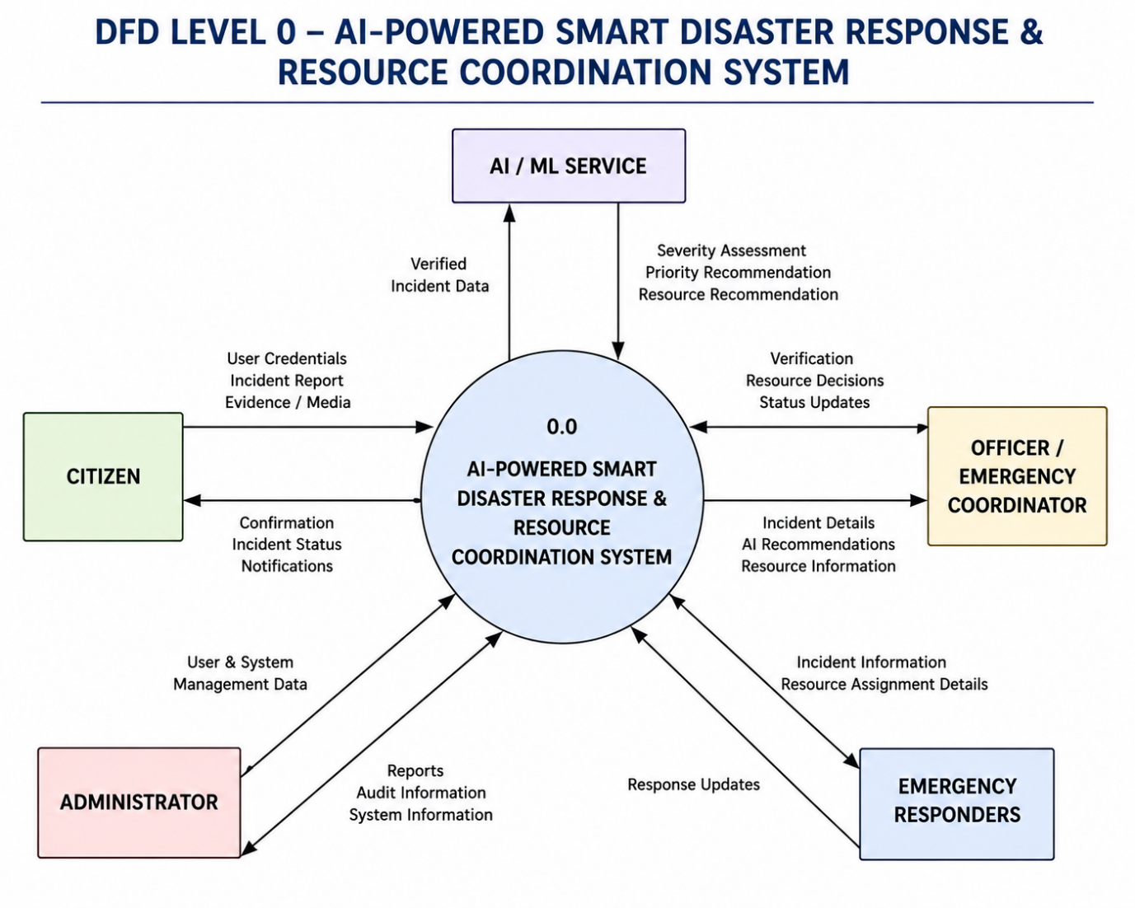
Figure 3.3: Data Flow Diagram – Level 0
The diagram represents the major input and output data flows between users and the disaster response platform.

- DFD Level 1
The Level 1 DFD decomposes the major processes of the AI-Rescue system into more detailed processes.
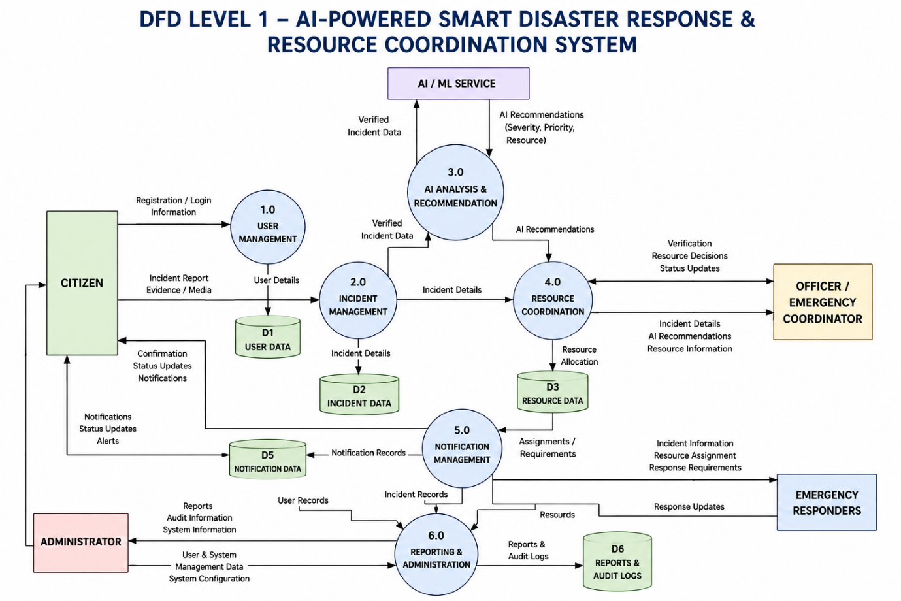
Figure 3.4: Data Flow Diagram – Level 1
This expands the major processes of the Level 0 DFD.
It illustrates the flow of incident information, verification data, AI recommendations, resource information, notifications, and response updates within the system.
3.6.2 Use Case Diagram
The Use Case Diagram represents the interactions between different users and the AI-Rescue system. It identifies the major actors and the functions available to each actor.
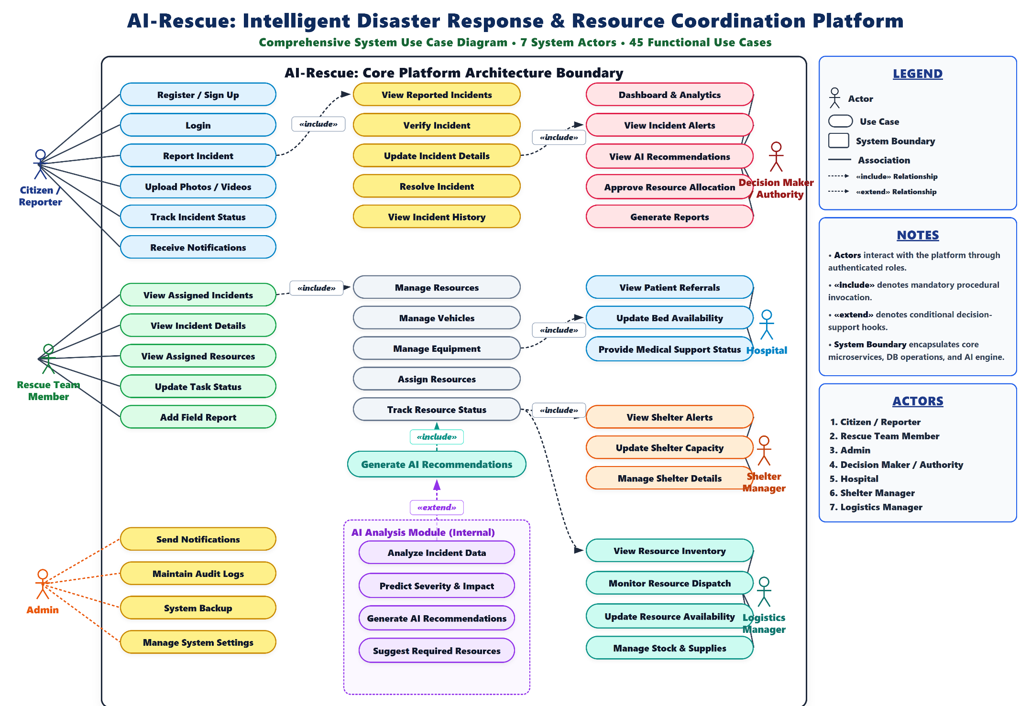

Figure 3.5: Use Case Diagram – AI-Powered Smart Disaster Response Platform
CHAPTER 4: SYSTEM DESIGN
4.1 Basic Modules
The AI-Rescue platform is divided into functional modules. Each module is responsible for a specific set of operations while communicating with other modules through the application's backend.
4.1.1 User Authentication and Role Management
This module manages user registration, login, authentication, and role-based access.
Main functions:
- User registration.
- User login.
- Credential verification.
- Role identification.
- Session management.
- Access control.
- Account status management.
The system provides different permissions according to the user's role.
Related tables:
- ROLE
- USER

4.1.2 Disaster Incident Management
This is the central operational module of the system.
It allows users to report disaster incidents and allows authorized officers to review and manage them.
Main functions:
- Create incident reports.
- Enter disaster details.
- Record incident location.
- Record affected population.
- Attach supporting evidence.
- Validate incident information.
- Review submitted incidents.
- Verify or reject incidents.
- Update incident status.
- Close resolved incidents.
Related tables:
- DISASTER_TYPE
- INCIDENT
- INCIDENT_MEDIA
- USER

4.1.3 AI Decision-Support Module
The AI module assists authorized officers in evaluating verified disaster incidents.
The AI module is not responsible for independently approving incidents or dispatching emergency resources.
The workflow is:
Incident Report
↓
Officer Verification
↓
Verified Incident
↓
AI Analysis
↓
Severity Assessment
↓
Priority Recommendation
↓
Resource Recommendation
↓
Officer Review
↓
Operational Decision
The module may generate:
- Severity score.
- Priority recommendation.
- Recommended resource types.
- Confidence score.
- Reasoning/explanation associated with the recommendation.
Related table:
- AI_RECOMMENDATION

4.1.4 Resource Management Module
This module manages the emergency resources available to the organization.
Resources can include general response resources, vehicles, and equipment.
Main functions:
- Add resources.
- Update resource information.
- View resource availability.
- Track resource status.
- Manage vehicles.
- Manage equipment.
- Assign resources to incidents.
Related tables:
- RESOURCE
- VEHICLE
- EQUIPMENT
- RESOURCE_ASSIGNMENT

4.1.5 Resource Assignment and Coordination Module
This module connects verified incidents with the resources required for response.
After the officer reviews the AI recommendation, the system checks available resources.
Verified Incident
↓
AI Recommendation
↓
Officer Review
↓
Determine Required Resources
↓
Check Availability
↓
Resources Available?
/ \
YES NO
↓ ↓
Assign Find Alternative /
Resources Escalate Requirement
↓ ↓
└──────→ Response Planning
If suitable resources are unavailable, the system can record the requirement for alternative resources or escalation to a higher-level authority/support mechanism.
Related tables:
- RESOURCE
- VEHICLE
- EQUIPMENT
- RESOURCE_ASSIGNMENT
- USER

4.1.6 Hospital Management Module
This module maintains information about hospitals that may be relevant during emergency response.
The information may include:
- Hospital name.
- Address.
- Location.
- Contact number.
- Emergency capacity.
- Available beds.
- Current status.
The module helps authorized users identify hospital capacity when emergency medical support is required.
Related table:
- HOSPITAL

4.1.7 Shelter Management Module
This module manages emergency shelter information.
The information may include:
- Shelter name.
- Address.
- Location.
- Contact number.
- Total capacity.
- Current occupancy.
- Availability/status.
The information can support decisions regarding temporary accommodation for affected populations.
Related table:
- SHELTER

4.1.8 Notification Module
The notification module manages communication of important system events to relevant users.
Notifications can be generated for events such as:
- New incident submission.
- Incident verification.
- Incident rejection.
- Resource assignment.
- Response updates.
- Other important operational events.
Related tables:
- NOTIFICATION
- USER
- INCIDENT

4.1.9 Dashboard and Reporting Module
The dashboard provides an overview of disaster-response activities.
Possible information displayed includes:
- Total incidents.
- Active incidents.
- Incident priority.
- Incident status.
- Resource availability.
- Response activities.
- Notifications.
- Summary statistics.
The reporting component allows authorized users to generate reports based on stored system information.
Related tables:
- REPORT_LOG
- INCIDENT
- RESOURCE
- RESOURCE_ASSIGNMENT

4.1.10 Audit and System Administration Module
This module provides administrative control and system traceability.
The audit component records important actions performed within the system.
Examples include:
- User-related changes.
- Incident modifications.
- Resource assignments.
- Administrative actions.
- Configuration changes.
The administrator can also manage system-level settings.
Related tables:
- AUDIT_LOG
- SYSTEM_SETTINGS
- USER

4.2 Data Design
Data design defines how information is organized, stored, related, and protected within the AI-Rescue platform.
The proposed system uses a relational database model with PostgreSQL.
The finalized V1 database consists of 16 tables.
These tables are organized into the following logical groups:
Category | Tables
Identity | ROLE, USER
Incident Management | DISASTER_TYPE, INCIDENT, INCIDENT_MEDIA
AI | AI_RECOMMENDATION
Resource Management | RESOURCE, VEHICLE, EQUIPMENT, RESOURCE_ASSIGNMENT
Emergency Services | HOSPITAL, SHELTER
Communication | NOTIFICATION
Administration | REPORT_LOG, AUDIT_LOG, SYSTEM_SETTINGS

4.2.1 Schema Design
1. ER DIAGRAM
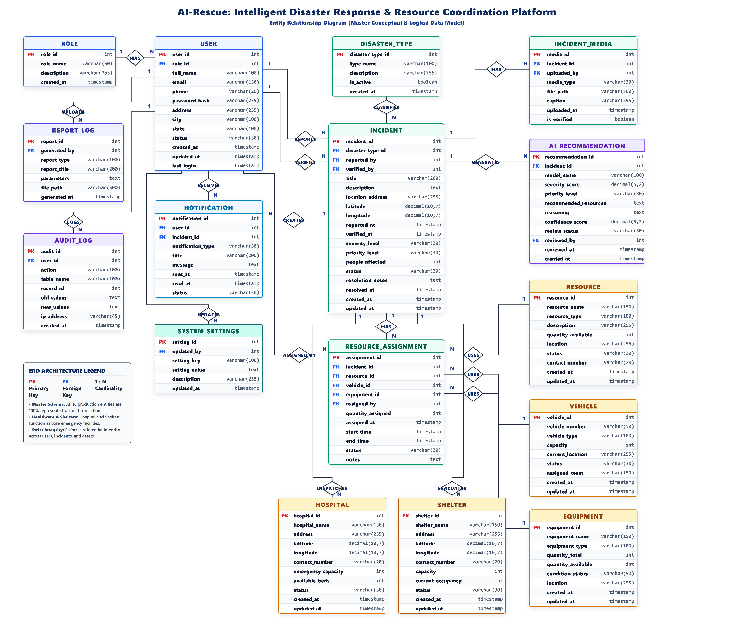
Figure 4.1: Entity Relationship Diagram of AI-Rescue

1. ROLE
Stores the roles available within the system.
Field | Description
role_id | Primary Key
role_name | Name of the role
description | Description of the role
created_at | Creation timestamp

2. USER
Stores registered users and their role information.
Field | Description
user_id | Primary Key
role_id | Foreign Key → ROLE
full_name | User's name
email | User email
phone | Contact number
password_hash | Encrypted/hashed password
address | User address
city | City
state | State
status | Account status
created_at | Creation timestamp
updated_at | Last update timestamp
last_login | Last login timestamp

3. DISASTER_TYPE
Stores the different types of disasters supported by the system.
Field | Description
disaster_type_id | Primary Key
type_name | Disaster type
description | Description
is_active | Active/inactive status
created_at | Creation timestamp

4. INCIDENT
Stores the main disaster incident information.
Field | Description
incident_id | Primary Key
disaster_type_id | Foreign Key → DISASTER_TYPE
reported_by | Foreign Key → USER
verified_by | Foreign Key → USER
title | Incident title
description | Incident description
location_address | Incident location
latitude | Geographic latitude
longitude | Geographic longitude
reported_at | Report timestamp
verified_at | Verification timestamp
severity_level | Severity classification
priority_level | Priority classification
people_affected | Number of affected people
status | Incident status
resolution_notes | Resolution information
resolved_at | Resolution timestamp
created_at | Creation timestamp
updated_at | Update timestamp

5. INCIDENT_MEDIA
Stores evidence associated with an incident.
Field | Description
media_id | Primary Key
incident_id | Foreign Key → INCIDENT
uploaded_by | Foreign Key → USER
media_type | Type of media
file_path | Stored file location
caption | Media description
uploaded_at | Upload timestamp
is_verified | Verification status

6. AI_RECOMMENDATION
Stores the output generated by the AI decision-support component.
Field | Description
recommendation_id | Primary Key
incident_id | Foreign Key → INCIDENT
model_name | AI model used
severity_score | AI-generated severity score
priority_level | Recommended priority
recommended_resources | Recommended resources
reasoning | Explanation of recommendation
confidence_score | AI confidence
created_at | Creation timestamp

7. RESOURCE
Stores general emergency resources.
Field | Description
resource_id | Primary Key
resource_name | Resource name
resource_type | Resource category
description | Description
quantity_available | Available quantity
location | Current location
status | Resource status
contact_number | Contact information
created_at | Creation timestamp
updated_at | Update timestamp

8. VEHICLE
Stores emergency-response vehicles.
Field | Description
vehicle_id | Primary Key
vehicle_number | Vehicle registration/identifier
vehicle_type | Vehicle category
capacity | Carrying/response capacity
current_location | Current location
status | Vehicle status
assigned_team | Assigned team
created_at | Creation timestamp
updated_at | Update timestamp

9. EQUIPMENT
Stores emergency equipment.
Field | Description
equipment_id | Primary Key
equipment_name | Equipment name
equipment_type | Equipment category
quantity_total | Total quantity
quantity_available | Available quantity
condition_status | Equipment condition
location | Current location
created_at | Creation timestamp
updated_at | Update timestamp

10. RESOURCE_ASSIGNMENT
Stores the assignment of resources to disaster-response activities.
Field | Description
assignment_id | Primary Key
incident_id | Foreign Key → INCIDENT
resource_id | Foreign Key → RESOURCE
vehicle_id | Foreign Key → VEHICLE
equipment_id | Foreign Key → EQUIPMENT
assigned_by | Foreign Key → USER
assigned_at | Assignment timestamp
start_time | Start of assignment
end_time | End of assignment
status | Assignment status
notes | Additional information

11. HOSPITAL
Stores emergency hospital information.
Field | Description
hospital_id | Primary Key
hospital_name | Hospital name
address | Hospital address
latitude | Geographic latitude
longitude | Geographic longitude
contact_number | Contact number
emergency_capacity | Emergency capacity
available_beds | Available beds
status | Hospital status
created_at | Creation timestamp
updated_at | Update timestamp

12. SHELTER
Stores emergency shelter information.
Field | Description
shelter_id | Primary Key
shelter_name | Shelter name
address | Shelter address
latitude | Geographic latitude
longitude | Geographic longitude
contact_number | Contact number
capacity | Total capacity
current_occupancy | Current occupants
status | Shelter status
created_at | Creation timestamp
updated_at | Update timestamp

13. NOTIFICATION
Stores notifications generated by the system.
Field | Description
notification_id | Primary Key
user_id | Foreign Key → USER
incident_id | Foreign Key → INCIDENT
notification_type | Notification category
title | Notification title
message | Notification message
sent_at | Sent timestamp
read_at | Read timestamp
status | Notification status

14. REPORT_LOG
Stores information about generated reports.
Field | Description
report_id | Primary Key
generated_by | Foreign Key → USER
report_type | Report category
report_title | Report title
parameters | Report parameters
file_path | Generated file location
generated_at | Generation timestamp

15. AUDIT_LOG
Stores records of important system activities.
Field | Description
audit_id | Primary Key
user_id | Foreign Key → USER
action | Action performed
table_name | Affected table
record_id | Affected record
old_values | Previous values
new_values | Updated values
ip_address | Source IP
created_at | Timestamp

16. SYSTEM_SETTINGS
Stores configurable system settings.
Field | Description
setting_id | Primary Key
updated_by | Foreign Key → USER
setting_key | Setting identifier
setting_value | Setting value
description | Setting description
updated_at | Update timestamp

2. Database Design
Figure 4.2: Database Design of AI-Rescue
The database design represents the relational structure of the AI-Rescue platform. The system uses 16 tables to store and manage operational data.
The database contains tables for user management, incidents, AI recommendations, resources, emergency facilities, notifications, reporting, auditing, and system configuration. Primary and foreign keys maintain relationships and data integrity.

4.2.2 Data Integrity and Constraints
Data integrity ensures that the information stored in the database remains accurate, consistent, and reliable.
The following constraints are considered in the database design.
Primary Key
Every table contains a unique primary key that identifies each record.
For example:
USER.user_id
INCIDENT.incident_id
RESOURCE.resource_id
HOSPITAL.hospital_id
Foreign Key
Foreign keys maintain relationships between related tables.
For example:
USER.role_id
↓
ROLE.role_id
and:
INCIDENT.disaster_type_id
↓
DISASTER_TYPE.disaster_type_id
NOT NULL
Important attributes should not be allowed to contain empty values.
For example, a user account should require essential information such as name, email, and password.
UNIQUE
Attributes such as email addresses can be restricted to unique values where required.
CHECK Constraints
Appropriate values can be restricted using validation rules.
For example:
people_affected >= 0
quantity_available >= 0
available_beds >= 0
current_occupancy >= 0
Referential Integrity
Foreign-key relationships prevent invalid references between related records.
Transaction Integrity
Database transactions can be used when multiple related operations must either complete successfully together or be rolled back.

4.3 Procedural Design
Procedural design describes the logical procedures followed by the system when processing different operations.
The major procedures include:
- User authentication.
- Incident reporting.
- Incident verification.
- AI analysis.
- Resource availability checking.
- Resource assignment.
- Incident response and status management.
- Notification processing.
- Report generation.

4.3.1 Logic Diagrams
Figure 4.3: Overall System Flowchart
The overall system flowchart represents the complete operational workflow of the AI-Rescue platform, from incident reporting to incident resolution.
The workflow includes authentication, incident reporting, validation, officer verification, AI-assisted analysis, resource allocation, emergency response, status updates, and incident closure.

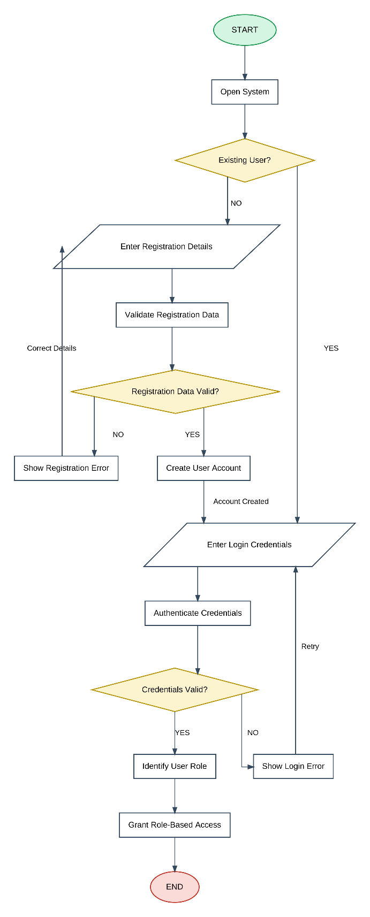
Figure 4.4: User Authentication Module Flowchart

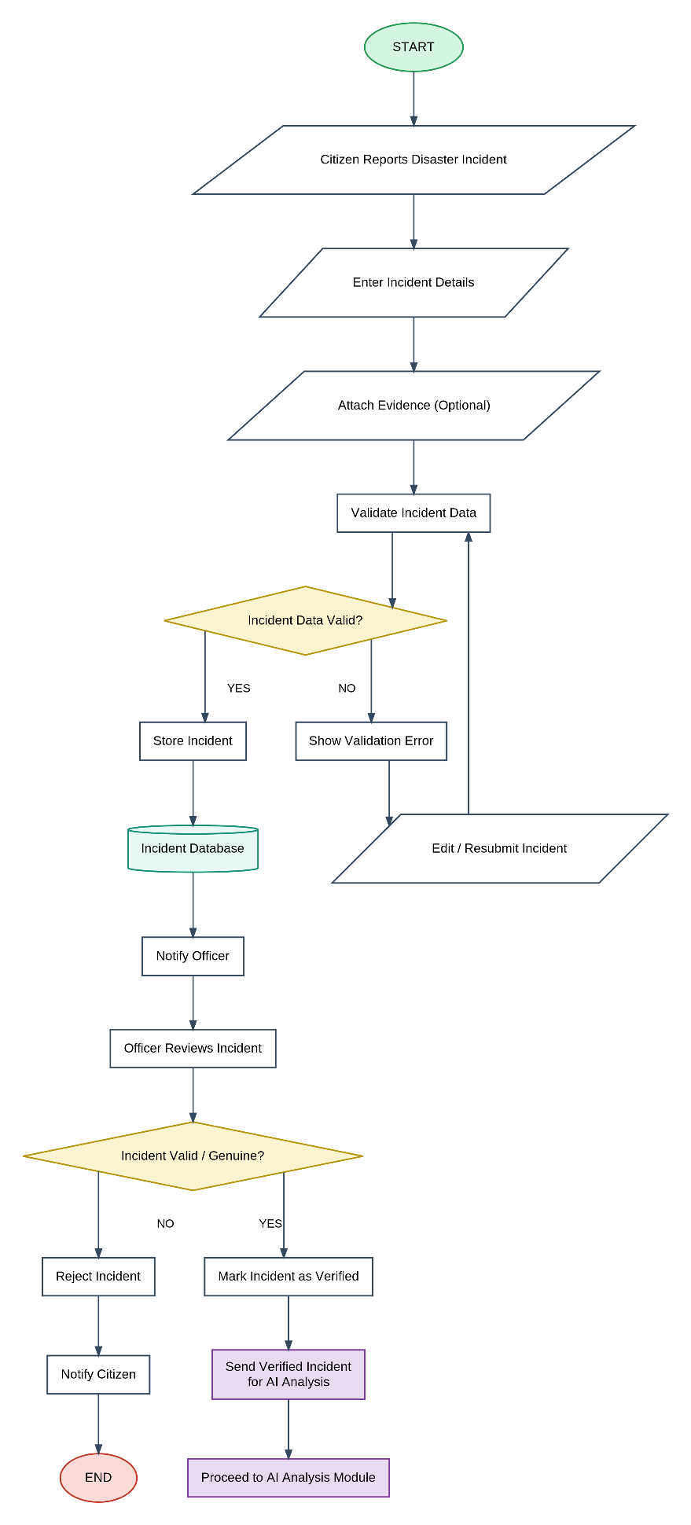
Figure 4.5: Incident Reporting Flowchart

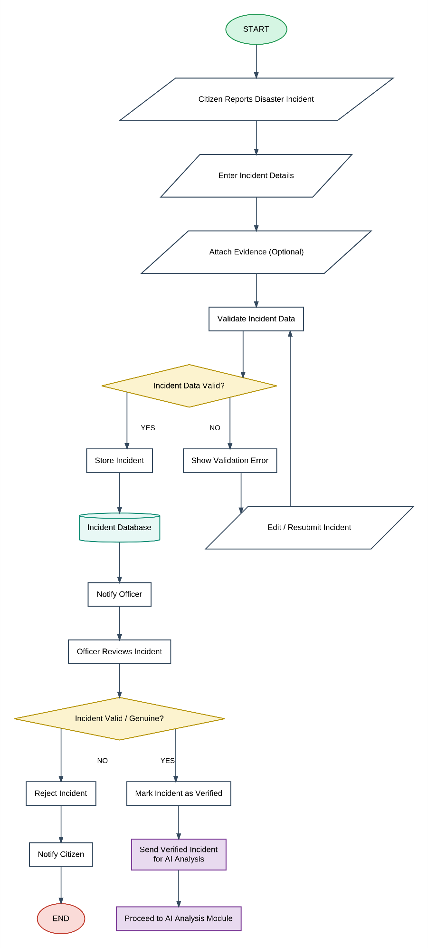
Figure 4.6: AI Analysis Flowchart

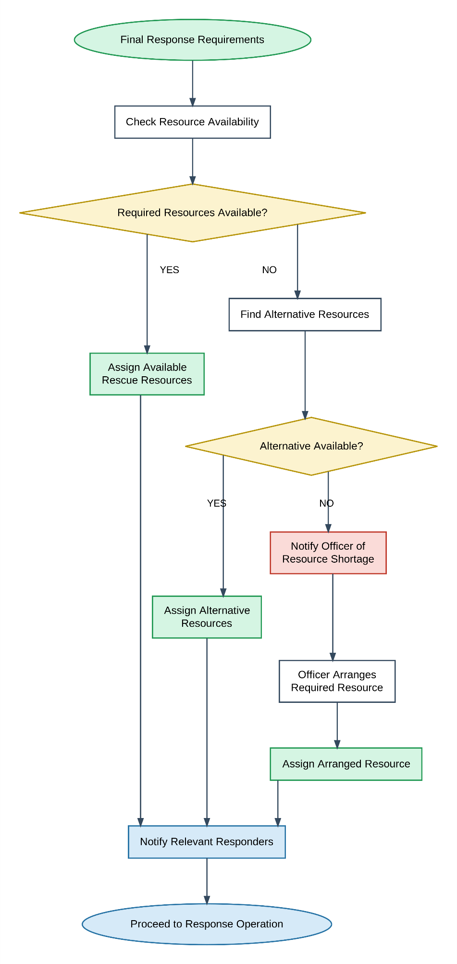

Figure 4.7: Resource Management and Assignment Module Flowchart

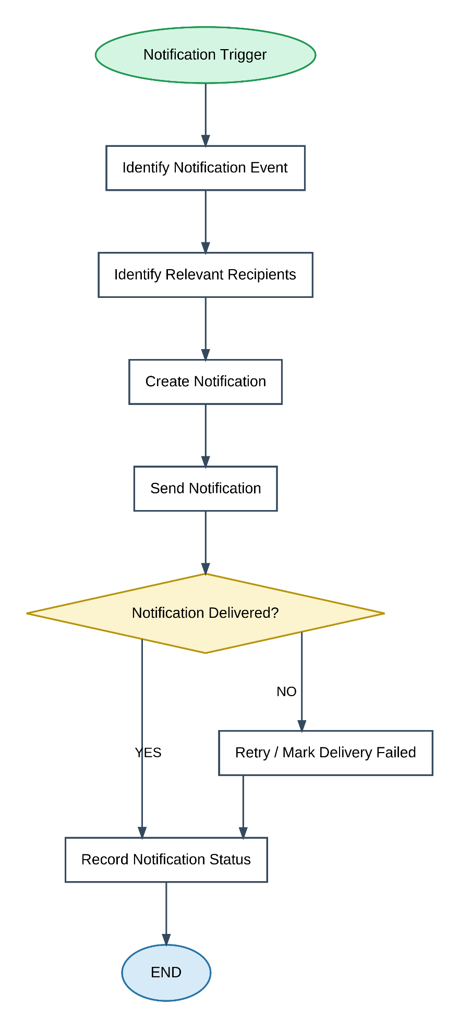
Figure 4.8: Notification Module Flowchart
The Sequence Diagram models the chronological procedural interaction between platform actors (Citizen, Response Officer, System Administrator) and core backend services (Authentication, Incident Service, AI Severity Engine, Resource Dispatcher, and Notification Engine) across the entire incident lifecycle.
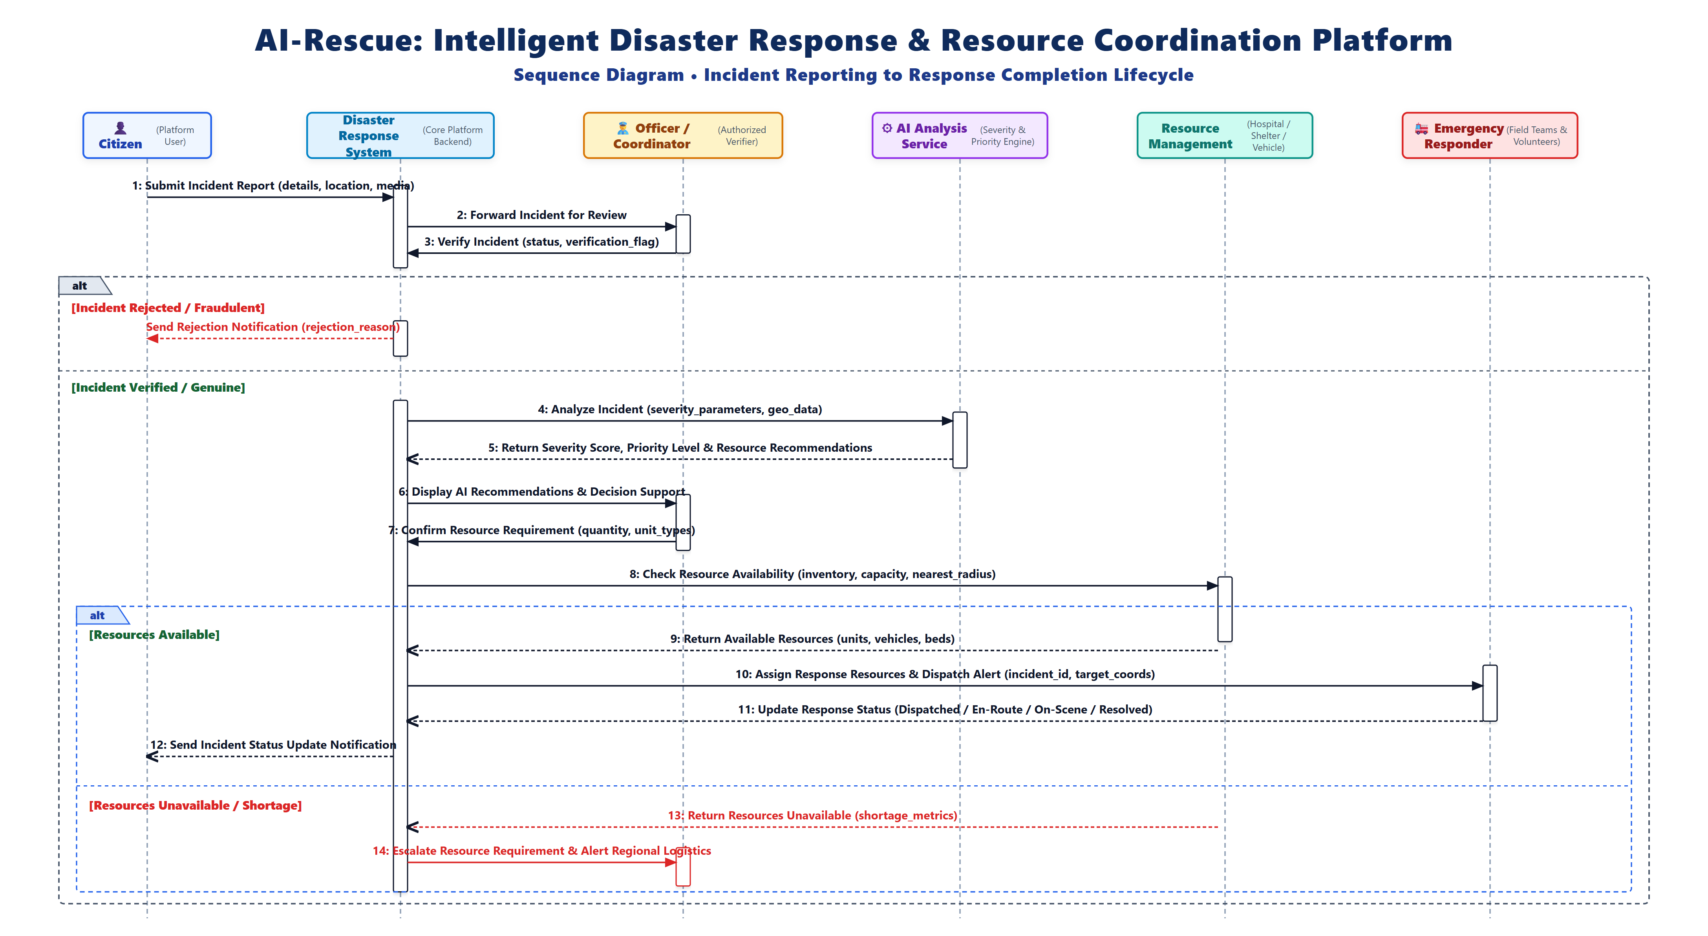
Figure 4.9: Sequence Diagram – Incident Reporting to Response Completion

4.3.2 Data Structures
The system uses several logical data structures during processing.
User Object
User
├── user_id
├── role_id
├── full_name
├── email
├── phone
└── status
Incident Object
Incident
├── incident_id
├── disaster_type_id
├── reported_by
├── location
├── severity
├── priority
├── people_affected
└── status
AI Recommendation Object
AI Recommendation
├── recommendation_id
├── incident_id
├── severity_score
├── priority_level
├── recommended_resources
└── confidence_score
Resource Assignment Object
Resource Assignment
├── assignment_id
├── incident_id
├── resource_id
├── vehicle_id
├── equipment_id
├── assigned_by
└── status
These structures represent the logical information handled by the application before or during database operations.

4.3.3 Algorithms Design
Algorithm 1: User Authentication
Step 1: Accept email and password.
Step 2: Validate the entered credentials.
Step 3: Search for the corresponding user account.
Step 4: Verify the password against the stored password hash.
Step 5: Check account status.
Step 6: If valid, create an authenticated session/token.
Step 7: Identify the user's role.
Step 8: Provide access according to the assigned role.
Step 9: Otherwise, display an authentication error.

Algorithm 2: Incident Verification
Step 1: Receive submitted incident.
Step 2: Display incident information to authorized officer.
Step 3: Officer reviews incident details and evidence.
Step 4: Determine whether the incident is genuine.
Step 5: If invalid:
Reject incident.
Update incident status.
Notify citizen.
Step 6: If valid:
Mark incident as verified.
Record verification details.
Send incident for AI analysis.

Algorithm 3: AI-Assisted Incident Analysis
Step 1: Receive verified incident data.
Step 2: Prepare relevant input attributes.
Step 3: Send the data to the AI service.
Step 4: AI processes the incident information.
Step 5: Calculate/estimate severity.
Step 6: Generate priority recommendation.
Step 7: Generate required-resource recommendation.
Step 8: Calculate confidence score.
Step 9: Return recommendation to the backend.
Step 10: Store the recommendation.
Step 11: Present the recommendation to the authorized officer.

Algorithm 4: Resource Availability and Assignment
Step 1: Receive verified incident and required resource information.
Step 2: Check available resources.
Step 3: Check vehicle availability.
Step 4: Check equipment availability.
Step 5: If suitable resources are available:
Select appropriate resources.
Create resource assignment.
Update resource status.
Notify relevant responders.
Step 6: If required resources are unavailable:
Identify possible alternatives.
Record the unmet requirement.
Escalate the requirement when necessary.
Step 7: Continue response planning.

4.4 User Interface Design
The user interface is designed to provide a simple and role-specific experience.
4.4.1 Login Page
The login interface provides:
- Email/username input.
- Password input.
- Login button.
- Registration option.
- Error messages.

4.4.2 Citizen Dashboard
The citizen dashboard can provide:
- Report disaster button.
- Submitted incidents.
- Incident status.
- Notifications.
- Profile information.

4.4.3 Officer Dashboard
The officer dashboard provides access to operational information such as:
- New incidents.
- Pending verification.
- Verified incidents.
- AI recommendations.
- Resource availability.
- Active responses.
- Notifications.
- Reports.

4.4.4 Administrator Dashboard
The administrator interface provides:
- User management.
- Role management.
- Resource management.
- System settings.
- Audit records.
- Reports.

4.4.5 Incident Reporting Interface
The incident reporting form can contain:
- Disaster type.
- Incident title.
- Description.
- Location.
- Geographic coordinates.
- People affected.
- Supporting evidence.
- Submit button.
The interface should clearly indicate mandatory and optional fields.

4.5 Security Issues
Because the platform handles user information and potentially sensitive disaster-response information, security is an important part of the system design.
4.5.1 Authentication
Users must authenticate before accessing protected functionality.
4.5.2 Password Security
Passwords should not be stored as plain text. Passwords should be stored using secure password hashing mechanisms.
4.5.3 Role-Based Access Control
Users should only access functions permitted by their roles.
For example:
Citizen
↓
Incident Reporting

Officer
↓
Incident Verification
AI Recommendation Review
Resource Assignment

Administrator
↓
System Management

4.5.4 Authorization
Authentication confirms who the user is, while authorization determines what the user is allowed to do.
4.5.5 Input Validation
User input should be validated to reduce invalid data and common security risks.
4.5.6 Secure Communication
Communication between clients and servers should use HTTPS in the deployed system.
4.5.7 Audit Logging
Important actions should be recorded so that system activities can be traced.
4.5.8 Database Security
Database credentials should be protected, and application users should receive only the permissions required for their operations.

4.6 Test Cases Design
Testing is required to verify that the system behaves according to its functional requirements.
The following test cases represent the major V1 functionality.
TC ID | Test Case | Input/Condition | Expected Result
TC-01 | User Registration | Valid registration details | Account created successfully
TC-02 | User Registration | Duplicate email | Registration rejected
TC-03 | Login | Valid credentials | User authenticated
TC-04 | Login | Invalid password | Error displayed
TC-05 | Role Access | Citizen accesses officer function | Access denied
TC-06 | Incident Reporting | Valid incident details | Incident submitted
TC-07 | Incident Validation | Missing mandatory field | Validation error
TC-08 | Incident Verification | Officer marks incident valid | Incident becomes verified
TC-09 | Incident Verification | Officer rejects incident | Incident rejected and notification generated
TC-10 | AI Analysis | Verified incident | AI recommendation generated
TC-11 | AI Analysis | Unverified incident | AI analysis not initiated
TC-12 | Resource Availability | Available resources | Resources can be assigned
TC-13 | Resource Availability | No suitable resource | Alternative/escalation process initiated
TC-14 | Resource Assignment | Valid assignment | Assignment stored and resource status updated
TC-15 | Notification | Operational event occurs | Relevant notification generated
TC-16 | Incident Resolution | Incident resolved | Incident closed
TC-17 | Report Generation | Valid report request | Report generated
TC-18 | Audit Logging | Important system action | Audit record created
TC-19 | Hospital Information | Update hospital capacity | Updated information stored
TC-20 | Shelter Information | Update shelter occupancy | Updated information stored

CHAPTER 4 SUMMARY
The system design defines the architecture, modules, database structure, processing logic, algorithms, interface design, security considerations, and testing approach of the AI-Rescue platform.

