**Proposal**

The goal of this project was to create a **Scientific Calculator and a Symbolic Derivative Calculator** in Python. Both the calculators can be operated separately. The Scientific Calculator will perform all the tasks from arithmetic to all the trigonometric functions whereas the Derivative Calculator will derive the equation provided and graph it with the derived equation.

**Requirements**

This project is fully based on python. So, the necessary modules needed for computation are:

* numpy
* tkinter
* matplotlib
* tkMessageBox

The commands needed for installing the above modules are:

* pip install numpy
* pip install tkinter
* pip install matplotlib
* pip install tkMessageBox

**Test Runs**

All the tests were run on the ilab devices. The results are the following.

1. Scientific Calculator. Run “python SciCalc.py” in command line.

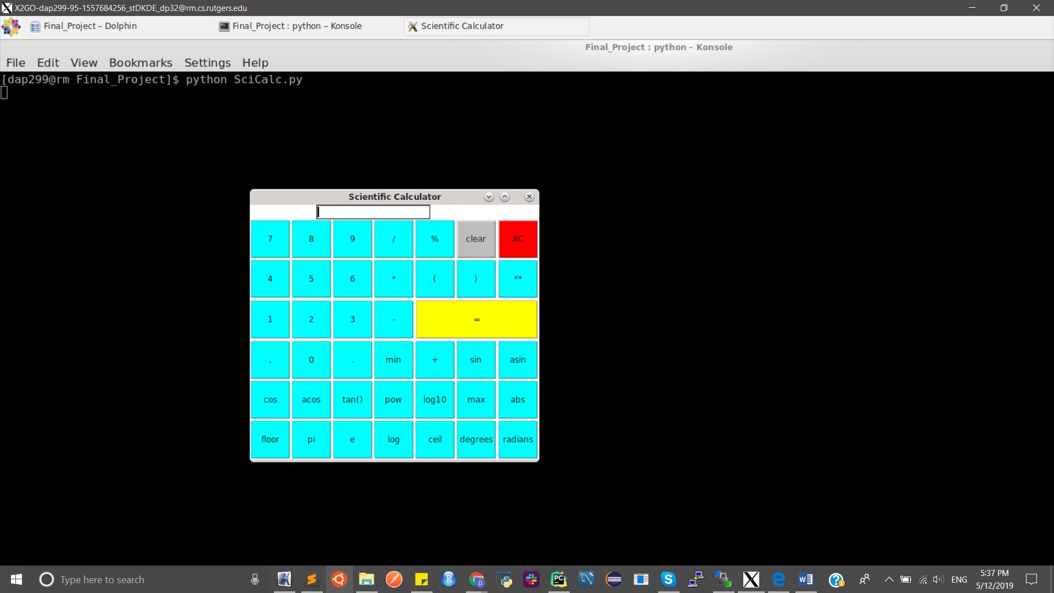

1. Derivative Calculator. Run “python DerivCalc.py” in command line.

