DETECTION AND MITIGATION OF HALLUCINATIONS IN LARGE LANGUAGE MODELS
Aditi Singh and Dev Vashishtha
Department of Data Science and Engineering, Manipal University Jaipur, Rajasthan, India

Abstract
Large language models (LLMs) can generate fluent responses containing unsupported or factually incorrect information, creating reliability concerns in knowledge-intensive applications such as healthcare question answering. This paper presents a lightweight research prototype for flagging and handling potentially unreliable answers by combining semantic retrieval, student–teacher answer comparison, heuristic risk assessment, and rule-based mitigation. The system uses FLAN-T5-small as the student model, FLAN-T5-base as the teacher model, and all-MiniLM-L6-v2 for semantic retrieval and similarity calculations. PubMedQA and filtered HealthCareMagic records provide the question-answer data used to construct a small retrieval knowledge base and evaluate the pipeline. The experiments compare student-only and teacher-only baselines, retrieval-assisted generation, baseline mitigation, and a support-check configuration that can abstain when neither candidate passes its support criterion. Across the saved experiment artifacts, baseline mitigation D is reported with a mean reference similarity of 0.481 and a 40% similarity-pass rate, while the separately recorded support-check configuration E has a mean similarity of 0.386 and a 35% pass rate, with six abstentions among 20 test questions. Because the D and E results are stored in separate experiment artifacts, their ranking is descriptive unless the held-out question identifiers and settings are confirmed to match. Reference similarity, however, is not factual accuracy, and manually verified hallucination labels are not yet available. The work therefore contributes an integrated, resource-conscious prototype and a preliminary comparative evaluation, rather than a validated factuality detector or a clinically validated medical system.
Index Terms—LLM hallucination, hallucination detection, hallucination mitigation, semantic similarity, retrieval-assisted generation, student–teacher models, healthcare question answering, abstention.

1. Introduction
Large language models (LLMs) can produce coherent explanations, summaries, and question-answering responses, but fluency does not guarantee factual reliability. Hallucinations are commonly understood as generated statements that are factually incorrect, fabricated, or unsupported by the available evidence. Surveys have organized their causes, forms, and possible mitigations across language-generation settings [1], [2]. A complementary theoretical account argues that language-model training and evaluation can reward guessing rather than appropriately acknowledging uncertainty [3].
Healthcare question answering is a useful setting for studying reliability because medical questions often require domain-specific evidence, and an unsupported response can mislead readers. This project focuses on a research prototype for healthcare-oriented questions rather than on clinical decision support. Its output should not be treated as medical advice or assumed correct merely because it is fluent or agrees with another model.
Existing research explores several complementary reliability signals. Semantic-consistency methods compare responses to paraphrased questions [4], while SelfCheckGPT examines variation across multiple sampled generations [5]. Context-tagging and structured prompts attempt to constrain answers using supplied evidence [6]. Other approaches detect internal self-contradictions [7] or test whether a model can identify fabricated bibliographic references through consistency checks [8]. Benchmarks such as HaluEval [9] and HaluEval 2.0 [10] support more systematic study, while LLM-Check investigates internal representation, attention, and token-probability signals [11]. Reviews of detection and mitigation methods further emphasize the diversity of approaches and the difficulty of comparing them under different settings [12], [13].
Additional directions include training models to express calibrated uncertainty [14], uncertainty-aware fusion of multiple model responses [15], metamorphic testing [16], and self-reflection for medical question answering [17]. Educational applications and multi-model consensus have also been investigated in narrower settings [18], [19]. These approaches motivate combining evidence retrieval, answer comparison, and mitigation, but they do not imply that a simpler implementation using cosine similarity can validate factual correctness.
This study investigates an integrated, resource-conscious pipeline using two pretrained FLAN-T5 model sizes and semantic retrieval. The smaller model generates a candidate answer, a larger model supplies a second candidate, and the system compares student–teacher and student–context similarity while applying an answer-length heuristic. Rule-based mitigation then selects a response, with a newer configuration allowing abstention when neither candidate passes a support criterion. The project evolved from a smaller proof of concept into a configurable experiment with two data sources, retrieval over multiple records, saved predictions, separate validation and test samples, and a FastAPI/React web interface [20].
The evaluation is preliminary. Its principal metric is cosine similarity between a generated answer and a reference answer, with a pass defined as a score strictly greater than 0.52. This measures semantic resemblance; it does not directly establish factual truth or evidence entailment. The repository also lacks completed manual factuality labels, preventing a defensible calculation of hallucination-detection precision, recall, and F1 [20].
The contributions of this work are: (1) an integrated prototype combining local semantic retrieval, two pretrained model sizes, heuristic risk screening, and rule-based mitigation; (2) a comparative evaluation of student-only, teacher-only, retrieval-assisted, baseline-mitigation, and support-check configurations; (3) a more structured workflow with separate validation/test samples, stored predictions, and a reported leakage check; and (4) an explicit analysis of the limitations of reference similarity as a proxy for factual reliability. The work does not claim a newly trained detector or validated reduction in factual hallucinations.

2. Related Work
Prior work can be grouped into consistency-based detection, context-grounded prompting and retrieval, contradiction detection, uncertainty estimation, and integrated detection–mitigation. Table 1 provides a compact survey of selected sources from the earlier project report and the uploaded research collection. The table focuses on papers relevant to the current text-only, healthcare-oriented prototype; multimodal hallucination studies are not directly comparable to the system evaluated here.
Curative prompt refinement attempts to reduce hallucinations by reformulating vague or malformed user prompts before generation [21]. Jančářík and Dušek describe an educational chatbot strategy that routes factual questions to authorised learning materials and offers human help when an answer cannot be traced [22]. Several uploaded papers address hallucination in vision-language systems through fine-grained detection datasets, parameter-efficient tuning, or evaluation of low-level visual perception [23]–[25]. These multimodal studies are relevant to the broader research landscape but are not direct baselines for this text-only healthcare QA prototype.

Table 1. Expanded Literature Survey of Prior Work
Author(s) (Year) | Ref. | Method / Technique | Primary datasets / setup | Limitations / gaps
Ye et al. (2023) | [1] | Taxonomy and survey of hallucination types, detection, and mitigation. | Literature across text-generation tasks; no single dataset. | Synthesis and taxonomy, not a directly evaluated detector.
Tonmoy et al. (2024) | [2] | Survey and taxonomy of more than 32 mitigation techniques. | Multiple datasets and tasks covered by reviewed studies. | Methods use different setups; survey does not establish one universally best technique.
Kalai et al. (2025) | [3] | Theoretical analysis of hallucination and incentives to guess under common training/evaluation procedures. | Conceptual/statistical analysis; no single empirical dataset. | Explains mechanisms but does not provide a plug-in factuality checker for this system.
Raj et al. (2022) | [4] | Semantic consistency across semantically equivalent or paraphrased prompts. | TruthfulQA with multiple models and decoding settings. | Consistency can diverge from factual accuracy; multiple prompts increase evaluation cost.
Manakul et al. (2023) | [5] | SelfCheckGPT compares multiple sampled generations to assess sentence-level factuality. | WikiBio-generated passages with human factuality annotations. | Requires multiple samples and is not a direct evaluation of the current student–teacher heuristic.
Feldman et al. (2023) | [6] | Structured context and embedded tags constrain prompt responses. | Prompt-response experiments; generated URLs are used as a detectable fabrication signal. | Results depend on tested prompts and the proxy used to identify hallucination.
Mündler et al. (2024) | [7] | Prompt-based self-contradiction detection followed by iterative refinement. | Open-domain text generation and short-form question answering. | Targets contradiction, not all factual errors; does not rely on external knowledge verification.
Agrawal et al. (2024) | [8] | Consistency checks ask models about details of references they generated. | Real and hallucinated book/article references. | Narrow focus on fabricated references rather than general healthcare answer factuality.
Li et al. (2023) | [9] | HaluEval benchmark for hallucination recognition. | QA, dialogue, and summarization benchmark tasks. | Benchmark detection results do not directly prove that a mitigation pipeline corrects errors.
Li et al. (2024) | [10] | HaluEval 2.0 and empirical analysis of hallucination sources, detection, and mitigation. | HaluEval 2.0; multiple LLMs and settings. | Broad empirical scope differs from a small FLAN-T5 pilot and does not validate this implementation.
Sriramanan et al. (2024) | [11] | LLM-Check uses internal states, attention, and token-probability/entropy signals. | FAVA annotation, SelfCheckGPT, RAGTruth, and related evaluation settings. | Internal signals require model or proxy-model access; current project does not implement these signals.
Luo et al. (2024) | [12] | Review of hallucination detection and mitigation strategies. | Literature across multiple benchmarks and tasks. | Evidence spans heterogeneous methods; results are not directly comparable to a single prototype.

Table 1. Expanded Literature Survey of Prior Work (continued)
Author(s) (Year) | Ref. | Method / Technique | Primary datasets / setup | Limitations / gaps
Woesle et al. (2025) | [13] | PRISMA-based systematic review and architecture-level classification. | 125 peer-reviewed papers across application domains. | Review-level gaps do not determine how well an individual detector performs.
Damani et al. (2025) | [14] | RL with calibration rewards (RLCR) trains reasoning models to output calibrated confidence. | Multiple reasoning and QA evaluations. | Requires reinforcement-learning training, unlike this project’s pretrained inference-only setup.
Dey et al. (2025) | [15] | Uncertainty-aware fusion combines model responses using self-assessment and uncertainty. | Factoid QA benchmarks. | Multi-model computation and uncertainty-estimation requirements differ from the simple threshold policy here.
Wu et al. (2025) | [16] | DrHall uses metamorphic testing and varied execution paths to detect and reduce factual hallucinations. | FactHalluQA, Refactory, and LeetCode. | Multiple test executions add query cost; methodology differs from single-pass similarity rules.
Ji et al. (2023) | [17] | Interactive self-reflection with knowledge acquisition and answer generation. | PubMedQA, MedQuAD, MEDIQA 2019, LiveMedQA 2017, MASH-QA. | Iterative workflow and models differ from the lightweight mitigation configurations evaluated here.
Ho et al. (2024) | [18] | Hybrid retrieval, prompt engineering, and self-refinement for educational LLM applications. | Educational grading/tutoring tasks; dataset details vary by experiment. | Domain-specific evaluation in education does not establish healthcare performance.
Nambiar and Sreedevi (2023) | [19] | Consensus strategies across generative chatbot responses. | Generative chatbot examples; no common benchmark identified in the paper summary. | Additional-model consensus adds computation and agreement does not ensure truth.
Shim et al. (2024) | [21] | Curative Prompt Refinement (CPR) cleans vague prompts and adds task descriptions before generation. | Prompt-rewriting experiments across tested language-model prompts; no external knowledge is required by the method. | Addresses prompt formulation; does not verify every factual claim against trusted evidence.
Jančářík and Dušek (2024) | [22] | Educational chatbot routes factual questions to authorised learning sources and can hand off unanswered questions to a person. | Edu-AI educational and mathematics-tutoring examples. | Domain-specific routing strategy; not a general-purpose answer-level hallucination detector.
Gunjal et al. (2024) | [23] | M-HalDetect dataset and fine-grained preference optimisation for vision-language hallucination detection and prevention. | 16k fine-grained annotations on visual question-answering examples. | Multimodal object/entity and relationship hallucinations differ from the text-only QA target here.
Li (2025) | [24] | MH-PEFT uses parameter-efficient fine-tuning and data augmentation to mitigate vision-language hallucinations. | Multimodal vision-language benchmarks reported in the paper. | Requires model tuning and targets image-grounded outputs, not the current inference-only text pipeline.
Sun et al. (2025) | [25] | QL-Bench evaluates model self-awareness for low-level visual attributes and paired-image comparison. | LLSAVisionQA: 2,990 single images and 1,999 image pairs. | Focuses on visual-perception hallucinations; not directly comparable to healthcare text question answering.

2.1 Thematic Synthesis and Research Positioning
Consistency-based work provides motivation for comparing semantically related answers, but a consistent answer may still be wrong [4], [5]. Context-grounded methods attempt to use supplied evidence to constrain generation [6], [9], [10], while contradiction detection and iterative refinement target inconsistent claims or revise an answer after a problem is identified [7], [16], [17]. Uncertainty-aware methods may calibrate or combine model outputs [14], [15], but can require additional training, computation, or model access. Methods based on hidden states or token probabilities are not implemented in the current prototype [11].
The gap addressed here is not the absence of prior integrated systems. Rather, the project examines a small, resource-conscious integration of retrieval, student–teacher comparison, simple heuristics, and several response policies. The distinctive emphasis is a comparative implementation study on a small healthcare-oriented QA sample. Because the available metric measures reference similarity and no manual labels have been completed, the present study cannot establish factuality detection performance. That limitation is central to the positioning of the work.

3. Proposed Methodology

3.1 System Overview
The system accepts a question, retrieves potentially relevant records from a local question-and-answer knowledge base, generates candidate responses with two pretrained models, evaluates heuristic risk signals, and applies a configured mitigation policy. Figure 1 summarizes the common components while keeping the D and E-family decision policies conceptually separate. The architecture is retrieval-assisted prompting, not a trained retrieval model or a live search over the internet or hospital databases [20].
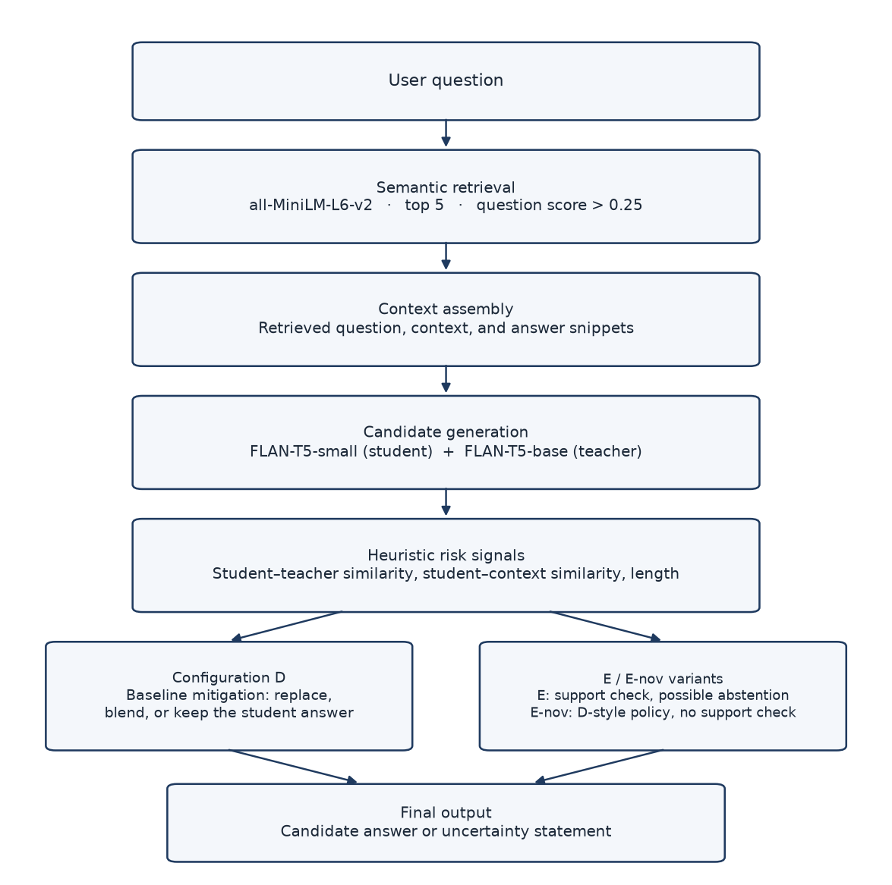
Fig. 1. Architecture of the implemented retrieval-assisted pipeline. Configurations D and E/E-nov are alternative experiment variants [20].

3.2 Datasets and Knowledge-Base Construction
The first source is PubMedQA, loaded from the pqa_labeled configuration. PubMedQA is a biomedical research QA dataset whose records include a question, abstract context, long answer, and a yes/no/maybe decision [26]. In this implementation, the long answer is used as reference text for similarity evaluation; the final-decision label is not used as the evaluation metric. The second source is lavita/ChatDoctor-HealthCareMagic-100k, loaded from the Hugging Face Datasets repository [27]. The broader ChatDoctor system has also been described in prior medical language-model work [28]; this experiment uses the dataset repository and does not run or evaluate that separate model. Records are filtered to retain questions with more than five words and outputs with more than twenty words. The doctor response is used as reference text, but is not independently verified as ground truth.
The seeded experiment described in the repository uses 20 validation questions and 20 test questions, with ten questions from each dataset in each split. It reports a knowledge base of 300 records, consisting of 150 from each source, excluding held-out questions; the saved leakage check reports zero overlaps. Normalized question text is used for duplicate removal. The small sample is intended for a pilot comparison and does not represent comprehensive medical coverage [20].

3.3 Semantic Retrieval
The system encodes stored questions and incoming queries with all-MiniLM-L6-v2 and ranks knowledge-base records using cosine similarity. Sentence embeddings make similarity-based retrieval computationally practical [29]. The use of retrieved supporting text follows the broader retrieval-augmented generation paradigm [30], although this prototype uses a small local question-record store rather than a full RAG system over a large document corpus. The baseline selects up to five candidates with question similarity strictly greater than 0.25 and concatenates their corresponding question, context, and answer snippets. The original baseline limits the joined context to 2,000 characters. Configurations E and E-nov instead cap the full prompt at 512 tokens. These differences mean that D and E-family results compare not only decision rules but also prompt/context handling [20].

3.4 Candidate Answer Generation
Two pretrained instruction-following text-to-text models are used: google/flan-t5-small as the student and google/flan-t5-base as the teacher. FLAN-T5 belongs to the family of instruction-finetuned language models described by Chung et al. [31]. The original baseline sets maximum generation lengths of 180 new tokens for the student and 200 for the teacher, with sampling disabled. Source-aware prompts distinguish research-style biomedical questions from patient-style healthcare questions. Neither model is treated as a factual authority, and neither is fine-tuned as part of this project [20].

3.5 Heuristic Risk Detection
The original baseline computes the cosine similarity between the student and teacher answers, denoted s_st, and between the student answer and retrieved context, denoted s_sc. It also checks the student answer’s word count L_s. The baseline flags a possible-risk response when both similarity scores are below 0.38 or when the student answer contains fewer than ten words [20]:
Flag = (s_st < 0.38 AND s_sc < 0.38) OR (L_s < 10).
This rule is a heuristic. Low similarity indicates disagreement or weak semantic alignment, not that the student is necessarily wrong. Very short answers may be correct, and a false response may closely resemble a retrieved passage. The implementation does not directly inspect model logits or attention weights and does not use a trained contradiction classifier. Similarity alone is not a formal entailment or fact-checking method [20].

3.6 Mitigation Configurations
Table 2. Experimental configuration definitions
Configuration | Role in comparison
A — Student only | Uses the student answer without a teacher-based mitigation step.
B — Teacher only | Uses the teacher answer as the sole candidate.
C — Student with retrieval | Uses retrieval-assisted student generation.
D — Baseline mitigation | Uses threshold rules to replace, blend, or keep the student answer.
E-nov | Uses the capped-context setup without the newer support check; applies the D-style mitigation policy.
E — Similarity-based support check | Accept the student when its similarity-based support check passes; otherwise consider the teacher, and abstain if neither passes the configured cutoff.

For Config D, the original code uses three main thresholds: a 0.38 detection threshold, a 0.55 blend threshold, and a 0.70 teacher-preference threshold. For Config E, the support-check threshold was selected from a validation grid of 0.30, 0.40, 0.50, 0.60, and 0.70. The saved experiment documentation says the selected 0.30 cutoff was chosen using reference-similarity performance on validation data; this makes the threshold proxy-oriented and does not establish calibrated factual support [20].
The E and E-nov comparison is the relevant ablation for examining the support-check variant under capped context. The configurations remain distinct experimental variants, and any performance difference should be interpreted with that exact distinction in mind [20].

4. Experimental Setup

4.1 Evaluation Protocol
The repository contains outputs from the original baseline, a reproduced baseline, the seeded A–D comparison, and the E/E-nov support-check experiment. These are not interchangeable. The original script uses fixed index slices and has no validation split, while the newer experiment artifacts document a seeded workflow with separate validation and test samples. Table 3 consolidates the saved seed-42 A–D comparison with the separately saved E/E-nov support-check experiment, each reporting a 20-question test sample. Because these results are stored in distinct experiment artifacts, direct A–D versus E/E-nov comparisons are descriptive unless the held-out question identifiers and run settings are confirmed to match. The original 65% result is reported separately as a non-reproducible historical result [20].
The knowledge-base leakage check reports zero overlaps between held-out questions and knowledge-base questions in the seeded workflow. The saved comparison provides per-configuration predictions, mean similarities, pass counts, latency, and Wilson intervals for pass rates. No significance test was performed, and none is claimed [20].

4.2 Metrics
A similarity pass is defined as cosine similarity between the generated response and reference text strictly greater than 0.52. The pass rate is the number of passing responses divided by the total number of test questions. Mean reference similarity is reported separately. In the support-check configuration, uncertainty statements are not counted as similarity wins; the abstention count is therefore reported separately [20].
Pass rate = (Number of answers with cosine similarity > 0.52) / N.
This metric is a similarity proxy, not factual accuracy. Without manually verified labels, the experiment cannot support precision, recall, F1-score, or a factual hallucination-rate claim. The repository annotation template remains incomplete and the metric script reports that labels are missing [20].

4.3 Implementation Environment
The repository contains a FastAPI/Uvicorn backend and a React/Vite frontend for running an analysis and viewing results. Model inference and data processing use PyTorch, Transformers, Hugging Face Datasets, Sentence Transformers, NumPy, and Matplotlib. The documented reproduction environment used CPU-only PyTorch with Transformers 4.40.1, Sentence Transformers 3.1.1, and Datasets 4.8.2; Node.js 22 was used for the frontend. The original code also attempts Apple MPS, then CUDA, then CPU device selection. These environment details are taken from the repository documentation and should be tied to the exact reproduction environment in future reruns [20].

4.4 Prototype Interface and Example Execution
The web interface exposes the analysis pipeline. Figure 4 shows one illustrative execution of that interface. It documents the prototype presentation layer and is not an additional evaluation sample.
Fig. 4. Example query analysis showing the student and teacher responses, the selected final-response tier, similarity scores, and retrieved evidence. In this example, the student response is repetitive. The displayed “Supported” status refers to the configured text-similarity check and does not establish medical correctness.

Figure 1 describes the logical processing flow, while Figs. 2 and 3 summarize the experimental comparisons. Figure 4 connects those descriptions to one running analysis view: the student and teacher responses, the selected tier, the similarity scores, and the retrieved passage. The displayed support status is the configured text-similarity check. The screenshot is included for implementation transparency, not as a substitute for controlled evaluation.

5. Results
Table 3 summarizes the test results recorded in the saved experiment artifacts. Each row reports N = 20; the A–D metrics and E/E-nov metrics come from separate saved experiments. The pass-rate intervals are descriptive 95% Wilson intervals for binomial proportions; no hypothesis test was performed. These intervals do not establish statistically significant differences, and cross-artifact comparisons should be interpreted cautiously unless the underlying test question identifiers match.
Table 3. Reported configuration results from saved artifacts (N = 20 per row; similarity threshold > 0.52)
Configuration | Passes / N | Pass rate (95% Wilson CI) | Mean similarity | Mean latency (s)
A: Student | 5/20 | 25% (11.2%–46.9%) | 0.379 | 0.715
B: Teacher | 6/20 | 30% (14.5%–51.9%) | 0.404 | 2.084
C: Student+retrieval | 5/20 | 25% (11.2%–46.9%) | 0.365 | 0.650
D: Mitigation | 8/20 | 40% (21.9%–61.3%) | 0.481 | 3.145
E-nov | 6/20 | 30% (14.5%–51.9%) | 0.441 | 3.161
E: Support check | 7/20 | 35% (18.1%–56.7%) | 0.386 | 1.839

Among the reported values, Configuration D has the highest mean reference similarity (0.481) and pass rate (8/20, 40%). Within the A–D experiment, D increases the reported mean similarity from 0.379 to 0.481 and the passing count from five to eight. This is an improvement under the defined similarity proxy only; it does not establish better factuality. D also has the highest reported mean latency among the listed configurations (3.145 seconds). Cross-artifact ranking against E/E-nov is descriptive unless the underlying test question identifiers and run settings match [20].
Configuration C does not improve the aggregate similarity metric relative to A on this test sample. This shows that retrieval-assisted generation, in this configuration and evaluation setting, did not improve the selected proxy metric; it does not establish that retrieval is generally ineffective. The small sample, prompt truncation, and the source-specific differences between the two datasets limit interpretation [20].
Config E has a pass rate of 35% (7/20), a mean similarity of 0.386, and six abstentions. E-nov has a pass rate of 30% (6/20) and a mean similarity of 0.441. E therefore has one more pass but a lower mean similarity and fewer emitted answers. This demonstrates a trade-off between response/abstention policy and similarity outcomes; it does not prove E is safer or less safe in terms of factual errors [20].
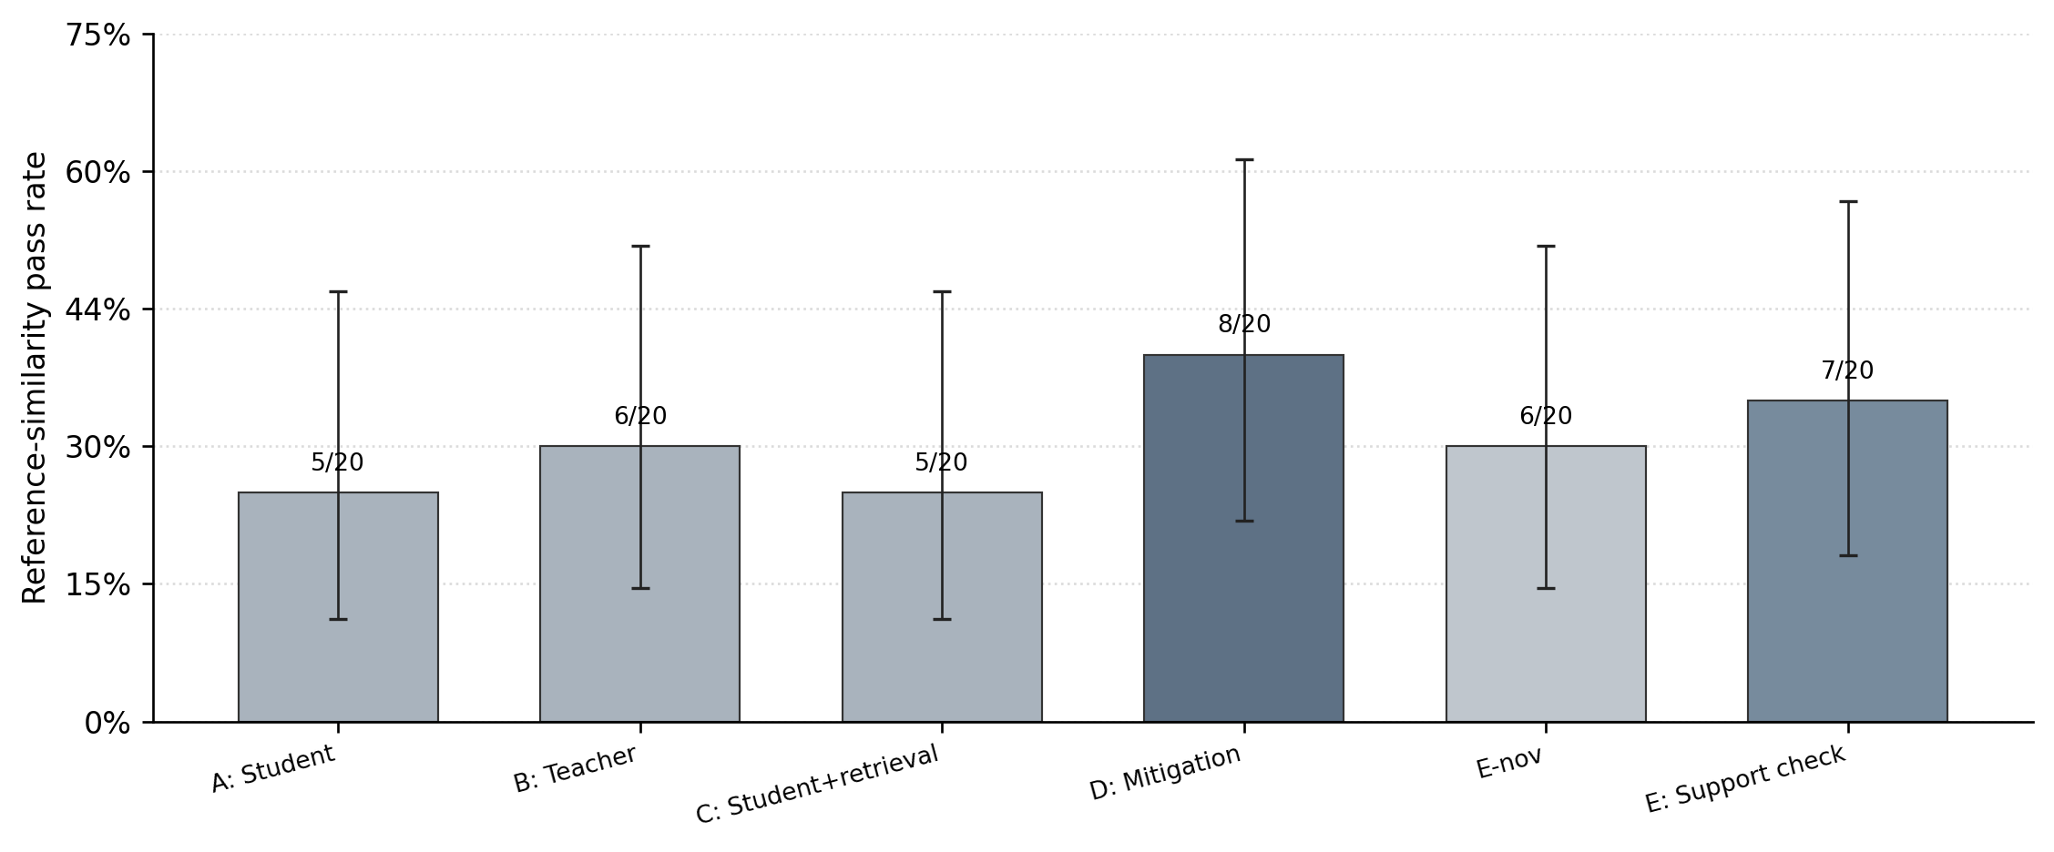
Fig. 2. Reference-similarity pass rates across configurations. A–D and E/E-nov come from separate saved artifacts; cross-group comparisons are descriptive unless test IDs and settings match. Error bars show 95% Wilson intervals; a pass is not factual accuracy [20].
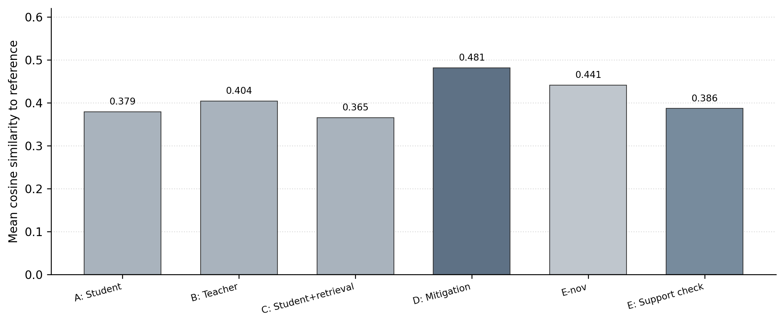
Fig. 3. Mean cosine similarity to reference answers across configurations. A–D and E/E-nov come from separate saved artifacts; cross-group comparisons are descriptive unless test IDs and settings match [20].

5.1 Historical Baseline: Kept Separate
The preserved original chart reports a 65% similarity-pass rate (13/20), with mean student, teacher, and final similarities of 0.462, 0.569, and 0.556. The repository identifies that run as non-reproducible because neither a random seed nor per-question predictions were saved. The later reproduced baseline reports 55% (11/20) and a mean final similarity of 0.514. These figures are kept separate from the seeded A–E comparison and must not be merged as if generated under the same split [20].

6. Discussion

6.1 Effect of Baseline Mitigation
The results indicate that the D policy changes the distribution of reference-similarity outcomes in the tested sample. Because D may replace, blend, or retain text based on heuristics, the final answer can be more similar to the reference without necessarily being more factually correct. The teacher is another pretrained model rather than a verified source of truth; both models may share an error. Blending two candidates may also introduce factual or grammatical inconsistencies [20].

6.2 Retrieval and Support Checking
Retrieval provides potentially relevant records and a context signal, but query similarity does not ensure that retrieved evidence is relevant or supports each answer claim. Config C's aggregate similarity result is not better than A in this test, and Config E's support check does not produce a higher mean similarity than D. These observations justify a more detailed retrieval and error analysis rather than a broad claim that retrieval or abstention always improves reliability [20].

6.3 Metric Validity
Cosine similarity can penalize valid paraphrases and reward answers that reuse reference wording without being factually correct. The 0.52 threshold therefore defines a semantic-similarity pass, not a correctness label. This is consistent with the broader literature's use of more direct annotations, benchmarks, or evidence-oriented approaches for hallucination evaluation [5], [9]–[11]. A manual factuality study is needed before claiming detector precision, recall, F1, or a measured decrease in hallucinations.

6.4 Practical Contribution
The primary contribution is engineering integration and comparative analysis: a local knowledge base, small pretrained student and teacher models, embedding-based retrieval, several mitigation configurations, saved outputs, and a browser-based interface. The prototype can be a starting point for experiments under resource constraints, but it is not a new learned detector, does not use hidden-state or logit-based detection, and is not clinically validated [11], [20].

7. Limitations and Future Work
First, the evaluation uses only 20 validation and 20 test questions; the test sample is too small to support broad generalization claims. Second, the reference sources do not establish factual ground truth for every response, particularly the HealthCareMagic doctor replies. Third, the heuristic thresholds are calibrated against similarity-based validation outcomes, not manually labelled factuality. Fourth, semantic similarity is not entailment and cannot reliably detect logical contradictions. Fifth, the teacher model may also be wrong, and text blending can introduce additional issues [20].
The most important next step is to manually label a representative set of generated answers using an explicit protocol and trusted supporting evidence. Labels should distinguish supported, unsupported, contradicted, and insufficient-evidence cases. The system can then be evaluated using precision, recall, F1-score, false-negative rate, abstention rate, and evidence-support measures alongside similarity. Thresholds should be selected on validation data, locked before final testing, and assessed on an untouched test set. Additional work should investigate claim-level entailment/contradiction verification, retrieval relevance, more diverse datasets, and reproducibility across repeated runs. Clinical use would require expert oversight and much stronger validation [13], [17], [20].

8. Conclusion
This paper presented a lightweight research prototype for flagging and handling potentially unreliable LLM responses. It integrates local semantic retrieval, FLAN-T5-small and FLAN-T5-base candidate generation, similarity-based risk heuristics, and several rule-based mitigation policies. The updated implementation includes a broader retrieval source set, validation/test experiments, saved outputs, and a web interface. Across the saved experiment artifacts, baseline mitigation D has a reported mean reference similarity of 0.481 and pass rate of 40%, while support-check configuration E has a reported mean similarity of 0.386 and pass rate of 35%, abstaining on six test answers. Since A–D and E/E-nov results come from separate artifacts, the cross-configuration ranking is descriptive unless held-out question IDs and settings are confirmed to match. These are preliminary semantic-similarity results, not verified factuality outcomes. The main conclusion is that a lightweight integrated pipeline is feasible to implement and compare, but claims about hallucination detection effectiveness require manually verified labels and evidence-based evaluation. The prototype should not be treated as a clinically validated medical system.

References
[1] H. Ye, T. Liu, A. Zhang, W. Hua, and W. Jia, “Cognitive Mirage: A Review of Hallucinations in Large Language Models,” arXiv:2309.06794, 2023. [Online]. Available: https://arxiv.org/abs/2309.06794.
[2] S. M. T. I. Tonmoy, S. M. M. Zaman, V. Jain, A. Rani, V. Rawte, A. Chadha, and A. Das, “A Comprehensive Survey of Hallucination Mitigation Techniques in Large Language Models,” arXiv:2401.01313, 2024. [Online]. Available: https://arxiv.org/abs/2401.01313.
[3] A. T. Kalai, O. Nachum, S. S. Vempala, and E. Zhang, “Why Language Models Hallucinate,” arXiv:2509.04664, 2025. [Online]. Available: https://arxiv.org/abs/2509.04664.
[4] H. Raj, D. Rosati, and S. Majumdar, “Measuring Reliability of Large Language Models through Semantic Consistency,” in NeurIPS 2022 Workshop on Machine Learning Safety, 2022. [Online]. Available: https://arxiv.org/abs/2211.05853.
[5] P. Manakul, A. Liusie, and M. Gales, “SelfCheckGPT: Zero-Resource Black-Box Hallucination Detection for Generative Large Language Models,” in Proc. EMNLP, 2023, pp. 9004–9017, doi: 10.18653/v1/2023.emnlp-main.557.
[6] P. Feldman, J. R. Foulds, and S. Pan, “Trapping LLM “Hallucinations” Using Tagged Context Prompts,” arXiv:2306.06085, 2023. [Online]. Available: https://arxiv.org/abs/2306.06085.
[7] N. Mündler, J. He, S. Jenko, and M. Vechev, “Self-Contradictory Hallucinations of LLMs: Evaluation, Detection and Mitigation,” in Proc. International Conference on Learning Representations (ICLR), 2024.
[8] A. Agrawal, M. Suzgun, L. Mackey, and A. T. Kalai, “Do Language Models Know When They’re Hallucinating References?,” in Findings of the Association for Computational Linguistics: EACL 2024, pp. 912–928, 2024, doi: 10.18653/v1/2024.findings-eacl.62.
[9] J. Li, X. Cheng, W. X. Zhao, J.-Y. Nie, and J.-R. Wen, “HaluEval: A Large-Scale Hallucination Evaluation Benchmark for Large Language Models,” in Proc. EMNLP, 2023, pp. 6449–6464, doi: 10.18653/v1/2023.emnlp-main.397.
[10] J. Li, J. Chen, R. Ren, X. Cheng, W. X. Zhao, J.-Y. Nie, and J.-R. Wen, “The Dawn After the Dark: An Empirical Study on Factuality Hallucination in Large Language Models,” in Proc. 62nd Annual Meeting of the Association for Computational Linguistics, vol. 1: Long Papers, 2024, pp. 10879–10899, doi: 10.18653/v1/2024.acl-long.586.
[11] G. Sriramanan, S. Bharti, V. S. Sadasivan, S. Saha, P. Kattakinda, and S. Feizi, “LLM-Check: Investigating Detection of Hallucinations in Large Language Models,” in Advances in Neural Information Processing Systems, vol. 37, 2024, doi: 10.52202/079017-1077.
[12] J. Luo, T. Li, D. Wu, M. Jenkin, S. Liu, and G. Dudek, “Hallucination Detection and Hallucination Mitigation: An Investigation,” arXiv:2401.08358, 2024. [Online]. Available: https://arxiv.org/abs/2401.08358.
[13] C. Woesle, L. Fischer-Brandies, and R. Buettner, “A Systematic Literature Review of Hallucinations in Large Language Models,” IEEE Access, vol. 13, pp. 148231–148253, 2025, doi: 10.1109/ACCESS.2025.3601206.
[14] M. Damani, I. Puri, S. Slocum, I. Shenfeld, L. Choshen, Y. Kim, and J. Andreas, “Beyond Binary Rewards: Training LMs to Reason About Their Uncertainty,” arXiv:2507.16806, 2025. [Online]. Available: https://arxiv.org/abs/2507.16806.
[15] P. Dey, S. Merugu, and S. R. Kaveri, “Uncertainty-Aware Fusion: An Ensemble Framework for Mitigating Hallucinations in Large Language Models,” in Companion Proc. ACM Web Conference 2025, pp. 947–951, 2025, doi: 10.1145/3701716.3715523.
[16] W. Wu, Y. Cao, N. Yi, R. Ou, and Z. Zheng, “Detecting and Reducing the Factual Hallucinations of Large Language Models with Metamorphic Testing,” Proc. ACM Softw. Eng., vol. 2, no. FSE, pp. 1432–1453, 2025, doi: 10.1145/3715784.
[17] Z. Ji, T. Yu, Y. Xu, N. Lee, E. Ishii, and P. Fung, “Towards Mitigating LLM Hallucination via Self Reflection,” in Findings of the Association for Computational Linguistics: EMNLP 2023, pp. 1827–1843, 2023, doi: 10.18653/v1/2023.findings-emnlp.123.
[18] H.-T. Ho, D.-T. Ly, and L. V. Nguyen, “Mitigating Hallucinations in Large Language Models for Educational Application,” in Proc. 2024 IEEE International Conference on Consumer Electronics-Asia (ICCE-Asia), 2024, doi: 10.1109/ICCE-ASIA63397.2024.10773965.
[19] J. P. Nambiar and A. G. Sreedevi, “Orchestrating Consensus Strategies to Counter AI Hallucination in Generative Chatbots,” in Proc. 2023 IEEE International Conference on Cloud Computing in Emerging Markets (CCEM), 2023, doi: 10.1109/CCEM60455.2023.00030.
[20] “Detection and mitigation of hallucinations in large language models,” project source repository, GitHub. [Online]. Available: https://github.com/devvvv100707/detection-and-mitigation-of-hallucinations-in-LLMs. Accessed: Oct. 13, 2026.
[21] J.-W. Shim, Y.-J. Ju, J.-H. Park, and S.-W. Lee, “Curative Prompt Refinement for Mitigating Hallucinations in Large Language Models,” in Proc. 2024 IEEE International Conference on Systems, Man, and Cybernetics (SMC), 2024, doi: 10.1109/SMC54092.2024.10830938.
[22] A. Jančařík and O. Dušek, “The Problem of AI Hallucination and How to Solve It,” in Proc. 23rd European Conference on e-Learning (ECEL), vol. 23, no. 1, pp. 122–128, 2024, doi: 10.34190/ecel.23.1.2584.
[23] A. Gunjal, J. Yin, and E. Bas, “Detecting and Preventing Hallucinations in Large Vision Language Models,” in Proc. AAAI Conference on Artificial Intelligence, vol. 38, no. 16, pp. 18135–18143, 2024, doi: 10.1609/aaai.v38i16.29771.
[24] F. Li, “MH-PEFT: Mitigating Hallucinations in Large Vision-Language Models through the PEFT Method,” in Proc. 2nd International Conference on Generative Artificial Intelligence and Information Security (GAIIS), 2025, pp. 137–142, doi: 10.1145/3728725.3728747.
[25] Y. Sun, Z. Zhang, H. Wu, X. Liu, W. Lin, G. Zhai, and X. Min, “Explore the Hallucination on Low-level Perception for MLLMs,” in Proc. IEEE International Conference on Acoustics, Speech and Signal Processing (ICASSP), 2025, pp. 1–5, doi: 10.1109/ICASSP49660.2025.10888437.
[26] Q. Jin, B. Dhingra, Z. Liu, W. Cohen, and X. Lu, “PubMedQA: A Dataset for Biomedical Research Question Answering,” in Proc. EMNLP-IJCNLP, 2019, pp. 2567–2577, doi: 10.18653/v1/D19-1259.
[27] Lavita AI, “ChatDoctor-HealthCareMagic-100k,” Hugging Face Datasets. [Online]. Available: https://huggingface.co/datasets/lavita/ChatDoctor-HealthCareMagic-100k. Accessed: Oct. 13, 2026.
[28] Y. Li, Z. Li, K. Zhang, R. Dan, S. Jiang, and Y. Zhang, “ChatDoctor: A Medical Chat Model Fine-Tuned on a Large Language Model Meta-AI (LLaMA) Using Medical Domain Knowledge,” Cureus, vol. 15, no. 6, e40895, 2023, doi: 10.7759/cureus.40895.
[29] N. Reimers and I. Gurevych, “Sentence-BERT: Sentence Embeddings using Siamese BERT-Networks,” in Proc. EMNLP-IJCNLP, 2019, pp. 3982–3992, doi: 10.18653/v1/D19-1410.
[30] P. Lewis et al., “Retrieval-Augmented Generation for Knowledge-Intensive NLP Tasks,” in Advances in Neural Information Processing Systems, vol. 33, pp. 9459–9474, 2020.
[31] H. W. Chung et al., “Scaling Instruction-Finetuned Language Models,” Journal of Machine Learning Research, vol. 25, no. 70, pp. 1–53, 2024.

