Homework 5

Name:_____Devon Layton________________ (Total points: 100 )

Requirement: All answers (except parse trees) must be typed.

- Consider the following program written in C syntax:

void f(int x, int y, int z) {
x = x + 1;
z = z + 2;
y = z;
}

void main() {
int value = 2;
int list[5] = {10, 9, 7, 8, 4};
f(value, list[value], value);
}

For each of the following parameter-passing methods, what are all of the values of the variables value and list after each of the three calls to f? (5 points. 15 points each)
- Passed by value
value: 2
list[value]: 7
list: {10,9,7,8,4}
- Passed by reference
value: 3
list[value]: 4
list: {10,9,4,8,4}

- Passed by value-result (the address of the actual parameters are computed at the BEGINNING of function f from left to right)
value: 3
list[value]: 4
list: {10,9,4,8,4}

- Please give the output of the following C# program. Please be noted that in C#, all object variables are reference-type variables, i.e. they are references to objects. (10 points)

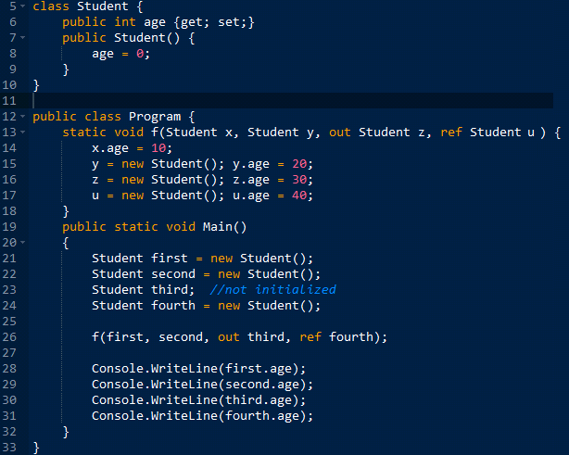

Output From:
10 Line 28
0 Line 29
30 Line 30
40 Line 40

- Describe the ways that aliases can occur with pass-by-reference parameters. (5 points)

Subprograms gain access to non-local variables when using pass-by-reference parameters by passin access paths to the subprogram, also known as pass-by-sharing. Aliases can occur when the same variable is passed to a subprogram in the same call (i.e f(i, i)), when the same array passed with different index’s (i.e f(i[k], i[m]), or when an element of an array as well as the whole array are passed (i.e f(i[k], i)).

- What’s generic subprogram, and how it is supported in C++, Java, and Python? (10 points)
A generic subprogram provides flexibility, adaptability, and efficient code by providing functionality that works with all or most parameter types during different activations.
C++ supports generic subprograms with function templates that can support on or more generic types. When the compiler comes across the template, it produces the correct types for every templated appearance in the function.
Java supports generic subprograms with generic methods that allows one method signature to be called with different types and the compiler decides the correct type during compilation.
Python supports generics naturally without requiring additional programmer declaration.

- How to check whether two functions are overloaded or not? (10 points)

To check if two functions are overloaded when the have the same name but they one of the following: different number of parameters, different parameter types, or different parameter order. If one of those conditions are not met, then the functions are not overloaded.

- Why are destructors rarely used in Java but essential in C++? (10 points)

Java variables are reference-type, objects are stored on the heap during allocation and garbage collection deallocates objects when they become inactive thus reducing the need for explicit destructors. C++ variables are value-typed, objects are allocated with a constructor via an explicit new operator, stored on the heap, and remains active until explicit deallocation occurs via a destructor. Destructors are essential in C++ anytime the new operator is used there must be a destructor release the resource when the object is no longer activated.

- Compare the class entity access controls of C++ and Java. (10 points)

Java class entity access controls have modifiers that are private or public rather than clauses and all entities in classes of a package that don’t have access modifiers remain visible to the package. C++ determines access controls with clauses. C++ clauses are private for hidden, public for interface, protected for inheritance, and friend functions that override certain access constraints to private members.

- Describe the categories of changes that a subclass can make to its parent class. (10 points)

In regard to is-a relationship, a subclass is capable of adding variables or methods, overriding inherited parent methods, or modifying behaviors of inherited methods.

- What are the differences between a C++ abstract class and a Java interface? (10 points)

Java and C++ have similar access controls at the class, subclass, world level but differences occur between C++’s friend functions (which is specific to C++) and Java’s package that organizes the set of classes and interfaces. C++’s friend is available at each access control (public, private, protected, default) whereas Java’s package does not allow private access. Other differences are that C++’s default is private, and modifiers can be specified for more than one member. Java’s default is package level and modifier can only be specific to one class member. Java also has package scoping that takes the place of friends.

- What is the primary reason why all Java objects have a common ancestors? (5 points)

Java objects have common ancestors due to inheritance and the primary reason for this is to provided uniform functionality among all children thus reducing the need to reuse, redefine, and improve readability as well as writability throughout the program.

- Compare the multiple inheritance of C++ with that provided by interfaces in Java. (5 points)

In C++, multiple inheritance can occur when a subclass can inherit multiple classes or have more than one parent. Java does not support multiple inheritance but does allow a class to implement multiple interfaces which implements methods of those interfaces in that class.

