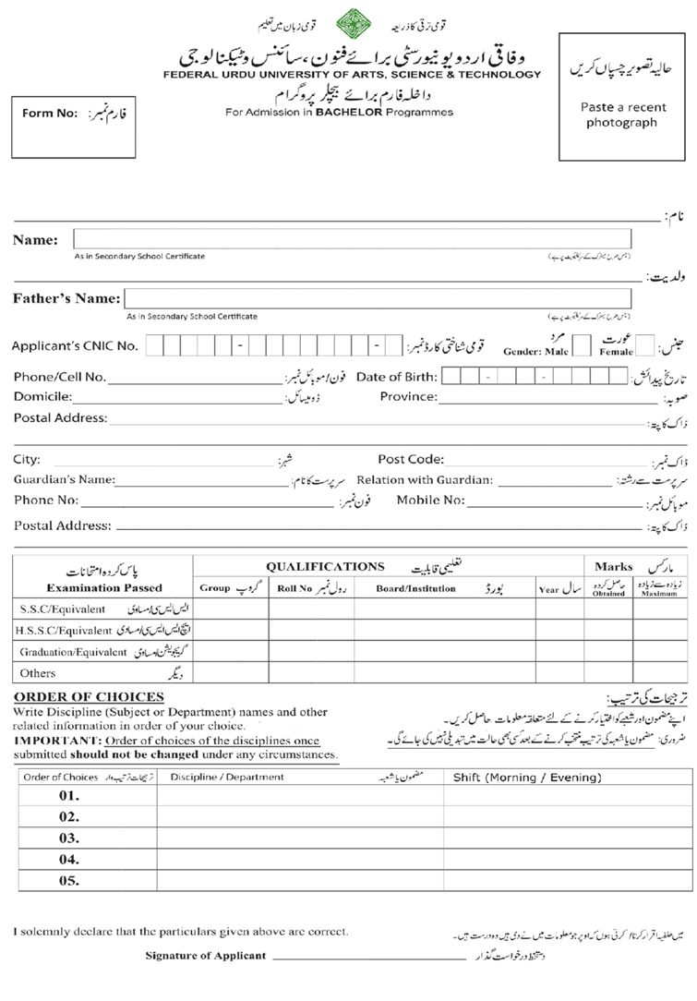

Punjab

Date : 27, Aug 2024

house#997, street#15 Phase#1 Farash Town house#997, street#15 Phase#1 Farash Town

A asdasd

Islamabad

✔

✗

SHAH KHAN

2234234

**ACADEMIC SESSION FALL 2024 - BS 1ST YR**

AHMED KHAN

6 1 1 0 1 3 4 0 5 8 4 4 5

0335-9055577

0 8 0 1 2 0 2 5

Islamabad

1231231

FATHER

UMER KHAN

0335-9055577

house#997, street#15 Phase#1 Farash Town house#997, street#15 Phase#1 Farash Town

A asdasd

|  |  |  |  |  |  |
| --- | --- | --- | --- | --- | --- |
| dat1 | dat2 | **dat3** | dat4 | dat5 | dat6 |
| dat1 | dat2 | **dat3** | dat4 | dat5 | dat6 |
| dat1 | dat2 | **dat3** | dat4 | dat5 | dat6 |
| dat1 | dat2 | **dat3** | dat4 | dat5 | dat6 |

|  |  |
| --- | --- |
| dat3 | dat4 |
| dat3 | dat4 |
| dat3 | dat4 |
| dat3 | dat4 |
| dat3 | dat4 |

Page 1

|  |  |
| --- | --- |
| **Hello** | |
| **PERSONAL INFORMATION** | |
| **Form Number** | Hello |
| **Voucher Number** | Hello |
| **Full Name** | Hello |
| **Father Name** | Hello |
| **CNIC** | Hello |
| **Email** | Hello |
| **Mobile Number** | Hello |
| **Ever Expelled From Any University?** | Hello |

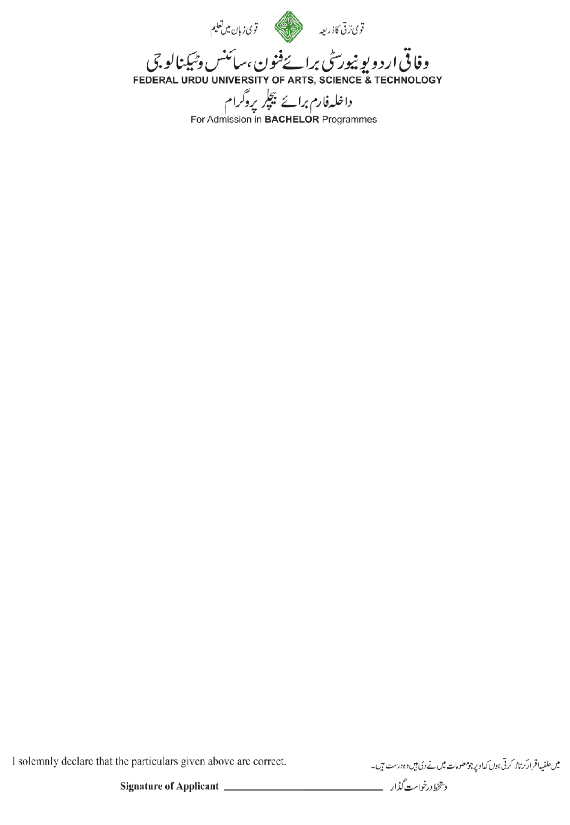

|  |  |
| --- | --- |
| **EMERGENCY CONTACT INFORMATION** | |
| **Contact Name** | Umer asKhan |
| **Relation with Contact** | FAasTHER |
| **Contact Phone No** | 03359055as577 |
| **Contact Address** | Waleed Waleedas Waleed Waleed Waleed |

Page 2

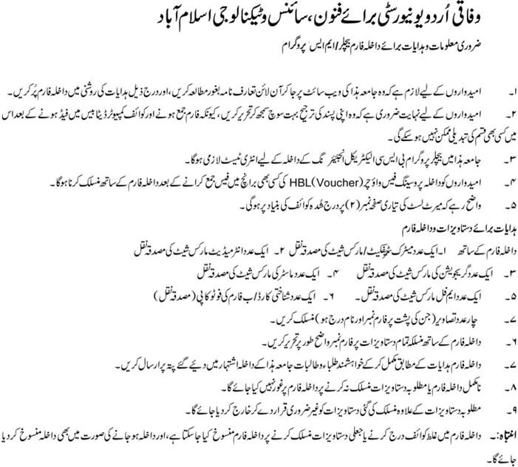

Page 3