**Bridging the Gap: UMD iSchool Talent Meets Maryland Workforce Needs***A Skills-Based Analysis of UMD iSchool Undergraduate Programs*

Prepared by: Elizabeth Poon, Luke Kadingo, Richmond Quarshie, Allison Li, Ayo,  
Devon Wilkes, Evan Hardy, Yann Mbianga, Ojie, Romeo Alvarenga

Client: iConsultancy, College of Information Studies, University of Maryland

Submitted to: TJ Rainsford, iConsultancy Program Lead

Date: May 2025

Contact: iconsultancy@umd.edu

### **Executive Summary**

This white paper highlights the skills developed in the University of Maryland’s College of Information Studies (iSchool) undergraduate programs, demonstrating how these competencies align with real-world job roles across the State of Maryland. By mapping both technical and soft skills to workforce demands and creating accessible visual tools, we illustrate the career-readiness of students from the three iSchool majors: Information Science, Information Design, and Social Data Science. Included in this report are a comprehensive skills matrix and intuitive visuals that showcase how iSchool graduates are prepared to add value in professional environments.

### **1. Introduction**

Many employers remain unfamiliar with the specific skill sets and professional capabilities associated with majors such as Information Science, Information Design, and Social Data Science. As a result, the contributions these graduates can make in data-driven, design-oriented, and tech-enabled roles are often under-recognized.

This white paper addresses a growing need across Maryland industries: clear, data-informed pathways from higher education to employment. While demand for skilled information professionals is rising, particularly in fields such as public sector IT, data analytics, user experience design, and operations, employers often lack visibility into what students in these majors are trained to do.

The following majors from the College of Information Studies are examined:

* Information Science
* Information Design
* Social Data Science

Our goal is to help businesses recognize how iSchool graduates are equipped to meet workforce needs, drive innovation, and make immediate contributions across both technical and non-technical domains.

### 2**. Methodology**

The project was carried out in four distinct phases.

#### Phase 1: Academic Analysis

We reviewed course syllabi, major requirements, and departmental learning outcomes to identify the specific skills taught in each program. We also conducted interviews with a College of Information career counselor and a member of the Info Advisory Council to gather additional information about job skills that weren’t covered in course descriptions. This data became the foundation for our matrix of technical and soft skills, and which majors teach them.

#### Phase 2: Labor Market Research

Our techniques included online research and content analysis to identify growing fields in Maryland, comparative analysis of employment trends using statistical tables, and qualitative interpretation of learning outcomes from academic programs. We also incorporated firsthand student insights to supplement official program documentation and ensure relevance to real-world applications. We utilized publicly available resources such as Maryland.gov and local labor statistics websites to source workforce data. Additionally, we referenced the University of Maryland’s College of Information website to analyze program learning outcomes as well as what job roles their programs prepare you for based on the skills taught and learned.

Regarding the data found from Maryland.gov, there were multiple sheets within an Excel workbook that required significant manipulation and cleaning. For example, the data included employment opportunities across almost all industries. Employment opportunities that clearly did not align with Information Science skills were deleted from the dataset. Once narrowed down, we compared the employment data with our Career Skills matrix to further clean the data. Once completed, we were left with a dataset of Maryland employment opportunities that included information about job postings, percent growth, degree requirements, and other helpful parameters.

#### Phase 3: Visualization & Feedback

We used tools like Tableau, Canva, Google Sheets, and Microsoft Excel to collect, clean, and visualize data on job-relevant skills taught in the iSchool’s undergraduate programs. Excel was used primarily for organizing and preparing the data, while Tableau and Canva were used to design dashboards and infographics that clearly present our key findings. These visualizations, which illustrate the distribution of technical, hard, and soft skills across the programs, are discussed in the next section.

### 3**. Key Findings**

#### **Courses**

To understand how each undergraduate iSchool program prepares students for the workforce, we analyzed and categorized the technical, hard, and soft skills embedded in their course offerings. This section summarizes the major patterns that emerged, highlighting the distinct emphases of each program, as well as shared skill areas. The findings help clarify how the Information Science, Information Design, and Social Data Science majors align with real-world job requirements and industry expectations.

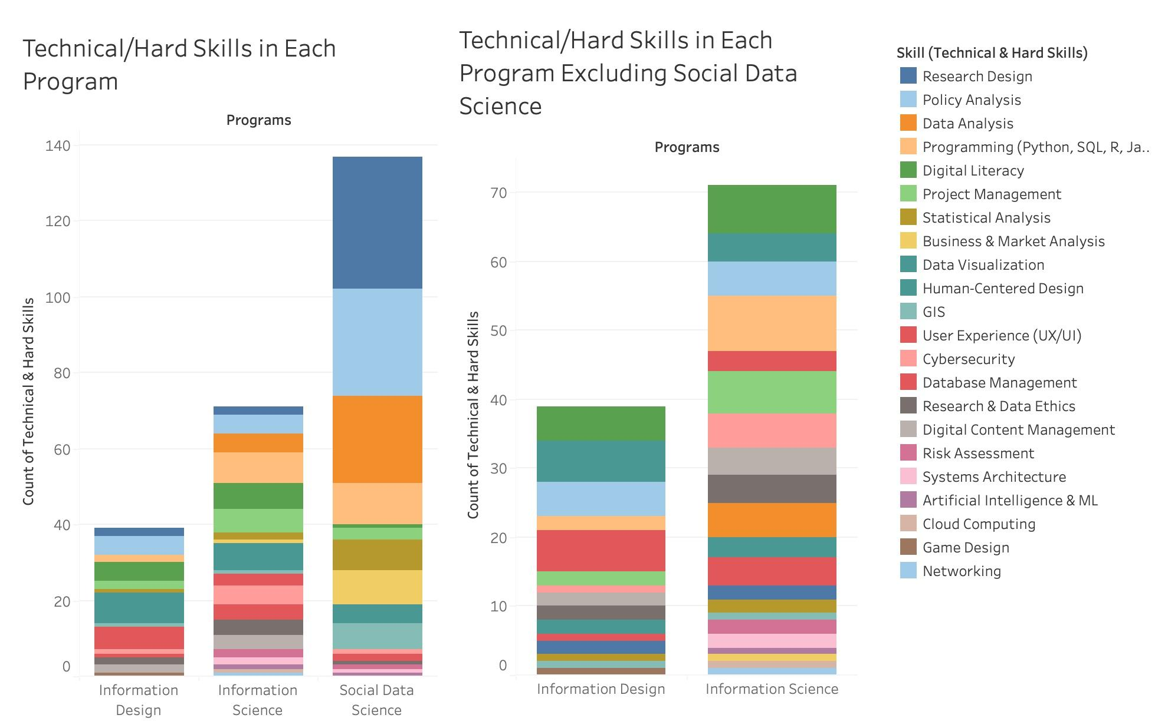

These visualizations highlight key differences in technical and hard skill coverage across the three iSchool undergraduate programs. Social Data Science stands out with a significantly higher number of technical skills, around 135, more than double the count in the other two programs. This is largely due to the program’s multiple specialized tracks, which result in a wide range of courses falling under the Social Data Science umbrella. To avoid a misleading comparison, Social Data Science was removed from the second chart, allowing for a clearer view of the other two programs. Social Data Science focuses heavily on data-centric skills such as Data Analysis, Programming (Python, SQL, R), Policy Analysis, and Research Design.

A clearer comparison emerges when examining Information Design and Information Science without Social Data Science. Information Science shows a broader and more diverse range of technical skills, nearly twice that of Information Design, covering areas such as Cybersecurity, Programming (Python, SQL, R, Javascript), Data Analysis, Project Management, Database Management, and Data Ethics. Information Science includes four concentrations within the major, Cybersecurity & Privacy, Data Science, Digital Curation, and Health Information. In contrast, Information Design leans more toward user-focused and applied design skills, with strong representation in User Experience (UX/UI), Project Management, Human-Centered Design, and Digital Literacy.

Despite these differences, certain skills, such as Data Visualization, Programming (Python, SQL, R, Javascript), Programming, Digital Literacy, and Human-Centered Design appear across all three programs, indicating a shared foundation in tech and design literacy. Overall, the distribution of skills reflects each program’s unique focus, with Social Data Science offering the most technically intensive curriculum, Information Science maintaining a broad technical scope, and Information Design emphasizing user experience and applied design skills.

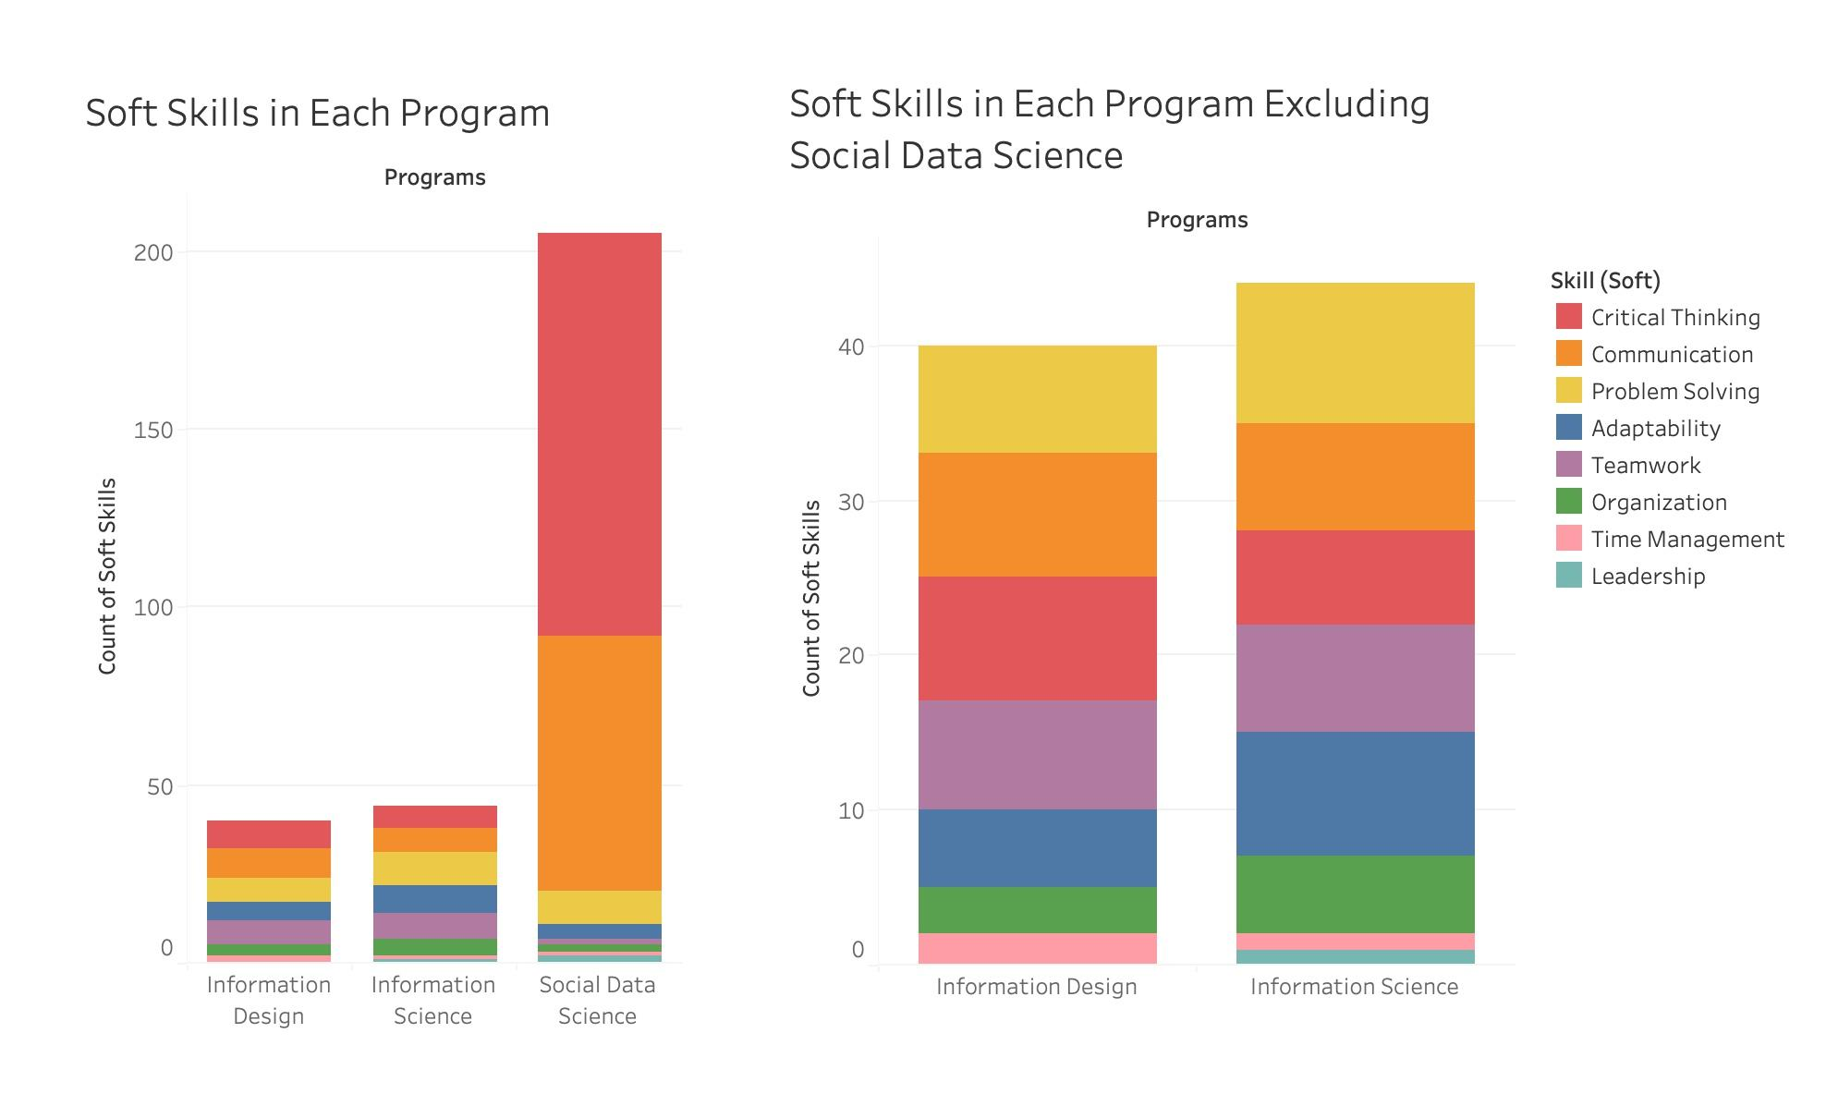

This visualization reveals notable differences in how soft skills are distributed across the iSchool programs. Social Data Science has a significantly higher count of soft skills, over 200, compared to fewer than 50 in both Information Science and Information Design. This is once again due to the program’s wide range of tracks, resulting in more total courses being part of the program. To avoid a misleading comparison, Social Data Science was once again separated from the second chart, allowing for a clearer view of the other two programs. Social Data Science stands out in Communication and Critical Thinking, which dominate the Social Data Science bar. When viewed independently, Information Science and Information Design have relatively similar totals, with Information Science having a slightly higher soft skill count. Both programs emphasize core workplace skills such as Critical Thinking, Communication, Teamwork, and Problem Solving, indicating that all three majors, regardless of technical focus, prioritize preparing students for collaborative and adaptive professional environments.

#### **Careers**

To better understand employment trends in Maryland’s IT sector, we analyzed job demographic and trend data from the state’s official government site (Maryland.gov). Our analysis revealed several patterns that illustrate the strength, accessibility, and earning potential of IT-related career paths in the region.

The first notable finding is the strong projected growth in Maryland’s IT job market, with openings expected to increase by an average of 10.7% each year beyond 2024. This sustained upward trend reflects a rising demand for IT professionals and is represented through a line graph that illustrates steady year-over-year growth through 2031.

Education requirements further highlight the accessibility of these roles: over 90% of current IT job listings call for candidates with a bachelor's degree, while only a small fraction require a master’s. This underscores the versatility and broad applicability of an Information Science degree, with a pie chart emphasizing the dominant share of roles accessible at the undergraduate level.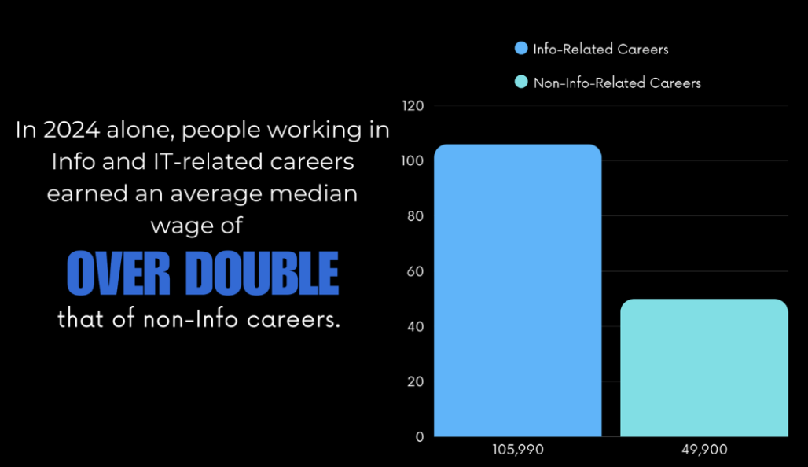

Salary trends reinforce the economic value of pursuing IT and Information Science-related careers. In 2024, professionals in these fields earned a median wage of $105,990—more than double the $49,900 median wage for non-IT careers. This significant wage premium, displayed through a bar graph, highlights the financial advantage that INFO-related careers can offer students and job seekers.

Finally, we identified the top 10 IT job titles in Maryland with the highest growth rates and number of openings. These roles not only offer strong employment prospects but also align closely with the technical and applied skills taught in Information Science programs. This alignment is visualized through two “Top 10” charts, helping to map educational outcomes directly to real-world career opportunities for graduates.

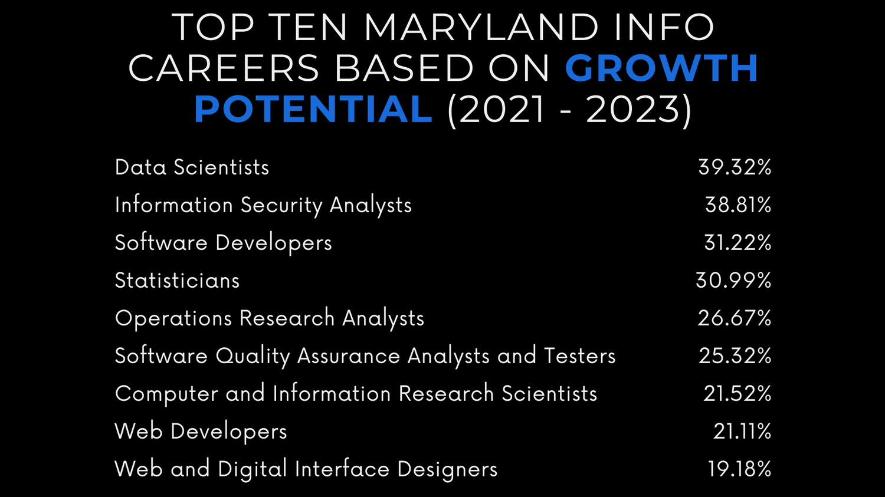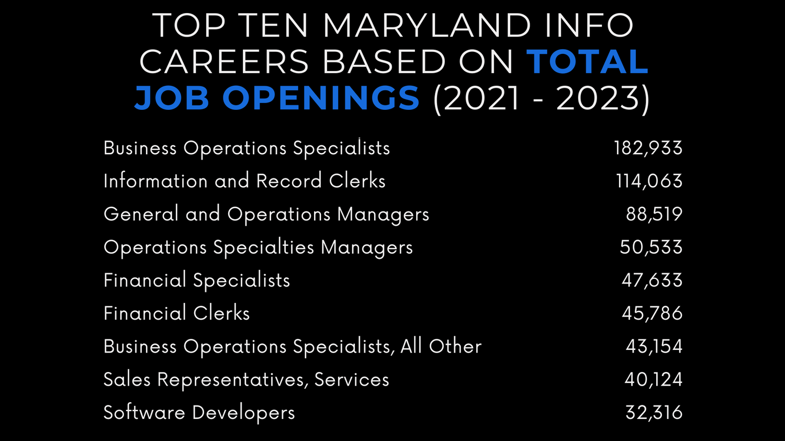

### 4. Workforce Relevance

This all demonstrates that iSchool students are uniquely positioned to solve workforce gaps in Maryland. They combine technical proficiency, communication skills, and systems thinking, making them valuable in:

* Public sector modernization (e.g., digital services, cybersecurity, open data)
* Tech-enabled operations (e.g., workflow automation, database management)
* Human-centered design (e.g., UX for government tools, internal systems)
* Data-informed decision making (e.g., dashboards, policy analysis, impact reporting)

Hiring iSchool graduates helps build diverse, collaborative teams equipped with both technical and soft skills.

### 5. Call to Action

The University of Maryland’s College of Information Studies is producing graduates who are ready to meet Maryland’s evolving workforce needs. Each of the iSchool’s three undergraduate programs, Information Science, Information Design, and Social Data Science, equips students with a unique mix of technical and soft skills that align with real-world job demands in both public and private sectors.

Employers across Maryland are increasingly seeking talent with data literacy, design thinking, and systems expertise. iSchool graduates are trained to work across functions, from cybersecurity and UX to analytics and information governance, and can contribute meaningfully from day one.

We invite businesses, agencies, and organizations to:

* Partner with the iSchool through internships, capstone projects, or advisory roles.
* Recruit iSchool graduates for roles in tech, design, data, operations, and policy.
* Reach out to the iConsultancy team at iconsultancy@umd.edu to start a conversation.

Together, we can build a more connected, skilled, and innovative Maryland workforce.

### 6. Bibliography

#### University of Maryland Testudo. Undergraduate Course Descriptions – College of Information Studies. <https://app.testudo.umd.edu/>

#### Maryland.gov Data - <https://labor.maryland.gov/lmi/iandoproj/maryland.shtml>