1.FIELD OF THE INVENTION
The present invention relates to the field of medical image analysis using artificial intelligence, specifically to AI-based segmentation systems for identifying optimal biopsy regions in oral cancer detection.

2. BACKGROUND OF THE INVENTION
Oral cancer remains one of the most prevalent and life-threatening malignancies worldwide, particularly in regions with high tobacco, betel quid, and alcohol consumption. Early detection is critical for improving survival rates; however, accurate identification of the most representative site for biopsy remains a persistent clinical challenge. In many cases, the lesion may appear heterogeneous, containing areas of benign, precancerous, and malignant changes within the same region. A biopsy taken from an unrepresentative portion often leads to inconclusive or false-negative results, delaying diagnosis and treatment.
Traditionally, the selection of a biopsy site relies heavily on the clinician’s visual judgment, experience, and interpretation of surface features such as color changes, ulceration, induration, or leukoplakic patches. However, these features can be subjective, and the decision process may vary widely among practitioners. Furthermore, early malignant transformations in oral tissues often exhibit subtle visual differences that are difficult to detect even for trained specialists. In resource-limited or rural clinical settings, where expert pathologists are not readily available, the challenge becomes even greater. As a result, patients frequently undergo multiple biopsies, causing physical discomfort, psychological stress, and unnecessary delays in diagnosis.
The development of AI-assisted biopsy region identification stems from the need to provide a more objective, consistent, and reliable aid to clinicians during oral cancer screening and diagnosis. With the increasing availability of digital intraoral imaging devices and large datasets, machine learning and deep learning techniques have emerged as powerful tools in medical imaging. These technologies have demonstrated remarkable success in tasks such as tumor detection, organ segmentation, and disease classification. However, while several studies have explored the use of AI in diagnosing oral cancer from histopathological or radiological images, few have focused on assisting clinicians during the pre-biopsy stage—specifically, identifying the most suitable region of tissue for sampling.
This innovation aims to bridge that gap by introducing an AI-powered image segmentation system that highlights the optimal biopsy region directly from clinical photographs of suspected oral lesions. The model employs a Swin Transformer-based U-Net++ architecture, capable of learning fine-grained spatial patterns and differentiating abnormal tissue from surrounding healthy mucosa. By integrating transformer-based attention with convolutional upsampling, the system generates precise segmentation masks that delineate the region of greatest diagnostic value. The output mask can then be superimposed on the original image, giving clinicians a visual guide for accurate biopsy site selection.
The primary beneficiaries of this invention are dentists, oral pathologists, and oncology specialists, who can use the model as a supportive diagnostic tool. It can also benefit medical and dental institutions by enhancing the reliability of biopsy sampling and reducing the dependence on expert intuition. In addition, patients gain from this innovation through faster, less invasive, and more accurate diagnostic workflows. Early and correct identification of the biopsy site means earlier detection of malignancies, leading to better prognosis and improved quality of life.
At present, the key challenges that motivated this development include:
- Subjectivity in biopsy site selection: Different clinicians may choose different sampling areas based on experience or visual interpretation, leading to inconsistent outcomes.
- Difficulty in identifying early lesions: Early-stage oral cancers often present minimal or ambiguous visual cues that may be overlooked.
- Limited availability of expert diagnosis: Many clinics lack specialists with adequate experience in differentiating pre-malignant lesions.
- Inconclusive biopsy results: Incorrectly targeted biopsies can result in false negatives, necessitating repeated procedures and increasing patient discomfort.
- Lack of accessible AI tools for real-time guidance: Existing AI models often focus on histopathology or radiographic images and are not adapted for clinical photographs used in initial screening.
By addressing these challenges, this innovation positions itself as a novel and practical advancement in the field of AI-driven oral oncology. The system supports medical professionals in making data-backed, evidence-driven decisions and helps democratize access to diagnostic assistance through scalable, software-based deployment. This approach not only improves accuracy and consistency in clinical decision-making but also aligns with global healthcare goals of early cancer detection and digital transformation in medical practice.

3. LITERATURE REVIEW (PRIOR ART)
1. US 2021/0137504 A1 — Geometric biopsy plan optimization
This application describes a method to compute the “tumor detection probability” over a 3D volume and generate a biopsy plan (number, length, arrangement of biopsy cores) maximize detection while minimizing false negatives
Difference: It solves a planning / sampling problem in 3D, especially for internal organs (e.g. prostate). It does not take clinical photographs, segment lesions in 2D camera images, nor run real-time inference on an edge device. Our system is about visual segmentation guidance for biopsy from intraoral images, not probabilistic core planning in 3D volumes.
2. US 11,382,329 (Grant) — Methods and systems for AI-based medical image segmentation
Assigned to Siemens, this patent covers automatically selecting segmentation algorithms based on the “segmentation context” and applying them to medical images to segment target anatomical structures.
Difference: That patent is broad and general—it addresses algorithm selection and segmentation in medical images (e.g. CT, MRI) broadly. It does not disclose a combined hardware + camera + local inference + biopsy-site suggestion system for oral lesions. You can argue your novelty lies in the integrated pipeline, the choice of hardware (Raspberry Pi + camera), and the domain-specific constraints (oral mucosa imaging, biopsy mapping).
3. WO 2008/121,773 A1 — Improved object recognition system for medical imaging
This patent describes fitting estimated boundaries (object recognition) in automated medical imaging segmentation—basically, a system that fits boundary models on anatomical structures, possibly taking patient metadata (age, ethnicity) into account.
Difference: It’s older, more generic. It doesn’t address lesion segmentation from photographic images or real-time guidance. It also lacks the “biopsy site localization” objective you have. Your method will need to highlight which part of lesion to biopsy, not just boundary segmentation.
4. US 10,957,043 B2 — AI systems for detecting and sizing lesions in real time during a clinical procedure
This patent describes an AI platform that, during a clinical procedure, detects lesions in real time and estimates their size.
Difference: This is closer to what you want. But it seems targeted at detection and sizing, not specifically marking biopsy zones or supporting biopsy decisions. Your system must go further: not just “there’s a lesion”, but “this subregion is the best biopsy target.” Also, your integration with a camera + IoT device + overlay interface is a system-level novelty
is a system-level novelty.
5. EP 003328309 B1 (recent) — Biopsy guidance & location documentation in ultrasound imaging
This European patent (or patent application) describes an imaging device combined with ultrasound, capturing images and automatically marking the biopsy needle tip, overlaying the marker on the video frame, etc.
Difference: This is a guidance system but using ultrasound video imaging and marking the needle tip location. It operates in a different imaging modality (ultrasound) and different workflow. You’re using photographic images, lesion segmentation, inference of the region to biopsy—not just tracking a needle in ultrasound. The modality, domain, and objective differ.

4. OBJECT OF THE INVENTION
- Early Detection of Oral Cancer:
To develop an AI-powered diagnostic system capable of detecting potential oral cancer regions at an early stage, helping clinicians make quicker and more accurate decisions.
- Assistance in Biopsy Region Identification:
To implement a deep learning model trained on annotated medical images that highlights the most probable biopsy regions, minimizing false sampling and improving diagnostic accuracy.
- Integration of IoT for Real-time Accessibility:
To integrate the device with a Raspberry Pi and IoT connectivity, allowing healthcare professionals to access live imaging and diagnostic results through a shared network or cloud interface.
- Portable and Cost-Effective Medical Solution:
To design a compact and affordable oral screening device that can be used in rural clinics and outreach camps, expanding access to diagnostic technology beyond urban hospitals.
- Secure Data Management and Visualization:
To ensure captured images and analysis reports are securely stored and visualized via a user-friendly web interface, supporting remote monitoring and clinical record maintenance.

5.GRAPHICAL REPRESENTATION OF THE SYSTEM

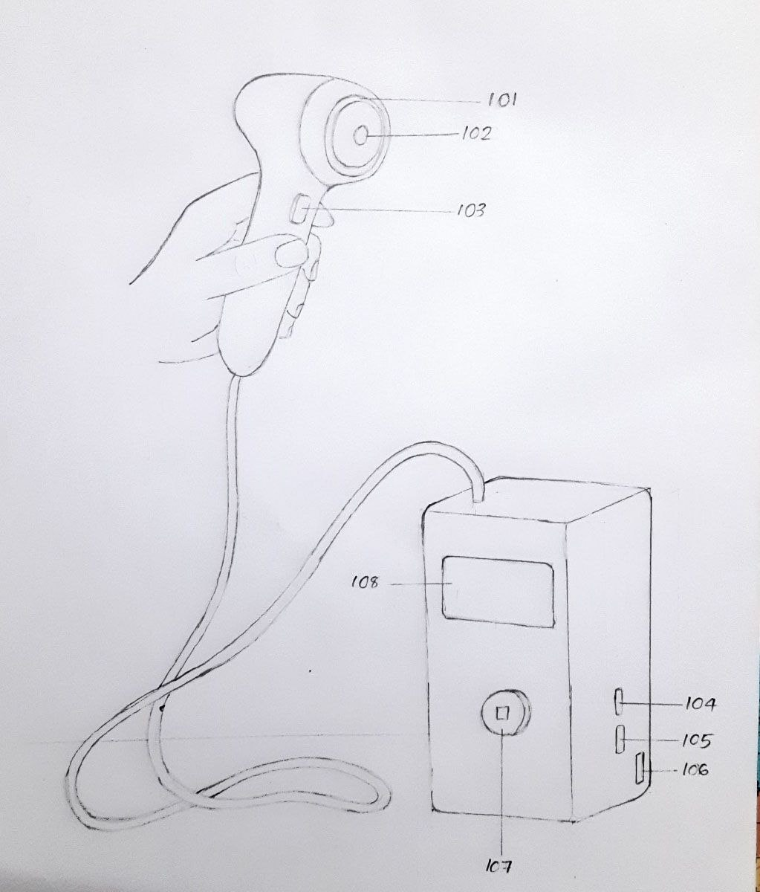

6. SUMMARY OF THE PRESENT INVENTION WITH DETAIL
The present invention provides a compact, intelligent, and portable AI-based oral cancer detection system that integrates deep learning–powered image analysis with IoT-enabled real-time accessibility. The device is designed to assist clinicians and medical practitioners in identifying suspicious lesions in the oral cavity that may require biopsy. The system combines a camera module, embedded light source, Raspberry Pi microcontroller, OLED display, and rechargeable power supply into a single self-contained diagnostic unit.
The invention leverages a pre-trained deep learning model that analyzes oral cavity images to highlight the region most likely to contain precancerous or cancerous tissue. The model is trained using a dataset of annotated oral images where pathologists have marked biopsy regions. The system captures an image through its onboard camera and transmits it to a Flask-based local server hosted on the Raspberry Pi for inference. The processed output is displayed both locally and remotely to the clinician through a secure web interface accessible within the same network.
Overview of the Figures
The accompanying figure (Figure 1) illustrates the structural and functional components of the proposed diagnostic device. Each component is marked numerically and described in detail below.
Component 101 – Illumination Module:
The illumination module (101) consists of an integrated LED light source positioned around the camera lens. Its purpose is to provide uniform illumination within the oral cavity, ensuring consistent lighting conditions during image capture. This controlled lighting minimizes shadowing and enhances the accuracy of color-based lesion detection performed by the AI model. The light can be toggled automatically when the device is activated or manually through the interface button (103).
Component 102 – Camera Module:
The camera module (102) serves as the primary imaging unit. It captures high-resolution photographs of the patient’s oral cavity and transmits them directly to the Raspberry Pi processor. The module operates in two modes: live-stream and capture. In live-stream mode, clinicians can visually align the focus area through any connected device on the same network. In capture mode, pressing the capture button (103) saves the image to the local system for processing by the Flask application. The camera feed is used both for diagnostic inference and for manual verification by medical staff.
Component 103 – Capture and Control Button:
The multifunction control button (103) enables user interaction with the system. When pressed once, it activates live mode, allowing the clinician to view a live camera feed. Pressing it again triggers the capture sequence, where the live stream pauses, and an image frame is taken for AI analysis. This simplified interaction ensures that the system remains user-friendly even in field conditions, where touch screens or external peripherals may be inconvenient.
Component 104 – HDMI 1 and Component 105 – HDMI 2 Ports:
The HDMI ports (104 and 105) allow external display connection for real-time visualization of diagnostic results. HDMI 1 can be used to project the camera feed or processed results onto a larger monitor, such as a clinic display or a laptop. HDMI 2 provides an optional secondary output for parallel display or recording purposes. The use of dual HDMI ports increases the system’s adaptability in clinical setups and educational demonstrations.
Component 106 – Power Supply and Charging Module:
The power supply unit (106) incorporates an internal rechargeable battery pack directly connected to the Raspberry Pi board. This configuration allows the device to operate independently without continuous external power, enabling use in mobile health camps or rural diagnostic centers. When the battery level becomes low, the system automatically enters a low-power mode and prompts the user to connect the charger. The charging circuit safely recharges the battery without interrupting active processes.
Component 107 – Power On/Off Switch:
The on/off switch (107) controls the system’s main power state. It activates both the Raspberry Pi and peripheral modules, including the illumination source, camera, and OLED display. When powered on, the device automatically initializes the Flask server and network services required for communication with connected devices. The power management system ensures safe startup and shutdown sequences to prevent data corruption or sudden process termination.
Component 108 – OLED Display Module:
The OLED display (108) serves as the interactive information panel for the user. Upon startup, the display shows a QR code, a welcome message, and system connection details. The QR code links directly to the device’s local web address, allowing any smartphone or computer on the same Wi-Fi network to access the live Flask interface. This interface displays the live camera feed, analysis results, and biopsy region prediction. The display also presents a one-time password (OTP) for authentication, ensuring that only authorized users can access the diagnostic interface. The OLED screen thus serves both as a security gateway and as a visual communication layer between the user and the embedded system.
WE CLAIM
1. An AI and IoT Based Oral Cancer Biopsy Guidance and Detection System consisting of;
i. A light source (101) configured to illuminate the oral cavity during image capture for optimal visibility and color accuracy.
ii. A high-resolution camera module (102) connected to a Raspberry Pi microcontroller for capturing intra-oral images.
iii. A user-operated control button (103) for toggling between live video mode and image capture mode through a Flask web interface.
iv. Dual HDMI ports (104, 105) for connecting external displays and viewing real-time diagnostic results.
v. A rechargeable power supply (106) directly connected to the Raspberry Pi, with an integrated charging system for portable operation.
vi. A power control switch (107) to turn the device on or off safely.
vii. An OLED display (108) for showing QR codes, OTP credentials, and network access details to securely connect external devices.
2. The AI and IoT Based Oral Cancer Biopsy Guidance and Detection System of Claim 1, wherein said Raspberry Pi microcontroller runs a Flask-based web application enabling live video streaming and remote image access from devices connected to the same network.
3. The AI and IoT Based Oral Cancer Biopsy Guidance and Detection System of Claim 1, wherein said OLED display (108) generates a dynamic QR code containing the local IP address and authentication OTP, enabling secure user login to the diagnostic interface.
4. The AI and IoT Based Oral Cancer Biopsy Guidance and Detection System of Claim 1, wherein said deep learning model is trained on annotated oral cancer datasets, identifying and segmenting regions most suitable for biopsy sampling.
5. The AI and IoT Based Oral Cancer Biopsy Guidance and Detection System of Claim 1, wherein said camera module (102) captures images under the illumination of said light source (101), ensuring even lighting and consistent color representation of oral lesions.
6. The AI and IoT Based Oral Cancer Biopsy Guidance and Detection System of Claim 1, wherein said control button (103) is configured such that a first press initiates the live preview mode and a subsequent press captures the image and triggers analysis.
7. The AI and IoT Based Oral Cancer Biopsy Guidance and Detection System of Claim 1, wherein the processed image and highlighted biopsy region are displayed on connected devices through the Flask application interface in real-time.
8. The AI and IoT Based Oral Cancer Biopsy Guidance and Detection System of Claim 1, wherein said rechargeable power module (106) further includes a battery status indicator and low-power warning to ensure continuous device operation during clinical procedures.
9. The AI and IoT Based Oral Cancer Biopsy Guidance and Detection System of Claim 1, wherein the system is configured for deployment in clinical and mobile screening environments, providing an affordable and accessible solution for early oral cancer detection.

ABSTRACT
The AI and IoT Based Oral Cancer Biopsy Guidance and Detection System is an intelligent medical imaging device designed to assist clinicians in identifying optimal biopsy regions in oral cancer–suspected areas. The system integrates a Raspberry Pi microcontroller, a high-resolution camera module (102), and an illumination unit (101) for accurate intra-oral imaging. A trained deep learning model performs real-time segmentation of cancer-affected regions to highlight the most suitable biopsy site. The device features an OLED display (108) that generates a QR code and OTP for secure access to the Flask-based web application, allowing doctors to view live images and analysis on connected devices within the same network. It includes HDMI ports (104, 105) for external display, a rechargeable battery module (106) for portable use, and a user-operated button (103) for simplified image capture and analysis. This innovation addresses the challenge of accurately locating biopsy regions in complex oral lesions, particularly in early-stage cancer detection. The system enables faster, more reliable, and non-invasive guidance for clinicians, improving diagnostic precision and reducing the likelihood of false or missed biopsies—ultimately enhancing patient outcomes and accessibility in both hospital and outreach settings.

