PG & HOSTEL MANAGEMENT
PG Manager
Everything your rent register does. Nothing it loses.
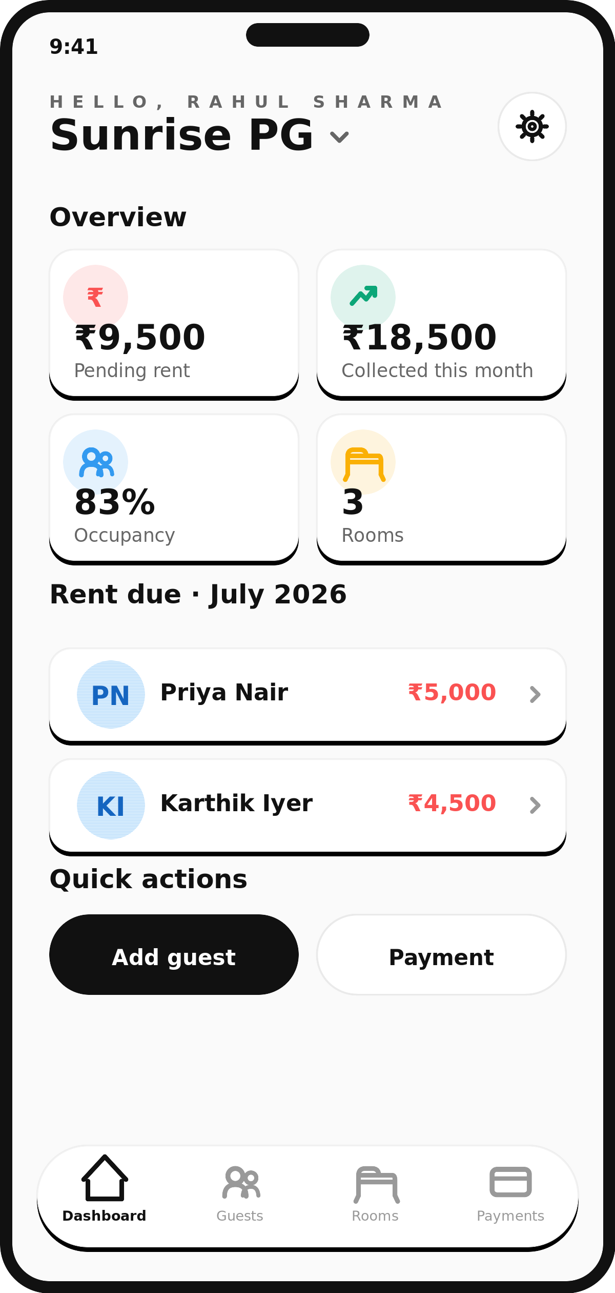
Product overview — prepared July 2026

OVERVIEW

Property management, built for Indian PG owners
PG Manager is a rooms-guests-rent system for people who run paying-guest accommodation and small hostels. It replaces the notebook a PG owner or manager currently uses to track who's staying, who's paid, and what's still owed — with something that does the arithmetic, keeps the history, and works from any phone or laptop, not just the one desk the register sits on.
It's built specifically around how a PG actually operates in India: rent quoted per room and split per bed, rent collected in cash, UPI, bank transfer or card, guests who stay for a semester or for years, and owners who often run more than one property at once.

HOW IT WORKS

Four steps, no paperwork
1. Set up your rooms. Add each room's capacity, whether it's AC or non-AC, and the room's total monthly rent.
2. Add your guests. Assign a guest to a room and their monthly rent is calculated automatically — the room's rent divided evenly by bed, editable if a particular guest's arrangement is different.
3. Record rent as it comes in. Pick the guest, the month, and the method (UPI, cash, bank transfer, card). The amount field is prefilled with exactly what's still owed.
4. See everything, live. Open the dashboard for occupancy, this month's collections, and exactly who still owes rent — from the property, from home, or from another city.

INSIDE THE APP

What it looks like
The screens below are illustrative mockups built from the app's real design system (colors, type, layout, copy) rather than live screenshots — they show the actual product structure and flow.

Dashboard — pending rent, this month's collections, occupancy and who owes what, in one screen.

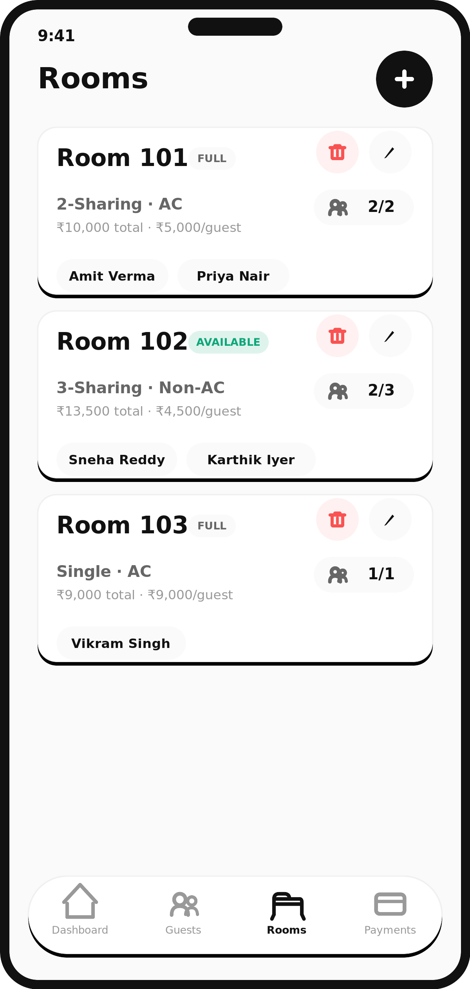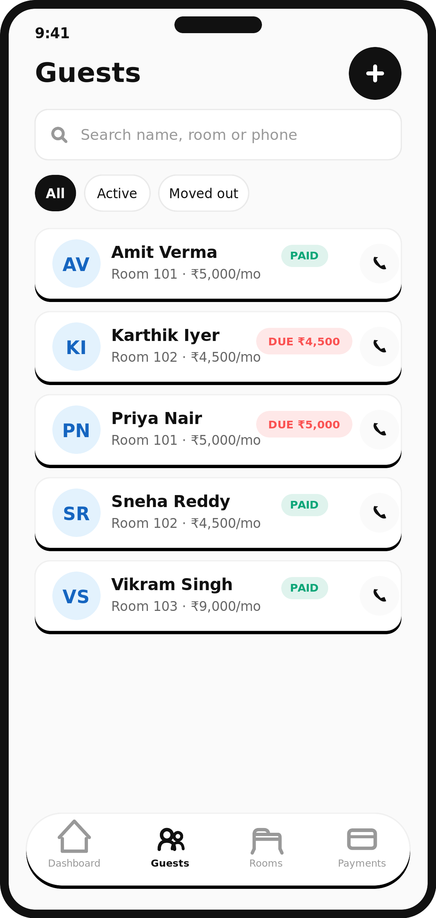
Rooms and Guests — room rent auto-splits per bed; every guest is searchable by name, room or phone.
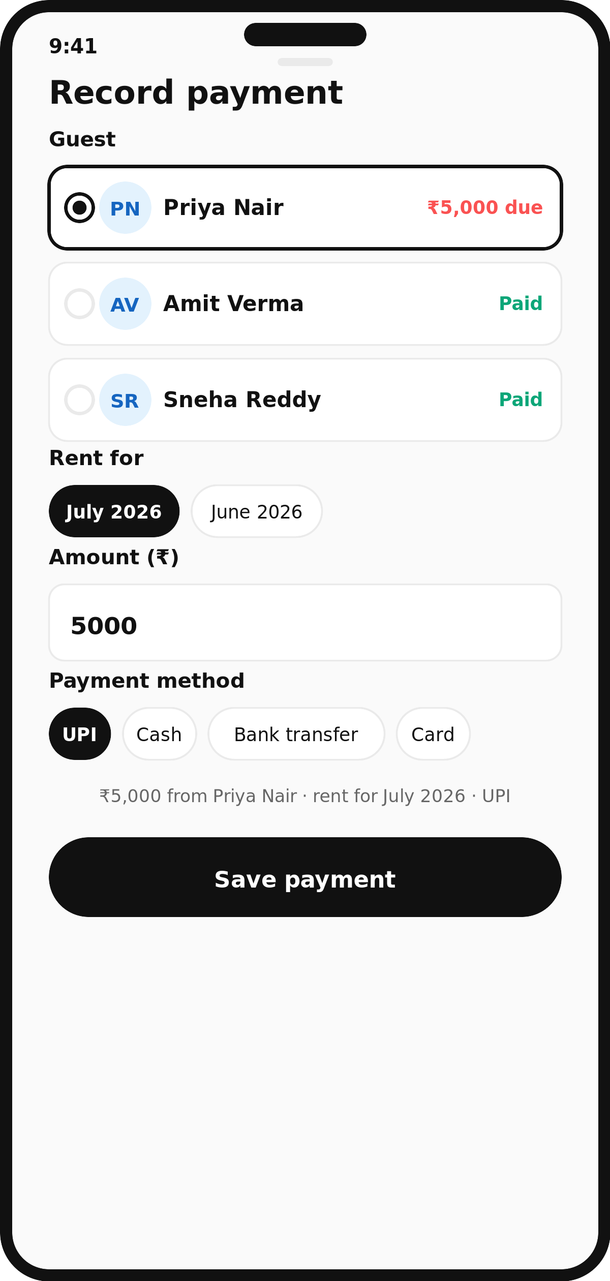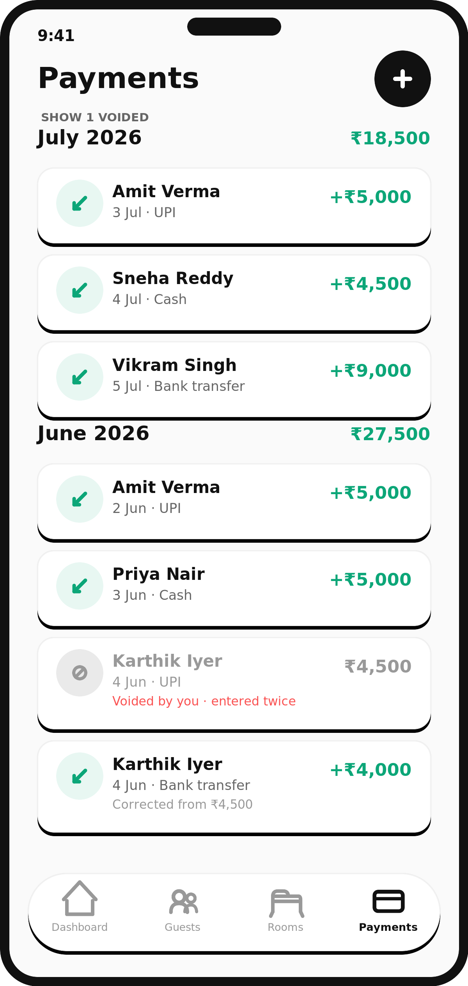
Record Payment and Payments — the balance due is prefilled; corrections are voided and re-entered, never edited.

FEATURES

Everything a PG owner actually needs
Multi-property, one login
Run one PG or five under a single account, and switch between them instantly.
Owner / Manager / Staff roles
Give staff access to record guests and payments without handing over the ability to void or correct one.
Automatic rent splitting
Set a room's total rent once; every guest assigned to it gets their per-bed share calculated for you.
Fat-finger guard
Flags a payment that looks like a typo — far too high or far too low against the guest's rent — before it's saved.
Live dashboard
Pending rent, this month's collections, occupancy and room count, always current.
Full guest history
Every guest's profile and complete payment history remain searchable long after they've moved out.
Search & one-tap calling
Find any guest by name, room number or phone, and call them directly from the app.
Move-out, not delete
Marking a guest as moved out frees their bed but keeps their entire record intact — reversible at any time.
Built for India
₹ formatting, DD/MM/YYYY dates, and Asia/Kolkata timezone by default.

WHY IT MATTERS

Nothing is ever thrown away
A paper register has a ceiling. It fills up, and the history either goes in a box that never gets reopened, or gets thrown out to make room for the next one. PG Manager is built so that ceiling doesn't exist.
- Every payment stays in the ledger — mistakes aren't deleted, they're voided and re-entered — so the original entry, the correction, and who made it all remain on record, permanently.
- Every guest is still there — a guest who moved out three years ago is still searchable, with their full stay and payment history intact.
- The record only grows — the longer a property uses it, the more complete its financial and occupancy history becomes — nothing resets, nothing is re-entered from scratch.

HEAD TO HEAD

The notebook vs. PG Manager
 | Paper register | PG Manager
Where it lives | One desk, one property | Any phone, any property, anywhere
Rent math | By hand, every month | Calculated automatically
A correction | A crossed-out number | A linked, timestamped entry
When it fills up | Archived in a box, or binned | Keeps growing — never resets
Running more than one PG | A separate register per property | One login, every property
Who wrote what | No record | Every entry attributed
Finding an old entry | If you remember which page | One search

ACCESS CONTROL

Control who can do what
Every property has three roles — Owner, Manager and Staff — each with different limits on what they can do.
Owner
Full control of the property, including who else has access to it.
Manager
Runs day-to-day operations, including voiding or correcting a payment.
Staff
Can record guests and payments, but can't undo one.
The payments ledger is append-only by design — there is no “edit” button that quietly rewrites a past entry. Every payment records who entered it, and, if it was voided, who voided it and when. A voided row is never hidden: it stays visible, struck through, and excluded from every total.

ROADMAP

What's next
PG Manager is under active development. Here's what's shipping soon, and what's further out.
Coming soon  - Invite staff by email, with scoped roles  - Attach guest ID & photo documents  - Encrypted storage for ID numbers  - A full audit log of every change | On the roadmap  - Automated rent-due reminders  - Online rent collection inside the app  - Multi-month arrears tracking  - A guest-facing view of their own rent status

Stop running your PG from a notebook.
PG Manager — built for Indian PG & hostel owners.
Phone +91 63744 26001
Email info@devworthtechonologies.com
Web devworthtechnologies.com

