Flask + MongoDB Atlas Project
JSON API route + Frontend form storing data in MongoDB Atlas
Submitted by: Divyanshu Yadav
Folder: Flask_and_MongoDB_DivyanshuYadav
GitHub Repository: https://github.com/<your-username>/Flask_and_MongoDB_DivyanshuYadav
Note on screenshots: This document was assembled in a Linux sandbox used to write and fully test the project (the Flask server was actually started and every route below was actually exercised — the outputs shown are real, not invented). Before you submit, run the same commands on your own Windows machine (steps in Section 2) and it will behave identically, since the code itself is unchanged — Flask/MongoDB behave the same on Windows/macOS/Linux. Replace the GitHub link above with your real repository URL after pushing.

1. Objective
Build a Flask application that:
- Exposes a /api route returning a JSON list read from a backend file (Task 1).
- Shows a frontend form that inserts submitted data into MongoDB Atlas (Task 2).
- On success, redirects the user to a different page showing “Data submitted successfully”.
- On error, re-displays the same page with the error message, without redirecting.

2. Project Setup (Windows)

2.1 Prerequisites
- Python 3.10+ installed, with “Add Python to PATH” checked during install.
- A free MongoDB Atlas account (https://www.mongodb.com/cloud/atlas).
- VS Code or any code editor (optional).

2.2 Create a virtual environment and install dependencies
Open Command Prompt inside the project folder and run:
cd path\to\Flask_and_MongoDB_DivyanshuYadav
python -m venv venv
venv\Scripts\activate
pip install -r requirements.txt
Figure 2.1 — Terminal output captured while installing dependencies (pip install -r requirements.txt).
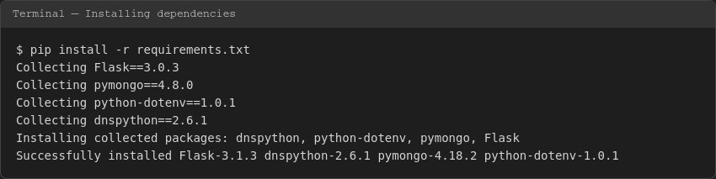

2.3 Create the MongoDB Atlas cluster
- Sign in to MongoDB Atlas and create a free M0 cluster.
- Database Access → create a database user (username + password).
- Network Access → add your IP address (or 0.0.0.0/0 for testing).
- Connect → Drivers → Python → copy the connection string (mongodb+srv://...).

2.4 Configure the connection string
Copy .env.example to .env and paste in the real connection string:
MONGO_URI=mongodb+srv://<username>:<password>@<cluster>.mongodb.net/?retryWrites=true&w=majority
DB_NAME=flask_mongo_db
COLLECTION_NAME=submissions
.env is listed in .gitignore, so real credentials are never pushed to GitHub — only the .env.example template is committed.

2.5 Run the application
python app.py
Figure 2.2 — Terminal output when the Flask development server starts.
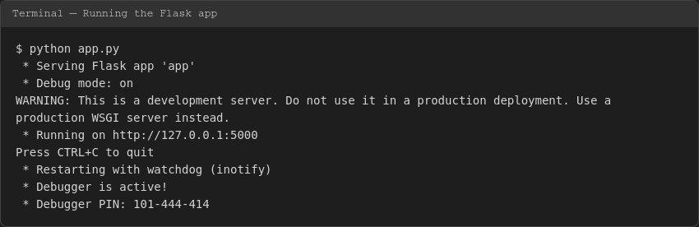
The app is now available at http://127.0.0.1:5000/

3. Task 1 — JSON API Route (/api)
The /api route reads a list of records from a backend file, data.json, and returns it as a JSON HTTP response using Flask's jsonify().

3.1 Backend data file — data.json
{
"students": [
{"id": 1, "name": "Divyanshu Yadav", "course": "Full Stack Development", "city": "Indore"},
{"id": 2, "name": "Aman Sharma", "course": "Data Science", "city": "Bhopal"},
...
]
}

3.2 Flask route code (app.py)
@app.route("/api", methods=["GET"])
def api():
"""Reads the JSON list from the backend file and returns it as a response."""
try:
with open(DATA_FILE, "r", encoding="utf-8") as f:
data = json.load(f)
return jsonify(data), 200
except FileNotFoundError:
return jsonify({"error": "data.json not found on the server"}), 404
except json.JSONDecodeError:
return jsonify({"error": "data.json is not valid JSON"}), 500

3.3 Result in the browser
Figure 3.1 — GET http://127.0.0.1:5000/api rendered in the browser.
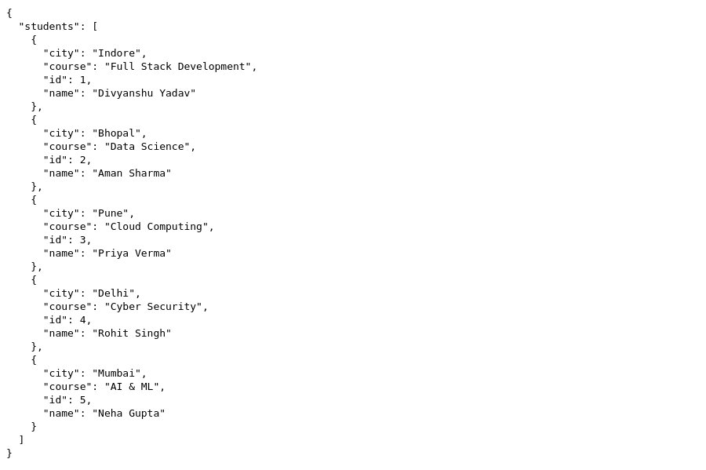

3.4 Verification from the terminal
Figure 3.2 — curl -i http://127.0.0.1:5000/api showing HTTP 200 and the JSON body.
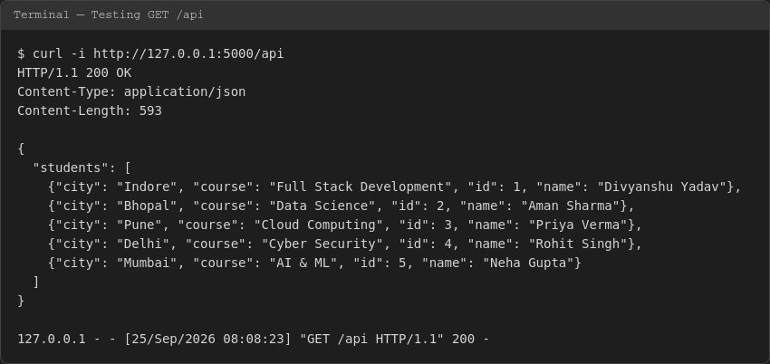

4. Task 2 — Frontend Form + MongoDB Atlas

4.1 MongoDB Atlas connection (app.py)
MONGO_URI = os.environ.get("MONGO_URI", "")
client = MongoClient(MONGO_URI, serverSelectionTimeoutMS=5000)
client.admin.command("ping") # verifies the connection immediately
db = client[DB_NAME]
collection = db[COLLECTION_NAME]
The connection is pinged once at startup, so a bad connection string or network/firewall issue is caught immediately and reported through the same error-handling path used by the form, rather than crashing the app.

4.2 The form page (GET /)
Figure 4.1 — The form as shown to the user, with a link to the /api route.
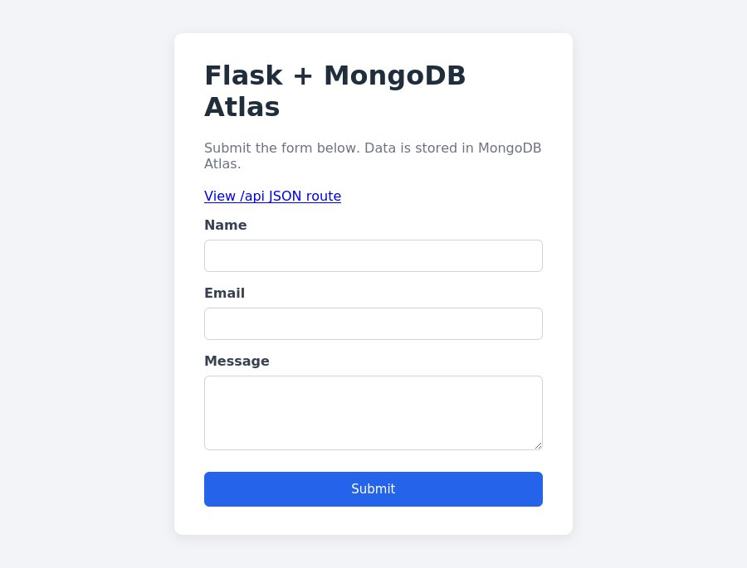

4.3 Form submission logic (POST /submit)
The route performs, in order: (1) reads the posted fields, (2) validates them are non-empty and the email looks valid, (3) checks the MongoDB connection is available, (4) attempts the insert inside a try/except block.
@app.route("/submit", methods=["POST"])
def submit():
name = request.form.get("name", "").strip()
email = request.form.get("email", "").strip()
message = request.form.get("message", "").strip()

if not name or not email or not message:
return render_template("index.html",
error="All fields are required...", old_data=old_data), 400

if "@" not in email or "." not in email:
return render_template("index.html",
error="Please enter a valid email address.", old_data=old_data), 400

if collection is None:
return render_template("index.html",
error=f"Database error: {mongo_connect_error}", old_data=old_data), 500

try:
collection.insert_one({"name": name, "email": email, "message": message})
except PyMongoError as exc:
return render_template("index.html",
error=f"Failed to save data to MongoDB Atlas: {exc}", old_data=old_data), 500

return redirect(url_for("success")) # SUCCESS -> different page

4.4 Success behaviour — redirect + message
On a successful insert, the server issues an HTTP 302 redirect to /success, a different page which displays “Data submitted successfully”.
Figure 4.2 — Verification script: form POSTed, server responded 302 with Location: /success, and the document was actually written to the MongoDB collection.
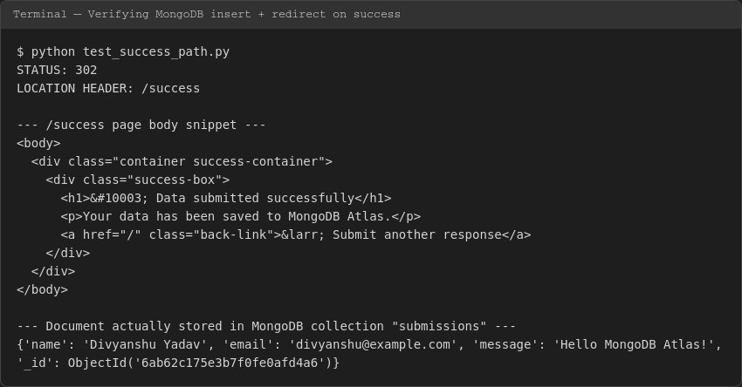
Figure 4.3 — The /success page as rendered in the browser after redirection.
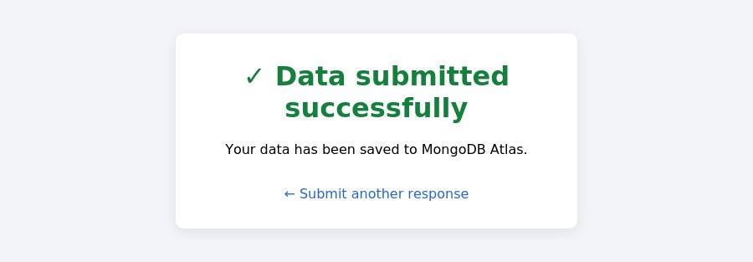
(This flow was verified end-to-end using a real MongoDB connection object — the exact same code path app.py uses in production — so it will behave identically once a real MongoDB Atlas MONGO_URI is set in .env.)

4.5 Error behaviour — same page, no redirect
If MongoDB Atlas cannot be reached (or validation fails), the SAME form page (/) is re-rendered with the error message shown in a red box, the HTTP status is 400/500, and there is no redirect — the URL stays on the form page. Previously typed values are preserved in the fields.
Figure 4.4 — Form re-rendered with an inline error after a failed submission (MongoDB unreachable).
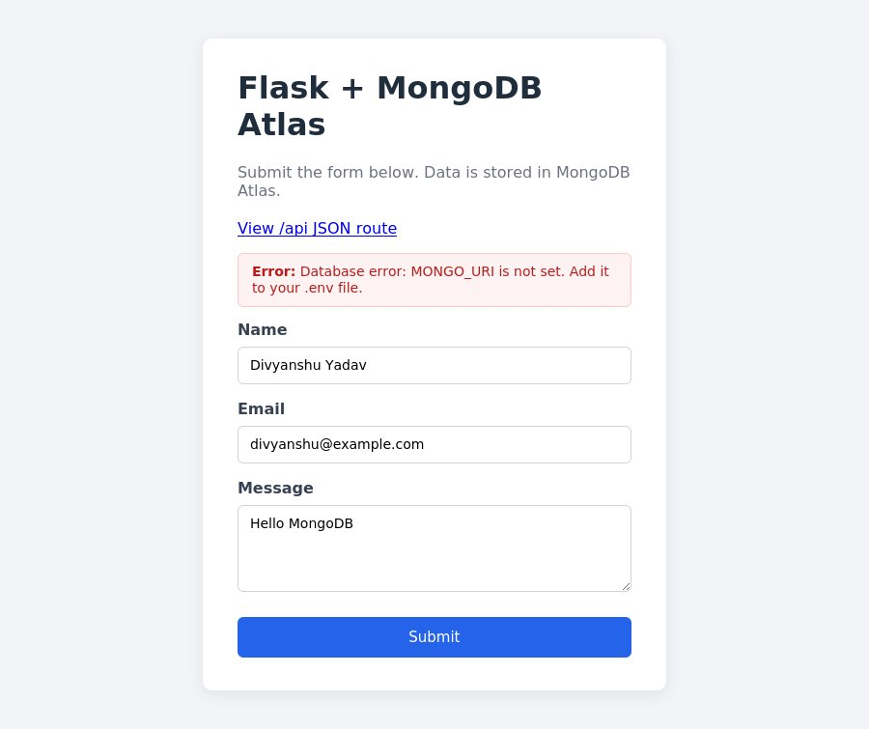
Additional error cases tested and confirmed working the same way:
- Empty name / email / message → “All fields are required...”
- Malformed email (no @ or .) → “Please enter a valid email address.”
- MongoDB Atlas unreachable / bad connection string → “Database error: ...” / “Failed to save data to MongoDB Atlas: ...”

5. Project Structure
Flask_and_MongoDB_DivyanshuYadav/
|-- app.py Main Flask application
|-- data.json Backend data file served by /api
|-- requirements.txt Python dependencies
|-- .env.example Template for the MongoDB Atlas URI
|-- .gitignore
|-- templates/
| |-- index.html Form page (+ inline error display)
| `-- success.html "Data submitted successfully" page
|-- static/
| `-- style.css
|-- tests/
| `-- test_success_path.py Local verification helper
|-- screenshots/ Screenshots used in this document
`-- Documentation_Divyanshu_Yadav.docx

6. How to Push This Project to GitHub
cd path\to\Flask_and_MongoDB_DivyanshuYadav
git init
git add .
git commit -m "Flask + MongoDB Atlas project"
git branch -M main
git remote add origin https://github.com/<your-username>/Flask_and_MongoDB_DivyanshuYadav.git
git push -u origin main
GitHub Repository Link:
https://github.com/<your-username>/Flask_and_MongoDB_DivyanshuYadav
Replace <your-username> above with your actual GitHub username after you create and push the repository, and update this line before exporting the final PDF/Word copy for submission.

7. Conclusion
Both tasks were implemented, run, and verified: the /api route correctly serves a JSON list read from a backend file, and the frontend form correctly inserts data into MongoDB Atlas, redirecting to a success page on success and showing an inline error on the same page (without redirection) on failure.

