**META LAB**

(MECHANICAL ENGINEERING)

**NAME – DEVYANI ARYA**

**META LAB**

**Index**

* Description

Users navigate a virtual world in the metaverse school that duplicates features of the physical world utilizing technologies such as virtual reality (VR), augmented reality (AR), artificial intelligence (AI), social media, and digital currency in the metaverse. “Browsing” on the internet is something that people do. People can, nevertheless, “live” in the metaverse to some extent

Avatars, objects, movements, currencies, and so on must all work across several worlds by definition. The metaverse must be open and unrestricted.

An imperative if metaverse for education is to become a possibility are the haptic gloves. Haptic feedback gloves are a type of wearable technology that provides users with realistic touch and interactions via improved tactile feedback. Haptic sensors within the gloves recreate a realistic sense of touch for users when activated. These gloves, which allow you to ‘feel’ items in virtual reality, have been around for a long time.

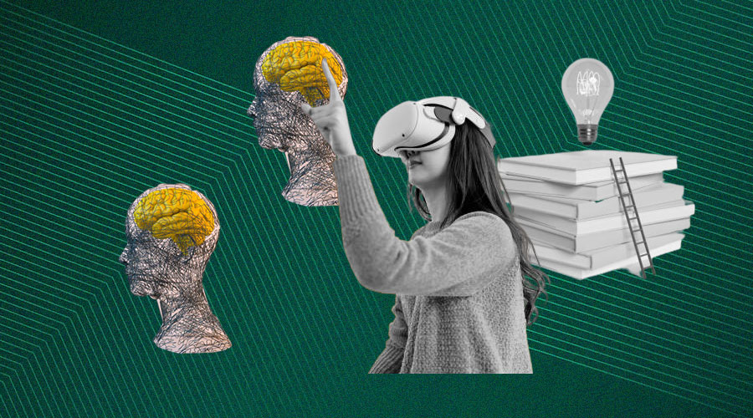

* On what problem we are working?

Work from Home for CS and IT engineers were not as difficult as for the civil and mechanical engineers.

As they faced many problems like lack of interactivity to machines and other equipments, the lockdown was not what they were ready for.

Till now many engineers who are doing distance learning and could barely come to college due to any reason are not that much aware of their subjects and practices.

There is no such “so called” interactive labs (virtual) which can help students to learn in a efficient manner.

* What is the approach for finding solution for the problem?

We will apply 3D approach in virtual labs to make it reliable to use. Gamify and learn is our approach to give the mechanical engineers a virtual environment where they can interact to machines and other equipment in such a way which can help them to understand their subject in an efficient manner.

* Technology stack for the problem statement

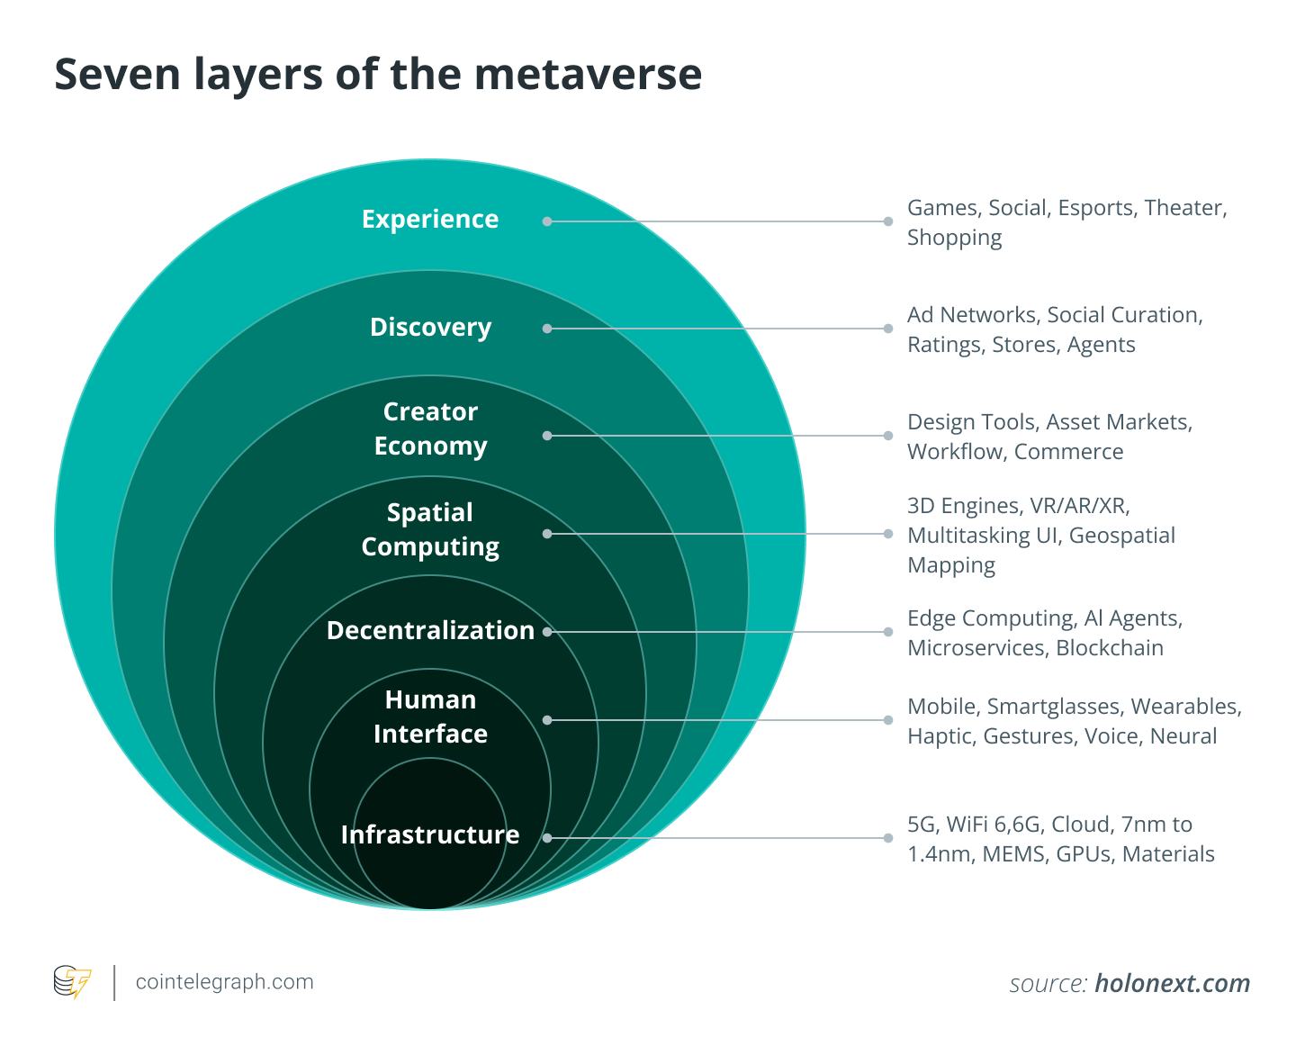

### Artificial intelligence

AI paired with Metaverse technology ensures the Metaverse infrastructure's stability while also delivering actionable information for the upper layers. NVIDIA technologies are a good example of how AI will be crucial in developing digital spaces where social interactions will occur in the Metaverse.

### Internet of things

While IoT will allow the Metaverse to study and interact with the real world, it will also serve as a 3D user interface for IoT devices, allowing for a more personalized IoT experience. Both the Metaverse and the Internet of Things will assist organizations in making data-driven judgments with minimal mental effort.

### Augmented and virtual reality

The idea of a Metaverse combines technologies like AI, AR and VR to let users enter the virtual world. For instance, virtual items can be embedded in the actual environment using augmented reality technology. Similarly, VR helps immerse you in a 3D virtual environment or 3D reconstruction using 3D computer modeling.

While wearing a virtual reality headset or other gear isn't required in the Metaverse, experts believe VR will become an essential part of the virtual environment. However, it is essential to note that the Metaverse is different from AR and VR. If you are curious to know how you can enter the Metaverse, the answer is that augmented and virtual reality technologies are a way to get into the dynamic 3D digital world.

### 3D modeling

3D modeling is a computer graphics approach for creating a three-dimensional digital representation of any surface or object. The Metaverse's 3D reality is crucial to ensuring the comfort of its consumers.

A lot of image collecting and graphic design are required to create a 3D world. The [3D graphics in most games like The Sandbox](https://cointelegraph.com/metaverse-for-beginners/sandbox-sand-a-beginners-guide-to-the-trending-metaverse-platform) ([SAND](https://cointelegraph.com/the-sandbox-sand-price-index)) provide the impression that the player is actually in the game. The Metaverse needs to be built on the same foundation.

### Spatial and edge computing

The practice of leveraging physical space as a computer interface is known as spatial computing. With technologies like the HoloLens, Microsoft is a pioneer in the field of spatial computing in the metaverse space. In contrast, edge computing is a network-based cloud computing and service delivery paradigm. Edge provides end-users with computation, storage, data and application solutions like cloud computing services.

To deliver the same level of experience as in reality, keeping the user interested and immersed in the Metaverse is critical. In light of this, the response time to a user's action should essentially be reduced to a level below what is detectable to humans. By hosting a series and combination of computing resources and communication infrastructures close to the users, edge computing provides quick response times.

1. Unity game development - for designing 3D models. For this we will learn C# (C sharp ) so that we can make our 3D model more accurate.

* What are the drawbacks in existing solution?

The drawbacks in present solution us that the virtual labs are consist of 2D models and machines, which is not an interactive way to study.

* How are solution is different from the existing solution?

Our solution is different from current existing solution because our idea is to implement solution in 3 dimension where a user is free to make changes to the particular model and can come to end result after the changes.

* References (if any) [Links]

* <http://vlabs.iitkgp.ernet.in/rtvlas/images/honda_G300.pdf>
* <https://cointelegraph.com/explained/the-key-technologies-that-power-the-metaverse>
* <https://gamedevacademy.org/wp-content/uploads/2018/04/Learn-Unity-by-Creating-a-3D-Multi-Level-Platformer-Game.pdf>

The links for the Virtual Labs for different subjects of Mechanical engineering stream are as follows:

|  |  |  |
| --- | --- | --- |
| **Sr. No.** | **Name of the Laboratory** | **Link for Virtual Lab** |
| **1** | Mechanics of Materials / Strength of  materials | [http://sm-nitk.vlabs.ac.in/#](http://sm-nitk.vlabs.ac.in/) |
| **2** | Metal Forming Lab | <http://msvs-dei.vlabs.ac.in/> |
| **3** | Workshop and machine shop practice  /General purpose lab for production shop simulation | <http://gssl.iitk.ac.in/pssl/> |
| **4** | Kinematics of Machines/ Mechanics of  Machine | <http://mm-nitk.vlabs.ac.in/> |
| **5** | Metallurgy and Materials Engineering/ Material response to micro-structural mechanical, thermal, and biological  stimulation | [http://mrmsmtbs-](http://mrmsmtbs-iitk.vlabs.ac.in/home%20page.html) [iitk.vlabs.ac.in/home%20page.html](http://mrmsmtbs-iitk.vlabs.ac.in/home%20page.html) |
| **6** | Fluid Mechanics | [http://fm-nitk.vlabs.ac.in/#](http://fm-nitk.vlabs.ac.in/) |
| **7** | Applied Thermodynamics/ RT Virtual lab  on Automotive systems | <http://vlabs.iitkgp.ernet.in/rtvlas/> |
| **8** | Turbo Machines / Fluid Machinery | <http://fmc-nitk.vlabs.ac.in/> |
| **9** | Heat and Mass transfer | <http://htv-au.vlabs.ac.in/> |
| **10** | Dynamics of machines/ Machine Dynamics and Mechanical Vibrations Lab | <http://mdmv-nitk.vlabs.ac.in/> |
| [http://vlabs.iitb.ac.in/vlabsdev/labs/nitk_la](http://vlabs.iitb.ac.in/vlabsdev/labs/nitk_labs/dynamics-ofmachinelab/labs/index.html)  [bs/dynamics-ofmachinelab/labs/index.html](http://vlabs.iitb.ac.in/vlabsdev/labs/nitk_labs/dynamics-ofmachinelab/labs/index.html) |
| **11** | Computer aided design and manufacturing /Mechanisms and robotics  lab | <http://vlabs.iitkgp.ernet.in/mr/> |