# Practical No 7

Sunishka Malviya

D-21

Aim: Demonstrate the Virtual Private cloud Security in the Public Cloud for the Virtual Machine, Databases and Storage. Describe the step-by-step process, including subnet creation, route table

configuration, and launching instances.

Task 1: the task of setting up a secure and isolated network environment using Amazon VPC in

AWS.

Task 2: to create a VPC with public and private subnets, configure appropriate routing, and

launch instances in both subnets

Task 3: Create a VPC Security Group

Task 4: Launch a Web Server Instance

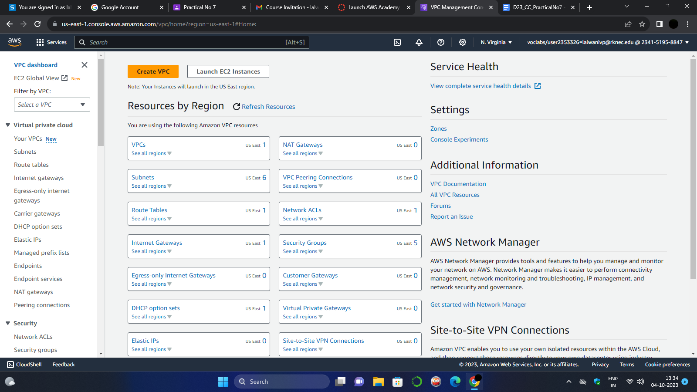

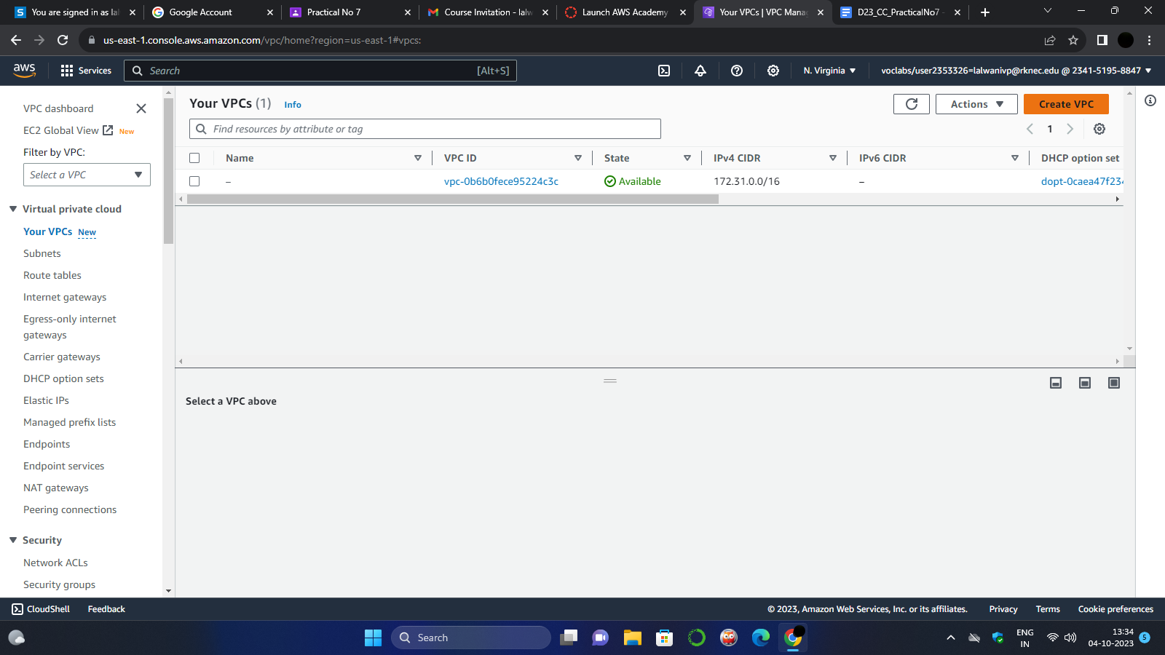

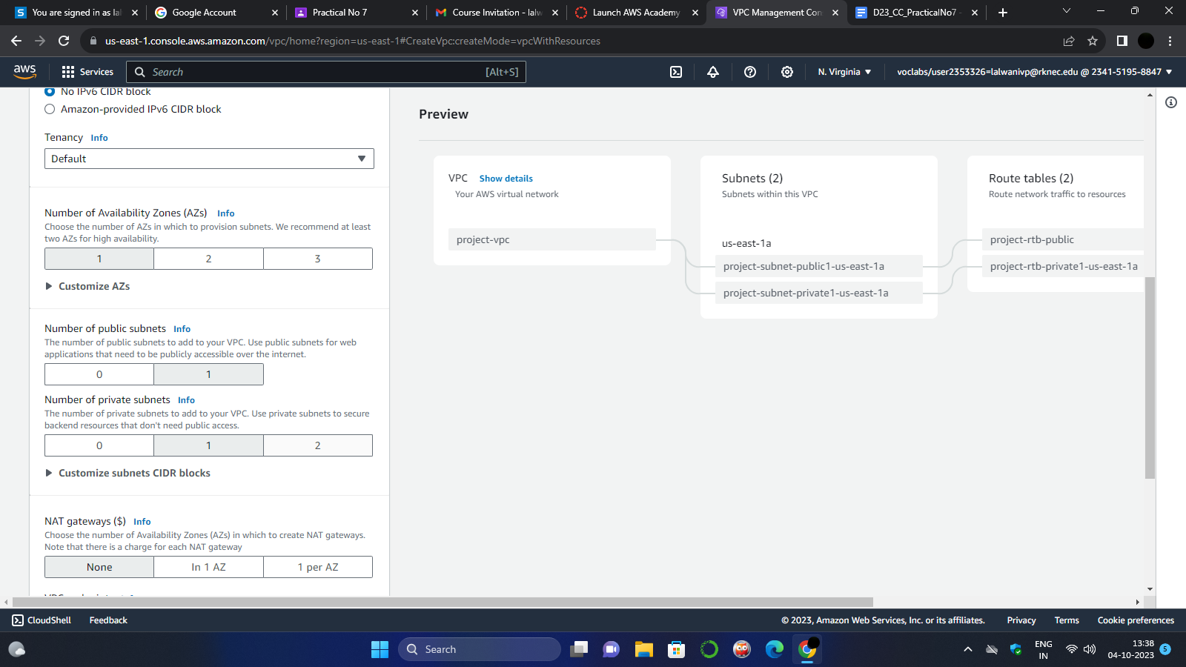

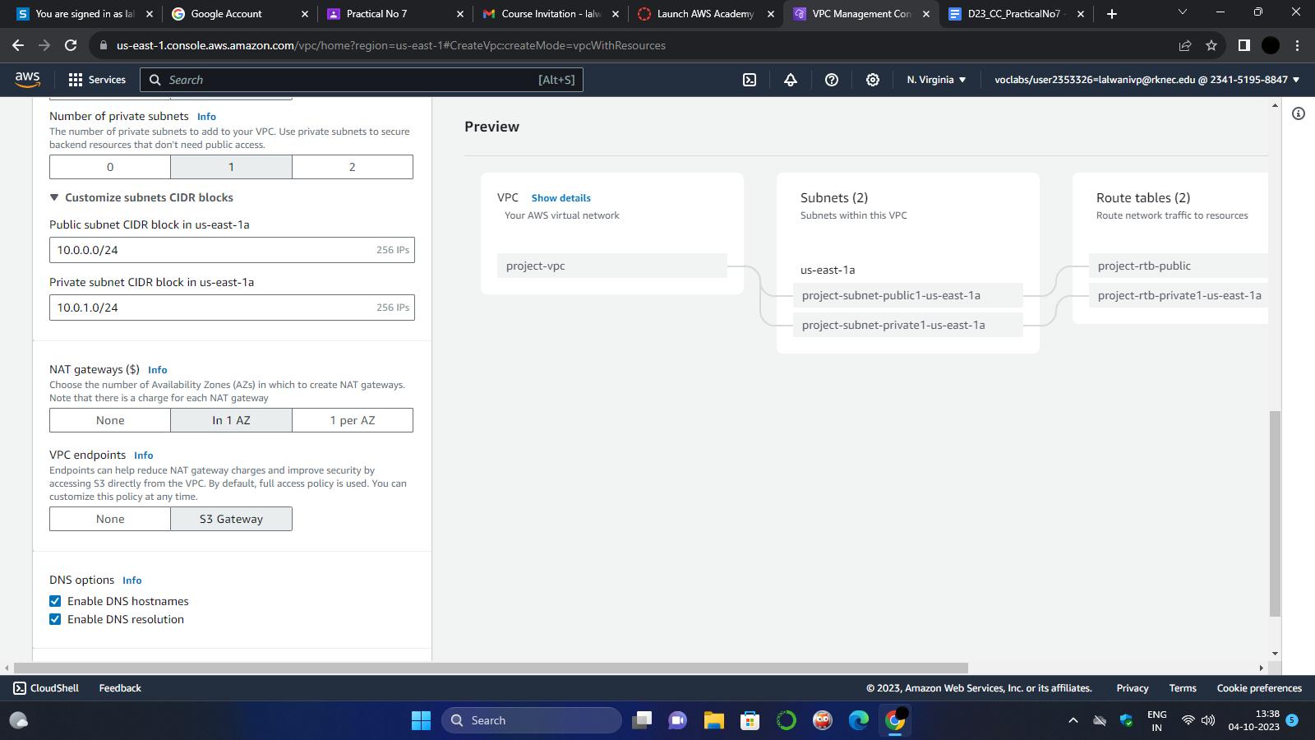

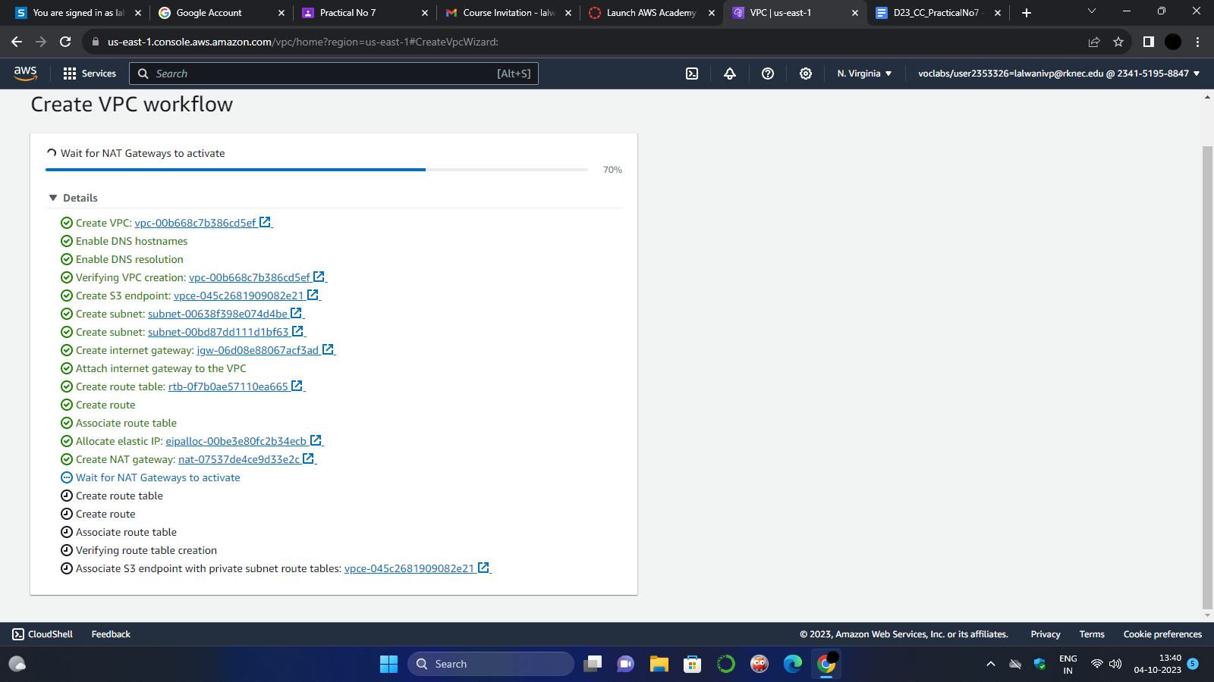

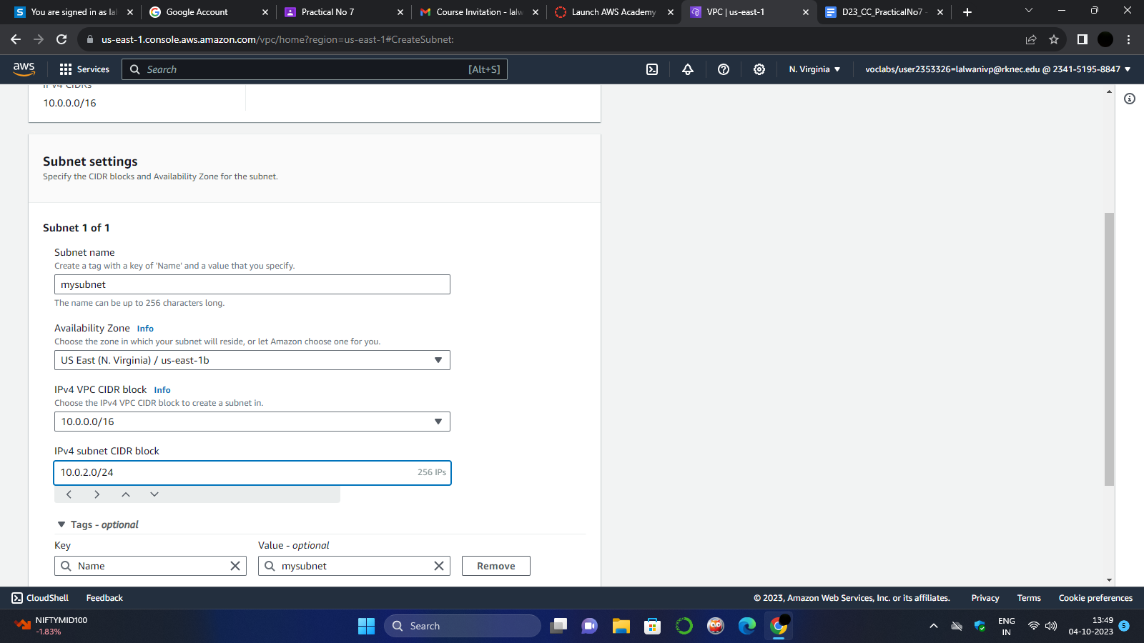

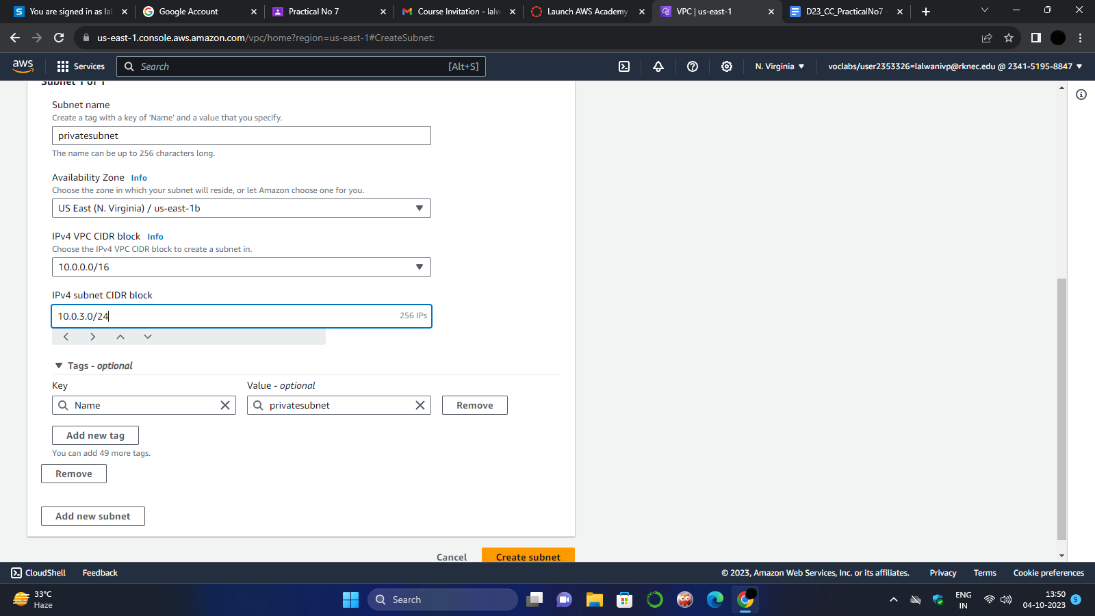

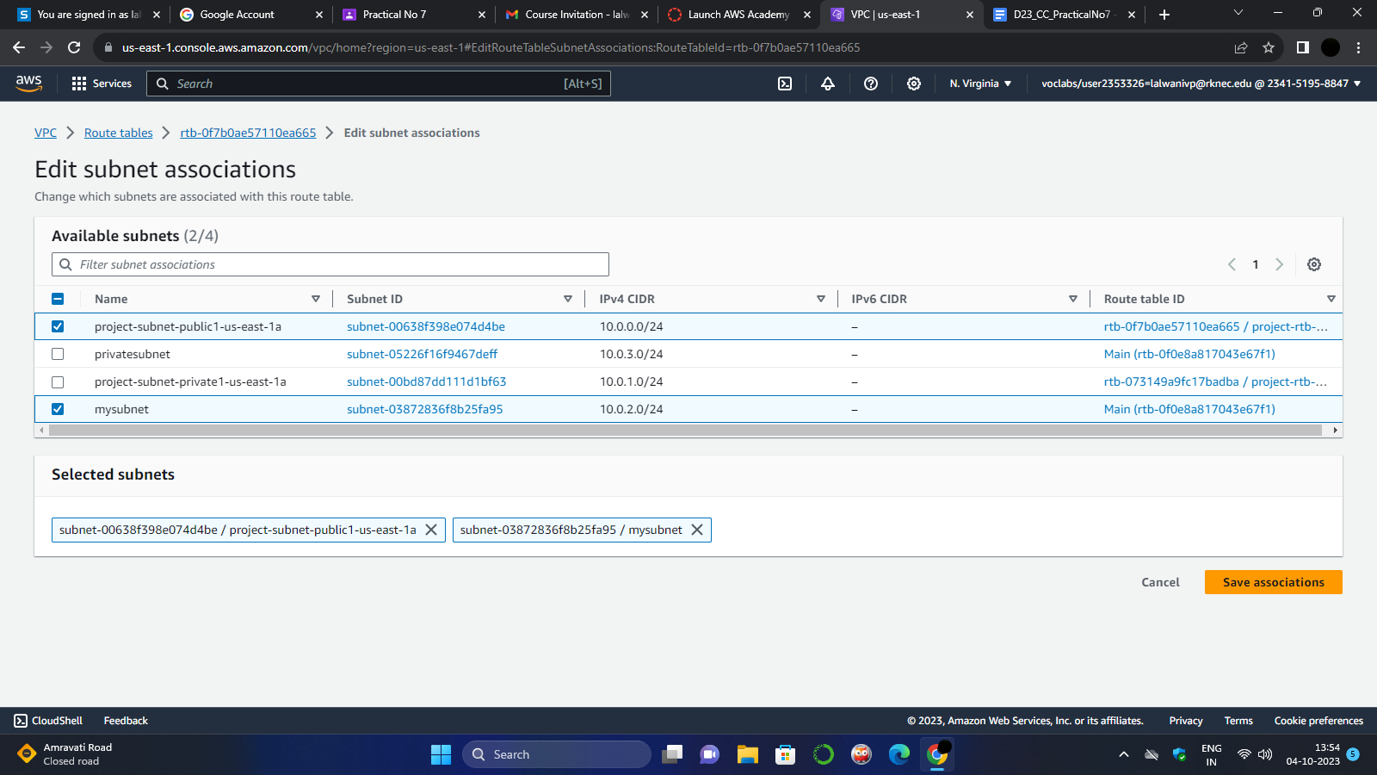

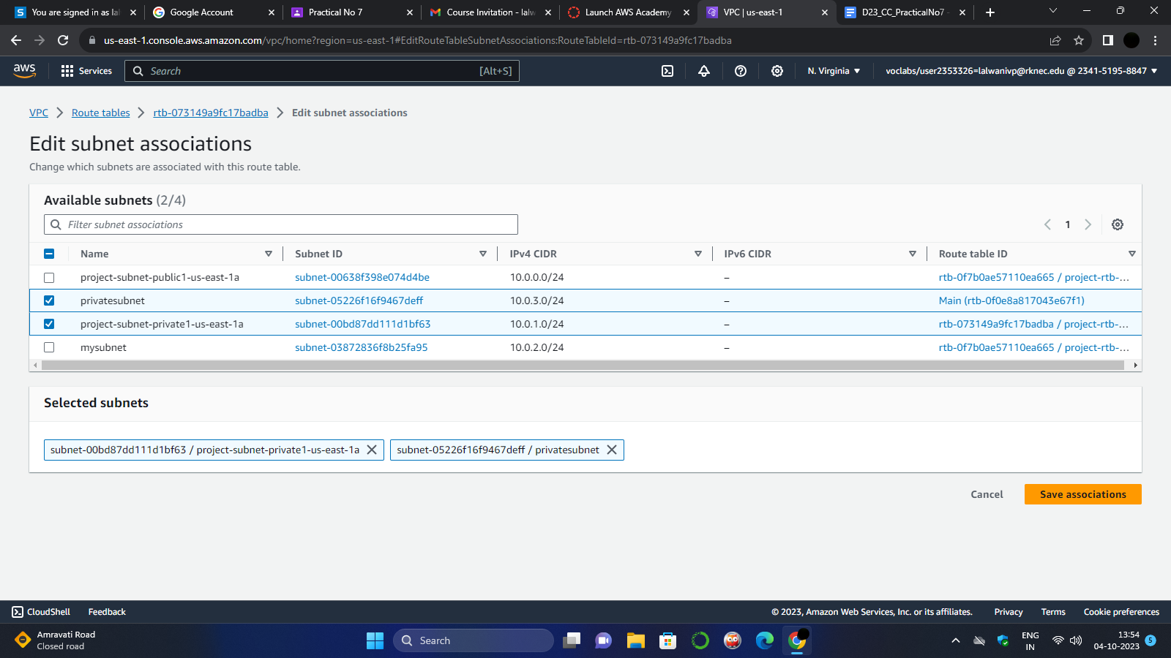

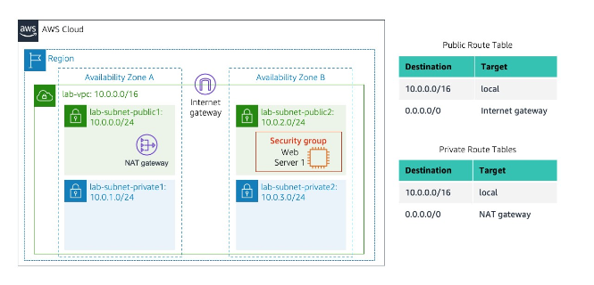

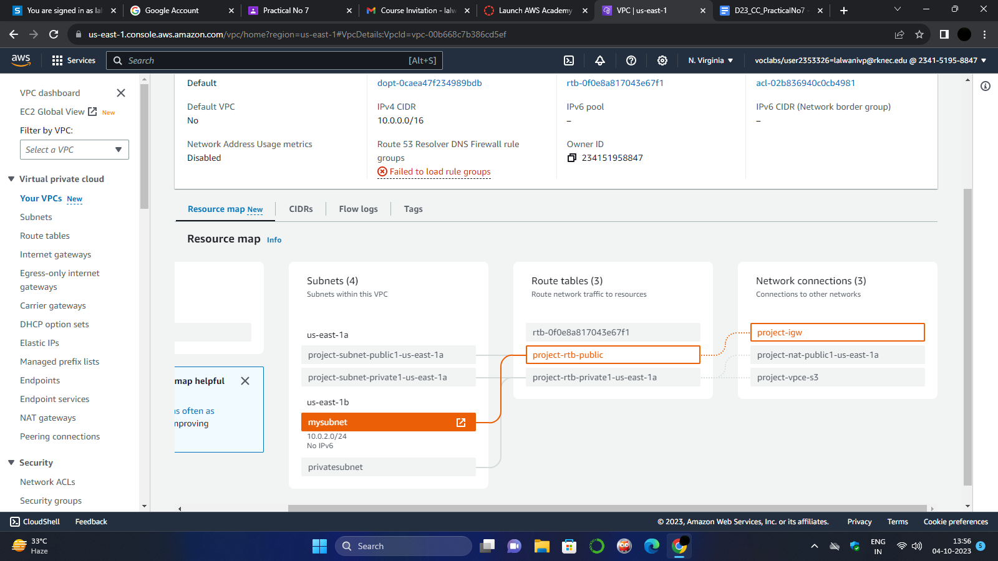

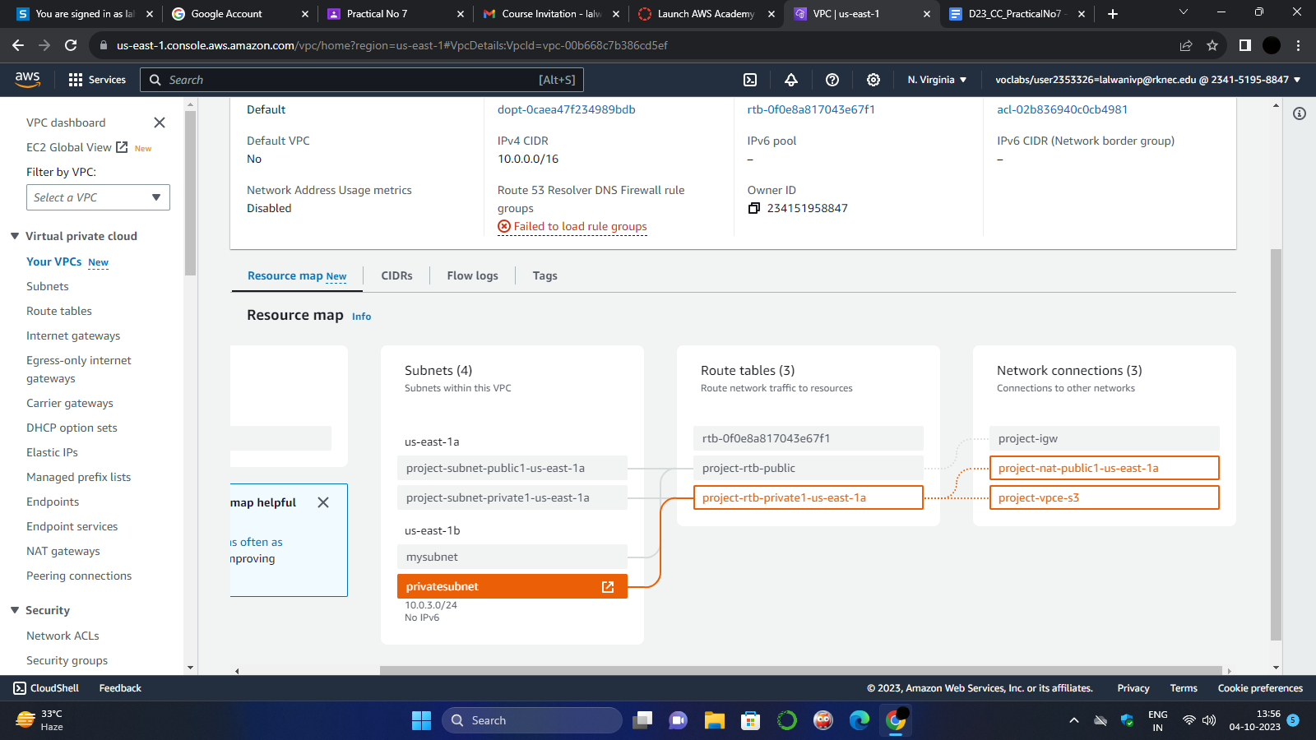

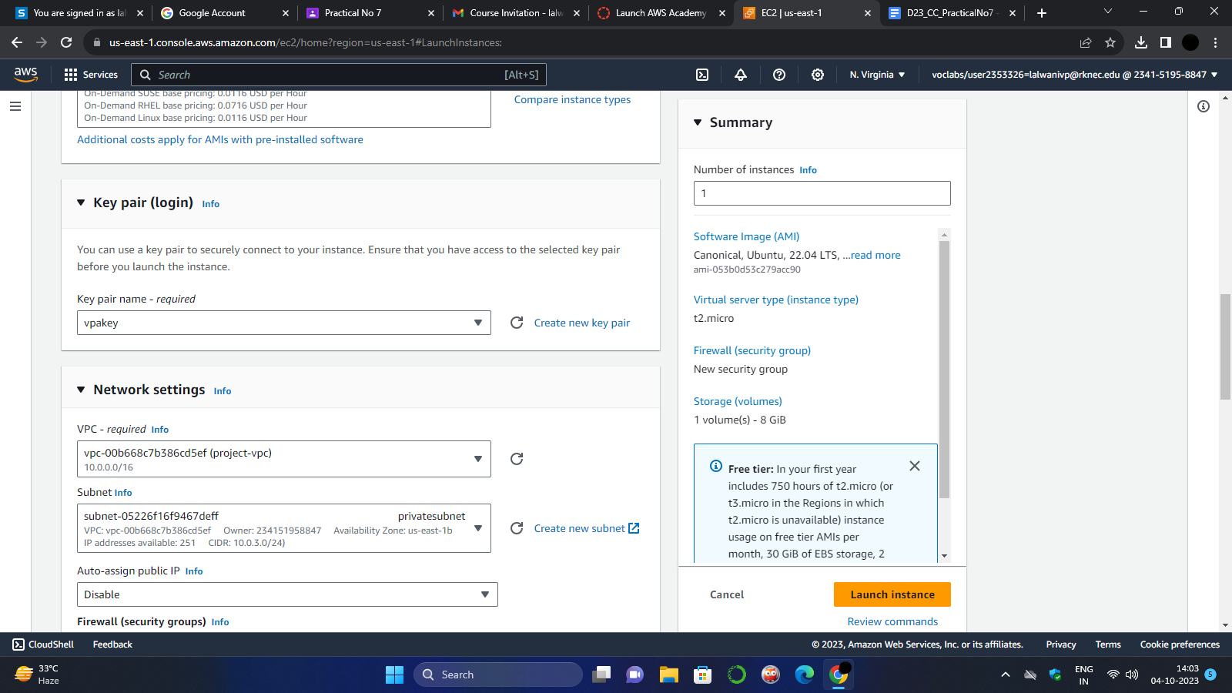

Task 4: Launch a Web Server Instance

In this task, you will launch an Amazon EC2 instance into the new VPC. You will configure the

instance to act as a web server.

