# Cloud Computing Lab: Practical No 8

D21 Sunishka Malviya

Aim: Simulate a cloud scenario using CloudSim and implement programs for its modeling and simulation.

CloudSim is an open-source framework, which is used to simulate cloud computing infrastructure and services. It is developed by the CLOUDS Lab organization and is written entirely in Java. It is used for modeling and simulating a cloud computing environment as a means for evaluating a hypothesis prior to software development in order to reproduce tests and results.

For example, if we were to deploy an application or a website on the cloud and wanted to test the services and load that our product can handle and also tune its performance to overcome bottlenecks before risking deployment, then such evaluations could be performed by simply coding a simulation of that environment with the help of various flexible and scalable classes provided by the CloudSim package, free of cost.

STEPS:

Java Project in Netbeans

CloudSim zip downloaded and extracted

Add jar files to library

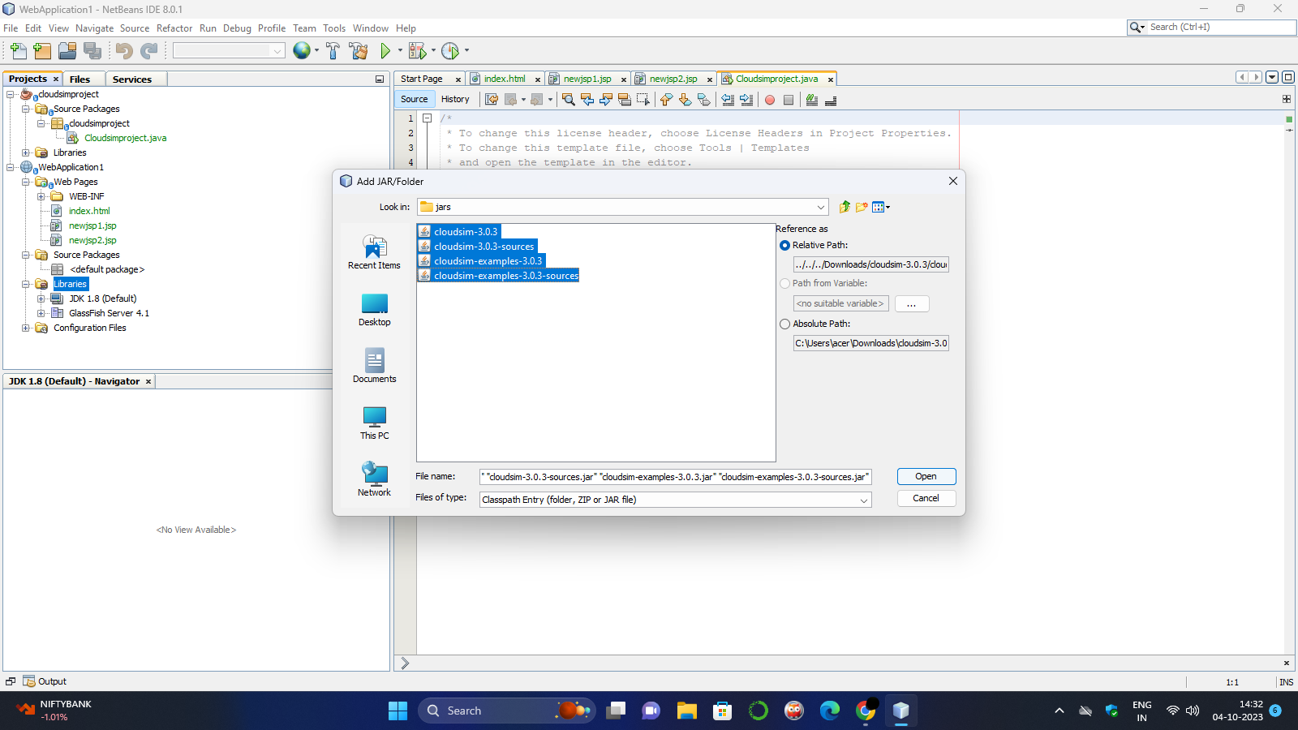

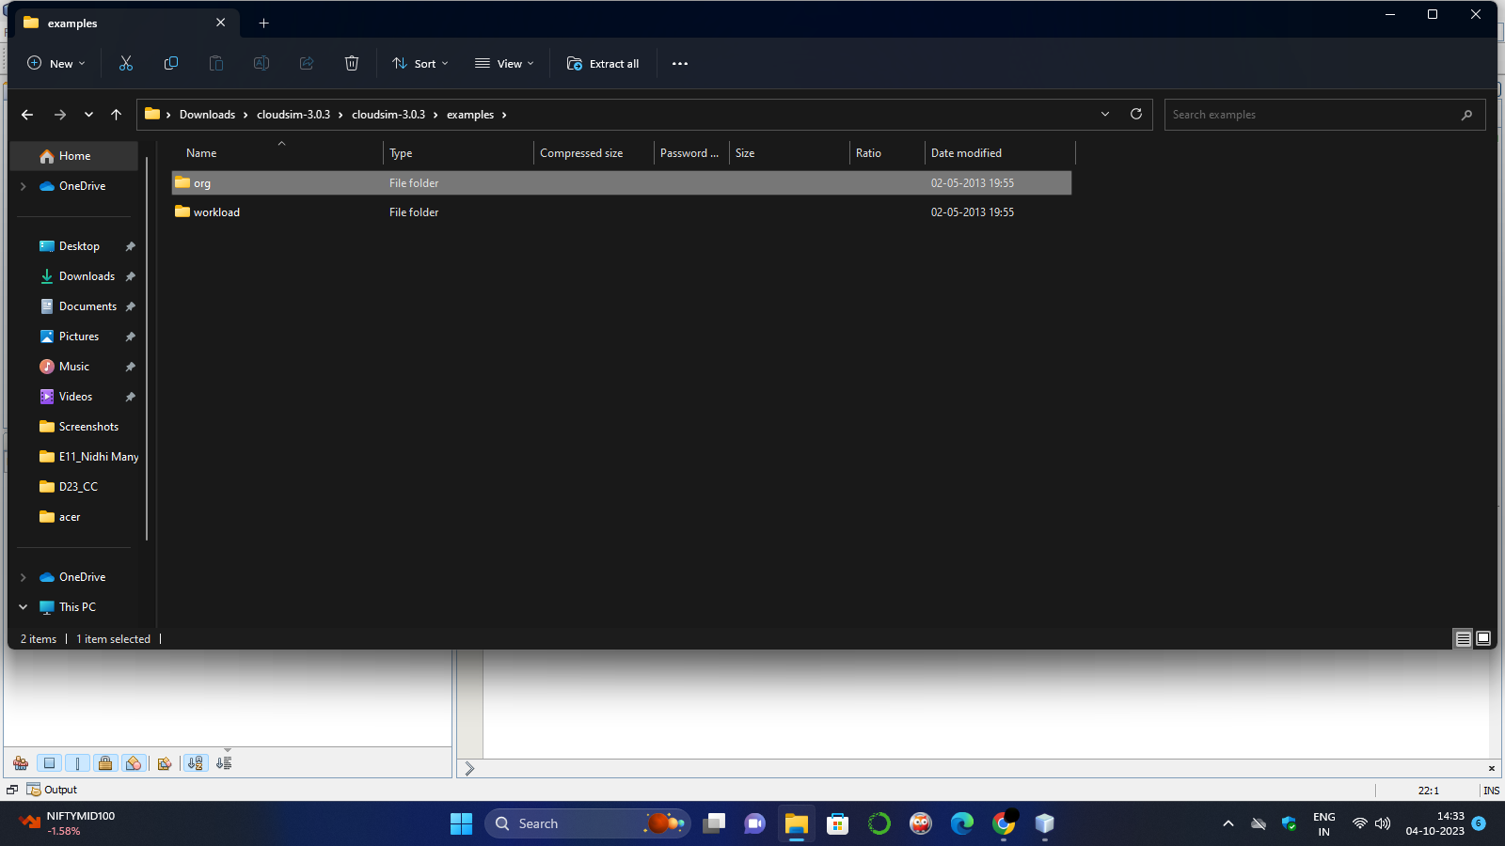

Adding org folder with examples (copying) and pasting it i the Source Packages

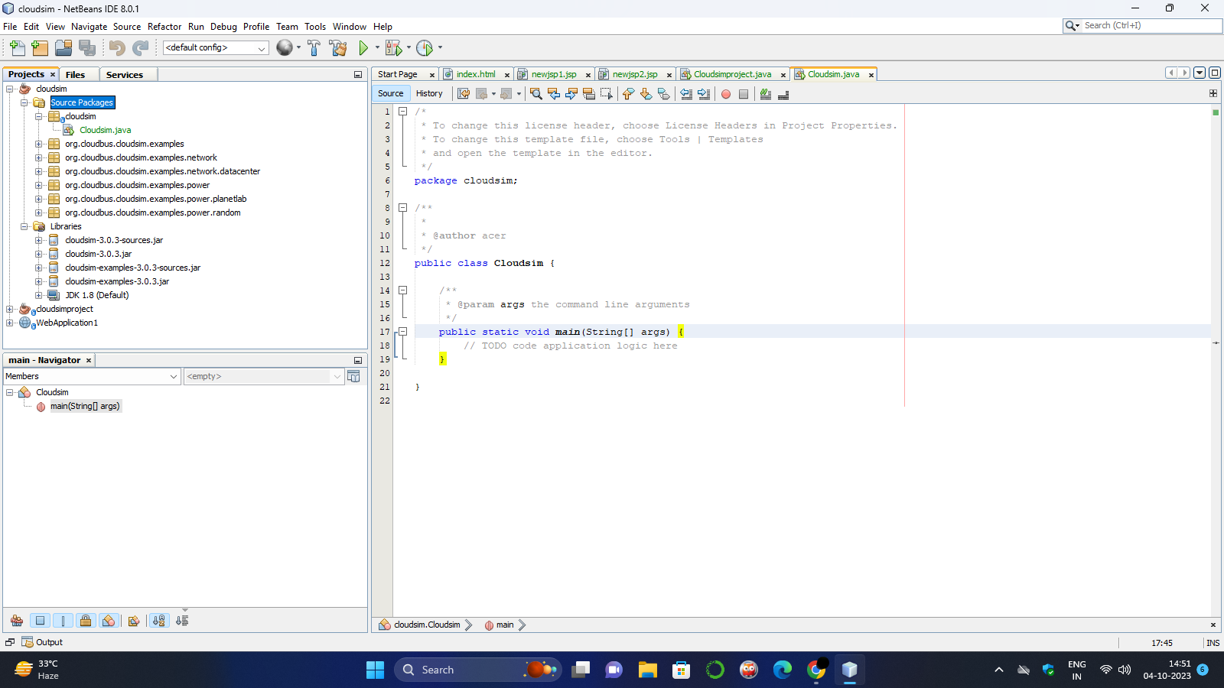

On running any example we get the following output:

