
Department of Artificial Intelligence and Machine Learning B.Tech. Sem: V Subject: Fullstack Development with NextJs (DJS23AMD302)

EXPERIMENT NO. 2

NAME | SAP_ID | ROLL NO. | DATE

AIM
To construct a completely responsive dashboard or marketplace UI using modern Tailwind CSS configurations.

THEORY
Utility-First Framework Model: Tailwind CSS operates on a utility-first architectural paradigm, exposing low-level utility classes that directly manipulate CSS rules within HTML/JSX layouts. This eliminates custom CSS file bloat and provides consistent design token enforcement (spacing, typography, color palettes).
Responsive Design Breakpoints: Tailwind uses a mobile-first breakpoint system using prefix modifiers.
CSS Grid & Flexbox Containers: Complex dashboard layouts combine grid and flex container directives:
Flexbox: flex, flex-col, items-center, justify-between for directional alignments and navigation bars.
Grid: grid, grid-cols-1, md:grid-cols-3, gap-6 for structured card layouts that automatically reflow on smaller viewports.

OBSERVATION

Department of Artificial Intelligence and Machine Learning B.Tech. Sem: V Subject: Fullstack Development with NextJs (DJS23AMD302)

OUTPUT




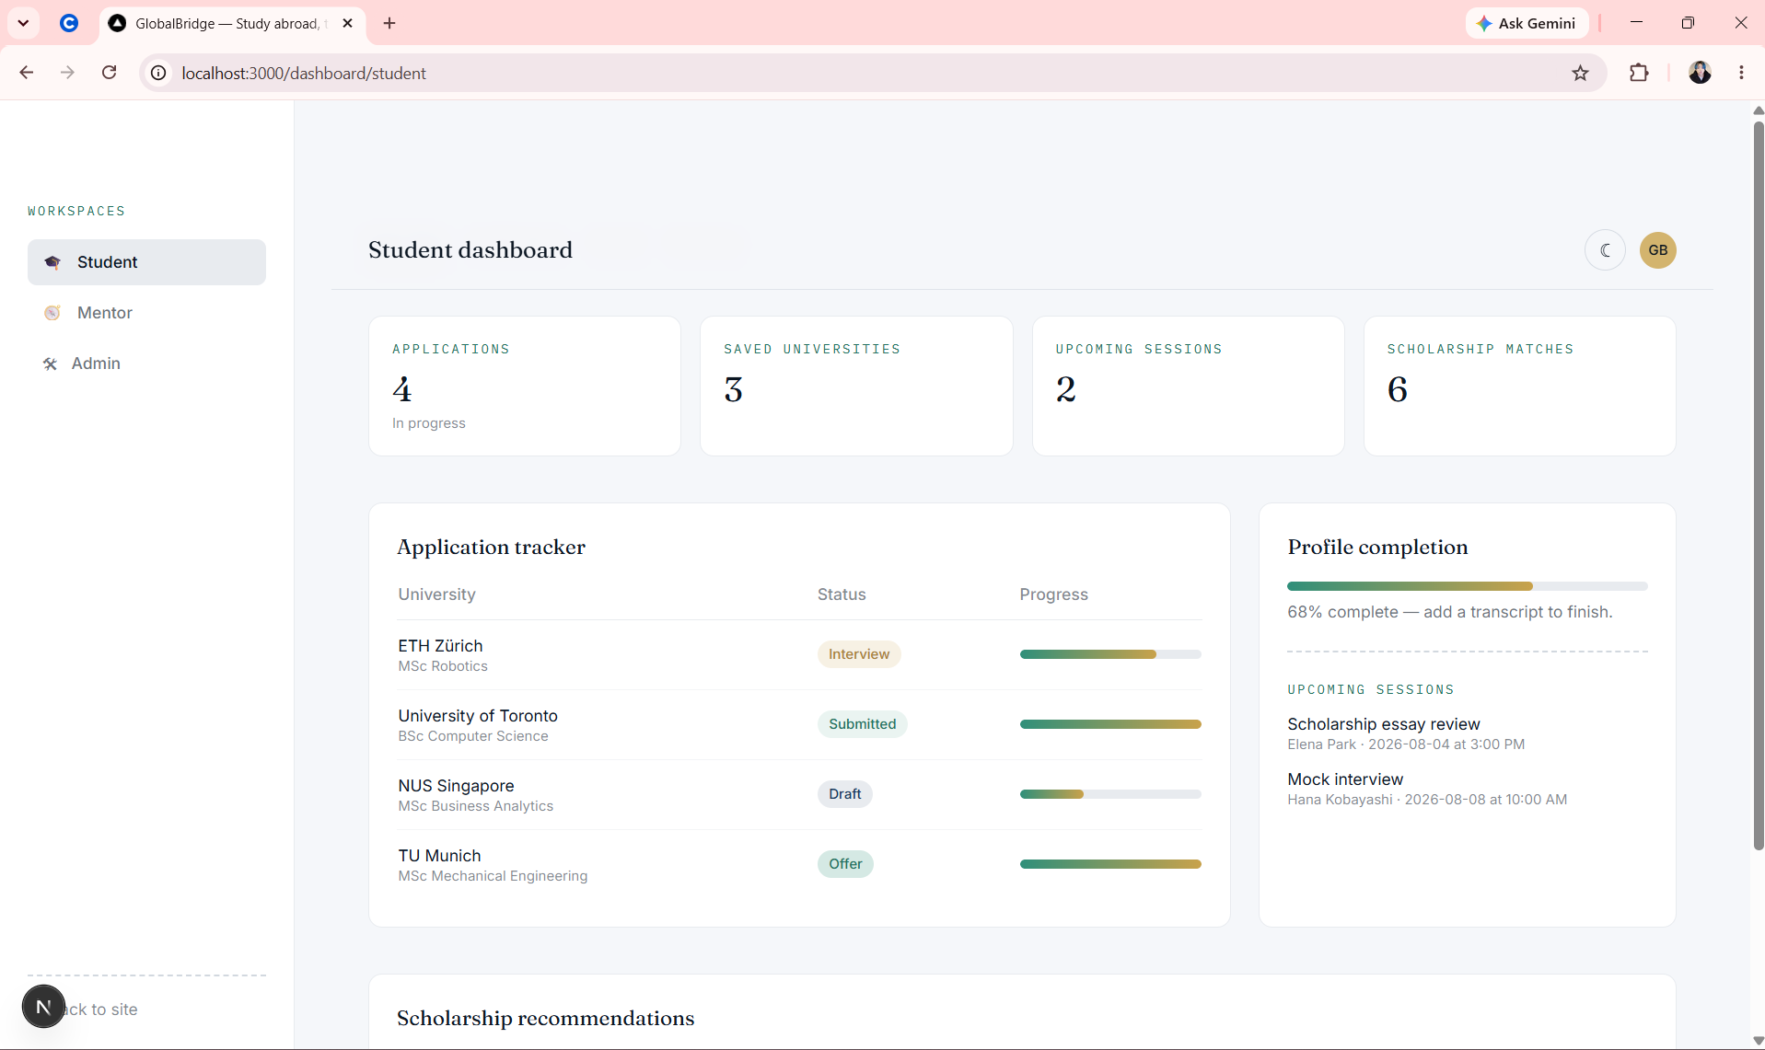

CONCLUSION

