EXPERIMENT NO. 3

AIM:
To construct layout compositions using Next.js root layouts and localized sub-layouts to safely maintain state during client-side transitions.

SOFTWARE REQUIRED:
- Operating System: Linux / macOS / Windows 10/11
- Node.js runtime environment: (v18.17.0 or higher)
- Package Manager: npm or pnpm
- Code Editor: Visual Studio Code

THEORY:
- Nested Layout Architecture (App Router): Next.js App Router organizes user interfaces through dynamic segment nesting. A layout.tsx file wraps child pages (children) and persists across route navigations within its directory scope. Unlike standard page components, layouts do not unmount during navigation between sibling routes in the same subtree.
- Partial Rendering & State Preservation: During client-side routing via Next.js <Link> components, Next.js performs partial rendering. It evaluates and re-renders only the dynamic leaf segments (page.tsx) while keeping parent layouts mounted in React's component tree. Consequently, local React state (useState, useRef), active timers (useEffect), and media playback initialized within a localized sub-layout remain entirely uninterrupted across route transitions.
- Layouts (layout.tsx) vs. Templates (template.tsx): While layouts preserve state and maintain their existing DOM nodes during navigation, templates create a new component instance on every navigation pass. Replacing a layout.tsx with a template.tsx forces React to reset internal hook states and re-mount DOM elements on each route change.

STEPS / ALGORITHM:

Step 1: Create the Root Layout (app/layout.tsx)
Define the global document structure and top-level navigation container.

import Link from 'next/link';

export default function RootLayout({

children,

}: {

children: React.ReactNode;

}) {

return (

<html lang="en">

<body style={{ fontFamily: 'system-ui, sans-serif', padding: '20px', background: '#0a0a0a', color: '#ededed' }}>

<nav style={{ marginBottom: '20px', display: 'flex', gap: '15px' }}>

<Link href="/" style={{ color: '#61dafb' }}>Home Root</Link>

<Link href="/blog" style={{ color: '#61dafb' }}>Blog Sub-Tree</Link>

</nav>

{children}

</body>

</html>

);

}

Step 2: Define the Root Landing Page (app/page.tsx)
Build a standard landing page component at the root route /.
export default function HomePage() {
return (
<div>
<h1>Root Landing Page</h1>
<p>Navigate to the Blog Sub-Tree to test localized sub-layout state preservation.</p>
</div>
);
}

Step 3: Implement Localized Sub-Layout with State (app/blog/layout.tsx)
Construct a client-rendered sub-layout ('use client') maintaining persistent uptime and counter state across nested /blog sub-routes.
'use client';

import { useState, useEffect } from 'react';
import Link from 'next/link';

export default function BlogLayout({
children,
}: {
children: React.ReactNode;
}) {
const [counter, setCounter] = useState<number>(0);
const [seconds, setSeconds] = useState<number>(0);

// Active interval timer to prove layout persistence during navigation
useEffect(() => {
const timer = setInterval(() => {
setSeconds((prev) => prev + 1);
}, 1000);

return () => clearInterval(timer);
}, []);

return (
<div style={{ border: '2px solid #2563eb', padding: '20px', borderRadius: '8px', background: '#121212', color: '#fff' }}>
<div style={{ paddingBottom: '15px', marginBottom: '15px', borderBottom: '1px solid #333' }}>
<h2 style={{ color: '#60a5fa', margin: '0 0 10px 0' }}>Localized Blog Sub-Layout</h2>

<div style={{ display: 'flex', gap: '20px', margin: '10px 0' }}>
<p>Uptime Timer: <strong style={{ color: '#22c55e' }}>{seconds}s</strong></p>
<p>State Counter: <strong style={{ color: '#f59e0b' }}>{counter}</strong></p>
</div>

<button
onClick={() => setCounter((prev) => prev + 1)}
style={{ padding: '8px 16px', background: '#2563eb', color: '#fff', border: 'none', borderRadius: '4px', cursor: 'pointer' }}
>
Increment State Counter
</button>

<nav style={{ marginTop: '15px', display: 'flex', gap: '15px' }}>
<Link href="/blog" style={{ color: '#93c5fd' }}>Blog Index</Link>
<Link href="/blog/post-1" style={{ color: '#93c5fd' }}>Post 1</Link>
<Link href="/blog/post-2" style={{ color: '#93c5fd' }}>Post 2</Link>
</nav>
</div>

<main>{children}</main>
</div>
);
}

Step 4: Build Blog Index View (app/blog/page.tsx)
Create the entry point page for the /blog route.
export default function BlogIndexPage() {
return (
<div>
<h3>Blog Overview Page</h3>
<p>Increment the counter or watch the uptime timer above, then click between Post 1 and Post 2.</p>
</div>
);
}

Step 5: Implement Dynamic Sub-Page View (app/blog/[slug]/page.tsx)
Implement an asynchronous Server Component to handle dynamic post routes (/blog/post-1, /blog/post-2).
export default async function BlogPostPage({
params,
}: {
params: Promise<{ slug: string }>;
}) {
const { slug } = await params;

return (
<div>
<h3>Post Page: <span style={{ color: '#f59e0b' }}>{slug}</span></h3>
<p>The page content rendered dynamically, while the outer timer and counter in the sub-layout remained unchanged.</p>
</div>
);
}

Step 6: Run and Validate Layout State Retention
Execute the development server:
npm run dev

- Navigate to http://localhost:3000/blog.
- Click "Increment State Counter" to modify the internal state.
- Switch between Post 1, Post 2, and Blog Index using client links. Observe that the timer continues incrementing and the counter holds its value without resetting.

OBSERVATION:
Observe how navigating between dynamic routes updates the inner viewport without triggering an unmount cycle on BlogLayout. The Uptime Timer interval continues ticking continuously, and the State Counter value is strictly preserved.
Note that navigating back to the root route (/) unmounts the localized sub-layout segment. Re-entering /blog instantiates a new sub-layout component instance, resetting the state variables back to their initial values (0).

OUTPUT:

Development Terminal Execution:
▲ Next.js 16.x
- Local: http://localhost:3000
- Environments: .env

✓ Starting...
✓ Ready in 980ms
○ Compiling /blog/[slug] ...
✓ Compiled /blog/[slug] in 240ms
GET /blog/post-1 200 in 45ms
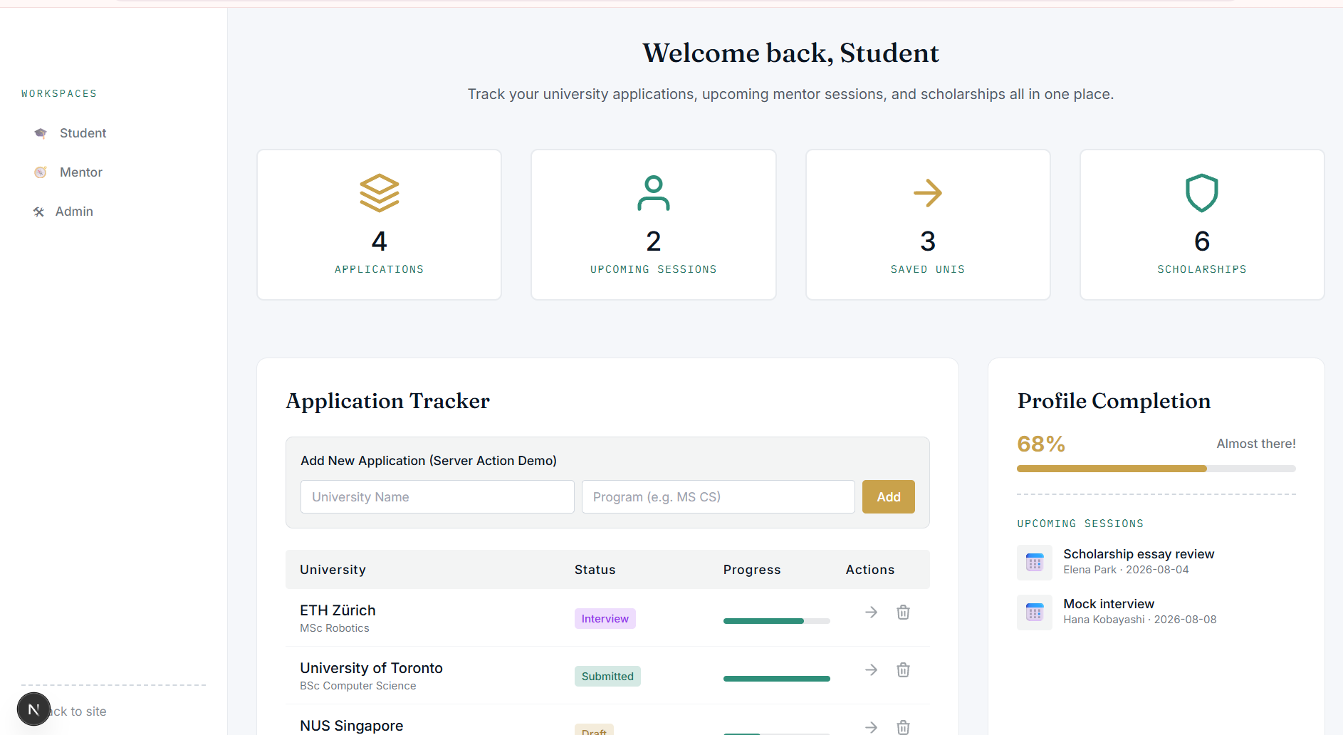
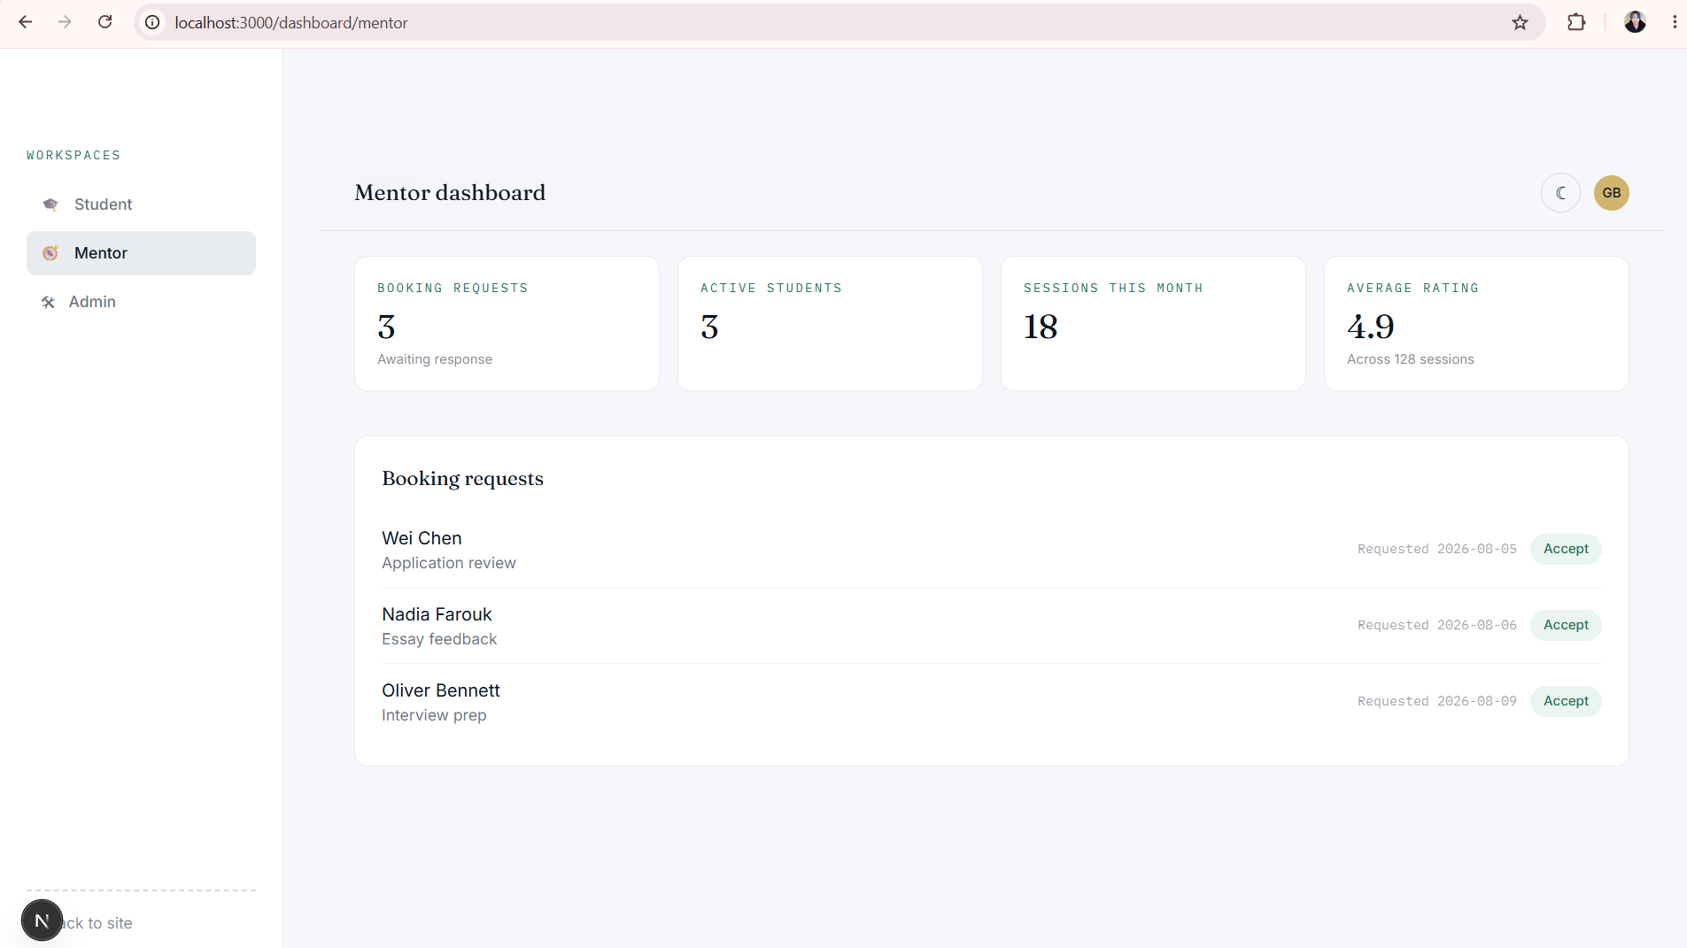
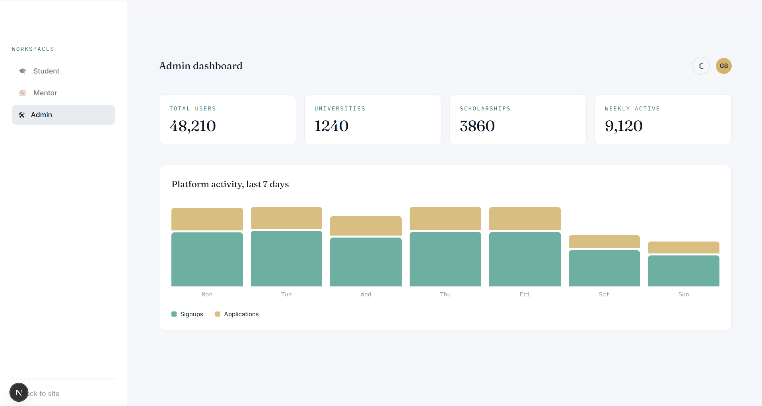

Rendered Viewport Verification:
- Sibling Sub-Route Navigation : Layout remains mounted. Uptime timer ticks continuously (12s, 13s, 14s...), and counter remains unchanged (5). Only the dynamic dynamic page slug header updates.
- Root Scope Navigation: The subtree unmounts completely. Navigating back to /blog resets Uptime Timer and State Counter to 0.

CONCLUSION:
Layout compositions using Next.js root layouts and localized client sub-layouts were successfully constructed. The experiment verified client-side partial rendering, tree reconciliation, state retention across nested sub-routes, and state reset behavior when leaving localized layout segment boundaries.

POST LAB QUESTION:
Q: What is the primary functional difference between layout.tsx and template.tsx during client-side route transitions in Next.js?
A: The primary difference lies in component persistence and state lifecycle during client-side navigation:
- layout.tsx wraps route segments and persists across navigations between sibling routes. React preserves the underlying DOM node and maintains all client-side React state (useState, useEffect, media stream instances) intact.
- template.tsx creates a new component instance on every route change. Next.js unmounts the previous template instance and mounts a fresh one, causing all React states to reset, useEffect hooks to re-run, and DOM nodes to be recreated every time the user navigates.

