EXPERIMENT NO. 6

AIM:
To write operational schemas for an e-commerce catalog tracking system connecting Next.js with MongoDB through a Mongoose modeling structure.

SOFTWARE REQUIRED:
- Operating System: Linux / macOS / Windows 10/11
- Database Engine: MongoDB (Local instance, Docker Container, or MongoDB Atlas)
- Node.js runtime environment: (v18.17.0 or higher)
- Package Manager: npm or pnpm
- Code Editor: Visual Studio Code

THEORY:
- Document-Oriented Data Modeling with MongoDB: MongoDB stores data as flexible, JSON-like BSON (Binary JSON) documents. Unlike rigid relational database management systems (RDBMS), MongoDB allows semi-structured schemas, polymorphic documents, and nested sub-documents, which are ideal for dynamic e-commerce product catalogs where attributes vary across categories.
- Schema Abstraction with Mongoose: Mongoose provides an Object Data Modeling (ODM) layer on top of the MongoDB native driver. It enforces strict application-level schema definitions, automatic type casting, field validation rules, default values, pre/post middleware lifecycle hooks, and virtual population across collections using Schema.Types.ObjectId.
- Database Connection Caching in Next.js Serverless Environment: Next.js Server Components and Server Actions execute in a stateless, ephemeral serverless/HMR environment. Calling mongoose.connect() inside standard route handlers or Server Actions without a connection caching mechanism creates a brand-new connection on every hot-reload or request, quickly exhausting the MongoDB connection pool. Caching the active connection promise on Node.js globalThis guarantees that server functions reuse existing connection handles across hot-module reloads.
- Embedded Documents vs. Document Referencing:
  - Embedded (Denormalized) Sub-documents: Used for attributes that are always retrieved together with the product, such as metadata, technical specifications, and inventory tracking dimensions.
  - Referenced (Normalized) Documents: Used for independent domain entities like Category or Vendor, mapped via ref pointers and populated using Mongoose .populate().

STEPS / ALGORITHM:

Step 1: Install Mongoose Dependencies
Install Mongoose in your Next.js project:
npm install mongoose

Configure your MongoDB connection string in .env:
MONGODB_URI="mongodb://localhost:27017/nextjs_ecommerce_catalog"

Step 2: Establish MongoDB Global Connection Cache (app/lib/mongodb.ts)
Create a persistent connection utility that caches the MongoDB connection promise globally to prevent connection leaks during Next.js hot-reloads.
import mongoose from 'mongoose';

const MONGODB_URI = process.env.MONGODB_URI;

if (!MONGODB_URI) {
throw new Error('Please define the MONGODB_URI environment variable inside .env');
}

interface MongooseCache {
conn: typeof mongoose | null;
promise: Promise<typeof mongoose> | null;
}

declare global {
var mongooseCache: MongooseCache | undefined;
}

let cached = global.mongooseCache;

if (!cached) {
cached = global.mongooseCache = { conn: null, promise: null };
}

export async function connectToDatabase(): Promise<typeof mongoose> {
if (cached!.conn) {
return cached!.conn;
}

if (!cached!.promise) {
const opts = {
bufferCommands: false,
};

cached!.promise = mongoose.connect(MONGODB_URI as string, opts).then((mongooseInstance) => {
return mongooseInstance;
});
}

try {
cached!.conn = await cached!.promise;
} catch (e) {
cached!.promise = null;
throw e;
}

return cached!.conn;
}

Step 3: Define Operational Mongoose Schemas (app/models/Product.ts)
Construct an e-commerce catalog schema incorporating embedded specification structures, enumeration constraints, validation rules, and inventory tracking.
import mongoose, { Schema, Document, Model } from 'mongoose';

// Interface for embedded inventory sub-document
export interface IInventory {
sku: string;
stock: number;
warehouseLocation: string;
}

// Interface for the Product Document
export interface IProduct extends Document {
title: string;
slug: string;
price: number;
category: string;
tags: string[];
inventory: IInventory;
inStock: boolean;
createdAt: Date;
updatedAt: Date;
}

// Embedded Inventory Schema
const InventorySchema = new Schema<IInventory>(
{
sku: {
type: String,
required: [true, 'SKU identifier is mandatory'],
uppercase: true,
trim: true,
},
stock: {
type: Number,
required: [true, 'Stock count is required'],
min: [0, 'Stock cannot be negative'],
default: 0,
},
warehouseLocation: {
type: String,
required: [true, 'Warehouse location must be specified'],
trim: true,
},
},
{ _id: false }
);

// Main Product Catalog Schema
const ProductSchema = new Schema<IProduct>(
{
title: {
type: String,
required: [true, 'Product title is required'],
trim: true,
maxlength: [100, 'Title cannot exceed 100 characters'],
},
slug: {
type: String,
required: [true, 'Product slug is required'],
unique: true,
lowercase: true,
trim: true,
},
price: {
type: Number,
required: [true, 'Price must be specified'],
min: [0, 'Price cannot be negative'],
},
category: {
type: String,
required: [true, 'Category is required'],
enum: ['Electronics', 'Footwear', 'Apparel', 'Accessories', 'Home'],
},
tags: {
type: [String],
default: [],
},
inventory: {
type: InventorySchema,
required: true,
},
inStock: {
type: Boolean,
default: true,
},
},
{
timestamps: true,
}
);

// Pre-save hook: Automatically evaluate stock status based on inventory levels
ProductSchema.pre<IProduct>('save', function (next) {
this.inStock = this.inventory.stock > 0;
next();
});

// Prevent model recompilation errors in Next.js development HMR
const Product: Model<IProduct> =
mongoose.models.Product || mongoose.model<IProduct>('Product', ProductSchema);

export default Product;
Step 4: Implement Catalog Server Actions (app/actions/catalogActions.ts)
Define Server Actions to handle catalog insertions and stock mutations using Mongoose validation logic.
'use server';

import { revalidatePath } from 'next/cache';
import { connectToDatabase } from '@/app/lib/mongodb';
import Product from '@/app/models/Product';

// Server Action: Add New Catalog Product
export async function createProductAction(formData: FormData) {
await connectToDatabase();

const title = formData.get('title') as string;
const price = parseFloat(formData.get('price') as string);
const category = formData.get('category') as string;
const sku = formData.get('sku') as string;
const stock = parseInt(formData.get('stock') as string, 10);
const warehouseLocation = formData.get('warehouseLocation') as string;
const tagsRaw = formData.get('tags') as string;

const tags = tagsRaw
? tagsRaw.split(',').map((tag) => tag.trim()).filter(Boolean)
: [];
const slug = title.toLowerCase().replace(/[^a-z0-9]+/g, '-').replace(/(^-|-$)+/g, '');

await Product.create({
title,
slug: `${slug}-${Date.now().toString().slice(-4)}`,
price,
category,
tags,
inventory: {
sku,
stock,
warehouseLocation,
},
});

revalidatePath('/catalog');
}

// Server Action: Delete Product
export async function deleteProductAction(productId: string) {
await connectToDatabase();
await Product.findByIdAndDelete(productId);
revalidatePath('/catalog');
}
Step 5: Construct Catalog Dashboard UI View (app/catalog/page.tsx)
Create an asynchronous Server Component that connects to MongoDB, reads catalog documents, and displays operational inventory statuses.

import { connectToDatabase } from '@/app/lib/mongodb';
import Product from '@/app/models/Product';
import { createProductAction, deleteProductAction } from '@/app/actions/catalogActions';

export default async function CatalogPage() {
await connectToDatabase();

// Fetch all products sorted by creation time
const products = await Product.find({}).sort({ createdAt: -1 }).lean();

return (
<div className="min-h-screen bg-slate-100 text-slate-900 p-6 sm:p-10 font-sans">
<div className="max-w-4xl mx-auto space-y-8">

{/* Page Header */}
<header className="border-b border-slate-200 pb-5">
<div className="flex items-center gap-2 mb-2">
<span className="px-2.5 py-0.5 rounded-full text-xs font-semibold bg-emerald-100 text-emerald-800">
Experiment 6
</span>
<span className="text-xs text-slate-500 font-mono">
Next.js 16 + MongoDB & Mongoose
</span>
</div>
<h1 className="text-2xl sm:text-3xl font-bold tracking-tight text-slate-900">
E-Commerce Catalog & Inventory Tracking
</h1>
<p className="mt-1 text-sm text-slate-600">
Managing document-oriented catalog models with embedded schemas and lifecycle middleware.
</p>
</header>

{/* Catalog Entry Form */}
<section className="bg-white rounded-xl border border-slate-200 shadow-sm p-6 sm:p-8">
<h2 className="text-lg font-semibold text-slate-900 mb-1">
Register Catalog Item
</h2>
<p className="text-xs text-slate-500 mb-6">
Inserts a strictly validated BSON document with an embedded inventory schema.
</p>

<form action={createProductAction} className="space-y-4">
<div className="grid grid-cols-1 sm:grid-cols-3 gap-4">
<div className="sm:col-span-2">
<label className="block text-xs font-semibold text-slate-700 uppercase tracking-wider mb-1">
Product Title
</label>
<input
type="text"
name="title"
placeholder="e.g. Wireless Noise-Cancelling Headphones"
required
className="w-full rounded-lg border border-slate-300 bg-white px-3 py-2 text-sm text-slate-900 focus:outline-none focus:ring-2 focus:ring-emerald-500"
/>
</div>

<div>
<label className="block text-xs font-semibold text-slate-700 uppercase tracking-wider mb-1">
Category
</label>
<select
name="category"
required
className="w-full rounded-lg border border-slate-300 bg-white px-3 py-2 text-sm text-slate-900 focus:outline-none focus:ring-2 focus:ring-emerald-500"
>
<option value="Electronics">Electronics</option>
<option value="Footwear">Footwear</option>
<option value="Apparel">Apparel</option>
<option value="Accessories">Accessories</option>
<option value="Home">Home</option>
</select>
</div>
</div>

<div className="grid grid-cols-1 sm:grid-cols-3 gap-4">
<div>
<label className="block text-xs font-semibold text-slate-700 uppercase tracking-wider mb-1">
Price ($)
</label>
<input
type="number"
step="0.01"
name="price"
placeholder="199.99"
required
className="w-full rounded-lg border border-slate-300 bg-white px-3 py-2 text-sm text-slate-900 focus:outline-none focus:ring-2 focus:ring-emerald-500"
/>
</div>

<div>
<label className="block text-xs font-semibold text-slate-700 uppercase tracking-wider mb-1">
SKU Identifier
</label>
<input
type="text"
name="sku"
placeholder="ELEC-WNC-01"
required
className="w-full rounded-lg border border-slate-300 bg-white px-3 py-2 text-sm text-slate-900 focus:outline-none focus:ring-2 focus:ring-emerald-500"
/>
</div>

<div>
<label className="block text-xs font-semibold text-slate-700 uppercase tracking-wider mb-1">
Initial Stock
</label>
<input
type="number"
name="stock"
placeholder="25"
required
className="w-full rounded-lg border border-slate-300 bg-white px-3 py-2 text-sm text-slate-900 focus:outline-none focus:ring-2 focus:ring-emerald-500"
/>
</div>
</div>

<div className="grid grid-cols-1 sm:grid-cols-2 gap-4">
<div>
<label className="block text-xs font-semibold text-slate-700 uppercase tracking-wider mb-1">
Warehouse Location
</label>
<input
type="text"
name="warehouseLocation"
placeholder="e.g. WH-East-A3"
required
className="w-full rounded-lg border border-slate-300 bg-white px-3 py-2 text-sm text-slate-900 focus:outline-none focus:ring-2 focus:ring-emerald-500"
/>
</div>

<div>
<label className="block text-xs font-semibold text-slate-700 uppercase tracking-wider mb-1">
Tags (Comma Separated)
</label>
<input
type="text"
name="tags"
placeholder="audio, bluetooth, wireless"
className="w-full rounded-lg border border-slate-300 bg-white px-3 py-2 text-sm text-slate-900 focus:outline-none focus:ring-2 focus:ring-emerald-500"
/>
</div>
</div>

<button
type="submit"
className="px-6 py-2.5 bg-emerald-600 hover:bg-emerald-700 text-white text-sm font-semibold rounded-lg shadow transition duration-150 cursor-pointer"
>
Add Catalog Item
</button>
</form>
</section>

{/* Product Catalog Records Feed */}
<section className="space-y-4">
<div className="flex justify-between items-center">
<h2 className="text-lg font-semibold text-slate-900">
Tracked Products ({products.length})
</h2>
<span className="text-xs text-slate-500">Mongoose Collection: <code>products</code></span>
</div>

{products.length === 0 ? (
<div className="bg-white border border-dashed border-slate-300 rounded-xl p-8 text-center text-slate-500 text-sm">
No products found in MongoDB. Register an item using the form above.
</div>
) : (
<div className="grid grid-cols-1 md:grid-cols-2 gap-4">
{products.map((p: any) => (
<div
key={p._id.toString()}
className="bg-white border border-slate-200 rounded-xl p-5 shadow-sm flex flex-col justify-between gap-4 hover:border-slate-300 transition"
>
<div className="space-y-2">
<div className="flex justify-between items-start gap-2">
<h3 className="text-base font-semibold text-slate-900 leading-tight">
{p.title}
</h3>
<span className="px-2 py-0.5 rounded text-xs font-bold bg-slate-100 text-slate-800">
${p.price.toFixed(2)}
</span>
</div>

<p className="text-xs font-mono text-slate-500">
Slug: {p.slug}
</p>

<div className="flex flex-wrap gap-1.5 pt-1">
<span className="px-2 py-0.5 rounded text-xs font-medium bg-blue-50 text-blue-700 border border-blue-100">
{p.category}
</span>
{p.inStock ? (
<span className="px-2 py-0.5 rounded text-xs font-medium bg-emerald-50 text-emerald-700 border border-emerald-100">
In Stock ({p.inventory.stock})
</span>
) : (
<span className="px-2 py-0.5 rounded text-xs font-medium bg-rose-50 text-rose-700 border border-rose-100">
Out of Stock
</span>
)}
<span className="px-2 py-0.5 rounded text-xs font-mono bg-slate-100 text-slate-600">
SKU: {p.inventory.sku}
</span>
<span className="px-2 py-0.5 rounded text-xs bg-slate-100 text-slate-600">
Loc: {p.inventory.warehouseLocation}
</span>
</div>
</div>

<div className="pt-2 border-t border-slate-100 flex justify-between items-center">
<div className="flex gap-1">
{p.tags.map((t: string, idx: number) => (
<span key={idx} className="text-[11px] text-slate-400">
#{t}
</span>
))}
</div>

<form action={deleteProductAction.bind(null, p._id.toString())}>
<button
type="submit"
className="px-2.5 py-1 bg-red-50 hover:bg-red-100 text-red-600 text-xs font-semibold rounded border border-red-200 transition cursor-pointer"
>
Remove
</button>
</form>
</div>
</div>
))}
</div>
)}
</section>

</div>
</div>
);
}

Step 6: Validate Catalog Workflow
- Execute the Next.js development server:
npm run dev
- Navigate to http://localhost:3000/catalog in your browser.
- Submit a new catalog item. Inspect the rendered cards to verify that Mongoose computed the slug, validated the category enum, embedded the inventory sub-document, and ran the pre-save hook to evaluate inStock.

OBSERVATION:
Observe how Mongoose enforces document validation rules prior to writing to the MongoDB database. If a non-whitelisted category or negative price is supplied, Mongoose validation halts execution and returns a structured validation error.

Note how embedded schemas (InventorySchema) are stored inline within the parent product document, allowing inventory levels and location coordinates to be read in a single round-trip query without relational joins.

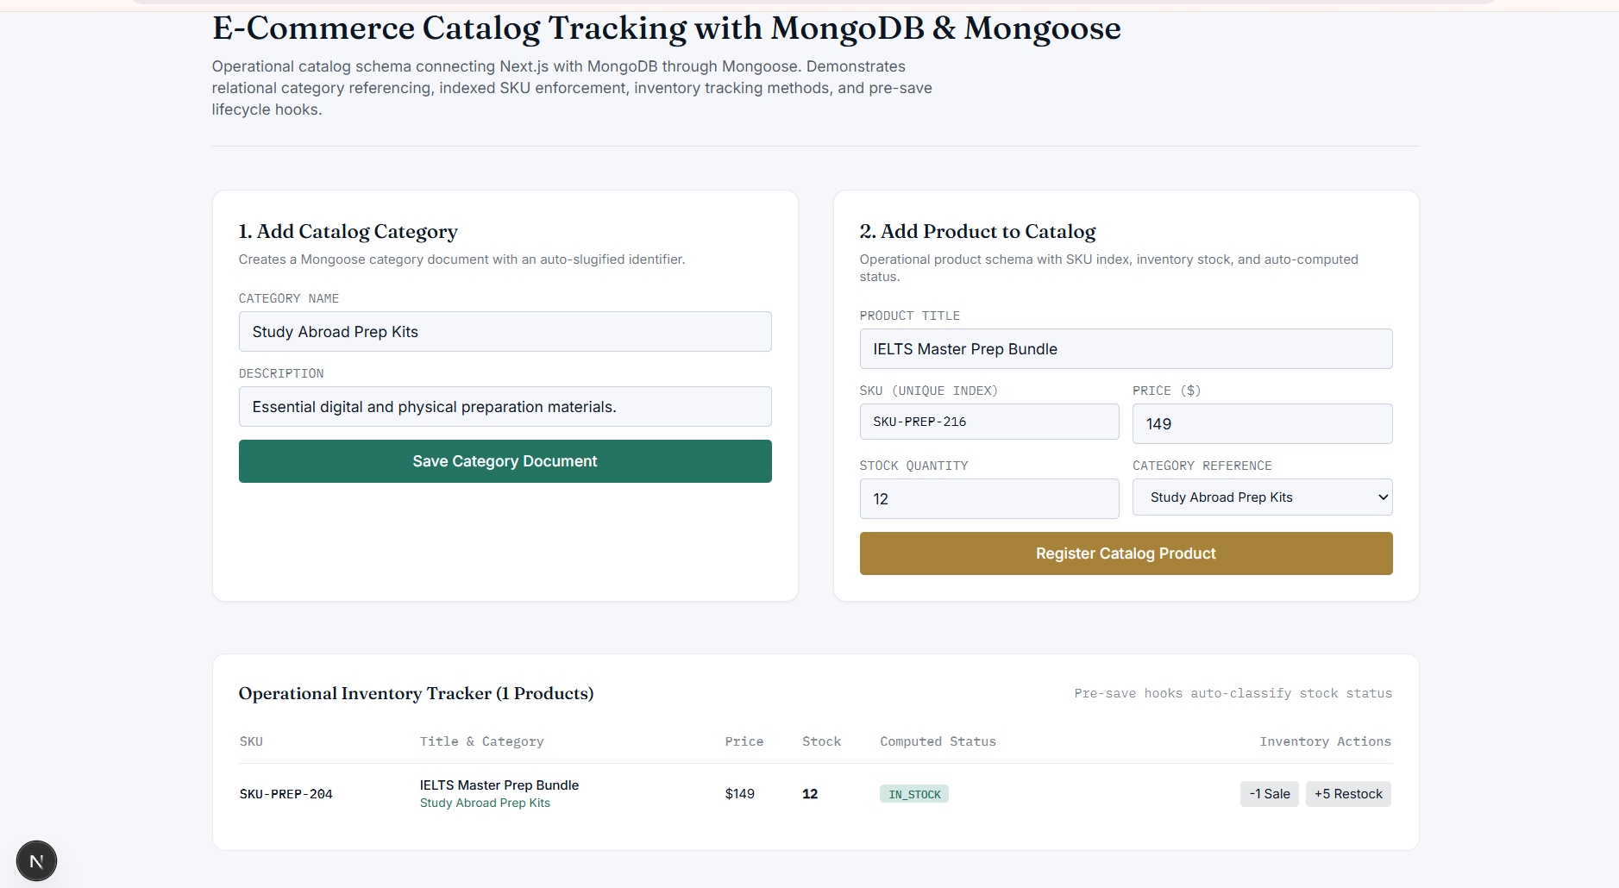
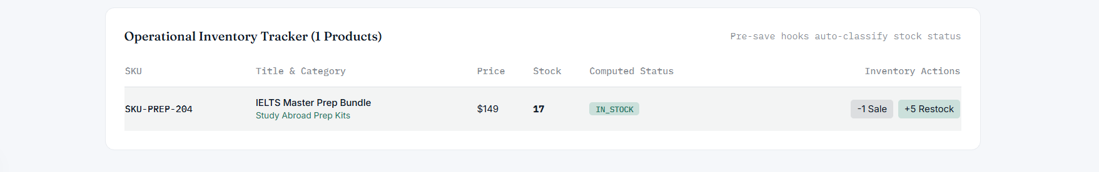

CONCLUSION:
Operational schemas for an e-commerce catalog tracking system were successfully constructed using Next.js and MongoDB via Mongoose. The experiment verified singleton database connection caching, embedded sub-document schema modeling, pre-save lifecycle hooks, and server-side data mutations using React Server Actions.

POST LAB QUESTION:
Q: Why is global connection caching (globalThis.mongooseCache) mandatory when connecting Mongoose with Next.js App Router applications, and how does it differ from traditional Express.js database connection lifecycles?

A:
In traditional Express.js architectures, the Node.js server process runs continuously as a long-lived stateful instance where mongoose.connect() is called once at application startup.

In Next.js App Router (especially during development with Hot Module Replacement and in serverless production runtimes), server-side modules are re-evaluated frequently. Without global connection caching, each file modification or server request invokes mongoose.connect(), creating multiple unmanaged database connection sockets.

Caching the connection promise on globalThis guarantees that across hot-reloads and concurrent server operations, Mongoose reuses the existing open connection pool instead of exhausting the database connection limits.

