EXPERIMENT NO. 9
NAME:
ROLL NO:
SAP ID:

AIM:
To containerize a production-grade Next.js application using multi-stage Docker builds with standalone output bundling, environment isolation, and Docker Compose orchestration for self-hosted infrastructure.

SOFTWARE REQUIRED:
- Operating System: Linux / macOS / Windows 10/11
- Container Engine: Docker Engine & Docker Compose (or Docker Desktop)
- Node.js runtime environment: (v18.17.0 or higher)
- Package Manager: npm or pnpm
- Code Editor: Visual Studio Code

THEORY:
- Production Containerization in Next.js: While platforms like Vercel provide managed serverless hosting, enterprise deployments and self-hosted environments (on premises, AWS ECS/EKS, DigitalOcean, or private VPS clusters) require containerized deployments. Docker encapsulates the application, system dependencies, runtime engines, and environment variables into an immutable, portable artifact.
- Multi-Stage Docker Builds: A standard Next.js application image can easily exceed 1.2 GB if node_modules, build tools, and cache files are copied directly. Multi-stage builds divide image generation into distinct isolated phases (base, deps, builder, runner). Intermediate build dependencies and source compilers are discarded, producing an ultra-lean runtime container image (typically under 120 MB).
- Standalone Output Mode (output: "standalone"): Next.js includes a native compilation mode that uses static code analysis to trace all imports, packages, and file dependencies needed by your application. Instead of requiring the entire node_modules directory in production, Next.js generates a self-contained server.js inside .next/standalone/ that bundles only the exact runtime dependencies required, drastically cutting down attack surfaces and deployment sizes.
- Principle of Least Privilege (Non-Root User Execution): Containers should never execute as root. If a containerized process running as root is compromised via an application vulnerability, the attacker may escape the container and compromise the host kernel. Multi-stage Dockerfiles establish a dedicated non-root user and group (nextjs:nodejs, UID/GID 1001) with explicit ownership boundaries.
- Layer Caching Optimization: Docker builds images layer-by-layer. By copying lock files (package.json, package-lock.json) and running npm ci before copying application source code, Docker reuses cached dependency layers across rebuilds when only source files change, cutting subsequent build times from minutes to seconds.

OBSERVATION:

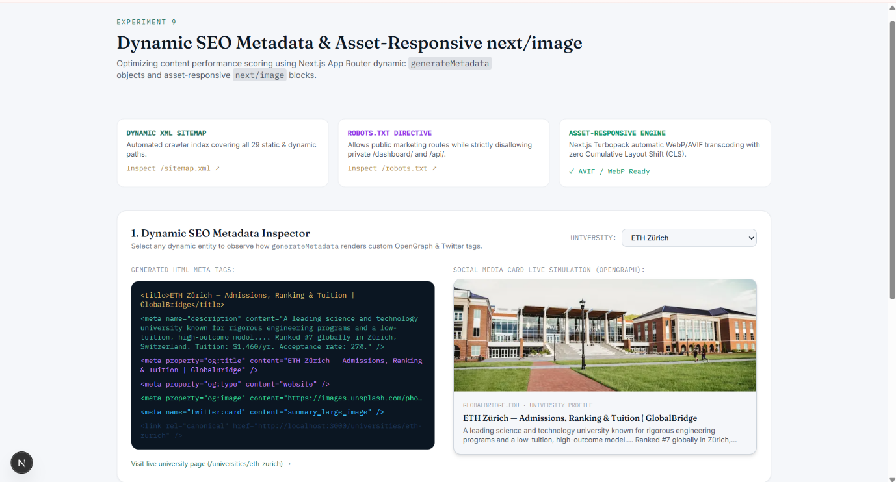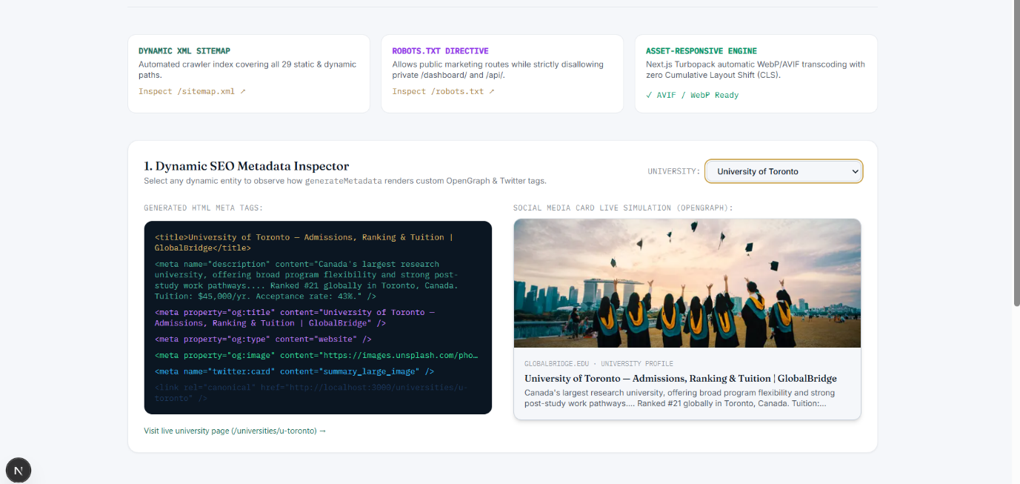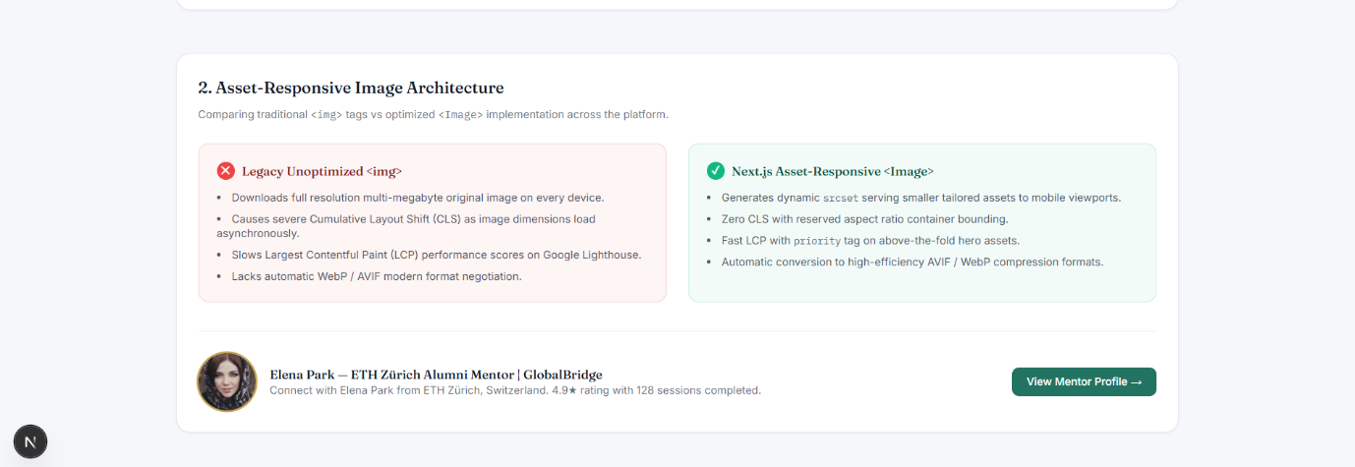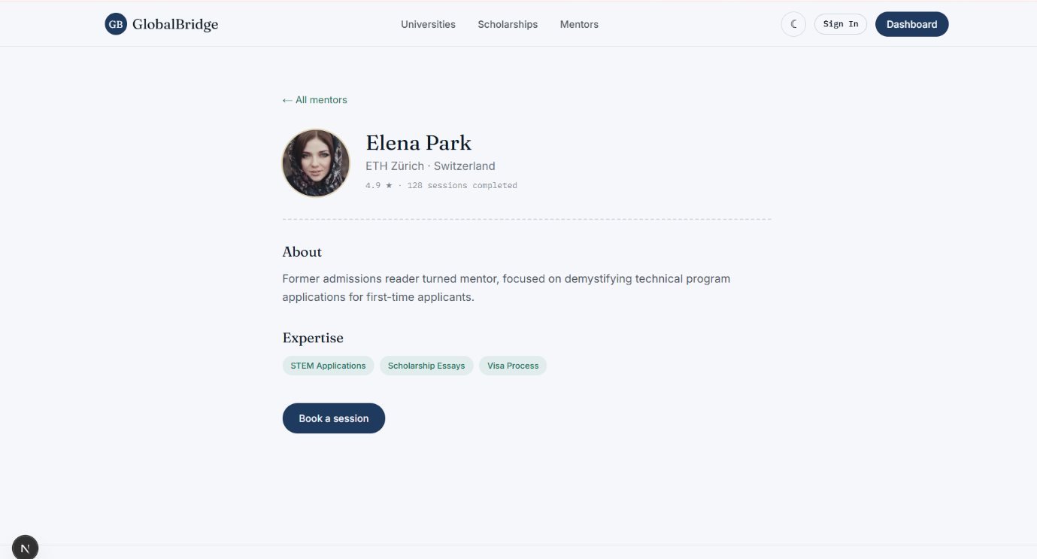

CONCLUSION:

