SCHOOL OF TECHNOLOGY | 

DATABASE MANAGEMENT SYSTEMS
PROJECT-BASED LEARNING (PBL) REPORT
Small Database Application Development using Java / Python

PROJECT TITLE
DESIGN AND IMPLEMENTATION OF A DATABASE MANAGEMENT SYSTEM FOR SALON AND SPA APPOINTMENT MANAGEMENT SYSTEM
(PROJECT 66)

Program | B.Tech – Computer Science and Engineering (AI & ML)
Section | AIML Rhinos
Faculty | Faculty name
Date of Submission | DD October 2026
Academic Year | 2026 – 27

Submitted by
Roll Number | Student Name | Mobile | Email ID
25WU0102069 | Devyani Pawar | Mobile | University email

ACKNOWLEDGEMENT
I express my sincere gratitude to Woxsen University, School of Technology, for providing me with the opportunity to undertake this Project-Based Learning (PBL) activity as part of the Database Management Systems (DBMS) course.
I thank my course faculty, [Faculty name], for the guidance, suggestions, and support throughout the design and development of this project. The guidance helped me understand the practical application of database concepts such as ER modelling, relational schema design, normalization, SQL, constraints, queries, and database application development.
This PBL activity has strengthened my understanding of DBMS concepts and provided valuable experience in applying them to a real-world problem.

UNDERTAKING
I hereby declare that the project entitled “Design and Implementation of a Database Management System for Salon and Spa Appointment Management System”, submitted as part of the Project-Based Learning activity for the Database Management Systems (DBMS) course, is my individual work carried out under the guidance of the course faculty.
I undertake that the project report, database design, SQL scripts, application source code, results, and supporting materials submitted by me have been prepared for academic purposes. Wherever information, ideas, tools, datasets, or other resources have been referred to, appropriate acknowledgement has been provided.
I further undertake that I am responsible for the correctness and authenticity of the work submitted and that I have followed the academic and project guidelines prescribed by the University.
 |  |  |  | Signature
Date | : |  | Name: | Devyani Pawar
Place | : | Hyderabad | Roll Number: | 25WU0102069
 |  |  | Program: | B.Tech CSE (AI & ML)

TABLE OF CONTENTS
Contents | Page No.
Abstract | 8
LIST OF TABLES | 5
LIST OF FIGURES | 6
LIST OF ACRONYMS | 7
1. PROBLEM STATEMENT, SOLUTION STRATEGY AND ER DIAGRAM | 9
1.1 Problem Statement | 9
1.2 Objectives | 9
1.3 Scope and Assumptions | 10
1.4 Proposed Solution Strategy | 10
1.5 Functional Requirements | 11
1.6 Entity-Relationship Diagram (ERD) | 11
1.7 Entity and Relationship Summary | 12
2. LOGICAL DATABASE DESIGN | 13
2.1 Relational Schema | 13
2.2 Keys and Integrity Constraints | 14
2.3 Functional Dependencies | 15
2.4 Normalization up to Third Normal Form (3NF) | 16
2.5 Data Dictionary | 17
2.6 Implementation of Logical Design: DDL and Sample Data | 20
3. APPLICATION DEVELOPMENT USING LOGICAL DATABASE DESIGN | 23
3.1 Application Overview | 23
3.2 Development Environment and Database Connectivity | 23
3.3 Application Modules and Database Mapping | 24
3.4 CRUD Operations | 24
3.5 Business Rules, Validation and Error Handling | 24
3.6 Reports and Database Operations | 25
3.7 Application Screens | 26
3.8 Testing and Results | 31
4. CONCLUSION | 33
4.1 Limitations and Future Enhancements | 33
5. REFERENCES | 34
6. APPENDICES | 35

LIST OF TABLES
Table No. | Table Title | Page No.
Table 1 | Scope and Assumptions | 10
Table 2 | Proposed Solution Strategy | 10
Table 3 | Functional Requirements | 11
Table 4 | Entity and Relationship Summary | 12
Table 5 | Relational Schema | 13
Table 6 | Keys and Integrity Constraints | 14
Table 7 | Normalization Status up to 3NF | 16
Table 8 | Data Dictionary | 17
Table 9 | Database Implementation Environment | 21
Table 10 | Sample Data Summary | 22
Table 11 | Representative Records from v_appointment_details | 22
Table 12 | Application Development Environment | 23
Table 13 | Application Module-to-Database Mapping | 24
Table 14 | CRUD Operations | 24
Table 15 | Business Rules, Validation and Error Handling | 25
Table 16 | Reports and Database Operations | 25
Table 17 | Test Cases | 31

LIST OF FIGURES
Figure No. | Figure Title | Page No.
Figure 1 | Entity-Relationship Diagram of the Proposed System | 12
Figure 2 | Relational Schema Diagram (foreign keys point to referenced primary keys) | 14
Figure 3 | Dashboard with daily schedule and key figures | 26
Figure 4 | Customer registration rejecting an invalid phone number and email | 26
Figure 5 | Booking screen offering only skilled, on-shift and free staff | 27
Figure 6 | Booking rejected by the database for a skill mismatch and rolled back | 27
Figure 7 | Manage Appointments – appointment marked completed | 28
Figure 8 | Reschedule rejected for an overlapping staff appointment | 28
Figure 9 | Package session redeemed at no charge during booking | 29
Figure 10 | Bill preview with Gold membership discount and GST | 29
Figure 11 | Payment above the outstanding balance rejected | 30
Figure 12 | Staff utilization report | 30
Figure 13 | Monthly revenue report – billed vs collected | 31
Figure 14 | Full-page Entity-Relationship Diagram | 36
Figure 15 | Package balances report | 37

LIST OF ACRONYMS
Acronym | Expansion
1NF / 2NF / 3NF | First / Second / Third Normal Form
BCNF | Boyce–Codd Normal Form
CRUD | Create, Read, Update, Delete
CSV | Comma-Separated Values
DBMS | Database Management System
DDL | Data Definition Language
DML | Data Manipulation Language
ER / ERD | Entity–Relationship / Entity–Relationship Diagram
FD | Functional Dependency
FK | Foreign Key
FR | Functional Requirement
GST | Goods and Services Tax
GUI | Graphical User Interface
INR | Indian Rupee
PBL | Project-Based Learning
PK | Primary Key
SQL | Structured Query Language
TC | Test Case
UPI | Unified Payments Interface

ABSTRACT
Salons and spas still commonly run their day on a paper appointment book, which cannot detect when a stylist is double-booked, when a service is given to someone without the right skill, how many prepaid package sessions a client has left, how much stock was consumed, or which bills are only partly paid. The objective of this project is to design and implement a relational database, with a small application on top of it, that manages the complete salon workflow from booking to payment while enforcing these rules automatically. The conceptual design identifies 14 entities and 16 relationships, which were mapped to 18 relations and normalized to Third Normal Form. The database was implemented in MySQL 8 with 85 declarative constraints, five triggers backed by a validation procedure, seven reporting views and seven secondary indexes, and populated with realistic data for 603 appointments. A Python application built with Streamlit provides customer registration, skilled-staff booking, package redemption, product issue, billing with membership discounts and GST, partial payments and six management reports. Testing showed that every invalid operation, including overlapping bookings, skill mismatches and over-payments, is rejected by the database itself, giving a dependable and practical system for small salons.

KEYWORDS
Keywords: Relational Database, ER Modelling, Normalization (3NF), MySQL Triggers, Python Streamlit, Salon Appointment Scheduling

CHAPTER 1

PROBLEM STATEMENT, SOLUTION STRATEGY AND ER DIAGRAM

1.1 Problem Statement
A typical neighbourhood salon and spa offers 20 or more services across hair, skin, nails, massage, makeup and grooming, performed by staff who each hold only some of the required skills and work different weekly shifts. Customers buy prepaid packages and annual memberships, products such as hair colour and facial kits are consumed during services, and bills are often settled in more than one payment. In most small salons all of this is still recorded in a paper appointment book, separate package cards and a cash register.
This manual process has clear failures. The book cannot see that a stylist is already busy, so two clients are booked into overlapping slots; it does not know who is trained for which service, so a barber can be booked for a facial; package sessions are over-used or disputed; product consumption is never linked to services; and partly paid bills are forgotten. The receptionist, the salon manager, the service staff and ultimately the customer are all affected. A database-driven application is needed that stores this information once, enforces the salon's business rules at the moment of entry and produces reliable reports on appointments, staff utilization, service popularity, package balances, product use and revenue.

1.2 Objectives
- Design a normalized (3NF) relational database that covers all twelve required areas: customers, services, categories, staff, skills, schedules, appointments, packages, memberships, product usage, bills and payments.
- Implement the five core business rules inside MySQL – no overlapping staff appointments, skill match, package-session limits, valid appointment times and payment limits – so that no client can bypass them.
- Populate the database with realistic sample data (40 customers, 10 staff, 600+ appointments) and write at least 20 SQL queries and 6 views for the required reports.
- Develop a Python application that performs registration, booking with skilled-staff assignment, package use, product issue, billing, payment and reporting on the live database.
- Validate the system with at least 15 positive and negative test cases and record a five-minute demonstration.

1.3 Scope and Assumptions
Table 1 defines what the system covers and the assumptions made about the salon.
Table 1. Scope and Assumptions
Item | Description
In Scope | Customer registration and search; service categories and services; staff, skills with proficiency and weekly schedules; multi-service appointments with staff assignment; rescheduling, cancellation, completion and no-show; packages and package redemption; memberships and discounts; product stock and product issue; bills with discount and GST; full and partial payments; six management reports.
Out of Scope / Exclusions | Online self-booking portal, SMS/WhatsApp reminders, payroll and commissions, supplier purchase orders, multi-branch operation, user login and role-based access control.
Assumptions | Single branch open 09:00–21:00 every day; prices in INR; GST at 18% on the discounted amount; one bill per visit; a customer can hold at most one active membership; package sessions are redeemable only by the buyer before expiry; time slots in 15-minute steps.

1.4 Proposed Solution Strategy
The solution follows the standard database design life-cycle – requirements, conceptual ER design, logical relational design, normalization and physical implementation [1]. Business rules that involve only one row are declared as CHECK, UNIQUE, NOT NULL and FOREIGN KEY constraints; rules that need other rows (overlaps, skills, package balances, payment totals) are enforced by BEFORE INSERT/UPDATE triggers, so the database itself rejects invalid data. A Python application then provides the screens used at the front desk. Table 2 summarises the strategy.
Table 2. Proposed Solution Strategy
Solution Element | Project-Specific Description
Primary Users / Roles | Receptionist (registration, booking, billing, payments); Salon manager (staff, skills, schedules, packages, stock, reports); Stylist / therapist (performs services, issues products); Customer (indirect user).
Major Application Modules | Dashboard, Customers, Book Appointment, Manage Appointments, Packages & Memberships, Products & Stock, Billing & Payments, Staff & Services, Reports.
Proposed Workflow | Register customer → book one or more services, choosing only skilled, on-shift and free staff (or redeem a package session) → complete the visit and issue products → generate the bill with membership discount and GST → record one or more payments → review reports.
Important Business Rules | No overlapping staff appointments; staff must hold the skill a service requires; slot = service duration and inside the staff shift and 09:00–21:00; package redemptions within sessions and validity, only by the owner; total payments ≤ bill total; bill only completed visits; stock never negative.
Expected Reports / Outputs | Daily appointment sheet and appointment statistics, staff utilization, service popularity and category revenue, package balances, product consumption with re-order alerts, monthly billed vs collected revenue and outstanding dues.

1.5 Functional Requirements
The twelve functional requirements in Table 3 were derived from the problem statement and the project brief.
Table 3. Functional Requirements
Req. ID | Functional Requirement | Remarks / Priority
FR-01 | Register, search, update and delete customers with input validation | High
FR-02 | Maintain service categories, services, durations and prices | High
FR-03 | Maintain staff, staff skills with proficiency, and weekly schedules | High
FR-04 | Book an appointment containing one or more services and time slots | High
FR-05 | Assign only staff who have the required skill, are on shift and are free | High
FR-06 | Reschedule, cancel, complete or mark an appointment as no-show | High
FR-07 | Sell packages and redeem sessions within limits and validity | High
FR-08 | Enrol customers in membership plans and apply plan discounts on bills | Medium
FR-09 | Issue products against performed services, update stock, flag re-order | Medium
FR-10 | Generate a bill (subtotal, discount, GST, total) for a completed visit | High
FR-11 | Record full or partial payments without exceeding the bill total | High
FR-12 | Produce reports: appointments, staff utilization, service popularity, package balances, product use and revenue | High

1.6 Entity-Relationship Diagram (ERD)
The conceptual model was drawn using Chen-style ER notation [2]. Figure 1 shows the 14 entities with their key attributes and the 16 relationships with cardinalities. Weak entities (STAFF_SCHEDULE, APPOINTMENT_SERVICE and PAYMENT) have a double border and total participation is shown by a double line. Many-to-many relationships carry their own attributes – for example HAS_SKILL carries proficiency_level and CONTAINS carries sessions_included. A full-page version is given in Appendix C.
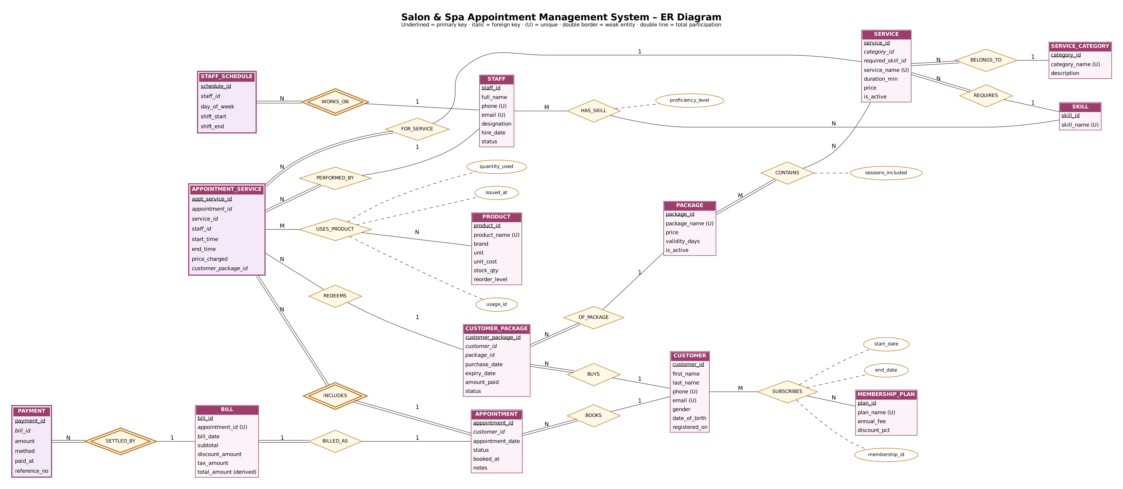
Figure 1. Entity-Relationship Diagram of the Proposed System

1.7 Entity and Relationship Summary
Table 4 summarises each relationship, its cardinality and the rule it represents.
Table 4. Entity and Relationship Summary
Entity / Relationship | Major Attributes / Cardinality | Purpose / Rule
BELONGS_TO (Service – Service_Category) | N : 1, total on Service | Every service belongs to exactly one category.
REQUIRES (Service – Skill) | N : 1, total on Service | Each service needs one skill; basis of the skill-match rule.
HAS_SKILL (Staff – Skill) | M : N; proficiency_level | A staff member may hold many skills, rated 1–5.
WORKS_ON (Staff – Staff_Schedule) | 1 : N, weak entity | Weekly shift per working day; validates appointment times.
BOOKS (Customer – Appointment) | 1 : N | A visit belongs to one customer on one date.
INCLUDES (Appointment – Appointment_Service) | 1 : N, weak entity | A visit contains one or more timed services.
FOR_SERVICE / PERFORMED_BY | N : 1 each | Each booked service line has one service and one staff member.
CONTAINS (Package – Service) | M : N; sessions_included | Defines what a prepaid package offers.
BUYS / OF_PACKAGE (Customer – Customer_Package – Package) | 1 : N, N : 1 | A customer's purchased package with validity.
REDEEMS (Appointment_Service – Customer_Package) | N : 1, optional | A service line may consume one package session.
SUBSCRIBES (Customer – Membership_Plan) | M : N; start_date, end_date | Membership gives a discount on bills.
USES_PRODUCT (Appointment_Service – Product) | M : N; quantity_used | Product consumed by a performed service.
BILLED_AS (Appointment – Bill) | 1 : 1 | One bill per completed visit.
SETTLED_BY (Bill – Payment) | 1 : N, weak entity | A bill may be paid in several parts.

CHAPTER 2

LOGICAL DATABASE DESIGN

2.1 Relational Schema
The ER model was mapped to relations using the standard rules of the relational model [3]: each strong entity became a table with a surrogate primary key, weak entities received the owner's key as a foreign key, 1:N relationships became foreign keys on the N side, and every M:N relationship became its own table (staff_skill, package_item, customer_membership, product_usage). Table 5 lists the 18 relations and Figure 2 shows how they are linked.
Table 5. Relational Schema
S.No. | Table Name | Attributes (PK / FK)
1 | service_category | category_id (PK), category_name, description
2 | skill | skill_id (PK), skill_name
3 | service | service_id (PK), category_id (FK), required_skill_id (FK), service_name, duration_min, price, is_active
4 | customer | customer_id (PK), first_name, last_name, phone, email, gender, date_of_birth, registered_on
5 | staff | staff_id (PK), full_name, phone, email, designation, hire_date, status
6 | staff_skill | staff_id (PK, FK), skill_id (PK, FK), proficiency_level
7 | staff_schedule | schedule_id (PK), staff_id (FK), day_of_week, shift_start, shift_end
8 | membership_plan | plan_id (PK), plan_name, annual_fee, discount_pct
9 | customer_membership | membership_id (PK), customer_id (FK), plan_id (FK), start_date, end_date
10 | package | package_id (PK), package_name, price, validity_days, is_active
11 | package_item | package_id (PK, FK), service_id (PK, FK), sessions_included
12 | customer_package | customer_package_id (PK), customer_id (FK), package_id (FK), purchase_date, expiry_date, amount_paid, status
13 | appointment | appointment_id (PK), customer_id (FK), appointment_date, status, booked_at, notes
14 | appointment_service | appt_service_id (PK), appointment_id (FK), service_id (FK), staff_id (FK), start_time, end_time, price_charged, customer_package_id (FK)
15 | product | product_id (PK), product_name, brand, unit, unit_cost, stock_qty, reorder_level
16 | product_usage | usage_id (PK), appt_service_id (FK), product_id (FK), quantity_used, issued_at
17 | bill | bill_id (PK), appointment_id (FK, UNIQUE), bill_date, subtotal, discount_amount, tax_amount, total_amount (generated)
18 | payment | payment_id (PK), bill_id (FK), amount, method, paid_at, reference_no

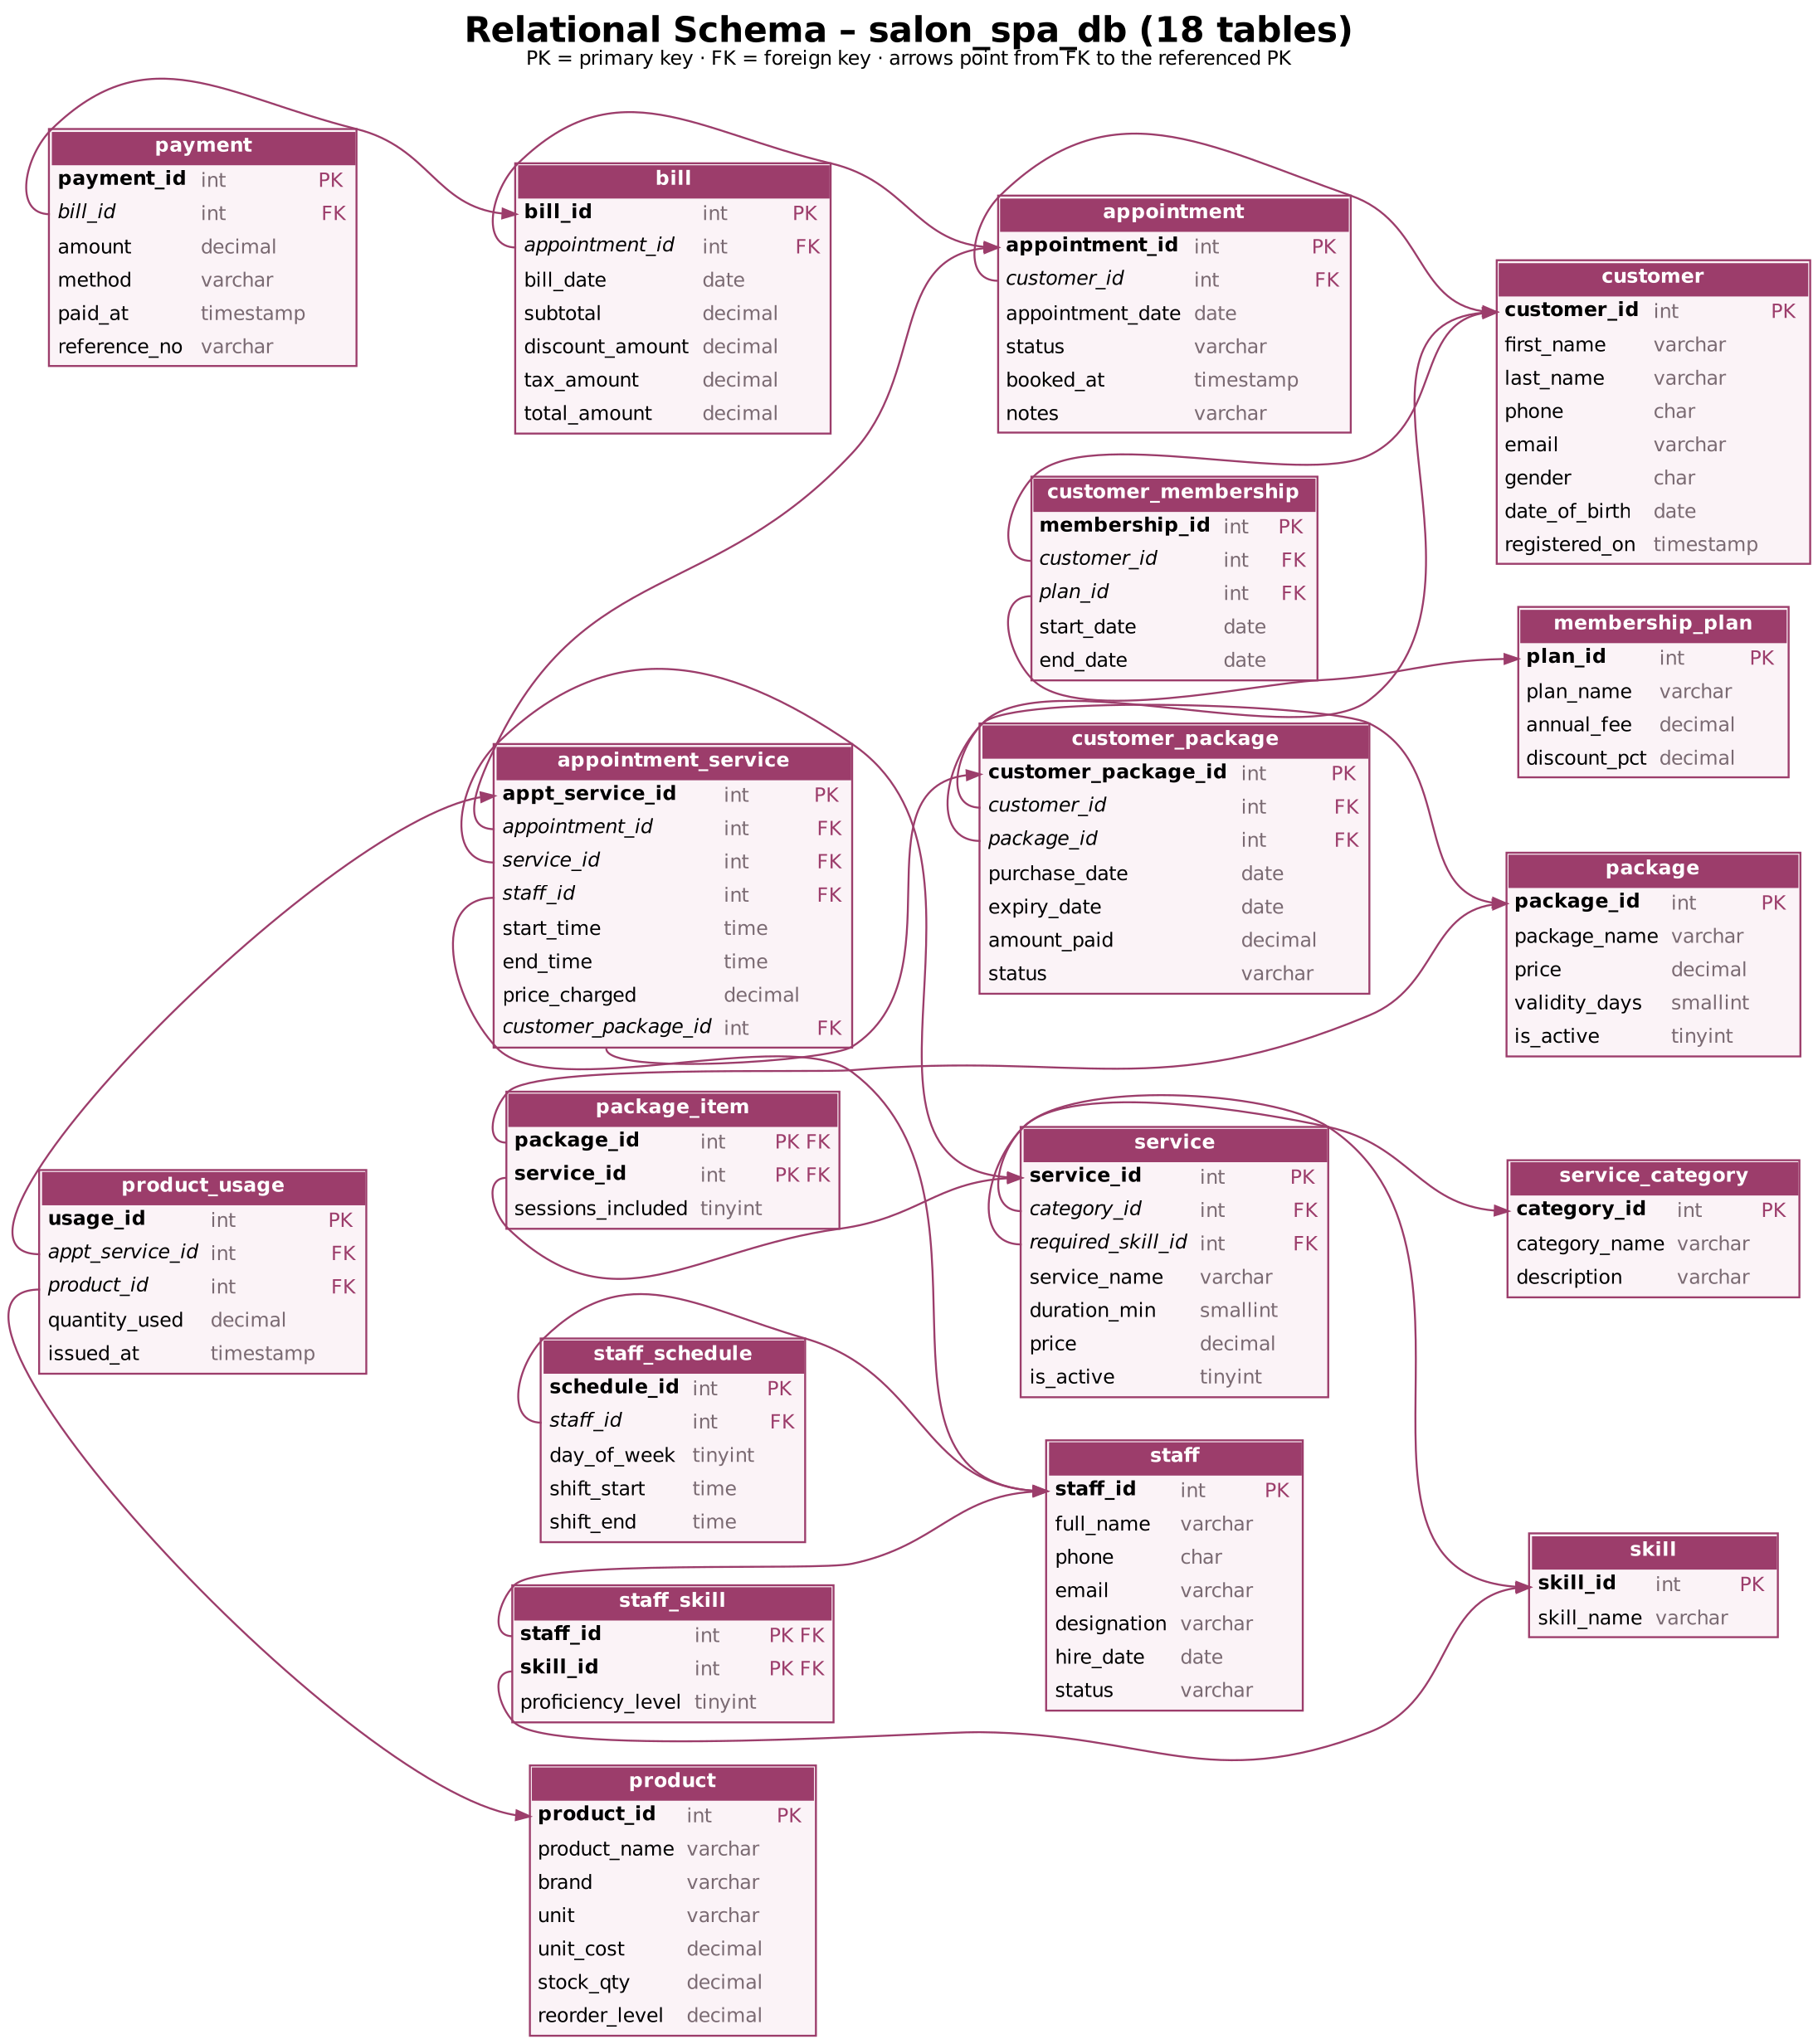
Figure 2. Relational Schema Diagram (foreign keys point to referenced primary keys)

2.2 Keys and Integrity Constraints
Table 6 lists the keys and constraints of every table. In total the schema declares 18 primary keys, 20 foreign keys, 12 UNIQUE constraints, 35 CHECK constraints, 17 DEFAULT values and 88 NOT NULL columns. Foreign keys use ON DELETE RESTRICT for history that must not be lost (a customer with appointments cannot be deleted), CASCADE for dependent detail rows (deleting a staff member removes his or her schedule and skills) and SET NULL for the optional package link.
Table 6. Keys and Integrity Constraints
Table Name | Key / Constraint | Attribute(s) | Business Rule Enforced
service_category | PK; UNIQUE | category_id; category_name | Each category listed once
skill | PK; UNIQUE | skill_id; skill_name | Each skill listed once
service | PK; FK; UNIQUE | service_id; category_id, required_skill_id; service_name | Service belongs to a category and needs a skill
service | CHECK; DEFAULT | duration_min 10–300, price > 0; is_active = 1 | Realistic duration and price
customer | PK; UNIQUE; NOT NULL | customer_id; phone, email; first_name, last_name, phone | No duplicate customers
customer | CHECK; DEFAULT | phone ^[6-9][0-9]{9}$, email pattern, gender F/M/O; registered_on = now | Valid Indian mobile number
staff | PK; UNIQUE; CHECK; DEFAULT | staff_id; phone, email; status in (ACTIVE, ON_LEAVE, INACTIVE); status = ACTIVE | Only active staff can be booked
staff_skill | PK; FK; CHECK; DEFAULT | (staff_id, skill_id); → staff CASCADE, → skill; level 1–5; 3 | Skill match source
staff_schedule | PK; FK; UNIQUE; CHECK | schedule_id; staff_id; (staff_id, day_of_week); day 1–7, end > start, 09:00–21:00 | One shift per staff per weekday
membership_plan | PK; UNIQUE; CHECK | plan_id; plan_name; fee ≥ 0, discount 0–50% | Bounded discounts
customer_membership | PK; FK; CHECK | membership_id; customer_id, plan_id; end_date > start_date | Valid membership period
package | PK; UNIQUE; CHECK | package_id; package_name; price > 0, validity 7–730 days | Valid packages
package_item | PK; FK; CHECK | (package_id, service_id); sessions 1–50 | Package-session limit source
customer_package | PK; FK; CHECK; DEFAULT | customer_package_id; customer_id, package_id; expiry > purchase, status list; ACTIVE | Package validity
appointment | PK; FK; CHECK; DEFAULT | appointment_id; customer_id (RESTRICT); status list; BOOKED, booked_at = now | Visit lifecycle
appointment_service | PK; FK; CHECK | appt_service_id; appointment (CASCADE), service, staff, customer_package (SET NULL); end > start, 09:00–21:00, price ≥ 0 | Valid appointment times
appointment_service | TRIGGER | trg_appt_service_bi / _bu → sp_validate_appt_service | No overlap, skill match, shift, duration, package limit
product | PK; UNIQUE; CHECK; DEFAULT | product_id; product_name; cost ≥ 0, stock ≥ 0, unit ml/g/pcs; unit = ml, stock = 0 | Stock never negative
product_usage | PK; FK; CHECK; TRIGGER | usage_id; appt_service_id, product_id; quantity > 0; trg_product_usage_bi | Issue only available stock
bill | PK; FK + UNIQUE; CHECK; TRIGGER | bill_id; appointment_id; discount ≤ subtotal, tax ≥ 0; trg_bill_bi | One bill per completed visit
payment | PK; FK; CHECK; DEFAULT; TRIGGER | payment_id; bill_id; amount > 0, method list; UPI, paid_at = now; trg_payment_bi | Payment limit

2.3 Functional Dependencies
The important functional dependencies are listed below. In every case the determinant is a candidate key of its relation, which is the condition for BCNF.
customer_id -> first_name, last_name, phone, email, gender,
date_of_birth, registered_on
phone -> customer_id (alternate key)
category_id -> category_name, description
skill_id -> skill_name
service_id -> category_id, required_skill_id, service_name,
duration_min, price, is_active
staff_id -> full_name, phone, email, designation, hire_date, status
{staff_id, skill_id} -> proficiency_level
schedule_id -> staff_id, day_of_week, shift_start, shift_end
{staff_id, day_of_week} -> schedule_id, shift_start, shift_end (alternate key)
plan_id -> plan_name, annual_fee, discount_pct
membership_id -> customer_id, plan_id, start_date, end_date
package_id -> package_name, price, validity_days, is_active
{package_id,service_id} -> sessions_included
customer_package_id -> customer_id, package_id, purchase_date, expiry_date,
amount_paid, status
appointment_id -> customer_id, appointment_date, status, booked_at, notes
appt_service_id -> appointment_id, service_id, staff_id, start_time,
end_time, price_charged, customer_package_id
product_id -> product_name, brand, unit, unit_cost, stock_qty,
reorder_level
usage_id -> appt_service_id, product_id, quantity_used, issued_at
bill_id -> appointment_id, bill_date, subtotal, discount_amount,
tax_amount
appointment_id -> bill_id (1:1, UNIQUE)
payment_id -> bill_id, amount, method, paid_at, reference_no

2.4 Normalization up to Third Normal Form (3NF)
Normalization was carried out on the paper booking slip, which in unnormalized form holds the customer's details, the date, a repeating group of {service, staff, staff skills, time, price}, the package used, the bill and a repeating group of payments [4].
- 1NF: repeating groups were removed – one row per service per visit (appointment_service), one row per payment (payment) and one row per staff skill (staff_skill); every attribute became atomic.
- 2NF: partial dependencies on composite keys were removed – service_name, duration and price depend only on service_id, and customer details only on customer_id, so they moved to service and customer.
- 3NF: transitive dependencies were removed – category_name depends on category_id, skill_name on skill_id and the membership discount on plan_id, so service_category, skill and membership_plan were split out.
Three attributes look derivable but are stored deliberately as historical snapshots: price_charged and end_time in appointment_service (service price and duration can change after booking) and expiry_date in customer_package (package validity can change after purchase). Over time these are not functionally determined by the current service or package, so they do not violate 3NF. bill.total_amount is a generated column, and amount paid, balance and payment status are not stored at all but computed in the view v_bill_summary. Table 7 gives the final status.
Table 7. Normalization Status up to 3NF
Relation Name | 1NF | 2NF | 3NF | BCNF | Remarks / Decomposition
service_category, skill | ✓ | ✓ | ✓ | ✓ | Single-attribute PK; names are alternate keys
service | ✓ | ✓ | ✓ | ✓ | Category and skill names moved out (3NF)
customer, staff | ✓ | ✓ | ✓ | ✓ | Phone and email are alternate keys
staff_skill | ✓ | ✓ | ✓ | ✓ | From staff's repeating skills (1NF); composite PK
staff_schedule | ✓ | ✓ | ✓ | ✓ | UNIQUE(staff_id, day_of_week) candidate key
membership_plan, customer_membership | ✓ | ✓ | ✓ | ✓ | Discount depends on plan only (3NF split)
package, package_item | ✓ | ✓ | ✓ | ✓ | M:N decomposed; sessions depend on full key
customer_package | ✓ | ✓ | ✓ | ✓ | expiry_date frozen at purchase
appointment | ✓ | ✓ | ✓ | ✓ | Header of the booking slip
appointment_service | ✓ | ✓ | ✓ | ✓ | Repeating service group (1NF); price/end time snapshots
product, product_usage | ✓ | ✓ | ✓ | ✓ | Usage separated from stock master
bill, payment | ✓ | ✓ | ✓ | ✓ | Repeating payments split (1NF); total generated

2.5 Data Dictionary
Table 8 is the data dictionary for all 18 tables, generated from the implemented schema.
Table 8. Data Dictionary
Table | Attribute | Data Type | Key / Constraint | Description
service_category | category_id | INT | PK, AUTO_INCREMENT | Category identifier
service_category | category_name | VARCHAR(50) | UNIQUE, NOT NULL | Name of the category
service_category | description | VARCHAR(200) |  | Short description
skill | skill_id | INT | PK, AUTO_INCREMENT | Skill identifier
skill | skill_name | VARCHAR(60) | UNIQUE, NOT NULL | Name of the skill
service | service_id | INT | PK, AUTO_INCREMENT | Service identifier
service | category_id | INT | FK → service_category, NOT NULL | Category identifier
service | required_skill_id | INT | FK → skill, NOT NULL | Skill needed to perform the service
service | service_name | VARCHAR(80) | UNIQUE, NOT NULL | Service name
service | duration_min | SMALLINT | NOT NULL | Duration in minutes
service | price | DECIMAL(8,2) | NOT NULL | Price in INR
service | is_active | TINYINT(1) | NOT NULL, DEFAULT 1 | 1 = available for sale
customer | customer_id | INT | PK, AUTO_INCREMENT | Customer identifier
customer | first_name | VARCHAR(40) | NOT NULL | First name
customer | last_name | VARCHAR(40) | NOT NULL | Last name
customer | phone | CHAR(10) | UNIQUE, NOT NULL | 10-digit mobile number
customer | email | VARCHAR(100) | UNIQUE | Email address
customer | gender | CHAR(1) |  | F / M / O
customer | date_of_birth | DATE |  | Date of birth
customer | registered_on | TIMESTAMP | NOT NULL, DEFAULT CURRENT_TIMESTAMP | Registration timestamp
staff | staff_id | INT | PK, AUTO_INCREMENT | Staff identifier
staff | full_name | VARCHAR(80) | NOT NULL | Full name
staff | phone | CHAR(10) | UNIQUE, NOT NULL | 10-digit mobile number
staff | email | VARCHAR(100) | UNIQUE | Email address
staff | designation | VARCHAR(40) | NOT NULL | Job title
staff | hire_date | DATE | NOT NULL | Date of joining
staff | status | VARCHAR(10) | NOT NULL, DEFAULT ACTIVE | ACTIVE / ON_LEAVE / INACTIVE
staff_skill | staff_id | INT | PK, FK → staff | Staff identifier
staff_skill | skill_id | INT | PK, FK → skill | Skill identifier
staff_skill | proficiency_level | TINYINT | NOT NULL, DEFAULT 3 | Skill level 1–5
staff_schedule | schedule_id | INT | PK, AUTO_INCREMENT | Schedule row identifier
staff_schedule | staff_id | INT | FK → staff, UNIQUE, NOT NULL | Staff identifier
staff_schedule | day_of_week | TINYINT | UNIQUE, NOT NULL | 1 = Sunday … 7 = Saturday
staff_schedule | shift_start | TIME | NOT NULL | Shift start time
staff_schedule | shift_end | TIME | NOT NULL | Shift end time
membership_plan | plan_id | INT | PK, AUTO_INCREMENT | Plan identifier
membership_plan | plan_name | VARCHAR(30) | UNIQUE, NOT NULL | Silver / Gold / Platinum
membership_plan | annual_fee | DECIMAL(8,2) | NOT NULL | Fee per year (INR)
membership_plan | discount_pct | DECIMAL(5,2) | NOT NULL, DEFAULT 0.00 | Discount on bills (%)
customer_membership | membership_id | INT | PK, AUTO_INCREMENT | Membership identifier
customer_membership | customer_id | INT | FK → customer, NOT NULL | Customer identifier
customer_membership | plan_id | INT | FK → membership_plan, NOT NULL | Plan identifier
customer_membership | start_date | DATE | NOT NULL | Membership start
customer_membership | end_date | DATE | NOT NULL | Membership end
package | package_id | INT | PK, AUTO_INCREMENT | Package identifier
package | package_name | VARCHAR(60) | UNIQUE, NOT NULL | Package name
package | price | DECIMAL(9,2) | NOT NULL | Package price (INR)
package | validity_days | SMALLINT | NOT NULL | Validity after purchase
package | is_active | TINYINT(1) | NOT NULL, DEFAULT 1 | 1 = available for sale
package_item | package_id | INT | PK, FK → package | Package identifier
package_item | service_id | INT | PK, FK → service | Service identifier
package_item | sessions_included | TINYINT | NOT NULL | Sessions of the service in the package
customer_package | customer_package_id | INT | PK, AUTO_INCREMENT | Purchased package identifier
customer_package | customer_id | INT | FK → customer, NOT NULL | Customer identifier
customer_package | package_id | INT | FK → package, NOT NULL | Package identifier
customer_package | purchase_date | DATE | NOT NULL | Date of purchase
customer_package | expiry_date | DATE | NOT NULL | Last date to redeem
customer_package | amount_paid | DECIMAL(9,2) | NOT NULL | Price paid (INR)
customer_package | status | VARCHAR(10) | NOT NULL, DEFAULT ACTIVE | ACTIVE / EXHAUSTED / EXPIRED / CANCELLED
appointment | appointment_id | INT | PK, AUTO_INCREMENT | Visit identifier
appointment | customer_id | INT | FK → customer, NOT NULL | Customer identifier
appointment | appointment_date | DATE | NOT NULL | Date of visit
appointment | status | VARCHAR(10) | NOT NULL, DEFAULT BOOKED | BOOKED / COMPLETED / CANCELLED / NO_SHOW
appointment | booked_at | TIMESTAMP | NOT NULL, DEFAULT CURRENT_TIMESTAMP | When the booking was made
appointment | notes | VARCHAR(200) |  | Optional remarks
appointment_service | appt_service_id | INT | PK, AUTO_INCREMENT | Booked service line identifier
appointment_service | appointment_id | INT | FK → appointment, NOT NULL | Visit identifier
appointment_service | service_id | INT | FK → service, NOT NULL | Service identifier
appointment_service | staff_id | INT | FK → staff, NOT NULL | Staff identifier
appointment_service | start_time | TIME | NOT NULL | Slot start
appointment_service | end_time | TIME | NOT NULL | Slot end
appointment_service | price_charged | DECIMAL(8,2) | NOT NULL | Price at booking (0 if from package)
appointment_service | customer_package_id | INT | FK → customer_package | Purchased package identifier
product | product_id | INT | PK, AUTO_INCREMENT | Product identifier
product | product_name | VARCHAR(80) | UNIQUE, NOT NULL | Product name
product | brand | VARCHAR(40) |  | Brand
product | unit | VARCHAR(10) | NOT NULL, DEFAULT ml | ml / g / pcs
product | unit_cost | DECIMAL(8,2) | NOT NULL | Cost per unit (INR)
product | stock_qty | DECIMAL(10,2) | NOT NULL, DEFAULT 0.00 | Quantity in stock
product | reorder_level | DECIMAL(10,2) | NOT NULL, DEFAULT 0.00 | Re-order threshold
product_usage | usage_id | INT | PK, AUTO_INCREMENT | Usage identifier
product_usage | appt_service_id | INT | FK → appointment_service, NOT NULL | Booked service line identifier
product_usage | product_id | INT | FK → product, NOT NULL | Product identifier
product_usage | quantity_used | DECIMAL(8,2) | NOT NULL | Quantity issued
product_usage | issued_at | TIMESTAMP | NOT NULL, DEFAULT CURRENT_TIMESTAMP | Issue timestamp
bill | bill_id | INT | PK, AUTO_INCREMENT | Bill identifier
bill | appointment_id | INT | FK → appointment, UNIQUE, NOT NULL | Visit identifier
bill | bill_date | DATE | NOT NULL | Bill date
bill | subtotal | DECIMAL(10,2) | NOT NULL | Sum of service prices
bill | discount_amount | DECIMAL(10,2) | NOT NULL, DEFAULT 0.00 | Membership discount
bill | tax_amount | DECIMAL(10,2) | NOT NULL, DEFAULT 0.00 | GST (18%)
bill | total_amount | DECIMAL(10,2) | GENERATED | subtotal − discount + tax (generated)
payment | payment_id | INT | PK, AUTO_INCREMENT | Payment identifier
payment | bill_id | INT | FK → bill, NOT NULL | Bill identifier
payment | amount | DECIMAL(10,2) | NOT NULL | Amount paid
payment | method | VARCHAR(10) | NOT NULL, DEFAULT UPI | CASH / CARD / UPI / WALLET
payment | paid_at | TIMESTAMP | NOT NULL, DEFAULT CURRENT_TIMESTAMP | Payment timestamp
payment | reference_no | VARCHAR(40) |  | UPI / card reference

2.6 Implementation of Logical Design: DDL and Sample Data
The design was implemented in MySQL 8.0, whose reference manual was followed for CHECK constraints, generated columns, triggers and SIGNAL [5]. The scripts are split into six files (Appendix A) and also run unchanged on MariaDB 10.11. Table 9 summarises the implementation environment.
Table 9. Database Implementation Environment
Item | Details
DBMS | MySQL Community Server (InnoDB storage engine)
DBMS Version | 8.0 (tested on 8.0.46; also verified on MariaDB 10.11)
Number of Tables | 18 tables, 7 views, 5 triggers, 1 stored procedure, 7 secondary indexes
Sample Data | 3,245 rows: 40 customers, 10 staff, 22 services, 603 appointments with 892 service lines, 674 product issues, 427 bills, 419 payments (Aug–Oct 2026)
A representative CREATE TABLE statement, for the central appointment_service relation, is shown below. Every constraint is named so that error messages identify the rule that failed.
CREATE TABLE appointment_service (
appt_service_id INT AUTO_INCREMENT PRIMARY KEY,
appointment_id INT NOT NULL,
service_id INT NOT NULL,
staff_id INT NOT NULL,
start_time TIME NOT NULL,
end_time TIME NOT NULL,
price_charged DECIMAL(8,2) NOT NULL,
customer_package_id INT NULL,
CONSTRAINT fk_as_appt FOREIGN KEY (appointment_id)
REFERENCES appointment(appointment_id) ON UPDATE CASCADE ON DELETE CASCADE,
CONSTRAINT fk_as_service FOREIGN KEY (service_id) REFERENCES service(service_id),
CONSTRAINT fk_as_staff FOREIGN KEY (staff_id) REFERENCES staff(staff_id),
CONSTRAINT fk_as_cpkg FOREIGN KEY (customer_package_id)
REFERENCES customer_package(customer_package_id) ON DELETE SET NULL,
CONSTRAINT chk_as_order CHECK (end_time > start_time),
CONSTRAINT chk_as_hours CHECK (start_time >= '09:00:00'
AND end_time <= '21:00:00'),
CONSTRAINT chk_as_price CHECK (price_charged >= 0)
) ENGINE=InnoDB;
The rules that depend on other rows are checked in one stored procedure called by the BEFORE INSERT and BEFORE UPDATE triggers. The overlap check uses the interval-overlap condition (start A < end B and start B < end A):
SELECT COUNT(*) INTO v_cnt
FROM appointment_service s
JOIN appointment a ON a.appointment_id = s.appointment_id
WHERE s.staff_id = p_staff_id AND a.appointment_date = v_date
AND a.status NOT IN ('CANCELLED','NO_SHOW')
AND s.appt_service_id <> p_self_id -- ignore the row being updated
AND s.start_time < p_end AND p_start < s.end_time;
IF v_cnt > 0 THEN
SIGNAL SQLSTATE '45000'
SET MESSAGE_TEXT =
'Staff conflict: staff member already has an overlapping appointment';
END IF;
Sample data was produced by a seeded Python generator that schedules every visit with the same rules, and it was loaded through the triggers, so every stored row is valid. Table 10 shows the number of rows per table and Table 11 shows representative records.
Table 10. Sample Data Summary
Table | Rows | Table | Rows
service_category | 6 | package | 6
skill | 10 | package_item | 11
service | 22 | customer_package | 14
customer | 40 | appointment | 603
staff | 10 | appointment_service | 892
staff_skill | 23 | product | 15
staff_schedule | 60 | product_usage | 674
membership_plan | 3 | bill | 427
customer_membership | 10 | payment | 419

Table 11. Representative Records from v_appointment_details
Date | Start | Customer | Service | Staff | Price ₹ | Status
2026-10-05 | 11:30 | Aditi Agarwal | Classic Manicure | Lakshmi Prasanna | 700 | COMPLETED
2026-10-05 | 12:00 | Sahithi Patel | Women's Haircut | Ananya Reddy | 600 | COMPLETED
2026-10-05 | 12:15 | Aditi Agarwal | Spa Pedicure | Lakshmi Prasanna | 1100 | COMPLETED
2026-10-05 | 12:15 | Varun Desai | Men's Haircut | Arjun Rao | 350 | COMPLETED
2026-10-05 | 12:45 | Sahithi Patel | Blow Dry & Styling | Mohammed Irfan | 450 | COMPLETED
2026-10-05 | 12:45 | Bhavana Chowdary | Hair Spa | Ananya Reddy | 1500 | COMPLETED

CHAPTER 3

APPLICATION DEVELOPMENT USING LOGICAL DATABASE DESIGN

3.1 Application Overview
The application, branded “Glow & Grace Salon Manager” for the demonstration, is a browser-based Python program used at the front desk by the receptionist and by the salon manager. It has nine screens grouped as Front desk (Dashboard, Customers, Book Appointment, Manage Appointments), Operations (Packages & Memberships, Products & Stock, Billing & Payments, Staff & Services) and Insights (Reports). Every screen reads and writes the tables and views designed in Chapter 2 through a single data-access module; there is no static data in the program. Input format is validated in Python before the database is called, and all business rules are enforced again by the database, whose error messages are shown to the user unchanged.

3.2 Development Environment and Database Connectivity
Connectivity is handled by db.py. It opens a connection with autocommit disabled, runs every statement with %s parameters, and exposes a transaction() context manager that issues START TRANSACTION, COMMIT on success and ROLLBACK on any error. MySQL errors are translated into readable messages: SQLSTATE 45000 messages raised by triggers are passed through, duplicate keys, foreign-key violations and CHECK failures get their own wording. Connection settings are read from environment variables (SALON_DB_HOST, SALON_DB_USER, SALON_DB_PASSWORD, SALON_DB_NAME). Table 12 lists the environment.
Table 12. Application Development Environment
Item | Details
Programming Language | Python 3.11+
DBMS | MySQL 8.0
IDE / Framework / GUI Toolkit | VS Code; Streamlit (browser-based GUI written in Python) [7]; pandas for tabular data
Database Connector / Driver | mysql-connector-python (official Oracle driver) [6]; parameterised queries, explicit transactions
Operating Environment | macOS / Linux / Windows; runs locally at http://localhost:8501
Repository Link | https://github.com/devyanipawar9003-max/DBMS_PBL

3.3 Application Modules and Database Mapping
Table 13 maps each screen of the application to the tables and views it uses.
Table 13. Application Module-to-Database Mapping
Module / Screen | Purpose | Tables Used | Main Operations
Dashboard | Daily snapshot | appointment, bill, v_appointment_details, v_bill_summary, v_product_usage | Read, aggregate
Customers | Registration and profile | customer, customer_membership | Create, search, update, delete
Book Appointment | Multi-service booking | appointment, appointment_service, service, staff_skill, staff_schedule, v_package_balance | Insert in one transaction
Manage Appointments | Lifecycle and reschedule | appointment, appointment_service | Search, update status/time/staff
Packages & Memberships | Sell and track | package, package_item, customer_package, membership_plan, customer_membership | Insert, read balances
Products & Stock | Issue and restock | product, product_usage | Insert usage, update stock
Billing & Payments | Bill and settle | bill, payment, v_bill_summary | Insert bill, insert payments
Staff & Services | Masters | staff, skill, staff_skill, staff_schedule, service | Read, update status/price, upsert skill
Reports | Six reports | seven views | Read, aggregate, CSV export

3.4 CRUD Operations
Table 14 shows where each create, read, update and delete operation is performed.
Table 14. CRUD Operations
Operation | Application Feature / Screen | Table(s) Affected | Evidence
Create | Register customer; book appointment; sell package; enrol membership; issue product; add product; generate bill; record payment | customer, appointment, appointment_service, customer_package, customer_membership, product_usage, product, bill, payment | Figures 4, 5, 9, 10
Read / Search | Customer search by name/phone/email; appointment search by date, status, customer; bill viewer; reports | all tables and views | Figures 3, 12, 13
Update | Edit customer; complete/cancel/no-show; reschedule time or staff; restock; change service price; staff status | customer, appointment, appointment_service, product, service, staff | Figures 7–8
Delete / Controlled Removal | Delete customer only after confirmation and only if no history (FK RESTRICT); remove a line from the booking cart before saving | customer | Test case TC-16

3.5 Business Rules, Validation and Error Handling
Validation works in two layers. The application checks input format before contacting the database (names, a 10-digit mobile number starting with 6–9, email pattern, non-future birth date, positive amounts, a reference number for UPI and card). It also prevents most rule violations by design: time-slot lists only offer slots that end by 21:00, and the staff list shows only staff with the right skill who are on shift and free. The database is the second and final layer – triggers and constraints reject anything that still breaks a rule, for example when the staff filter is switched off or two receptionists book the same slot at once. All SQL uses bound parameters, which prevents SQL injection [8]. Destructive actions need a confirmation tick, and multi-statement operations run in a transaction that is rolled back on error. Table 15 lists the rules.
Table 15. Business Rules, Validation and Error Handling
Rule / Validation | How Implemented | Evidence / Message
No overlapping staff appointments | Staff list excludes busy staff; trigger sp_validate_appt_service (insert and update) | “Staff conflict: staff member already has an overlapping appointment” (Figure 8)
Skill match | Staff list joined with staff_skill; trigger re-check | “Skill mismatch: staff member does not have the skill required for this service” (Figure 6)
Valid appointment times | Slot list 09:00–21:00 in 15-min steps; CHECK chk_as_hours; trigger checks duration and staff shift | “Invalid time slot: this service takes 30 minutes” / “not on shift”
Package-session limit | Redeem option shown only with sessions left; trigger checks owner, validity, coverage, count | “Package session limit reached for this service”
Payment limit | Amount defaults to balance; trigger trg_payment_bi | “Payment exceeds balance: outstanding amount is Rs. …” (Figure 11)
Stock and billing rules | trg_product_usage_bi, trg_bill_bi, CHECK stock_qty ≥ 0 | “Insufficient stock: only 13.00 available”; “Bill can be generated only for a completed appointment”
Input format and uniqueness | Python regex checks; CHECK chk_customer_phone; UNIQUE phone/email | “Phone must be a 10-digit Indian mobile number…” (Figure 4); “Duplicate value: this phone already exists.”

3.6 Reports and Database Operations
The six required reports, the SQL concepts behind them and their output are listed in Table 16. Each report can be exported as CSV.
Table 16. Reports and Database Operations
Report / Operation | SQL / Database Concept Used | Application Output
Appointments | v_appointment_details (5-table join); COUNT(DISTINCT CASE …) per day; correlated subquery for last visit | Daily totals by status, line chart, CSV
Staff utilization | v_staff_utilization: derived tables, CROSS JOIN, SUM of minutes ÷ shift minutes | Utilization % per staff (Figure 12)
Service popularity | v_service_popularity: LEFT JOIN with IN-subquery, GROUP BY; category revenue share | Bookings, package use and revenue per service
Package balances | v_package_balance: correlated subquery counting sessions used | Included / used / left per customer package
Product use | v_product_usage: SUM, CASE re-order flag; average material cost per service | Consumption cost and re-order alerts
Revenue | v_monthly_revenue, v_bill_summary: GROUP BY month, billed vs collected, outstanding | Monthly bar chart and dues (Figure 13)

3.7 Application Screens
Figures 3 to 13 show the main screens running on the sample database.
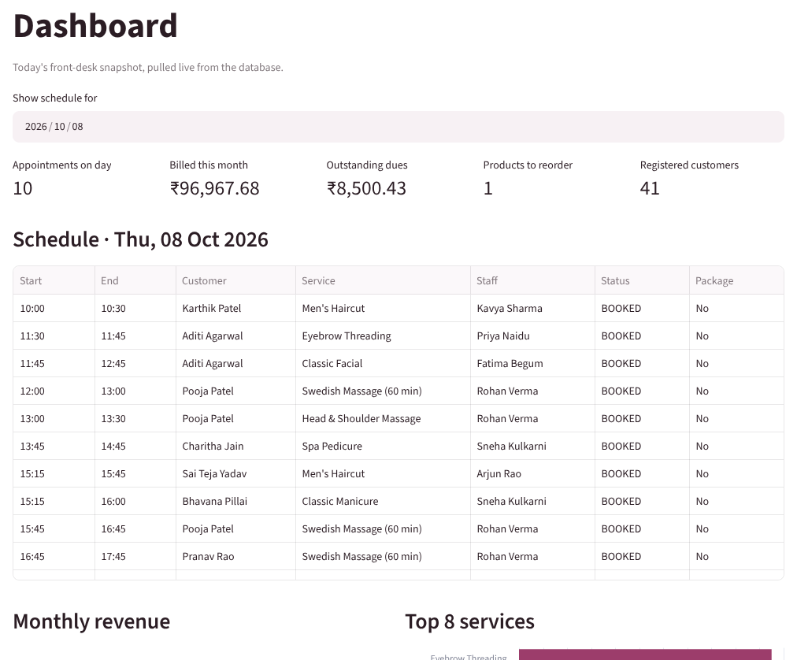
Figure 3. Dashboard with daily schedule and key figures
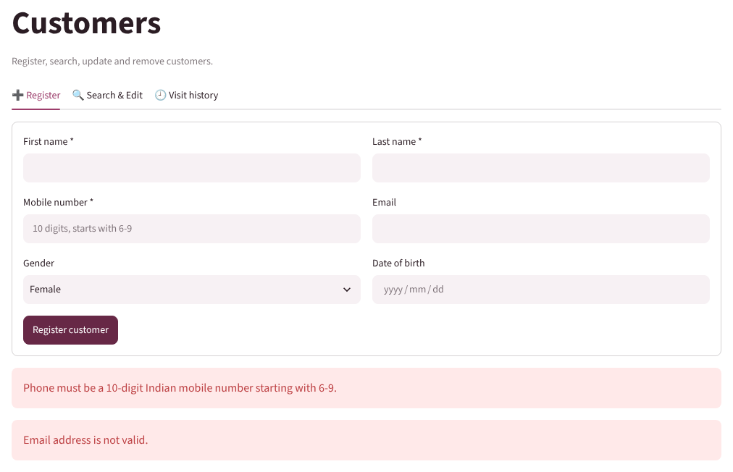
Figure 4. Customer registration rejecting an invalid phone number and email
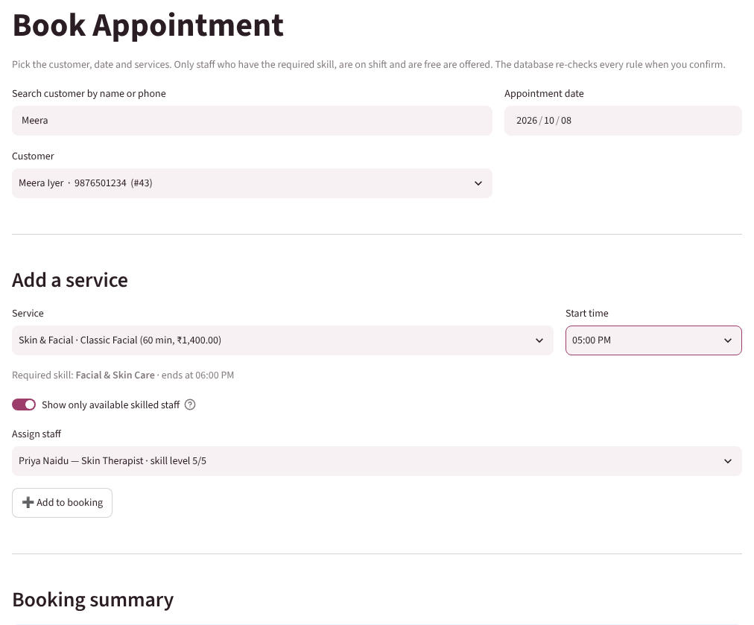
Figure 5. Booking screen offering only skilled, on-shift and free staff
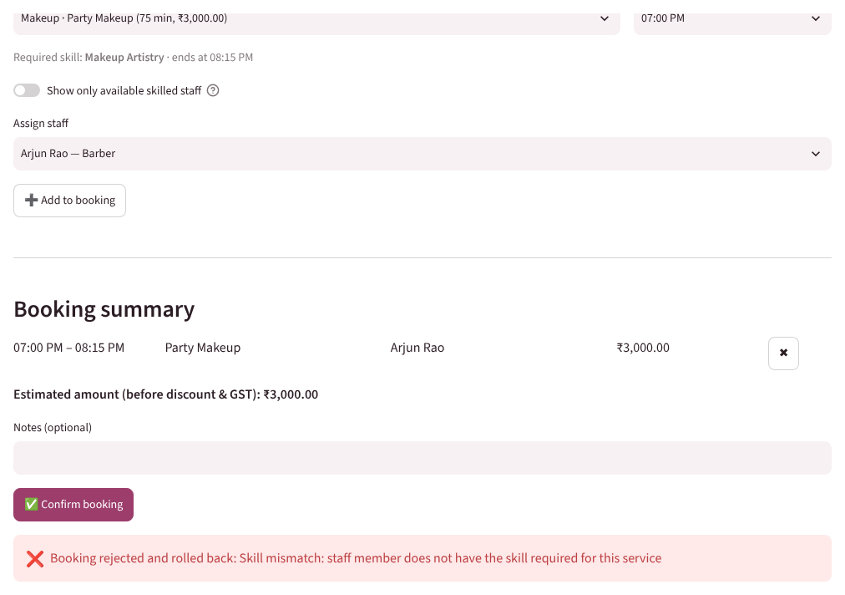
Figure 6. Booking rejected by the database for a skill mismatch and rolled back
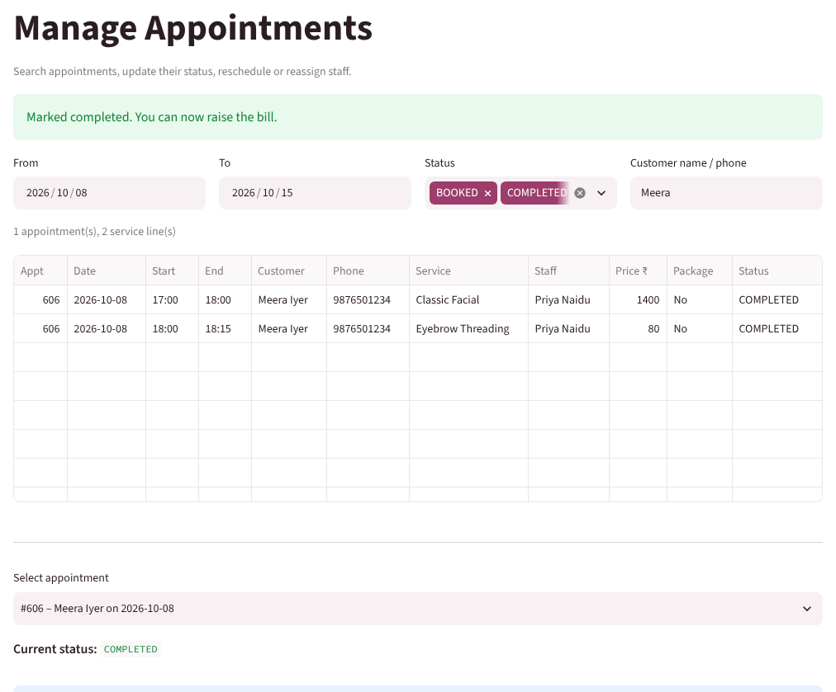
Figure 7. Manage Appointments – appointment marked completed
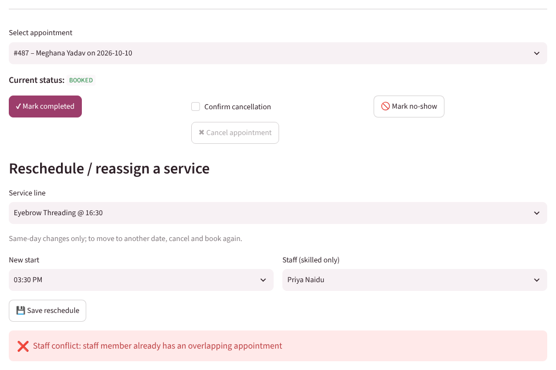
Figure 8. Reschedule rejected for an overlapping staff appointment
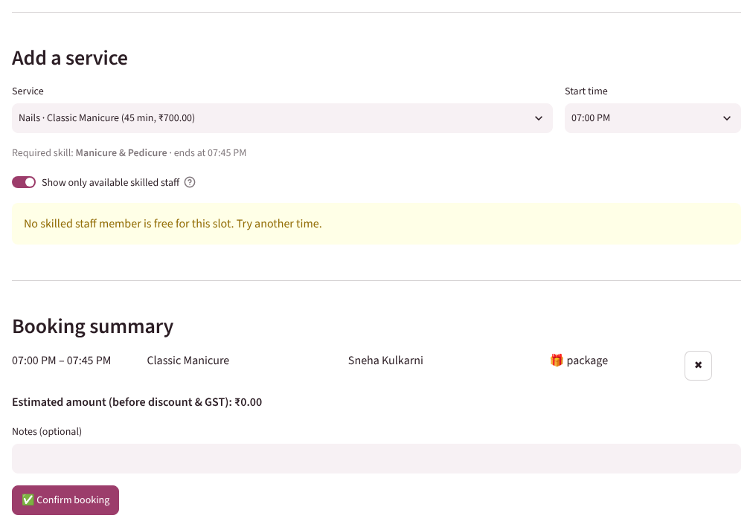
Figure 9. Package session redeemed at no charge during booking
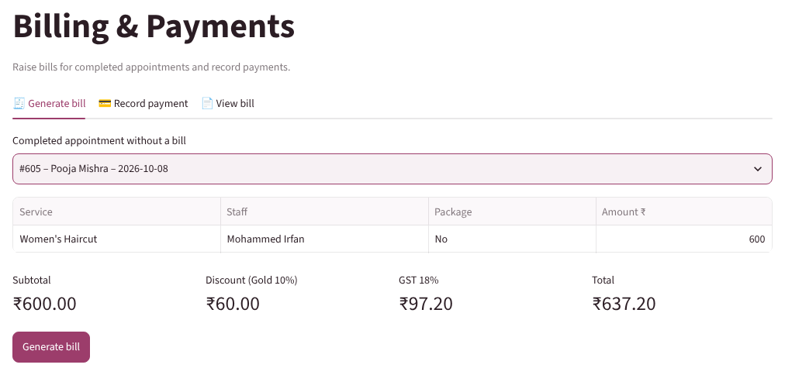
Figure 10. Bill preview with Gold membership discount and GST
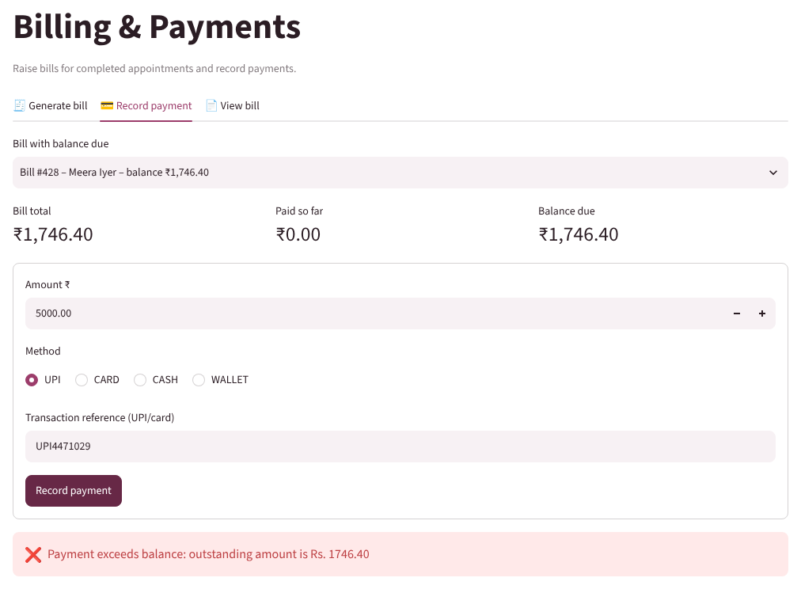
Figure 11. Payment above the outstanding balance rejected
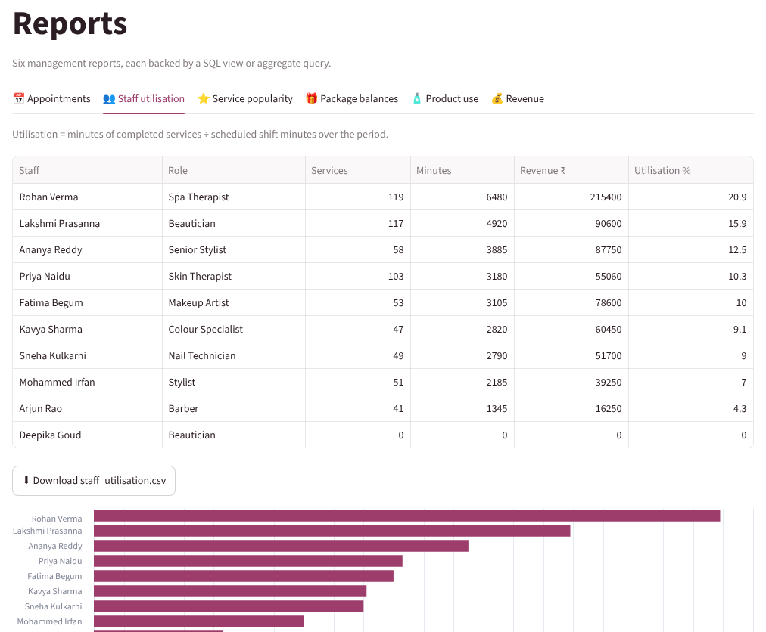
Figure 12. Staff utilization report
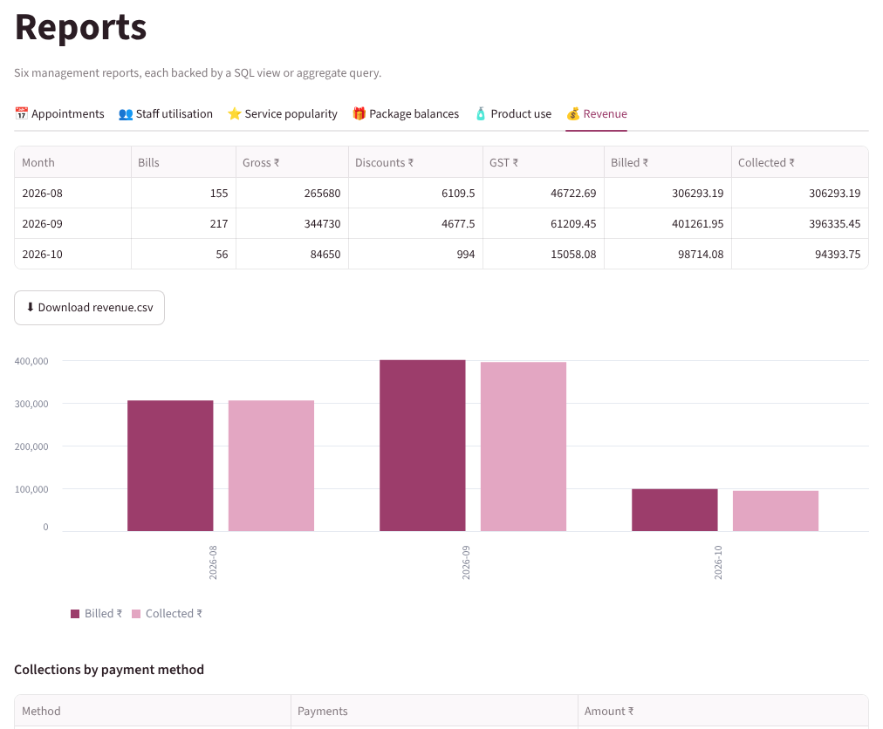
Figure 13. Monthly revenue report – billed vs collected

3.8 Testing and Results
Testing combined a database-level script (database/06_test_business_rules.sql, run in a transaction that is rolled back) and manual tests through the application. Table 17 lists the main positive and negative cases with the observed results.
Table 17. Test Cases
Test ID | Feature | Input / Action | Expected Result | Actual Result | Status
TC-01 | Booking (DB) | Valid Swedish massage 13:00–14:00 for Rohan | Row inserted | 1 row inserted | Pass
TC-02 | Overlap rule | Second booking for Rohan 13:30–14:30 | Rejected | Staff conflict error | Pass
TC-03 | Overlap rule | Back-to-back booking 14:00–15:00 | Accepted | Inserted | Pass
TC-04 | Skill match | Bridal makeup assigned to the barber | Rejected | Skill mismatch error | Pass
TC-05 | Valid times | 30-min haircut booked for 45 min | Rejected | Invalid time slot error | Pass
TC-06 | Valid times | Massage at 10:00, before the 12:00 shift | Rejected | Not on shift error | Pass
TC-07 | Package limit | Redeem another customer's package | Rejected | Package does not belong error | Pass
TC-08 | Package limit | Redeem 4th of 4, then a 5th manicure | 4th at ₹0; 5th rejected | ₹0.00, then limit error | Pass
TC-09 | Billing rule | Bill a BOOKED appointment | Rejected | Completed-only error | Pass
TC-10 | Payment limit | Pay balance + 100, then exact balance | First rejected, then PAID | Error, then status PAID | Pass
TC-11 | Stock rule | Issue 500 gold facial kits | Rejected | Insufficient stock error | Pass
TC-12 | Registration (app) | Phone 12345, email meera.iyer@gmail | Two validation errors | Both errors shown (Fig. 4) | Pass
TC-13 | Booking (app) | Facial 17:00 + threading 18:00 for new customer | Booked with skilled staff | Confirmation shown | Pass
TC-14 | Reschedule (app) | Move threading to 15:30 onto a facial slot | Rejected | Staff conflict (Fig. 8) | Pass
TC-15 | Billing (app) | ₹600 haircut for Gold member | ₹60 off, GST ₹97.20, total ₹637.20 | As expected (Fig. 10) | Pass
TC-16 | Delete (app) | Delete customer who has appointments | Blocked by FK | “Cannot delete …” message | Pass
TC-17 | Uniqueness | Register a duplicate phone number | Rejected | Duplicate value message | Pass
TC-18 | Check constraint | Discount larger than subtotal | Rejected | chk_bill_discount violated | Pass
All 18 test cases produced the expected result. Every invalid operation was stopped by the database even when the application's own filters were bypassed, and multi-statement bookings were rolled back completely on error, so no partial data was left behind. Valid edge cases – such as back-to-back appointments and redeeming the last package session – were accepted. The application therefore uses the designed database correctly and enforces all of the important business rules.

CHAPTER 4

CONCLUSION
This project replaced the error-prone paper appointment book of a salon and spa with a relational database and a Python application. Starting from the requirements, an ER model of 14 entities and 16 relationships was designed and converted into 18 relations in Third Normal Form. The MySQL implementation uses 85 declarative constraints, five triggers, seven views and seven indexes, so that overlapping staff bookings, skill mismatches, invalid times, package over-use and over-payment are rejected by the database itself. The Streamlit application supports the full workflow from registration to payment and produces the six required reports.
The main learning was that placing business rules inside the database, rather than only in the user interface, keeps the data correct no matter which program or person changes it, and that careful normalization made the reports simple to write as views.

4.1 Limitations and Future Enhancements
- There is no login yet; role-based access for receptionist, manager and staff can be added with a user table and permissions.
- The design assumes one branch; adding branch_id to staff, appointments and stock would support a chain of salons.
- Appointment reminders, a customer self-booking portal and online payment links are not implemented.
- Staff utilization uses scheduled shift time only; leave and holidays could be modelled for more accurate utilization.

REFERENCES
[1] A. Silberschatz, H. F. Korth, and S. Sudarshan, Database System Concepts, 7th ed. New York, NY, USA: McGraw-Hill Education, 2020.
[2] P. P. Chen, “The entity-relationship model—Toward a unified view of data,” ACM Trans. Database Syst., vol. 1, no. 1, pp. 9–36, Mar. 1976, doi: 10.1145/320434.320440.
[3] E. F. Codd, “A relational model of data for large shared data banks,” Commun. ACM, vol. 13, no. 6, pp. 377–387, Jun. 1970, doi: 10.1145/362384.362685.
[4] R. Elmasri and S. B. Navathe, Fundamentals of Database Systems, 7th ed. Boston, MA, USA: Pearson, 2016.
[5] Oracle Corporation, MySQL 8.0 Reference Manual. Accessed: Oct. 8, 2026. [Online]. Available: https://dev.mysql.com/doc/refman/8.0/en/
[6] Oracle Corporation, MySQL Connector/Python Developer Guide. Accessed: Oct. 8, 2026. [Online]. Available: https://dev.mysql.com/doc/connector-python/en/
[7] Snowflake Inc., Streamlit Documentation. Accessed: Oct. 8, 2026. [Online]. Available: https://docs.streamlit.io/
[8] OWASP Foundation, “SQL injection prevention cheat sheet,” OWASP Cheat Sheet Series. Accessed: Oct. 8, 2026. [Online]. Available: https://cheatsheetseries.owasp.org/cheatsheets/SQL_Injection_Prevention_Cheat_Sheet.html

APPENDICES

APPENDIX A - COMPLETE DATABASE SCRIPT
The complete script is submitted in the repository folder database/ (https://github.com/devyanipawar9003-max/DBMS_PBL). Run the single file salon_spa_full.sql, or the parts in order:
- 01_schema.sql – database, 18 tables, constraints and indexes (DDL)
- 02_triggers.sql – validation procedure and five business-rule triggers
- 03_sample_data.sql – sample data (DML), generated by generate_sample_data.py
- 04_views.sql – seven reporting views
- 05_queries.sql – 20 retrieval queries: joins, subqueries, aggregation, views
- 06_test_business_rules.sql – 18 positive / negative rule tests (rolled back)

APPENDIX B - APPLICATION SOURCE CODE
Repository: https://github.com/devyanipawar9003-max/DBMS_PBL. The application is in the app/ folder: streamlit_app.py (entry point and navigation), db.py (connection, parameterised queries, transactions, error mapping), ui.py (validation and shared widgets) and views/ (one file per screen). Run: pip install -r requirements.txt, then streamlit run app/streamlit_app.py. The five-minute demonstration video link is in video/VIDEO_LINK.md.

APPENDIX C - ADDITIONAL TEST DATA AND OUTPUTS
Output of the business-rule test script on MySQL 8.0 (abridged):
TC-01 valid booking rows_ok = 1
ERROR 1644 (45000): Staff conflict: staff member already has an overlapping appointment
ERROR 1644 (45000): Skill mismatch: staff member does not have the required skill
ERROR 1644 (45000): Invalid time slot: this service takes 30 minutes
ERROR 1644 (45000): Invalid time: staff member is not on shift for this slot
ERROR 1644 (45000): Package does not belong to this customer
TC-09 package redemption price_charged = 0.00
ERROR 1644 (45000): Package session limit reached for this service
ERROR 1644 (45000): Bill can be generated only for a completed appointment
ERROR 1644 (45000): Payment exceeds balance: outstanding amount is Rs. 1888.00
TC-13 settle bill payment_status = PAID, balance = 0.00
ERROR 1644 (45000): Insufficient stock: only 17.00 available
ERROR 3819 (HY000): Check constraint 'chk_customer_phone' is violated.
ERROR 1062 (23000): Duplicate entry '9374481727' for key 'customer.phone'
ERROR 1451 (23000): Cannot delete or update a parent row: a foreign key ... fails
ERROR 3819 (HY000): Check constraint 'chk_bill_discount' is violated.
All tests finished - transaction rolled back
Figure 14 is the full-page ER diagram (rotated) and Figure 15 the package-balance report.
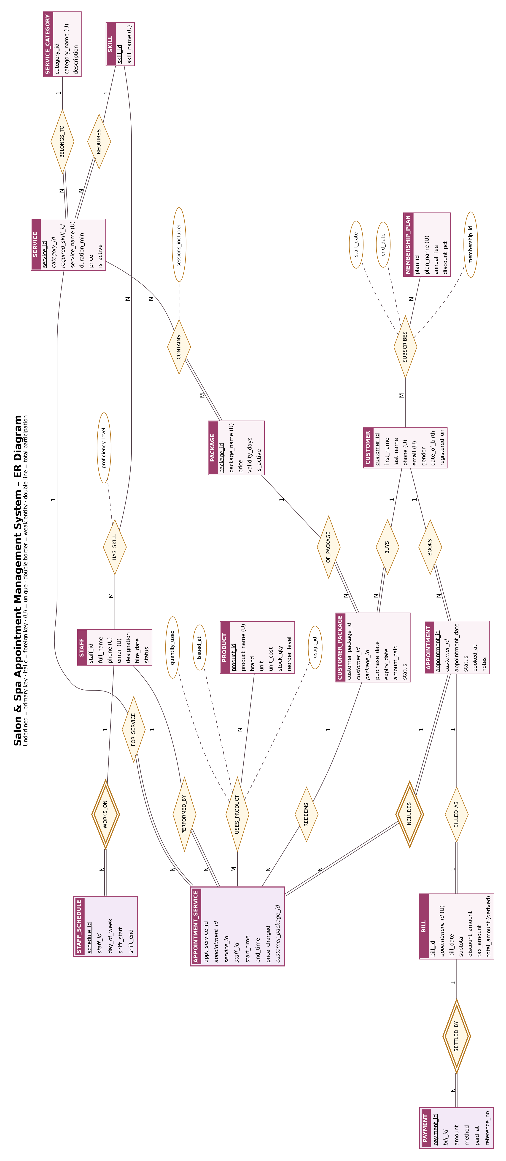
Figure 14. Full-page Entity-Relationship Diagram
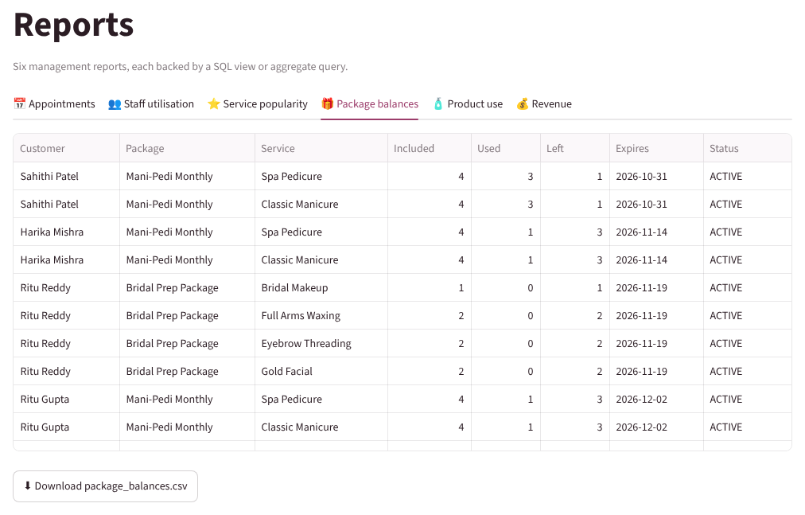
Figure 15. Package balances report

