**Introduction to Social Innovation**

“Practical solutions to societal problems in a creative way”

**Social Issue**

A **social issue** (also called a **social problem** or a **social situation**) is an issue that relates to society's perception of a person's personal life. Different cultures have different perceptions and what may be "normal" behavior in one society may be a significant social issue in another society.

**Man's duty to "allow the same rights to others as we allow ourselves". The failure to do so causes the birth of a social issue.**

**Personal Issue versus Social Issue**

Personal issues are those that individuals deal with themselves and within a small range of their peers and relationships. On the other hand, social issues threaten values cherished by widespread society.

The line between a personal issue and a public issue may be subjective; however, when a large enough sector of society is affected by an issue, it becomes a social issue.

**The Social Innovation process moves through five main phases:**

**Phase 1: ENGAGE**

This phase allows the observer to study the uncommon situations in the community and connection with the society has been established. The phase comprises of the following activities:

* Initial visit/s to the community
* Observe the current situations & identify problems of the community
* Document the observation
* Brain storm

The observations captured through the community visit/s are detailed as below:

|  |  |  |  |
| --- | --- | --- | --- |
| Sl. No | Observations | Consequences | Positive impact on the society |
| 1. | **Rayapura** |  | (providing a solution) |
| (a) | Unaware of government  schemes related to farming | Practicing the old ways resulting in more loss but less yield and profit | Will teach new skills that will benefit the farmers as well as the consumers |
| (b) | Unemployment in village | Wastage of manpower and erosion of skills | Will help the people financially and make a contribution in the economy |
| (c) | Pre-primary school with  no adequate classrooms  and books. | Will hinder in children’s academic learning | Will help the children to learn more and gain knowledge |
| 2. | **Navalur** |  |  |
| (a) | Devoid of electricity | Less development | Will spread awareness about schemes in turn developing the homes |
| (b) | Devoid of water facility | Becomes harder to get the basic necessities for survival | Making it easier to lead daily life |
| 3. | **Bairidevarkoppa** |  |  |
| (a) | Improper waste management and disposal | Spreads-unwanted diseases | It will help in preventing deadly diseases |
| (b) | No proper disposal for left over mid-day meals | wastage of food which can be utilised | Will provide a way to utilize and not waste resources |
| (c) | No facility of science labs | Hinder in children’s capacity to understand concepts | Will help them increase their capacity to understand the subject and make them think critically |
|  |  |  |  |

**Table 1.1: Observation dairy**

**1.2: Framing the design Challenge (Social Issue)**

1. **What is your issue title?**

Enhancing the capacity of students to apply theoretical knowledge.

1. **Provide the detailed justification of the Social Issue.**

* We have seen how they lag in application of the theoretical knowledge.
* On conversing with the students, we came to know that they mainly tend to rote learn the facts without an idea of how science actually works.
* We observed that the children do not have science lab and in turn miss out on the opportunities to apply the theoretical knowledge that they gain.

1. **What are some of the possible solutions to your social issue?**

* By conducting workshop.
* Smart class (smart-phone projector).
* Request the teacher to perform simple class activity.
* Group discussions and group projects.
* Make a confined syllabus of required and important experiments.

1. **In your team’s opinion what are the challenges you may face while resolving the issue?**

**Write down some of the hurdles you may come across during resolving the issue.**

* Most of the students were not aware of their experiments which are in their syllabus.
* Students were not at all motivated in learning their experiments and did not know its importance.
* How to involve large number of students in workshop was also a big problem.
* Students were hesitating to interact with us.

**Phase 2: INSPIRATION**

Creating meaningful solutions begins with gaining a deep understanding of people’s needs.

In the Inspiration phase, we will learn directly from the people and immerse ourselves in their lives and come to deeply understand their needs and aspirations. The steps involved are:

Step 1: Research Planning

Step 2: Building Interview Guide

Step 3: Capture Learnings

**2.1: Research Plan**

Research is the fuel for ideas. During the Inspiration phase we will plan research activities to learn from the people we are designing for and explore unfamiliar contexts. As part of this course, we’ve selected four good starting points—learn from people, learn from experts, immerse yourself in context, and seek analogous inspiration.

**Social innovation is about spending quality time with people to gain insight about and inspiration from the people you’re designing for.**

**People to Learn from (8+ individuals)**

|  |  |
| --- | --- |
| Name | Background Details |
| Ravi Shetty | Student |
| Anirudh k | Student |
| Varsha p challegri | Student |
| Naresh V. Lokhand | Student |
| A.M Lobo | Principal of government school baridevarkoppa |
| S.M Madiwalar | Science teacher |

**Learnings from experts**

Though social innovation is all about talking with people, there are moments where there is need for more context or history than a typical interview can afford. This is where both expert interviews come into play.

Outcome: Access to in-depth knowledge in a certain area of expertise.

In this category we interviewed people who have some expertise in the social issue that they are trying to solve.

**Experts identified Speak to**

|  |  |
| --- | --- |
| Name | Background Details |
| Sadhana.S | Principal jss smcs |
| Nandini Mam | private school physics teacher |
| Basavaraj | Owns a mobile lab (works for NGO) |

**Analogous Inspiration**

Analogous research takes inspiration from a different region to give us a fresh perspective. In this category we will talk to people who are facing the same issue somewhere else (another region).

Analogous Inspiration Locations ( 1+ location )

|  |  |
| --- | --- |
| Name of the location | Brief description of the location |
| Basvaraj | He owns a mobile van as he will be knowing the experiments that are necessary for the students of class 7 and 8 to perform |
| Ruchi Danish Ashraf | an IAS officer taught physics to over 90 students in remote area of Arunachal Pradesh for free, helping them clear examinations |

**2.2: Building Interview Guide**

**Open General**

What are some broad questions you can ask to open the conversation and warm people up

**To students:**

|  |  |
| --- | --- |
| Q. No | Question |
| 1. | what is your name? |
| 2. | which standard are you from? |
| 3. | how is your experience in the school? |
| 4. | are the classes held regularly**?** |
| 5. | do teachers come to the class regularly and do you understand the way of teaching? |
| 6. | are the practical classes held? |
| 7. | are any science exhibitions held in the school? |

**To teacher:**

|  |  |
| --- | --- |
| Q. No | Question |
| 1. | how long have you been a teacher in this school? |
| 2. | have you seen any changes in the learning style of children over the period? |
| 3. | are the students aware of modern learning techniques? |
| 4. | are they aware of the practicals? are they interested? |
| 5. | why do you think they are important? |
| 6. | has anyone approached the students before on this topic? if so, what have they done? was is successful? |
| 7 | is the class activity part given in the textbook are done? |
| 8 | in what way do you think that a private school student of the same grade has a better experience and an advantage? |
| 9 | what do you think what changes have to be made in learning system of the children? |

**To principal:**

|  |  |
| --- | --- |
| Q. No | Question |
| 1. | how long have you been doing this? |
| 2. | has there been any improvement in the learning system of the children? |
| 3. | how is the attendance of the school children? |
| 4. | how is the parent-teacher and parent-student relationships? |
| 5. | how is the interest of students in extracurricular activities? |
| 6. | what do you think about practical labs? Are they important? |
| 7. | as there are no labs in the school, are the students interested in performing experiments? |
| 8. | how do you think the problem of lack of practical knowledge can be overcome? |
| 9. | in what all ways do you think that a private school student are having much more advantage? |
| 10. | was there any attempt to solve this problem, before? |

**Go Deep (Specific to the Issue)**

Questions that can help us start to understand the person’s hopes, fears, and ambitions connected to the issue.

**Science teacher and principal:**

|  |  |
| --- | --- |
| Q. No | Question |
| 1. | how do you think that the practicals are important to the present generation school children? |
| 2. | do you think that this must be made compulsory for government school children? |
| 3. | how do you think they help in shaping career? |
| 4. | are the modern ways of learning helpful to the students? |
| 5. | as there will be no exams on practicals {in government school} it might be a case that many students may not show their interest and not even attend the labs if made available, so what steps do we have to take in order to prevent this? |
| 6. | in what all other ways do you think we can help in increasing the practical knowledge of the school children? |
| 7. | is it enough to just show the experiments to the children, by the teacher? |

**To mobile lab (works for NGO):**

|  |  |
| --- | --- |
| Q. No | Question |
| 1. | how do you think that the practicals are important to the present generation school children? |
| 2. | do you think that this must be made compulsory for government school children? |
| 3. | how do you think they help in shaping career? |
| 4. | are the modern ways of learning helpful to the students? |
| 5. | as there will be no exams on practicals {in government school} it might be a case that many students may not show their interest and not even attend the labs if made available, so what steps do we have to take in order to prevent this? |
| 6. | in what all other ways do you think we can help in increasing the practical knowledge of the school children? |
| 7. | is it enough to just show the experiments to the children, by the teacher? |

**Step 2.3: Learnings Captured**

Once research was conducted, we have noted down everything that we have observed and learnt from the people that we have talked to-

**A. Learnings from people**

On talking with the kids of Higher Primary school of Bairidevarakoppa we found that they aren’t able to understand all the topics theoretically.Class activities that are given behind each chapter are not performed.

They are not able to visualize the concepts explained to them and lack exposure as compared to kids going to private schools.

They do want to learn beyond class-room.

On talking with teachers of the school, they told it is very difficult to have a continuity in performing practical as there are no means to do so. Although if teachers perform and show the experiments to the children, they might not understand until and unless they perform it by themselves, but that is not possible due to lack of equipment.

As no practical exams are held, many students might not show their interest. Some things cannot be explained in class but has to be experienced by the children. Syllabus is vast so not all experiments can be performed in all

subjects. There is no proper set of experiments which has to be taught and performed.

**B. Learnings from Experts**

On talking with expert, they told that the practical is very important for the present generation because they play a very important role in shaping their career. Some things are necessary to be

taught through practical as it has to be experienced individually.it is not only important to show to the children but it also has to be performed by them.

It would be very useful if and only if they have a system for which the students attend it without fail. the modern ways of learning are very useful as many may find it very interesting to learn

digitally. There should be special practical session held for the children to give them insights on what they are learning.

**C. Seek Analogous Inspiration**

Talking to the private school teacher, we got to know about how the students of these private schools were exposed to an atmosphere that the government school children were not provided.

Ruchi Danish Ashraf, an IAS officer taught physics to over 90 students in remote area of Arunachal Pradesh for free, helping them clear examinations. The school did not have pysics teacher for over five years initiative increased the passing percentage among the students to 89% from 21% in the previous year.

Talking to the expert, owner of a mobile van, we got an idea of the list of experiments that would be beneficial to the students.

**Phase 3: Ideation -Synthesis**

The Ideation phase transform research into meaningful and actionable insights that will become the foundation of design. Drawing from everything we observed and heard from the people we have identified key themes and insights that will help to define opportunities for design that are differentiated and generative.

Step 1: Search for Meaning

Step 2: Create “How Might We” Questions

**3.1 Synthesis: Search for Meaning-Turn Learnings into Opportunities for Design**

The Ideation phase begins with synthesis, translate learnings into opportunities. We have streamlined the synthesis piece of Ideation into a few steps. Here’s a glance at how learnings will eventually evolve into ideas that can take forward into the second major part of the Ideation phase prototyping.



**Write your Issue Identified:**

Enhancing the capacity of students to apply theoretical knowledge.

**Theme 1.: Application knowledge**

Insights:

1. students don’t know the application part of what they are learning.

2. it is very difficult for the children to learn every aspect theoretically without imagination, visualization and experience.

3. children don’t get the opportunity to enhance and showcase their knowledge as no workshops, programs are held in the school.

**Theme 2.:resources: (non-technical)**

Insights:

1.Government schools don’t have a proper topics, syllabus, sources and ideas on which

experiments have to be performed

2. lack of sources for obtaining information.

3. syllabus is vast.

4.No science labs (due to cost) and no libraries**.**

**Theme3.: Technology:**

Template 5

Insights:

1. lack of modern method of learning like smart boards and other visual equipment.

2. the method of teaching must be changed, no technology to stay up-to-date with the schools all around.

**Theme 4.: student faculty interaction:**

Insights:

1.no one – one interaction between students and teacher.

2.teachers do not know and thus do not spread the importance of practicals

3.slow learners are ignored.

**3.2 Synthesis: Create “How might we” Questions**

Insights are most valuable when they can be used to generate inspiring new ideas. The trick is to transform the insight statements into generative questions which will become the springboard that our design team uses to brainstorm innovative new solutions. We call these questions “How Might We” (HMW) questions.

**Framing Insights as Questions**

During this step, we created generative questions that build off of the insight sentences that our team just created. Start each statement with “How Might We...?” as an invitation for input, suggestions, and exploration. Generate multiple questions for every insight statement.

**Select the Top Three**

Our design team will select three of best HMW questions for the brainstorm session.

**How Might We Questions**

**Insight:** Apply the practical knowledge to the questions

*How might we* improve the application knowledge of the children of govt school?

**Insight:** Expect a proper way for performing the experiments

*How might we* bring a proper system{way} for performing experiments?

**Insight:** Expect modern method of teaching such as e-labs and smart class

*How might we* bringmodern *teaching techniques in school?*

**Insight:** Expect to increase interest level of students

*How might we* increase interest level of students?

**Ideation Phase: Prototyping**

**3.3: Prototyping: Select best solution**

The next part of the Ideation phase will be to turn our opportunities for design into innovative concepts to prototype. First, we brainstorm and list lots of new ideas and select a few of the most promising to move forward with. Then, we have built prototypes to test these concepts in the

community and continue to gather feedback and improve on your ideas. This cycle of prototyping and iterating will ultimately help shape a more innovative, effective solution. This phase involves following steps:

Step 1: Generate Ideas

Step 2: Select Promising Ideas

Step 3: Determine What to Prototype

Step 4: Make Your Prototypes

Step 5: Test & Get Feedback

Step 6: Integrate Feedback & Iterate

**Select your best ideas**

***Conducting workshops Least Most***

Instinctively, how excited are you about this idea? 1 2 3 4 **5**

How innovative and different from what’s out there does 1 2 3 **4** 5

this idea feel?

How practical do you think this idea is? Does 1 2 3 4 **5**

implementing it seem realistic?

***Provide visual learnings Least Most***

Instinctively, how excited are you about this idea? 1 2 **3** 4 5

How innovative and different from what’s out there does 1 **2** 3 4 5

this idea feel?

How practical do you think this idea is? Does 1 2 3 **4** 5

implementing it seem realistic?

***Flip learning Least Most***

Instinctively, how excited are you about this idea? 1 2 **3** 4 5

How innovative and different from what’s out there does 1 **2** 3 4 5

this idea feel?

How practical do you think this idea is? Does 1 2 3 **4** 5

implementing it seem realistic?

***Awareness about practicals Least Most***

Instinctively, how excited are you about this idea? 1 2 **3** 4 5

How innovative and different from what’s out there does 1 **2** 3 4 5

this idea feel?

How practical do you think this idea is? Does 1 2 3 **4** 5

implementing it seem realistic?

**Phase 4: Implementation**

The Implementation phase is about understanding how to bring our solution to life, and to market in the real world. In the end, we will know that the solution will be a success because we have kept the very people we were looking to serve at the heart of the process.

As a part of implementation,

* We decided to conduct a workshop for the students of class 7 and 8 on two days 28-11-2019 and 29-11-2019
* On the first day we spoke to the principal, teacher and we did a small interaction session.
* We performed a few experiments, conducted an interaction session and taught them a few helpful Vedic math tricks.
* The experiments that we conducted were:
* 1.litmus paper experiment.
* 2.oxygen is needed for combustion.
* 3.Anatomy of human body
* 4.Gravitational force
* 5. Vedic maths tricks
* 6.parts of a flower.
* 7. A question and answer session.
* 8. Newton's law
* 9. interaction session.

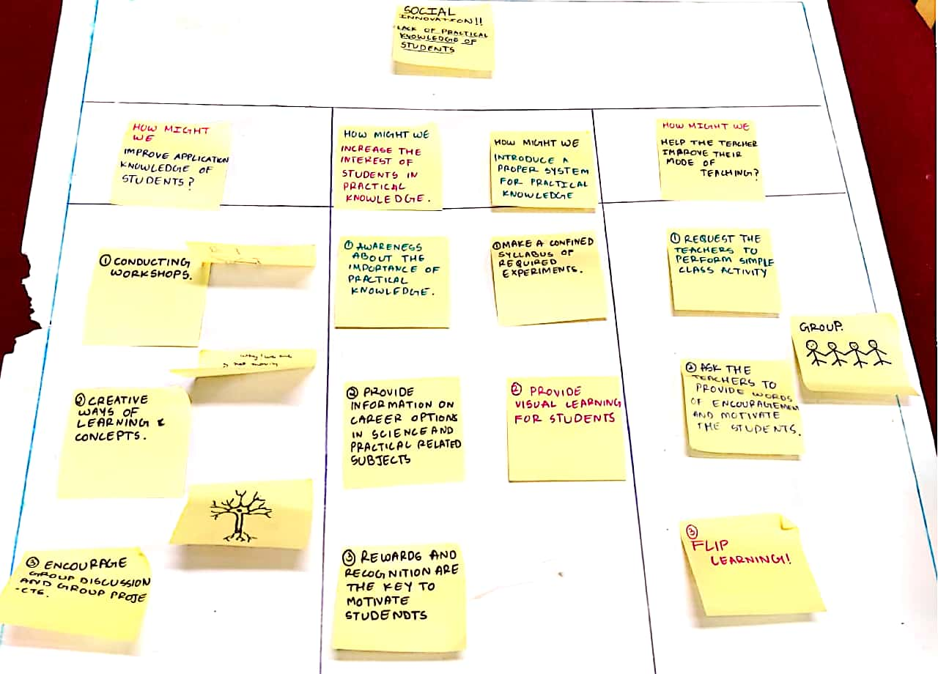

**Gallery – Images in action (Self explanatory)**

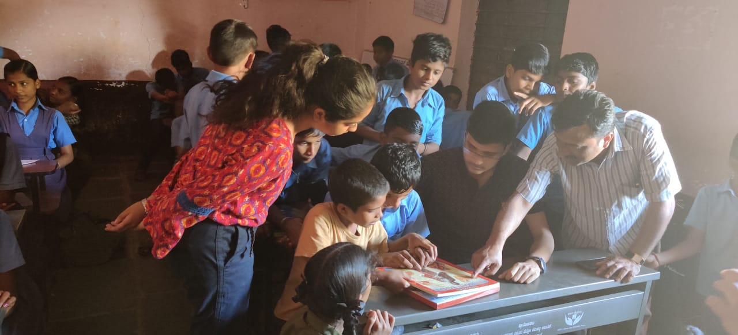

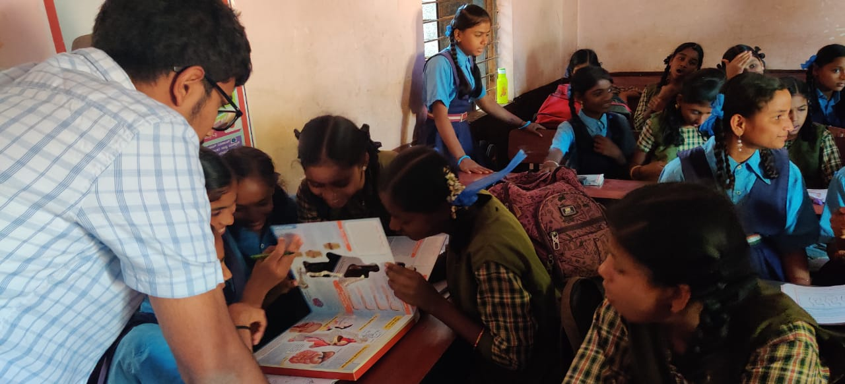

**Gallery – Images in action (Self explanatory)**

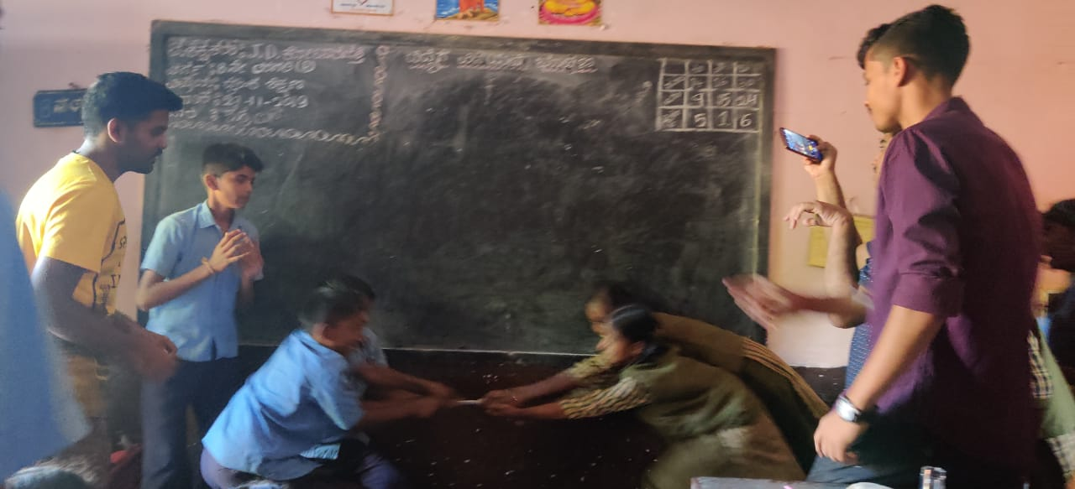

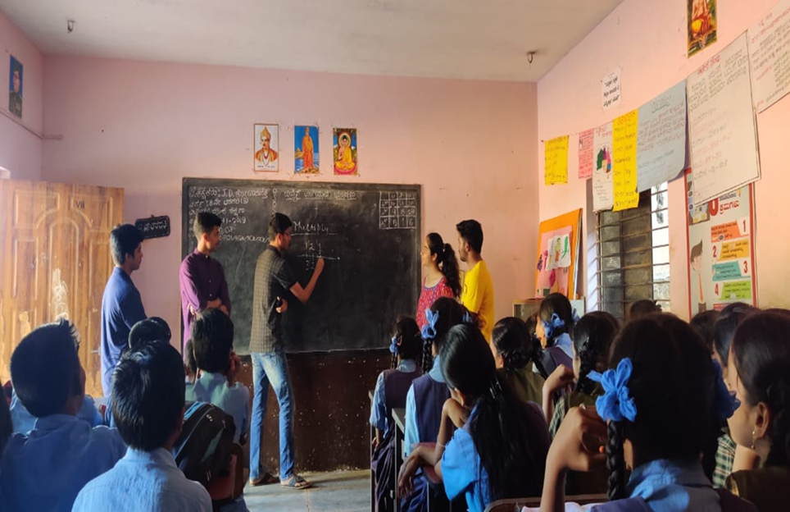

**Primary Stakeholder’s Feedback**

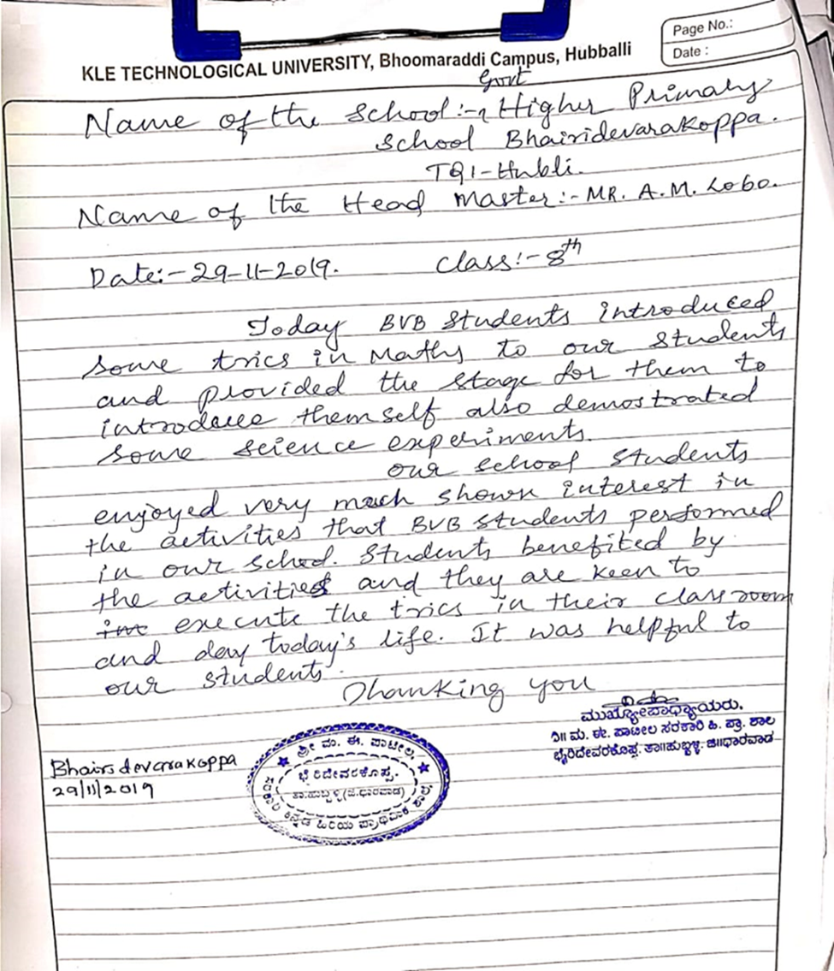

**Phase 5: Reflect**

As part of the course, our team got a chance to reflect as a group on team dynamics, working styles, and what it was like to collaborate as problem solvers.

Below paragraphs explains the overall learning that has happened through Social Innovation course.

**What was it like to work as a team? What was most inspiring? What was most frustrating?**

As part of the course, our team got a chance to reflect as a group on team dynamics, working styles, and what it was like to collaborate as problem solvers.

We got an opportunity to interact with children. We spent a very pleasant time with them. During this session, we enhanced our skills like decision making, problem analyzing, finding the solutions, communications skills. Interacting with the children, giving the solutions to their problems and during implementation, having smiles on their faces was most inspiring.

During the engage phase, when we came to know that students of this government school does not have the science labs for performing the experiments, and they don’t have the knowledge to apply the theoretical part of the syllabus into the real world and don’t get as much exposure as compared to the private school children was the most frustrating.

**What were the most successful aspects of the course for you? What were the weakest parts of the course? How might we improve the course for next time?**

Engage was the most successful part as this phase allows the observer to study the uncommon situation in the community and connection with the society has been established.

Implementation was the weakest part, since we don’t have enough resources to provide a permanent solution to this problem

This course can be improved by removing the real-life implementation part because we don’t have enough knowledge yet to make complex projects and provide a technical aspect/view to the selected problems

**FUTURE PROSPECTS:**

Education is the building base for any developing country. And we know that the India is a developing country. So, education should be the main concern.

And the issue we found is related to the education. Students of the government school in Bairideverkoppa, Hubballi, Karnataka were not able to apply the theoretical part into the real world as the students lag in practical knowledge, school doesn’t have the science labs and resources to perform the experiments.

So, we came up with the simple idea to conduct a workshop on experiments, Mathematics practicals, so, that the students can learn the basic insights of the experiments that are included in their syllabus. This solution can be permanent if the government and the government school decide to conduct extra class on any regular day. In this extra class, the teachers of that subject can perform or give insights of that experiment. This workshop (idea) can be the best possible permanent solution for this issue.

**CONCLUSION:**

The journey of social innovation helped us to understand the society as an engineer. Initial observations, knowing the people through interview and by following the advice of the consulted experts. Our Social Innovation project for the academic year 2019 was about "Enhancing the ability of students to apply theoretical knowledge”. The issue we found out was the students studying in Bairidevarakoppa higher primary school did not perform much practical experiments related to the theoretical topics they learnt. We did not addressed our topic with preconceived notions. We wanted to completely immerse ourselves into the “suffers” life and obtain their perspective. We came up with how we could help students in a small yet creative way. The workshop we conducted has certainly helped the students to learn various science concepts in a fun and interesting way. It was a breath of fresh air for the students from the usual classes. It has become very integral for students nowadays in these changing times to perform practical experiments in their school life to help them connect to practical life. The Indian education system should also take steps in this direction.