**Assignment 2**

Devyesh Tandon

120010008

**Part 1 (Without Blobs):**

**Total Time = 1 sec**

**Time Step = 0.001 sec**

No. Of Particles = 20

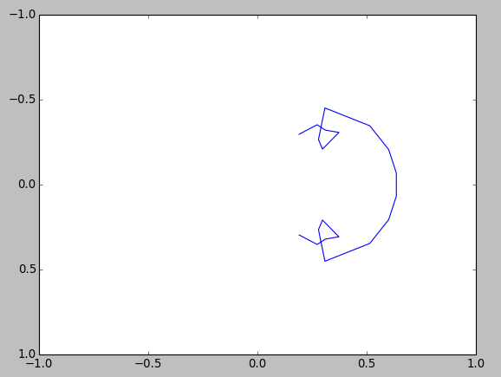

No. Of Paticles = 40

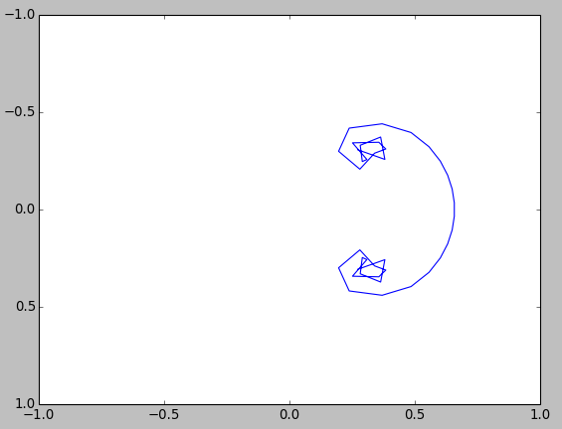

Clearly, the situation does not seem to improve with increaing number of vortex.

**Part 2 (With Blobs):**

**Total Time = 1 sec**

**Time Step = 0.001 sec**

**Blob ratio = 2**

Num. Of Paticles = 30

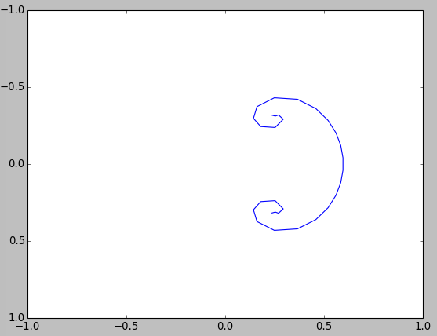

No. Of Particles = 60

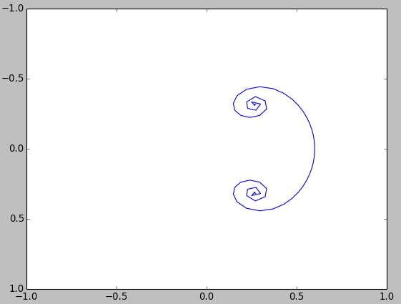

Num. Of Particles = 90

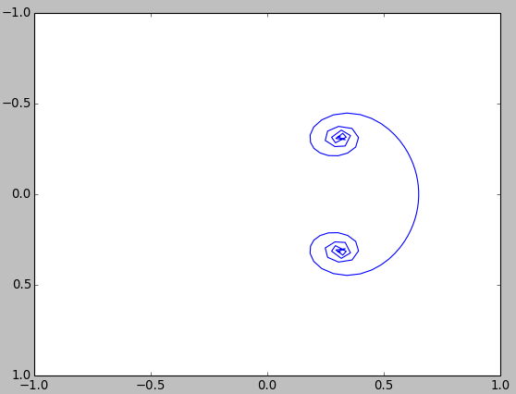

The number of particles gives a better resolution with increase in rolling up speed, and also shows sheet cutting through itself in very interior of the rollup with higher number of particles.

By increaing the the blob size, the rolling of sheet slows down, clealy because of reduction in strength. The Plot with changing blob radius is shwn below:

Number of particles = 90

time step = 0.01

Total time = 1

Blob Ratio = 2

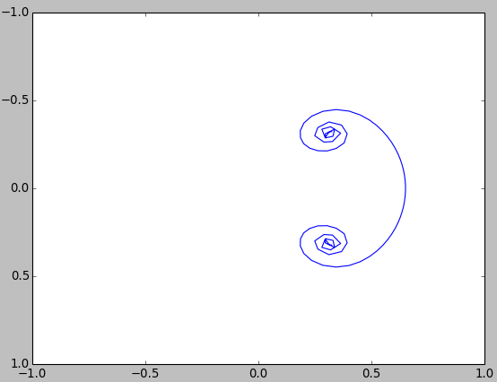

Blob Ratio = 3

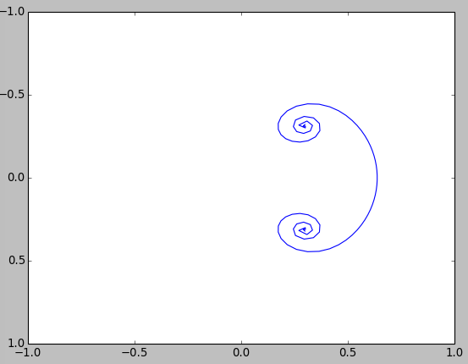

Blob Ratio = 4

