**Assignment 3**

Devyesh Tandon

120010008

**Question 1**

time_step = 0.01

Uniform Field Strength = 3

Number of Panels = 30

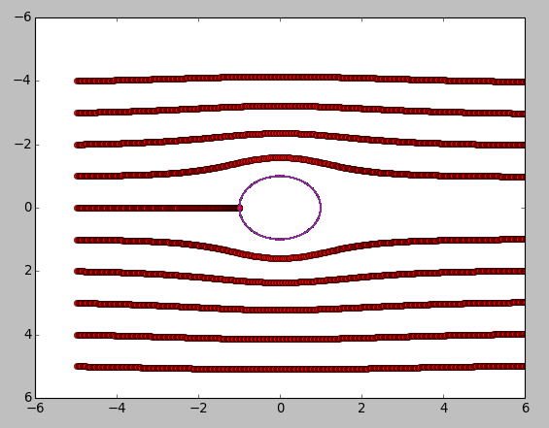

The traces enter the cylinder if the discretization length of Panels on th Cylinder is large. We face similar situationwhen strength of uniform flow is arbitarily high.

**Question 2**

time_step = 0.1

Strength of Vortex = 5

Number of Panels = 30

Cylinder Radius = 1

Simulation Time = 5 sec

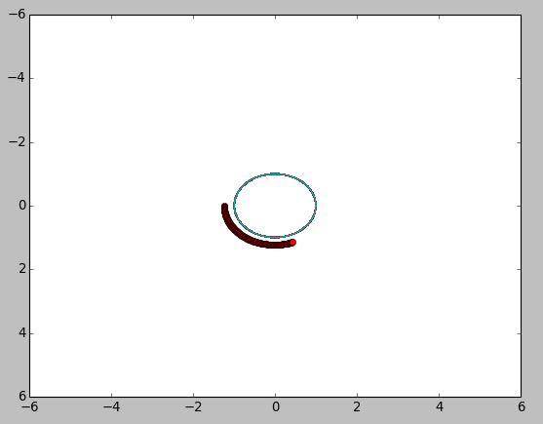

Number of panels = 50 Number of panels = 10

Strength = 5

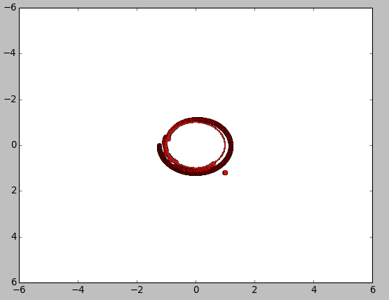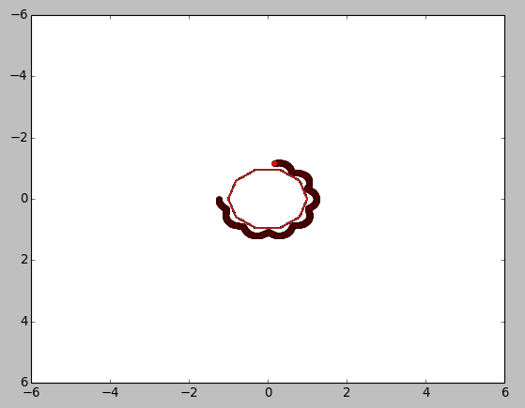

2@

Number of Panels = 50

Strength = 15

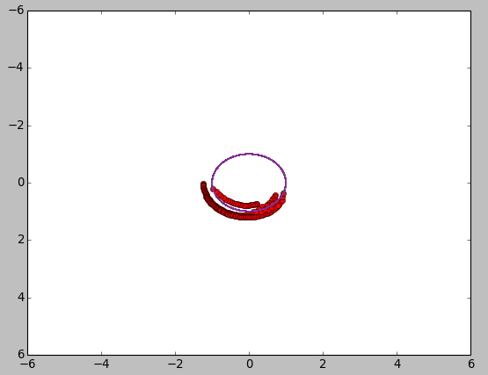

Question 3

Simulation using image method

