**Assignment 3**

Devyesh Tandon

120010008

**Question 1**

time_step = 0.01

Uniform Field Strength = 3

Number of Panels = 30

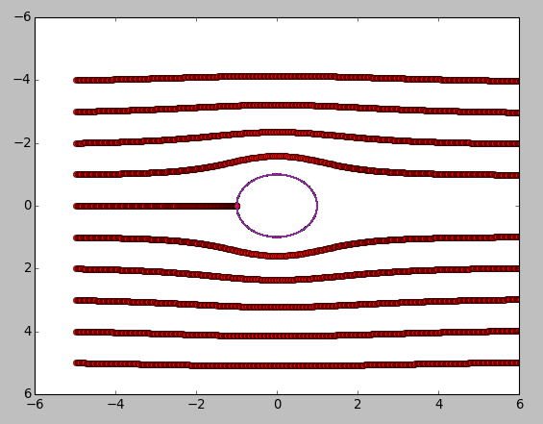

The traces enter the cylinder if the discretization length of Panels on th Cylinder is large. We face similar situationwhen strength of uniform flow is arbitarily high.

**Question 2**

time_step = 0.1

Strength of Vortex = 5

Number of Panels = 30

Cylinder Radius = 1

Simulation Time = 5 sec

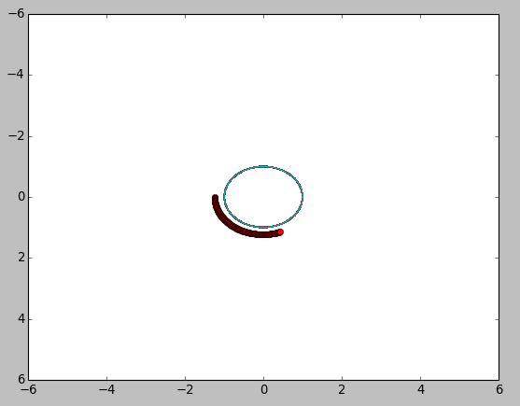

Num Of Panels = 10

Strength = 5

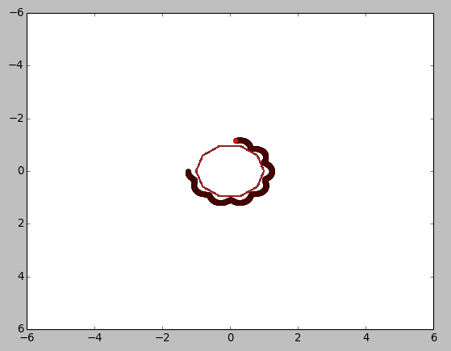

Question 3

Simulation using image method

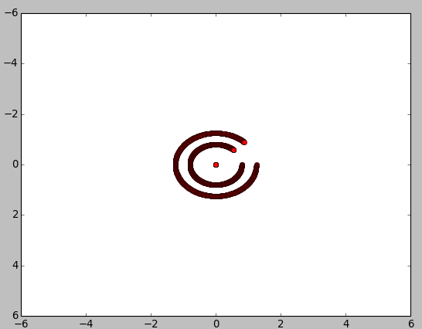

Error Comparision with method of images:

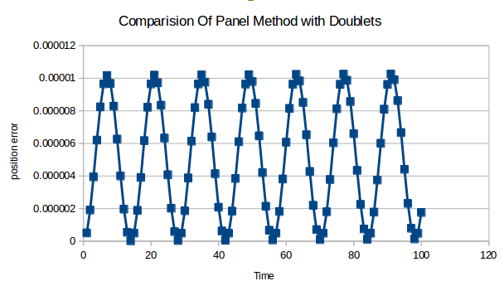

Question 4:

For Delta = 0.01

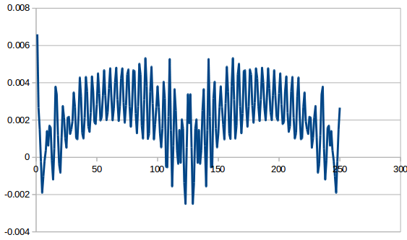

For Delta = 0.05

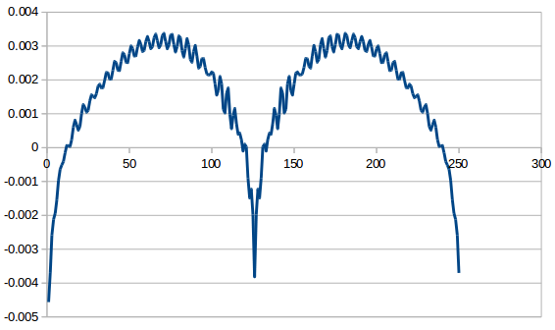

For Delta = 0.1

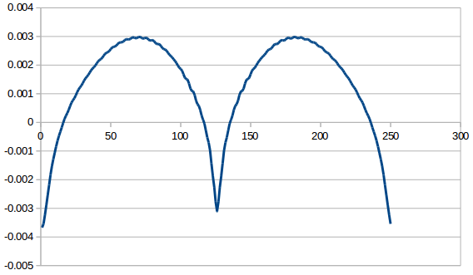

Conclusion:

As we approach 0, The oscillations begin to increase. For higher deltas, the variation is smooth.

Basically, its a sinosouid with small frequency superimosed with sinosoiud with larger frequencies. Magnitude of these large frequencies increase as delta -> 0