**Assignment 5**

Devyesh Tandon

120010008

Part A:

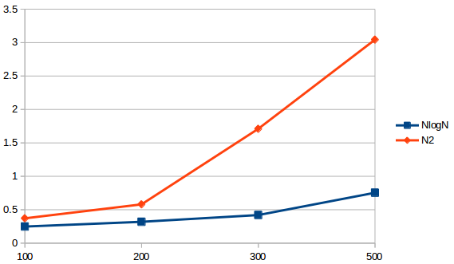

X-axis = particles

Y-axis = Time

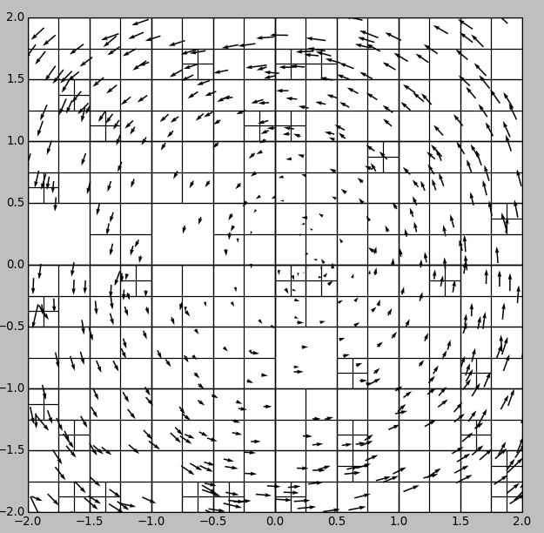

No. Of particles = 500 (all vortices)

Error norm with N2 = 0.000837852606601

No. of terms in expansion = 10

Max Particles in a cell = 3

Part B:

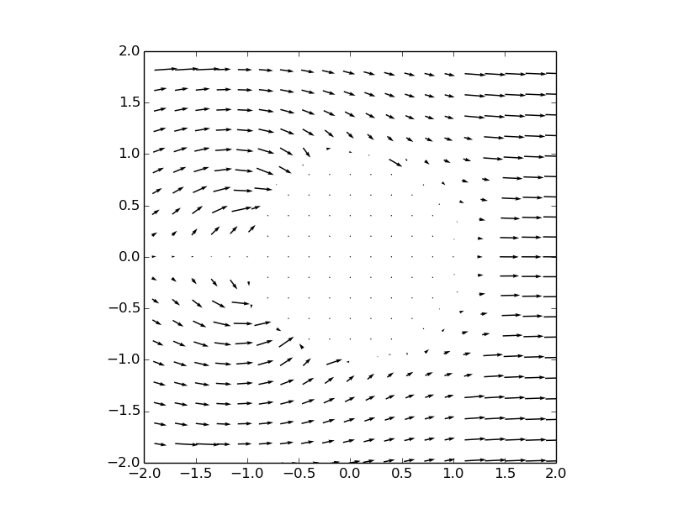

The results are not obtained upto the mark. There is a possibility error in code. I will complete this part and mail it

Conclusion:

The tree code or Fast multipole method is way faster than the original.