Assignment 1

Devyesh Tandon
120010008

Part 1:
Euler:
Time Step = 0.1

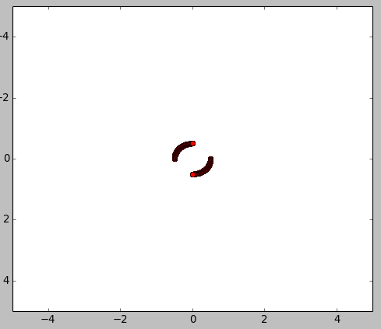

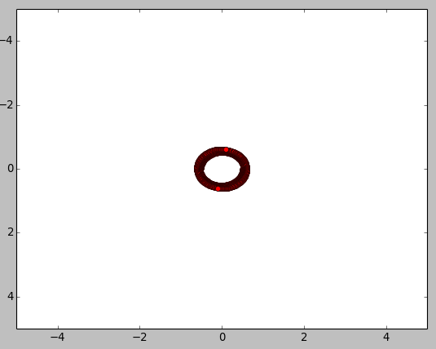

RK2:
Time Step = 0.1

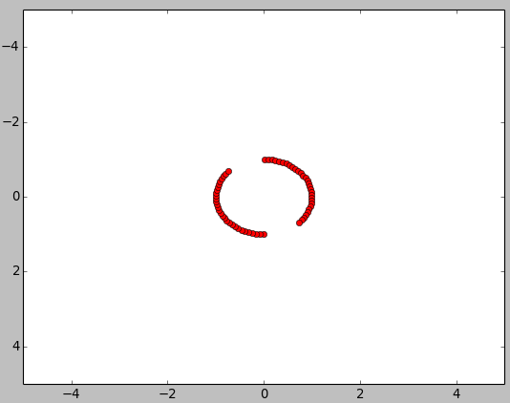

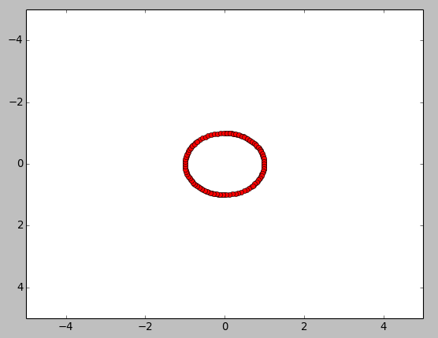

RK2 Proof
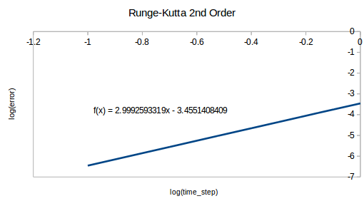

Part2 :
Vortex Strength Magnitude = 1

Fixed Vortex Points
Opposite Direction Rotation:
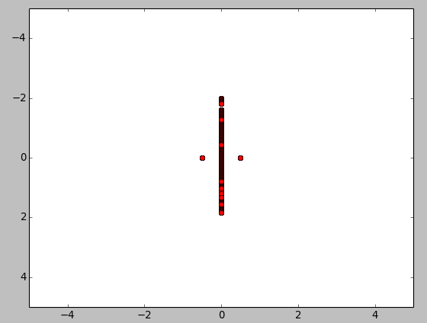

Same Direction Rotation:
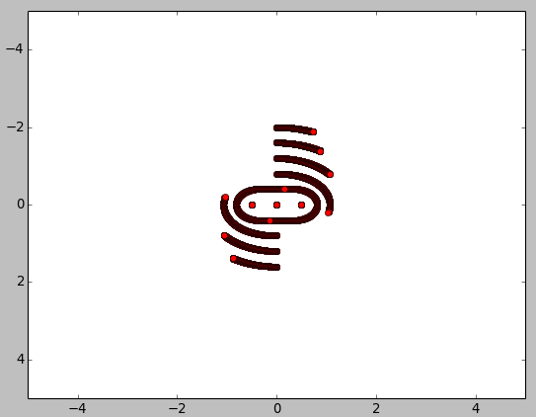

Part 3:
Doublet and Uniform flow

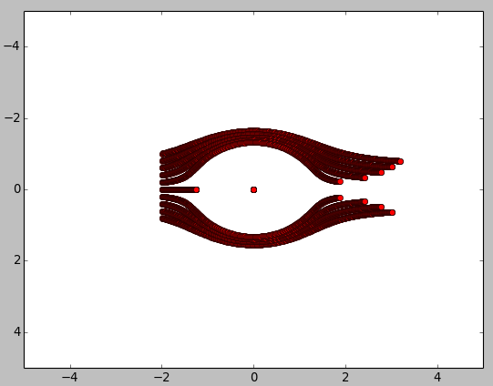

Part 4:
Source at (-0.25, 0) and sink at (0.25, 0).
Time ~50 sec
