SV300/SV350

Ventilator

Parts

Parts

SV300&SV350 Ventilator Main Unit Assembly

Exploded View
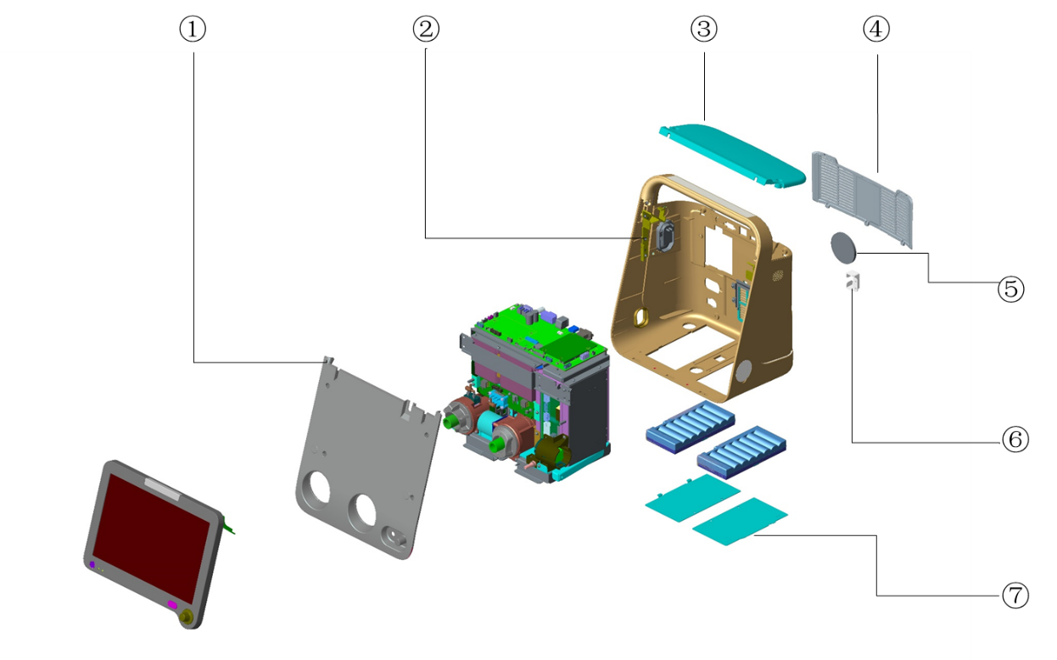

Parts List
No. | Order Number | Part Description | Qty | Remark
1 | 115-028045-00 | Front cover FRU (CE) | 1 | /
2 | 115-028046-00 | Host back cover FRU(CE) | 1 | /
3 | 115-021483-00 | EV20 host top cover assembly | 1 | /
4 | 115-028048-00 | Host inlet fence FRU(CE) | 1 | /
5 | 048-004133-00 | Dustproof net | 1 | /
6 | 042-010558-00 | EV20 power fixer | 1 | /
7 | 115-028049-00 | Battery door FRU | 1 | /

Display Front Housing Assembly

Exploded View
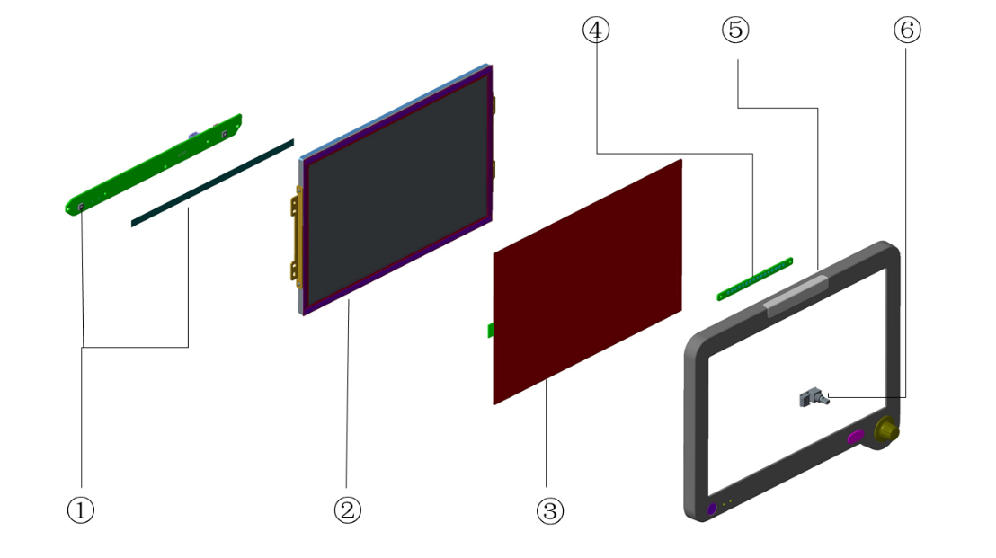

Parts List
No. | Order Number | Part Description | Qty | Remark
1 | 115-028055-00 | Key control PCBA FRU | 1 | /
2 | 115-022782-00 | EV20 Sharp display material package | 1 | /
3 | 021-000149-00 | Touch-panel resistive 12.1" 5-line wide | 1 | /
4 | 051-001554-00 | EV20 Alarm LED PCBA | 1 | /
5 | 115-028053-00 | Display front cover FRU(SV300) | 1 | /
5 | 115-028054-00 | Display front cover FRU(SV350) | 1 | /
5 | 115-049085-00 | Display front cover FRU(Acoma) | 1 | Only for "ACOMA"
6 | DA8K-30-27114 | Encoder | 1 | /

Kernel Assembly

Exploded View
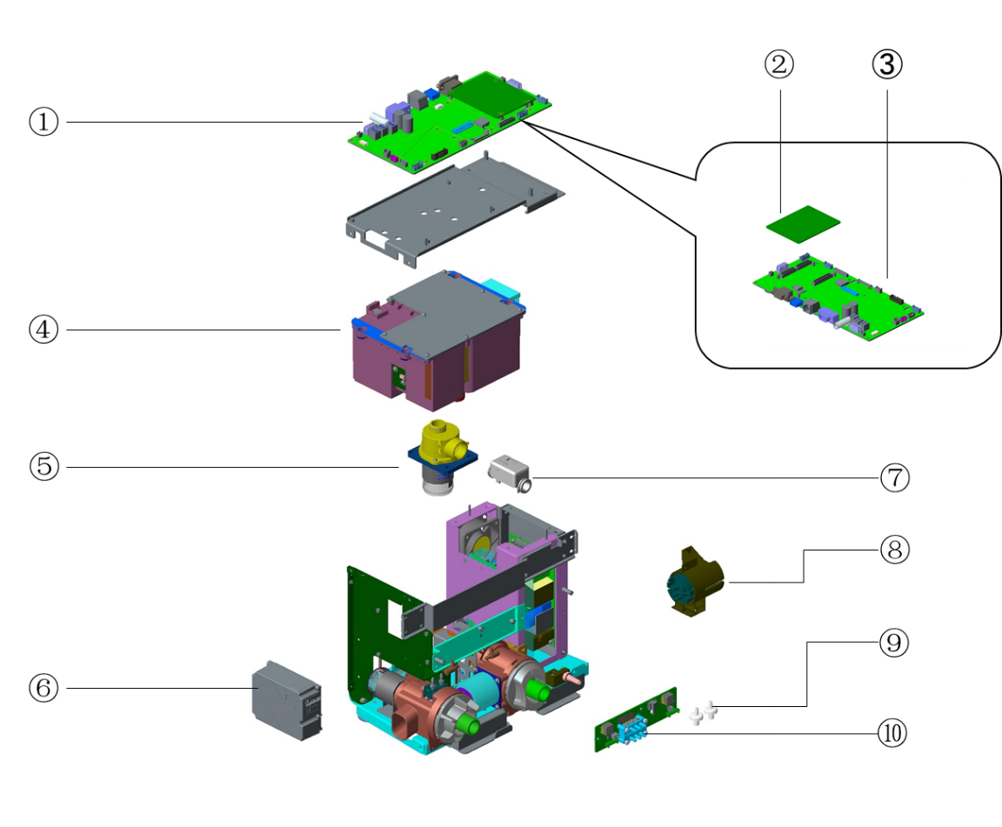

Parts List
No. | Order Number | Part Description | Qty | Remark
1 | 051-001779-04 | EV20 control assembly(classic) | 1 | /
1 | 051-005187-00 | EV20 control assembly(classic)-T | 1 | /
1 | 051-004439-00 | EV20 control assembly(single vc) | 1 | with software
1 | 051-001780-04 | EV20 control assembly(VGA&nurse call) | 1 | Only for "ACOMA",, with software
1 | 051-005186-00 | EV20 control assembly(VGA&nurse call)-T | 1 | Only for "ACOMA",, with software
2 | 051-001491-00 | EV20 main control board PCBA | 1
3 | 051-001778-02 | EV20 main board PCBA(VGA&nurse call) | 1 | /
3 | 051-001550-02 | EV20 VCM Main board （classic） PCBA | 1 | /
4 | 115-028051-00 | Blower box FRU | 1 | /
5 | 115-020420-00 | Inspiration valve | 1 | /
6 | 115-010077-00 | CO2 Module Unit(M02C) | 1 | /
7 | 012-000018-00 | SENSOR Flow Air 300slpm | 1 | /
8 | 115-021480-00 | O2 Mount of EV20 | 1 | /
9 | 082-001903-00 | PTFE Syringe Filter 13mm 5.0µm | 2 | /
10 | 051-003379-00 | EV20 Sensor Interface PCBA | 1 | Could be used to replace 051-001555-00
10 | 051-001555-00 | EV20 Sensor Interface PCBA | 1 | /

Main Unit Bracket Assembly

Exploded View
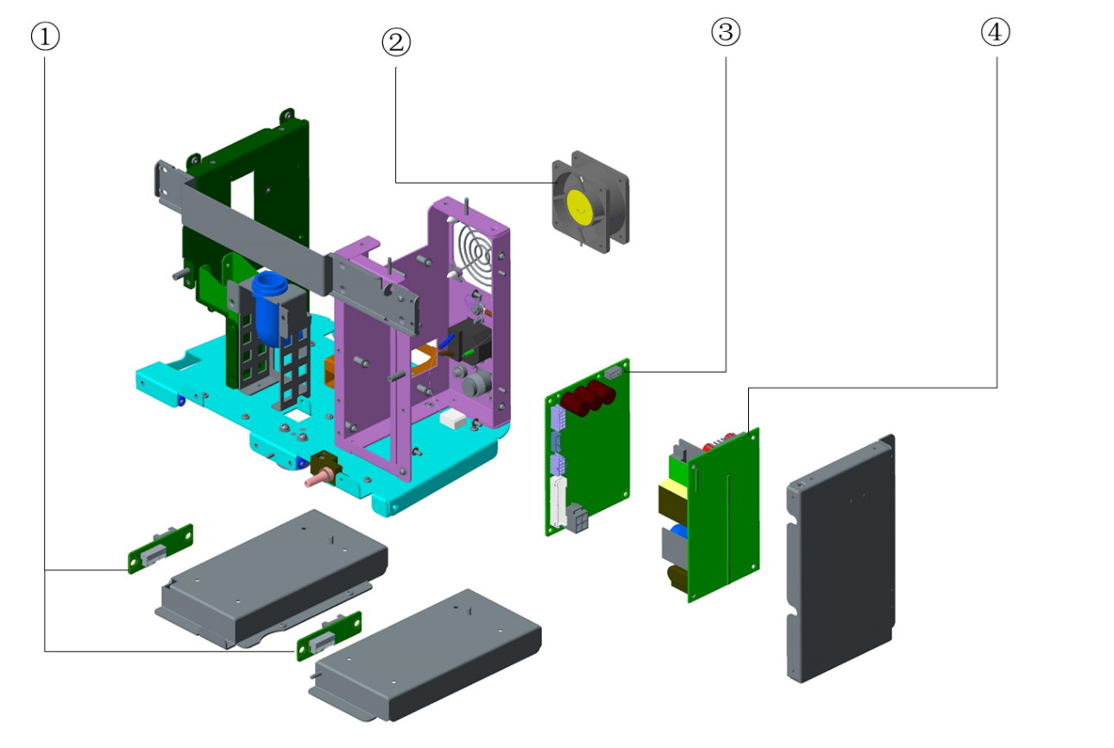

Parts List
No. | Order Number | Part Description | Qty | Remark
1 | 051-001551-01 | EV20 Battery Interface PCBA | 1 | /
2 | 115-028052-00 | Fan FRU | 1 | /
3 | 051-001777-00 | EV20 DC-DC power board PCBA(DC-IN) | 1 | /
3 | 051-001481-00 | EV20 DC-DC power board PCBA（without DC-IN） | 1 | /
4 | 115-074253-00 | POWER SUPPLY BOARD 18.8V 160W | 1 | /

Main Unit Rear Housing Assembly

Exploded View
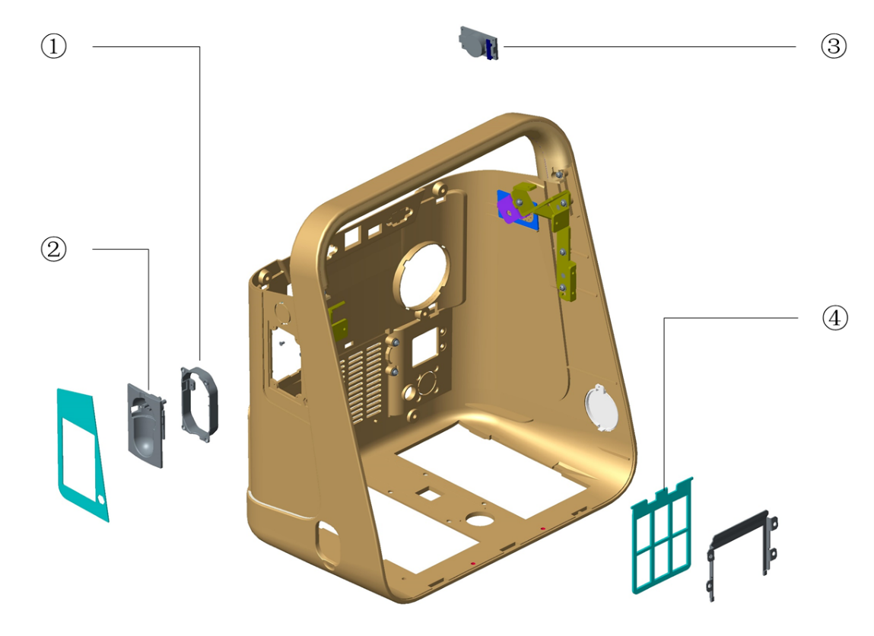

Parts List
No | Order Number | Part Description | Qty | Remark
1 | 9200-10-10591 | Mounting Frame. DRYLINE, Flush | 1 | /
2 | 040-000119-00 | Dry line receptacle Mindray 60-13510-01 | 1 | /
3 | 115-028050-00 | Speaker FRU | 1 | /
4 | 043-004111-00 | Fence for dustproof of EV20 | 1 | /

O2 Inlet Assembly（NIST）

Exploded View
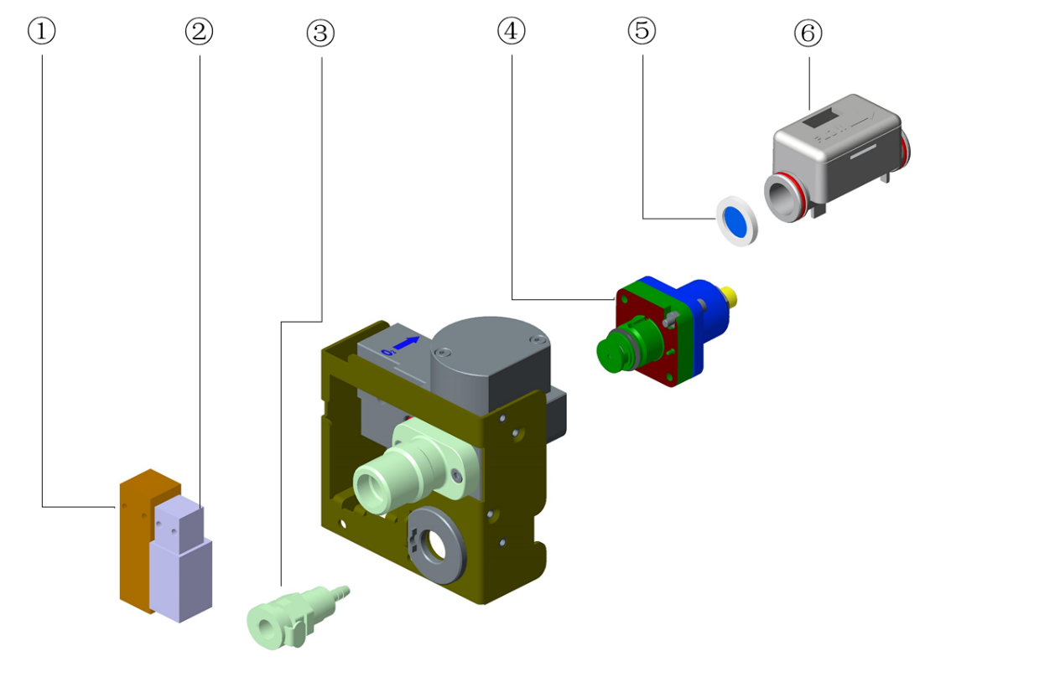

Parts List
No. | Order Number | Part Description | Qty | Remark
1 | 009-004173-00 | EV20 O2 proportional value with cable | 1 | /
1 | 009-008987-00 | EV20 O2 proportional valve with cable | 1 | Could be used to replace 009-004173-00
2 | 009-004174-00 | EV20 Nebulizer value with cable | 1 | /
3 | M6Q-030107--- | Panel mount hose barb PMCD160212 | 1 | /
4 | 115-045674-00 | Main body of regulator（220kPa） | 1 | /
5 | 049-000702-00 | Filter net | 1 | /
6 | 012-000019-00 | SENSOR Flow Oxygen 300slpm | 1 | /

Expiration Valve Assembly

Exploded View
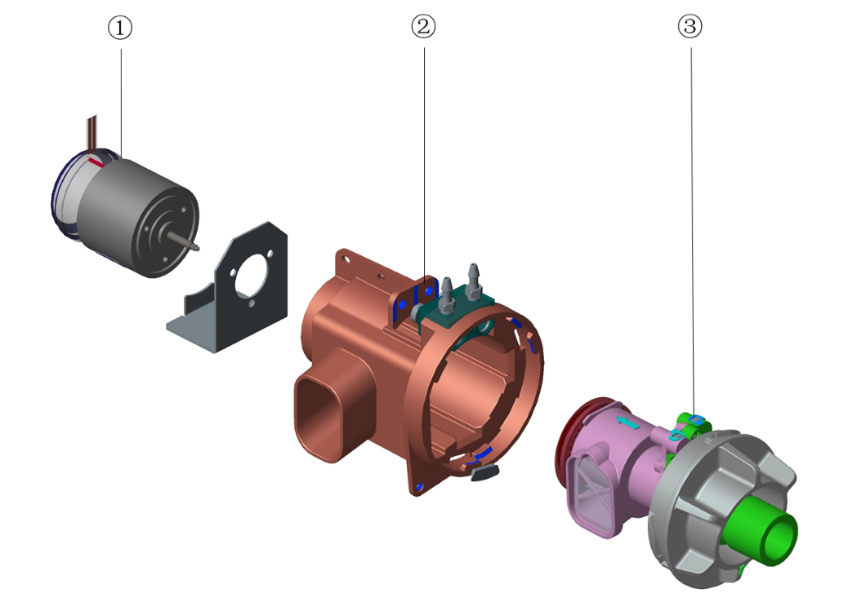

Parts List
No. | Order Number | Part Description | Qty | Remark
1 | 024-000565-00 | Voice coil motor | 1 | /
2 | 043-004013-00 | Exp. valve seat | 1 | /
3 | 115-021461-00 | Disinfectable exp. valve assembly | 1 | /

Safety Valve Assembly

Exploded View
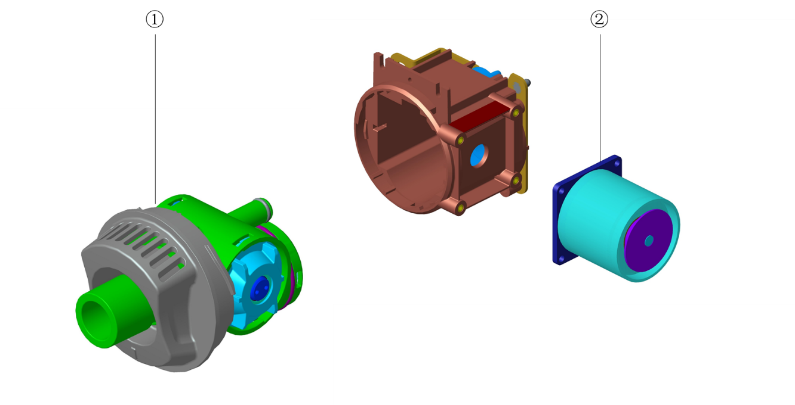

Parts List

No. | Order Number | Part Description | Qty | Remark
1 | 115-021478-00 | Detachable part of safety valve | 1 | /
2 | 024-000566-00 | Electromagnet 12V 48Ohm 4.8mm | 1 | /

Safety Valve Detachable Part

Exploded View
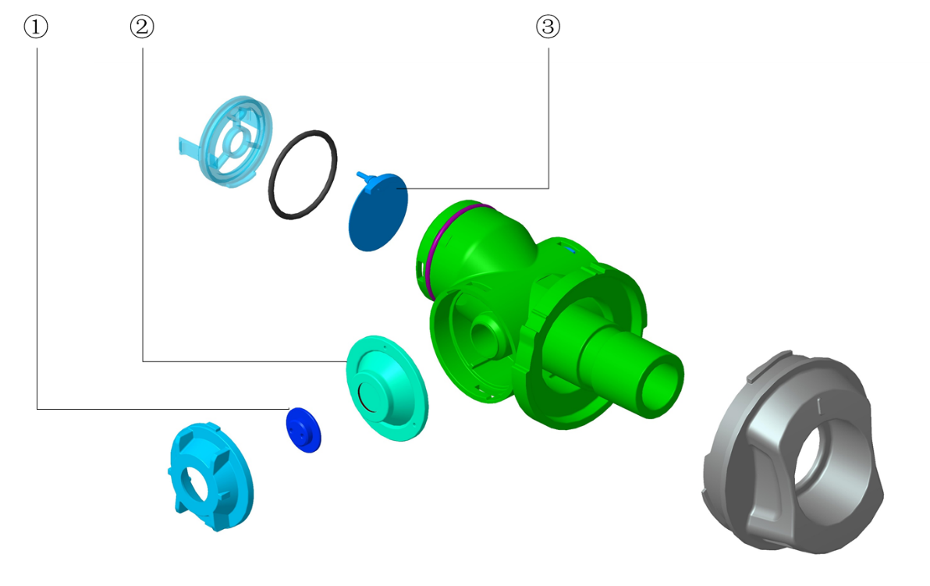

Parts List
Note: The P/N of this assembly is 115-021478-00。
No. | Order Number | Part Description | Qty | Remark
1 | 041-010186-00 | Supporting of membrane | 1 | /
2 | 049-000654-00 | Membrane of safety valve | 1 | /
3 | 049-000693-00 | Membrane of check valve | 1 | /

Expiration Valve Detachable Part

Exploded View
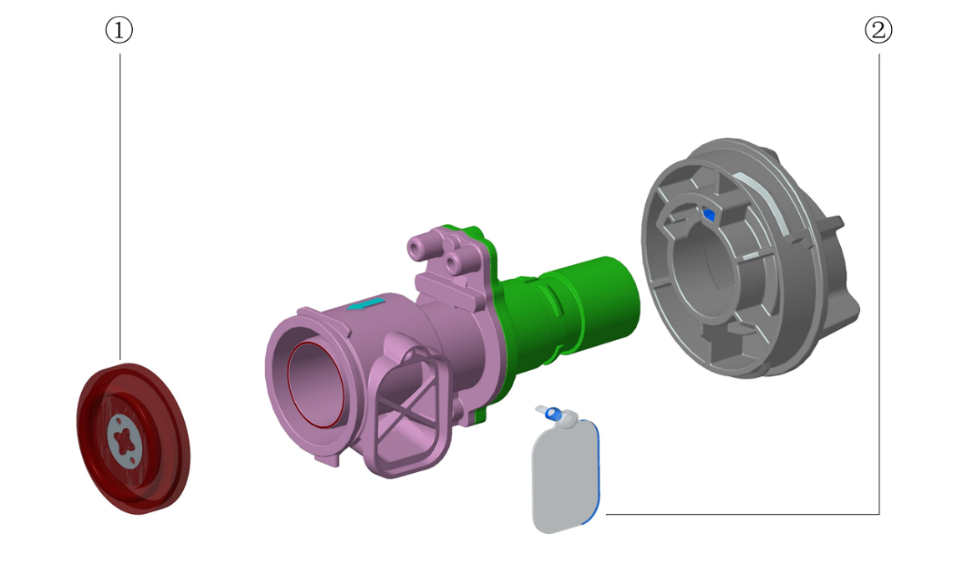

Parts List
Note: The P/N of this assembly is 115-021461-00。
No. | Order Number | Part Description | Qty | Remark
1 | 049-000778-01 | Exp. valve membrane | 1 | /
2 | 049-000684-00 | Exp. check valve | 1 | /

Blower Box Assembly

Exploded View
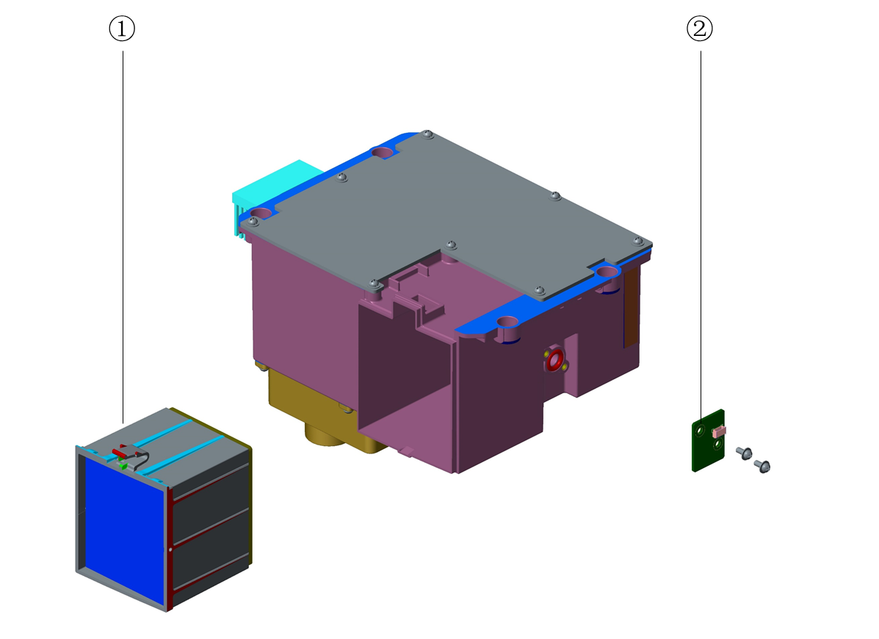

Parts List

No. | Order Number | Part Description | Qty | Remark
1 | 045-001333-01 | HEPA filter | 1 | /
2 | 051-001556-00 | EV20 negative pressure sensor PCBA | 1 | /

Trolley Assembly

Exploded View

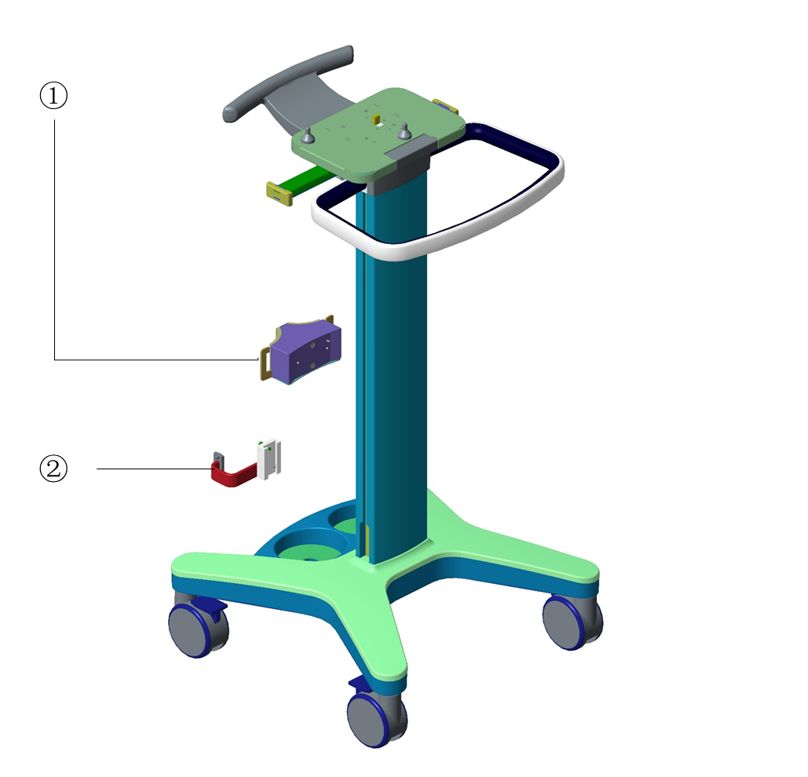

Parts List
No. | Order Number | Part Description | Qty | Remark
1 | 115-022677-00 | EV20 trolley gas cylinder fixed assembly | 1 | /
2 | 115-022676-00 | EV2O trolley humidifier fixed assembly | 1 | /

Trolley Handle Assembly

Exploded View
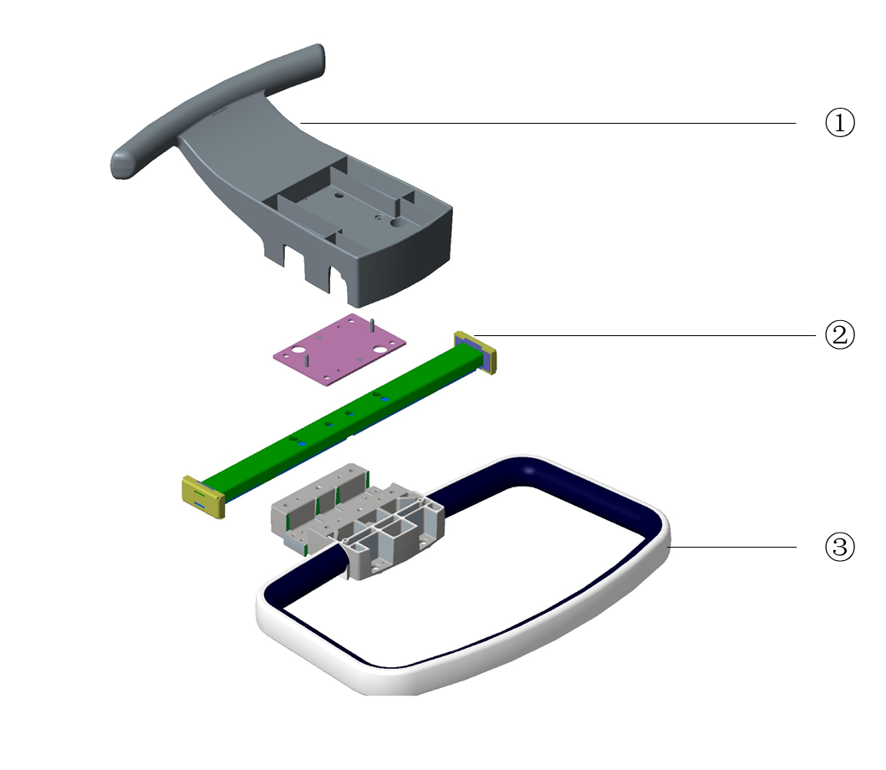

Parts List
No. | Order Number | Part Description | Qty | Remark
1 | 115-028057-00 | Trolley rear handle FRU | 1 | /
2 | 042-011007-00 | EV20 trolley arm support | 1 | /
3 | 044-000454-00 | EV20 trolley front handle | 1 | /

Trolley Support Platform Assembly

Exploded View
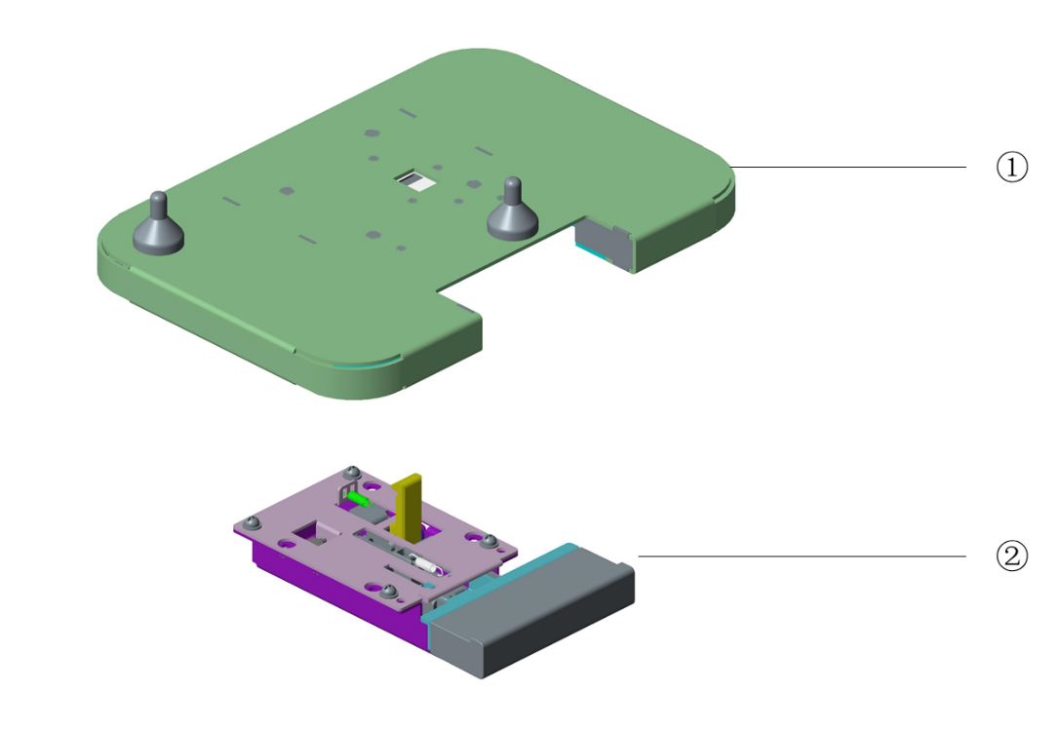

Parts List
No. | Order Number | Part Description | Qty | Remark
1 | 115-022675-00 | EV2O support table assembly | 1 | /
2 | 115-022678-00 | EV20 trolley push-button assembly | 1 | /

Trolley Base Assembly

Exploded View
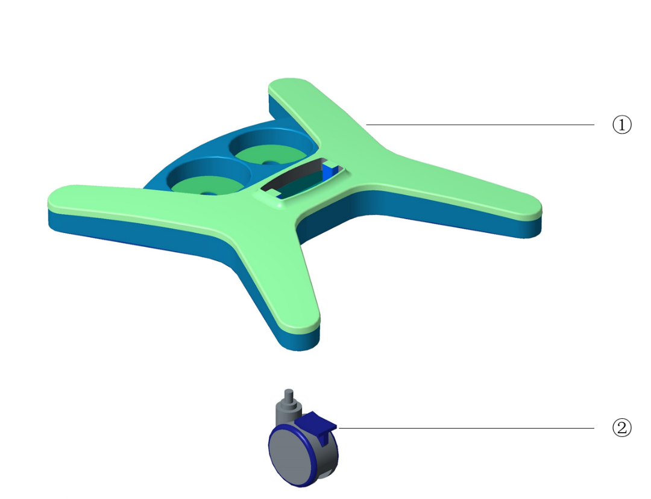

Parts List
No. | Order Number | Part Description | Qty | Remark
1 | 115-028056-00 | Trolley base cover FRU | 1 | /
2 | 0020-10-12509 | Caster.4" white, with brakes (FRU) | 4 | /

Others
No. | Order Number | Part Description | Qty | Remark
1 | A21-000007--- | Tube,Silicone,3/32"X7/32" | 1 | /
2 | M6G-020006--- | Tubing,Silicone,1/16"ID,1' | 1 | /
3 | M02A-10-25936 | Nafion(MR CO2),PM7,8E,9E | 1 | /
4 | 9200-10-10556 | AION System Tubing PUR 1.4 mm / 2.8 mm | / | /
5 | 115-030700-00 | Activation Code(USB/NIV)FRU | / | Optional function, If Applied, need to provide machine's SN and machine ID
6 | 115-030701-00 | Activation Code(USB/APRV)FRU | /
7 | 115-030702-00 | Activation Code(USB/PRVC)FRU | /
8 | 115-030703-00 | Activation Code(USB/P-V tool)FRU | /
9 | 115-030704-00 | Activation Code(USB/ATRC)FRU | /
10 | 115-031929-00 | Activation Code(USB/PRVC-SIMV)FRU | /
11 | 115-028397-00 | EV20 one year maintance kit | 1 | /
12 | 115-028389-00 | Side stream CO2 upgrade kit (Adu/Ped) | 1 | Optional，with accessory kit
13 | 115-028385-00 | Side stream CO2 upgrade kit (Neo) | 1 | Optional，with accessory kit
14 | 115-028386-00 | Mainstream CO2 upgrade kit | 1 | Optional，with accessory kit
15 | 115-028396-00 | Mindray SpO2 upgrade kit (Adu) | 1 | Optional，with accessory kit
16 | 115-028395-00 | Mindray SpO2 upgrade kit (Ped) | 1 | Optional，with accessory kit
17 | 115-022527-00 | Main Stream CO2 kit | 1 | Optional，without accessory kit
18 | 115-028393-00 | EV20 calibration set (maintance kit) | / | /
19 | 009-004548-00 | EV20 SHARP display cable | 1 | /
20 | 009-003008-00 | DC-IN power cord | 1 | /
21 | 009-004036-00 | EV20 sensor adapt board cable | 1 | /
22 | 0000-20-10901 | Cable, Power China | 1 | /
23 | 045-001298-01 | Dust preventing net | 1 | For humidifier mounting bracket on pendant
24 | 034-000123-00 | Heptagonal knob M8X30 | 1 | /
25 | M07-00130F--- | FUSE Time-lag 250V 3.15AD5X20 | 1 | /

