SynoVent E3&E5

Ventilator

Parts

Contents
1 Parts 3
1.1 E5 Main Unit 3
1.1.1 Exploded View 3
1.1.2 Parts List 3
1.2 E3 Main Unit 4
1.2.1 Exploded View 4
1.2.2 Parts List 4
1.3 E5 Display Assembly 5
1.3.1 Exploded View 5
1.3.2 Parts List 5
1.4 E3 Display Assembly 7
1.4.1 Exploded View 7
1.4.2 Parts List 7
1.5 Hardware Box 9
1.5.1 Exploded View 9
1.5.2 Parts List 9
1.6 Flow Sensor 10
1.6.1 Exploded View 10
1.6.2 Parts List 10
1.7 Gas way assembly 11
1.7.1 Exploded View 11
1.7.2 Parts List 11
1.8 Safety Valve Assembly 13
1.8.1 Exploded View 13
1.8.2 Parts List 13
1.9 Expiration Valve Seat Assembly 14
1.9.1 Exploded View 14
1.9.2 Parts List 14
1.10 Expiration Valve Assembly (E3/E5) 15
1.10.1 Exploded View 15
1.10.2 Parts List 15
1.11 Trolley Assembly 16
1.11.1 Exploded View 16
1.11.2 Parts List 16
1.12 Others 17

Parts

E5 Main Unit

Exploded View
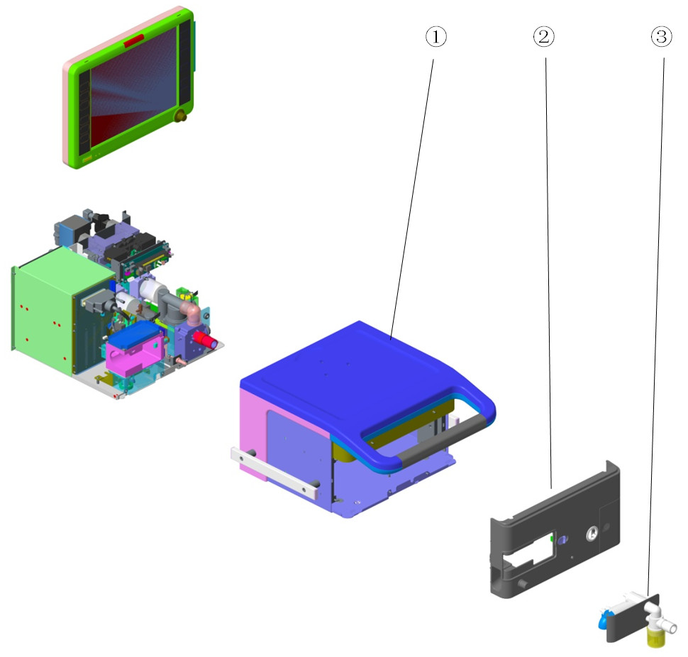

Parts List
No. | Order Number | Part Description | Qty | Remarks
1 | 801-VT50-00022-00 | Host shell assembly(VT50) | 1 | /
2 | 115-005258-00 | Main unit front housing assembly (E5) | 1 | /
3 | 801-VT50-00032-00 | Expiration valve assembly(E3/E5) | 1 | Used for E3 & E5

E3 Main Unit

Exploded View
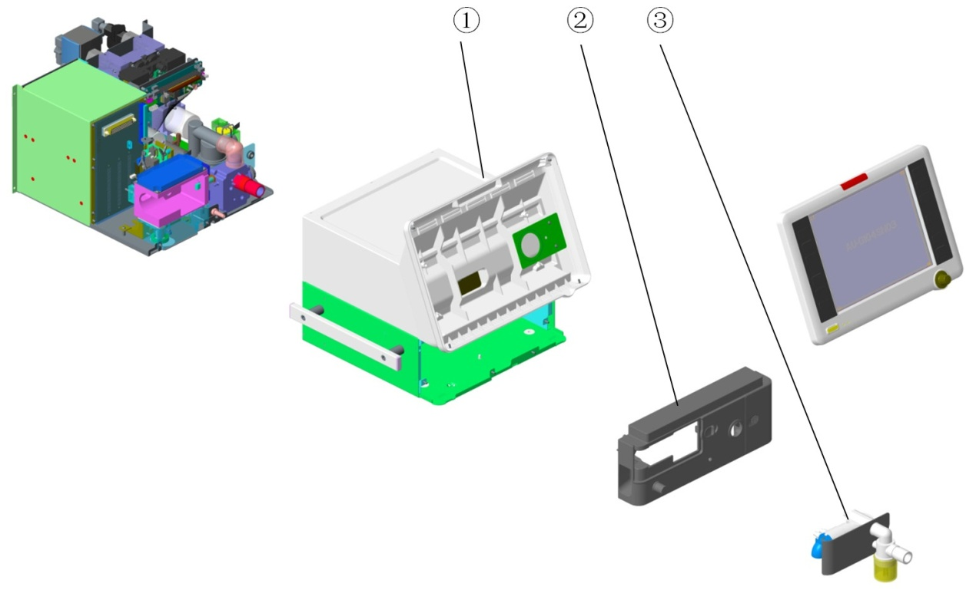

Parts List
No. | Order Number | Part Description | Qty | Remarks
1 | 801-VT50-00001-00 | Host shell assembly(VT30) | 1 | /
2 | 115-005257-00 | Front panel assembly (E3) | 1 | /
3 | 801-VT50-00032-00 | Expiration valve assembly(E3/E5) | 1 | Used for E3 & E5

E5 Display Assembly

Exploded View
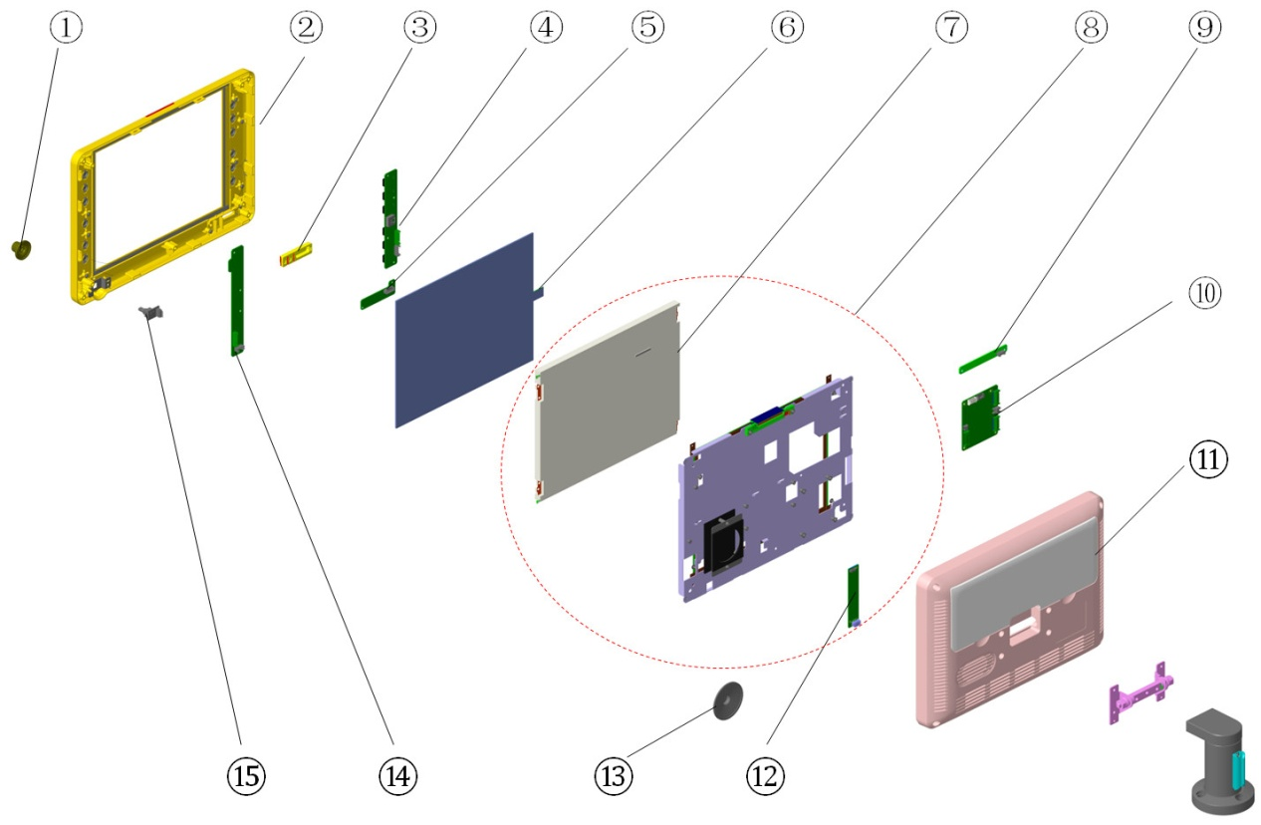

Parts List
No. | Order Number | Part Description | Qty | Remarks
1 | 043-000342-00 | control knob | 1 | /
2 | 801-VT50-00078-00 | UI front housing kit (E5/EN) (FRU) | 1 | Refer to TMZ-18005. Include Movement With The Key and Keypad Labels(English)
2 | 115-028445-00 | Front Cover of UI(E5/Multi-language) | 1 | Refer to TMZ-18005. Include Movement With The Key and Keypad Labels(German, Portuguese, French, Spanish, Italian, Polish)
3 | 6800-20-50201-51 | Power switch,T8 | 1 | /
4 | 051-000179-00 | Button scanning board (left) (FRU) | 1 | /
5 | 051-000181-00 | Power switch board (FRU) | 1 | /
6 | 0000-10-10799 | Touch Screen 12.1" | 1 | /
7 | 115-018030-00 | 12.1in display FRU(SHARP/LED) | 1 | /
8 | 115-018032-00 | E5 display kit (12.1' Sharp/LED) | 1 | Include 115-018030-00 and 051-001281-00. Refer to TMZ-13006
9 | 051-000182-00 | Alarm indicator board PCBA (FRU) | 1 | /
10 | 801-VT50-00057-00 | Button control board PCBA (FRU) | 1 | /
11 | 801-VT50-00061-00 | E5 rear housing kit (FRU) | 1 | /
12 | 051-001281-00 | 8.4 inch LED BACKLIGHT PCBA | 1 | Refer to TMZ-13006
13 | 9200-21-10633 | Speaker and Connecting Cable | 1 | /
14 | 051-000180-00 | Button scanning board (right) (FRU) | 1 | /
15 | 0010-30-43089 | Encoder board | 1 | /

E3 Display Assembly

Exploded View
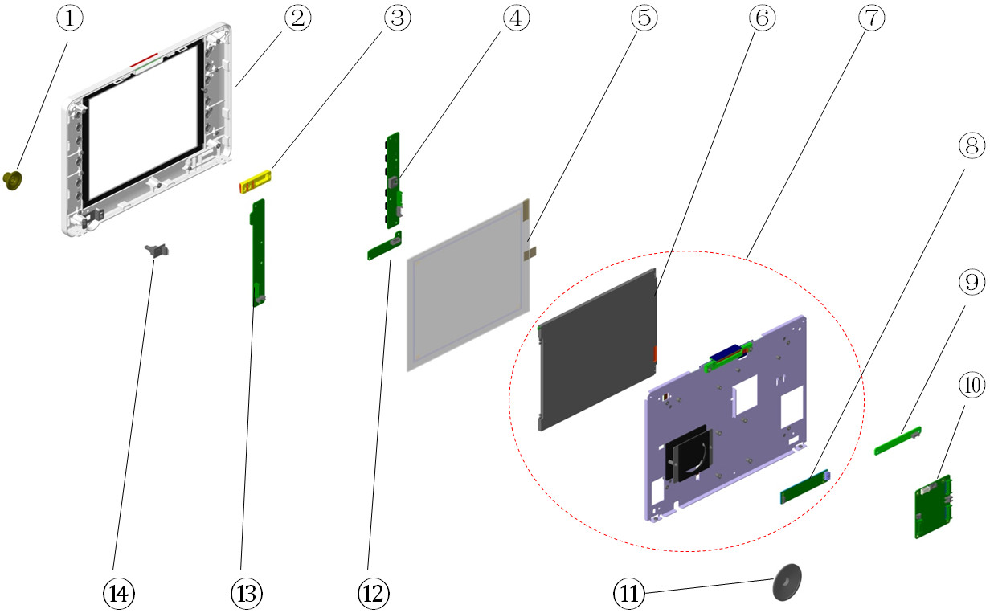

Parts List
No. | Order Number | Part Description | Qty | Remarks
1 | 043-000342-00 | control knob | 1 | /
2 | 801-VT50-00077-00 | UI front housing (E3/EN) kit (FRU) | 1 | Refer to TMZ-18005. Include Movement With The Key and Keypad Labels(English)
2 | 115-028444-00 | Front Cover of UI(E3/Multi-language) | 1 | Refer to TMZ-18005. Include Movement With The Key and Keypad Labels(German, Portuguese, French, Spanish, Italian, Polish)
3 | 6800-20-50201-51 | Power switch,T8 | 1 | /
4 | 051-000179-00 | Button scanning board (left) (FRU) | 1 | /
5 | 801-0613-00019-00 | Touch Screen 10.4" | 1 | /
6 | 115-018029-00 | 10.4 in display FRU(AU/LED) | 1 | /
7 | 115-018031-00 | E3 display kit (10.4'AU/LED) | 1 | Include 115-018029-00 and 051-001281-00. Refer to TMZ-13006
8 | 051-001281-00 | 8.4 inch LED BACKLIGHT PCBA | 1 | Refer to TMZ-13006
9 | 051-000182-00 | Alarm indicator board PCBA (FRU) | 1 | /
10 | 801-VT50-00057-00 | Button control board PCBA (FRU) | 1 | /
11 | 9200-21-10633 | Speaker and Connecting Cable | 1 | /
12 | 051-000181-00 | Power switch board (FRU) | 1 | /
13 | 051-000180-00 | Button scanning board (right) (FRU) | 1 | /
14 | 0010-30-43089 | Encoder board | 1 | /

Hardware Box

Exploded View
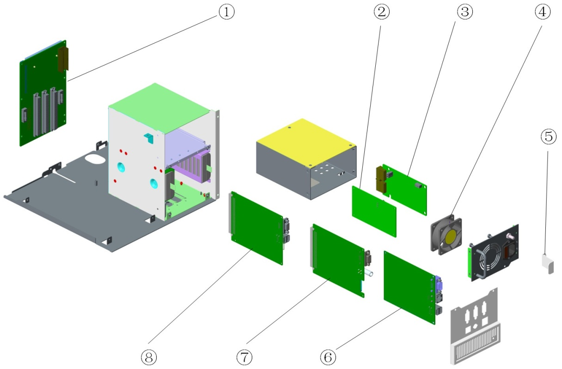

Parts List
No. | Order Number | Part Description | Qty | Remarks
1 | 801-VT50-00023-00 | Motherboard PCBA | 1 | /
2 | 051-000152-00 | AC-DC power board PCBA | 1 | /
3 | 115-060142-00 | DC-DC power board PCBA （with wire） | 1 | /
4 | 024-000102-00 | FAN 12V 60*60*25mm 19.1CFM 33.5dB 80mm | 1 | /
5 | 042-001455-00 | Power cord mounting plate | 1 | /
6 | 051-000139-02 | VT50 Main Control Board PCBA | 1 | E5 software
6 | 115-023939-00 | VT30 Main Control Board(TV20-2000ml/CE) | 1 | E3 software, for CE
6 | 801-VT50-00118-00 | E3 main control board PCBA(TV40-2000ml) | 1 | E3 software
7 | 051-000311-00 | Extension board PCBA | 1 | /
8 | 051-000632-02 | VT30 monitoring board PCBA | 1 | /

Flow Sensor

Exploded View
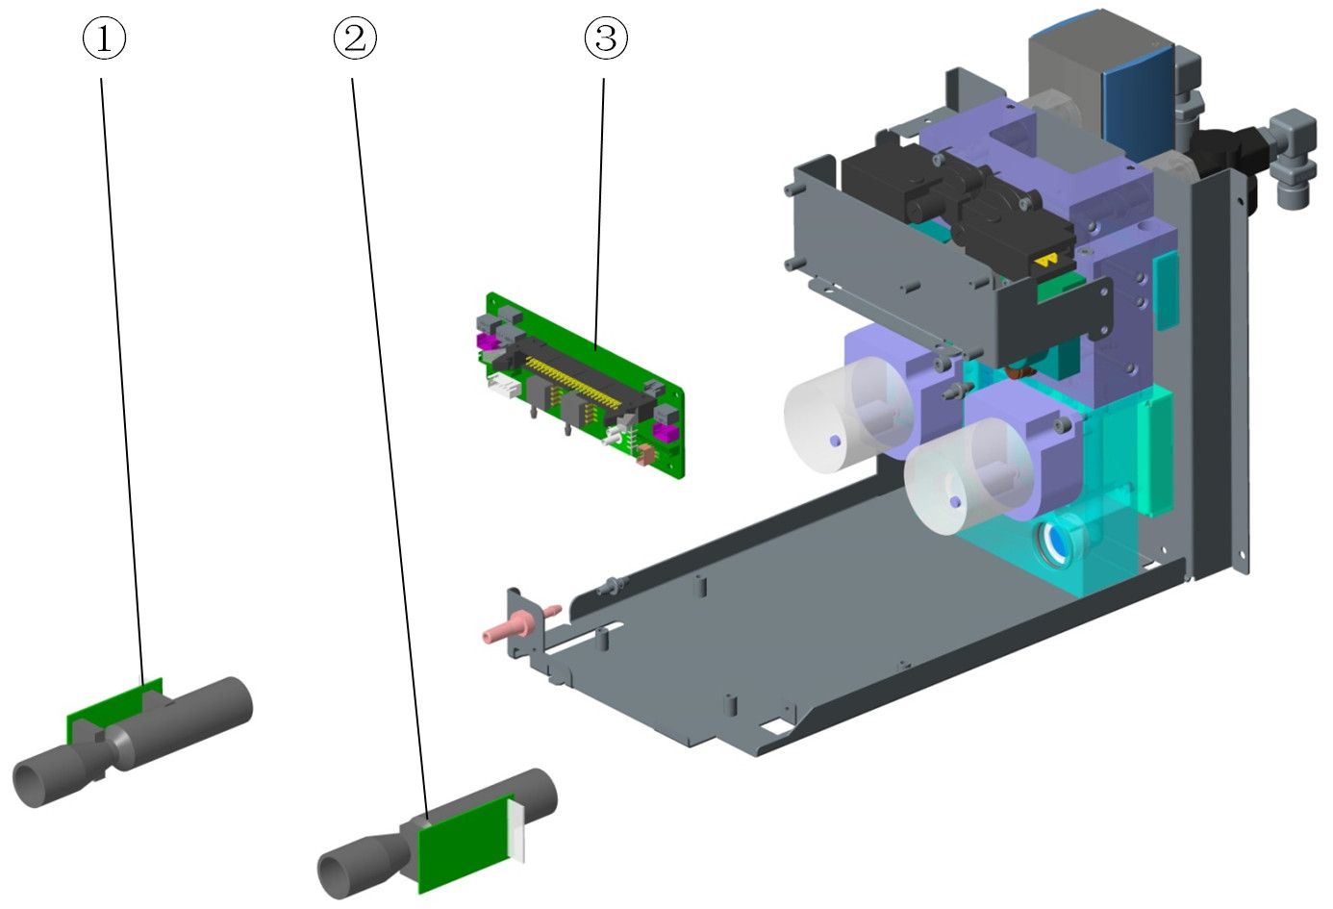
Notes:
This figure shows gas way assembly of old type (with two white proportional valves). In TMZ-13001, the gas way assembly changed to new type (with two black proportional valves, as shown in 1.7.1). If you encounter an old type gas way assembly failure, please replace it with a new type one.

Parts List
No. | Order Number | Part Description | Qty | Remarks
1 | 012-000021-00 | SENSOR Flow Air 300slpm 5VDC | 1 | Refer to TMZ-13009
2 | 012-000022-00 | SENSOR Flow Oxygen 300slpm 5VDC | 1 | Refer to TMZ-13009
3 | 051-000161-00 | Inspiration module board PCBA (FRU) | 1 | /

Gas way assembly

Exploded View
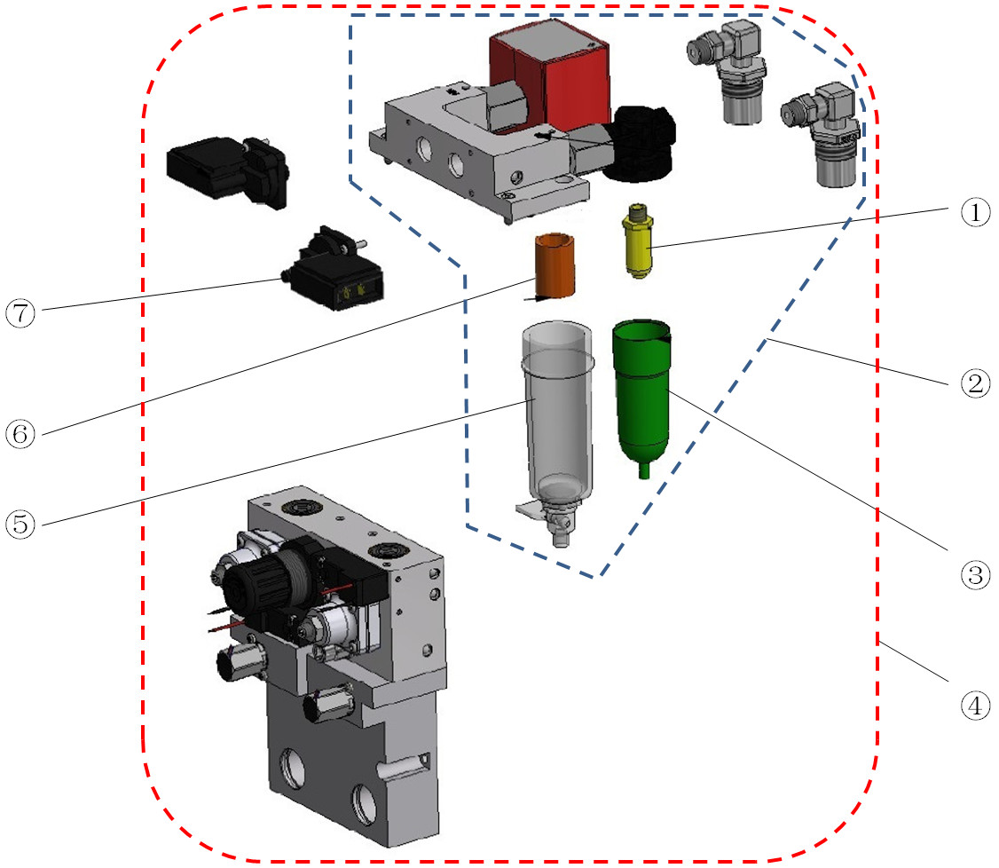

Parts List
No. | Order Number | Part Description | Qty | Remarks
1 | 082-000753-00 | Filter element 5um | 1 | In O2 inlet watertrap
2 | 082-002369-00 | DISS ASSY REPAIR KITS | 1 | W/O valve. Refer to TMZ-16014
2 | 082-002370-00 | NIST ASSY REPAIR KITS | 1 | W/O valve. Refer to TMZ-16014
3 | 082-000754-00 | Filter.bowl assembly | 1 | Watertrap for O2 inlet. And also used as Air inlet watertrap when it is the same with O2 inlet watertrap
4 | 115-041792-00 | gas way assembly(VT50/DISS)（Seal） | 1 | W/ valve. Refer to TMZ-16066
4 | 115-041793-00 | gas way assembly(VT50/NIST)（Seal） | 1 | W/ valve. Refer to TMZ-16066
5 | 082-001555-00 | Bowl assembly for air gas inlet (with O-ring) (service kit) | 1 | Watertrap for new Air inlet, bigger than 082-000754-00
6 | 082-001240-00 | FILTER.F92G-KIT 5um | 1 | In Air inlet watertrap
7 | 115-026517-00 | Pressure Switch(FRU) | 2 | Only 1 pressure switch in each 115-026517-00

Safety Valve Assembly

Exploded View
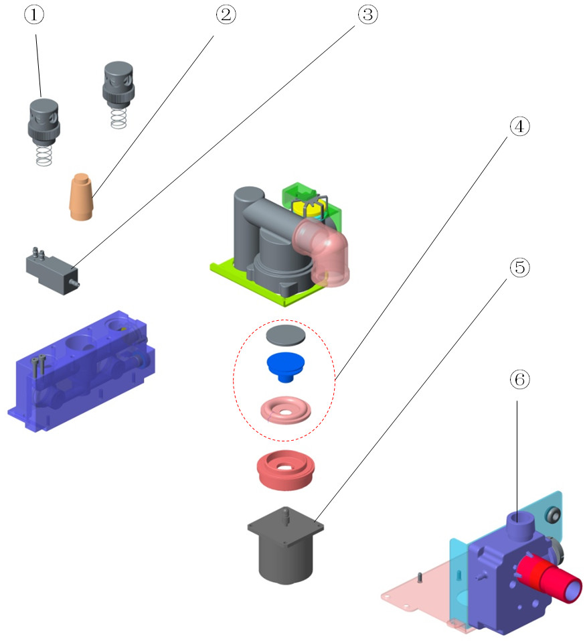

Parts List
No. | Order Number | Part Description | Qty | Remarks
1 | 115-008960-00 | 11kPa pressure relief valve | 2 | Only 1 valve in each 115-008960-00
2 | 082-000533-00 | Muffler.G3/8,06700017 | 1 | /
3 | 115-041552-00 | 3-way valve and wire ( with screw) | 1 | /
4 | 801-VT50-00048-00 | Safety valve membrane assembly | 1 | /
5 | 801-VT50-00047-00 | Safety electromagnet | 1 | /
6 | 115-004729-01 | Gas Reservoir Assembly(Gray) | 1 | /

Expiration Valve Seat Assembly

Exploded View
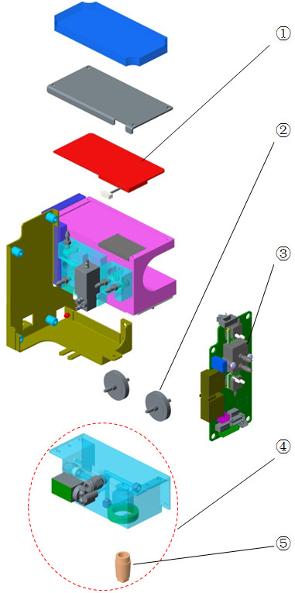

Parts List
No. | Order Number | Part Description | Qty | Remarks
1 | 024-000087-00 | Heating plate assembly | 1 | /
2 | 082-001062-00 | Filter.Accuracy 0.22μm.Diameter 25mm | 3 | Only 1 filter in each 082-001062-00
3 | 115-060534-00 | Expiration module board PCBA kit | 1 | /
4 | 115-006751-00 | Peep valve base assembly | 1 | Include proportional solenoid valve
5 | 082-000532-00 | Muffler.G1/4,06700013 | 1 | /

Expiration Valve Assembly (E3/E5)

Exploded View
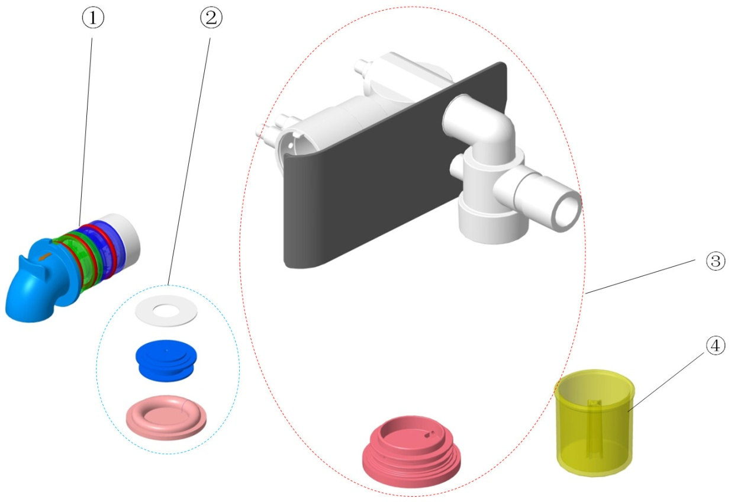

Parts List
No. | Order Number | Part Description | Qty | Remarks
1 | 115-016682-00 | Exp-Flow Sensor(pressure calibration)FRU | 1 | /
2 | 801-VT50-00051-00 | Expiration valve membrane assembly | 1 | /
3 | 801-VT50-00050-00 | Expiration valve body kit (FRU) | 1 | /
4 | 043-000551-01 | Water trap (PPSU) | 1 | /

Trolley Assembly

Exploded View
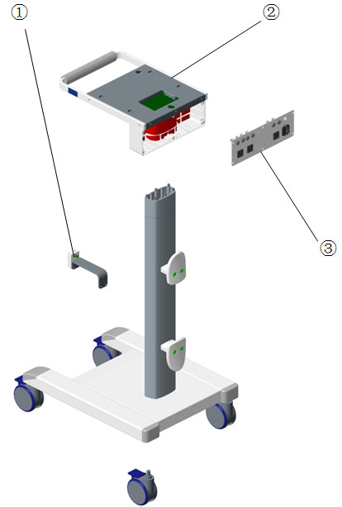

Parts List
No. | Order Number | Part Description | Qty | Remarks
1 | 115-004890-00 | Humidifier mounting bracket ass'y (FRU) | 1 | /
2 | 115-006075-00 | Mounting plate Assembly(VT30) | 1 | Only for E3
3 | 801-VT50-00070-00 | Auxiliary output ass'y (India) | 1 | /
3 | 801-VT50-00073-00 | Auxiliary output ass'y (UK) | 1 | /
3 | 801-VT50-00074-00 | Auxiliary output ass'y (EU) | 1 | /
3 | 801-VT50-00076-00 | Auxiliary output ass'y (US) | 1 | 110V
3 | 801-VT50-00094-00 | Auxiliary output ass'y (US 220V) | 1 | /
3 | 801-VT50-00101-00 | Auxiliary output ass'y (Brazil) | 1 | /
3 | 801-VT50-00102-00 | Auxiliary output ass'y (CN/AU) | 1 | /

Others
No. | Order Number | Part Description | Qty | Remarks
1 | 115-016712-00 | Activation Code(USB/PV tool) | 1 | Need to provide machine's SN and machine ID
2 | 801-VT50-00104-00 | Activation Code(USB/PRVC) | 1 | Need to provide machine's SN and machine ID
3 | 801-VT50-00105-00 | Activation Code(USB/APRV) | 1 | Need to provide machine's SN and machine ID
4 | 801-VT50-00106-00 | Activation Code(USB/DUOLEVEL) | 1 | Need to provide machine's SN and machine ID
5 | 801-VT50-00107-00 | Activation Code(USB/NIV) | 1 | Need to provide machine's SN and machine ID
6 | 801-VT50-00108-00 | Activation Code(USB/P0.1) | 1 | Need to provide machine's SN and machine ID
7 | 801-VT50-00109-00 | Activation Code(USB/NIF) | 1 | Need to provide machine's SN and machine ID
8 | 801-VT50-00112-00 | Activation Code(USB/WOB) | 1 | Need to provide machine's SN and machine ID
9 | 115-023205-00 | Activation Code(USB/ATRC) | 1 | Need to provide machine's SN and machine ID
10 | 115-035867-00 | Activation Code(USB/O2 therapy) | 1 | Need to provide machine's SN and machine ID
11 | 115-031929-00 | Activation Code(USB/PRVC-SIMV)FRU | 1 | Need to provide machine's SN and machine ID
12 | 115-012504-00 | Watertrap socket assembly | 1 | For Mindray CO2 module
13 | 040-002174-00 | Tanks for infant(CE version) | 1 | /
14 | 115-037824-00 | CO2 and Neonatal module package | 1 | /
15 | 010-000003-00 | FUSE Time-lag 250V 10A CER 5*20mm | 2 | /
16 | 023-000755-00 | Industrial SD 1G | 1 | /
17 | 801-VT50-00114-00 | 1-year maintenance kit | 1 | /
18 | 046-000997-00 | SynoVent E3/E5 Service Manual (EN) | 1 | /
19 | 803-010504-00 | SynoVent E5 main unit Warranty (1-year) | 1 | /
20 | 803-010505-00 | SynoVent E3 main unit warranty | 1 | /

