WATO EX-35(KG-)

Anesthesia Machine

Parts

Contents
1 Parts 4
1.1 WATO EX-35 Main Unit 4
1.1.1 Exploded View 4
1.1.2 Parts List 4
1.2 Gas bench receptacle assembly 5
1.2.1 Exploded View 5
1.2.2 Parts List 5
1.3 Liquid collection bottle assembly 6
1.3.1 Exploded View 6
1.3.2 Parts List 6
1.4 AGSS assembly 7
1.4.1 Exploded View 7
1.4.2 Parts List 7
1.5 Work table assembly 8
1.5.1 Exploded View 8
1.5.2 Parts List 8
1.6 Vaporizer bracket assembly 9
1.6.1 Exploded View 9
1.6.2 Parts List 9
1.7 Hardware box assembly 10
1.7.1 Exploded View 10
1.7.2 Parts List 10
1.8 Flow meter and pressure gauge panel assembly 12
1.8.1 Exploded View 12
1.8.2 Parts List 12
1.9 Display assembly 14
1.9.1 Exploded View 14
1.9.2 Parts List 14
1.10 Gas supply inlet assembly 15
1.10.1 Exploded View 15
1.10.2 Parts List 15
1.11 Main body of the patient circuit 17
1.11.1 Exploded View 17
1.11.2 Parts List 17
1.12 Lifting device 19
1.12.1 Exploded View 19
1.12.2 Parts List 19
1.13 Sodalime canister assembly 20
1.13.1 Exploded View 20
1.13.2 Parts List 20
1.14 Others 21

Parts

WATO EX-35 Main Unit

Exploded View
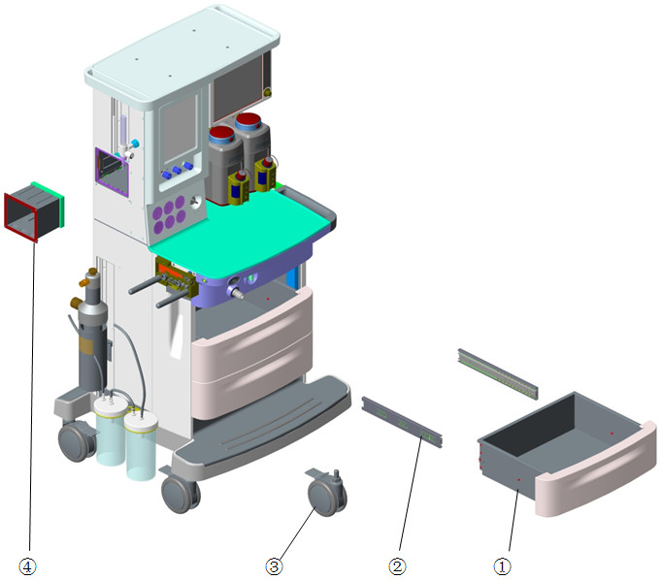

Parts List
No. | Order Number | Part Description | Qty | Remarks
1 | 115-025663-00 | drawer assembly(0625) | 3 | Only one in each 115-025663-00
2 | 031-000041-00 | ball guided.3flod 350mm blue zinc-plated | 6 | Only one in each 031-000041-00
3 | 801-0616-00036-00 | Caster with brake | 4 | Only one in each 801-0616-00036-00
4 | 115-036995-00 | Gas bench configure upgrade kit(0619) | 1 | /

Gas bench receptacle assembly

Exploded View
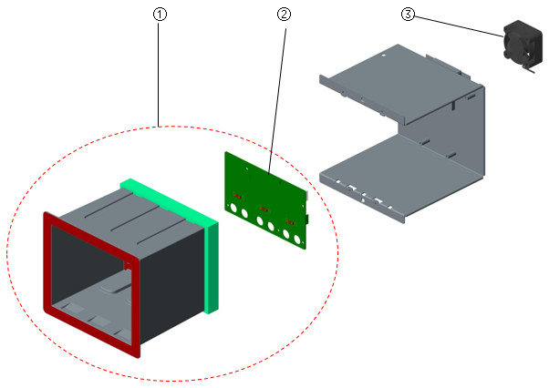

Parts List
No. | Order Number | Part Description | Qty | Remarks
1 | 115-016480-00 | gas bench receptacle assembly | 1 | /
2 | 801-0621-00165-00 | 0621 Infrared Communication Board | 1 | /
3 | 024-000407-00 | FAN 12V 40*40*20mm 6.3CFM 18dB typeF | 1 | /

Liquid collection bottle assembly

Exploded View
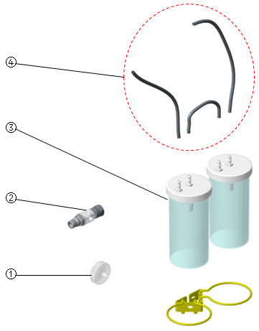

Parts List
No. | Order Number | Part Description | Qty | Remarks
1 | 082-001327-00 | Disposable Filter.0.45μm | 1 | /
2 | 115-020572-00 | Suction T-joint air(NIST)check valve | 1 | /
3 | 040-001532-00 | Vacuum flask | 1 | w/ overflow protection
3 | 040-001533-00 | Vacuum flask(no protection ) | 1 | w/o overflow protection
3 | 040-001659-00 | collecting bottle | 1 | w/ overflow protection, icon is printed on the side
4 | 040-001658-00 | tube.pvc | 1 | /

AGSS assembly

Exploded View
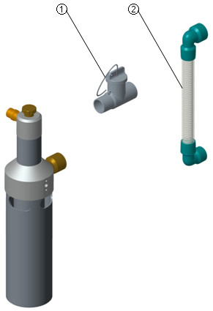

Parts List
No. | Order Number | Part Description | Qty | Remarks
1 | 115-042912-00 | AGSS 3 ways connector assembly | 1 | /
2 | 801-0631-00074-00 | AGSS Transfer Tube | 1 | /

Work table assembly

Exploded View
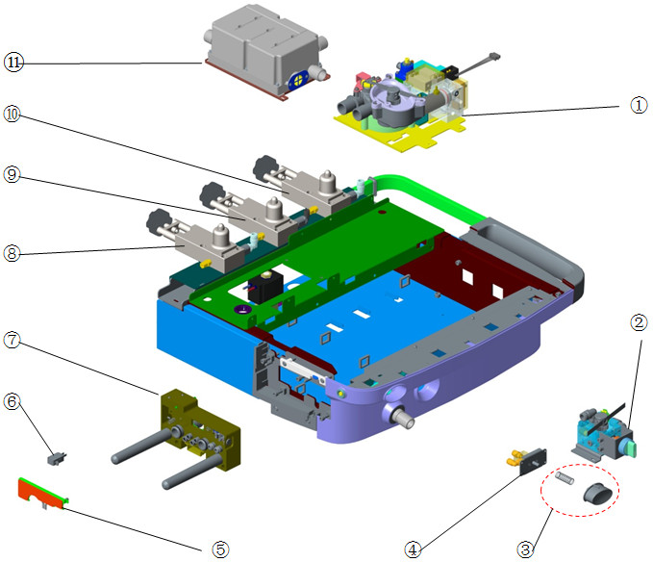

Parts List
No. | Order Number | Part Description | Qty | Remarks
1 | 115-011265-01 | Ventilation valve assembly(0616) | 1 | /
2 | 115-061227-00 | mechanical ACGO assembly(0625) | 1 | /
3 | 115-037147-00 | O2 flush button service kit(0619/0625) | 1 | /
4 | 801-0613-00026-00 | O2 flush switch assembly | 1 | /
5 | 024-000185-00 | BC heater for 0616 | 1 | /
6 | 801-0613-00055-00 | Snap action switch (rolling type 200gf) | 1 | /
7 | 115-006653-00 | assembly of block(No ACGO/No bypass) | 1 | /
7 | 115-006652-00 | assembly of block(No ACGO/bypass) | 1 | /
8 | 115-002250-01 | Cylinder Bracket for O2 | 1 | w/ regulator
9 | 115-002251-02 | Cylinder Bracket for N2O(Φ6) | 1 | w/ regulator
10 | 115-002728-01 | Cylinder Bracket for AIR | 1 | w/ regulator
11 | 115-032992-00 | Gas reservoir assembly(0625) | 1 | /

Vaporizer bracket assembly

Exploded View
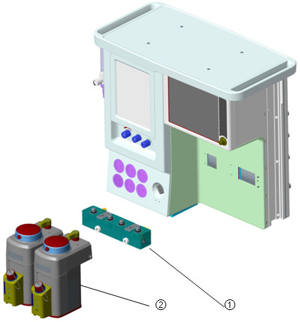

Parts List
No. | Order Number | Part Description | Qty | Remarks
1 | 115-030766-00 | Single vaporizer assembly(0625) | 1 | /
1 | 115-032993-00 | double vaporizer assembly(0625) | 1 | /
1 | 115-017631-00 | vaporizer bracket package | 1 | /
1 | 115-027692-00 | D-vaporizer assembly(plug-in)(0635) | 1 | /
2 | 0621-30-78720 | 5% Isoflurane Vaporizer(Pour fill) | 1 | /
2 | 115-005349-00 | Sevoflurane Pour Fill Vaporizer | 1 | /
2 | 0621-30-78727 | 5% Isoflurane Vaporizer(Keyed filler) | 1 | /
2 | 115-002355-00 | 8% Sevoflurane Vaporizer(Keyed filler) | 1 | /

Hardware box assembly

Exploded View
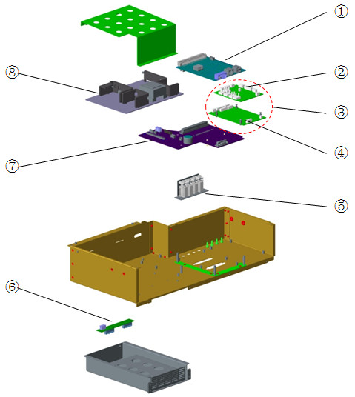

Parts List
No. | Order Number | Part Description | Qty | Remarks
1 | 115-043755-00 | 0619 main control board FRU | 1 | Factory configuration support VCV mode only. If you want the board support the same function with your AM, please provide Machine ID and Function configuration when make Order.
1 | 115-036951-00 | 0619 main control board FRU(VCV+PCV) | 1 | With VCV+PCV mode
2 | 051-003167-00 | 0625 Ventilation&Control PCBA | 1 | Old type, monitoring sensor's nozzle is metal. Compatible with 115-066429-00
2 | 115-066429-00 | 0625 Ventilation&Control PCBA FRU | 1 | New type, monitoring sensor's nozzle is black. Compatible with 051-003167-00
3 | 115-066431-00 | 0619 Monitor PCBA FRU | 1 | 115-066429-00+051-002364-00
4 | 051-002364-00 | 0619 Ventilater&Protect PCBA(Parker) | 1 | /
5 | 115-042876-00 | three way valve asm(0625) | 1 | 3 piece of valves, for machine w/o ACGO
5 | 115-042877-00 | three way valve asm(0625) | 1 | 4 piece of valves, for machine w/ ACGO
6 | 051-000768-00 | 0623 battery board PCBA | 1 | /
7 | 051-002165-00 | 0619 Mother Board PCBA | 1 | /
8 | 051-003469-00 | 0625 Power board PCBA | 1 | /

Flow meter and pressure gauge panel assembly

Exploded View
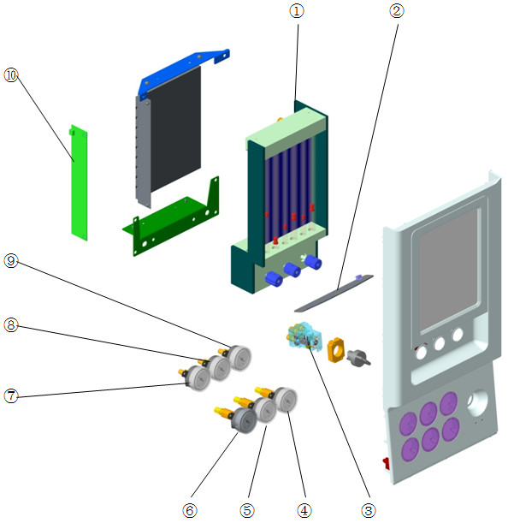

Parts List
No. | Order Number | Part Description | Qty | Remarks
1 | 115-036955-00 | flowmeter FRU (O2/Air,EU) | 1 | /
1 | 115-036956-00 | flowmeter FRU (O2/N2O,EU) | 1 | /
1 | 115-036957-00 | flowmeter FRU (O2/N2O/Air,EU) | 1 | /
1 | 115-036958-00 | flowmeter FRU (O2/Air,US) | 1 | /
1 | 115-036959-00 | flowmeter FRU (O2/N2O,US) | 1 | /
1 | 115-036960-00 | flowmeter FRU (O2/N2O/Air,US) | 1 | /
1 | 115-036961-00 | flowmeter FRU (O2/N2O,Reverse_EU) | 1 | /
1 | 115-036962-00 | flowmeter FRU (O2/N2O/Air,Reverse_EU) | 1 | /
2 | 051-002386-00 | 0619 auxiliary lighting board PCBA | 1 | /
3 | 801-0611-00044-00 | O2&Air system switch | 1 | for machine w/ O2&Air supply
3 | 801-0613-00021-00 | SYSTEM SWITCH | 1 | for machine w/o Air supply
4 | 115-035357-00 | High pressure gauge assembly(Air/0619) | 1 | /
5 | 115-035358-00 | High pressure gauge assembly(N2O/0619) | 1 | /
6 | 115-035356-00 | High pressure gauge assembly(O2/0619) | 1 | /
7 | 115-035353-00 | Pressure gauge assembly(O2/0619) | 1 | /
8 | 115-035355-00 | Pressure gauge assembly(N2O/0619) | 1 | /
9 | 115-035354-00 | Pressure gauge assembly(Air/0619) | 1 | /
10 | 051-000040-00 | Flow Meter Lighting Board PCBA | 1 | /

Display assembly

Exploded View
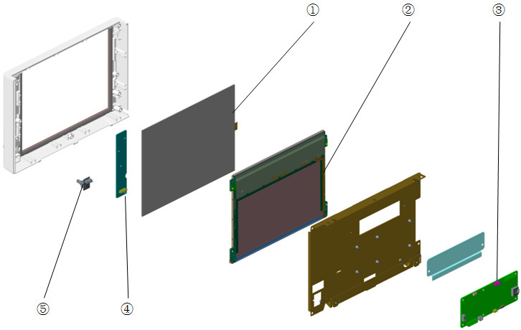

Parts List
No. | Order Number | Part Description | Qty | Remarks
1 | 021-000221-00 | Touch Panel Five wire 10.4" Narrow Frame | 1 | /
2 | 021-000171-00 | LCD TFT 10.4" 1024*768 3.3V LED-BL | 1 | /
3 | 051-002365-00 | 0619 Keypad Control Board PCBA | 1 | /
4 | 051-002163-00 | 0619 Key and Alarm Light Board PCBA | 1 | /
5 | 801-0613-00035-00 | Encoder(FRU) | 1 | /

Gas supply inlet assembly

Exploded View

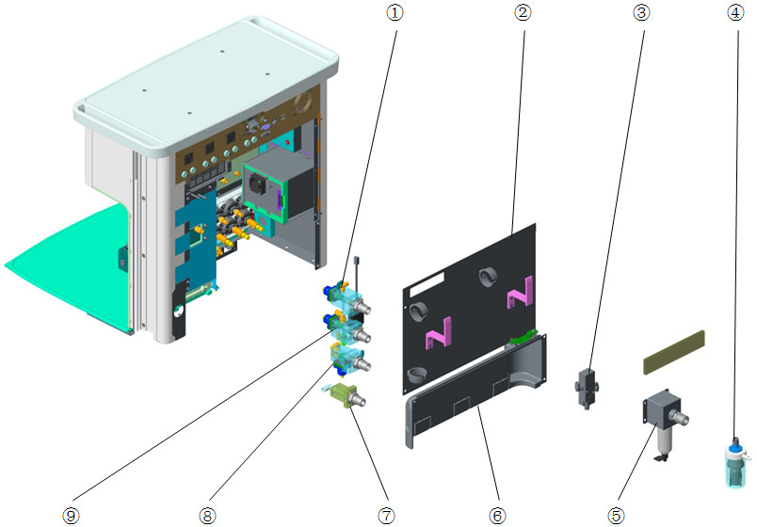

Parts List
No. | Order Number | Part Description | Qty | Remarks
1 | 115-033838-01 | N2O supply inlet assembly(0615) | 1 | NIST
1 | 115-034149-01 | N2O supply inlet assembly | 1 | DISS
2 | 115-030690-00 | backcover assembly(0619) | 1 | /
3 | 082-001231-00 | valve.2-way,air-piloted valves | 1 | O2-N2O block valve
4 | 115-018131-00 | Overflow Unit | 1 | /
5 | 115-048529-00 | Air filter (F92G2VNQT1) | 1 | Only for Air-compressor configuration.
6 | 115-025552-00 | Rear Cover Assembly | 1 | /
7 | 115-034706-01 | Backup O2 assembly(0615) | 1 | /
8 | 115-033837-01 | Air supply inlet assembly(0615) | 1 | NIST
8 | 115-035360-01 | Air supply inlet assembly(NIST/0619) | 1 | w/ pressure switch
8 | 115-034150-01 | AIR supply inlet assembly | 1 | DISS
8 | 115-035359-01 | Air supply inlet assembly(DISS/0619) | 1 | w/ pressure switch
9 | 115-033836-01 | O2 supply inlet assembly(0615) | 1 | NIST
9 | 115-034148-01 | O2 supply inlet assembly | 1 | DISS

Main body of the patient circuit

Exploded View
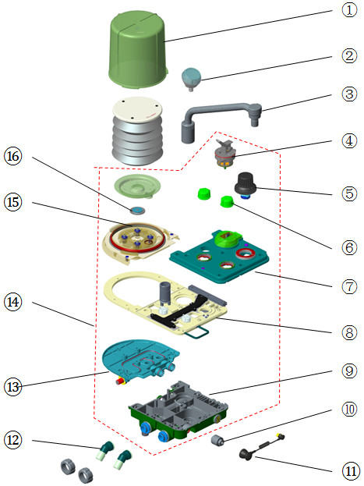

Parts List
No. | Order Number | Part Description | Qty | Remarks
1 | 801-0631-00054-00 | Bellows Dome， A series | 1 | /
2 | 115-034210-00 | Airway pressure gauge | 1 | /
3 | 115-048600-00 | Bag arm assembly(silvery/spacing) | 1 | W/ position limit, refer to TMZ-17026
3 | 801-0601-00005-00 | Bag arm assembly | 1 | W/O position limit, refer to TMZ-17026
4 | 801-0601-00017-00 | Bag/mechanical ventilation switch | 1 | /
5 | 801-0621-00168-00 | (New) APL Valve assembly(FRU) | 1 | Machine before Oct 2017, refer to TMZ-17026
5 | 115-046754-00 | APL valve FRU | 1 | Machine after Oct 2017, refer to TMZ-17026
6 | 801-0631-00061-00 | Check valve dome， A series | 2 | w/ Seal(O-ring). Only one check valve dome in each 801-0631-00061-00
7 | 115-034979-00 | upper cover assembly FRU | 1 | Seals and screws are included
8 | 115-048640-00 | mid-plate assembly(0625/prepak)FRU | 1 | For prepak canister
8 | 115-048642-00 | mid-plate assembly(heat/arm)(0619)FRU | 1 | For non-prepak canister. Seals are included
9 | 115-034980-00 | lower cover assembly(bag arm)FRU | 1 | Seals and screws are included
10 | 0611-10-45654 | O2 sensor，MedicelMOX-2 | 1 | /
10 | 040-000898-00 | sensor oxygen | 1 | O2 sensor with translucent shell
11 | 0601-20-78941 | O2 sensor cable | 1 | /
12 | 801-0631-00057-00 | Insp/Exp Connector， A series | 2 | Only connector in each 801-0631-00057-00
13 | 115-034190-00 | lower cover 2 assembly(0615) | 1 | Seals and screws are included
14 | 115-034909-00 | Circuit main unit(heat/bag arm) | 1 | For non-prepak canister(spiral interface)
14 | 115-048843-00 | patient main unit | 1 | For prepak canister
14 | 115-037183-00 | Circuit main unit FRU(heat/bag arm/0619) | 1 | For non-prepak canister(lifting)
15 | 115-034189-00 | upper cover 2 assembly(0615) | 1 | Seals and screws are included
16 | 801-0601-00002-00 | Pop-off valve assembly | 1 | /

Lifting device

Exploded View
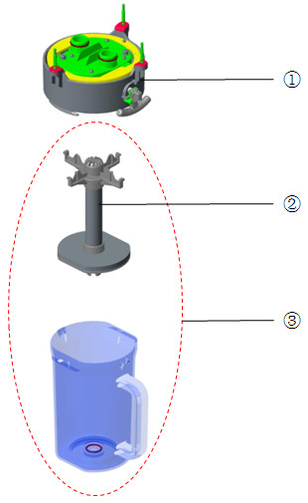

Parts List
No. | Order Number | Part Description | Qty | Remarks
1 | 115-034208-00 | Lifting device(with bypass/0615) | 1 | The whole lifting device
2 | 115-034689-00 | Absorb canister shore(0625) | 1 | /
3 | 115-030838-00 | Canister assembly(0625) | 1 | /

Sodalime canister assembly

Exploded View
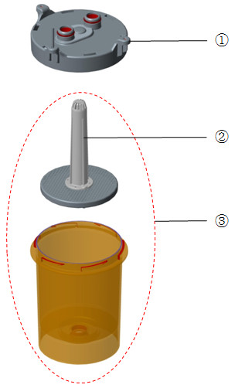

Parts List
No. | Order Number | Part Description | Qty | Remarks
1 | 115-034193-00 | Canister upper cover assembly(20B) | 1 | /
2 | 115-036950-00 | Absorber caniste support module FRU(20B) | 1 | /
3 | 115-034194-00 | Sodalime canister assembly(20B) | 1 | /

Others
No. | Order Number | Part Description | Qty | Remarks
1 | 115-036966-00 | USB flash memory(SIMV-VC+SIMV-PC) | 1 | Need to provide machine's SN and machine ID
2 | 115-033012-00 | USB flash memory(PS) | 1 | Need to provide machine's SN and machine ID
3 | 115-033014-00 | USB flash memory(Loop) | 1 | Need to provide machine's SN and machine ID
4 | 115-024461-00 | Support arm kit(0634) | 1 | Mechanical arm, mounted to GCX compatible rail system to fix tube
5 | 115-035836-00 | pendant adapter package(no_sup_cylinder) | 1 | /
6 | 115-021015-00 | Accessory hook kit(0632) | 1 | /
7 | 801-0601-00008-00 | Inspiratory/Expiratory flow sensors | 1 | /
8 | 115-036963-00 | Maintain Kit(0619,Basic,1 yr) | 1 | No need to replace spiral canister's seal, since this seal is not FRU.
9 | 115-036964-00 | Maintain Kit(0619,Extend,1yr) | 1 | No need to replace spiral canister's seal, since this seal is not FRU.
10 | 115-036965-00 | Maintain Kit(0619,Advanced,1 yr) | 1 | No need to replace spiral canister's seal, since this seal is not FRU.
11 | 115-034694-00 | Maintain Kit(0625,Basic,1 yr/Prepark) | 1 | For prepak canister
12 | 115-034696-00 | Maintain Kit(0625,Extend,1yr/Prepark) | 1 | For prepak canister
13 | 115-034698-00 | Maintain Kit(0625,Advanced,1 yr/Prepark) | 1 | For prepak canister
14 | 115-051201-00 | 0619 Ventilation kit FRU(O2 Drive) | 1 | 115-066431-00(0619 Monitor PCBA FRU) and 115-011265-01(Ventilation valve assembly(0616)) are included
15 | 115-051202-00 | 0619 Ventilation kit FRU(Air Drive) | 1 | 115-066431-00(0619 Monitor PCBA FRU) and 115-011265-01(Ventilation valve assembly(0616)) are included
16 | 115-018429-00 | suction tube kit(inner suction) | 1 | /
17 | 115-035676-00 | Auxiliary O2 Package(0619) | 1 | Upgrade kit for auxiliary O2 supply
18 | 115-018012-00 | Li-ion Bat Pack (11.1V4500mAh LI23S002A) | 1 | /
19 | 801-0631-00132-00 | Power Socket 3C (black)(FRU) | 1 | rear cover
20 | 801-0631-00028-00 | Fan | 1 | rear cover
21 | 051-001866-00 | 0625 toplight board PCBA | 1 | under screen
22 | 801-0631-00038-00 | Speaker and Connecting Cable | 1 | /
23 | 115-002015-00 | AGSS passive scavenging tube assembly | 1 | /
24 | 082-001372-00 | AGSS receiving hosing(35G-WAGD-DS/FG2-3) | 1 | /
25 | 115-009073-00 | AGSS low-flow Receiving hoses assembly | 1 | /
26 | 115-020745-00 | AGSS connector package(UK) | 1 | /
27 | 040-000065-00 | Keyed Fill Adaptor for Isoflurane 53453 | 1 | /
28 | 040-000066-00 | Keyed Fill Adaptor for Sevoflurane 53454 | 1 | /
29 | 115-036182-00 | Medicine filler sleeve(0605) FRU | 1 | /
30 | 115-036167-00 | Filler cap FRU | 1 | /
31 | 115-039569-00 | Filler cap of ENF(Pour Fill) | 1 | /
32 | 115-039571-00 | Filler cap of ISO(Pour Fill) | 1 | /
33 | 115-039572-00 | Filler cap of SEV(Pour Fill) | 1 | /
34 | 115-039573-00 | Filler cap of SEV(Quik-Fil) | 1 | /
35 | 115-039574-00 | Filler cap of Hal(Pour Fill) | 1 | /
36 | 034-000353-00 | Drawer lock | 1 | /
37 | 803-011648-00 | WATO EX-35 main unit warranty | 1 | /
38 | 115-033063-00 | gas cylinder wrench assembly | 1 | /
39 | 801-0613-00051-00 | Gas pressure switch | 2/3 | There are 2 pressure switches in O2 supply inlet assembly and Ventilation valve assembly. Whether Air supply inlet have 1 pressure switch is depended on AM configuration. Only one pressure switch in each 801-0613-00051-00

