WATO EX-20&30(DW-&DY-)

Anesthesia Machine

Parts

Contents
1 Parts 4
1.1 Main Unit 4
1.1.1 Exploded View 4
1.1.2 Parts List 4
1.2 Flow Meter Assembly 6
1.2.1 Exploded View 6
1.2.2 Parts List 6
1.3 Pressure Gauge Assembly 8
1.3.1 Exploded View 8
1.3.2 Parts List 8
1.4 Work Table 10
1.4.1 Exploded View 10
1.4.2 Parts List 10
1.5 Top Plate Assembly 13
1.5.1 Exploded View 13
1.5.2 Parts List 13
1.6 Hardware Box I 14
1.6.1 Exploded View 14
1.6.2 Parts List 14
1.7 Hardware Box II 16
1.7.1 Exploded View 16
1.7.2 Parts List 16
1.8 Display Assembly 17
1.8.1 Exploded View 17
1.8.2 Parts List 17
1.9 Upper Half 19
1.9.1 Exploded View 19
1.9.2 Parts List 19
1.10 Auxiliary Output Assembly 23
1.10.1 Exploded View 23
1.10.2 Parts List 23
1.11 Isolation Transformer Assembly 24
1.11.1 Exploded View 24
1.11.2 Parts List 24
1.12 Heating Control Assembly 25
1.12.1 Exploded View 25
1.12.2 Parts List 25
1.13 Liquid Collection Bottle Assembly 26
1.13.1 Exploded View 26
1.13.2 Parts List 26
1.14 Main Body of the Patient Circuit 27
1.14.1 Exploded View 27
1.14.2 Parts List 27
1.15 Check Valve Assembly 30
1.15.1 Exploded View 30
1.15.2 Parts List 30
1.16 Lifting Device Assembly 31
1.16.1 Exploded View 31
1.16.2 Parts List 31
1.17 Sodalime Canister Assembly 33
1.17.1 Exploded View 33
1.17.2 Parts List 33
1.18 Others 34

Parts

Main Unit

Exploded View
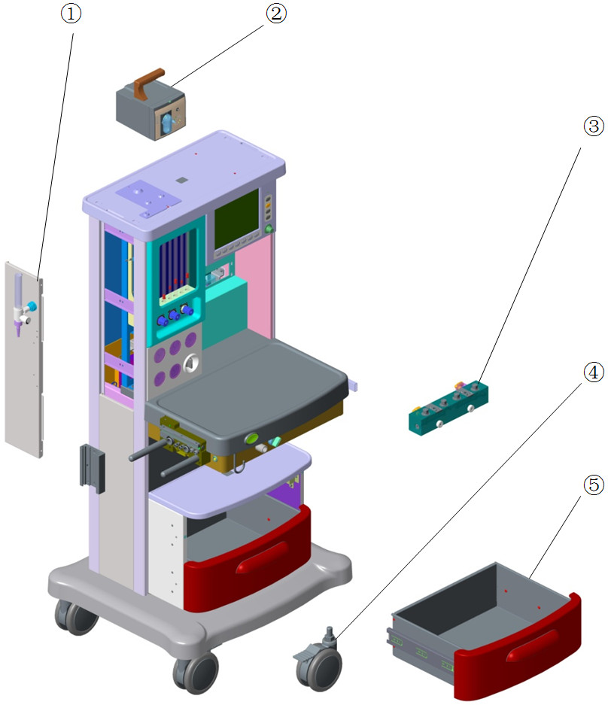

Parts List
No. | Order Number | Part Description | Qty | Remarks
1 | 115-002606-00 | Auxiliary Gas Outlet Assembly | 1 | /
2 | 801-0616-00043-00 | Case for CO2 module (FRU) | 1 | /
3 | 801-0616-00008-00 | Manifold for single-vaporizer | 1 | /
3 | 801-0616-00009-00 | Manifold for dual-vaporizer | 1 | /
3 | 115-032600-00 | Plug-in Upgrade kit(0616) | 1 | /
4 | 801-0616-00036-00 | Caster with brake | 4 | Only one caster in each 801-0616-00036-00
5 | 801-0621-00051-00 | Drawer | 1 | 26cm height, used for single drawer configuration machine. Refer to TMZ-12012
5 | 115-011667-00 | assembly of drawer(0616) | 2 | 15cm height, used for two drawers configuration machine. Refer to TMZ-12012. Only one drawer in each 115-011667-00

Flow Meter Assembly

Exploded View
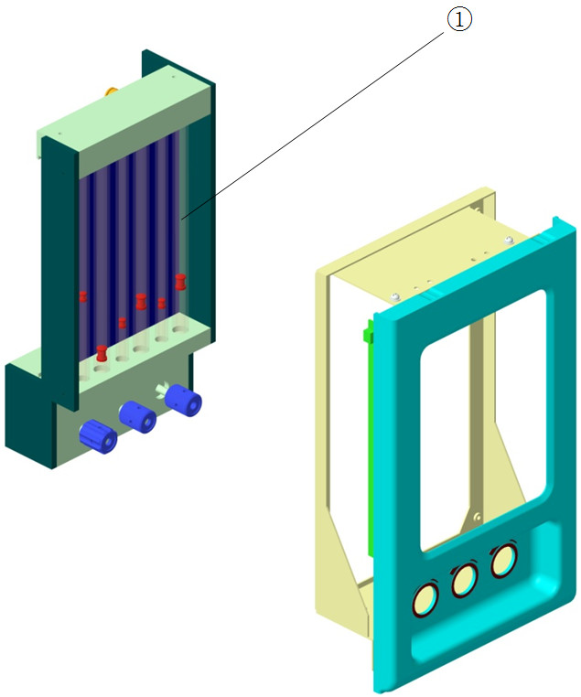

Parts List
No. | Order Number | Part Description | Qty | Remarks
1 | 801-0616-00023-00 | Flow meter(O2/IEC) | 1 | Only O2
1 | 801-0616-00026-00 | Flow meter(O2/US) | 1 | Only O2
1 | 801-0616-00024-00 | Flow meter(N2O, O2/IEC) | 1 | O2&N2O
1 | 801-0616-00027-00 | Flow meter( N2O,O2/US) | 1 | O2&N2O
1 | 801-0616-00025-00 | Flow meter(Air,N2O,O2/IEC) | 1 | O2&N2O&Air
1 | 801-0616-00028-00 | Flow meter(Air,N2O,O2 / US) | 1 | O2&N2O&Air
1 | 115-016501-00 | O2 & AIR flowmeter assembly(EN Standard) | 1 | O2&Air
1 | 115-016500-00 | O2 & AIR flowmeter assembly(US Standard) | 1 | O2&Air
1 | 115-062672-00 | Flow meter(Sri Lanka)(FRU) | 1 | O2&N2O&Air flowmeter assembly(EN Standard)(6 tubes), O2 minimum flow 0.25L/min. Only for EX-30 in Sri Lanka, Refer to TMZ-19013

Pressure Gauge Assembly

Exploded View
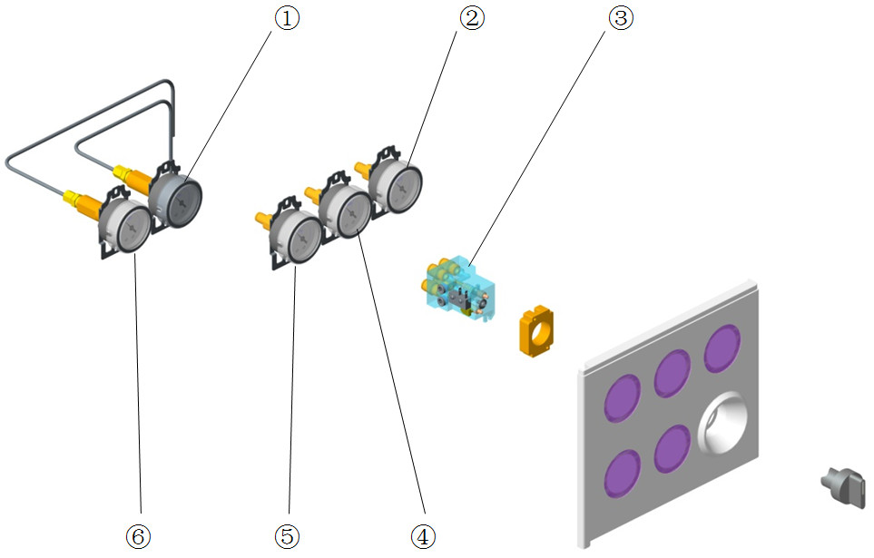

Parts List
No. | Order Number | Part Description | Qty | Remarks
1 | 801-0616-00029-00 | High Pressure Gauge Assembly(Right) | 1 | w/o O2/N2O/AIR label
1 | 115-008975-01 | high pressure gauge assembly,AIR | 1 | /
1 | 115-008976-01 | high pressure gauge assembly,N2O | 1 | /
2 | 115-009025-01 | pressure gauge assembly,AIR | 1 | /
2 | 801-0613-00005-00 | Pipeline supply gauge | 1 | w/o O2/N2O/AIR label
3 | 801-0611-00044-00 | O2&Air system switch | 1 | /
3 | 801-0613-00021-00 | SYSTEM SWITCH | 1 | Only O2
4 | 115-009026-01 | pressure gauge assembly,N2O | 1 | /
4 | 801-0613-00005-00 | Pipeline supply gauge | 1 | w/o O2/N2O/AIR label
5 | 115-009024-01 | pressure gauge assembly,O2 | 1 | /
5 | 801-0613-00005-00 | Pipeline supply gauge | 1 | w/o O2/N2O/AIR label
6 | 801-0616-00030-00 | High Pressure Gauge Assembly(Left) | 1 | w/o O2/N2O/AIR label
6 | 115-008974-01 | high pressure gauge assembly,O2 | 1 | /

Work Table

Exploded View
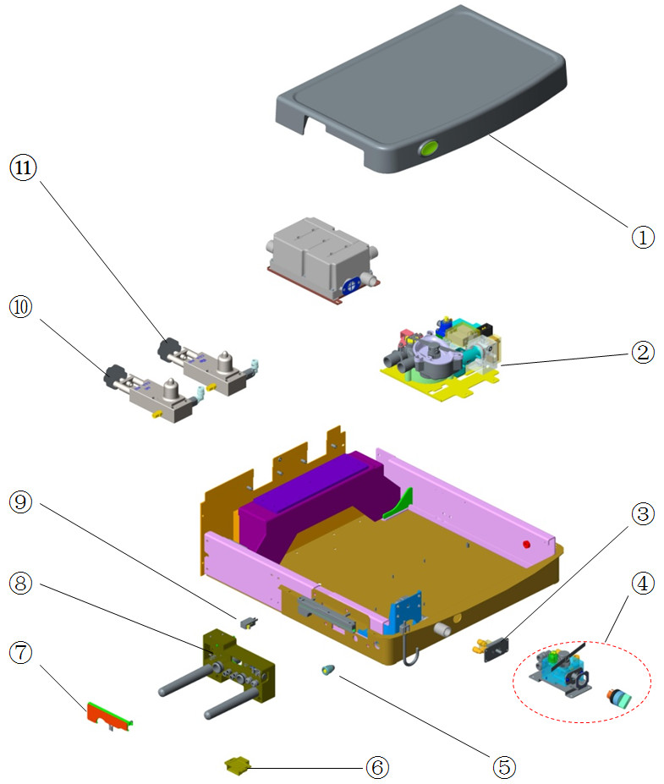

Parts List
No. | Order Number | Part Description | Qty | Remarks
1 | 801-0616-00045-00 | table cover assembly | 1 | w/ O2 flush button
2 | 115-011265-01 | Ventilation valve assembly(0616) | 1 | Proportional valve is Parker, main unit is black. Refer to: TMZ-15053, TMZ-15057
2 | 115-034207-00 | Ventilation valve(pressure switch) | 1 | Proportional valve is Parker, main unit is white. Refer to: TMZ-15053, TMZ-15057
2 | 801-0621-00047-00 | Breathing Valve Assembly | 1 | Proportional valve is Norgren, main unit is black
3 | 801-0611-00026-00 | O2 flush button assembly | 1 | w/o O2 flush button
4 | 801-0616-00126-00 | AGGO assembly(FRU new switch) | 1 | /
4 | 801-0616-00128-00 | ACGO update package,FRU | 1 | w/ tubes and fresh gas connector
5 | 801-0621-00154-00 | 2Pin Female Socket Assembly (FRU) | 1 | /
6 | 801-0613-00053-00 | Lock with micro switch(FRU) | 1 | /
7 | 024-000185-00 | BC heater for 0616 | 1 | /
8 | 115-034171-00 | BS block (ACGO/no bypass/0615) | 1 | /
8 | 115-034170-00 | BS block (no ACGO/no bypass/0615) | 1 | /
9 | 801-0613-00055-00 | Snap action switch (rolling type 200gf) | 1 | /
10 | 801-0616-00013-00 | O2 cylinder yoke assembly | 1 | For machines before 2012.04. Refer to TMZ-12010
10 | 115-002250-01 | Cylinder Bracket for O2 | 1 | For machines after 2012.04. Refer to TMZ-12010. Change to another PN in TMZ-16006, and then change back again in TMZ-16028.
11 | 115-015027-00 | Cylinder Bracket for N2O(Φ6) | 1 | /
11 | 801-0616-00032-00 | Air cylinder yoke assembly | 1 | For machines before 2012.04. Refer to TMZ-12010
11 | 115-002728-01 | Cylinder Bracket for AIR | 1 | For machines after 2012.04. Refer to TMZ-12010. Change to another PN in TMZ-16006, and then change back again in TMZ-16028.

Top Plate Assembly

Exploded View
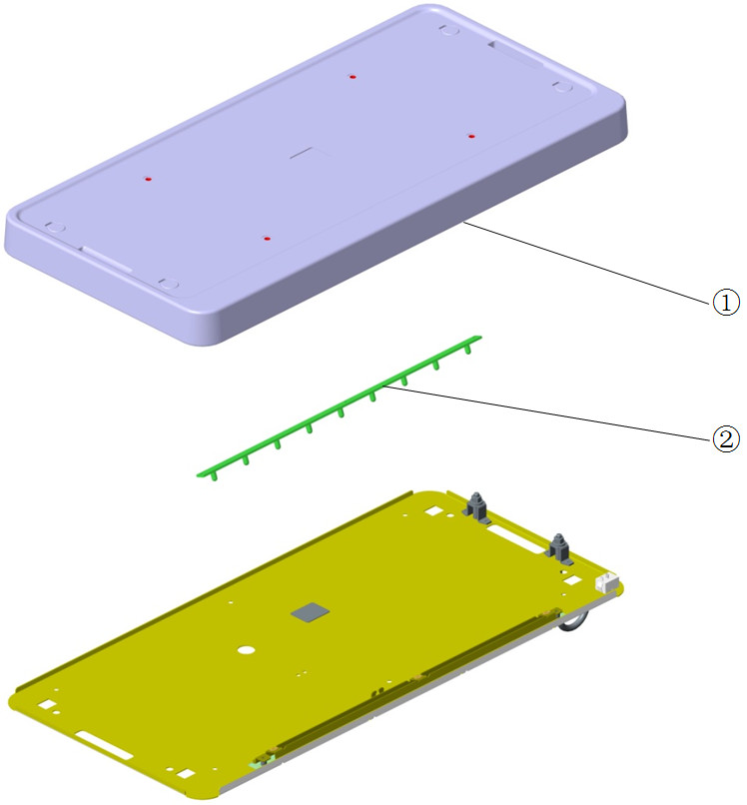

Parts List
No. | Order Number | Part Description | Qty | Remarks
1 | 801-0616-00049-00 | Top Plate Assembly(FRU)(0616) | 1 | /
2 | 801-0621-00026-00 | Tabletop light board | 1 | /

Hardware Box I

Exploded View
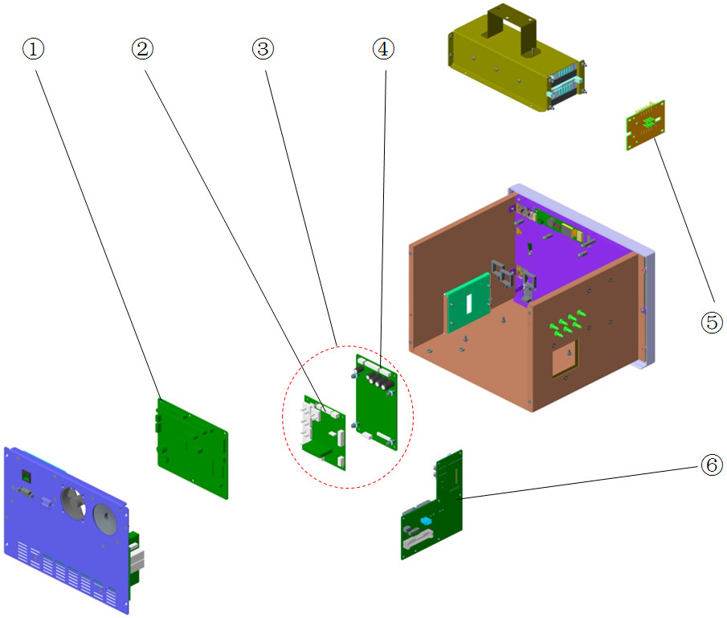

Parts List
No. | Order Number | Part Description | Qty | Remarks
1 | 801-0615-00001-00 | Main board (VCV, English,0615) | 1 | For WATO EX-20. Factory configuration support VCV mode only. If you want the board support the same function with your AM, please provide Machine ID and Function configuration when make Order.
1 | 801-0617-00011-00 | main board | 1 | For WATO EX-30. Factory configuration support VCV+PCV mode only. If you want the board support the same function with your AM, please provide Machine ID and Function configuration when make Order.
2 | 115-051193-00 | Monitored signal detection board (FRU) | 1 | /
3 | 115-051195-00 | Monitor board assembly | 1 | /
4 | 801-0616-00060-00 | Drive Board for Monitoring Valve | 1 | /
5 | 801-0613-00041-00 | lithium battery connection board | 1 | /
6 | 115-027184-00 | power adapt board FRU | 1 | Include 024-000582-00

Hardware Box II

Exploded View
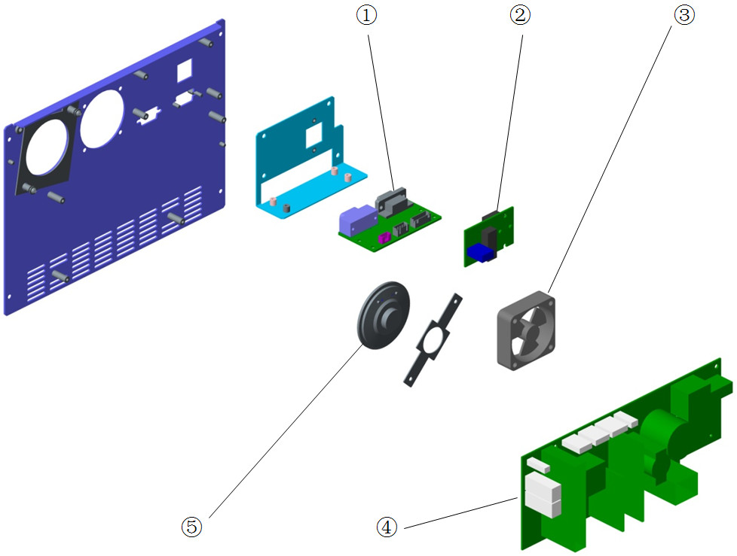

Parts List
No. | Order Number | Part Description | Qty | Remarks
1 | 051-000961-00 | 0616 Calibrating and Communicating PCBA | 1 | /
2 | 9210-30-30152 | Ntwrk pcb,PM7,8E,9E,MEC12vet | 1 | /
3 | 024-000582-00 | FAN 12V 9.4CFM 20.1dB 50*50*15*355mm | 1 | Used in hardware box
4 | 801-0616-00058-00 | 0616power board | 1 | /
5 | 801-0621-00156-00 | 2.25 Speaker (w wire, FRU) | 1 | /

Display Assembly

Exploded View
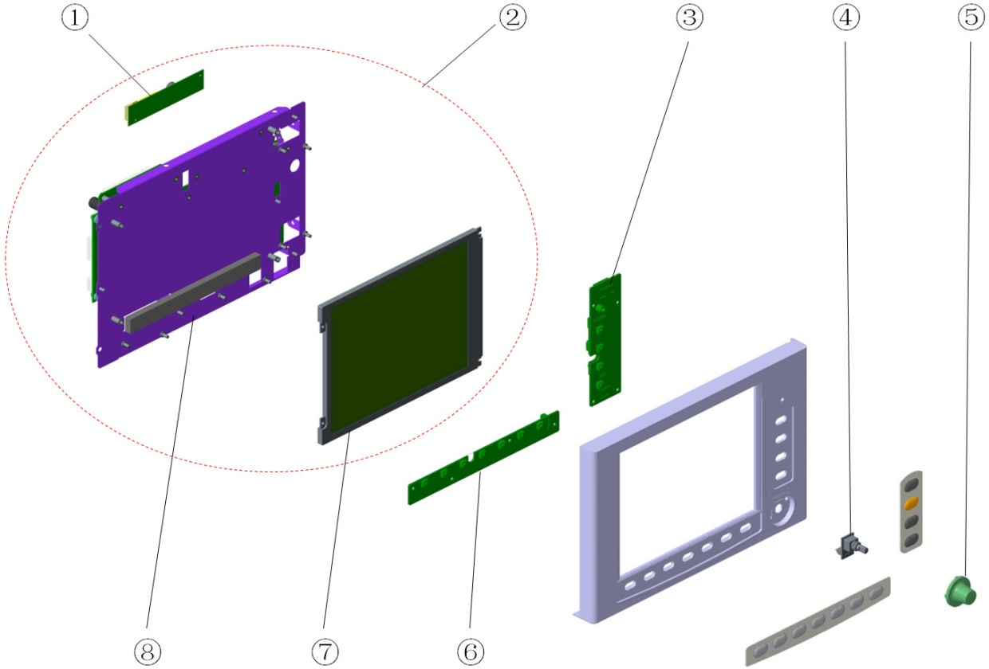

Parts List
No. | Order Number | Part Description | Qty | Remarks
1 | 801-0616-00103-00 | Adapter brd for 7" Innolux Display | 1 | For WATO EX-20
1 | 115-030476-00 | backlight drive board PCBA | 1 | For WATO EX-30, 8" display
2 | 115-048599-00 | Service kit for 8"display(w/ display) | 1 | /
3 | 801-0616-00054-00 | 0616keyboard | 1 | /
4 | 801-0613-00035-00 | Encoder(FRU) | 1 | /
5 | 043-000342-00 | Knob | 1 | /
6 | 801-0616-00055-00 | 7" keyboard scan board | 1 | For WATO EX-20
6 | 801-0616-00056-00 | 8.4" keyboard scan board | 1 | For WATO EX-30
7 | 115-032939-00 | 7" screen FRU | 1 | Refer to TMZ-15045. Including LCD, Silicone Case and Waterproof lens
7 | 115-034741-00 | 7" screen upgrade kit FRU | 1 | Refer to TMZ-15045. Only Silicone Case and Waterproof lens, no LCD
8 | 115-048598-00 | Service kit for 8"display(w/o display) | 1 | /

Upper Half

Exploded View
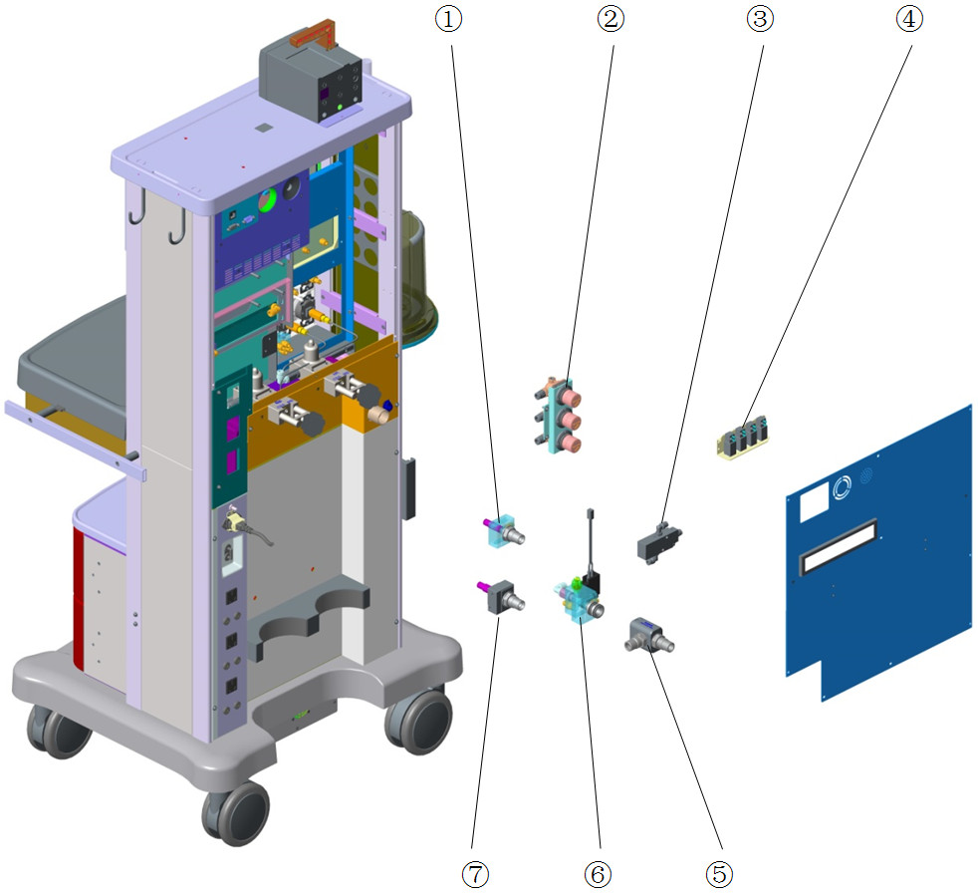

Parts List
No. | Order Number | Part Description | Qty | Remarks
1 | 115-003681-00 | N2O pipeline inlet assembly (DISS, 0616) | 1 | DISS, w/ pressure relief valve, w/ pressure regulator. For machines without N2O cylinder yoke
1 | 115-003683-00 | N2O p-line inlet ass'y, w/yoke DISS 0616 | 1 | DISS, w/ pressure relief valve, w/ pressure regulator. For machines with N2O cylinder yoke
1 | 115-015025-00 | Nitrous oxide inlet assembly (0616,DISS) | 1 | DISS, w/o pressure relief valve, w/o pressure regulator
1 | 115-034149-01 | N2O supply inlet assembly | 1 | DISS, w/o pressure relief valve, w/ pressure regulator
1 | 115-015026-00 | Nitrous oxide inlet assembly | 1 | NIST, w/o pressure relief valve, w/o pressure regulator
1 | 115-033838-01 | N2O supply inlet assembly(0615) | 1 | NIST, w/o pressure relief valve, w/ pressure regulator
1 | 115-039044-00 | N2O supply inlet assembly FRU(0616) | 1 | NIST, w/ pressure relief valve, w/o pressure regulator
1 | 115-038640-00 | N2O supply inlet assembly(0615) | 1 | NIST, w/ pressure relief valve, w/ pressure regulator
1 | 801-0613-00008-00 | N2O supply inlet assembly | 1 | NIST, w/ pressure relief valve, w/ pressure regulator(marked "PULLTOADJUST"). For machines without N2O cylinder yoke
1 | 801-0613-00010-00 | N2O supply inlet assembly(with cylinder) | 1 | NIST, w/ pressure relief valve, w/ pressure regulator(marked "PULLTOADJUST"). For machines with N2O cylinder yoke
2 | 115-015124-00 | Pressure Regulator Assembly | 1 | Include 115-007621-00 and tubes
2 | 115-015125-00 | Pressure Regulator Assembly | 1 | For O2&N2O
2 | 115-007621-00 | Regulator assembly(N2O,O2,Air) | 1 | For O2&N2O&Air
2 | 115-016549-00 | Regulator assembly(O2,Air) | 1 | For O2&Air
2 | 801-0631-00087-00 | Regulator Assembly for O2 or Air FRU | 1 | For O2 or Air
3 | 082-001231-00 | valve.2-way,air-piloted valves | 1 | /
4 | 801-0621-00192-00 | 3-way Valve Assembly (0616/FRU) | 1 | 3 piece of valves, for machine w/o ACGO
4 | 115-034978-00 | 3 way valve assembly FRU | 1 | 4 piece of valves, for machine w/ ACGO
5 | 115-037227-00 | oxygen supply T-connection package | 1 | Used as upgrade kit. Refer to TMZ-16006
5 | 115-036788-00 | Reserve O2 Supply Connector(vale) | 1 | Square body. Refer to TMZ-16006、16007
6 | 115-003680-00 | O2 Pipeline Inlet Assembly (DISS, 0616) | 1 | DISS, w/ pressure regulator(marked "PULLTOADJUST")
6 | 115-034148-01 | O2 supply inlet assembly | 1 | DISS, w/ pressure regulator
6 | 115-036778-00 | O2 supply inlet assembly(0623/DISS/vale) | 1 | DISS, w/o pressure regulator
6 | 801-0613-00007-00 | O2 supply inlet assembly | 1 | NIST, w/ pressure regulator(marked "PULLTOADJUST")
6 | 115-033836-01 | O2 supply inlet assembly(0615) | 1 | NIST, w/ pressure regulator
6 | 115-036781-00 | O2 supply inlet assembly(0623/vale) | 1 | NIST, w/o pressure regulator
6 | 115-036780-00 | Reserve O2 Supply Base(vale) | 1 | W/ pressure relief valve, w/ pressure switch, used with 115-036788-00. Refer to TMZ-16006、16007
6 | 115-034706-01 | Backup O2 assembly(0615) | 1 | W/O pressure relief valve, w/o pressure switch. Refer to TMZ-16006、16007
7 | 115-003682-00 | Air pipeline inlet assembly (DISS, 0616) | 1 | DISS, w/ pressure relief valve, w/ pressure regulator. For machines without Air Drive
7 | 115-003684-00 | Air p-line inlet ass'y,AirDrive DISS0616 | 1 | DISS, w/ pressure relief valve, w/ pressure regulator. For machines with Air Drive
7 | 115-011513-00 | air inlet assembly (0616,DISS) | 1 | DISS, w/o pressure relief valve, w/o pressure regulator
7 | 115-034150-01 | AIR supply inlet assembly | 1 | DISS, w/o pressure relief valve, w/ pressure regulator
7 | 801-0616-00109-00 | AIR supply inlet assembly | 1 | NIST, w/o pressure relief valve, w/o pressure regulator
7 | 115-033837-01 | Air supply inlet assembly(0615) | 1 | NIST, w/o pressure relief valve, w/ pressure regulator
7 | 115-037712-00 | Air supply inlet assembly(0616) | 1 | NIST, w/ pressure relief valve, w/o pressure regulator
7 | 115-038641-00 | Air supply inlet assembly(0615) | 1 | NIST, w/ pressure relief valve, w/ pressure regulator
7 | 801-0613-00009-00 | Air supply inlet assembly | 1 | NIST, w/ pressure relief valve, w/ pressure regulator(marked "PULLTOADJUST"). For machines without Air Drive
7 | 801-0616-00004-00 | Air supply inlet assembly(Air drive) | 1 | NIST, w/ pressure relief valve, w/ pressure regulator(marked "PULLTOADJUST"). For machines with Air Drive

Auxiliary Output Assembly

Exploded View
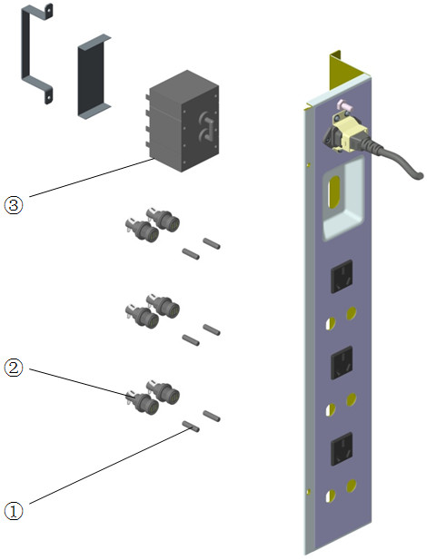

Parts List
No. | Order Number | Part Description | Qty | Remarks
1 | 801-0613-00068-00 | FUSE time-lag250V2AGLS5*20mm | 6 | Only one fuse in each 801-0613-00068-00
2 | 801-0611-00102-00 | HEADER Fuse Holder φ5*20 (FRU) | 6 | Only one holder in each 801-0611-00102-00
3 | 801-0613-00030-00 | Breaker 250V 7.5A welded terminal | 1 | For machines with power outlet breaker

Isolation Transformer Assembly

Exploded View
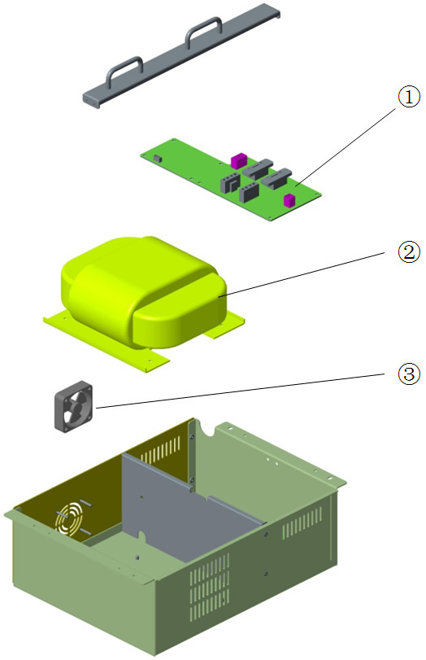

Parts List
No. | Order Number | Part Description | Qty | Remarks
1 | 801-0616-00051-00 | isolation power drive board | 1 | /
2 | 801-0611-00005-00 | Isolation transformer R800 620VA(FRU) | 1 | /
3 | 801-0611-00006-00 | Fan for Isolation transformer (w wire) | 1 | Used in isolation transformer box

Heating Control Assembly

Exploded View
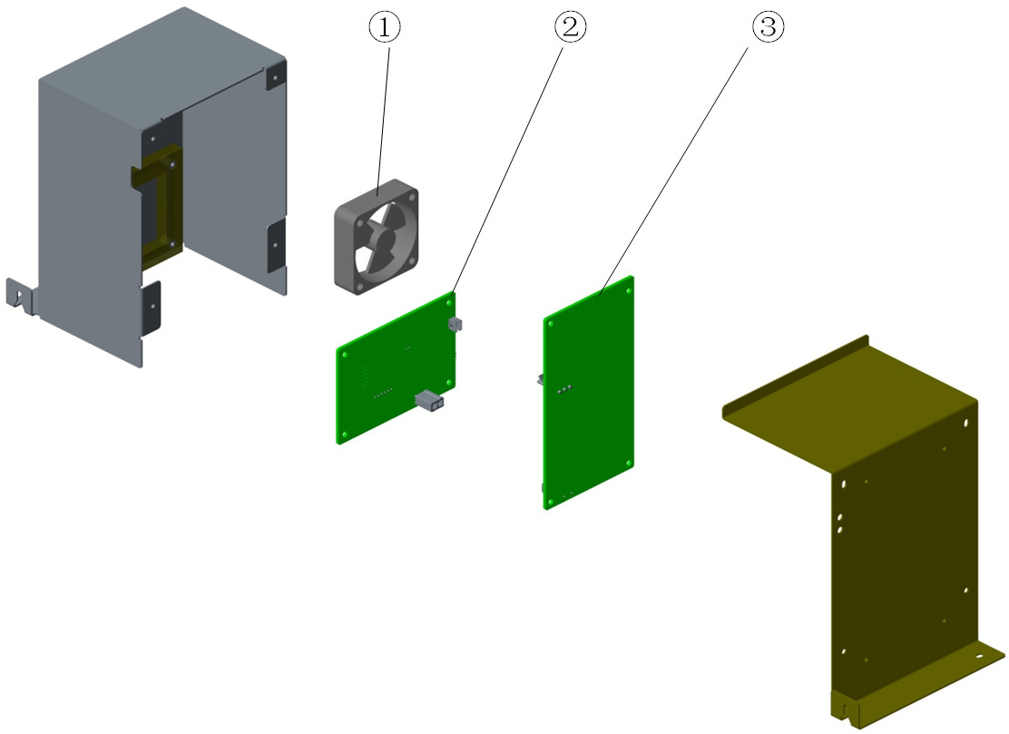

Parts List
No. | Order Number | Part Description | Qty | Remarks
1 | 801-0616-00061-00 | Fan | 1 | Used in heating control box
2 | 051-000152-00 | AC-DC power board PCBA | 1 | /
3 | 801-0616-00118-00 | Heating control Board(FRU) | 1 | /

Liquid Collection Bottle Assembly

Exploded View
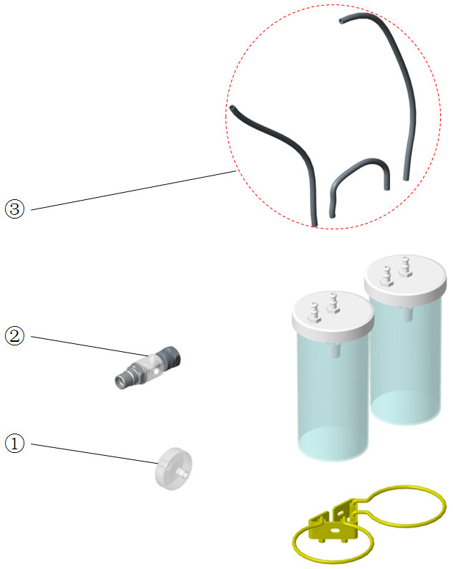

Parts List
No. | Order Number | Part Description | Qty | Remarks
1 | 082-001327-00 | Disposable Filter.0.45μm | 1 | /
2 | 115-020571-00 | Suction T-joint air(DISS)check valve | 1 | /
2 | 115-020572-00 | Suction T-joint air(NIST)check valve | 1 | /
2 | 115-020573-00 | Suction T-joint O2(NIST)check valve | 1 | /
2 | 115-020574-00 | Suction T-joint O2(DISS)check valve | 1 | /
3 | 040-001658-00 | tube.pvc | 1 | 4 meters

Main Body of the Patient Circuit

Exploded View
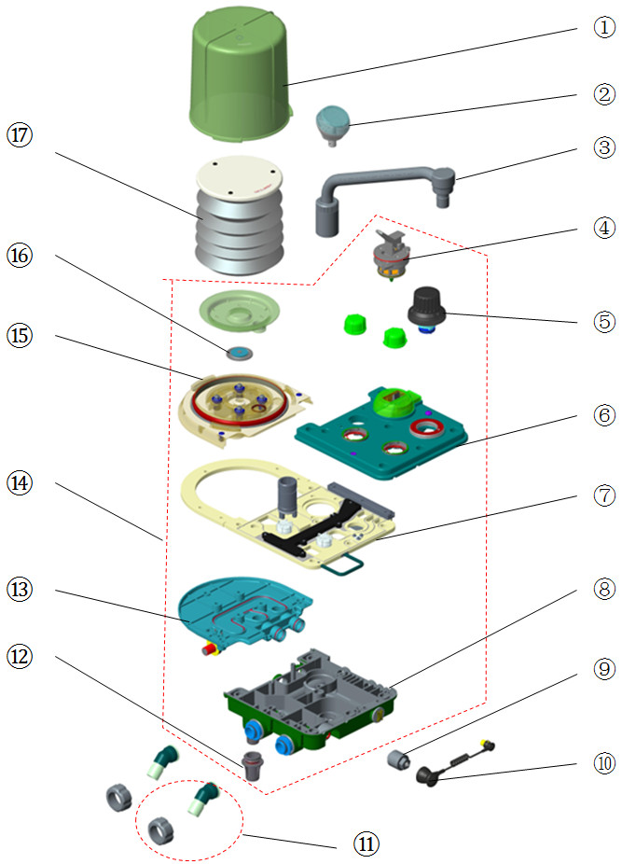

Parts List
No. | Order Number | Part Description | Qty | Remarks
1 | 801-0616-00001-00 | Bellows housing | 1 | /
2 | 115-025563-00 | Airway pressure gauge | 1 | /
3 | 801-0601-00005-00 | Bag arm assembly | 1 | /
4 | 801-0601-00017-00 | Bag/mechanical ventilation switch | 1 | /
5 | 801-0621-00168-00 | (New) APL Valve assembly(FRU) | 1 | /
6 | 115-015126-00 | Upper cover FRU(0616) | 1 | /
7 | 115-048634-00 | mid-plate assembly(no heat/no arm)FRU | 1 | /
7 | 115-048635-00 | mid-plate assembly(no heat/arm)FRU | 1 | /
7 | 115-048636-00 | mid-plate assembly(heat/no arm)FRU | 1 | /
7 | 115-048638-00 | mid-plate assembly(heat/arm)FRU | 1 | /
8 | 115-002370-00 | Lower cover assembly(0616) | 1 | For BC with bag arm. PSU
8 | 115-002377-00 | Lower cover assembly (optional)(0616) | 1 | For BC without bag arm. PSU
8 | 115-034981-00 | lower cover assembly(no bag arm)FRU | 1 | For BC without bag arm. Nylon. Refer to TMZ-15053
9 | 0611-10-45654 | O2 sensor,MedicelMOX-2 | 1 | /
9 | 040-000898-00 | sensor oxygen | 1 | The same type with factory configuration
10 | 0601-20-78941 | O2 sensor cable | 1 | /
11 | 0621-30-78446 | Inspiration / expiration connectors asse | 2 | One connector and one rotary cap in each 0621-30-78446
12 | 801-0631-00058-00 | Water Collection Cup, A series | 1 | Include colorless O-ring
12 | 801-0616-00005-00 | Water collection cup assembly | 1 | Include red O-ring
13 | 043-000121-00 | Lower cover 2(PSU) | 1 | /
14 | 115-015359-00 | Patient circuit (no bag arm/no BYPASS) | 1 | /
14 | 115-015358-00 | Patient circuit(bag arm/no BYPASS) | 1 | /
14 | 801-0616-00020-00 | Breathing circuit(with arm/BYPASS/PS) | 1 | PSU
14 | 801-0616-00021-00 | Breath circuit(with arm,w/o BYPASS,PS) | 1 | PSU
14 | 801-0616-00018-00 | Breath circuit(w/o arm,with BYPASS,PS) | 1 | PSU
14 | 801-0616-00019-00 | Breathing circuit(w/o arm/BYPASS,PS) | 1 | PSU
14 | 115-034910-00 | Circuit main unit(no heat/bag arm) | 1 | Nylon. Refer to TMZ-15053
14 | 115-034909-00 | Circuit main unit(heat/bag arm) | 1 | Nylon. Refer to TMZ-15053
14 | 115-034908-00 | Circuit main unit(no heat/no bag arm) | 1 | Nylon. Refer to TMZ-15053
14 | 115-034907-00 | Circuit main unit(no heat/bag arm) | 1 | Nylon. Refer to TMZ-15053
15 | 043-000119-00 | Upper cover 2(PSU) | 1 | /
16 | 801-0601-00002-00 | Pop-off valve assembly | 1 | /
17 | 801-0601-00001-00 | Folding bag assembly | 1 | /

Check Valve Assembly

Exploded View
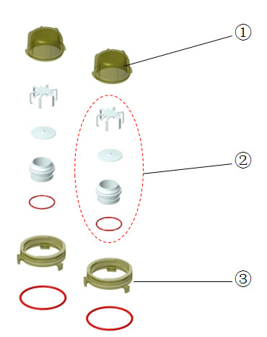

Parts List
No. | Order Number | Part Description | Qty | Remarks
1 | 801-0616-00002-00 | Check valve cover | 2 | Only one cover in each 801-0616-00002-00
2 | 801-0616-00003-00 | In&ex-piration check valve assembly | 2 | Only one check valve assembly in each 801-0616-00003-00
3 | 043-000127-00 | Check Valve bracket(PSU) | 2 | For PSU BC. Only one bracket in each 043-000127-00
3 | 0613-20-87681 | Check valve bracket (mold MR87681) | 2 | For Nylon BC. Refer to TMZ-15030. Only one bracket in each 0613-20-87681

Lifting Device Assembly

Exploded View
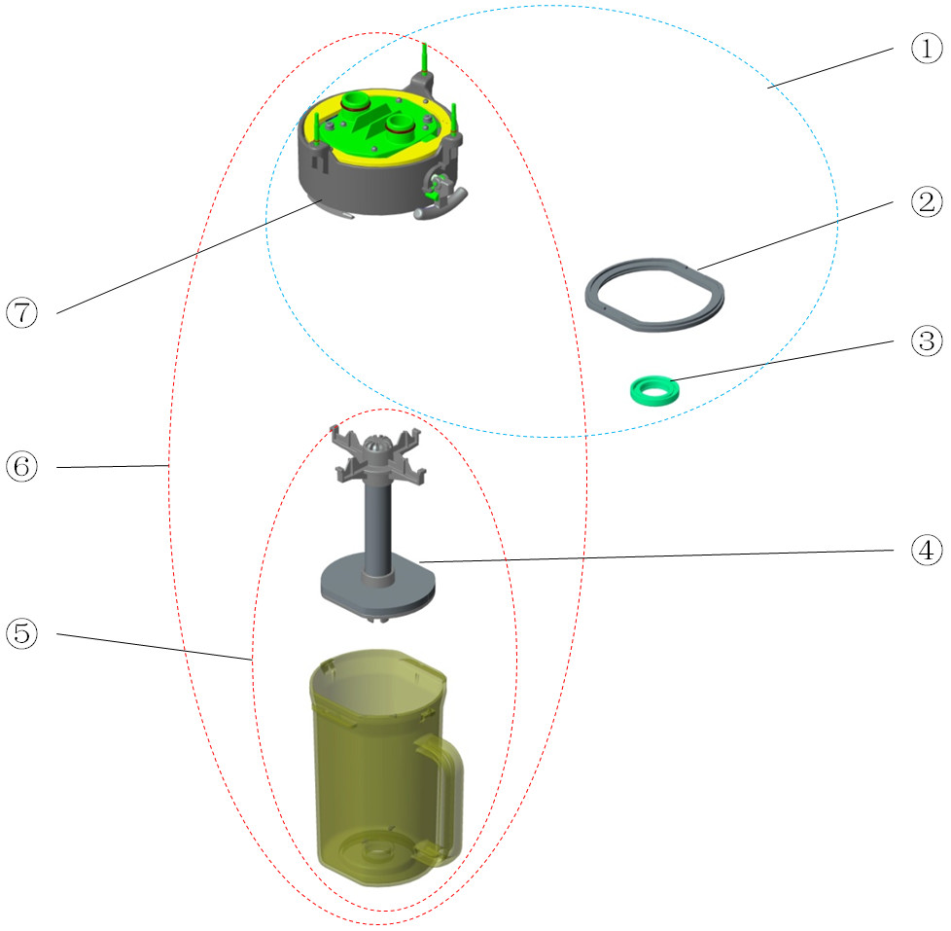

Parts List
No. | Order Number | Part Description | Qty | Remarks
1 | 115-034208-00 | Lifting device(with bypass/0615) | 1 | For Nylon BC. Refer to TMZ-15053
1 | 115-034209-00 | Lifting device(no bypass/0615) | 1 | For Nylon BC. Refer to TMZ-15053
2 | 0601-20-78842 | Seal for sodalime canister | 1 | Only for lifting canister
3 | 049-000154-00 | sealed tray of exit | 1 | /
4 | 801-0601-00014-00 | Absorber support assembly | 1 | /
5 | 115-002374-00 | Sodalime canister assembly | 1 | PSU
5 | 115-030838-00 | Canister assembly(0625) | 1 | For Nylon BC. Refer to TMZ-15053
6 | 801-0616-00017-00 | Lifting device (with BYPASS) | 1 | For PSU BC. Include 115-023264-00 & 115-002374-00
6 | 801-0616-00022-00 | Lifting device(without BYPASS) | 1 | For PSU BC. Include 115-023265-00 & 115-002374-00
7 | 115-023264-00 | Lifting device FRU(with bypass/0616) | 1 | For PSU BC
7 | 115-023265-00 | Lifting device FRU(0616) | 1 | For PSU BC. Without BYPASS

Sodalime Canister Assembly

Exploded View
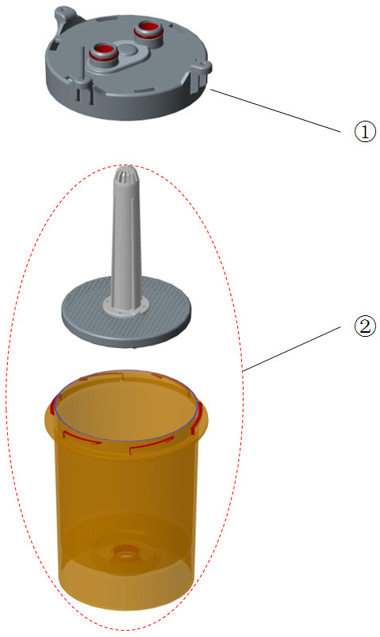

Parts List
No. | Order Number | Part Description | Qty | Remarks
1 | 115-014605-00 | Canister upper cover assembly(20L) | 1 | /
1 | 115-034193-00 | Canister upper cover assembly(20B) | 1 | For Nylon BC. Refer to TMZ-15053
2 | 115-014606-00 | Sodalime canister assembly(20L) | 1 | /
2 | 115-034194-00 | Sodalime canister assembly(20B) | 1 | For Nylon BC. Refer to TMZ-15053

Others
No. | Order Number | Part Description | Qty | Remarks
1 | 115-034982-00 | circuit screw Kits | 1 | Refer to TMZ-15053
2 | 115-034999-00 | Heating Module Package 0615) | 1 | Include heater box assembly and BC heater(not the whole BS block). Refer to TMZ-15053
2 | 801-0616-00132-00 | Heating Module Package (ACGO and bypass) | 1 | Include heater box assembly and BS block
2 | 801-0616-00129-00 | Heating Module Package (ACGO Only) | 1 | Include heater box assembly and BS block
2 | 801-0616-00131-00 | Heating Module Package (bypass Only) | 1 | Include heater box assembly and BS block
2 | 801-0616-00130-00 | Heating Module Package(Neither) | 1 | Include heater box assembly and BS block
3 | 115-004332-01 | Pendant assembly(0616) | 1 | /
4 | 0621-30-78719 | quick connector | 1 | /
5 | 801-0621-00109-00 | USB Disk with Activation Code (PCV) | 1 | Sys software Ver Higher than 04.08.00, need to provide machine's SN and machine ID
6 | 801-0621-00110-00 | USB Disk with Activation Code (SIMV) | 1 | Sys software Ver Higher than 04.08.00, need to provide machine's SN and machine ID
7 | 115-021121-00 | Maintain Kit(0616/0625,Basic,1 yr) | 1 | /
8 | 115-021122-00 | Maintain Kit(0616/0625,Extend,1 yr) | 1 | /
9 | 115-021123-00 | Maintain Kit(0616/0625,Advanced,1 yr) | 1 | /
10 | 095-000031-00 | wrench 6700-0020-300 | 1 | /
11 | 115-036182-00 | Medicine filler sleeve(0605) FRU | 1 | /
12 | 115-036167-00 | Filler cap FRU | 1 | /
13 | 115-039569-00 | Filler cap of ENF(Pour Fill) | 1 | /
14 | 115-039571-00 | Filler cap of ISO(Pour Fill) | 1 | /
15 | 115-039572-00 | Filler cap of SEV(Pour Fill) | 1 | /
16 | 115-039573-00 | Filler cap of SEV(Quik-Fil) | 1 | /
17 | 115-039574-00 | Filler cap of Hal(Pour Fill) | 1 | /
18 | 115-051200-00 | ventilator(AIR drive) | 1 | Include 115-034207-00 and 115-051195-00
18 | 115-051199-00 | ventilator(O2 drive) | 1 | Include 115-034207-00 and 115-051195-00
19 | 801-0631-00107-00 | spring of Vaporizer Mounting Manifold | 1 | /
20 | 801-0611-00094-00 | Gas inlet Filter | 1 | /
21 | 801-0613-00051-00 | Gas pressure switch | 1 | /
22 | 801-0616-00099-00 | Pipeline Gas Inlet Regulator (FRU) | 1 | /
23 | 801-0621-00164-00 | Drawer Lock.LA-W613 (FRU) | 1 | For machines before 2014.01
23 | 115-023320-00 | LOCK FRU | 1 | For machines after 2014.01. Refer to TMZ-14002
24 | 115-003706-00 | Common Gas Outlet(No ACGO Switch) | 1 | /
25 | 115-009073-00 | AGSS low-flow Receiving hoses assembly | 1 | /
25 | 115-009097-00 | AGSS high-flow Receiving hoses assembly | 1 | /
26 | 115-020745-00 | AGSS connector package(UK) | 1 | /
27 | 801-0621-00169-00 | (New) APL valve cover assembly(FRU) | 1 | Used with grey APL
28 | 049-000243-00 | Gasket,Bellows Canister Base | 1 | /
29 | 115-037748-00 | Nylon circuit(w/ arm,w/o bypass) | 1 | Refer to TMZ-16024
29 | 115-037749-00 | Nylon circuit(w/o arm,w/o bypass) | 1 | Refer to TMZ-16024
29 | 115-037750-00 | Nylon circuit(w/ arm,w/ bypass) | 1 | Refer to TMZ-16024
29 | 115-037751-00 | Nylon circuit(w/o arm,w/ bypass) | 1 | Refer to TMZ-16024
29 | 115-037752-00 | Nylon circuit(w/arm,w/o bypass,w/o Lift) | 1 | Refer to TMZ-16024
29 | 115-037753-00 | Nylon circuit(w/o arm&bypass,w/o Lift) | 1 | Refer to TMZ-16024
30 | M40-A00027--- | TBD | 1 | Filter power 250VAC 10A panel mount
31 | 115-051197-00 | Ventilator assembly (Air drive) | 1 | /
32 | 115-051198-00 | Ventilator assembly (O2 drive) | 1 | /
33 | 803-010170-00 | WATO EX-30 main unit warranty | 1 | /
34 | 803-010171-00 | WATO EX-20 main unit warranty | 1 | /

