WATO EX-55&65(KU-&KT-)

Anesthesia Machine

Parts

Contents
1 Parts 3
1.1 Main Unit 3
1.1.1 Exploded View 3
1.1.2 Parts List 3
1.2 Gas Bench Receptacle Assembly 5
1.2.1 Exploded View 5
1.2.2 Parts List 5
1.3 Work Surface 6
1.3.1 Exploded View 6
1.3.2 Parts List 6
1.4 Work Table 8
1.4.1 Exploded View 8
1.4.2 Parts List 8
1.5 Hardware Box 10
1.5.1 Exploded View 10
1.5.2 Parts List 10
1.6 Display Assembly 12
1.6.1 Exploded View 12
1.6.2 Parts List 12
1.7 Upper Half 14
1.7.1 Exploded View 14
1.7.2 Parts List 14
1.8 Main Body of the Breathing Circuit 16
1.8.1 Exploded View 16
1.8.2 Parts List 17
1.9 Lifting Device Assembly 19
1.9.1 Exploded View 19
1.9.2 Parts List 19
1.10 Pre-pak Absorb Canister Assembly 20
1.10.1 Exploded View 20
1.10.2 Parts List 20
1.11 Others 21

Parts

Main Unit

Exploded View
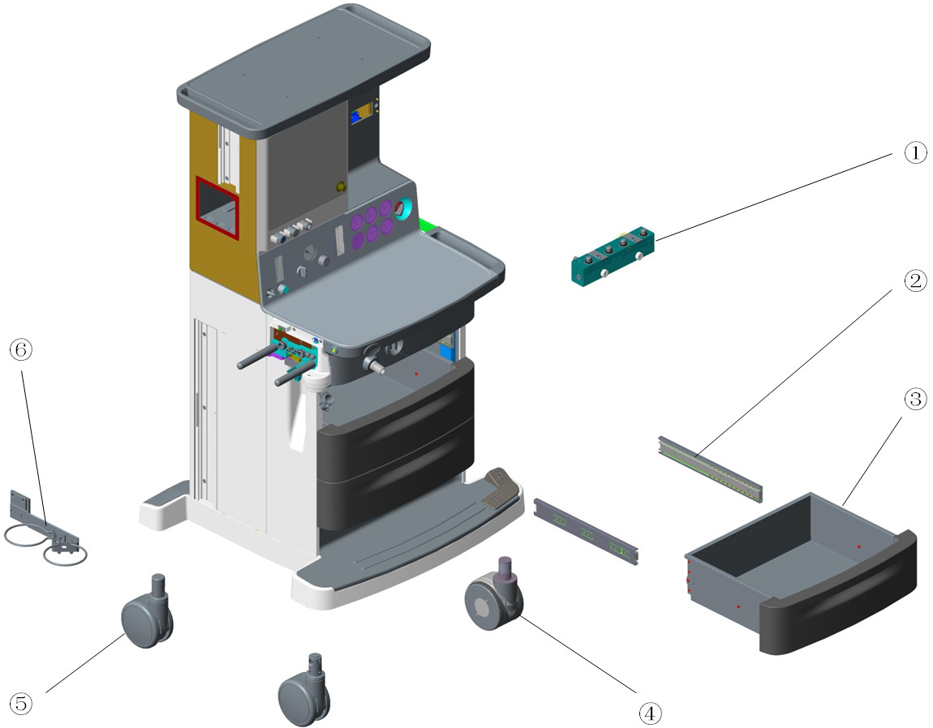

Parts List
No. | Order Number | Part Description | Qty | Remarks
1 | 115-030766-00 | Single vaporizer assembly(0625) | 1 | /
1 | 115-032993-00 | double vaporizer assembly(0625) | 1 | /
1 | 115-027827-00 | D-vaporizer assembly FRU(0635/plug-in) | 1 | /
2 | 031-000041-00 | ball guided.3flod 350mm blue zinc-plated | 6 | Only 1 rail in each 031-000041-00
3 | 115-025663-00 | drawer assembly(0625) | 3 | Only 1 drawer in each 115-025663-00
4 | 034-000462-00 | 5inch caster with brake | 3 | Only 1 caster in each 034-000462-00. For machines with central-brake system before 20160407, refer to TN:TMZ-16039.
4 | 034-000506-00 | Caster.5" white, total lock | 3 | Only 1 caster in each 034-000506-00. For machines with central-brake system after 20160407, refer to TN:TMZ-16039.
5 | 034-000463-00 | 5inch caster without brake | 1 | The caster near AGSS outlet. For machines with central-brake system before 20160407, refer to TN:TMZ-16039.
5 | 034-000507-00 | Caster.5" white, without brakes | 1 | The caster near AGSS outlet. For machines with central-brake system after 20160407, refer to TN:TMZ-16039.
6 | 115-017947-00 | suction bottle bracket assembly | 1 | /

Gas Bench Receptacle Assembly

Exploded View
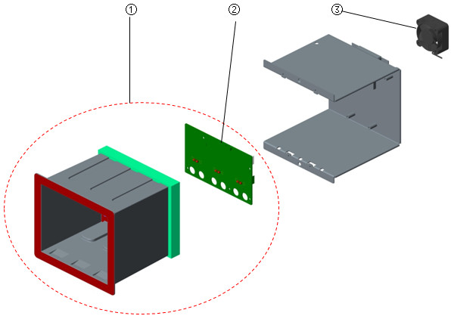

Parts List
No. | Order Number | Part Description | Qty | Remarks
1 | 115-016480-00 | gas bench receptacle assembly | 1 | /
2 | 801-0621-00165-00 | 0621 Infrared Communication Board | 1 | /
3 | 024-000407-00 | FAN 12V 40*40*20mm 6.3CFM 18dB typeF | 1 | /

Work Surface

Exploded View
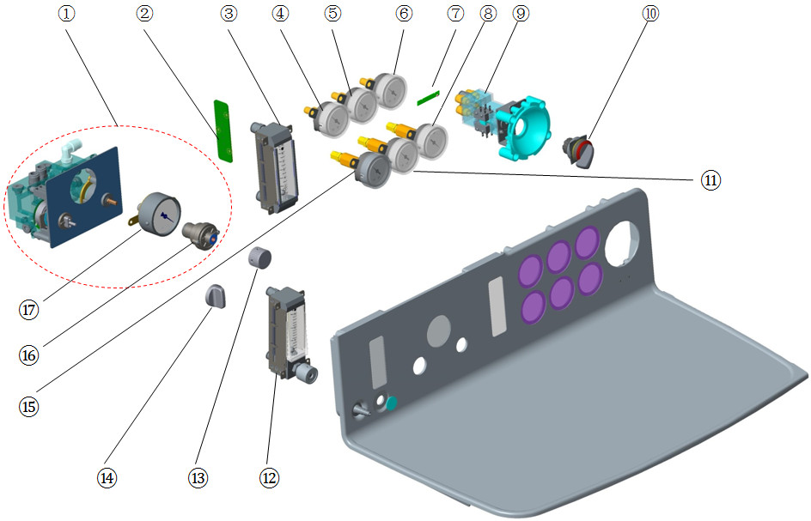

Parts List
No. | Order Number | Part Description | Qty | Remarks
1 | 115-028423-00 | suction control assembly(0625) | 1 | w/o neither Select switch of suction nor Switch of suction needle valve
2 | 051-001256-00 | 0632 Total Flowmeter Lighting Board PCBA | 1 | /
3 | 082-001535-00 | Total flowmeter 0.5～10L/min | 1 | w/o PCBA
4 | 115-030821-00 | Pressure gauge assembly(O2/0625) | 1 | /
5 | 115-030823-00 | Pressure gauge assembly(N2O/0625) | 1 | /
6 | 115-030822-00 | Pressure gauge assembly(Air/0625) | 1 | /
7 | 051-001934-00 | 0625 Indicator Board PCBA | 1 | /
8 | 115-030825-00 | High pressure gauge assembly(Air/0625) | 1 | /
9 | 115-030610-00 | system switch(0625/O2/AIR) | 1 | /
9 | 115-006954-00 | system switch assembly(0631) | 1 | Only O2, for machines w/o Air
10 | 010-000088-00 | SWITCH Latching 1X90°form V | 1 | System Switch Knob
11 | 115-030826-00 | High pressure gauge assembly(N2O/0625) | 1 | /
12 | 115-031113-00 | auxiliary flowmeter Assembly | 1 | w/o label
12 | 115-034687-00 | Auxiliary O2 supply kit(EU) | 1 | w/ O2 knob label(EU)
12 | 115-034688-00 | Auxiliary O2 supply kit(US) | 1 | w/ O2 knob label(US)
13 | 115-033001-00 | Switch of suction needle valve（0625） | 1 | /
14 | 115-033000-00 | Select switch of suction（0625） | 1 | /
15 | 115-030824-00 | High pressure gauge assembly(O2/0625) | 1 | /
16 | 115-015247-00 | suction needle valve assembly | 1 | /
17 | 115-024874-00 | ction gauge assembly(0635) | 1 | /

Work Table

Exploded View
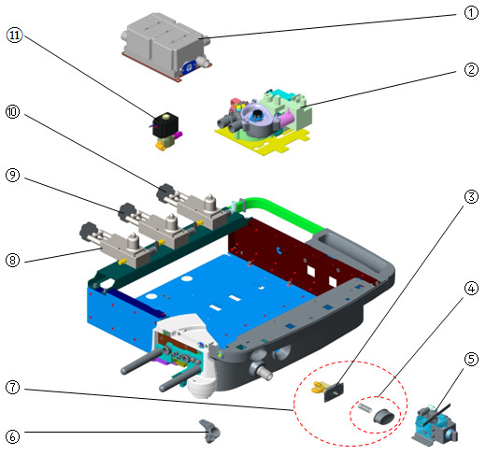

Parts List
No. | Order Number | Part Description | Qty | Remarks
1 | 115-032992-00 | Gas reservoir assembly（0625） | 1 | /
2 | 115-001372-01 | AVMA(0623) | 1 | /
3 | 115-009482-00 | O2 flush assembly(0623) | 1 | /
4 | 115-037147-00 | O2 flush button service kit(0619/0625) | 1 | /
5 | 115-061227-00 | mechanical ACGO assembly(0625) | 1 | /
5 | 115-033251-00 | ACGO(AG/0625) | 1 | only for machines with Built-in AG module
6 | 043-003125-00 | HOLSTER_G_SMALLCLIP | 1 | /
7 | 115-037130-00 | O2 flush module service kit(0619/0625) | 1 | /
8 | 115-002250-01 | Cylinder Bracket for O2 | 1 | w/o Electronic pressure sensor
9 | 115-002251-02 | Cylinder Bracket for N2O(Φ6) | 1 | w/ regulator
10 | 115-002728-01 | Air cylinder yoke assembly | 1 | w/ regulator
11 | 115-031022-00 | assembly of drive gas valve(0625) | 1 | /

Hardware Box

Exploded View
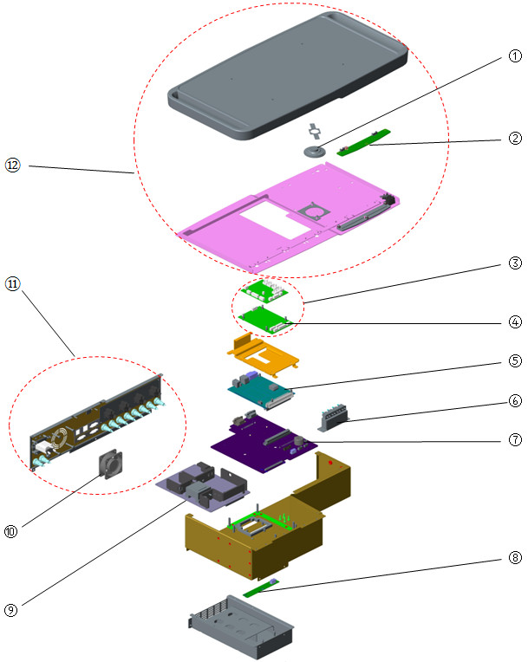

Parts List
No. | Order Number | Part Description | Qty | Remarks
1 | 801-0631-00038-00 | Speaker and Connecting Cable | 1 | /
2 | 051-001866-00 | 0625 toplight board PCBA | 1 | /
3 | 115-066430-00 | 0625 Monitor PCBA FRU | 1 | /
4 | 051-001996-00 | 0625 Ventilater&Protect PCBA(Norgren) | 1 | /
5 | 115-033246-00 | Main Board(VCV+PCV/0625) | 1 | For WATO EX-65, with VCV+PCV mode.
5 | 115-033247-00 | Main Board(VCV+PCV/0626) | 1 | For WATO EX-55, with VCV+PCV mode.
5 | 051-001863-00 | 0625 main control board PCBA | 1 | Factory configuration support VCV mode only. If you want the board support the same function with your AM, please provide Machine ID and Function configuration when make Order.
6 | 115-042876-00 | three way valve asm(0625) | 1 | 3 piece of valves, for machine w/o ACGO
6 | 115-042877-00 | three way valve asm(0625) | 1 | 4 piece of valves, for machine w/ ACGO
7 | 051-001864-01 | 0625 mother board PCBA | 1 | /
8 | 051-000768-00 | 0623 battery board PCBA | 1 | /
9 | 051-003469-00 | 0625 Power board PCBA | 1 | /
10 | 801-0631-00028-00 | Fan | 1 | back cover
11 | 115-025866-00 | back cover asm ofHD box(EU0625NONE) | 1 | EU,w/o outlet
11 | 115-025587-00 | back cover asm ofHD box(0625EU/100-240V) | 1 | EU,w/ outlet
11 | 115-038703-00 | 0625 back cover service kit(US/100-120V) | 1
11 | 115-038704-00 | 0625 back cover kit(US_B/100-240V) | 1
12 | 115-038708-00 | 0625 Top cover service kit(w_o Pro) | 1 | the label is "WATO EX-65"
12 | 115-038706-00 | 0626 Top cover service kit(w_o Pro) | 1 | the label is "WATO EX-55"

Display Assembly

Exploded View
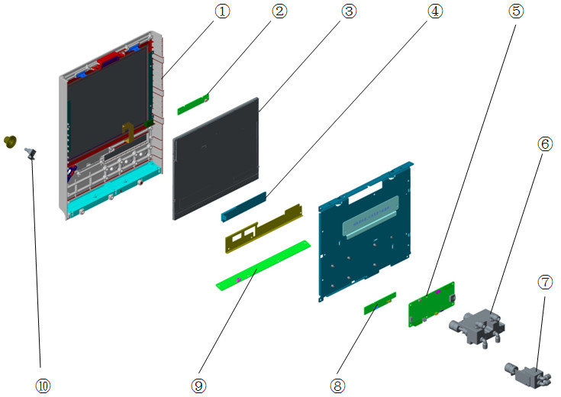

Parts List
No. | Order Number | Part Description | Qty | Remarks
1 | 115-034664-00 | Shell&touch screen(12'/O2-N2O/Air) | 1 | For 2 gas supply, O2&N2O or O2&Air
1 | 115-034665-00 | Shell&touch screen(12'/O2/N2O/Air) | 1 | For 3 gas supply, O2&N2O&Air
2 | 051-001868-00 | 0625 alarm LED board PCBA | 1 | /
3 | 115-034666-00 | Display screen FRU(12') | 1 | For WATO EX-65
3 | 115-034667-00 | Display screen FRU(10') | 1 | For WATO EX-55
4 | 021-000202-00 | LCD segment-mode 124*11mm I2C 10pin | 1 | /
5 | 051-001865-00 | 0625 key control board PCBA | 1 | /
6 | 082-002116-00 | O2&N2O Flow regulator(EN/GB/0625) | 1 | /
6 | 082-002115-00 | O2&N2O Flow regulator(ANSI/Reverse EN) | 1 | /
6 | 115-034669-00 | Flow adjust valve FRU(O2-N2O/EU) | 1 | Included 082-002116-00 and O2&N2O knob label
6 | 115-034670-00 | Flow adjust valve FRU(O2-N2O/Rev_EU) | 1 | Included 082-002115-00 and O2&N2O knob label
6 | 115-034671-00 | Flow adjust valve FRU(O2-N2O/US) | 1 | Included 082-002115-00 and O2&N2O knob label
6 | 115-034676-00 | Flow adjust valve FRU(O2/EU) | 1 | w/ O2 knob label(EU)
6 | 115-034677-00 | Flow adjust valve FRU(O2/US) | 1 | w/ O2 knob label(US)
7 | 115-034673-00 | Flow adjust valve FRU (Air/EU) | 1 | w/ Air knob label(EU)
7 | 115-034674-00 | Flow adjust valve FRU(Air/US) | 1 | w/ Air knob label(US)
8 | 051-001995-00 | 0625 touch-key board PCBA | 1 | /
9 | 051-001867-00 | 0625 auxiliary lighting board PCBA | 1 | /
10 | 801-0613-00035-00 | Encoder(FRU) | 1 | w/o metal fixing plate

Upper Half

Exploded View
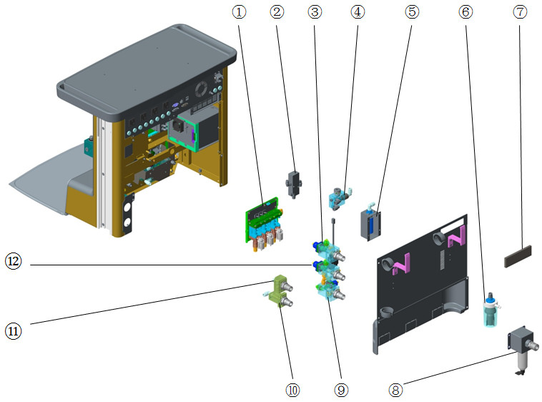

Parts List
No. | Order Number | Part Description | Qty | Remarks
1 | 115-025551-00 | Electronic Flowmeter Module(O2&N2O&Air) | 1 | /
1 | 115-031173-00 | Electronic Flowmeter Module(O2&N2O) | 1 | /
1 | 115-031174-00 | Electronic Flowmeter Module(O2&Air) | 1 | /
2 | 082-001231-00 | valve.2-way,air-piloted valves | 1 | /
3 | 115-030787-01 | N2O supply inlet assembly(NIST/0625) | 1 | /
3 | 115-030790-01 | N2O supply inlet assembly(DISS/0625) | 1 | /
4 | 115-017748-00 | vacuum generator unit | 1 | /
5 | 115-018356-00 | Muffler Asembly | 1 | /
6 | 115-018131-00 | Overflow Unit | 1 | /
7 | 045-001620-00 | dustproof(0625) | 1 | /
8 | 115-048529-00 | Air filter (F92G2VNQT1) | 1 | Only for Air-compressor configuration.
9 | 115-030788-01 | Air supply inlet assembly(NIST/0625) | 1 | w/o pressure switch
9 | 115-030791-01 | Air supply inlet assembly(DISS/0625) | 1 | w/o pressure switch
9 | 115-038065-00 | Air Inlet Service Kit(NIST/w_gas switch) | 1 | /
9 | 115-038066-00 | Air Inlet Service Kit(DISS/w_gas switch) | 1 | /
10 | 115-030793-01 | kup O2 supply inlet assy( NIST/0625) | 1 | /
11 | 115-004519-01 | O2 input assembly(Big Cylinder) | 1 | /
11 | 115-004558-01 | O2 input assembly(DISS/Big Cylinder) | 1 | /
11 | 115-004520-01 | N2O supply inlet assembly(Big Cylinder) | 1 | /
11 | 115-004559-01 | N2O inlet assembly(DISS/Big Cylinder) | 1 | /
11 | 115-018132-00 | Vacuum pipeline supply assembly(NIST) | 1 | /
11 | 115-018133-00 | Vacuum pipeline supply assembly(DISS) | 1 | /
12 | 115-030786-01 | O2 supply inlet assembly(NIST/0625) | 1 | w/o backup O2
12 | 115-030789-01 | O2 supply inlet assembly(DISS/0625) | 1 | /
12 | 115-030792-01 | Supply inlet assy(Backup O2 NIST/0625) | 1 | /

Main Body of the Breathing Circuit

Exploded View
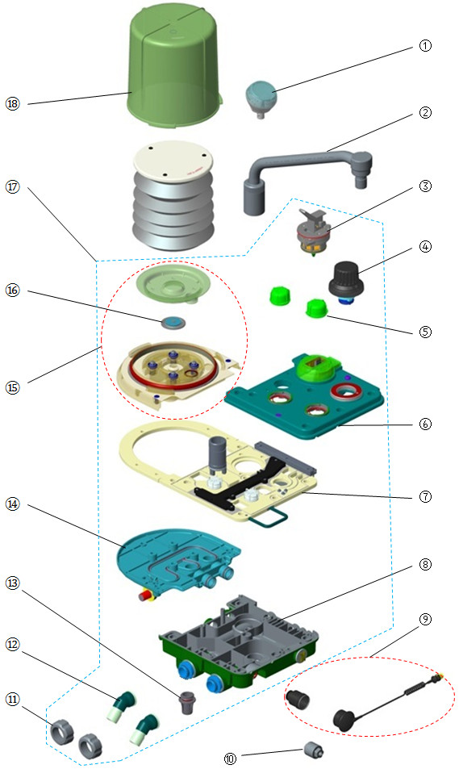

Parts List
No. | Order Number | Part Description | Qty | Remarks
1 | 115-025563-00 | Airway pressure gauge | 1 | /
2 | 115-048600-00 | Bag arm assembly(silvery/spacing) | 1 | w/ position limit, refer to TMZ-17026
2 | 801-0601-00005-00 | Bag arm assembly | 1 | w/o position limit, refer to TMZ-17026
3 | 801-0631-00065-00 | Bag/mechanical ventilation switch | 1 | /
4 | 115-046754-00 | APL valve FRU | 1 | /
5 | 801-0631-00061-00 | Check valve dome, A series | 2 | w/ Seal(O-ring). Only one check valve dome in each 801-0631-00061-00
6 | 115-030839-00 | Upper cover assembly(0625) | 1 | For lifting absorb canister
6 | 115-030845-00 | Upper cover assembly(gas return/0625) | 1 | For lifting absorb canister
6 | 115-006544-00 | upper cover assembly(0631) | 1 | For pre-pak absorb canister
7 | 115-048639-00 | mid-plate assembly(heat/arm)FRU | 1 | For lifting absorb canister
7 | 115-048640-00 | mid-plate assembly(0625/prepak)FRU | 1 | For pre-pak absorb canister
7 | 115-048641-00 | mid-plate assembly(heat/no arm)FRU | 1 | For lifting absorb canister
8 | 115-030840-00 | Lower cover assembly(0625) | 1 | For lifting absorb canister
8 | 115-030841-00 | Lower cover assembly(bag connector/0625) | 1 | For lifting absorb canister, w/o bag arm
8 | 115-009046-00 | Lower Cover Assembly | 1 | For pre-pak absorb canister
9 | 801-0631-00102-00 | O2 sensor cable module FRU | 1 | /
10 | 0611-10-45654 | O2 sensor,MedicelMOX-2 | 1 | /
11 | 801-0631-00059-00 | Insp/Exp Connector Rotary Cap, A series | 2 | Only one cap in each 801-0631-00059-00
12 | 801-0631-00057-00 | Insp/Exp Connector, A series | 2 | Only one connector in each 801-0631-00057-00
13 | 801-0631-00058-00 | Water Collection Cup, A series | 1 | w/ Seal(O-ring)
14 | 115-030843-00 | Lower cover 2 assembly(0625) | 1 | For lifting absorb canister
14 | 115-006548-00 | lover cover 2 assembly(0631) | 1 | For pre-pak absorb canister
15 | 115-030842-00 | Upper cover 2 assembly(0625) | 1 | For lifting absorb canister
15 | 115-006547-00 | upper cover 2 assembly(0631) | 1 | For pre-pak absorb canister
16 | 801-0601-00002-00 | Pop-off valve assembly | 1 | /
17 | 115-033004-00 | Patient main unit(with bag arm/0625) | 1 | For lifting absorb canister. W/O APL
17 | 115-033005-00 | Patient main unit(no bag arm/0625) | 1 | For lifting absorb canister. W/O APL
17 | 115-033006-00 | Patient main unit(gas return/0625) | 1 | For lifting absorb canister. W/O APL
17 | 801-0623-00011-00 | patient main unit | 1 | For pre-pak absorb canister. W/ APL. W/O bag arm position limit, refer to TMZ-17026
17 | 115-048843-00 | patient main unit | 1 | For pre-pak absorb canister. W/ APL. W/ bag arm position limit, refer to TMZ-17026
18 | 801-0631-00054-00 | Bellows Dome, A series | 1 | /

Lifting Device Assembly

Exploded View
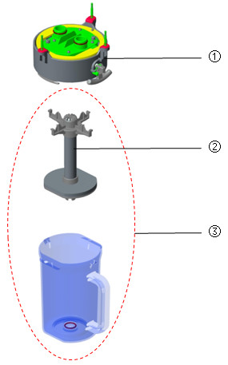

Parts List
No. | Order Number | Part Description | Qty | Remarks
1 | 115-030836-00 | Lifting device(0625) | 1 | w/o bypass
1 | 115-030837-00 | Lifting device(with bypass/0625) | 1 | /
2 | 115-034689-00 | Absorb canister shore(0625) | 1 | /
3 | 115-030838-00 | Canister assembly(0625) | 1 | Only for warranty

Pre-pak Absorb Canister Assembly

Exploded View
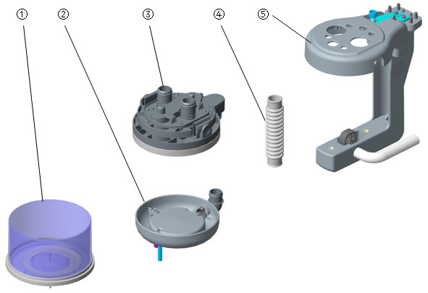

Parts List
No. | Order Number | Part Description | Qty | Remarks
1 | 801-0631-00066-00 | CO2 Absorbent Canister, A series | 1 | /
2 | 801-0631-00100-00 | CO2 Absorber Base, A series | 1 | /
3 | 115-006554-00 | pre-pak assembly(0631) | 1 | /
4 | 801-0631-00092-00 | CO2 Absorber Hose, A series | 1 | /
5 | 115-017030-00 | L-shape bracket assembly FUR(0631) | 1 | /

Others
No. | Order Number | Part Description | Qty | Remarks
1 | 115-033008-00 | USB flash memory（PCV-VG） | 1 | Need to provide machine's SN and machine ID
2 | 115-033011-00 | USB flash memory（SIMV-VG） | 1 | Need to provide machine's SN and machine ID
3 | 115-033012-00 | USB flash memory（PS） | 1 | Need to provide machine's SN and machine ID
4 | 115-033013-00 | USB flash memory（CPAP/PS） | 1 | Need to provide machine's SN and machine ID
5 | 115-033014-00 | USB flash memory（Loop） | 1 | Need to provide machine's SN and machine ID
6 | 115-036966-00 | USB flash memory(SIMV-VC+SIMV-PC) | 1 | Need to provide machine's SN and machine ID
7 | 115-035836-00 | pendant adapter package（no_sup_cylinder） | 1 | Refer to TN:TMZ-16040-WATO EX-65(0625)
7 | 115-035837-00 | pendant adapter package（sup_cylinder） | 1 | Refer to TN:TMZ-16040-WATO EX-65(0625)
8 | 115-036182-00 | Medicine filler sleeve(0605) FRU | 1 | /
9 | 115-036167-00 | Filler cap FRU | 1 | For SEV, Quik-Fill, w/o medicine filler sleeve
10 | 115-039569-00 | Filler cap of ENF（Pour Fill） | 1 | /
11 | 115-039571-00 | Filler cap of ISO（Pour Fill） | 1 | /
12 | 115-039572-00 | Filler cap of SEV（Pour Fill） | 1 | /
13 | 115-039573-00 | Filler cap of SEV（Quik-Fil） | 1 | w/ medicine filler sleeve
14 | 115-039574-00 | Filler cap of Hal（Pour Fill） | 1 | /
15 | M07-00131F--- | FUSE Time-lag 250V 3.15AD5X20 | 8 | Only one fuse in each M07-00131F---
16 | 115-060426-00 | 0625 alarm LED board cable FRU | 1 | /
17 | 115-060427-00 | 0625 display module data cable（12.1"）FRU | 1 | /
18 | 115-060428-00 | 0625 touch-key board cable FRU | 1 | /
19 | 034-000353-00 | Drawer lock | 1 | /
20 | 115-034691-00 | Pressure gage label&cover kit(0625/CFDA) | 1 | /
20 | 115-034692-00 | Pressure gage label&cover kit(0625/EU) | 1 | /
20 | 115-034693-00 | Pressure gage label&cover kit(0625/US) | 1 | /
21 | 082-000527-00 | Check valve AKH08-00 | 1 | Only for Air-compressor configuration
22 | 115-045674-00 | mainbody of regulator(220kPa) | 1 | Refer to TN:TMZ-17018
23 | 801-0613-00051-00 | Gas pressure switch | 1 | There are 2 pressure switch in O2 supply inlet assembly and Ventilation valve assembly. Whether Air supply inlet & N2O supply inlet have pressure switch is depended on AM configuration. Only one pressure switch in each 801-0613-00051-00
24 | 115-051204-00 | Breathing system FRU(O2 drive) | 1 | 115-066430-00 (0625 Monitor PCBA FRU) and 115-001372-01(AVMA(0623)) are included
24 | 115-051203-00 | Breathing system FRU(Air drive) | 1 | 115-066430-00 (0625 Monitor PCBA FRU) and 115-001372-01(AVMA(0623)) are included
25 | 082-001327-00 | Disposable Filter.0.45μm | 1 | Used with liquid collection bottle
26 | 115-034690-00 | Check valve assembly（0625） | 1 | /
27 | 115-039752-00 | Nylon circuit(w/o arm/0625/PA) | 1 | Included upper cover & lower cover & upper cover2 & lower cover 2, made by nylon
27 | 115-039754-00 | Nylon circuit(w/ arm,w/o bypas/0625/PAs) | 1 | Included upper cover & lower cover & upper cover2 & lower cover 2, made by nylon
28 | 049-000243-00 | Gasket,Bellows Canister Base | 1 | /
29 | 115-034694-00 | Maintain Kit(0625,Basic,1 yr/Prepark) | 1 | /
30 | 115-034696-00 | Maintain Kit(0625,Extend,1yr/Prepark) | 1 | /
31 | 115-034698-00 | Maintain Kit(0625,Advanced,1 yr/Prepark) | 1 | /
32 | 115-021121-00 | Maintain Kit(0616/0625,Basic,1 yr) | 1 | /
33 | 115-021122-00 | Maintain Kit(0616/0625,Extend,1 yr) | 1 | /
34 | 115-021123-00 | Maintain Kit(0616/0625,Advanced,1 yr) | 1 | /
35 | 803-010125-00 | WATO 65 main unit warranty | 1 | /
35 | 803-010127-00 | WATO 55 main unit warranty | 1 | /

