WATO EX-55Pro&65Pro(F1-&KY-)

Anesthesia Machine

Parts

Contents
1 Parts 4
1.1 Main Unit 4
1.1.1 Exploded View 4
1.1.2 Parts List 4
1.2 Gas Bench Receptacle Assembly 5
1.2.1 Exploded View 5
1.2.2 Parts List 5
1.3 AGSS Assembly 6
1.3.1 Exploded View 6
1.3.2 Parts List 6
1.4 Work Surface 7
1.4.1 Exploded View 7
1.4.2 Parts List 7
1.5 Work Table 9
1.5.1 Exploded View 9
1.5.2 Parts List 9
1.6 Hardware Box 11
1.6.1 Exploded View 11
1.6.2 Parts List 11
1.7 Display Assembly 14
1.7.1 Exploded View 14
1.7.2 Parts List 14
1.8 Upper Half 15
1.8.1 Exploded View 15
1.8.2 Parts List 15
1.9 EFCS Assembly 18
1.9.1 Exploded View 18
1.9.2 Parts List 18
1.10 Gas Inlet Assembly 19
1.10.1 Exploded View 19
1.10.2 Parts List 19
1.11 Main Body of the Breathing Circuit 20
1.11.1 Exploded View 20
1.11.2 Parts List 21
1.12 Lifting Device Assembly 23
1.12.1 Exploded View 23
1.12.2 Parts List 23
1.13 Pre-pak Absorb Canister Assembly 24
1.13.1 Exploded View 24
1.13.2 Parts List 24
1.14 Others 25

Parts

Main Unit

Exploded View
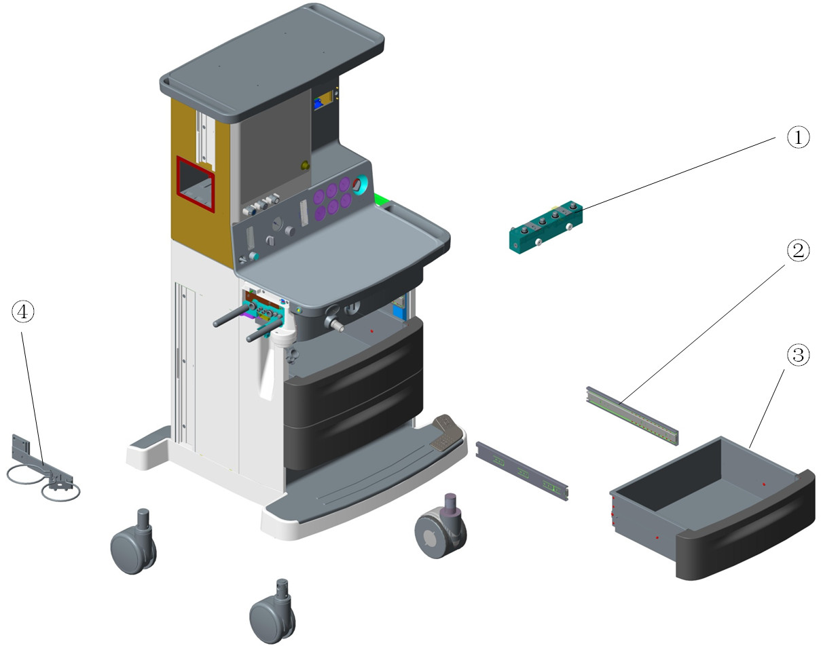

Parts List
No. | Order Number | Part Description | Qty | Remarks
1 | 115-030766-00 | Single vaporizer assembly(0625) | 1 | /
1 | 115-032993-00 | double vaporizer assembly(0625) | 1 | /
1 | 115-027827-00 | D-vaporizer assembly FRU(0635/plug-in) | 1 | /
2 | 031-000041-00 | ball guided.3flod 350mm blue zinc-plated | 6 | Only 1 rail in each 031-000041-00
3 | 115-025663-00 | drawer assembly(0625) | 3 | Only 1 drawer in each 115-025663-00
4 | 115-017947-00 | suction bottle bracket assembly | 1 | /

Gas Bench Receptacle Assembly

Exploded View
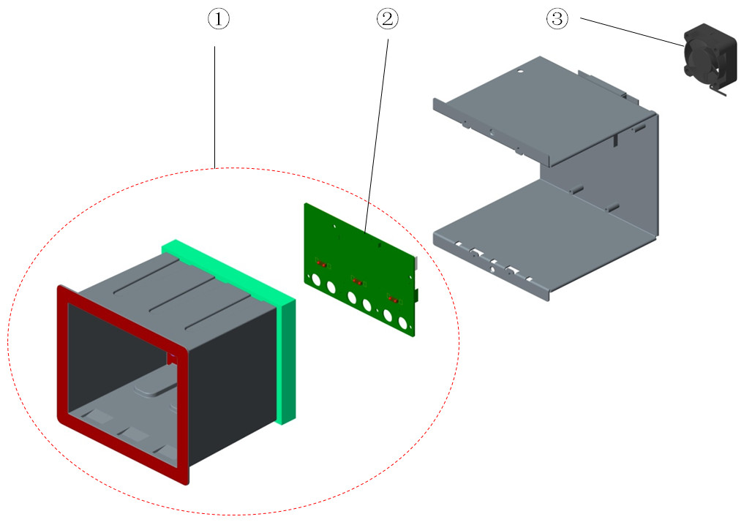

Parts List
No. | Order Number | Part Description | Qty | Remarks
1 | 115-016480-00 | gas bench receptacle assembly | 1 | /
2 | 801-0621-00165-00 | 0621 Infrared Communication Board | 1 | /
3 | 024-000407-00 | FAN 12V 40*40*20mm 6.3CFM 18dB typeF | 1 | /

AGSS Assembly

Exploded View
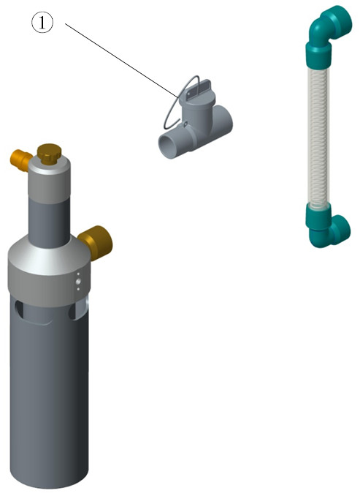

Parts List
No. | Order Number | Part Description | Qty | Remarks
1 | 115-042912-00 | AGSS 3 ways connector assembly | 1 | /

Work Surface

Exploded View
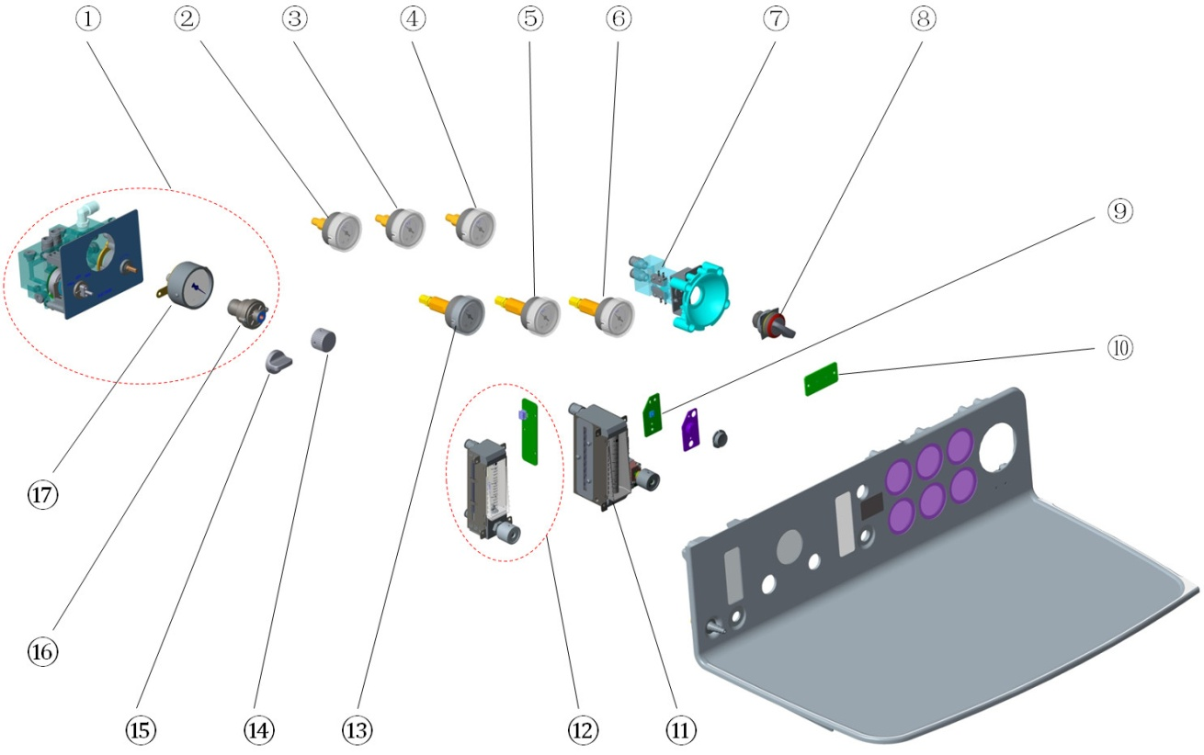

Parts List
No. | Order Number | Part Description | Qty | Remarks
1 | 115-028423-00 | suction control assembly(0625) | 1 | w/o neither Select switch of suction nor Switch of suction needle valve
2 | 115-040113-00 | Pressure gauge assembly(O2/0627) | 1
3 | 115-040115-00 | Pressure gauge assembly(N2O/0627) | 1
4 | 115-040114-00 | Pressure gauge assembly(Air/0627) | 1
5 | 115-040111-00 | High pressure gauge assembly(N2O/0627) | 1
6 | 115-040110-00 | High pressure gauge assembly(Air/0627) | 1
7 | 115-006954-00 | system switch assembly(0631) | 1 | Only O2
8 | 010-000088-00 | SWITCH Latching 1X90°form V | 1 | System Switch Knob
9 | 051-002581-00 | 0627 BFCS Key Board PCBA | 1
10 | 051-001934-00 | 0625 Indicator Board PCBA | 1
11 | 082-002459-00 | Backup Oxygen Flowmeter 0~10L/min | 1
12 | 115-034687-00 | Auxiliary O2 supply kit(EU) | 1 | W/ O2 knob label(EU)
12 | 115-034688-00 | Auxiliary O2 supply kit(US) | 1 | W/ O2 knob label(US)
13 | 115-040112-00 | High pressure gauge assembly(O2/0627) | 1
14 | 115-033001-00 | Switch of suction needle valve（0625） | 1 | /
15 | 115-033000-00 | Select switch of suction（0625） | 1 | /
16 | 115-015247-00 | suction needle valve assembly | 1 | /
17 | 115-024874-00 | ction gauge assembly(0635) | 1 | /

Work Table

Exploded View
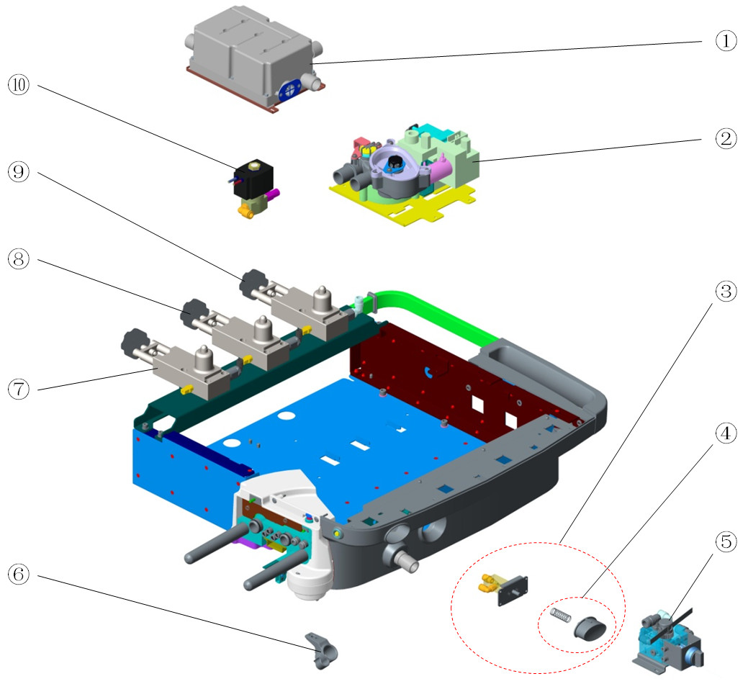

Parts List
No. | Order Number | Part Description | Qty | Remarks
1 | 115-032992-00 | Gas reservoir assembly（0625） | 1 | /
2 | 115-001372-01 | AVMA(0623) | 1 | /
3 | 115-037130-00 | O2 flush module service kit(0619/0625) | 1 | /
4 | 115-037147-00 | O2 flush button service kit(0619/0625) | 1 | /
5 | 115-061227-00 | mechanical ACGO assembly(0625) | 1 | /
5 | 115-033251-00 | ACGO(AG/0625) | 1 | Only for machines with Built-in AG module
6 | 043-003125-00 | HOLSTER_G_SMALLCLIP | 1 | /
7 | 115-002250-01 | Cylinder Bracket for O2 | 1 | W/O electronic pressure sensor
7 | 115-056316-00 | O2 cylinder yoke assembly(0627) | 1 | W/ electronic pressure sensor
8 | 115-002251-02 | Cylinder Bracket for N2O(Φ6) | 1 | W/O electronic pressure sensor
8 | 115-056317-00 | N2O cylinder yoke assembly(0627) | 1 | W/ electronic pressure sensor
9 | 115-002728-01 | Air cylinder yoke assembly | 1 | W/O electronic pressure sensor
9 | 115-056318-00 | Air cylinder yoke assembly(0627) | 1 | W/ electronic pressure sensor
10 | 115-031022-00 | assembly of drive gas valve(0625) | 1 | /

Hardware Box

Exploded View
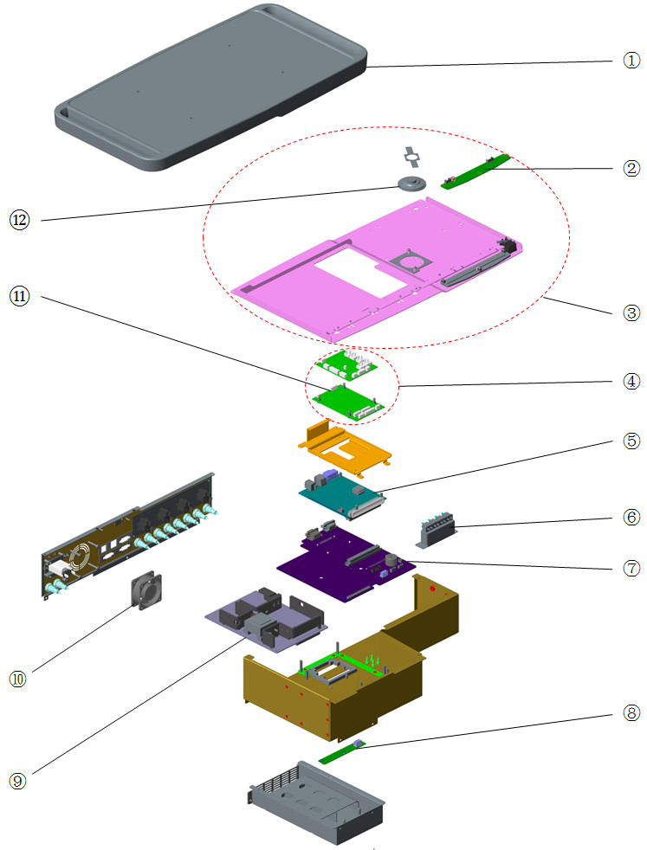

Parts List
No. | Order Number | Part Description | Qty | Remarks
1 | 115-038712-00 | Top Cover Assembly (0627) | 1 | /
2 | 051-001866-00 | 0625 toplight board PCBA | 1 | /
3 | 115-038711-00 | Top Plate Asembly (0627) | 1 | /
4 | 115-066430-00 | 0625 Monitor PCBA FRU | 1 | /
5 | 115-040643-00 | Main Board（VCV+PCV）FRU(0627) | 1 | For 65Pro. Factory configuration support VCV+PCV mode only. If you want the board support the same function with your AM, please provide Machine ID and Function configuration when make Order.
5 | 115-040736-00 | Main board kit (0627) | 1 | For 65Pro. Factory configuration support VCV mode only. If you want the board support the same function with your AM, please provide Machine ID and Function configuration when make Order.
5 | 115-041386-00 | Main Board（VCV+PCV/0628） | 1 | For 55Pro. Factory configuration support VCV+PCV mode only. If you want the board support the same function with your AM, please provide Machine ID and Function configuration when make Order.
5 | 115-041387-00 | Main board (0628) | 1 | For 55Pro. Factory configuration support VCV mode only. If you want the board support the same function with your AM, please provide Machine ID and Function configuration when make Order.
6 | 115-042876-00 | three way valve asm(0625) | 1 | 3 piece of valves, for machine w/o ACGO
6 | 115-042877-00 | three way valve asm(0625/3way) | 1 | 4 piece of valves, for machine w/ ACGO
7 | 051-002637-00 | 0627 Mother Board PCBA | 1 | /
8 | 051-000768-00 | 0623 battery board PCBA | 1 | /
9 | 051-003468-00 | 0627Power Board PCBA | 1 | /
10 | 801-0631-00028-00 | Fan | 1 | Back cover
11 | 051-001996-00 | 0625 Ventilater&Protect PCBA（Norgren） | 1 | /
12 | 801-0631-00038-00 | Speaker and Connecting Cable | 1 | /

Display Assembly

Exploded View
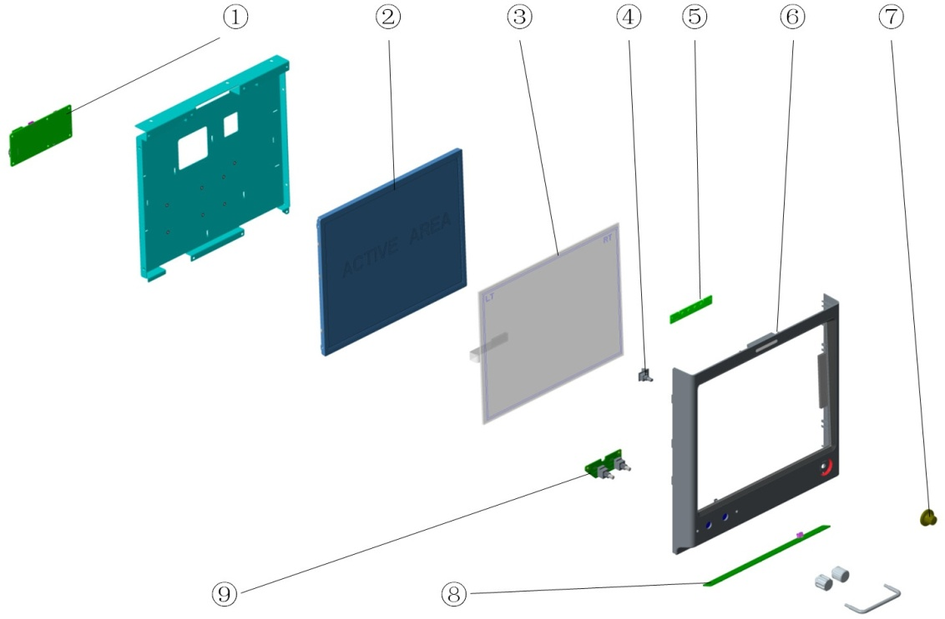

Parts List
No. | Order Number | Part Description | Qty | Remarks
1 | 051-002623-00 | 0627 Key Board PCBA | 1 | /
2 | 115-040737-00 | LCD FRU KIT | 1 | 15" LCD
3 | 021-000287-00 | Touchscreen 15" 5-wire resistive | 1 | /
4 | 801-0613-00035-00 | Encoder(FRU) | 1 | W/O metal fixing plate
5 | 801-0631-00019-00 | 0631 warning light board PCBA | 1 | /
6 | 115-040641-00 | Front Display Cover FRU（0627） | 1 | /
7 | 043-000342-00 | Knob | 1 | /
8 | 051-001867-00 | 0625 auxiliary lighting board PCBA | 1 | /
9 | 051-001260-00 | 0632 Encoder Board PCBA | 1 | /

Upper Half

Exploded View
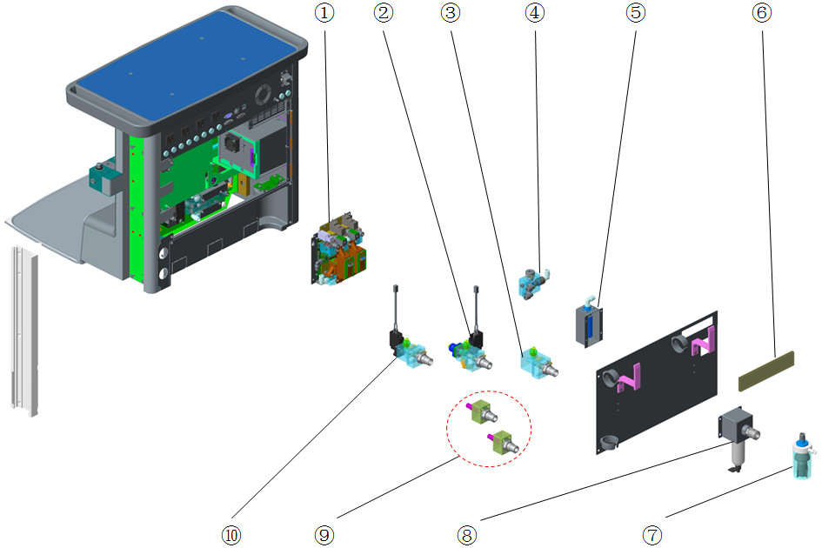

Parts List
No. | Order Number | Part Description | Qty | Remarks
1 | 115-040738-00 | Module of auto-flowmeter FRU(O2&N2O&Air) | 1 | /
1 | 115-040739-00 | Module of auto-flowmeter FRU(O2&Air) | 1 | /
1 | 115-040740-00 | Module of auto-flowmeter FRU(O2&N2O) | 1 | /
2 | 115-030786-01 | O2 supply inlet assembly(NIST/0625) | 1 | W/O electronic pressure sensor, w/ pressure switch
2 | 115-056320-00 | O2 origin inlet module(0627/NIST) | 1 | W/ electronic pressure sensor, include 051-002521-00, w/o backup O2
2 | 115-056326-00 | O2 supply inlet assembly(NIST/0627) | 1 | W/ electronic pressure sensor, include 051-002521-00, w/ backup O2
2 | 115-030789-01 | O2 supply inlet assembly(DISS/0625) | 1 | W/O electronic pressure sensor
2 | 115-056321-00 | O2 origin inlet module(0627/DISS) | 1 | W/ electronic pressure sensor, include 051-002521-00,
3 | 115-040098-00 | Air supply inlet ( NIST/0627) | 1 | W/O electronic pressure sensor, w/o pressure switch
3 | 115-039357-00 | Air supply inlet ( P switch/NIST/0627) | 1 | W/O electronic pressure sensor, w/ pressure switch
3 | 115-056324-00 | Air origin inlet module(0627/NIST) | 1 | W/ electronic pressure sensor, include 051-002521-00, w/o pressure switch
3 | 115-040099-00 | Air supply inlet ( DISS/0627) | 1 | W/O electronic pressure sensor, w/o pressure switch
3 | 115-040097-00 | Air supply inlet ( P switch/DISS/0627) | 1 | W/O electronic pressure sensor, w/ pressure switch
3 | 115-056325-00 | Air origin inlet module(0627/DISS) | 1 | W/ electronic pressure sensor, include 051-002521-00, w/o pressure switch
4 | 115-017748-00 | vacuum generator unit | 1 | /
5 | 115-018356-00 | Muffler Asembly | 1 | /
6 | 045-000032-00 | Dust filter | 1 | /
7 | 115-018131-00 | Overflow Unit | 1 | /
8 | 115-048529-00 | Air filter (F92G2VNQT1) | 1 | Only for Air-compressor configuration.
9 | 115-034706-01 | Backup O2 supply assembly(0615) | 1 | /
9 | 115-004520-01 | N2O supply inlet assembly(Big Cylinder) | 1 | NIST
9 | 115-004559-01 | N2O inlet assembly(DISS/Big Cylinder) | 1 | /
9 | 115-004519-01 | O2 input assembly(Big Cylinder) | 1 | NIST
9 | 115-004558-01 | O2 input assembly(DISS/Big Cylinder) | 1 | /
9 | 115-018132-00 | Vacuum pipeline supply assembly(NIST) | 1 | /
9 | 115-018133-00 | Vacuum pipeline supply assembly(DISS) | 1 | /
10 | 115-039268-00 | N2O supply inlet assembly（NIST/0627) | 1 | W/O electronic pressure sensor, w/o pressure switch
10 | 115-056322-00 | N20 origin inlet module(0627/NIST) | 1 | W/ electronic pressure sensor, include 051-002521-00
10 | 115-040096-00 | N2O supply inlet assembly（DISS/0627) | 1 | W/O electronic pressure sensor, w/o pressure switch
10 | 115-056323-00 | N20 origin inlet module(0627/DISS) | 1 | W/ electronic pressure sensor, include 051-002521-00

EFCS Assembly

Exploded View
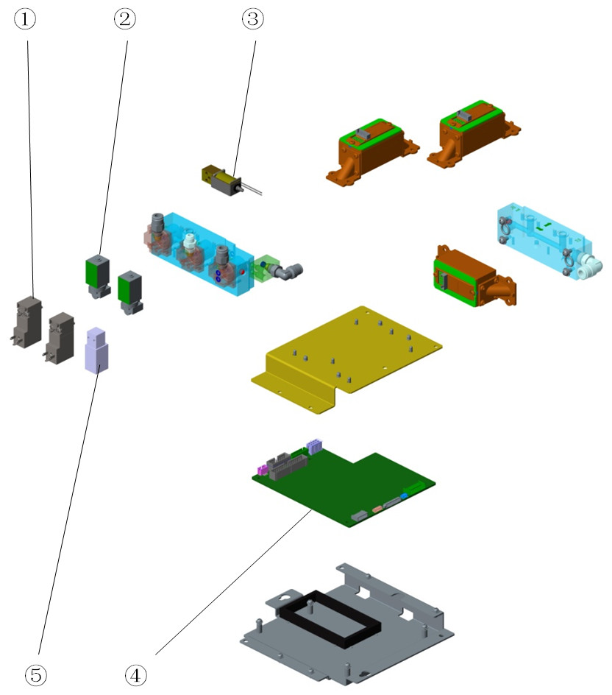

Parts List
No. | Order Number | Part Description | Qty | Remarks
1 | 082-002567-00 | Gas valve 2Pos. 3Port DC12V 2W 10bar | 2 | /
2 | 009-007236-00 | 0627 Proportional valve cable（valve） | 2 | /
3 | 009-007237-00 | 0627 NO valve for auto-flowmeter (w cable) | 1 | /
4 | 115-040642-00 | Auto-Flow Monitor Board FRU(0627) | 1 | /
5 | 009-007238-00 | 0627 NC valve for auto-flowmeter (w cable) | 1 | /

Gas Inlet Assembly

Exploded View
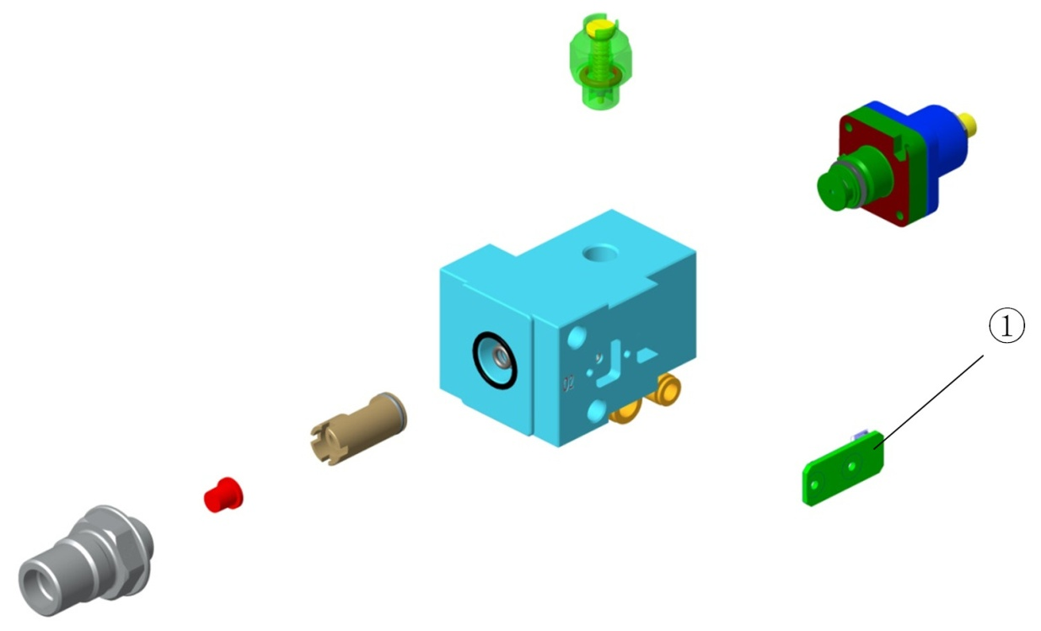

Parts List
No. | Order Number | Part Description | Qty | Remarks
1 | 051-002521-00 | VT70 air source press sensor PCBA | 1 | /

Main Body of the Breathing Circuit

Exploded View
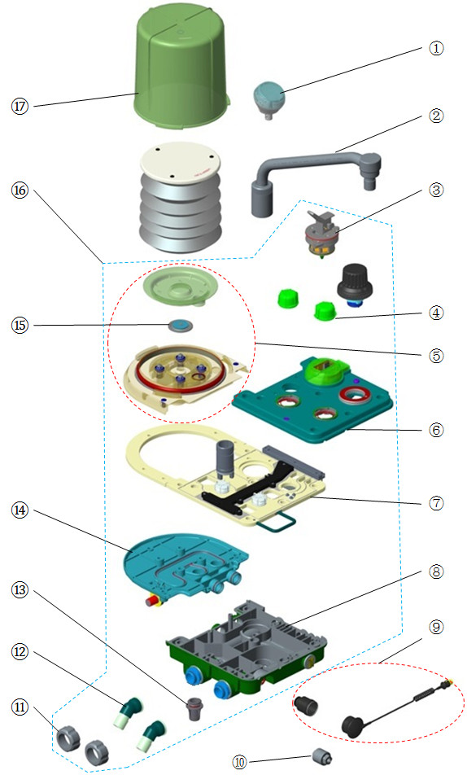

Parts List
No. | Order Number | Part Description | Qty | Remarks
1 | 115-025563-00 | Airway pressure gauge | 1 | /
2 | 115-048600-00 | Bag arm assembly(silvery/spacing) | 1 | w/ position limit, refer to TMZ-17026
2 | 801-0601-00005-00 | Bag arm assembly | 1 | w/o position limit, refer to TMZ-17036
3 | 801-0631-00065-00 | Bag/mechanical ventilation switch | 1 | /
4 | 801-0631-00061-00 | Check valve dome, A series | 2 | w/ Seal(O-ring). Only one check valve dome in each 801-0631-00061-00
5 | 115-030842-00 | Upper cover 2 assembly(0625) | 1 | For lifting absorb canister
5 | 115-006547-00 | upper cover 2 assembly(0631) | 1 | For pre-pak absorb canister
6 | 115-030839-00 | Upper cover assembly(0625) | 1 | For lifting absorb canister
6 | 115-030845-00 | Upper cover assembly(gas return/0625) | 1 | For lifting absorb canister
6 | 115-006544-00 | upper cover assembly(0631) | 1 | For pre-pak absorb canister
7 | 115-048639-00 | mid-plate assembly(heat/arm)FRU | 1 | For lifting absorb canister
7 | 115-048640-00 | mid-plate assembly(0625/prepak)FRU | 1 | For pre-pak absorb canister
7 | 115-048641-00 | mid-plate assembly(heat/no arm)FRU | 1 | For lifting absorb canister
8 | 115-030840-00 | Lower cover assembly(0625) | 1 | For lifting absorb canister
8 | 115-030841-00 | Lower cover assembly(bag connector/0625) | 1 | For lifting absorb canister, w/o bag arm
8 | 115-009046-00 | Lower Cover Assembly | 1 | For pre-pak absorb canister
9 | 801-0631-00102-00 | O2 sensor cable module FRU | 1 | /
10 | 0611-10-45654 | O2 sensor,MedicelMOX-2 | 1 | /
11 | 801-0631-00059-00 | Insp/Exp Connector Rotary Cap, A series | 2 | Only one cap in each 801-0631-00059-00
12 | 801-0631-00057-00 | Insp/Exp Connector, A series | 2 | Only one connector in each 801-0631-00057-00
13 | 801-0631-00058-00 | Water Collection Cup, A series | 1 | w/ Seal(O-ring)
14 | 115-030843-00 | Lower cover 2 assembly(0625) | 1 | For lifting absorb canister
14 | 115-006548-00 | lover cover 2 assembly(0631) | 1 | For pre-pak absorb canister
15 | 801-0601-00002-00 | Pop-off valve assembly | 1 | /
16 | 115-033004-00 | Patient main unit(with bag arm/0625) | 1 | For lifting absorb canister
16 | 115-033005-00 | Patient main unit(no bag arm/0625) | 1 | For lifting absorb canister
16 | 115-033006-00 | Patient main unit(gas return/0625) | 1 | For lifting absorb canister
16 | 801-0623-00011-00 | patient main unit | 1 | For pre-pak absorb canister. W/O bag arm position limit, refer to TMZ-17026
16 | 115-048843-00 | patient main unit | 1 | For pre-pak absorb canister. W/ bag arm position limit, refer to TMZ-17026
17 | 801-0631-00054-00 | Bellows Dome, A series | 1 | /

Lifting Device Assembly

Exploded View
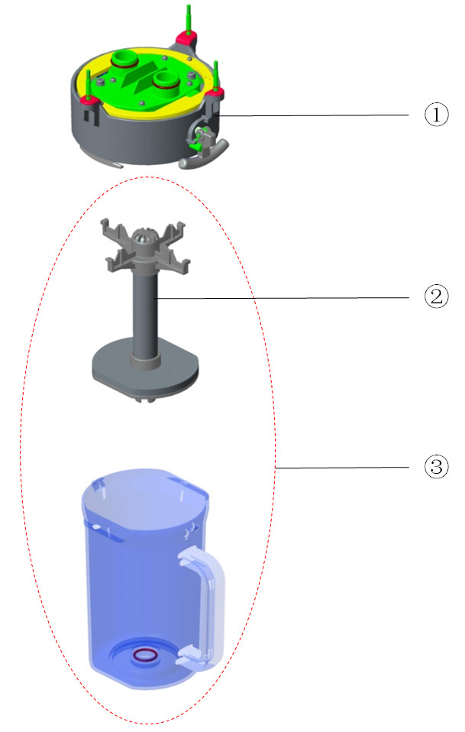

Parts List
No. | Order Number | Part Description | Qty | Remarks
1 | 115-030836-00 | Lifting device(0625) | 1 | w/o bypass
1 | 115-030837-00 | Lifting device(with bypass/0625) | 1 | /
2 | 115-034689-00 | Absorb canister shore(0625) | 1 | /
3 | 115-030838-00 | Canister assembly(0625) | 1 | Only for warranty

Pre-pak Absorb Canister Assembly

Exploded View
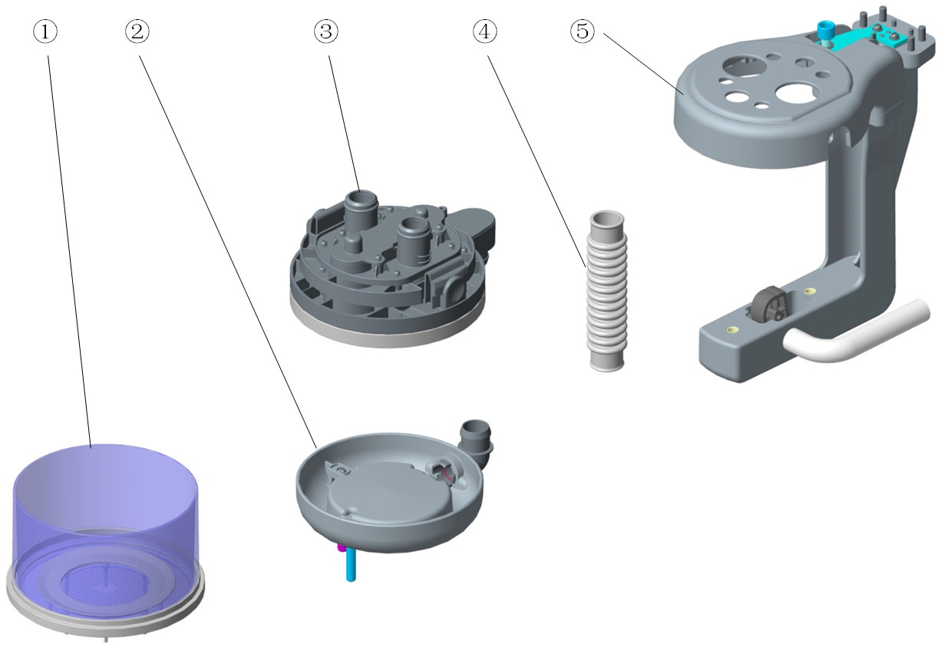

Parts List
No. | Order Number | Part Description | Qty | Remarks
1 | 801-0631-00066-00 | CO2 Absorbent Canister, A series | 1 | /
2 | 801-0631-00100-00 | CO2 Absorber Base, A series | 1 | /
3 | 115-006554-00 | pre-pak assembly(0631) | 1 | /
4 | 801-0631-00092-00 | CO2 Absorber Hose, A series | 1 | /
5 | 115-009490-00 | L-shape bracket assembly(0623) | 1 | /

Others
No. | Order Number | Part Description | Qty | Remarks
1 | 115-033008-00 | USB flash memory（PCV-VG） | 1 | Need to provide machine's SN and machine ID
2 | 115-033011-00 | USB flash memory（SIMV-VG） | 1 | Need to provide machine's SN and machine ID
3 | 115-033012-00 | USB flash memory（PS） | 1 | Need to provide machine's SN and machine ID
4 | 115-033013-00 | USB flash memory（CPAP/PS） | 1 | Need to provide machine's SN and machine ID
5 | 115-033014-00 | USB flash memory（Loop） | 1 | Need to provide machine's SN and machine ID
6 | 115-036966-00 | USB flash memory(SIMV-VC+SIMV-PC) | 1 | Need to provide machine's SN and machine ID
7 | 115-045689-00 | Activation Code(USB/Recruitment) | 1 | Need to provide machine's SN and machine ID
8 | 082-001327-00 | Disposable Filter.0.45μm | 1 | Used with liquid collection bottle
9 | 115-039569-00 | Filler cap of ENF（Pour Fill） | 1 | /
10 | 115-039571-00 | Filler cap of ISO（Pour Fill） | 1 | /
11 | 115-039572-00 | Filler cap of SEV（Pour Fill） | 1 | /
12 | 115-039573-00 | Filler cap of SEV（Quik-Fil） | 1 | W/ medicine filler sleeve
13 | 115-039574-00 | Filler cap of Hal（Pour Fill） | 1 | /
14 | 115-060430-00 | 0627 display module data cable FRU | 1 | /
15 | 115-060429-00 | 0627 alarm LED board cable FRU | 1 | /
16 | 010-000257-00 | Optical Encoder 24detent 5VDC Cable | 1 | /
17 | M07-00131F--- | FUSE Time-lag 250V 3.15AD5X20 | 8 | Only one fuse in each M07-00131F---
18 | 115-034694-00 | Maintain Kit(0625,Basic,1 yr/Prepark) | 1 | /
19 | 115-034696-00 | Maintain Kit(0625,Extend,1yr/Prepark) | 1 | /
20 | 115-034698-00 | Maintain Kit(0625,Advanced,1 yr/Prepark) | 1 | /
21 | 115-021121-00 | Maintain Kit(0616/0625,Basic,1 yr) | 1 | /
22 | 115-021122-00 | Maintain Kit(0616/0625,Extend,1 yr) | 1 | /
23 | 115-021123-00 | Maintain Kit(0616/0625,Advanced,1 yr) | 1 | /
24 | 034-000353-00 | Drawer lock | 1 | /
25 | 049-000243-00 | Gasket,Bellows Canister Base | 1 | /
26 | 115-034690-00 | Check valve assembly（0625） | 1 | /
27 | 115-034693-00 | Pressure gage label&cover kit(0625/US) | 1 | /
28 | 082-000527-00 | Check valve AKH08-00 | 1 | Only for Air-compressor configuration
29 | 115-034692-00 | Pressure gage label&cover kit(0625/EU) | 1 | /
30 | 115-051204-00 | Breathing system FRU(O2 drive) | 1 | 115-066430-00 (0625 Monitor PCBA FRU) and 115-001372-01(AVMA(0623)) are included
30 | 115-051203-00 | Breathing system FRU(Air drive) | 1 | 115-066430-00 (0625 Monitor PCBA FRU) and 115-001372-01(AVMA(0623)) are included
31 | 803-011600-00 | WATO EX-65 Pro main unit warranty | 1 | /
32 | 803-011601-00 | WATO EX-55 Pro main unit warranty | 1 | /

