**LAPORAN PRAKTIKUM**

**KEAHLIHAN KHUSUS – SAP**

Disusun Oleh:

|  |  |
| --- | --- |
| Hermanus R. Horo | 71220826 |

**PROGRAM STUDI INFORMATIKA**

**FAKULTAS TEKNOLOGI INFORMASI**

**UNIVERSITAS KRISTEN DUTA WACANA**

**YOGYAKARTA**

**2O23**

**HASIL DAN PEMBAHASAN**

**Exercise 2.1: Logging on to SAP systems**

Task 1

Create an entry in the SAP GUI logon screen based upon the information provided by the instructor.

|  |  |
| --- | --- |
| **Field** | **Entry** |
| Description | SAP Course |
| Client |  |
| Application Server |  |
| SAP Router String |  |
| System Number |  |

You have now created a logon entry. Use this entry to gain access to the SAP system with the information provided.

|  |  |
| --- | --- |
| **Field** | **Entry** |
| User | **07SAP01R-20** |
| Password | **365686** |
| Client | **947** |
| Language | EN |
| New Password | 112704 |

Task 2

You are just beginning to use the SAP system and you want to personalize your user interface

Screenshot 2.1 Task 2

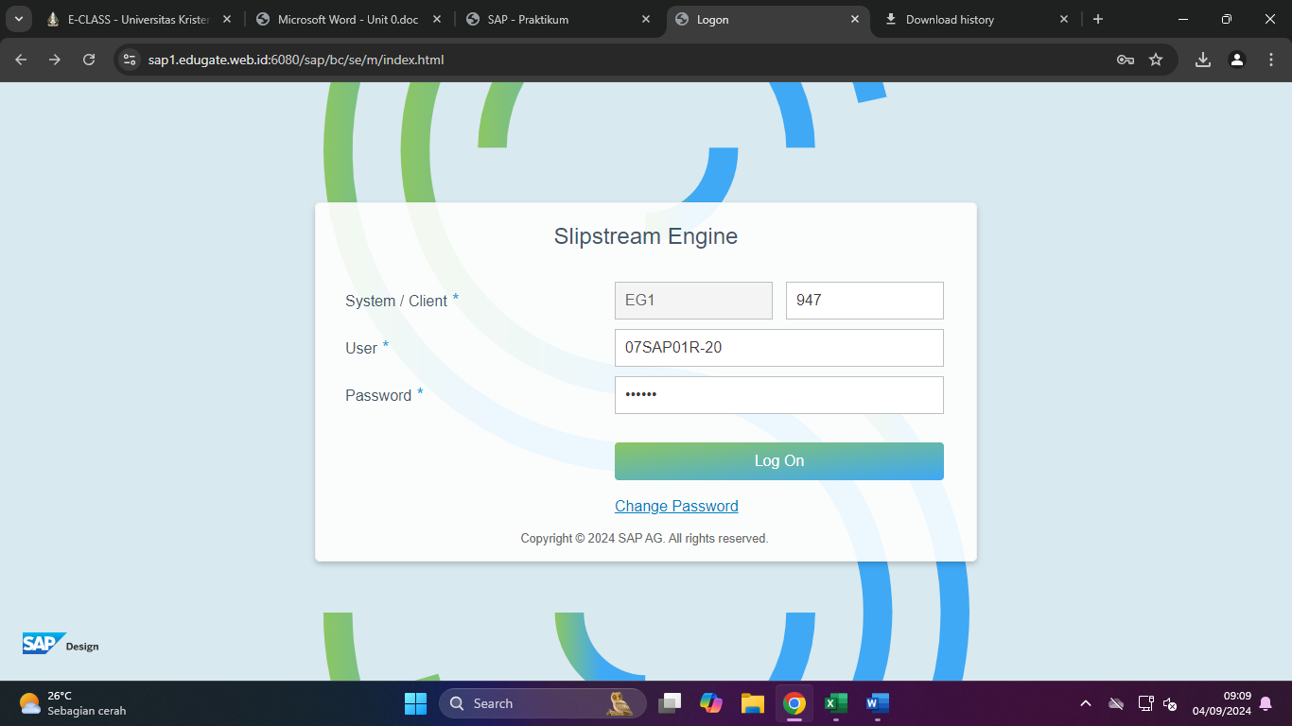

Untuk login, pertama mengakses Halaman SAP edugate.or.id/upp, lalu setelah berada di halaman login kemudian mengisi form login lalu klik log On.

Maka langsung diarahkan ke halaman utama

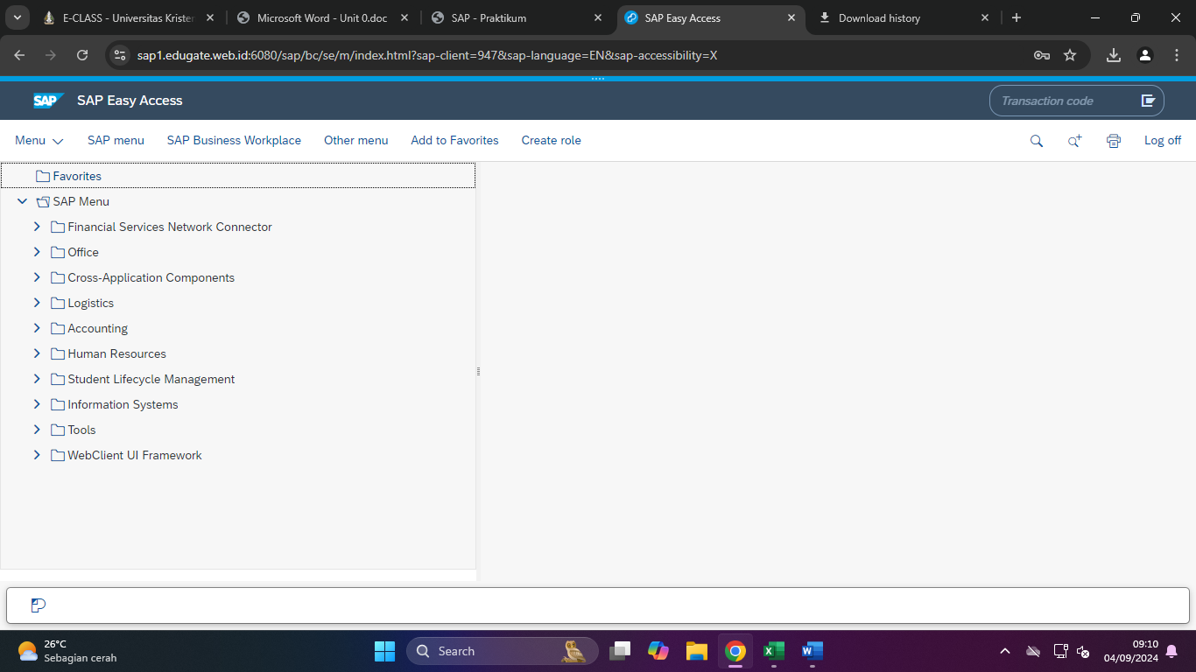

(Screenshoot Hasil)

(Berilah penjelasan beserta langkah pengerjaan)

**Exercise 2.2: Navigating in the SAP System**

Task 1

Locate a variety of transactions by navigating the SAP Easy Access menu.

Task 2

You have found that transaction codes provide an easy way to navigate directly to a transaction. Try out a few transaction codes

|  |  |
| --- | --- |
| **Field** | **Transaction Name** |
| Transaction | Create |
| Transaction | Change |
| Transaction | Display |
| Transaction | Create Using Part Load Lift Order |

Screenshot Task 1

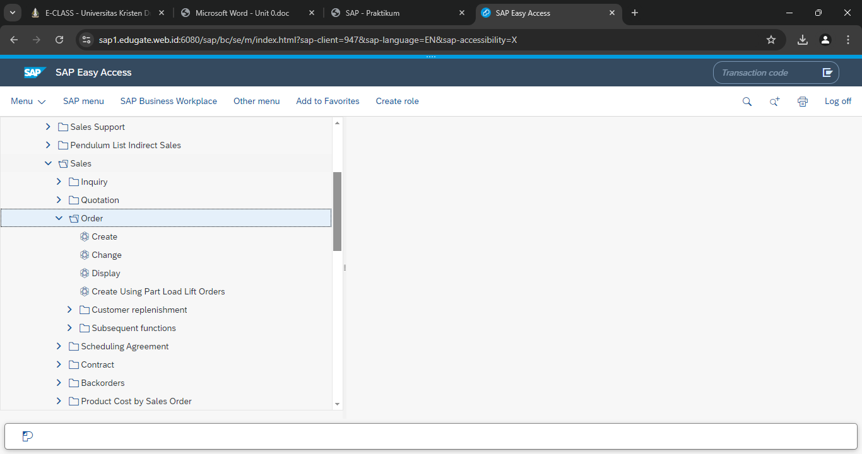

Pertama Pilih folder SAP Menu > Logistic > Sales and Distribution > Sales > Order. Hingga menampilkan 4 macam pilihan lainya yaitu “Create”, “Change”, “Display”, dan “Create Using Part Load Lift Orders”.

|  |  |
| --- | --- |
| **Field** | **Transaction Name** |
| Transaction | Enter G/L Account Document |
| Transaction | Enter G/L Account Document for Ledger Group |
| Transaction | General Posting |
| Transaction | Enter General Posting for Ledger Group |
| Transaction | Edit or Park G/L Document |
| Transaction | Park G/L Account Document for Ledger Group |
| Transaction | General Document Parking |
| Transaction | Post with Clearing |
| Transaction | Incoming Payments |
| Transaction | Outgoing Payments |
| Transaction | Cash Journal Posting |
| Transaction | Valuate Foreign Currency |

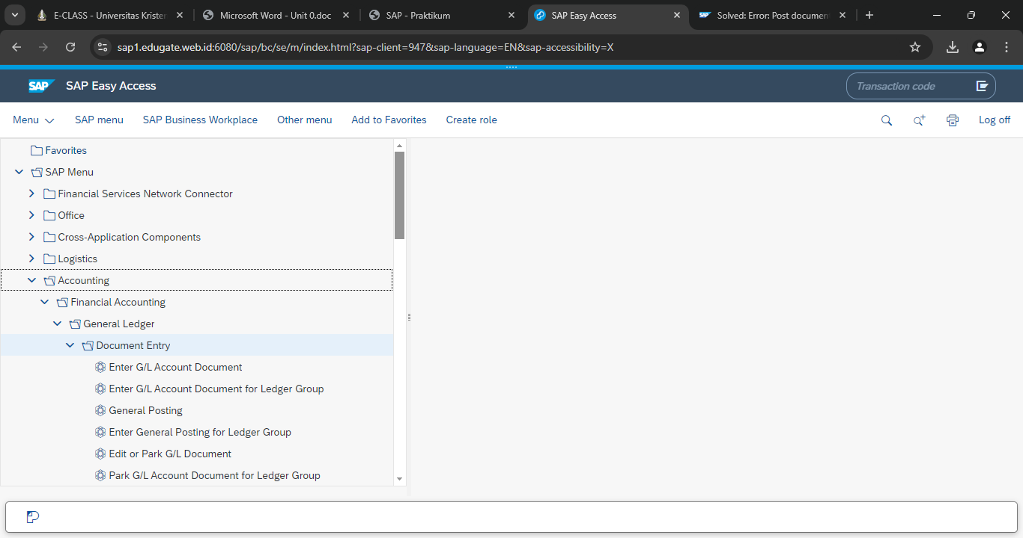Pertama Pilih folder SAP Menu > Financial Accounting> General Ledger > Document Entry. Seperti pada Screenshot diatas.

Task 2

|  |  |
| --- | --- |
| Entry | Result |
| su03 | ECL Viewer |
| sm04 |  |
| /nsm04 |  |
| /nend |  |

**Exercise 2.3: Creating Favorites Using the Menu**

Task:

Create a variety of favorite transactions that will appear in the Favorites menu on your SAP Easy Access screen.

1. Create a favorite for the transaction to post an incoming payment in accounts receivable. This is transaction code F-28.

2. Create a favorite for the transaction to display a customer (centrally) in sales and distribution. This is transaction code XD03.

3. Create a favorite for the transaction to maintain master data in human resources. This is transaction code PA30

(Screenshot Hasil)

(Berilah penjelasan beserta langkah pengerjaan)