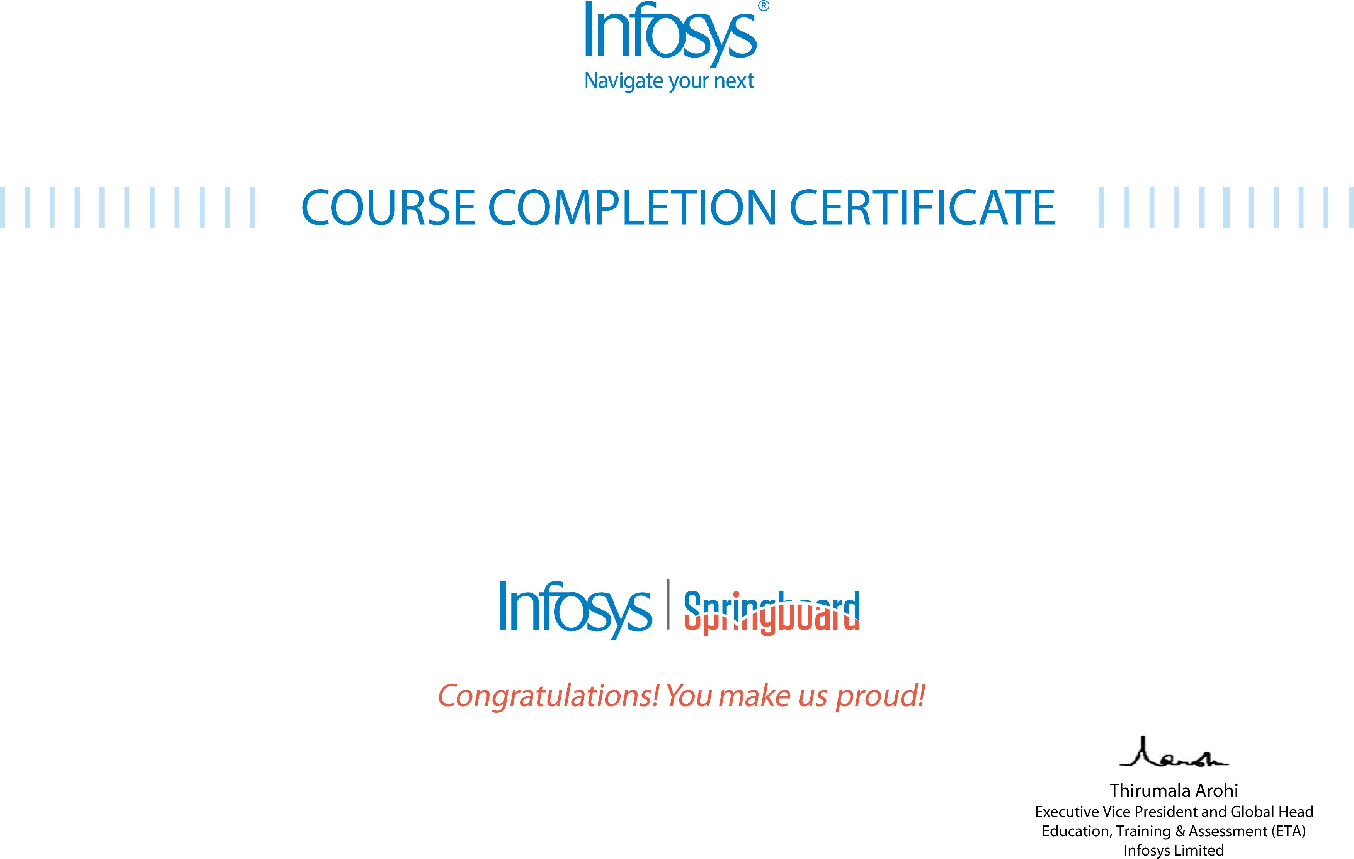
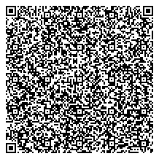

The certificate is awarded to

Dewang Jagtap

for successfully completing the course
Database Management System (DBMS) & SQL : Complete Pack

on July 16, 2025

Issued on: Wednesday, July 23, 2025
To verify, scan the QR code at https://verify .onwingspan.com

