Cinnamon Image embedded in a test OpenOffice Document:
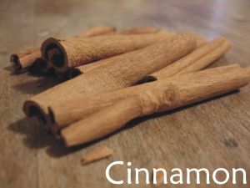
This file is intended to test if and how tika can extract an image from an ODT file and if it is possible to have this automatically rendered to a PDF file with xhtmlrenderer.

