PROJECT IN AUTOMATA AND LANGUAGE THEORY

GENDER NEUTRAL LANGUAGE RECOGNIZER

Submitted by:
Wendell Quito Jotojot
Anna Marie Deloso Gultiano
Karen Marie Amper
Loressa Nalasa Salise
BSCS 3B

Submitted to:

ALMA MAE B. AUXTERO
Instructor

Date submitted: October 29, 2026

1 Project overview
The Gender Neutral Language Recognizer is a web application that reads a .txt, .docx, or .pdf document, finds predefined gender-specific words and phrases such as "chairman", "fireman", "he", and "cleaning lady", and suggests gender-neutral alternatives. Its purpose is to help writers review their text for inclusive wording. It shows a results table with each detected term, how many times it occurred, and a suggested alternative, together with a preview of the document in which the detected terms are highlighted. It also has an automaton panel where a word can be traced through the automaton state by state, and a question helper that answers questions about the project. Suggestions are for review only; the application never changes the document.

2 Tools and recognition approach
Language and tools. The application is written in HTML, CSS, and plain JavaScript with no framework. mammoth.js (version 1.8.0) extracts text from .docx files and pdf.js (version 3.11.174) extracts text from .pdf files. Node.js is used only to run the unit tests. The site is hosted on Vercel at https://gender-neutral-recognizer.vercel.app.
Approach: finite state automata. Terms are recognized with a hand-built deterministic finite automaton (DFA). No regular expression is used to match the terms. We chose a finite automaton because it can be drawn as a state diagram and a transition table, and because a single pass over the text recognizes all terms at once.
- Alphabet. Σ = { a–z, space }. Each character is converted to lowercase first, so matching ignores capitalization. Any whitespace (space, tab, line break) becomes the space symbol. Any other character has no transition.
- Construction. The DFA is a trie built from the term list. State q0 is the start state. For each term we move from q0 one symbol at a time and create a new state whenever the needed transition does not exist yet. The state reached after the last symbol is an accepting state that remembers its term. Terms with a common beginning share states.
- Dead state. Any missing transition goes to an implicit dead state ∅, which means the input cannot match.
- Space loop. Every state entered on a space loops to itself on a space, so a phrase such as "cleaning lady" still matches when the words are separated by several spaces, a tab, or a line break.
- Whole words. The automaton starts only at the beginning of a word, and a match counts only when the next character is not a letter or digit. So "he" is detected in "he", "(he)", and "he’s", but not in "the", "there", or "hello".
- Longest match. The scan keeps going after an accepting state and keeps the longest match, so "herself" is detected as one term, not as "her" or "he".
- Size. The complete automaton has 125 states, of which 24 are accepting.
Figure 1 shows how the automaton recognizes the term "fireman". Reading the letters f, i, r, e, m, a, n moves it from q0 through q27 … q32 to the accepting state q33, so the word is accepted and its suggestion "firefighter" is reported. A word such as "the" has no transition for "t" from q0, so it goes to the dead state at once and is rejected.
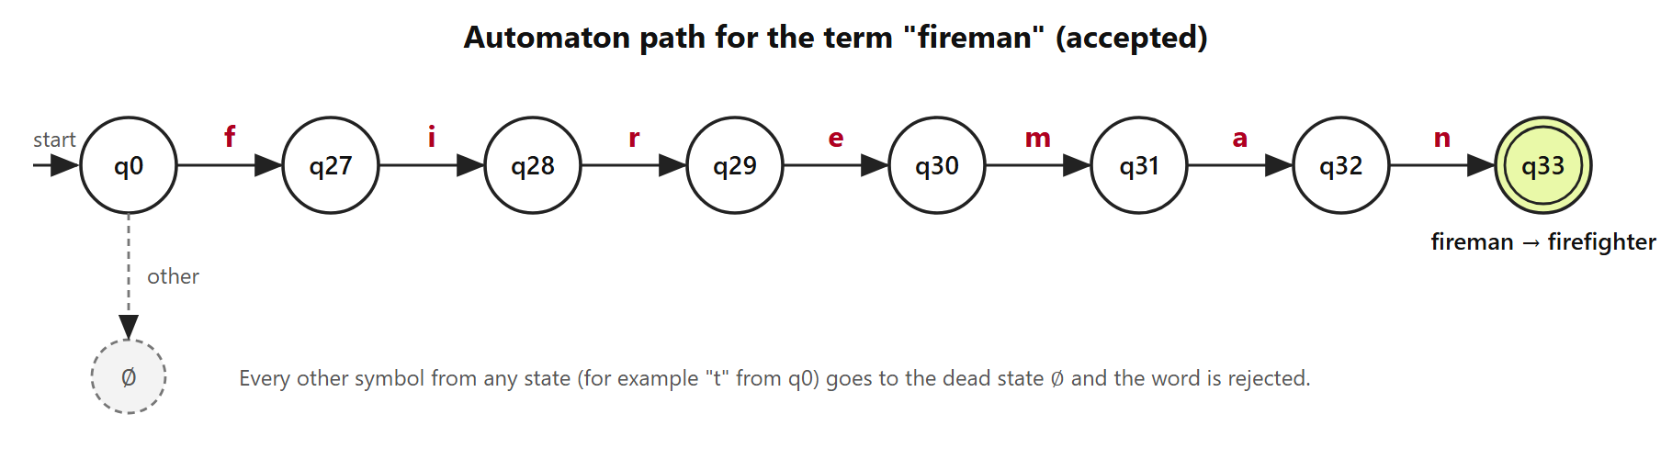
Figure 1. State path for the term "fireman".
Figure 2 shows that the terms "he", "her", "hers", and "herself" share one path. The states q110, q115, q117, and q124 are accepting.
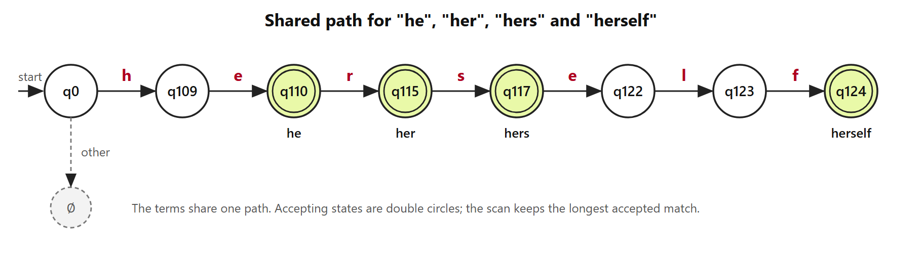
Figure 2. Shared path for "he", "her", "hers", and "herself".
Transition table for the path of "fireman"
From state | Symbol | To state | Note
q0 | f | q27
q27 | i | q28
q28 | r | q29
q29 | e | q30
q30 | m | q31
q31 | a | q32
q32 | n | q33 | accepting: fireman

Terms and suggested alternatives (24)
# | Term | Suggested alternative
1 | chairman | chairperson
2 | chairmen | chairpersons
3 | policeman | police officer
4 | policemen | police officers
5 | policewoman | police officer
6 | fireman | firefighter
7 | firemen | firefighters
8 | stewardess | flight attendant
9 | mankind | humankind
10 | businessman | businessperson
11 | salesman | salesperson
12 | spokesman | spokesperson
13 | mailman | mail carrier
14 | manpower | workforce
15 | waitress | server
16 | cleaning lady | cleaner
17 | he | they
18 | she | they
19 | him | them
20 | her | them / their
21 | his | their / theirs
22 | hers | theirs
23 | himself | themself
24 | herself | themself

3 Application screenshots
Live application (Vercel): https://gender-neutral-recognizer.vercel.app (publicly accessible).
Source code (GitHub, public): https://github.com/dewdew-del/gender-neutral-recognizer
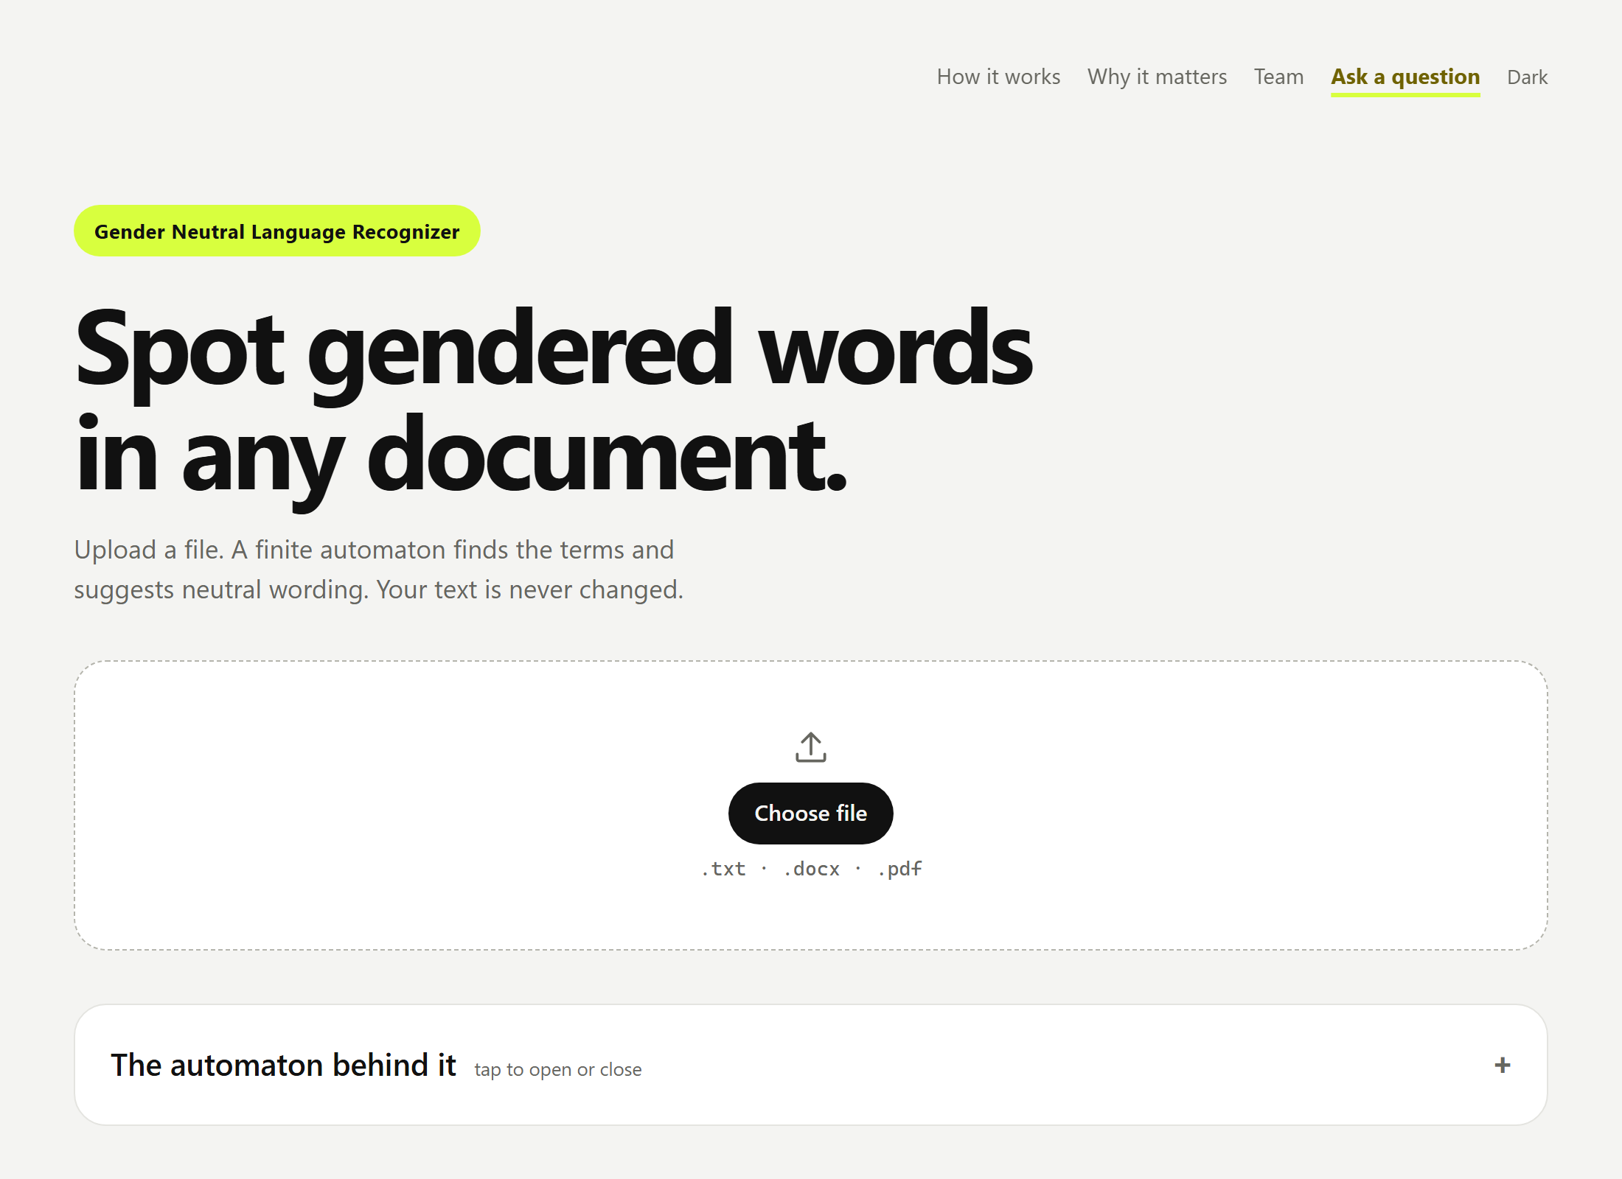
Figure 3. File selection: the user chooses a .txt, .docx, or .pdf file.
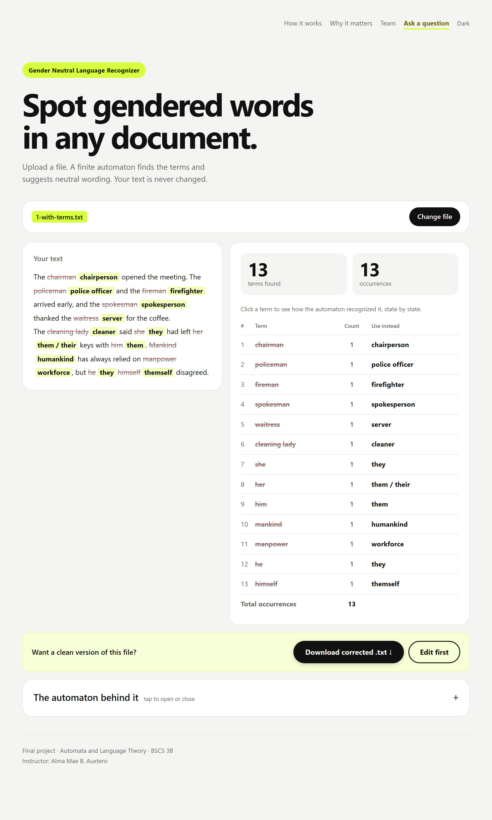
Figure 4. Detected terms with counts and suggested alternatives, and the highlighted document preview.
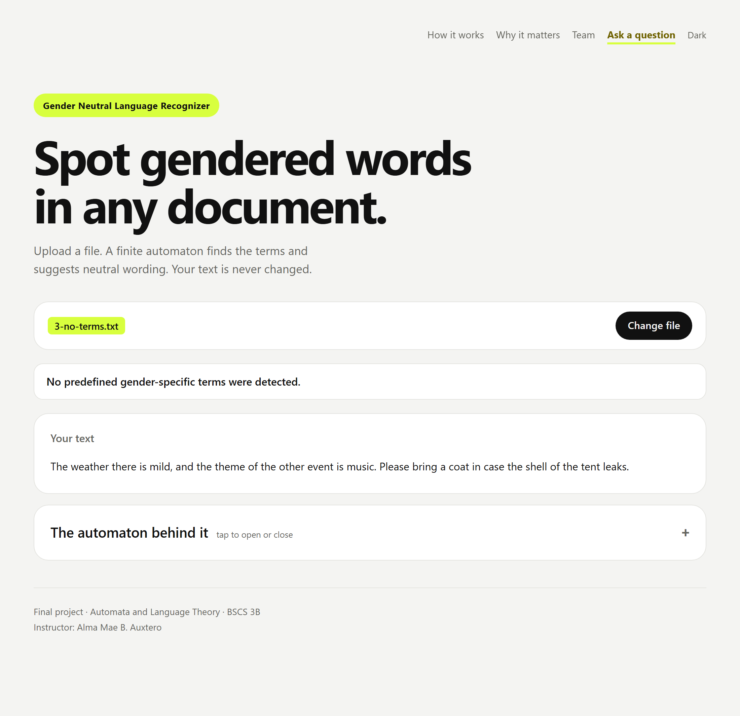
Figure 5. A document with no detected terms shows "No predefined gender-specific terms were detected."
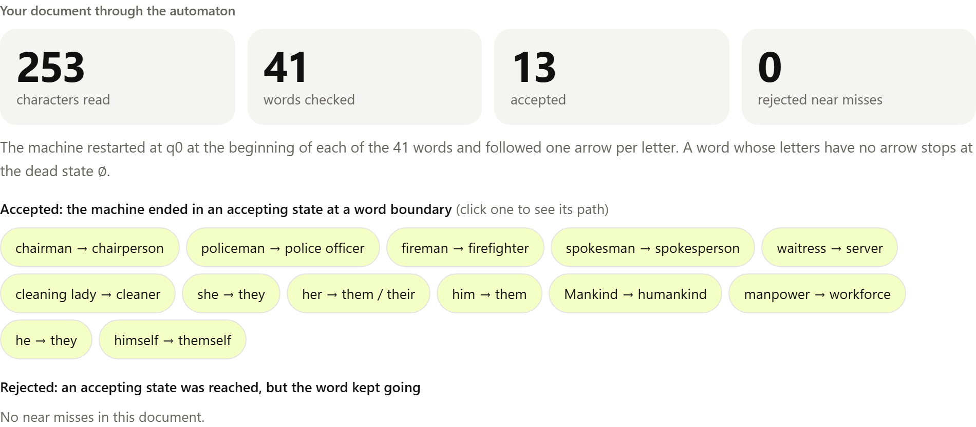
Figure 6. "The automaton behind it": how the machine processed the uploaded document (words checked, accepted terms, and rejected near misses).
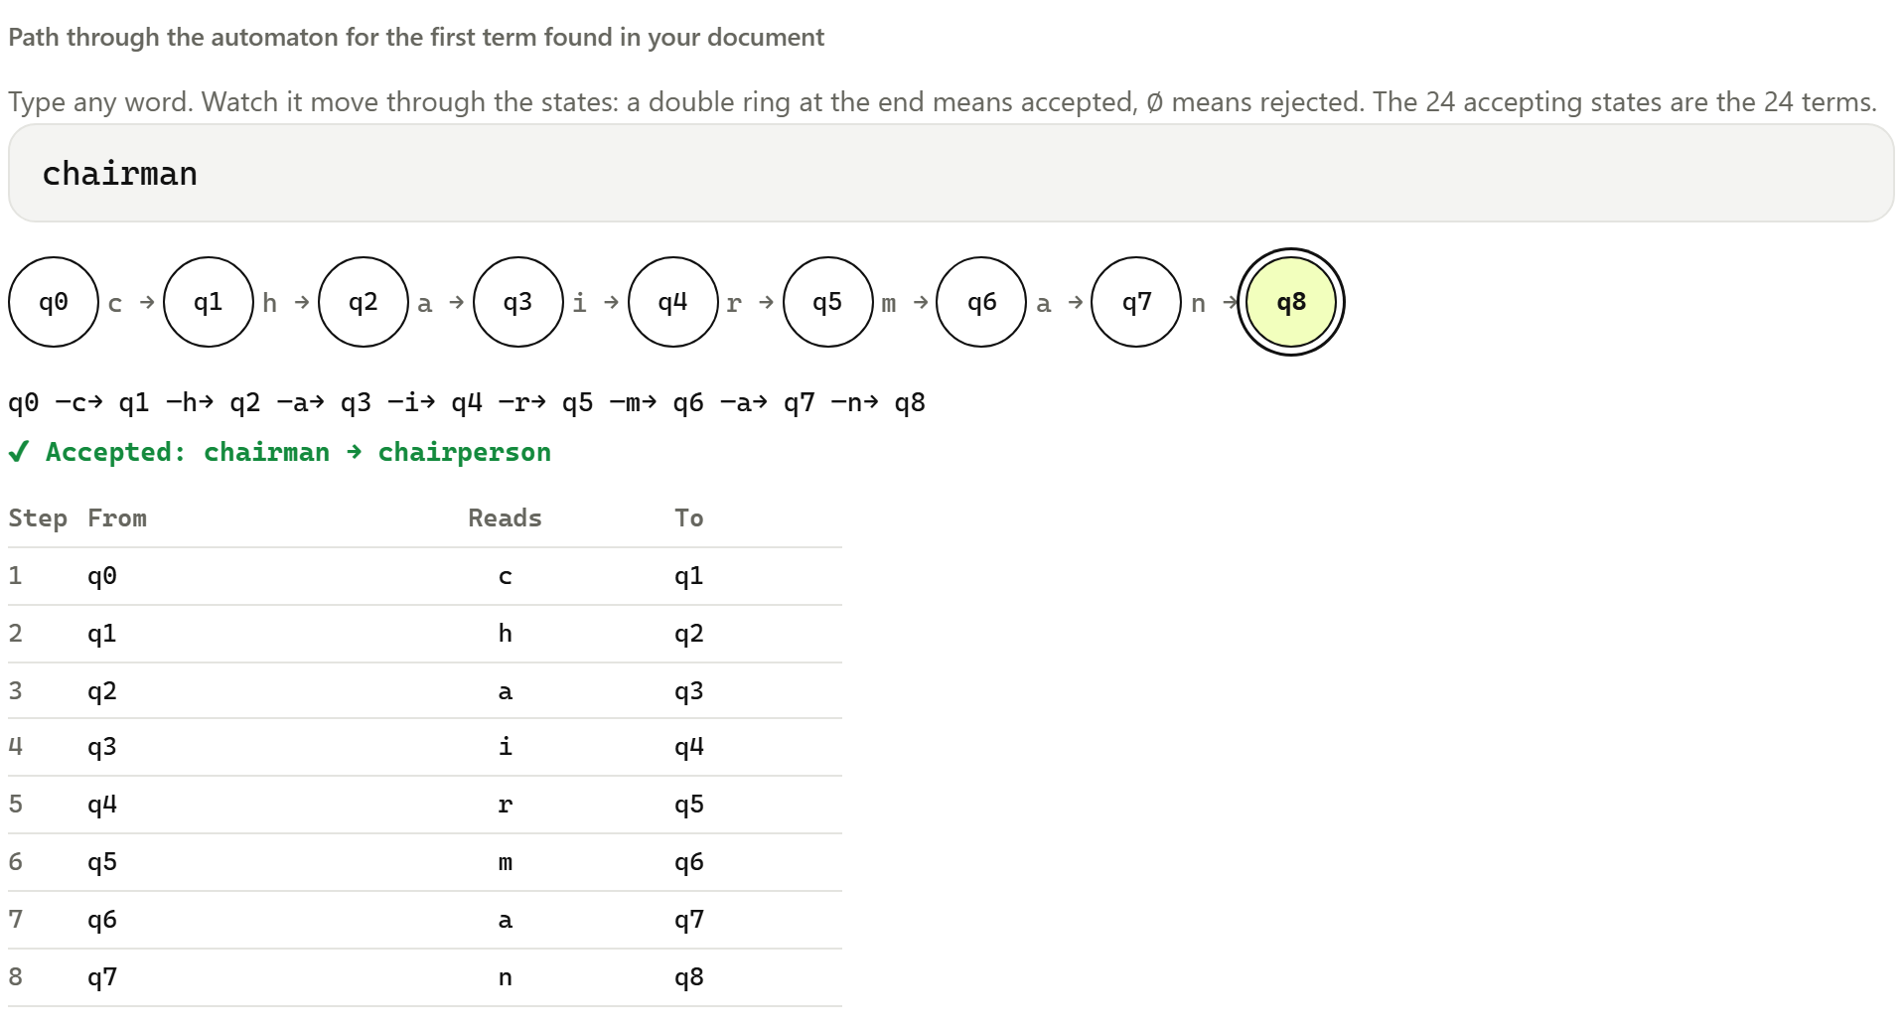
Figure 7. The path of one word through the automaton, state by state, with its step table.

4 Testing
Each test was run in the deployed application by uploading the sample file, and the actual results come from the application. The sample files are in the samples folder of the source code. In addition, 40 automated unit tests (run with "npm test") cover every term, whole-word matching, capitalization, phrases across extra spaces and line breaks, the trace function, file validation, and a 1 MB file that scans in under one second.
# | Test | Expected result | Actual result | Result
1 | A document containing listed gender-specific terms (1-with-terms.txt) | A table with each detected term, its count, and its suggested alternative. | 13 different terms found, 13 occurrences in total (chairman, policeman, fireman, spokesman, waitress, cleaning lady, she, her, him, mankind, manpower, he, himself), each with its suggestion. | Pass
2 | The same term more than once, in different capitalization (2-repeated-mixed-case.txt) | Counts are combined regardless of capitalization. | chairman = 3 (Chairman, CHAIRMAN, chairman) and he = 3 (He, he, HE); total 6. | Pass
3 | No listed terms, including "the", "there", "other" (3-no-terms.txt) | "No predefined gender-specific terms were detected." and "the" does not trigger "he". | The exact message is shown and no results table is shown. | Pass
4 | An empty .txt file (4-empty.txt) | A clear message for an empty file. | "The file is empty. Please upload a file that contains text." | Pass
5 | A file in an unsupported format (5-unsupported.rtf) | A clear message for an unsupported format. | "Unsupported file format. Please upload a .txt, .docx, or .pdf file." | Pass
6 | Optional: Word document (6-sample.docx) | Same result as test 1. | Same result as test 1 (13 terms, 13 occurrences). | Pass
7 | Optional: PDF document (7-sample.pdf) | Same result as test 1. | Same result as test 1 (13 terms, 13 occurrences). | Pass

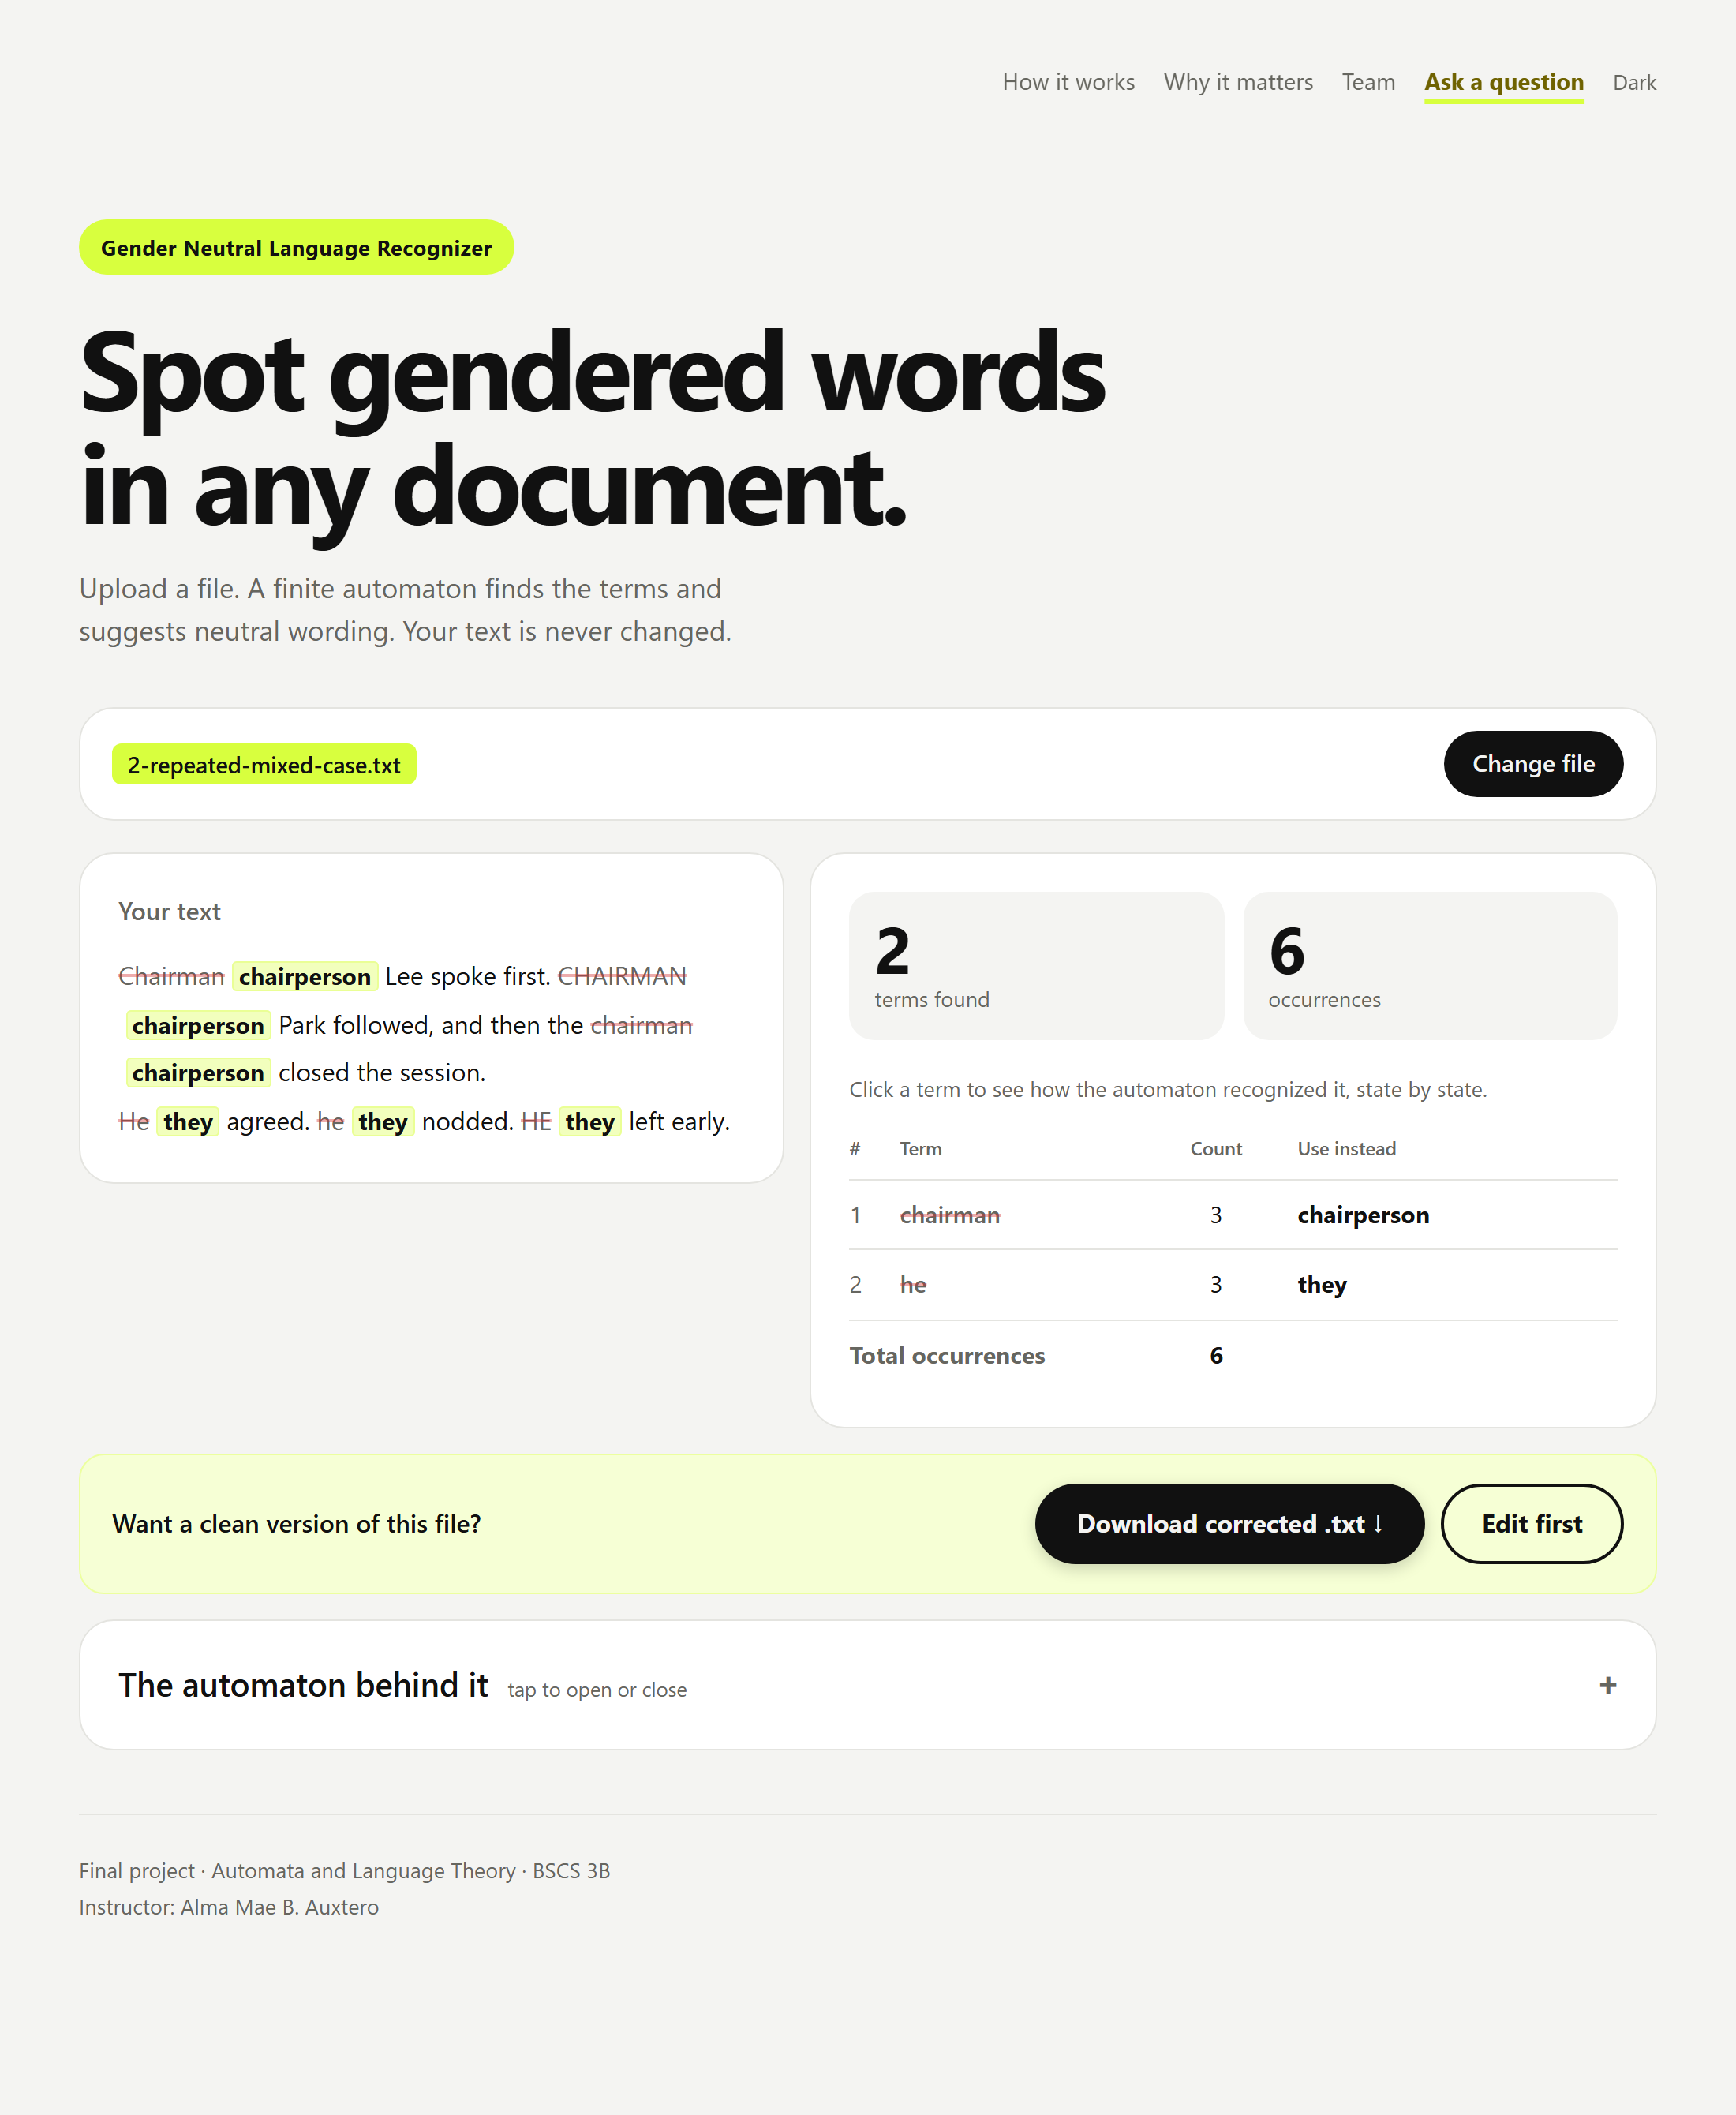
Figure 8. Test 2: the same term in different capitalization is counted together.
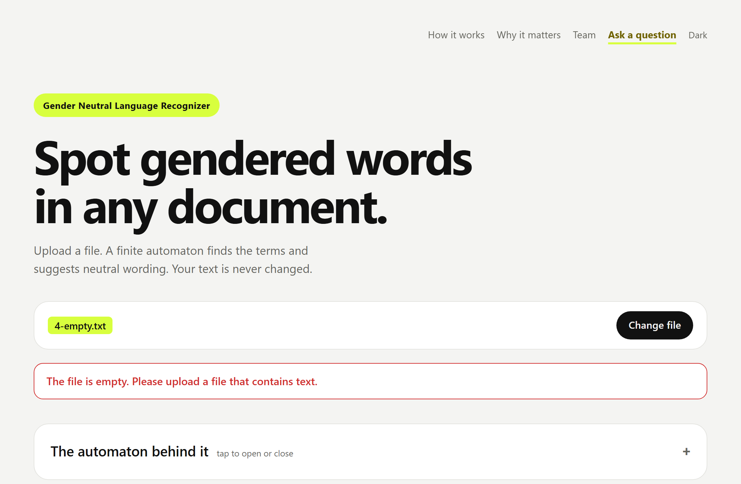
Figure 9. Test 4: message for an empty file.
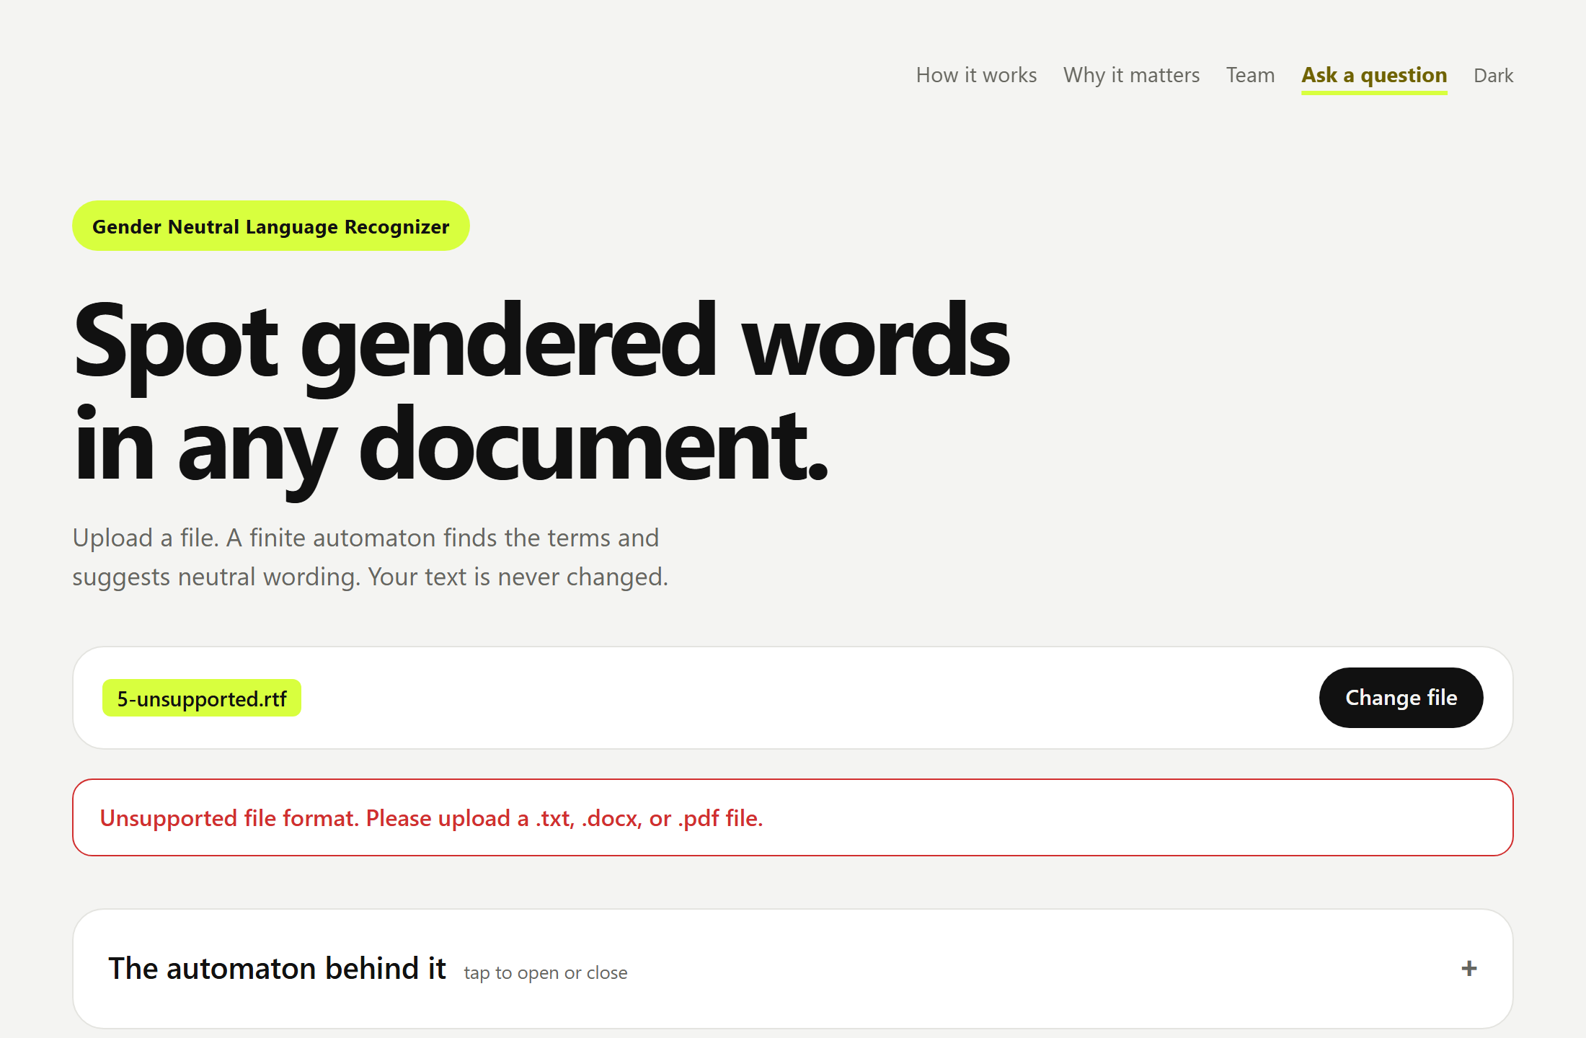
Figure 10. Test 5: message for an unsupported file format.

5 Conclusion
We completed a web application that recognizes 24 gender-specific terms, including a phrase, with a hand-built deterministic finite automaton of 125 states. It matches whole words regardless of capitalization, reads .txt, .docx, and .pdf files, shows a results table with counts and suggestions, highlights the terms in a preview, and shows clear messages for empty and unsupported files. All required tests passed. Through this project we learned how a trie can be turned into a DFA, how the dead state and the loops on the space symbol handle missing transitions and phrases, and how to make a scan match whole words and the longest term. Known limitations are that the application has no knowledge of context (for example, "her" is always flagged, so a person must review each suggestion), scanned PDFs that contain only images have no readable text, and old Word 97–2003 (.doc) files are not supported.

6 Sources and contributions
Libraries and services
- mammoth.js 1.8.0 (https://github.com/mwilliamson/mammoth.js) for reading .docx files.
- pdf.js 3.11.174 (https://github.com/mozilla/pdf.js) for reading .pdf files.
- Groq API (https://groq.com) for the "Ask a question" helper, which answers questions about the project.
- Vercel (https://vercel.com) for hosting the application.
AI assistance. Claude (an AI assistant by Anthropic, used through Claude Code) was used to help design the application, write and test the code, build the interface, and prepare this document. The group reviewed and tested the application.
Member contributions
Member | Contribution
Wendell Quito Jotojot | Developer. Designed and built the application: the automaton, file reading, results page, automaton explanation, testing, and publishing.
Anna Marie Deloso Gultiano | Documentation. Wrote and prepared the project document, test results, and screenshots.
Karen Marie Amper | Documentation. Wrote and prepared the project document, test results, and screenshots.
Loressa Nalasa Salise | Documentation. Wrote and prepared the project document, test results, and screenshots.

