King James

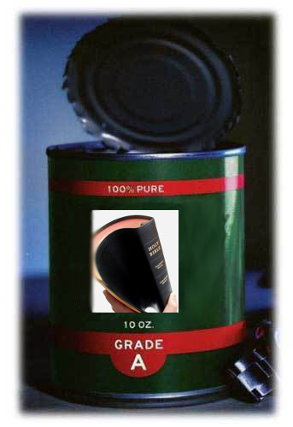

Pure Bible Search

Version 1.0

Preface

Welcome to the King James Pure Bible Search application! This application has been brought to you by the fervent prayers of Bethel Church, Festus, MO.

This application was developed to allow the student of the King James Bible to effectively search and seek out the patterns of the Divine Fingerprints of God in His inerrant and infallible Holy Written Word.

This program is free software; you can redistribute it and/or modify it under the terms of the GNU General Public License as published by the Free Software Foundation; either version 3 of the License, or (at your option) any later version.

This program is distributed in the hope that it will be useful, but WITHOUT ANY WARRANTY; without even the implied warranty of MERCHANTABILITY or FITNESS FOR A PARTICULAR PURPOSE. See the GNU General Public License for more details.

You should have received a copy of the GNU General Public License along with this program; if not, write to the Free Software Foundation, Inc., 675 Mass Ave, Cambridge, MA 02139, USA.

‘Free’ software refers to your free uninhibited ability to access and obtain this software in its exact original form, and your freedom to copy and share it with others, not necessarily that it was obtained ‘for free’, as reasonable fees may be charged to recover distribution costs.

This application was originally developed using open source Qt 4.8.3, and has been built and tested against Qt 4.8.4 and Qt 5.0.0, available at http://qt-project.org/.

This application is copyrighted for the same reason that the King James Bible is copyrighted, to protect and ensure its integrity:
King James Pure Bible Search (Can Opener)
Copyright (C) 2012 Donna Whisnant, a.k.a. Dewtronics.
Contact: http://www.dewtronics.com/
This is an open source application. The source code is available upon request.

Written and Developed for:

Bethel Church
1233 American Legion Drive
Festus, MO 63028
USA
636-931-3999
http://visitbethelchurch.com/

Table of Contents
Preface 2
Table of Contents 3
Portability 5
Installation on Windows 5
Basic Application Layout 11
First Search 13
Search Results Views 16
Search for the Missing “the” 18
Understanding References 21
Search Results Verse Detail Popup 22
Multi-Phrase Search 23
Search Scope 26
Search Phrase Editor 30
Search Phrase Text 31
Phrase List 32
Add to Database 32
Remove from Database 33
Clear 33
Case Sensitivity 33
Close 34
Search Phrase Summary 34
Browsing Scripture in the Scripture Browser 35
Navigating in the Scripture Browser 37
Passage Navigator 40
Absolute Mode 41
Relative Mode 45
Absolute Mode Counting vs. Relative Mode Counting 49
Relative Mode Confusions 51
Fonts 54
The Ever Changing “Edit” Menu 57
Search Phrase Edit Menu 57
Search Results Edit Menu 57
Copy Verse Text 59
Copy Raw Verse Text 59
Copy Very Raw Verse Text 59
Copy References 59
Copy Reference Details 59
Copy Complete Verse Text and Reference Details 60
Scripture Browser Edit Menu 63
Copy as Shown 64
Copy as Shown (plain) 64
Copy Raw Text (No Headings) 64
Copy Very Raw Text (No Punctuation) 64
Copy as Verses 65
Copy as Verses (plain) 65
Copy Reference Details 65
Copy Passage Statistics 66
Copy Entire Passage Details 66
Save/Load King James Search Files 68
Example Files 69
The Toolbar 70
Special Shortcut Keys 71
How Pure Bible Search Performs Its Searches 74
KJV Statistics 77
Counterfeit King James Bibles 80
Believers Beware Of Counterfeit King James Bibles (by Nic Kizziah) 81
Quick Check List When Buying a King James Bible (by Nic Kizziah) 86
1611 vs. 1769 King James 87
KJV Fun Facts 88
Useful Links 90
Bible Resources 90
Programming Resources 90
Planned Future Enhancements 91

Portability

This version of King James Pure Bible Search is available as a native binary installation for the Microsoft Windows operating system and works on both 32-bit and 64-bit versions of Windows XP, Windows Vista, Windows 7, and Windows 8. It will also run under the Wine environment in the Linux operating system, as a Windows-based application.

Plans are in progress to provide a Linux-native port, an Android port, and a Macintosh port, each with appropriate binary installers. At present, the Linux-native version can currently be realized by obtaining the source code and necessary dependent Qt (http://qt-project.org/) and runtime libraries and the GNU C++ compiler (http://gcc.gnu.org/) and support tools and compiling it.

It is believed to be compatible with the Macintosh, with the appropriate Qt library, but it has not yet been tested. And currently, no Android or other portable device ports have been attempted, but is in the near term plans. It’s believed this version, as-is, will likely run with minimal changes on the larger size (10” or larger) Android tablet.

Installation on Windows

First obtain the installer for Windows. This can be downloaded from:

http://www.dewtronics.com/KingJamesPureBibleSearch/

or by requesting it on CD/DVD or via email from either Bethel Church or Dewtronics.

With the installer downloaded to your local hard drive, or from the distribution CD or DVD, double-click the executable file to run the installer. You need to have Administrator Access Rights on your computer in order to install applications. When you launch the installer, Windows may prompt you for confirmation and/or require you to login with Administrator credentials in order to continue the installation process. Follow the prompts and confirm that you wish to install the King James Pure Bible Search software.

Once you’ve launched the install you’ll see a window on your screen similar to the following:

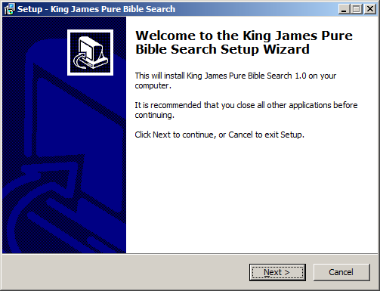

Click ‘Next’:

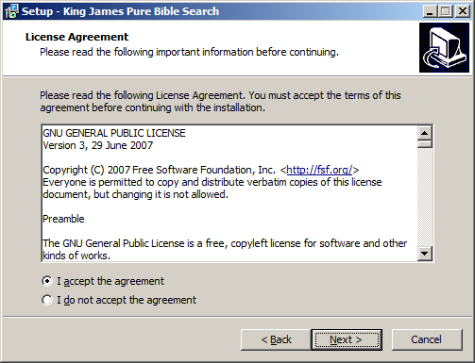

The license you are presented will be the standard GNU General Public License for free software. The term ‘free’ refers to your free uninhibited ability to access and obtain this software in its exact original form, and your freedom to copy and share it with others, not necessarily that it was obtained ‘for free’, as reasonable fees may be charged to recover distribution costs.

Read through the license agreement. Clicking the ‘accept’ radio button will enable you to click ‘Next’:

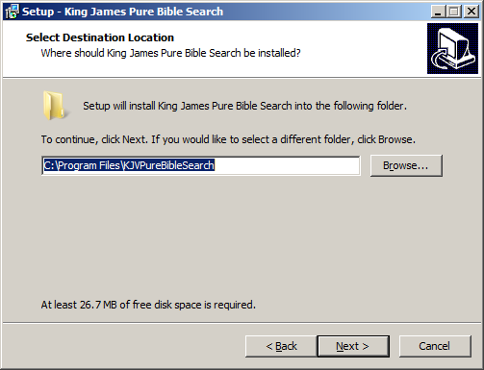

The default location for installation, the system ‘Program Files’ folder, will be displayed. Note that if you are running on a 64-Bit version of Windows, this folder will be listed as: “C:\Program Files (x86)\KJVPureBibleSearch”, with a “(x86)” in the path.

If you wish to install the application to a different location, enter the desired path or click ‘Browse’ and navigate to it. Note that if you are installing over an old version, this application maintains a user database file for storing custom search phrases.

This database is currently stored with the application itself. Therefore, if you are upgrading an old version of this program and are now installing to a different location, you may wish to locate your old user database and copy or move it to the new installation. More details on this user database file will be given later in this manual.

After selecting the installation path, click ‘Next’ and proceed to specify the folder in the system start menu to install application shortcuts:
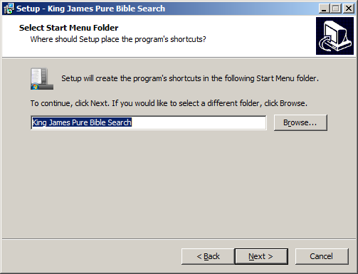

Click ‘Next’ and select whether you want the installer to create desktop and/or Quick Launch icons for you. By default, these will be checked, but if you wish for them to not be created, uncheck them. Click ‘Next’:

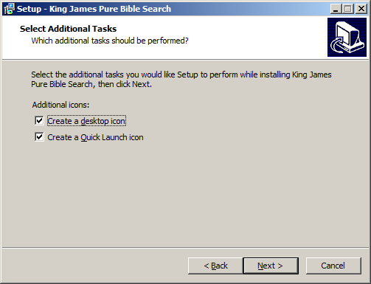

A summary of the installation will be displayed. Review it and click ‘Install’:

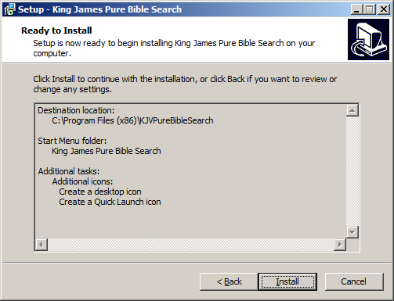

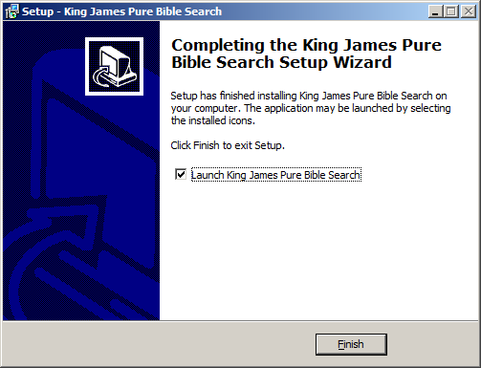
Once the installation is complete, you can select to immediately launch the King James Pure Bible Search application. Leave this checked and click ‘Finish’ to launch it for the first time. Installation is now complete.

After installation, you can run the program again in the future by locating the “King James Pure Bible Search” folder in the System Start Menu folder, or by clicking the desktop and/or Quick Launch icons, if you created those during installation.

Basic Application Layout
The King James Pure Bible Search program main window is divided into three distinct panes:

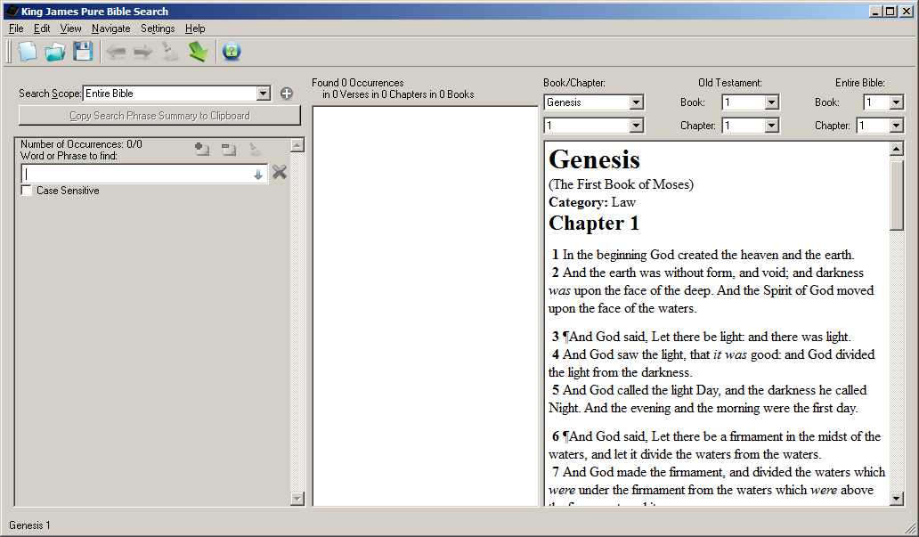

The three panes are:

- Search Phrase Pane:
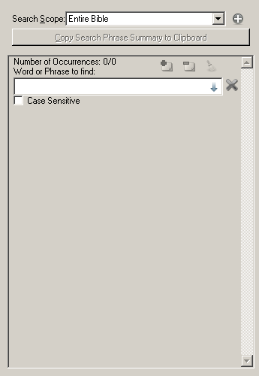

- Search Results Pane:
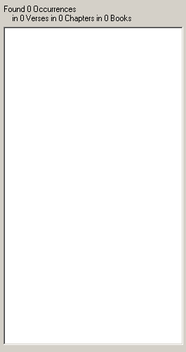

- Scripture Browser Pane:
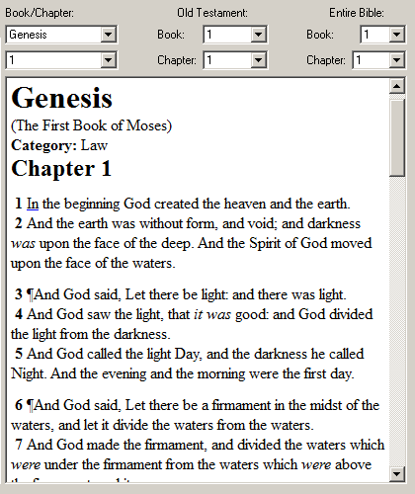

First Search
For your first search, let’s search for the word “Christ”. With your cursor in the Search Phrase Editor within the Search Phrase Pane, start typing:

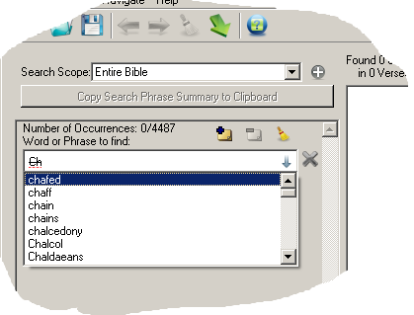

Most Bible Search programs require you to enter a word or phrase and click ‘search’ and wait for it to try and find the word or phrase that you entered, often times to find you mistyped the phrase.

Not so for this application. King James Pure Bible Search searches the entire King James text in real time and instantly shows you whether the word or phrase is found and how many times.

As you begin to type, a drop list will appear with all possible matching words in the entire King James text. The list will automatically navigate to the word as you type, or you can use your up/down arrow keys or mouse to scroll to the desired word and select it.

The text in the editor will appear in a “strikeout” font if it doesn’t match, as seen in the illustration above. And the occurrence statistics for that specific phrase is shown above it. In the above example, you see “Number of Occurrences: 0/4487”. This means that there are 4487 words that begin with the letters “ch”. And 0 are contributing to the Search Scope being searched, since you don’t have a completely matching word yet.

Wildcards of “*” and “?” are accepted and have the same meaning as they do in most operating systems, with “*” matching any of zero or more characters and “?” matching any single character. Also, character-sets specified in matching brackets (“[” and “]”) can be used to match from a specific list of characters for a given position. See “Search Phrase Text” in the “Search Phrase Editor” section of this document.

Therefore, if you wanted to search for all words beginning with “ch”, you could simply enter “ch*”. Once you’ve added the “*”, the statistics, in this example, would change to 4484/4487, as the phrase would be matching 4487 occurrences and 4487 of them would be contributing to the “Entire Bible” Search Scope, as selected above the Search Phrases.

If you continue to typing the word “Christ”, that we began to search for, once you have “Christ” entered, you’ll notice the font will change from a “strikeout” font back to normal to indicate the word is found, and the Search Results Pane will update with the results:

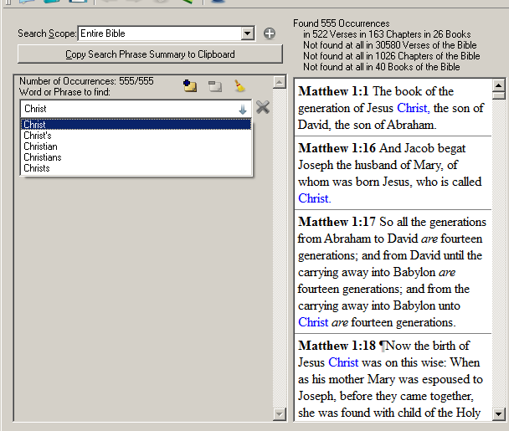

You will find that the word “Christ” appears 555 times in the Search Scope of the Entire Bible. Note that this is ONLY the word “Christ”. It does not include “Christ’s” or “Christs”, as you see in the drop list. Nor does it include “Christian” or “Christians”.

If you wanted to include all of those words, you could enter “Christ*” and you’ll find 576 occurrences: 555 for Christ, 16 for Christ’s, 2 for Christs, 2 for Christian, and 1 for Christians, for a total of 576.

If you want to search for “Christ” or “Christs”, but not “Christ’s” or the other words, you can add a second search phrase, as will be explained later, and enter “Christ” for one phrase and “Christs” for the other.

As you can see, the Search Results Pane is now updated to show all of the 555 locations that “Christ” was found. You can scroll through this list, select verses to copy, or double-click or click ‘enter’ on a verse to navigate to that verse in the Scripture Browser:

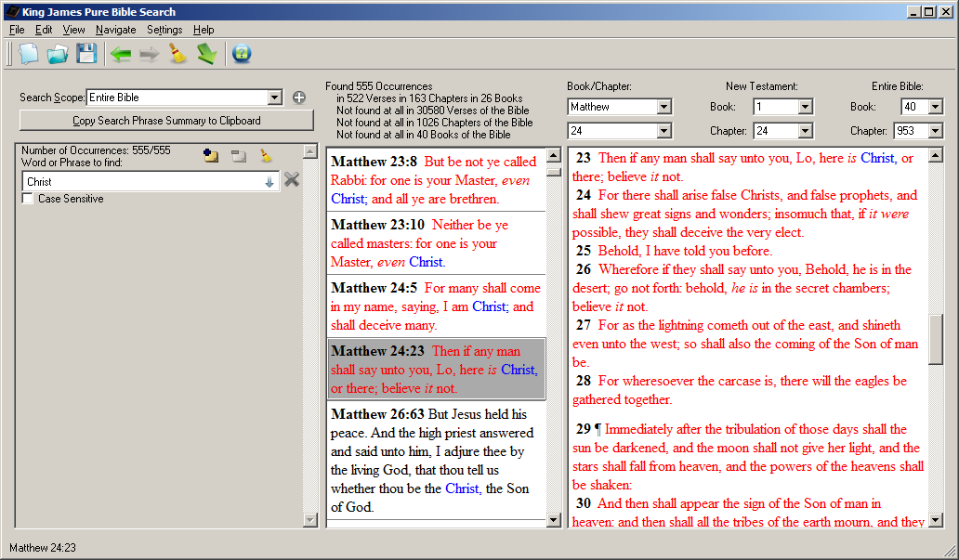

Above the Search Results Pane, you’ll find detailed search occurrence details:

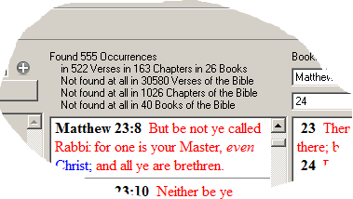

The word “Christ” was found 555 times total in 522 Verses in 163 Chapters and 26 Books of the Bible. There were 30580 Verses in the Bible that doesn’t contain a match, 1026 Chapters without a match, and 40 Books without a match.

This is an interesting result. We know there are 39 books in the Old Testament and 27 books in the New. Without searching further, I’d guess that perhaps every book in the New Testament contains the word “Christ”, except for one. But how do we use this application to find which one?? Easy…

Search Results Views
On the ‘View’ menu, you’ll find an option called “View as Tree by Book”:

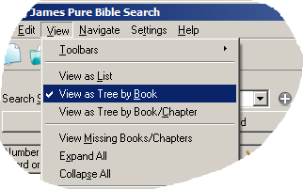

This will change the Search Results Pane into a Tree View:

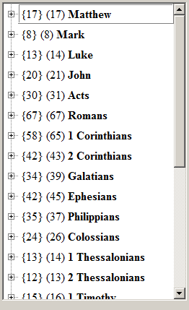
For each entry in the list, you’ll see two numbers. For “{17} (17) Matthew”, the first number {17} indicates that the search has 17 verses matching in the book of Matthew and that there were 17 occurrences of the search phrase (or phrases) in those 17 verses. In this case, each of the 17 verses has one occurrence each.

By contrast, “{42} (45) Ephesians” means there were 42 verses matching in Ephesians, but the phrase was found 45 times, meaning the phrase was found several times in the same verse.

Now you’re probably thinking that to figure out what book in the New Testament doesn’t contain “Christ”, you’ll have to search through the list and try to determine what is missing. But no, it’s much easier than that.

Back in the “View” menu you will find an option called “View Missing Books/Chapters”:

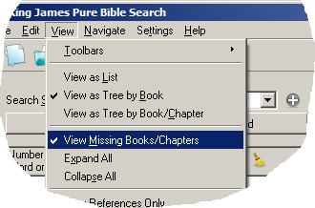

Turning this option on shows all of the Books or Book and Chapters (depending on the View Mode) that are missing in the Tree View of the Search Results:

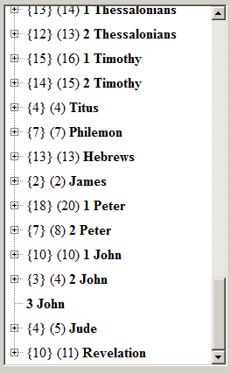

In this view, you quickly see that “3 John” has no matches. Neat, isn’t it?

Search for the Missing “the”
While we are discussing doing searches to discover missing things, here’s another neat search and a search that shows how Pure Bible Search sets an upper bound on what is displayed for search results, while not limiting any actual results.

To try this, first clear your current search. This you can do by either clicking the ‘blank paper’ icon on the toolbar or by selecting “New Search” in the File menu or by pressing Ctrl-N.

With a new search started, enter the word “the” for the search phrase. If you have the Search Results Pane showing in List mode, this is what you’ll see:

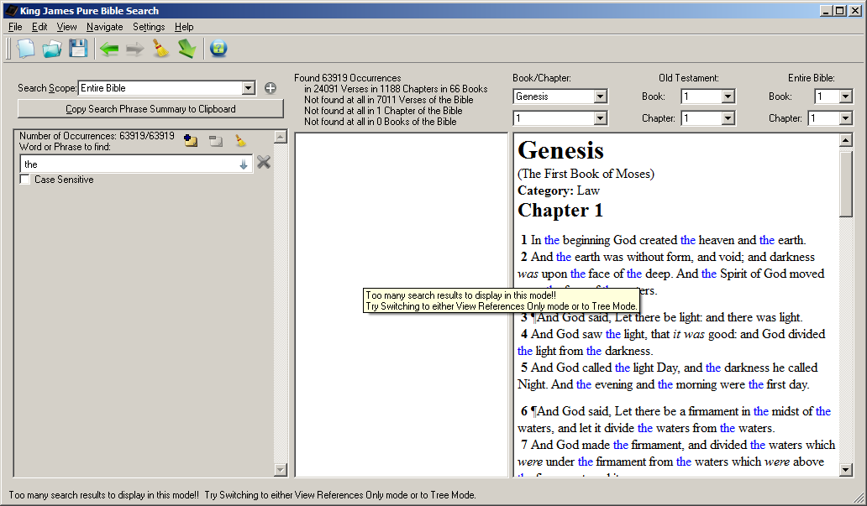

The mouse pointer didn’t get captured in this picture, but it’s hovering over the Search Results Pane where you see the yellow ToolTip message. That ToolTip and the Status Tip message at the bottom both say: “Too many search results to display in this mode!! Try Switching to either View References Only mode or to Tree Mode.”

There are 63919 occurrences of the word “the”. If the program were to try and format the text for all of those 24091 verses that they occur in, you’d be waiting a very long time. But do not fear. You can still see the results.

One way to solve this is to switch the View Tree by Book mode that we saw in the last search example. Since the results are folded up in the nodes of the tree, the program only has to render the verses for the tree parts that you expand.

Consequently, when you have large numbers of results like this, the program will also disable the “Expand All” tree option on the View menu, for the same reason. But there’s also another view you can use, and that’s the “View References Only” mode. This option can be found on the View menu as well:

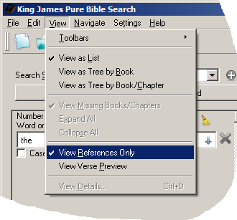

This will switch the Search Results Pane to view only the references where the Search Phrases are found, rather than rendering the Rich Text of the Verse Preview. The References Only mode looks like this:

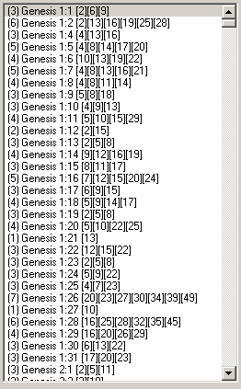

If the numbers next to the verses don’t make sense, sit tight, after we finish looking at this interesting search with the word “the”, we’ll show how to interpret these numbers.

On the Search Results Summary, you find that “the” is found 63919 times in 24091 Verses, 1188 Chapters, and 66 Books. But wait, there’s one chapter that doesn’t contain “the”. That’s neat. I wonder what chapter of the Bible doesn’t have the word “the”?

This is easy enough to find out by using the Tree Mode, but use the “View Tree by Book/Chapter” mode instead of “View Tree by Book” mode. After selecting “View Tree by Book/Chapter” in the View menu, you’ll see this:

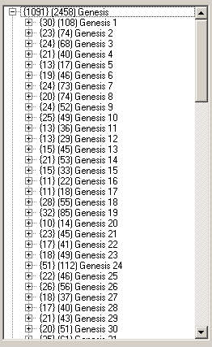

In this mode, not only is each Book of the Bible listed, but every Chapter in every Book is listed as well. But we don’t want to count around and try to hunt down the chapter that’s missing. After all, if it’s in the last chapter of some book, we would miss it completely unless we happened to know how many chapters are in each book.

So, we’ll once again turn on “View Missing Books/Chapters” mode in the View menu. This will cause all chapters, even those with no results, to be listed. By quickly scanning each book in the list, we quickly spot that the missing chapter is Psalm 70:

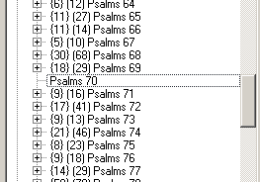

Understanding References
In our example searches, you’ve already seen how to interpret the numbers in front of references, like “{36} (73) Matthew 12”. The {36} means there’s 36 verses with results and 73 occurrences were found within these 36 verses.

That is for Book and Chapter Level Results. If we look at the individual Verse Level Results, you will see something like the following (borrowed from the search results for the word “the”):

“(5) Matthew 12:5 [7][12][15][18][21]”

Similar to the Chapters, the “(5)” means there are 5 occurrences within this verse. The numbers after the traditional looking “Matthew 12:5” part, that looks familiar to you, are the indexes of the word where each occurrence of a matching search phrase begins.

In this example, we see that the 7th, 12th, 15th, 18th, and 21st words of this verse match our search phrase of “the”:

Matthew 12:5 Or have ye not read in the law, how that on the sabbath days the priests in the temple profane the sabbath, and are blameless?

This is the standard convention used throughout the King James Pure Bible Search program.

Want to see even more details about this search result? Just view the details for it in the Search Result Verse Detail Popup window…

Search Results Verse Detail Popup
With the desired Search Result verse selected as the current entry in the Search Results Pane, either press Ctrl-D or select “View Details…” from the View menu:

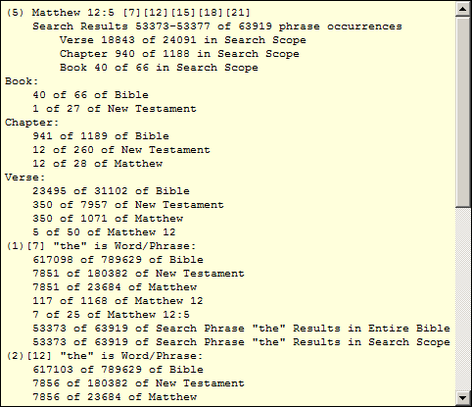

This view gives you every imaginable detail about this verse and the related search phrases that Pure Bible Search can give. In this example, the summary information at the top tells you it’s the same “(5) Matthew 12:5 [7][12][15][18][21]” reference we were looking at.

We find that of the 63919 occurrences of the word “the”, this verse encapsulates results numbered 53373 through 53377. And if we were to number the 24091 verses that results were found in, this is verse number 18843 within those results. And chapter 940 of the 1188 chapters it was found within, and book 40 of the 66 books it was found in.

The Book, Chapter, and Verse details are specifically about “Matthew 12:5”. Notice that it’s chapter 941 of the 1189 chapters of the Bible, but above that we found that this was chapter 940 of the results – don’t forget that Psalm 70 doesn’t have the word “the” and so this truly is the 940th chapter with results.

After the Book, Chapter, Verse details of “Matthew 12:5”, you’ll find the details about each search phrase occurrence. Here the (1), (2), (3), etc, is the result number within this verse. That is followed by the word index number, “[7]” for the 1st result in this example.

This tells us that the 1st search result in this verse is for the phrase “the” (obviously since we were only searching on a single word in a single phrase). This first occurrence is the 617098th word of the Bible, the 7851st word of the New Testament (and of Matthew, since Matthew is the first book of the New Testament), the 117th word of Chapter 12 of Matthew, and the 7th word of this verse.

For the phrase “the”, this result is number 53373 within the Entire Bible and 53373 within our Search Scope, since our currently selected Search Scope is the “Entire Bible”. This detail will be much more useful when you later narrow down the Search scope.

If you use this program much, you’ll quickly memorize the statistics of the King James and you’ll instantly know there are 789629 Words, 31102 Verses, 1189 Chapters, and 66 Books in the entire text.

However, here’s an interesting fact for you: In the book of Revelation, there are 11995 words. If you were to include the complete title of that book, “The Revelation of Jesus Christ” (or even the often attributed title of “The Revelation of Saint John”), which is 5 words, you have exactly 12000 words! I think that’s very interesting given all of the 12000’s in that book.

Multi-Phrase Search
Now that you’ve gotten your feet wet doing several simple single phrase, even single word, searches, let’s try simultaneously searching multiple phrases.

Clear your current search by pressing Ctrl-N (or click the ‘blank paper’ icon on the toolbar or select “New Search” in the File menu), and set your View to see a Tree by Books in Verse Preview Mode and without displaying missing books/chapters:

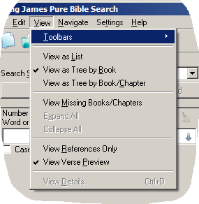

For your first Search Phrase, enter: “in Christ”:

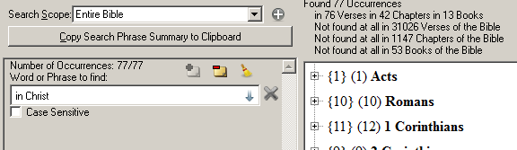

To add your second Search Phrase, either click on the little “+” icon next to the Search Scope drop list or press Ctrl-P:

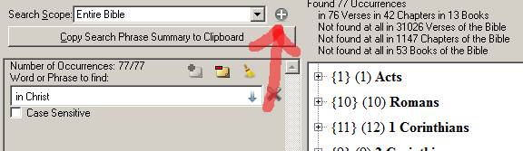

This will add a second Search Phrase:

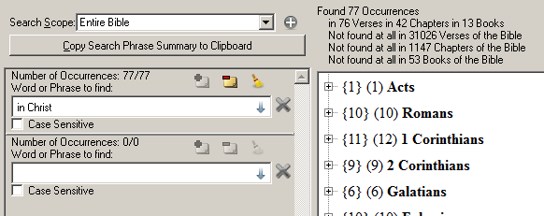

For your second Search Phrase, enter “church”:

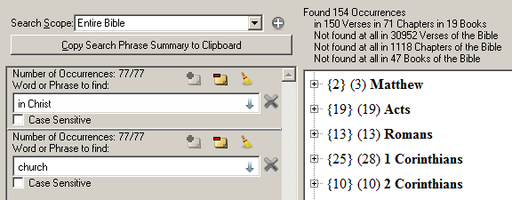

It’s getting interesting already. Both “in Christ” and “church” where each found 77 times in the Bible, or a total of 154 occurrences for both phrases combined. But these are found together in 150 different verses. That immediately tells us that 4 of the occurrences must be located together in the same verse in some fashion.

But, we don’t yet know how these occurrences are grouped. It could be that one verse has 4 occurrences by itself. Or two verses could have 2 occurrences each. So how do we tell? We use Search Scope…

Search Scope
To see words or phrases appearing within certain proximity of each other, we use the Search Scope setting. Initially, the Search Scope is set to the “Entire Bible”. That means that the phrases will contribute to the Search Results when found together anywhere in the Entire Bible – in other words, it’s every occurrence of every phrase.

In the current example, with searching for the phrase “in Christ” and the phrase “church” found together in the Entire Bible, there are 77 occurrences of each, or 154 total. But what if we want to see only where they appear together in the same verse? Just change the Search Scope to “Same Verse”:

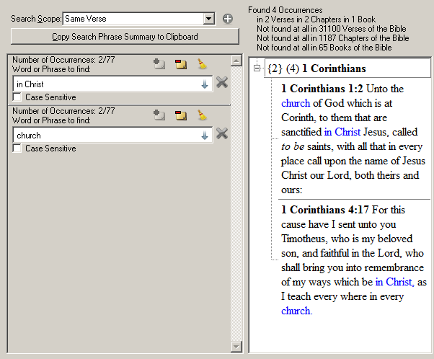

Aha, now of the 154 Phrase Occurrences found in the 150 verses, we’ve found that 4 of the Phrase Occurrences where they are found together, 2 each in the same verse of 2 of the 150 verses.

This brings up a good point to remember – the word “Occurrence” is the occurrence of any one of our search phrases, not an occurrence of where they are found together. To find which verses they appear together, look at the Verse count – and likewise for the Chapter and Book counts.

You can also see another detail here that’s worth mentioning. Above each Search Phrase, the Search Statistics for each phrase has changed. They now say: “Number of Occurrences: 2/77”. The 77 has the same meaning as before, indicating that that phrase is found a total of 77 times in the Entire Bible. But the 2 indicates that 2 of those occurrences are contributing to the Search Results when combined with the other phrases.

Now that we have multiple phrases and a narrow Search Scope, the Search Results Verse Detail popup makes more sense, or is at least more useful:

1 Corinthians 4:17:
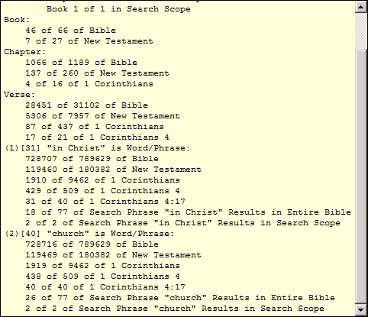

The first occurrence in this verse is the phrase “in Christ”, beginning at word 31. It is the 18th occurrence of “in Christ” of the 77 for this phrase in the Entire Bible, and is the 2nd of 2 results for “in Christ” contributing to the combined Search Results of all phrases.

And the second occurrence in this verse is the phrase “church”, beginning at word 40. It is the 26th occurrence of “church” of the 77 in the Entire Bible, and is the 2nd of 2 results for “church” contributing to the combined Search Results of our two search phrases.

Let’s continue our search one step further. Let’s add any word that begins with “baptiz”. Click on the “+” (Add Phrase) button or press Ctrl-P and enter “baptiz*” in the 3rd Search Phrase:

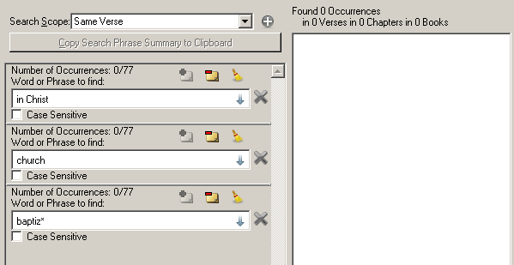

The “baptiz*” entry uses the “*” wildcard to find anything beginning with the letters “baptiz”. This includes things like baptize, baptized, baptizest, baptizeth, batizing, etc., while excluding baptism, baptisms, Baptist, and Baptist’s. In other words, it happens to be all of the action forms of the word, excluding the passive nouns.

Hint: When entering words into a Search Phrase editor, you can instantly see the list matching part of any word you currently have typed. To see the matching words, just move the cursor to somewhere on top of the word, and press the Down Arrow key. A drop list will be displayed showing the matching words:

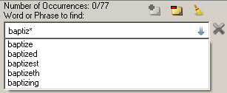

If you want to replace the word in the editor with one of the words in the list, simply select it in the list and press ‘Enter’ or click it with the mouse.

Now that we’ve entered “baptiz*” we see that it too has 77 occurrences in the Entire Bible. This shows one of the fingerprints of God’s Divine Inspiration on the King James text. Not only do we have each of these phrases appearing exactly 77 times, but we have a noun, the “church”; we have a verb, “baptize” or “baptized”; and a prepositional phrase, “in Christ”. We literally have “[The] church [is] baptized in Christ”.

Our Search Scope is still set to “Same Verse”, but it turns out that while these three phrases appear 77 times each in the Bible, they aren’t all found together in the same verse anywhere – hence, the reason why they are all showing “0/77” occurrences. Let’s broaden the scope to be “Same Chapter” instead:

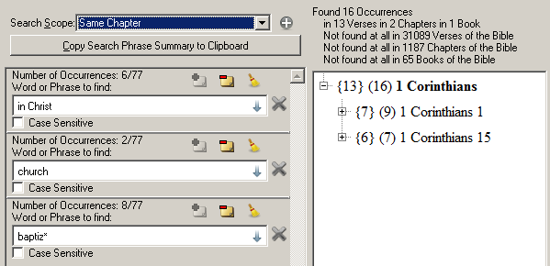

Hint: Note that when searching a Search Scope of “Same Chapter”, it’s less confusing when viewing the results as a Tree to switch to “View as Tree by Book/Chapter” instead of “View as Tree by Book”. Just remember if searching within chapters, then you should view them as chapters.

Interesting… The only book where all the occurrences were in the same chapter is “1 Corinthians”, the same that we saw previously for just “in Christ” and “church” in the Same Verse. And we see that there are 2 Chapters within this Book where all three Search Phrases were found.

And if we increase the Search Scope one more notch, to “Same Book”, we see that there are 4 Books that contain all three Search Phrases. And now we have 101 Occurrences in 93 Verses of 38 Chapters of those 4 Books.

We could increase the Search Scope to “Same Testament”, but for this particular search example, we already know that all of the results are in the New Testament, and so “Entire Bible” and “Same Testament” will give us the same results.

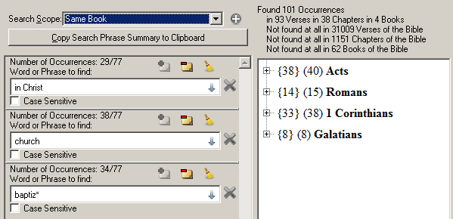

Experiment around with various Search Phrases, Search Results View Modes, and Search Scopes until you are comfortable with doing searches.

OK… You’re probably asking “What are those little buttons and icons around the Search Phrase Editor”? Good question…

Search Phrase Editor
For Search Phrases, you can have any number of Search Phrases Editors as you wish. If the Search Phrase has no matches (either empty or incorrect text that has no matches), Pure Bible Search will automatically ignore the editor’s content and the phrase won’t contribute to the overall Search Results. And, they will not be saved when saving and loading King James Search files.

Each Search Phrase Editor looks like this:

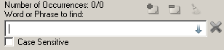

You’ve already seen in this document how you can add additional Search Phrase Editors by clicking the “+” button next to the Search Scope selection or by pressing Ctrl-P.

Hint: You can quickly navigate to one of the Search Phrase Editors by clicking Ctrl-1 to go to the first editor, Ctrl-2 to go to the second editor, and so on, up to the 8th editor with Ctrl-8. The Ctrl-9 key sequence will activate the Search Results View Pane and Ctrl-0 will activate the Scripture Browser Pane.

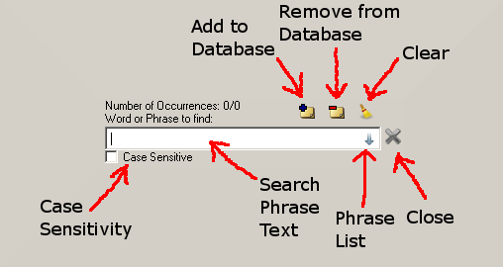

Search Phrase Text
Enter the text to search here. It can be either a single word or a complete phrase. Auto-completion drop lists will automatically appear as you type. Words that aren’t found as they are typed will appear in a strike-out font.

Pressing the Down Arrow key will drop the auto-completion drop list for the word the cursor is currently on. You can dismiss the drop list without selecting anything by pressing Escape. The auto-completion list will reflect all possible next words within the King James Bible text. If you enter a phrase that isn’t found, you’ll immediately know it – no blind searches.

Wildcard symbols of “*” and “?” are accepted and character sets can be entered using matching brackets (“[” and “]”). The “*” matches zero or more characters in the position it’s typed. For example, you can enter “baptiz*” to find all words that start with “baptiz”, like baptize, baptizing, baptizeth, etc.

You can also use the “*” in the middle of a word. For example, “ba*ed” will match: baked, banded, banished, baptized, barbed, barked, bathed, and battered.

The “?” symbol matches any single character for the position it’s given in. For example, “ba?e” will match: babe, bade, bake, bare, and base.

Brackets can be used to enter character sets to match for a given position. For example, in the case given above with “ba?e”, if you only wanted to match bade and bake, but not the other words, you can enter: “ba[dk]e”. The ‘[dk]’ character-set in this example means match either a ‘d’ or a ‘k’ for the 3rd character.

Phrase List
Clicking the little blue arrow button at the right-hand side of the Search Phrase Text editor causes the Search Phrases stored in the databases to be displayed in a drop list. This list is made up by combining the contents of the program’s built-in common phrase list and the user defined database.

The User Database stores Search Phrases defined by you, the user. As you enter search phrases, you have the option of adding them or removing them to your User Database by clicking on the ‘Add to Database’ or ‘Remove from Database’ buttons accordingly (see below).

Search Phrases that are set to be case-sensitive will appear in the drop list prefixed with a “§” symbol, which sort of looks like a ‘c’ and ‘s’ combined for “case sensitive”.

Just like the auto-completer drop lists in the Search Phrase Text, the Phrase List drop list text can be selected by pressing Enter or clicking it with the mouse. You can dismiss the drop list by pressing Escape.

Unlike the auto-completer which only replaces the current word in the editor, the Phrase List entry will replace the entire editor content when selected.

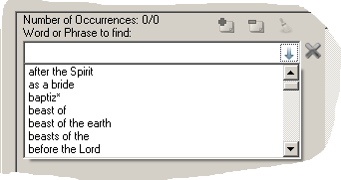

Add to Database
When you’ve entered a unique phrase that is not currently in either the Main Database or in the User Database, the ‘Add to Database’ button will be enabled. Clicking it will add the phrase to the User Database. Once added to the User Database, the phrase will be available in the Phrase List (see above) for all Search Phrase Editors.

After adding or removing phrases to/from the User Database, you will be prompted to save these phrases to the User Database when you exit the application. If you choose not to save the changes you’ve made, they will be lost and not saved in the database.

You cannot add or remove phrases that are already in the Main Database, only those that are unique to the User Database.

The User Database is a SQLite 3 database file named “kjvuser.s3db” and is stored in the ‘db’ folder in the location that the King James Pure Bible Search program was installed. This database is not removed when uninstalling the application and is not overwritten when installing new application versions overtop of old versions.

If you ever reinstall the application and decide to install it in a different folder, you may wish to move your old database to the new installation folder. If you don’t, you will lose the phrases you previously had and will start with a new User Database.

Remove from Database
When you’ve entered a phrase that is currently in the User Database, the ‘Remove from Database’ button will be enabled. Clicking it will remove the phrase from the User Database. Once removed, the phrase will no longer appear in the Phrase List (see above) of any Search Phrase Editor.

After adding or removing phrases to/from the User Database, you will be prompted to save these phrases to the User Database when you exit the application. If you choose not to save the changes you’ve made, they will be lost and not saved in the database.

You cannot add or remove phrases that are already in the Main Database, only those that are unique to the User Database.

See “Add to Database” for more details on the database file type and location and how to preserve your database when upgrading Pure Bible Search to a new version.

Clear
The ‘Clear’ button is enabled whenever there is text within the Search Phrase Text Editor. Clicking it will clear the text entered and return the Search Phrase Editor to the state it was in when it was originally created, with the exception of the “Case Sensitive” checkbox. The “Case Sensitive” checkbox will continue to remain in the last mode selected.

Case Sensitivity
The ‘Case Sensitive’ checkbox determines whether or not the phrase entered requires the case of the text to match what’s given or not. For example, if you wish to search for “spirit”, without case sensitivity turned on, you’ll find 505 matches, matching either Spirit or spirit.

However, if you turn case-sensitivity on and search for “spirit” (all lowercase), you’ll find that it appears exactly 333 times in the Entire Bible. But if you search for “Spirit” (initial caps), you’ll get 172 matches. And if you turn off case-sensitivity again, you’ll have 505 matches, as would be expected, since it’s the sum of 333 and 172.

Close
As would be expected, the ‘Close’ button removes the corresponding Search Phrase Editor from the list of Search Phrases and updates the Search Results to be based on just the other Search Phrases.

Search Phrase Summary
Just above the Search Phrase Editor list is a button to “Copy Search Phrase Summary to Clipboard”:



Clicking this button will copy a summary of the search phrases and their search results statistics. With the phrases: “§baptiz*”, “Christ”, and “water” within the Same Chapter, that we were just looking at, the summary will look like this:

Search of 3 Phrases in the same Chapter:

"§baptiz*" (Found 77 Times in the Entire Bible, 32 in Scope)
"Christ" (Found 555 Times in the Entire Bible, 15 in Scope)
"water" (Found 396 Times in the Entire Bible, 23 in Scope)

(§ = Case Sensitive)

Found 70 Combined Occurrences
in 49 Verses
in 8 Chapters
in 4 Books

Not found together at all in 31053 Verses of the Bible
Not found together at all in 1181 Chapters of the Bible
Not found together at all in 62 Books of the Bible

Browsing Scripture in the Scripture Browser
The Scripture Browser works a lot like a regular web browser, but with the text of the King James Bible:

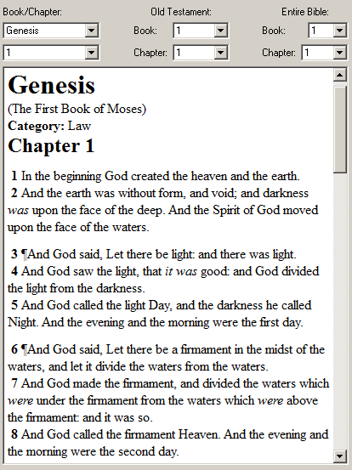

Due to rendering limitations with text selection, highlighting, and formatting, only a single Chapter is shown on the screen at any one given time.

As you browse through the scripture text, the status bar in the lower-left corner of the application displays the passage reference of the cursor’s location and the exact selection and word count if you are selecting words.

Note that on word counts, only the actual word of the King James text is counted. Decorations, like chapter headings, verse numbers, chapter descriptions and footnotes, etc, are not counted.
For example:
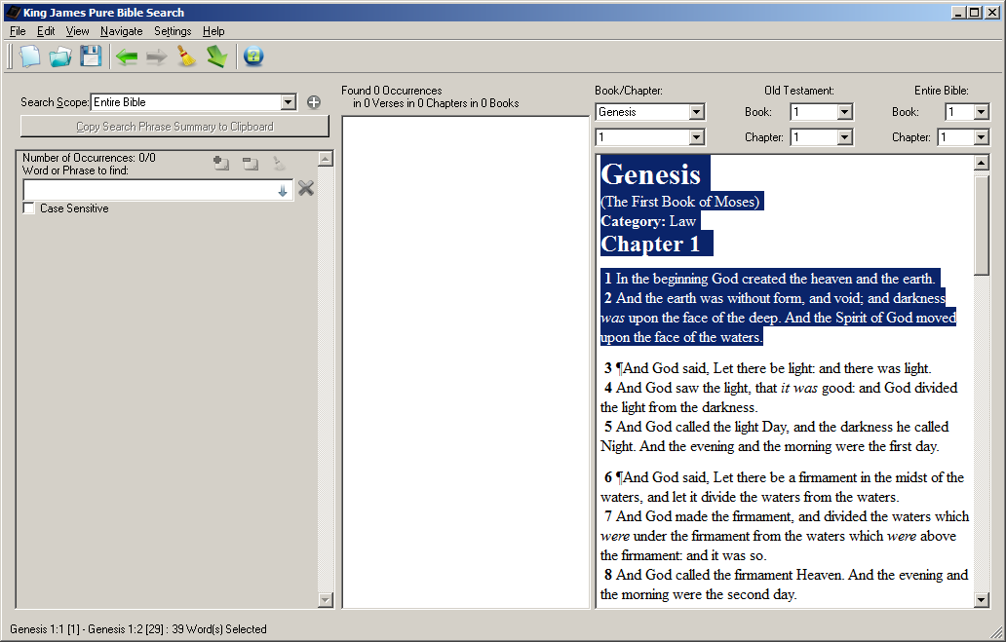

If we zoom in on the status bar text:



You’ll notice that it correctly indicates that only 39 words of the King James text is actually selected, from Genesis 1:1 [1] to Genesis 1:2 [29], as verse one contains 10 words and verse two contains 29 words. The titles and headings aren’t counted.

This feature is most helpful when you want to count significant words in the text. Without this, you’d have to manually count in order to skip the verse and chapter numbers – a very time consuming and error-prone task.

An example of the types of places where you might wish to use this is counting the words in the poison that the serpent spoke to Eve in the Garden of Eden … a total of 46 words:

He spoke two phrases to Eve, one in Genesis 3:1:

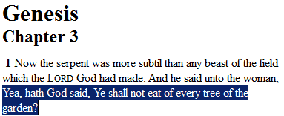



Phrase one has 14 words. And the second phrase is in Genesis 3:4-5:

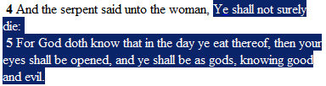



Phrase two has 32 words. That gives us a total of 46 words – one word of poison for each of the 46 chromosomes of human DNA.

So what navigation options are there for getting around in the text?

Navigating in the Scripture Browser
At the top of the Scripture Browser, you’ve probably noticed the drop lists for the Book and Chapter:

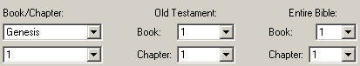
The two drop lists on the far left are probably the easiest understood. They contain the Book Name and Chapter within that Book currently being viewed in the Scripture Browser. As you switch Books, the number of Chapters in the Chapter drop list will change to reflect the content of the book.

In the middle, you have the current Book Number and Chapter Number within the currently selected Testament. These numbers are relative to the current testament. That means if you’re in the Old Testament, you’ll have Book Numbers 1 to 39 and Chapters 1 to 929, since there are 39 Books in the Old Testament, containing a total of 929 Chapters.

If you are in the New Testament, you’ll see Book Numbers 1 to 27 and Chapters 1 to 260, since that’s the counts for the New Testament. Note that in order to switch the Testament selected, you need to pick a book in the left-hand Book drop list from the desired Testament – doing so will automatically change the middle list.

On the right-hand side, you’ll find the Book Number and Chapter Number relative to the Entire Bible. For Books, you’ll find 1 to 66 and Chapters 1 to 1189.

Selecting a Book or Chapter from any of these drop lists will automatically navigate the Scripture Browser to that passage. If, for example, you wanted to go to the 666th chapter of the Bible, simply select “666” in the Chapter drop list under “Entire Bible”, and you’ll instantly find yourself in Ecclesiastes 7, which is the 666th Chapter in the Bible, and also the 666th of the Old Testament.

Under the “Navigate” menu, you’ll find even more navigation options:

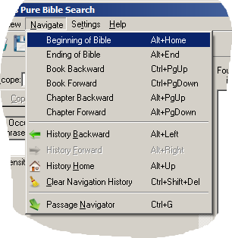
Here, you’ll find quick shortcuts to go to the beginning or ending of the Entire Bible, forward or backward one Book, or forward backward one chapter. As you navigate, the program remembers where you’ve been, just like a web browser does when navigating the internet. Therefore, you’ll also see options for navigating forward and backward through your history, along with options to go to the first location in your history or to even clear your browsing history.

All of these options have keyboard shortcuts as well, as shown next to each item in the menu. Ctrl-PageUp and Ctrl-PageDown go backward and forward, respectively, by an entire Book and Alt-PageUp and Alt-PageDown go backward and forward, respectively, by an entire Chapter.

Home and End keys will take you to the beginning and ending of the current line, respectively. Ctrl-Home and Ctrl-End take you to the beginning and ending of the chapter displayed, respectively. And Alt-Home and Alt-End take you to the beginning and ending of the Entire Bible, respectively.

Alt-Left and Alt-Right go backward and forward, respectively, through your navigation history. And Ctrl-Left and Ctrl-Right moves you left or right, respectively, by one word at a time through the text.

From the Search Results Pane, you can instantly navigate to the passage in the Browser by either double-clicking the desired entry or selecting it as the current index and pressing enter, and you will be instantly taken to the exact verse of the Search Result.

And if you are having difficulty seeing and reading the text, you can hold down the Ctrl-key and roll the mouse wheel to zoom in/out or change the display font in the Settings Menu (See Fonts).

If you want to find a word or phrase within the Scripture Browser screen for the currently displayed Chapter, but you don’t want to remove or otherwise alter your current Search Phrases, press Ctrl-F or select “Find” from the Edit menu:

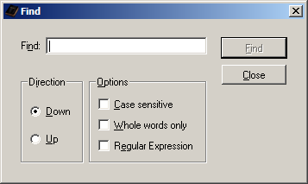

The Find dialog works just like the Find operations of your favorite word processor, web browser, or other program you are already used to using.

But what if you want to go forward exactly 666 verses from the location where the cursor is correctly at? How do you do that without counting? Simple, you use the Passage Navigator…

Passage Navigator
Any time you press Ctrl-G or select “Passage Navigator” on a menu, you’ll be shown the Passage Navigator dialog:

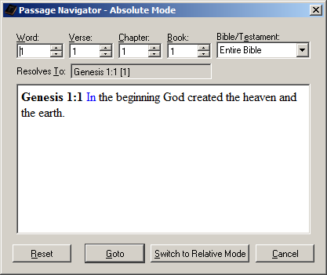

The current location shown in the Passage Navigator will depend on which of the three main panes had focus when you entered the Navigator. If you are in one of the Search Phrase Editors, you’ll be taken to Genesis 1:1, as shown above.

If you are in the Search Results Pane, then you’ll be taken to the verse of the current index in the Search Results Tree/List view.

If you are in the Scripture Browser Pane, you will be taken to the location where the cursor is currently at and if text is selected, then that text will be selected in the navigator and used in the navigation process.

The Passage Navigator has two modes: Absolute Mode and Relative Mode. The Absolute Mode is probably the easiest to understand. It will allow you to navigate to an absolute location within the King James text using specific counts.

The Relative Mode, by contrast, will allow you to navigate to a new location in the King James text relatively from a given location using specific counts. As you’ll see in a minute when we discuss this mode, relative counts can be tricky, especially in the reverse direction.

Absolute Mode
The Absolute Mode of the Passage Navigator allows you to go to the w^{th} Word from the x^{th} Verse, from the y^{th} Chapter, from the z^{th} Book within the selected Testament or the Entire Bible.

It’s written with the least significant count first to remind you that these are counts and not an actual reference. Though in Absolute Mode, there is always a “most-reduced count” that represents a given reference.

The “most-reduced count” will be very intuitive to you, but it is best learned by example and illustration. Suppose you wanted to navigate to the 666th Chapter of the Bible. You want to go to the 1st Word from the 1st Verse from the 666th Chapter from the 1st Book of the Entire Bible:

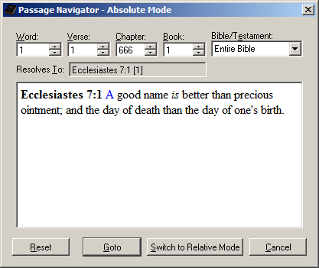

From our previous discussion of navigating in the Scripture Browser and discussing the Book/Chapter drop lists, you already know that the 666th Chapter of the Bible is Ecclesiastes 7. So as you’d expect, entering: “1, 1, 666, 1, Entire Bible” in the Passage Navigator will take you to Ecclesiastes 7:1 [1], as shown above.

If you click “Goto”, you’ll be taken to the computed verse in the Scripture Browser Pane, with the word you just calculated selected:

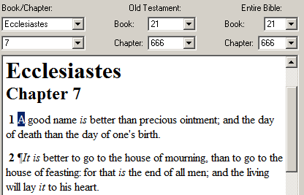

Now, if you immediately press Ctrl-G (or select the Passage Navigator) again, you’ll be presented with:

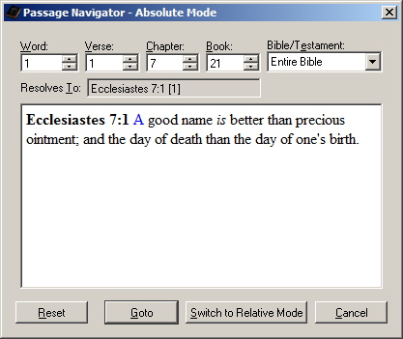

This will show you what is meant by the “most-reduced count” for a given passage. In this case, the 1st Word from the 1st Verse from the 7th Chapter from the 21st Book in the Entire Bible is another way (the “most-reduced” way) of saying Ecclesiastes 7:1 [1].

It is identical to saying the 1st Word from the 1st Verse from the 666th Chapter from the 1st Book in the Entire Bible. The Pure Bible Search application will automatically reduce counts when first displaying them in the Passage Navigator or when switching modes within the navigator. They are synonymous, so it doesn’t matter which you type. Simply type the numbers for the counts you want to see and let it calculate the rest.

And now, for another example – what if you wanted to calculate the middle verse of the entire Bible? Simple – you already know from the many detail, summary, and statistic views that there are 31102 verses in the entire Bible, so halfway through the Bible is the 15551st verse, or 31102 divided by 2. Since it divides evenly, the 15551st verse is the last verse in the left-half, and the 15552nd verse is the first verse in the right-half.

To calculate what verse this is, click the “Reset” button to clear the Passage Navigator back to the start of the Bible (or “1, 1, 1, 1, Entire Bible”) and enter 15551 for the Verse:

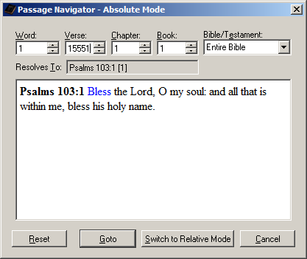

So the middle two verses of the Bible are Psalms 103:1-2. Click “Goto” to navigate there in the Scripture Browser, and you’ll find:

(Psalms 103:1-2) "Bless the Lord, O my soul: and all that is within me, bless his holy name. {2} Bless the LORD, O my soul, and forget not all his benefits:"

This is a very interesting passage for the very middle of the Bible in terms of verses – “all that is within me”. While you are in the Scripture Browser with this passage, press Ctrl-D (or select “View Details…”). Look at what verse this is within the Book of Psalms. It is verse 1611 – the very year of the King James. Coincidence?

Side Note: If you want to do an interesting side-study, search the phrase “within me”.

And of course to see what “1, 15551, 1, 1, Entire Bible” reduces to as a “most-reduced count” (even though you probably already know based on the examples thus far), simply press Ctrl-G (or select the Passage Navigator) again and have it display it for you.

No surprise, you’ll find the “most-reduced count” to be: “1, 1, 103, 19, Entire Bible”, or the 1st Word from the 1st Verse from the 103rd Chapter from the 19th Book of the Entire Bible, or “Psalm 103:1 [1]”, since Psalms is the 19th book of the Bible:

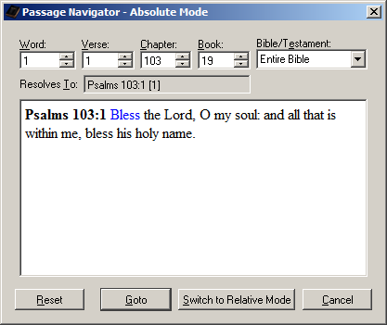

Experiment around with the Passage Navigator in Absolute Mode until you are comfortable with it. When you think you have it figured out, with the above reference still displayed, click the button to “Switch to Relative Mode” and we will cover Relative Mode…

Relative Mode
Relative mode can be confusing, particularly in reverse direction searches, because it literally counts from the exact location you are at and it’s easy to not start from the location you are thinking about starting from. So, we’ll start with something less confusing and work our way to the more difficult examples:

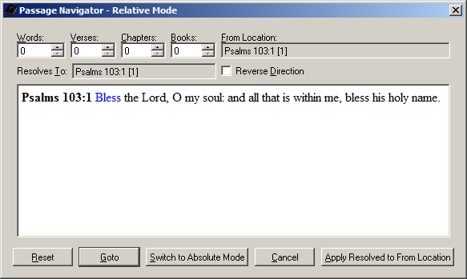

After switching to Relative Mode with the previous “Psalms 103:1 [1]” reference as the current location, you should see the above Passage Navigator dialog.

Unlike the Absolute Mode which had “1, 1, 1, 1, Entire Bible” as the “Reset” state, the Relative Mode will have “0, 0, 0, 0, <From Location>” as the “Reset” state. When your counts are reset to all 0, the “Resolves To” reference should match the original “From Location” that you started with. In other words, you are telling it to move 0 Words, 0 Verses, 0 Chapters, and 0 Books, from the starting location.

In this example, with the given reference of “Psalms 103:1 [1]” we happen to be at the 1st Word and the 1st Verse of this Chapter, which is good to help avoid confusion for this first example. You will see why in a minute. But let’s use this and start with some simple relative calculations.

Suppose you want to calculate what 147 Chapters back will be. Simple – First, click the “Reverse Direction” checkbox, since you want to go backward in the text. Next, enter “147” in the Chapters spin-box (the minus signs will remind you that you’re going backward in the text). You will get:

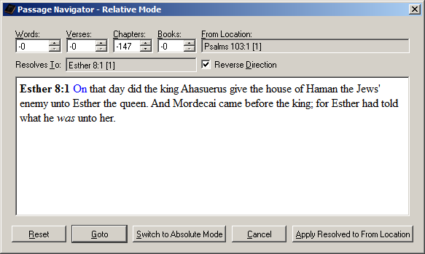

This means that if you count 147 Chapters back from Psalm 103:1, you will be in Esther 8:1. Sure beats counting by hand doesn’t it?

Now, if you change your mind and realize you meant to enter 147 Verses backward instead of 147 Chapters, you still have the same “From Location”. So you can simply either click “Reset” or set the Chapters spin-box back to 0, and then enter 147 in the “Verses” spin-box instead:

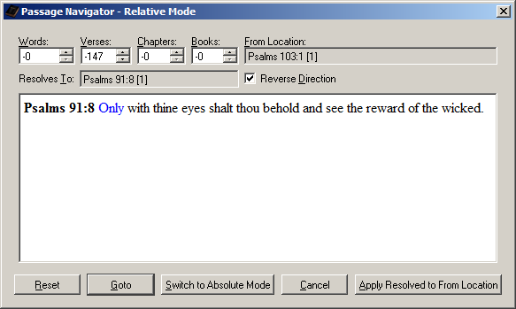

You now find that Psalm 91:8 is 147 Verses before Psalm 103:1. “Psalms 103:1 [1]” is still the current “From Location”, so when you change counts, you are still counting from that location.

But suppose instead you want to count from the new location. Just click the “Apply Resolved to From Location” button and it will copy the “Psalms 91:8 [1]” to the “From Location”, in this example. And it will automatically “Reset” the counts back to 0:

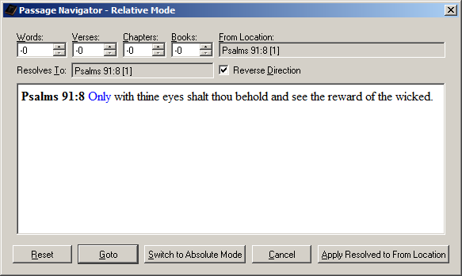

If you want to confirm that you really are 147 Verses prior to the original Psalm 103:1 location, uncheck the “Reverse Direction” checkbox and enter 147 in the Verses spin-box:

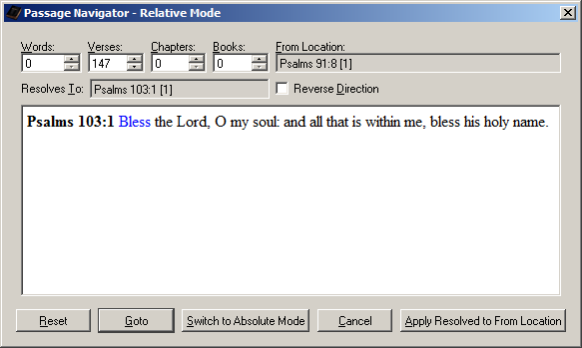

No surprise, you find that indeed 147 verses forward from Psalm 91:8 would put you back to Psalm 103:1. But now suppose you want to count Forward 333 Chapters and 123 Words from this Psalm 91:8 location. With the “Reverse Direction” checkbox still turned off, enter 123 in the Words spin-box and 333 in the Chapters spin-box:

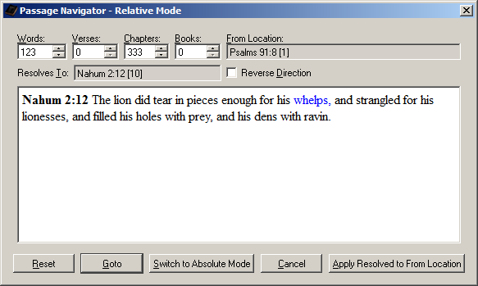

This means if you went forward 333 Chapters from “Psalms 91:8 [1]” and then forward 123 Words from that, you’d end up at “Nahum 2:12 [10]” – or the 10th Word of the 12th Verse of the 2nd Chapter of Nahum.

Absolute Mode Counting vs. Relative Mode Counting
One import thing to remember between Absolute Mode and Relative Mode is that Absolute is an Absolute Position. It therefore starts counting from zero, or just outside the entire Bible and counts inward to reach the desired number of counts. Relative, however, starts on a specific reference and begins counting from there.

To illustrate this difference between Absolute Mode and Relative Mode, let’s refer back to our Chapter 666 example. Go to Absolute mode and enter “1, 1, 666, 1, Entire Bible”:

You should find yourself at the Ecclesiastes 7:1 passage again.

Now, click “Reset” to clear your location back to “1, 1, 1, 1, Entire Bible” and click “Switch to Relative Mode” and enter 666 for the Chapters count:

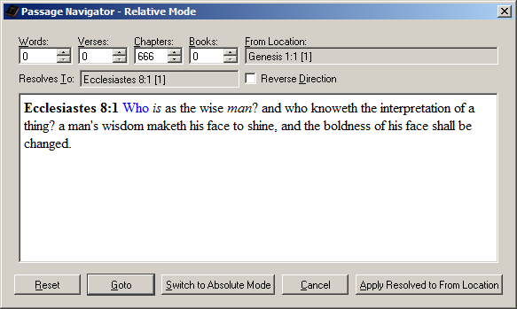

This time, you will end up at Ecclesiastes 8 instead of Ecclesiastes 7. This is because Ecclesiastes 7 is the 666th Chapter of the Bible, if you start outside the Bible and beginning counting, with Genesis 1 being your first Chapter.

But, if you are already at Genesis 1:1 and you start counting chapters, and you wanted to move forward 666 chapters from where you are at (i.e. move Relative to your current location), you wouldn’t count the Chapter you are on, but you’d flip the page and Genesis 2 would be “one chapter forward”. Genesis 3 would be “two chapters forward”, and so on. And thus you get Ecclesiastes 8:1 as being 666 Chapters after Genesis 1:1. If instead, you would have entered 665 Chapters, you would have been at Ecclesiastes 7:1:

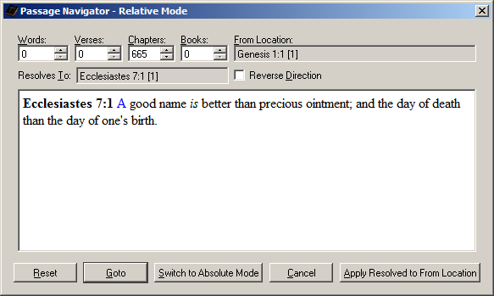

All of this should seem very straight forward (or I hope it does). So where does the confusion come in that I mentioned? Well, before I introduce you to the confusion, if what you’ve seen so far is confusing, go back and study this much and understand it thoroughly before moving on. Otherwise, meet the confusion…

Relative Mode Confusions
The Passage Navigator Relative Mode can be confusing if you don’t start with the location that you have in mind to start with. This can best be illustrated by example. And for that, I’m going to pick a random location. Let’s pick “Revelation 12:6 [18]”, or the 18th Word of the 6th Verse of the 12th Chapter of Revelation, which is Book 66 of the entire Bible.

You can get there in one of two ways. You can either navigate the Scripture Browser to Revelation 12:6 and go to that specific word (using the Status Bar as a guide) and with that word highlighted press Ctrl-G (or select “Passage Navigator” from the menu).

Or you can click Ctrl-G (or select “Passage Navigator” from the menu) and enter “18, 6, 12, 66, Entire Bible” in the Absolute Mode that is displayed. Either way, you’ll be at the same location:

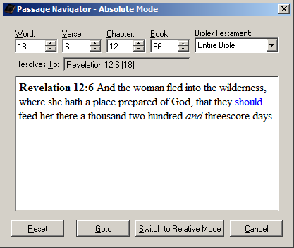

Now, click the button to “Switch to Relative Mode”:

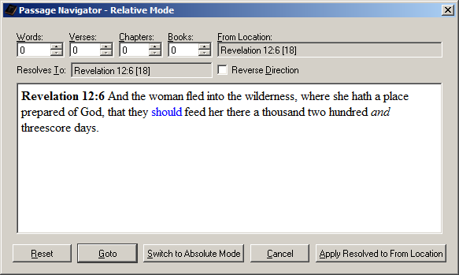

This much should seem very familiar with nothing confusing yet. Now let’s say you want to go backward 5 Books, and you click the “Reverse Direction” checkbox and enter 5 for Books:

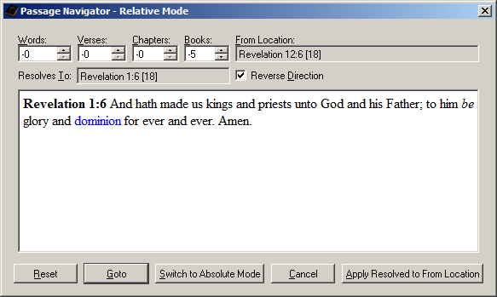

We find ourselves at “Revelation 1:6 [18]”, or the 18th Word of the 6th Verse of the 1st Chapter of Revelation. You are probably wondering how we can move backward by 5 Books and still be in the Book of Revelation?

Here’s how: Your starting location wasn’t at the beginning of the Book of Revelation. It wasn’t even the beginning of a Chapter or Verse either. You were on the 12th Chapter of the Book and on the 6th Verse of the Chapter and the 18th Word of that Verse.

When you directed it to go back 5 books, it counted back 5 books from Revelation to find “2 Peter”. Since you were on 12:6 [18] of Revelation, it tries to apply that to “2 Peter” to put you at the same relative location as you were before, just 5 Books back. But 2 Peter doesn’t have a “2 Peter 12:6 [18]”, as 2 Peter only has 3 Chapters.

It then counts forward 12 Chapters, counting 2 Peter 1 as the first Chapter, and you come to Revelation 1. It then moves to the 6th Verse from there and then the 18th Word from there. Now in this example, there happens to be more than 6 Verses in Revelation 1, and that Verse happens to have move than 18 Words. If they didn’t, it would have continued on to the next Chapter and/or Verse as necessary to get to the equivalent of “12:6 [18]” from “2 Peter”.

Most likely what you really wanted to do was go back 5 Books from Revelation 1:1 [1], not 12:6 [18]. If you had been at Revelation 1:1 [1] and gone back 5 Books, it would have taken you to 2 Peter 1:1 [1]:

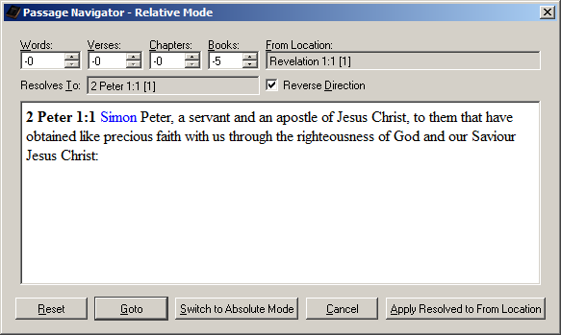

In general, counting by Words alone will never lead to this confusion, as you can always move backward by the specified number of Words. However, if you move by Verses, chances are you want to be at the 1st Word of the Current Verse before you begin, since the Verse you are going to may not have as many words as the Verse you’re currently on.

And similarly, if you are moving backward by Chapters, chances are you want to be at the 1st Verse of the Current Chapter before you begin, since the Chapter you are going to may have fewer Verses than the Chapter you are currently on.

And finally, if you are moving backward by Books, chances are you want to be at the 1st Chapter of the Current Book before you begin, since the Book you are going to may have fewer Chapters than the Book you are currently on.

You essentially want to mask you movement calculations based on the current reference. And yes, the program could have enforced this and automatically set the current location to “1” for any position of lower value than the one being set, so you wouldn’t forget to do so. It doesn’t, however, because there are some special cases where moving in this, seemingly weird, relative fashion is actually desired.

So if you aren’t getting the result you think you should be, check to make sure you are at the starting place you intended to be at. If you are thinking of moving by verses, for example, chances are you aren’t thinking about the Words of the Verse you are on and instead want to move relative to the first Word of the Verse. Do yourself a favor and move to the first Word of the Verse before calculating the relative Verse jump.

The same applies to Chapters and Books. If you want to move backward a certain number of Chapters or Books, most likely you want to do so from the first Verse of the Chapter you are on or the first Chapter of the Book you are on.

Chances are you are still confused by this, as it’s a very confusing topic. Hopefully with a bit of experimentation, starting with the examples that have been given, it will become clear. So start experimenting.

Fonts
Initially, the Fonts for the Scripture Browser Pane and Search Results Pane is set to “Times New Roman” at 12 point, as it seems to work best for most screens and is very readable, and that particular Font has all of the necessary characters to render the text, including the special Hebrew characters found in Psalm 119.

But you may find that this point size or specific Font isn’t compatible with your eyesight. And so provisions have been made to independently set the Fonts for these two panes.

The Scripture Browser Pane also supports a temporary method of Zooming the window, activated by holding down the Ctrl key and rolling the wheel on the mouse. When you exit the application, the Zoom Factor isn’t stored and the Font Size is restored to your Font setting.

To change the Font Size and have it to remain changed or to change the Font Family or other Font characteristic, you will need to use the Font Settings. This is found on the “Settings” menu:

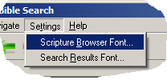

On the Settings Menu, you’ll find “Scripture Browser Font” and “Search Results Font”. Selecting one of these will display the Font Setting Dialog for the corresponding pane. Both Font Setting Dialogs are identical, except for the pane whose Font is being set. Therefore, we’ll only look at the Scripture Browser Font Dialog here:

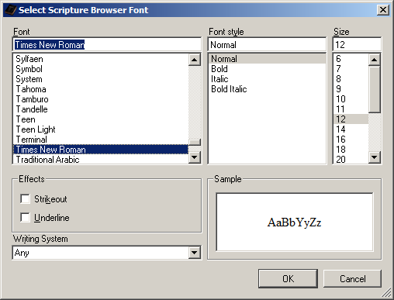

The specific list of Fonts that are listed on your computer will be different from the list in the above screenshot, as it depends on what Fonts you happen to have installed on your computer.

While you can set Font Effects, like Strikeout and Underline, and Font Style, like Bold and Italic, it is recommended that you leave the Effects turned off and the Font Style set to “Normal”. Otherwise, you will not be able to distinguish text that specifically appears in one format vs. another.

For example, there are words in the Bible that are italicized. If you change everything to be italics, you can no longer determine what is and what isn’t italicized.

The “Writing System” drop list simply filters the Font names listed to only show the ones compatible with the selected Writing System. This is perhaps useful if you are trying to determine a font compatible with the special Hebrew characters that are displayed in Psalm 119. If the Font you select isn’t compatible with the Hebrew Writing System, those will not display correctly. Similarly, if you pick a Font that isn’t compatible with basic English text, then the Scripture Text won’t appear correctly.

It’s recommended that you only change the Font Size and/or Font name on this dialog. When you are happy with your selection, simply click ‘OK’ and the corresponding Scripture Browser Pane or Search Phrase Pane will be updated. Or if you change your mind, just click ‘Cancel’ or press Escape to leave the Font unchanged.

Note that changing the Font only changes what is displayed within the King James Pure Bible Search program. When you copy-and-paste text, the software you are pasting into will determine how to format the text within the context of where you are pasting it.

If you are wondering if the King James Pure Bible Search application will ever be translated to languages other than English, the answer is ‘No’. No provisions or plans have been made to do internationalization of this application.

Why, you might ask? Because this application is specifically designed to Search and Study the King James Bible text, which, by its very nature, is give in English. It’s assumed if you can read and understand the English of the King James Bible, you can understand the English labels and documentation for the King James Pure Bible Search application.

The Ever Changing “Edit” Menu
Perhaps by now, you’ve noticed that the “Edit” menu changes depending on which of the three main panes has the focus. A variation of the corresponding “Edit” menu is also displayed when you right-click on the corresponding pane. These are summarized here:

Search Phrase Edit Menu
When one of the Search Phrase Editors is active, the Edit menu changes to a traditional simple edit menu:

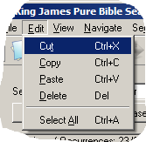

Right-clicking within the Search Phrase Editor gives the same exact menu. The items on this menu allow you to cut, copy, paste, delete, and select all text in the currently selected Search Phrase Editor.

In addition to these clipboard operations, you can also drag-and-drop text to/from the Search Phrase Editor. When dropping normal text into the Search Phrase, the text is inserted at the cursor location. However, when dropping text from the Scripture Browser, the text is interpreted as a complete phrase you’d like to search and will replace any text in the Search Phrase Editor you drop it on.

Search Results Edit Menu
When the Search Results List/Tree View is active, the Edit menu changes to support the selected Search Results. Note that you can have more than one verse from the Search Results selected at a time.

To select more than one, use the Shift and/or Control keys while clicking the desired Search Result with the mouse. The Control key lets you add or remove a single verse from the selection. The Shift key, however, selects all of the verses between the currently active verse (indicated by the square box around the verse) and the verse at the point you click.

When you select items on the Edit menu (or the corresponding items on the right-click menu), the item selected from the menu applies to all items currently selected in the Search Results Pane. In other words, when you select “Copy Verse Text”, the verse text for all of the selected verses are copied, not just the current index.

Edit menu:

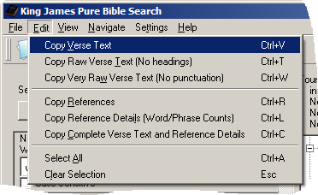

Right-click menu (gives related View options as well as Edit options):

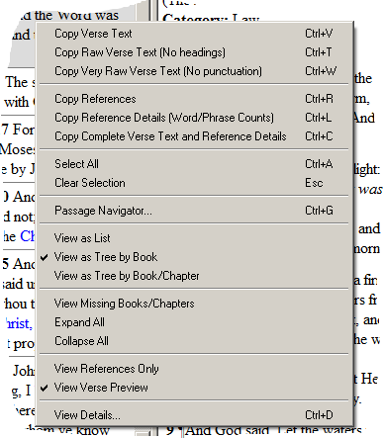
The first three Copy options copies the text for the currently selected verses. “Copy Verse Text” copies the verses in the same format it is rendered on the screen. “Copy Raw Verse Text” copies the same verse text, but copies it in plaintext (without colorized highlighting, italics, etc) and without the reference headings, but with the punctuation still intact. And “Copy Very Raw Verse Text” copies the same text, but eliminates punctuation as well, which is useful if you are building word lists, for example.

Here’s an example of copying John 1:1 and John 1:2 from the Search Results Pane in each of these three modes, when searching for the phrase “In the beginning”:

Copy Verse Text
John 1:1 In the beginning was the Word, and the Word was with God, and the Word was God.
John 1:2 The same was in the beginning with God.

Copy Raw Verse Text
In the beginning was the Word, and the Word was with God, and the Word was God.
The same was in the beginning with God.

Copy Very Raw Verse Text
In the beginning was the Word and the Word was with God and the Word was God
The same was in the beginning with God

Copy References
The “Copy References” option just copies the list of verse references from the Search Results Pane. This will look the same as when displaying “View References Only”:

(1) John 1:1 [1]
(1) John 1:2 [4]

Copy Reference Details
The “Copy Reference Details” option copies the same data that is displayed when you either press Ctrl-D or click “View Details…” on the menu. However, the Copy function copies the Details for all of the selected verses, and Ctrl-D or “View Details…” only shows the details for the Current Index in the Search Results Pane (as indicated by the rectangular box around the Current Index). Here’s an example of copying the data from the same John 1:1 and John 1:2 verses while searching for “In the beginning”, “Christ”, and “baptiz*” within the Same Chapter:

(1) John 1:1 [1]
Search Result 1 of 12 phrase occurrences
Verse 1 of 10 in Search Scope
Chapter 1 of 1 in Search Scope
Book 1 of 1 in Search Scope
Book:
43 of 66 of Bible
4 of 27 of New Testament
Chapter:
998 of 1189 of Bible
69 of 260 of New Testament
1 of 21 of John
Verse:
26046 of 31102 of Bible
2901 of 7957 of New Testament
1 of 879 of John
1 of 51 of John 1
[1] "In the beginning" is Word/Phrase:
674037 of 789629 of Bible
64790 of 180382 of New Testament
1 of 19094 of John
1 of 1004 of John 1
1 of 17 of John 1:1
14 of 17 of Search Phrase "In the beginning" Results in Entire Bible
1 of 2 of Search Phrase "In the beginning" Results in Search Scope

(1) John 1:2 [4]
Search Result 2 of 12 phrase occurrences
Verse 2 of 10 in Search Scope
Chapter 1 of 1 in Search Scope
Book 1 of 1 in Search Scope
Book:
43 of 66 of Bible
4 of 27 of New Testament
Chapter:
998 of 1189 of Bible
69 of 260 of New Testament
1 of 21 of John
Verse:
26047 of 31102 of Bible
2902 of 7957 of New Testament
2 of 879 of John
2 of 51 of John 1
[4] "in the beginning" is Word/Phrase:
674057 of 789629 of Bible
64810 of 180382 of New Testament
21 of 19094 of John
21 of 1004 of John 1
4 of 8 of John 1:2
15 of 17 of Search Phrase "In the beginning" Results in Entire Bible
2 of 2 of Search Phrase "In the beginning" Results in Search Scope

Copy Complete Verse Text and Reference Details
The “Copy Complete Verse Text and Reference Details” combines the functionality of “Copy Verse Text” and “Copy Reference Details” into a single function. Each selected verse is copied, followed by the results detail for that verse:

John 1:1 In the beginning was the Word, and the Word was with God, and the Word was God.
Search Result 1 of 12 phrase occurrences
Verse 1 of 10 in Search Scope
Chapter 1 of 1 in Search Scope
Book 1 of 1 in Search Scope
Book:
43 of 66 of Bible
4 of 27 of New Testament
Chapter:
998 of 1189 of Bible
69 of 260 of New Testament
1 of 21 of John
Verse:
26046 of 31102 of Bible
2901 of 7957 of New Testament
1 of 879 of John
1 of 51 of John 1
[1] "In the beginning" is Word/Phrase:
674037 of 789629 of Bible
64790 of 180382 of New Testament
1 of 19094 of John
1 of 1004 of John 1
1 of 17 of John 1:1
14 of 17 of Search Phrase "In the beginning" Results in Entire Bible
1 of 2 of Search Phrase "In the beginning" Results in Search Scope

John 1:2 The same was in the beginning with God.
Search Result 2 of 12 phrase occurrences
Verse 2 of 10 in Search Scope
Chapter 1 of 1 in Search Scope
Book 1 of 1 in Search Scope
Book:
43 of 66 of Bible
4 of 27 of New Testament
Chapter:
998 of 1189 of Bible
69 of 260 of New Testament
1 of 21 of John
Verse:
26047 of 31102 of Bible
2902 of 7957 of New Testament
2 of 879 of John
2 of 51 of John 1
[4] "in the beginning" is Word/Phrase:
674057 of 789629 of Bible
64810 of 180382 of New Testament
21 of 19094 of John
21 of 1004 of John 1
4 of 8 of John 1:2
15 of 17 of Search Phrase "In the beginning" Results in Entire Bible
2 of 2 of Search Phrase "In the beginning" Results in Search Scope
The remaining Edit menu functions for the Search Results Pane, which are “Select All” and “Clear Selection”, are self-explanatory. And the View Options on the right-click menu have already been covered in the search examples we’ve looked at, as have the Passage Navigator details.

Scripture Browser Edit Menu
The Edit menu for the Scripture Browser is very similar to that of the Search Results Edit Menu, with a few exceptions:

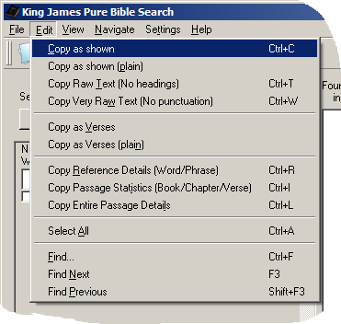

And the Scripture Browser right-click menu:
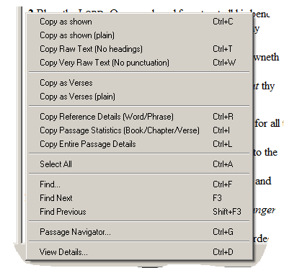

Copy as Shown
The “Copy as Shown” function works just like the conventional Copy function in any text editor. It copies exactly what is selected on the screen in exactly the format that it’s presented. This includes headings, footnotes, chapter descriptions, etc. For example:

Psalms
Chapter 103
A Psalm of David.
1 Bless the Lord, O my soul: and all that is within me, bless his holy name.

Copy as Shown (plain)
“Copy as Shown (plain)” is identical to “Copy as Shown” except that font formatting is lost. Punctuation, headings, footnotes, chapter descriptions, etc, are copied, but relative Font Size changes, color, italics, etc, are lost and only plain text is copied. For example:

Psalms
Chapter 103
A Psalm of David.
1 Bless the Lord, O my soul: and all that is within me, bless his holy name.

Copy Raw Text (No Headings)
“Copy Raw Text (No Headings)” is identical to “Copy as Shown (plain)”, but gets rid of headings, footnotes, chapter descriptions, etc, in addition to font formatting. Punctuation, however, is preserved. This is useful for extracting raw sentences. For example (copied with the same text selected in the Scripture Browser as above):

Bless the Lord, O my soul: and all that is within me, bless his holy name.

Copy Very Raw Text (No Punctuation)
“Copy Very Raw Text (No Punctuation)” is identical to “Copy Raw Text (No Headings)” except that punctuation is also removed. This actually copies the internally processed raw words from the Word Search algorithm. For example (also copied with the same text selected in the Scripture Browser as above):

Bless the Lord O my soul and all that is within me bless his holy name

This mode is useful for doing things like building a word list, where you don’t want punctuation to interfere.

Copy as Verses
The “Copy as Verses” was designed to copy verses formatted as individually quoted verses. This is useful when building a presentation or writing a paper and quoting scripture. It was patterned to have a similar look and feel as some commercial Bible Search applications, but yet still retain some characteristics unique to Pure Bible Search. For example (again copied with the same text selected in the Scripture Browser as above, but with a second verse selected as well):

(Psalms 103:1-2) "Bless the Lord, O my soul: and all that is within me, bless his holy name. {2} Bless the LORD, O my soul, and forget not all his benefits:"
Note that you don’t have to actually select the entire verse when using this special copy mode, only part of the desired verse(s). Since you are “copying as verses”, the program knows that you want to copy whole verses and so selecting any word from a verse will copy that entire verse. It also handles copying across Book and Chapter boundaries.

Copy as Verses (plain)
“Copy as Verses (plain)” is identical to “Copy as Verses” except that font formatting, like Font Size changes, color, italics, etc, is removed. For example (with the same text as shown for “Copy as Verses” to illustrate):
(Psalms 103:1-2) "Bless the Lord, O my soul: and all that is within me, bless his holy name. {2} Bless the LORD, O my soul, and forget not all his benefits:"

Copy Reference Details
“Copy Reference Details” for the Scripture Browser is similar to “Copy Reference Details” of the Search Results Pane, but here, the details will be applied to either the current word, if you don’t have any text selected, or to the selected text if you do have text selected. With the first two verses of Psalm 103 selected, we get the following:
Phrase: "Bless the Lord O my soul and ..."
Psalms 103:1 [1] - Psalms 103:2 [12] (28 Words)

Book:
19 of 66 of Bible
19 of 39 of Old Testament
Chapter:
581 of 1189 of Bible
581 of 929 of Old Testament
103 of 150 of Psalms
Verse:
15551 of 31102 of Bible
15551 of 23145 of Old Testament
1611 of 2461 of Psalms
1 of 22 of Psalms 103
Word/Phrase:
408148 of 789629 of Bible
408148 of 609247 of Old Testament
29255 of 42682 of Psalms
1 of 342 of Psalms 103
1 of 16 of Psalms 103:1

Copy Passage Statistics
“Copy Passage Statistics” will copy the statistical information for either the cursor location, if no text is selected, or for the selected text if you do have text selected. With the cursor inside the 1st Verse of Psalm 103, but nothing selected, we get:
Psalms contains:
150 Chapters
2461 Verses
42682 Words

Psalms 103 contains:
22 Verses
342 Words

Psalms 103:1 contains:
16 Words

With the first two verses of Psalm 103 selected, we get:
Psalms contains:
150 Chapters
2461 Verses
42682 Words

Psalms 103 contains:
22 Verses
342 Words

28 Word(s) Selected

Copy Entire Passage Details
“Copy Entire Passage Details” is equivalent to combining “Copy Reference Details” and “Copy Passage Statistics” into a single copy function. This is identical to the data you will see when you press Ctrl-D (or selected “View Details…”). You can also select and copy text from the “View Details” popup window. With the first two verses of Psalm 103 selected, we get:

Phrase: "Bless the Lord O my soul and ..."
Psalms 103:1 [1] - Psalms 103:2 [12] (28 Words)

Book:
19 of 66 of Bible
19 of 39 of Old Testament
Chapter:
581 of 1189 of Bible
581 of 929 of Old Testament
103 of 150 of Psalms
Verse:
15551 of 31102 of Bible
15551 of 23145 of Old Testament
1611 of 2461 of Psalms
1 of 22 of Psalms 103
Word/Phrase:
408148 of 789629 of Bible
408148 of 609247 of Old Testament
29255 of 42682 of Psalms
1 of 342 of Psalms 103
1 of 16 of Psalms 103:1

Psalms contains:
150 Chapters
2461 Verses
42682 Words

Psalms 103 contains:
22 Verses
342 Words

28 Word(s) Selected

The remaining Edit menu item for the Scripture Browser Pane, which is “Select All”, is self-explanatory. And the “Find”, “Find Next”, and “Find Previous” were discussed in the “Navigating in the Scripture Browser” section, and apply only to finding literal text within the Scripture Browser window itself (Not a full-Bible search!). And the “View Details” and “Passage Navigator” items have already been addressed.

Save/Load King James Search Files
The King James Pure Bible Search application lets you save your current Search Phrases and selected Search Scope to a “King James Search” (.kjs) file. These files are a plaintext (INI format) text file containing the phrases entered, along with the necessary settings to restore them.

While these are plaintext in nature, it’s not recommend that you edit them by hand. To change them, load the .kjs file in Pure Bible Search, make your changes, and resave the file overtop of the original.

The .kjs file extension is automatically associated with King James Pure Bible Search when you install the program. Double-clicking a .kjs file in a Windows Explorer window will launch Pure Bible Search and load the selected .kjs file.

Loading a .kjs file will clear any current search prior to loading the .kjs file, the same as selecting “New Search”. If you don’t want to lose your current search, you should save it first to a separate file.

You can access these function from the File menu or the left-end of the Toolbar:

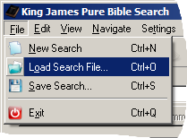



You can also use keyboard shortcuts of Ctrl-N for a New Search, Ctrl-O to Load a Search File, and Ctrl-S to Save a Search File.

Example Files
King James Pure Bible Search ships with some example .kjs files corresponding to all of the primary searches described in this document. These are stored in the “examples” folder in the location where you installed Pure Bible Search. Summarized here:

example01.kjs: “Christ”
example02.kjs: “the”
example03.kjs: “in Christ”
example04.kjs: “in Christ” and “church” within Entire Bible
example05.kjs: “in Christ” and “church” within Same Verse
example06.kjs: “in Christ”, “church”, and “baptiz*” within Entire Bible
example07.kjs: “in Christ”, “church”, and “baptiz*” within Same Verse
example08.kjs: “in Christ”, “church”, and “baptiz*” within Same Chapter
example09.kjs: “in Christ”, “church”, and “baptiz*” within Same Book
example10.kjs: “within me”
example11.kjs: “ba?e”
example12.kjs: “ba[dk]e”
example13.kjs: “Spirit”, case-sensitive with initial caps
example14.kjs: “spirit”, case-sensitive, all lower-case

The Toolbar

Pure Bible Search has a movable, dockable Toolbar widget that contains many common used functions. You can have it undocked and floating or you can dock it on any of the four sides of the main application window:



The first group of icons are from the File Menu and are “New Search”, “Load Search File”, and “Save Search File”, in the order that they are given.

The second group of icons are from the View Menu and are “History Backward”, “History Forward”, “Clear Navigation History”, and “Passage Navigator”, in the order that they are given.

The last icon is the “About…” icon from the Help menu. It tells you important things like the version of King James Pure Bible Search that you are running and helps you navigate to Visit Bethel Church:

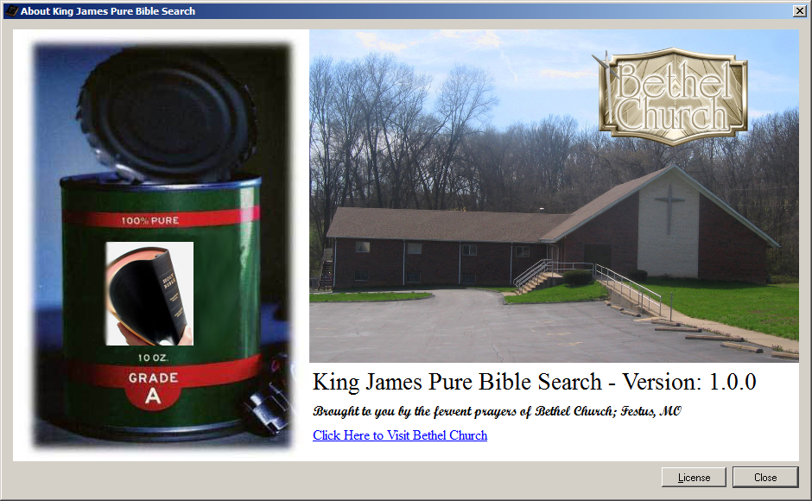

You can also hide or show the Toolbar by disabling/enabling it in the View Menu:
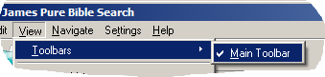

Special Shortcut Keys
The following list shows all of the available shortcut keys and their function based on the specified context(s), if it’s context sensitive:

Function | Shortcut Key | Context
New Search | Ctrl-N | Anywhere
Load Search File | Ctrl-O | Anywhere
Save Search File | Ctrl-S | Anywhere
Exit | Ctrl-Q | Anywhere
Cut | Ctrl-X | Search Phrase Editor with text selected
Copy | Ctrl-C | Search Phrase Editor with text selected
Paste | Ctrl-V | Search Phrase Editor
Delete | Del | Search Phrase Editor with text selected
Select All | Ctrl-A | Search Phrase Editor  Search Results List/Tree  Scripture Browser
New Search Phrase | Ctrl-P | Anywhere
View Details | Ctrl-D | Search Results List/Tree  Scripture Browser  Passage Navigator
Passage Navigator | Ctrl-G | Anywhere, but starting reference depends on active cursor focus location
Navigate to Beginning of Bible | Alt-Home | Anywhere
Navigate to Ending of Bible | Alt-End | Anywhere
Navigate Book Backward | Ctrl-PgUp | Anywhere
Navigate Book Forward | Ctrl-PgDn | Anywhere
Navigate Chapter Backward | Alt-PgUp | Anywhere
Navigate Chapter Forward | Alt-PgDn | Anywhere
Navigate History Backward | Alt-Left | Anywhere
Navigate History Forward | Alt-Right | Anywhere
Navigate History Home | Alt-Up | Anywhere
Navigate History Clear | Ctrl-Shift-Del | Anywhere
About Dialog | F1 | Anywhere
Help | Shift-F1 | Anywhere
Focus Search Phrase 1 | Ctrl-1 | Anywhere
Focus Search Phrase 2 | Ctrl-2 | Anywhere
Focus Search Phrase 3 | Ctrl-3 | Anywhere
Focus Search Phrase 4 | Ctrl-4 | Anywhere
Focus Search Phrase 5 | Ctrl-5 | Anywhere
Focus Search Phrase 6 | Ctrl-6 | Anywhere
Focus Search Phrase 7 | Ctrl-7 | Anywhere
Focus Search Phrase 8 | Ctrl-8 | Anywhere
Focus Search Results List | Ctrl-9 | Anywhere
Focus Scripture Browser | Ctrl-0 | Anywhere
Copy Verse Text | Ctrl-V | Search Results List/Tree with selection
Copy Raw Verse Text | Ctrl-T | Search Results List/Tree with selection or Scripture Browser with text selected
Copy Very Raw Verse Text | Ctrl-W | Search Results List/Tree with selection or Scripture Browser with text selected
Copy Reference(s) | Ctrl-R | Search Results List/Tree with selection or Scripture Browser with or without text selected
Copy Reference Details | Ctrl-L | Search Results List/Tree with selection
Copy Complete Verse Text and Reference Details | Ctrl-C | Search Results List/Tree with selection
Clear Selection | Esc | Search Results List/Tree with selection
Copy as Shown | Ctrl-C | Scripture Browser with text selected
Copy Passage Statistics | Ctrl-I | Scripture Browser with or without text selected
Copy Entire Passage Details | Ctrl-L | Scripture Browser with or without text selected
Zoom-In | Ctrl + MouseWheelUp | Scripture Browser
Zoom-Out | Ctrl + MouseWheelDn | ScriptureBrowser
File Menu | Alt-F | Anywhere
Edit Menu | Alt-E | Anywhere
View Menu | Alt-V | Anywhere
Navigate Menu | Alt-N | Anywhere
Settings Menu | Alt-T | Anywhere
Help Menu | Alt-H | Anywhere
Search Scope | Alt-S | Anywhere
Copy Search Phrase Summary to Clipboard | Alt-C | Anywhere
Close Search Phrase | Alt-W | Anywhere, will close a single search phrase or activate next close button if more than one search phrase
Navigate to Current Search Result | Enter or Double-Click | Search Results List/Tree with a verse as the current index
Word Offset/Count | Alt-W | Passage Navigator
Verse Offset/Count | Alt-V | Passage Navigator
Chapter Offset/Count | Alt-H | Passage Navigator
Book Offset/Count | Alt-B | Passage Navigator
Bible/Testament Index | Alt-E | Passage Navigator
Reset Offsets/Counts | Alt-R | Passage Navigator
Go to Computed Reference | Alt-G | Passage Navigator
Switch Absolute/Relative Modes | Alt-S | Passage Navigator
Resolves To Text Select | Alt-T | Passage Navigator
From Location Text Select | Alt-F | Passage Navigator
Reverse Direction | Alt-D | Passage Navigator
Apply Resolved to From Location | Alt-A | Passage Navigator
Cancel | Alt-C or Esc | Passage Navigator
Font Face Name | Alt-F | Font Dialog
Font Style | Alt-Y | Font Dialog
Font Size | Alt-S | Font Dialog
Font Strikeout | Alt-K | Font Dialog
Font Underline | Alt-U | Font Dialog
Font Writing System | Alt-I | Font Dialog
Find | Ctrl-F | Scripture Browser  Find Dialog
Find Next | F3 | Scripture Browser
Find Previous | Shift-F3 | Scripture Browser
Find Text | Alt-N | Find Dialog
Find Down | Alt-D | Find Dialog
Find Up | Alt-U | Find Dialog
Find Case Sensitive | Alt-S | Find Dialog
Find Whole Words | Alt-W | Find Dialog
Find using Regular Expression | Alt-X | Find Dialog
Find Close | Alt-C or Esc | Find Dialog

And of course Tab and Shift-Tab navigate from control element to control element, either forward or backward, respectively.

King James Pure Bible Search was designed to be used entirely from the keyboard or entirely from the mouse or any combination of the two.

How Pure Bible Search Performs Its Searches
If you’ve used other Bible Search programs, either commercial or free/open-source programs, you’ve probably discovered that the search method of King James Pure Bible Search is very very different.

Most Bible Search programs treat the text as a large blob of unknown text as if it were some arbitrary, even changing, document. They require you to type in some word or phrase, click ‘search’, and wait and wait as it attempts to search through the entire database to try and find that word or phrase, while trying to employ special matching algorithms to match similar things, because it knows you’ve probably typed the phrase wrong, since it itself doesn’t even know what’s in the text and what isn’t.

But in reality, the King James Bible text is neither unknown nor does it arbitrarily change. Therefore, Pure Bible Search makes use of this and treats it as a known list of words, indexed by their exact position and word forms.

For the character set, Pure Bible Search treats all letters, the hyphen, and the apostrophe, as unique characters composing a word. It also treats regular Arabic Numerals as unique characters too, but the King James doesn’t have any numbers written as numbers, they are all written as words. It’s the “Holy Word of God”, not the “Holy Numbers”.

Using this character set, all 12808 unique words (excluding case) were extracted. A concordance was created mapping each word to its exact position in the text. For example, using Genesis 1:1, we have the following unique words and index mappings:

and : 8
beginning : 3
created : 5
earth : 10
God : 4
heaven : 7
In : 1
the : 2, 6, 9

This is what is stored in the database, but minimized to combine words that appear with varying case, which minimizes the number of searches, as we can see if the words match as lowercase and if so, then compare their correct case if the user happens to be doing a case sensitive search.

As the database is loaded into memory, an inverse table is created mapping position back to individual words:

1: in
2: the
3: beginning
4: god
5: created
6: the
7: heaven
8: and
9: the
10: earth

All punctuation is completely discarded at this level.

When a word is typed in a Search Phrase, we simply find that word in the concordance and see what indexes it appears at in the text. In the above example, if the user types “the”, we would find that we have indexes 2, 6, and 9.

Using this list, it simply adds ‘1’ to those indexes, which in this example gives 3, 7, and 10, as that will be the position of the next word. It then looks in the inverse mapping and sees what words are at those positions. In this example: beginning, heaven, earth.

Once it has this list, it alphabetizes them and removes duplicates, and presents that in the drop list as your possible next words for the phrase you are typing. There is no guessing as to what comes next. By the time you’ve finished typing, you know if your word or phrase is found – instantly. It even automatically knows how many times it’s found, because the number of indexes that is found is the number of occurrences. It’s that easy.

When you have multiple phrases and have the Search Results restricted to a Search Scope, it simply looks for the intersection of results by converting these Normalized Indexes into Relative (Book, Chapter, Verse, Word) Indexes, masking off the numbers based on the Search Scope, and compares them to see if they are equal. If they are, it knows that they are found together in the same Search Scope.

For the actual text rendering, the database also contains the entire King James Bible text verse-by-verse in its full Rich Text format, complete with punctuation, red-letter markup tags, italics tags, paragraph pilcrow characters, etc. And that is the text that is rendered in the Scripture Browser and the Search Results Verse Preview mode.

To do all of the index conversion and calculation magic, the database contains complete Book, Chapter, Verse, and Word counts at all levels – Testament, Book, Chapter, and Verse. Using these, it can quickly calculate when given an arbitrary Word number (or a Normalized Index within the Bible) what the Relative Index or Book, Chapter, Verse, Word Reference is, and vice versa.

This special way of searching by word is unique to King James Pure Bible Search and is the very reason why this program was written when there are already so many Bible Search programs available.

Note that since apostrophe and hyphen are included as word characters, words that are possessive, for example “Jesus’” (with the apostrophe) is considered a different word than “Jesus” (without the apostrophe). This was done intentionally so that possessive forms of the word can be uniquely searched without it getting confused with other forms.

This means that if you want to search for either “Jesus” or “Jesus’”, where your search doesn’t distinguish between the two, you will need to use “Jesus*” instead. “Jesus” (no apostrophe) appears 973 times and “Jesus’” (with apostrophe) appears 10 times. “Jesus*” will match all 983 occurrences. Without doing it this way, we’d have no way to independently search the various forms of words.

Included with the application is a spreadsheet file (kjv_summary.xls), installed in the “doc” folder where King James Pure Bible Search is installed. This spreadsheet lists all 12808 unique words as defined by Pure Bible Search and includes a list of their alternate forms and shows the count by Book of where that word is found in the Bible.

If you sum the first column of counts, which is the occurrence counts within the Entire Bible, you will get the 789629 total words within the King James. And you can quickly sum the other columns to get the total number of words per Testament or per Book. There wasn’t a good way of showing Chapters or Verses in the spreadsheet. To get those counts, use Pure Bible Search to display them (by pressing Ctrl-D or selecting View Details from the menu).

In the development of King James Pure Bible Search, absolutely nothing is hardcoded or is unique to the King James text itself, even the names and number of Testaments isn’t hardcoded. This means that the program could be used to search and study any translation of the Bible (or other text for that matter) as long as a database is built for it. You could easily add the Apocrypha or the Book of Mormon or whatever.

You would, however, have to find the text and parse it and build your own database files to support it. No generic tools have been developed nor are they planned to be developed to facilitate generation of other database files.

Similarly, no provisions have been made nor are planned to be made to allow multiple or simultaneous database files to be open concurrently. The code only allows for a single database to be open.

However, other than to prove that these other texts are not divinely inspired, I have no idea why you’d want to waste time building a database for them. But this application is completely Open Source and you are free to request a copy of the source code and use it for any text you wish, as long as your development is within the constraints of the GNU General Public License version 3 as outlined elsewhere in this document.

KJV Statistics
Well over 90% of the statistics and information you will find online on the internet regarding the King James is just simply wrong. I had to do very diligent searches to find texts and statistics that were accurate. I don’t know if this is necessarily malicious or if it was that someone erred in their calculations and counting, posted it, and it simply got copied over and over by people who can cut-and-paste but who apparently can’t count.

In any case, do not trust the statistics you find online unless you verify it first! All text sources and counts in King James Pure Bible Search have been cross verified by at least two or three independent “witnesses” (or source documents) and validated and/or verified computationally using software word search and parsing techniques.

No one source was trusted for any of the King James Bible Text that you’ll find in this application. Therefore, to the best of my knowledge and ability, the text used by this application is 100% error free.

I have also made every reasonable attempt at verifying and debugging the computation and search algorithms used by King James Pure Bible Search. In order to make errors more easily detected, I’ve attempted to design the algorithms such that they will either work, and work correctly, or they will fail to work at all. However, being human, I’m sure bugs and quirks exist. Please report any error or discrepancy you may find.

For your quick reference, here’s a list of the 66 Books along with the number of Chapters, Verses, and Words within each, and totals for the Entire Bible. Note that some Books and/or Chapters, particularly Old Testament Books, have subtitles for the Book or Chapter that aren’t part of the text. While displayed by Pure Bible Search, they aren’t part of the verse text of the Bible, and therefore, they are not included in the statistics.

Similarly, many of Pauline Epistles have a subscription or footnote at the end of the book, often credited to Bishop Euthalius of the 5th Century. While Pure Bible Search displays them with the text, they aren’t verses or part of the text proper and therefore are not counted in the statistics.

Also, every 8th Verse of Psalm 119 begins with a Hebrew letter. These letters are in Hebrew and transliterated to the English equivalent of the letter for benefit of the English speaking reader. This comes from how every 8th verse of this Psalm starts with a different successive letter of the Hebrew alphabet in the original language. The King James preserves them, and so does Pure Bible Search, but they were letters within the original text, not unique words in their own right. Therefore, they are not counted in the statistics either.

I know what you are thinking. You are wondering if all of those statistics on the internet might be correct, only counting these extra things. Nope. Sorry. If that were true, their counts would be higher than mine. Not less than. And the vast majority were less than.

 | Book | Chapters | Verses | Words
1 | Genesis | 50 | 1533 | 38262
2 | Exodus | 40 | 1213 | 32685
3 | Leviticus | 27 | 859 | 24541
4 | Numbers | 36 | 1288 | 32896
5 | Deuteronomy | 34 | 959 | 28352
6 | Joshua | 24 | 658 | 18854
7 | Judges | 21 | 618 | 18966
8 | Ruth | 4 | 85 | 2574
9 | 1 Samuel | 31 | 810 | 25048
10 | 2 Samuel | 24 | 695 | 20600
11 | 1 Kings | 22 | 816 | 24513
12 | 2 Kings | 25 | 719 | 23517
13 | 1 Chronicles | 29 | 942 | 20365
14 | 2 Chronicles | 36 | 822 | 26069
15 | Ezra | 10 | 280 | 7440
16 | Nehemiah | 13 | 406 | 10480
17 | Esther | 10 | 167 | 5633
18 | Job | 42 | 1070 | 18098
19 | Psalms | 150 | 2461 | 42682
20 | Proverbs | 31 | 915 | 15038
21 | Ecclesiastes | 12 | 222 | 5579
22 | Song of Solomon | 8 | 117 | 2658
23 | Isaiah | 66 | 1292 | 37036
24 | Jeremiah | 52 | 1364 | 42654
25 | Lamentations | 5 | 154 | 3411
26 | Ezekiel | 48 | 1273 | 39401
27 | Daniel | 12 | 357 | 11602
28 | Hosea | 14 | 197 | 5174
29 | Joel | 3 | 73 | 2033
30 | Amos | 9 | 146 | 4216
31 | Obadiah | 1 | 21 | 669
32 | Jonah | 4 | 48 | 1320
33 | Micah | 7 | 105 | 3152
34 | Nahum | 3 | 47 | 1284
35 | Habakkuk | 3 | 56 | 1475
36 | Zephaniah | 3 | 53 | 1616
37 | Haggai | 2 | 38 | 1130
38 | Zechariah | 14 | 211 | 6443
39 | Malachi | 4 | 55 | 1781
39 | Old Testament | 929 | 23145 | 609247
40 | Matthew | 28 | 1071 | 23684
41 | Mark | 16 | 678 | 15166
42 | Luke | 24 | 1151 | 25939
43 | John | 21 | 879 | 19094
44 | Acts | 28 | 1007 | 24245
45 | Romans | 16 | 433 | 9422
46 | 1 Corinthians | 16 | 437 | 9462
47 | 2 Corinthians | 13 | 257 | 6065
48 | Galatians | 6 | 149 | 3084
49 | Ephesians | 6 | 155 | 3022
50 | Philippians | 4 | 104 | 2183
51 | Colossians | 4 | 95 | 1979
52 | 1 Thessalonians | 5 | 89 | 1837
53 | 2 Thessalonians | 3 | 47 | 1022
54 | 1 Timothy | 6 | 113 | 2244
55 | 2 Timothy | 4 | 83 | 1666
56 | Titus | 3 | 46 | 896
57 | Philemon | 1 | 25 | 430
58 | Hebrews | 13 | 303 | 6897
59 | James | 5 | 108 | 2304
60 | 1 Peter | 5 | 105 | 2476
61 | 2 Peter | 3 | 61 | 1553
62 | 1 John | 5 | 105 | 2517
63 | 2 John | 1 | 13 | 298
64 | 3 John | 1 | 14 | 294
65 | Jude | 1 | 25 | 608
66 | Revelation | 22 | 404 | 11995
27 | New Testament | 260 | 7957 | 180382
66 | Bible Totals | 1189 | 31102 | 789629

These statistics are identical for the 1611 King James and the 1769 King James, as the two texts are identical. See 1611 vs 1769 for details.

Many thanks to Nic Kizziah for providing his cross-verified statistics, which, when compared with the counts I had programmatically arrived at, matched completely. And many thanks for his insight on Counterfeit King James Bibles, of which I found even more numerous online than I have in printed form, of which he commented on.

Counterfeit King James Bibles
In my quest to seek out a concise and correct copy of the King James Bible to create the King James Pure Bible Search application, my journey crossed paths with a man by the name of Nic Kizziah, in Tuscaloosa, Alabama, USA.

At the time, I had several different copies of the King James Bible text I had downloaded online. The problem was they didn’t agree with each other. They were all supposed to be the original “King James” text, but after even very simple comparison on a computer, they were markedly different.

By a process of elimination, I finally narrowed my search down to the SWORD Project’s 1769 version and a plaintext version of the 1611 Authorized Version. They agreed with each other on counts. I will delineate the exact side-by-side differences between the 1611 text and the 1769 text in the next chapter, in case you’ve ever wondered.

But while my text sources finally agreed with each other, I wanted yet another independent witness to at least verify the statistical counts and confirm that the numbers I had were indeed correct. However, none of the websites I found that had detailed statistics on the word counts of the King James agreed with my numbers, nor the numbers of any of the other texts I had either. I was getting very frustrated, to say the least.

Then, God allowed my search to cross paths with Nic Kizziah. I had come across his numbers online from a website that turned out not to be his website, but a clone of an old copy his website that someone had copied.

I spoke with him on the phone and he explained how in their early days of researching the counts, they had attempted to do so via a computer program, but arrived at incorrect results, and didn’t realize it until after it was published. By then, many many people had copied the results to their own websites and thus erroneous counts spread.

He had a later article that he had published in September 2003 using the data generated by another computer programmed, David Dougherty, whom had fixed the errors of the previous attempt. He pointed me to that newsletter on his website at thebelieversorganization.org and lo and behold, they matched my numbers perfectly. I had my third independent witness who was able to confirm that the other two witnesses I had (the 1611 text and 1769 text that I had copies of) were indeed correct.

I’ve known that the other translations of the Bible are corruptions of God’s Word, but one thing I hadn’t considered was the possibility of purchasing a King James Bible from a “reputable” publisher and find it to be a corrupt counterfeit as well.

I know most of you using this application are King James Only Believers, as I am, and will be interested in reading Nic’s article on “Counterfeit King James Bibles”. So I’ve included it in its entirety (completely unedited). I don’t know Nic well enough to say I believe everything he does, but the parts I’m sharing seem to be true to scripture:

Believers Beware Of Counterfeit King James Bibles (by Nic Kizziah)
King James Bible believers are faced with an array of problems to day. Of course we all know that the multiplicity of all the new modern versions are a big problem but another big problem is the fact that many of the worldly publishing companies are publishing Bibles and calling them King James Bibles when in actuality they are not. They are counterfeits.
Because the King James Bible is in the publick domain and not copyrighted, these worldly publishing companies think they can make minor changes to the standard text so that they can please certain groups which translates into extra sales for them. That’s the way the modern world operates to day. All the common ordinary Bible believer wants is the same Bible that his grandmother had and the same Bible her grandmother had and the same Bible her grandmother had etc… that’s all.
Just give us the text that has established itself as the standard text of the Holy Bible, an old fashioned, Christ exalting, devil kicking, Authorized King James Bible. To the best of my understanding this is the 1769 edition of the 1611 King James Bible with a few minor printing errors and spellings corrected along the way in the1800’s.
Until the twenty-first century you could get a copy of it in any nickel and dime book store. To day you can still find it but you must proceed with caution. You will be hard pressed to find it at all in any typical Christian book store without some alterations to the text. The Bible of our forefathers which we received through process of time comes with three specific warning labels. One is near the front. The other is near the middle and the last one is at the very end. Let’s read them:
WARNING LABEL # 1…Deuteronomy 4:2
2 Ye shall not add unto the word which I command you, neither shall ye diminish ought from it, that ye may keep the commandments of the LORD your God which I command you.
WARNING LABEL # 2…Proverbs 30:5-6
5 Every word of God is pure: he is a shield unto them that put their trust in him.
6 Add thou not unto his words, lest he reprove thee, and thou be found a liar.
WARNING LABEL # 3…Revelation 22:18-19
18 For I testify unto every man that heareth the words of the prophecy of this book, If any man shall add unto these things, God shall add unto him the plagues that are written in this book:
19 And if any man shall take away from the words of the book of this prophecy, God shall take away his part out of the book of life, and out of the holy city, and from the things which are written in this book.
I would like to think these worldly publishing companies are just ignorant to the seriousness of what they are doing. However in some cases I’m sure that these deceptive maneuvers are being done with fore thought. In other words they are aware of the warning labels but choose to ignore them. They have hardened their hearts against the standard text of the Holy Bible.
Let me give you an example of what I’m talking about. It was approximately six months ago I purchased a King James Bible from a popular on line book store. It was a straight text (advertised as the standard text) meaning it had no notes, no references, no helps, and no maps. It was just what I wanted. Just give me the Bible and if I need help with a difficult passage I’ll ask the Holy Spirit for guidance and I’ll check other scriptures for references.
Don’t get me wrong. I’m not against some of the commentaries and other Bible study tools. In fact I consider some of them a necessity, for example a good dictionary. It’s just that commentaries, dictionaries, concordances and the like are the words of men and not the words of God. They are not infallible. Therefore I do not believe they should be mixed together under the same cover and be called the word of God. In actuality it is the word of God plus the words of a man or a group of men. In my opinion the Holy Bible should be the word of God only from cover to cover. That is why I prefer a straight text.
At any rate I had bought the Bible I thought I wanted. It had been published by Cambridge. They have always been the giant in the industry. In fact they are the oldest Printer and Publisher in the world. They are suppose to be the gold standard for dependability according to many King James Bible believers. This Bible had a nice black French Morocco leather cover with golden coloured gilt edges. It was very nice on the outside but when I started checking out the inside I was shocked. This particular edition of the Cambridge Bible that calls itself a King James Bible is not genuine. IT’S A COUNTERFEIT! It’s not the Bible of my forefathers!
Here are some of the changes I located: Asswaged has been changed to assuaged. Basons has been changed to basins. Chesnut has been changed to chestnut. Cloke has been changed to cloak. Enquire has been changed to inquire. Further has been changed to farther. Jubile has been changed to jubilee. Intreat has been changed to entreat. Morter has been changed to mortar. Ought has been changed to aught, and rereward has been changed to rearward.
Brother Nic, why get so upset? These are just minor changes in spelling. Well maybe they are, but have you never read “a little leaven leaveneth the whole lump?” You see I believe God wrote the Bible through sinful men. I believe God copied the Bible through sinful men. I believe God translated the Bible through sinful men, and I believe God edited (purified) the Bible through sinful men. So therefore I believe God gave us the exact words in the exact order He wanted us to have them in. If that’s the case then He spelled the words exactly the way He wanted to spell them, and gave them to us in a pure language, and that language is the standard text of the King James Bible. This is the Bible that has stood the test of time without any editing whatsoever and this is the Bible The Believers organization, with God’s help, intends to preserve for all future generations.
Beside all this, Cambridge has also taken the liberty of making doctrinal changes. Notice the following: The capital S in the word Spirit has been changed to a lower case s in numerous passages. The capital S refers to the Holy Spirit, the third member of the Godhead, whereas the lower case s in the word spirit could have multiple definitions such as simply referring to a mood or emotion. Its primary definition means to breath. All living self moving creatures have a spirit within them. So many definitions could apply to the word spirit when it is not capitalized.
To change the capital S in the word Spirit to a lower case s is an attack against the Godhead, the most powerful threefold cord in heaven and earth: the Father, the Son, and the Holy Spirit. Cambridge has made this critical error in the following places: Genesis 1:2, 41:38, Judges 3:10, 6:34, 11:29, 13:25, 14:6, 14:19, 15:14, 1 Samuel 10:6, 10:10, 11:6, 16:13, 16:14, 19:20, 19:23, 2 Samuel 23:2, 1 Kings 18:12, 22:24, 2 Kings 2:16, 2 Chronicles 15:1, 18:23, 20:14, 24:20, Job 33:4, Isaiah 40:13, 48:16, 61:1, 63:10, 11, 14, Ezekiel 11:5, 24. For hundreds of years Cambridge published these verses with a capital S, but now in the twenty-first century it has been changed. Actually this so called standard text edition first hit the market in 1993 and is being endorsed by many King James Bible believing websites to day. I assume that they are not aware that it has been modernized.
Here is another change that has been made in this particular edition: the word twoedged has become two-edged. They added a hyphen. This word is only in the King James Bible four times (Psalms 149:6, Proverbs 5:4, Hebrews 4:12, and Revelation 1:16.) Now check this out: they added the hyphen in only three of the four verses. They left it without a hyphen in Hebrews 4:12. Why? Was this a mistake or did they mean to do it that way? Why tamper with it in the first place? Don’t say you were trying to help us Cambridge. If that’s the case then please don’t try to help us any more. All we want you to do is to publish the same standard text of the King James Bible as you have done so very well for hundreds of years. Don’t publish something that is not the standard and call it the standard. Once you modernize spelling, change capital letters to lower case letters and add hyphens, you are changing the standard text in order to please modern society.
Here are some other ploys that some of these other worldly publishing companies are pulling on an unaware publick. One thing a lot of them do is change the spelling of words that end with the letters o-u-r to the more modern American spelling of o-r. For example armour becomes armor. Behaviour becomes behavior. Clamour becomes clamor. Colour becomes color. Endeavour becomes endeavor. Favour becomes favor. Honour becomes honor. Labour becomes labor. Neighbour becomes neighbor. Odour becomes odor. Rigour becomes rigor. Rumour becomes rumor. Valour becomes valor and vapour becomes vapor. Well Brother Nic what’s wrong with that? Remember what we said about the warning labels? Remember what the scripture said about a little leaven leaventh the whole lump?
Now the very worst of this battle of o-u-r vs. o-r comes when dealing with the only begotten Son of God, our Lord and Saviour Jesus Christ. The modern day counterfeiters have changed Saviour to Savior. They have given us a six-letter Savior in place of a seven letter Saviour. In Bible numerics seven is the number of completeness, purity, and spiritual perfection. On the other hand six is the number of man which is earthly not heavenly. Every one has heard of 666. It has a bad connotation and is not highly esteemed in Bible numerics.
The seven-letter Saviour is the only begotten Son of God, the Lord Jesus Christ. The six letter Savior is the son of perdition, the antichrist. He wants to be like the most High (Isaiah 14:14,) but not in a good way, but in an evil way. He is not a follower. He’s a counterfeiter. Therefore his final destination is the lake of fire. The new versions, along with the new age movement, and some of the King James Bible counterfeits are preparing the way for this six-letter so called Savior. That’s the way he will spell his name, S-a-v-i-o-r not S-a-v-i-o-u-r. No thank you Satan. I’m sticking with the seven-letter Saviour as portrayed in the old black Book that I inherited from my forefathers.
There are many other things going on by the worldly publishing companies. All most all of them have hardened their hearts against the standard text of the Holy Bible. They do not believe God actually had His hand upon it much less wrote it. They treat it as a product of men. That is why they do not hesitate to publish all the different new versions. Nor do they hesitate to change the old King James and still call it the King James. If a person can’t see the fingerprints of God upon this Book then he is either clouded in the cabassis or he is as lost as a duck in the desert with his head in the sand!
The rules of English grammar may change but the King James Bible is fixed in a moment of time (the 1800’s, the 1900’s and for ever more) and is unchangeable. This is the standard text and there is no other. This is the Book that spread the gospel of Jesus Christ all over the world. This is the Book my grandmother had and her grandmother had and her grandmother had without any alterations (editing) whatsoever. It is basically the same Book that rolled off the printing press in 1611. The only differences being it was changed from Gothic type to Roman type, printer’s errors were corrected and spelling was stabilized. The King James Bible is a very old Book.
Now consider this: the scriptures have been translated in whole or in part into over 1,200 languages. Of all these many were translated straight from the Elizabethan English of the King James Bible. Not from the Hebrew, Aramaic, and Greek. Not from the Latin, not from the German, but straight from the Authorized King James. Now some of these people have learned English as a second language. They are not familiar with these modern Americanized spellings nor are most of the other English speaking people of the world. Can you see what God has woven together through process of time? The Holy Bible is from above and is a finished book from God. It is written in a pure language. Furthermore this language is very peculiar and has been used and still is being used in a very unique way. Let’s preserve it as we received it and quit trying to change it!

Quick Check List When Buying a King James Bible (by Nic Kizziah)

Scripture Reference | The Real Bible | Counterfeit
GENESIS 1:1 | heaven | heavens
GENESIS 1:2 | Capital S (Spirit) | lower case s (spirit)
GENESIS 8:1 | asswaged | assuaged
GENESIS 11:3 | throughly | thoroughly
GENESIS 11:3 | morter | mortar
GENESIS 12:1 | shew | show
GENESIS 21:26 | to day | today
GENESIS 23:8 | intreat | entreat
GENESIS 24:57 | enquire | inquire
GENESIS 30:37 | chesnut | chestnut
GENESIS 31:42 | labour | labor
GENESIS 41:38 | Capital S (Spirit) | lower case s (spirit)
EXODUS 8:23 | to morrow | tomorrow
EXODUS 24:6 | basons | basins
EXODUS 25:30 | shewbread | showbread
EXODUS 25:30 | alway | always
LEVITICUS 25:9 | jubile | jubilee
NUMBERS 10:25 | rereward | rearward
NUMBERS 22:26 | further | farther
1 SAMUEL 18:6 | musick | music
PSALMS 149:6 | twoedged | two-edged
ISAIAH 59:17 | cloke | cloak
MATTHEW 1:19 | publick | public
MATTHEW 4:1 | Capital S (Spirit) | lower case s (spirit)
LUKE 2:11 | Saviour | Savior
PHILIPPIANS 3:17 | ensample | example
1 TIMOTHY 6:20 | so called | so-called
JAMES 4:14 | vapour | vapor

This is just a very short list of the changes being made by some of the worldly publishing companies. If you find one counterfeit word then that is a pretty good indication there are many more. Don’t buy that Bible, check elsewhere.

(King James Pure Bible Search uses the 1769 King James Red-Letter edition as available from the SWORD Project – validated by three witnesses to be correct.)

1611 vs. 1769 King James
Until I worked on this project, I had no idea how similar or different the 1769 King James text was compared to that of the 1611 King James. Like many of you, I had heard people say everything from “there are no changes at all”, to “it was a complete rewrite”.

In the process of verifying and authenticating the source text for this application, I did a side-by-side comparison of the 1611 with the 1769, and am happy to report there are essentially no differences.

The biggest difference was words that are no longer written with an apostrophe because they are self-possessive: our’s vs ours (12 occurrences), their’s vs theirs (21 occurrences), and your’s vs yours (12 occurrences). Since all occurrences of these words were changed and not just a single word or two here or there, you can get these lists by searching for: “ours”, “theirs”, and “yours”. The results you get are the locations that changed.

Other than the three words above, here’s a complete listing of all differences. The numbers are the Word Indexes in case you wish to look them up. If you don’t know how to look them up, go back and study the section on the Passage Navigator. Or in short: Press Ctrl-G to display the Passage Navigator, in the Absolute Mode press Alt-R to reset the navigator, enter the number given below for the Word value, and click “Goto”:

1611 Word | 1769 Word | Word Indexes
Haphraim | Hapharaim | 170704
Gesham | Geshan | 292181
Achsa | Achsah | 292219
Shemidah | Shemida | 295983
flotes | floats | 312262
sope | soap | 2 times: 483000, 608571
ankles | ankles | 565653
instructors | instructers | 728648
LORD'S | Lord's | 384577
LORD | Lord | 75 times: 379230, 379540, 379780, 379939, 380266, 380436, 381150, 381277, 381430, 381679, 381988, 382300, 383486, 383637, 384456, 384754, 385096, 385110, 385277, 385289, 385622, 385820, 385827, 386001, 386230, 387320, 387667, 389153, 389788, 390191, 391961, 392529, 398156, 403152, 403372, 403584, 404005, 404308, 405797, 407111, 407440, 407530, 407697, 408150, 411908, 413719, 414130, 414245, 414467, 414583, 414936, 415608, 415708, 416025, 416135, 416342, 416550, 416670, 416775, 416869, 416882, 416984, 417207, 417313, 417373, 417722, 417728, 417738, 418782, 419194, 419430, 419637, 419646, 419788, 420039

KJV Fun Facts
- The book of Revelation, if you include the 5 words of its proper title (“The Revelation of Jesus Christ”), has exactly 12000 words
- Books in Bible: 66 (22 x 3)
- Books in Old Testament: 39 (13 x 3)
- Books in New Testament: 27 (9 x 3)
- Total Chapters: 1189
- Old Testament Chapters: 929
- New Testament Chapters: 260
- Total Verses: 31102
- Old Testament Verses: 23145
- New Testament Verses: 7957
- Total Words: 789629
- Old Testament Words: 609247
- New Testament Words: 180382
- Longest Chapter of the Bible: Psalm 119
- Shortest Chapter of the Bible: Psalm 117
- Center Chapter of the Bible: Psalm 117 (Chapter 595 in the Bible)
- Center Verses of the Bible (when dividing by verse count): Psalm 103:1-2
- Psalm 103:1, the Left-Center Verse is the 1611th verse of Psalms.
- There are no Arabic Numerals in the King James Bible. All numbers are written out as words. It’s the “Holy Word of God”, not the “Holy Numbers”.
- Most Alike Chapters: 2 Kings 19 and Isaiah 37 – Compare them side-by-side, they are nearly identical
- Shortest Verse: John 11:35
- Longest Verse: Esther 8:9
- The Garden Verse: Numbers 11:5
- The word “the” doesn’t appear in Psalm 70 at all, but appears in every other Chapter of the Bible
- The word “Christ” appears in every New Testament Book except for “3 John”
- “Christ” appears 555 times
- “in Christ” appears 77 times
- “church” appears 77 times
- “baptiz*” (words beginning with “baptiz”) appears 77 times
- “spirit” (all lowercase) appears 333 times
- Son (initial caps) appears 297 times (33 x 9)
- “mystery” appears 22 times
- Longest word: “Maher-shalal-hash-baz” in Isaiah 8:1
- “Jesus Christ” appears 196 times (49 x 4)
- “Son of man” appears 196 times (49 x 4)
- “Word of God” appears 49 times (7 x 7)
- “Most High” appears 49 times (7 x 7)
- Daniel, the 27th book of the Old Testament is “sealed”. Revelation, the 27th book of the New Testament is “unsealed”.
- Revelation 13:18 says “Here is wisdom. Let him that hath understanding count the number of the beast: for it is the number of a man; and his number is Six hundred threescore and six.” Chapter 666 of the Bible is Ecclesiastes 7. And Ecclesiastes 7:27 says “Behold, this have I found, saith the preacher, counting one by one, to find out the account:”

Useful Links

Bible Resources
- Bethel Church: http://visitbethelchurch.com/
- King James Pure Bible Search Download: http://www.dewtronics.com/KingJamesPureBibleSearch/
- The Believers Organization: http://www.thebelieversorganization.org/
- AV1611, Fighting Back: http://www.av1611.org/kjv/fight.html
- Printable KJV Bible in Text and Word Formats: http://printkjv.ifbweb.com/
- Kings James Bible Online: http://www.kingjamesbibleonline.org/
- Authorized Version Publications: http://www.avpublications.com/
- AV King James Bible Directory (U.K.): http://www.avkingjamesbible.org/
- Biblical Chronology: http://www.nwcreation.net/biblechrono.html

Note: Apart from my personal website at www.dewtronics.com, I cannot personally attest to the validity or Scriptural Correctness of any of the websites listed, since I didn’t create them nor have I read every page and document on them. I do believe the doctrine and teachings of Pastor Mike Hoggard at Bethel Church to be sound and true, based on the volume of material I’ve heard presented and verified from Scripture. The other links were found interesting and are presented for reference only. In all cases, verify all things that you read and study with the King James Bible and through prayer for guidance from the Holy Ghost.

Programming Resources
- Qt Project (the API Library used to develop Pure Bible Search):
http://qt-project.org/
- Minimalist GNU for Windows (the C++ Compiler used on Windows to develop Pure Bible Search): http://www.mingw.org/
- InnoSetup (the Installer Package used by Pure Bible Search on Windows): http://www.jrsoftware.org/isinfo.php
- Cygwin tools (Tools used for Pure Bible Search development and text analysis): http://www.cygwin.com/
- Ubuntu Linux (Linux Development Platform used by Pure Bible Search): http://www.ubuntu.com/
- C++ Language Reference: http://www.cplusplus.com/reference/
- The SWORD Project: http://www.crosswire.org/sword/index.jsp

Planned Future Enhancements

- Porting to all major Operating Systems
- Porting to portable devices
- User Search Phrase Database Editor Dialog
- Scripture Browser History View
- User Study Notes Database
- Additional Search Scope Options
- Additional Views for Search Phrase Matched Words
- Graphical View of Search Results Distribution
- Additional Book/Chapter Footnotes
- More User-Settable Visibility Options
- Drag-and-Drop Support for Search Results View
- Scripture Browser Extended Selection Text Export
- Special-Word Analysis Support (words whose meaning is significantly different depending on capitalization of the word)
- Additional Search Phrases and Examples
- More King James Fun Facts

