Student __________Deniss Belovs 4801BD____________

***REPORT***

***Laboratory Work N6***

1. ***Results of the multiple regression model construction***

***Regression model equation:***

=

***Quality parameters:***

|  |  |  |  |  |  |
| --- | --- | --- | --- | --- | --- |
| ***R2*** | ***Adj. R2*** | ***RSS*** | ***ESS*** | ***F*** | ***p-level*** |
| ***0.9557*** | ***0.9482*** | ***340.1*** | ***7677.298*** | ***126.7*** | ***2.2e-16*** |

*Make a conclusion about the quality of the model:*

***Analysis of the significance of the coefficients of the model***

|  |  |  |  |  |
| --- | --- | --- | --- | --- |
| **Variable Name** | **Coefficient value** | **Std. Error of Coefficient** | **t** | **p-level** |
| X1 | -2.05992 | 1.86753 | -2.385 | 0.0849 |
| X2 | 0.12046 | 1.17020 | -1.760 | 0.7222 |
| X3 | 0.39964 | 0.33678 | 0.358 | 5.48e-05 |
| X4 | 0.29855 | 0.09008 | 4.437 | 0.0231 |
| X5 | 0.09134 | 0.18276 | 0.500 | 0.6195 |
| X6 | 4.87669 | 0.97050 | 5.025 | 7.73e-06 |
| X7 | 1.30829 | 1.11078 | 1.178 | 0.2448 |
| X8 | -0.13648 | 0.07211 | -1.893 | 0.0646 |

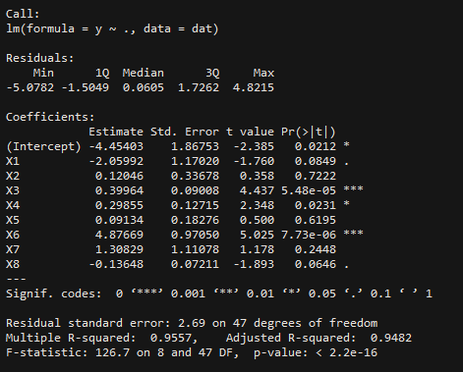

*Make a conclusion about the significance of the coefficients:*

***The Gauss-Markov requirements for residues***

*Scatterplot for residuals:*

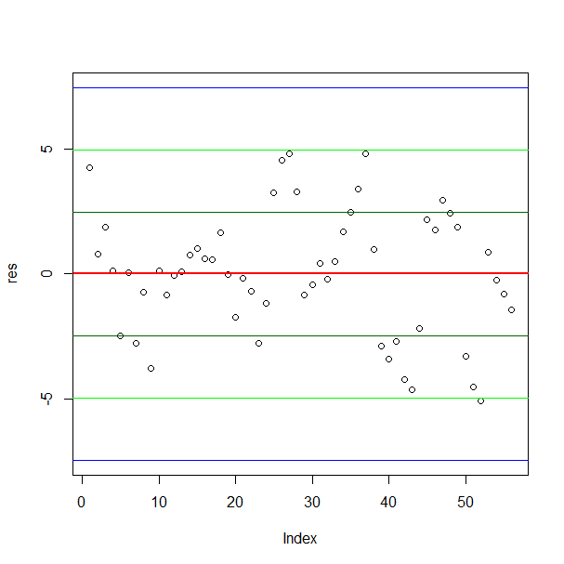

*Make a conclusion:*

1. ***Exclusion of outliers***

|  |  |  |  |  |  |
| --- | --- | --- | --- | --- | --- |
| ***Number of excluded observations*** | ***Adj. R2*** | ***SEE*** | ***F*** | ***p-level*** | ***Insignificant variables in the model*** |
|  |  |  |  |  |  |
|  |  |  |  |  |  |
|  |  |  |  |  |  |

*The equation of the final model after excluding all outliers:*

1. ***Exclusion of insignificant variables from the model***

|  |  |  |  |  |  |
| --- | --- | --- | --- | --- | --- |
| ***Excluded variable*** | ***Adj. R2*** | ***SEE*** | ***F*** | ***p-level*** | ***List of the significant variables*** |
|  |  |  |  |  |  |
|  |  |  |  |  |  |
|  |  |  |  |  |  |

*The equation of the final model after excluding all insignificant variables:*

1. ***Nonlinear models***

|  |  |  |  |  |  |  |
| --- | --- | --- | --- | --- | --- | --- |
| ***Model*** | ***R2*** | ***Adj. R2*** | ***RSS*** | ***ESS*** | ***F*** | ***p-level*** |
| ***Quadratic*** |  |  |  |  |  |  |
| ***Log*** |  |  |  |  |  |  |

1. ***Results of the multiple regression model construction using Forward Stepwise method.***
2. ***Results of the multiple regression model construction using Backward Stepwise method.***
3. ***Comparison of models obtained in the previous stages.***

|  |  |  |  |  |  |  |
| --- | --- | --- | --- | --- | --- | --- |
| ***Model*** | ***R2*** | ***Adj. R2*** | ***RSS*** | ***ESS*** | ***F*** | ***p-level*** |
|  |  |  |  |  |  |  |
|  |  |  |  |  |  |  |
|  |  |  |  |  |  |  |