Student Deniss Belovs 4801BD

***REPORT***

***Laboratory Work N6***

1. ***Results of the multiple regression model construction***

***Regression model equation:***

**= $-4.45403 + -2.05992*x_{1}+0.12046*x_{2}+0.39964*x_{3}+0.29855*x_{4}+0.09134*x_{5}+4.87669*x_{6}+1.30829*x_{7}+\left(-0.13648\right)*x_{8}+2.69$**

***Quality parameters:***

|  |  |  |  |  |  |
| --- | --- | --- | --- | --- | --- |
| ***R2*** | ***Adj. R2*** | ***RSS*** | ***ESS*** | ***F*** | ***p-level*** |
| ***0.9557*** | ***0.9482*** | ***340.1*** | ***7677.298*** | ***126.7*** | ***2.2e-16*** |

*Make a conclusion about the quality of the model:*

***Качество модели изначально достаточно высокое, если судить по значению p-level и Adjusted R squared.***

***Analysis of the significance of the coefficients of the model***

|  |  |  |  |  |
| --- | --- | --- | --- | --- |
| **Variable Name** | **Coefficient value** | **Std. Error of Coefficient** | **t** | **p-level** |
| ***X1*** | ***-2.05992*** | ***1.86753*** | ***-2.385*** | ***0.0849*** |
| ***X2*** | ***0.12046*** | ***1.17020*** | ***-1.760*** | ***0.7222*** |
| ***X3*** | ***0.39964*** | ***0.33678*** | ***0.358*** | ***5.48e-05*** |
| ***X4*** | ***0.29855*** | ***0.09008*** | ***4.437*** | ***0.0231*** |
| ***X5*** | ***0.09134*** | ***0.18276*** | ***0.500*** | ***0.6195*** |
| ***X6*** | ***4.87669*** | ***0.97050*** | ***5.025*** | ***7.73e-06*** |
| ***X7*** | ***1.30829*** | ***1.11078*** | ***1.178*** | ***0.2448*** |
| ***X8*** | ***-0.13648*** | ***0.07211*** | ***-1.893*** | ***0.0646*** |

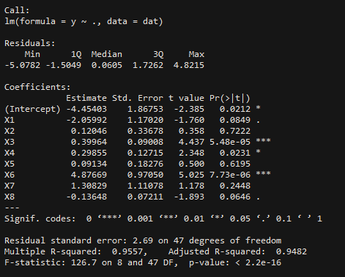

*Make a conclusion about the significance of the coefficients:*

***ОПГ (-1.67; 1.67)***

***Только значения X2, X5, X7 попали в ОПГ, следовательно в их случае мы НЕ отвергаем гипотезу о том, что все коэффициенты равны 0. Для всех остальных коэффициентов (X1, X3, X4, X6, X8) мы отвергаем нулевую гипотезу.***

***The Gauss-Markov requirements for residues***

|  |  |  |
| --- | --- | --- |
| *The Gauss-Markov conditions check* | | |
| *The Gauss-Markov conditions* | *TRUE* | *FALSE* |
| *The means is zero:* |  |  |
| *The variance is constant:* |  |  |

*Scatterplot for residuals:*

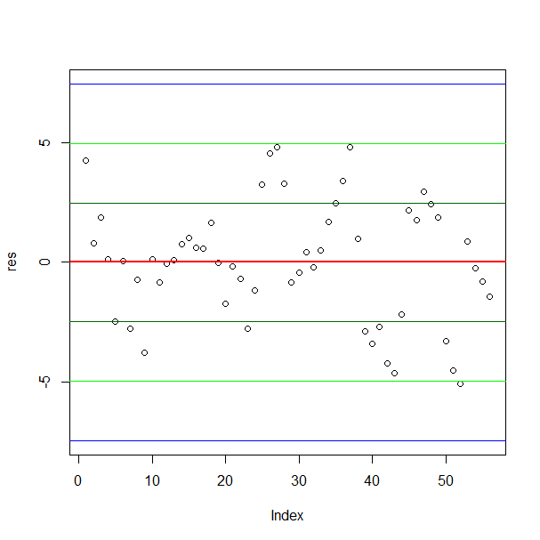

*Make a conclusion:*

***Среднее значений остатков близко к 0, дисперсия остатков НЕ является константной, так как имеются выбросы (значения выходящие за пределы двух стандартных отклонений от среднего)***

1. ***Exclusion of outliers***

|  |  |  |  |  |  |
| --- | --- | --- | --- | --- | --- |
| ***Number of excluded observations*** | ***Adj. R2*** | ***SEE*** | ***F*** | ***p-level*** | ***Insignificant variables in the model*** |
| ***1*** | ***0.9529*** | ***2.575*** | ***137.4*** | ***2.2e-16*** | ***X1, X2, X5, X7, X8*** |
| ***3*** | ***0.9661*** | ***2.242*** | ***182.7*** | ***2.2e-16*** | ***X2, X5, X7, X8*** |
| ***2*** | ***0.9703*** | ***2.075*** | ***201*** | ***2.2e-16*** | ***X5, X7, X8*** |
| ***1*** | ***0.9726*** | ***1.995*** | ***213.8*** | ***2.2e-16*** | ***X5, X7, X8*** |
| ***1*** | ***0.975*** | ***1.918*** | ***230.4*** | ***2.2e-16*** | ***X2, X5, X7, X8*** |

*The equation of the final model after excluding all outliers:*

***= $-3.7245 +(-2.66224)*x_{1}+0.38828*x_{2}+0.40041*x_{3}+0.33795*x_{4}+0.08579*x_{5}+3.46440*x_{6}+(-0.96791)*x_{7}+0.05406*x_{8}+1.918$***

1. ***Exclusion of insignificant variables from the model***

|  |  |  |  |  |  |
| --- | --- | --- | --- | --- | --- |
| ***Excluded variable*** | ***Adj. R2*** | ***SEE*** | ***F*** | ***p-level*** | ***List of the significant variables*** |
| ***X2*** | ***0.9743*** | ***1.947*** | ***255.3*** | ***2.2e-16*** | ***X1, X3, X4, X6*** |
| ***X5*** | ***0.9746*** | ***1.933*** | ***301.8*** | ***2.2e-16*** | ***X1, X3, X4, X6*** |
| ***X7*** | ***0.9745*** | ***1.94*** | ***359.6*** | ***2.2e-16*** | ***X1, X3, X4, X6*** |
| ***X8*** | ***0.975*** | ***1.92*** | ***458.9*** | ***2.2e-16*** | ***X1, X3, X4, X6*** |

*The equation of the final model after excluding all insignificant variables:*

***= $-3.05676 +(-2.87826)*x_{1}+0.43059*x_{3}+0.31422*x_{4}+3.48424*x_{6}+1.92$***

1. ***Nonlinear models***

|  |  |  |  |  |  |  |
| --- | --- | --- | --- | --- | --- | --- |
| ***Model*** | ***R2*** | ***Adj. R2*** | ***RSS*** | ***ESS*** | ***F*** | ***p-level*** |
| ***Quadratic*** | ***0.938*** | ***0.9352*** | ***429.4*** | ***6493.594*** | ***340.3*** | ***2.2e-16*** |
| ***Log*** | ***0.5833*** | ***0.5742*** | ***2884.9*** | ***4038.1*** | ***64.39*** | ***2.725e-10*** |

1. ***Results of the multiple regression model construction using Forward Stepwise method.***

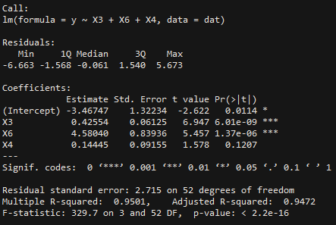

1. ***Results of the multiple regression model construction using Backward Stepwise method.***

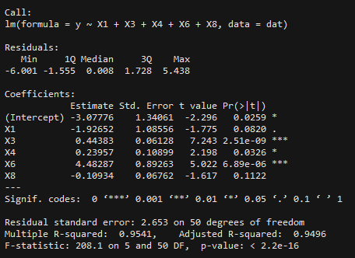

1. ***Comparison of models obtained in the previous stages.***

|  |  |  |  |  |  |  |
| --- | --- | --- | --- | --- | --- | --- |
| ***Model*** | ***R2*** | ***Adj. R2*** | ***RSS*** | ***ESS*** | ***F*** | ***p-level*** |
| ***Multiple regression*** | ***0.9557*** | ***0.9482*** | ***340.1*** | ***7677.298*** | ***126.7*** | ***2.2e-16*** |
| ***Exclusion of outliers*** | ***0.9793*** | ***0.975*** | ***143.4*** | ***6779.542*** | ***230.4*** | ***2.2e-16*** |
| ***Exclusion of insignificant variables*** | ***0.9771*** | ***0.975*** | ***158.5*** | ***6779.51*** | ***458.9*** | ***2.2e-16*** |
| ***Quadratic*** | ***0.938*** | ***0.9352*** | ***429.4*** | ***6493.594*** | ***340.3*** | ***2.2e-16*** |
| ***Log*** | ***0.5833*** | ***0.5742*** | ***2884.9*** | ***4038.1*** | ***64.39*** | ***2.725e-10*** |
| ***Forward Stepwise method*** | ***0.9501*** | ***0.9472*** | ***340.1*** | ***7293.867*** | ***329.7*** | ***2.2e-16*** |
| ***Backward Stepwise method*** | ***0.9541*** | ***0.9496*** | ***352*** | ***7325.294*** | ***208.1*** | ***2.2e-16*** |