Deniss Belovs 4801BD

Running **SLAVE** process **without arguments**: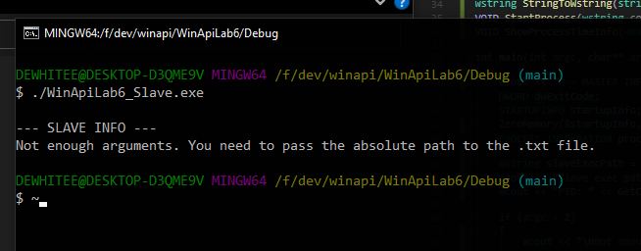

Running **SLAVE** process **with absolute path** to file provided: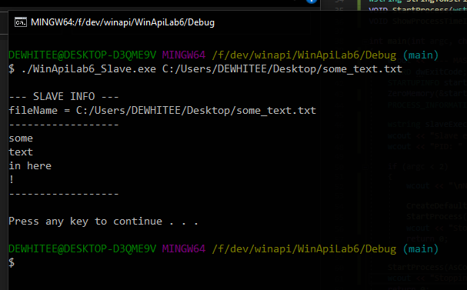

Running **MASTER** process from Visual Studio Local Windows Debugger**. Using default parameters:**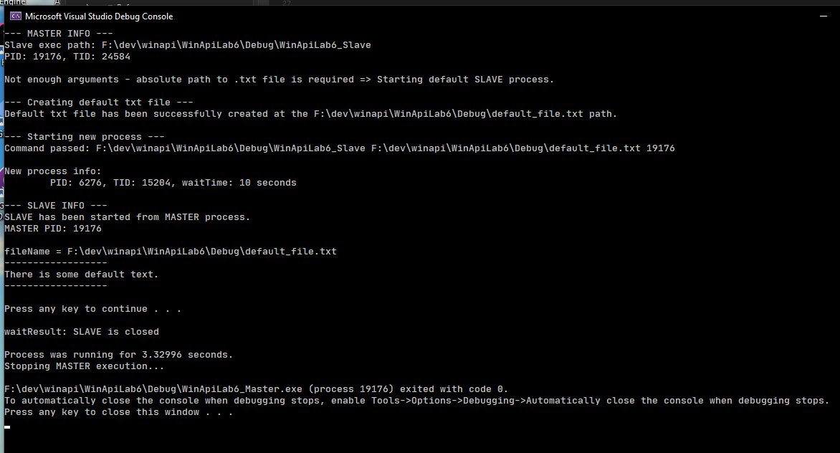

Running **MASTER** process from bash **using default parameters:**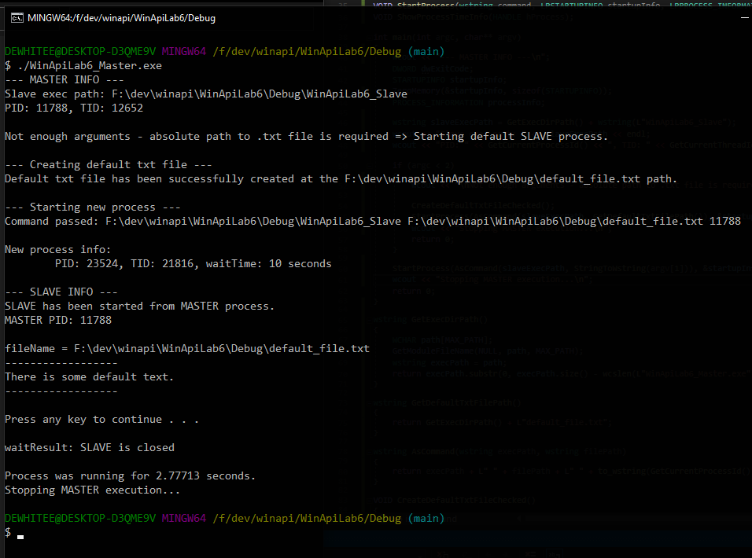

Running **MASTER** process passing the path to **some_text.txt** file on the desktop: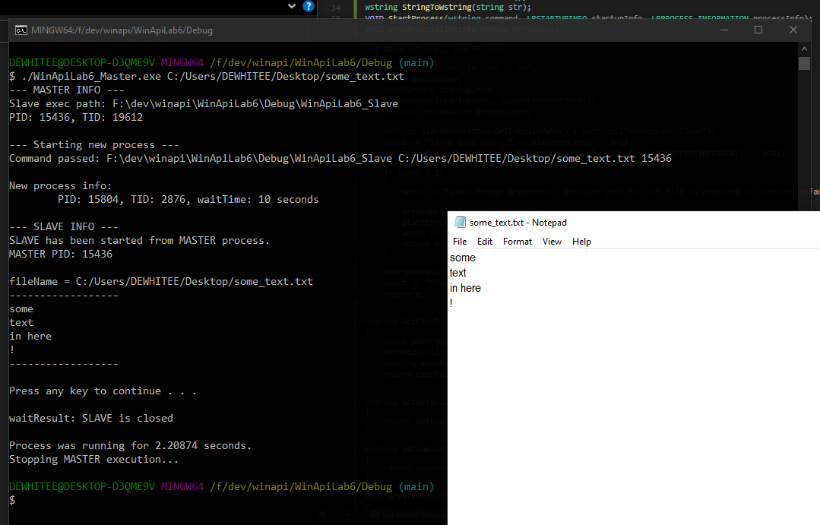

Running **MASTER** process passing the path to **some_text.txt** file on the desktop. **Waiting until TIMEOUT:**