PERSONAL LOAN DEFAULT
CAPSTONE – General Assembly – DAB05 (11 June 2025)
Prepared by Dewiana W

Introduction:
Singapore Ministry of Law reported a significant figure of 24% increase of individual bankruptcy cases in 2024.
No figure of total amount of Personal Loan debt as the impact reported.
However, American personal loan debt 2024 reach a huge figure of USD251billion.
An initial model has been built to help the bank minimize the risk of loss due to loan default.
Problem Statement:
Can bank identify the possibility of default at the point of customer on boarding?
Current Situation:
Several customers have default after settling the installment within 30-40% into the loan tenor.
In worse case these customers declare bankruptcy.
No model used to check the default possibility before onboarding.

Measured Success:

Bank officer can use the model by entering customer data/information and run the model. Model returns the Loan Default possibility.
Reduce default loan, increase full settled loan.

Objectives:
What : Onboard customer with minimum default risk
Why : Reduce the bank risk of loss
Who : Bank-Loan Department (offering Personal Loan).

Data Source:
https://www.kaggle.com/datasets/nikhil1e9/loan-default
Dataset contains of 255347 rows and 18 columns.

Data Limitation:
No date features (of Loan Disbursement and Loan Default Date).
This information are necessary for the bank to monitor the loss of each Default case.
No information whether the co signer may also a joint borrower.
Assume: Co Signer is not a joint borrower.
Any joint borrower features should be included in the same process as the main borrower. His feature may give impact to the end result.

Technical steps:
PYTHON NOTEBOOK
- CLEANING
- Check for duplicate ( result : none)

# Check for duplicate rows
duplicates = df[df.duplicated()]
print(duplicates)

- Check for NULL ( result : none)

# Check for NULLs in each column
print(df.isnull().sum())

# Check for NULLs in rows
null_rows = df[df.isnull().any(axis=1)]
print(null_rows)

- DROP FEATURE

Column ‘HasCoSigner’ chose to be dropped as assumed that CoSigner is not a main borrower whom creditworthiness considered. He is not the payer of the loan installment.

df = df.drop(columns=['HasCoSigner'])
df

- CONVERT DATA TYPE OF ‘DEFAULT’

Column ‘Default’ converted from Numeric to Boolean for logical check on the target result df [Default] and machine learning compatibility.

df_train['Default'] = df_train['Default'].astype(bool)

- CHECK THE DATA TYPE

df_train.dtypes

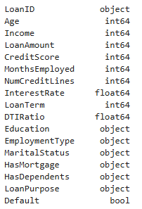
df_train

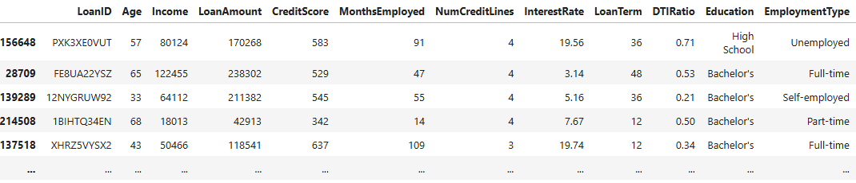
191510 rows × 17 columns

df_test
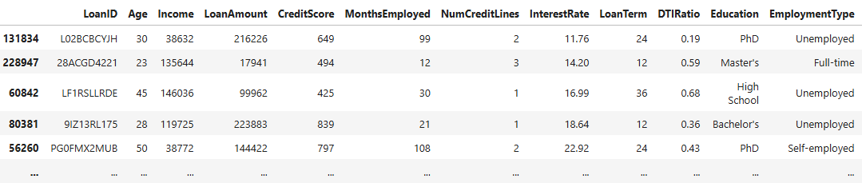

63837 rows × 17 columns

- DATA DICTIONARY

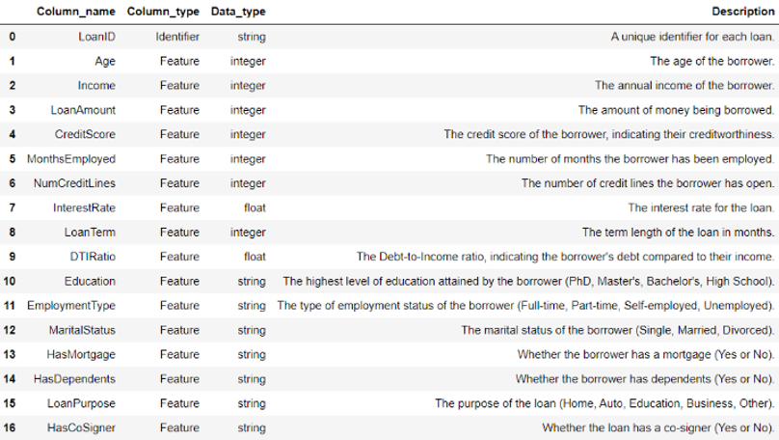
17 Default Target Boolean The target indicating possibility loan default (1)
or not (0)

- TECHNICAL ANALYSIS

- SPLIT DATASET INTO DATA TRAIN AND DATA TEST

The splitting of dataset into data_train and data_test .
Train the machine learning model using data_train.
Testing the model using the data_test.
Evaluate the model performance (preserve the distribution of the target variable (Default) using stratified sampling.

df_train, df_test = train_test_split(df, stratify=df['Default'], random_state=42)

DATA TRAIN (df_train)
- Describe the numeric features visually using histograms (to show frequency distribution) and boxplots ( to show spread, median, quartiles and outliers).

def numeric_describe(df):
fig, axes = plt.subplots(1, 2, figsize=(13, 4), gridspec_kw={'width_ratios':[3, 1], 'wspace':0.2})
df.plot.hist(ax=axes[0])
df.plot.box(ax=axes[1])
plt.show()

- Describe the non-numeric features visually using histograms (to show frequency distribution) and boxplots ( to show spread, median, quartiles and outliers ).

def non_numeric_describe(df):
df1 = df.value_counts(dropna=False).reset_index()
df2 = round(df.value_counts(normalize=True, dropna=False).reset_index()*100,2)
df2 = df2.drop(df2.columns[0], axis=1)
df3 = pd.concat([df1,df2], axis=1)

if is_numeric_dtype(df3.iloc[:,0]):
df3.iloc[:,0] = df3.iloc[:,0].round(0).astype('Int64').astype(str)

fig = plt.figure(figsize=(13, 4))
gs = GridSpec(1, 2, width_ratios=[1, 1])

ax1 = fig.add_subplot(gs[0])
ax1.axis('off')
table = ax1.table(cellText=df3.values, colLabels=df3.columns, loc='center', cellLoc='center')
table.auto_set_font_size(False)
table.set_fontsize(10)
table.scale(1, 2)

ax2 = fig.add_subplot(gs[1])
ax2.bar(df3.iloc[:,0], df3.iloc[:,2], color='skyblue')
ax2.set_xticklabels(df3.iloc[:,0], rotation=45)

- Exploratory Data Analysis (df_train) on numeric features (Age, Income, Loan Amount, Credit Score, Months Employed, NumCreditLines, InterestRates, LoanTerm, DTIRatio).

Extracting each of the above datas (i.e: age) from the data_train to create a histogram showing the frequency of different ages and a boxplot showing the spread, median, range and outliers in the age data.

numeric_describe(df_train['Age'])

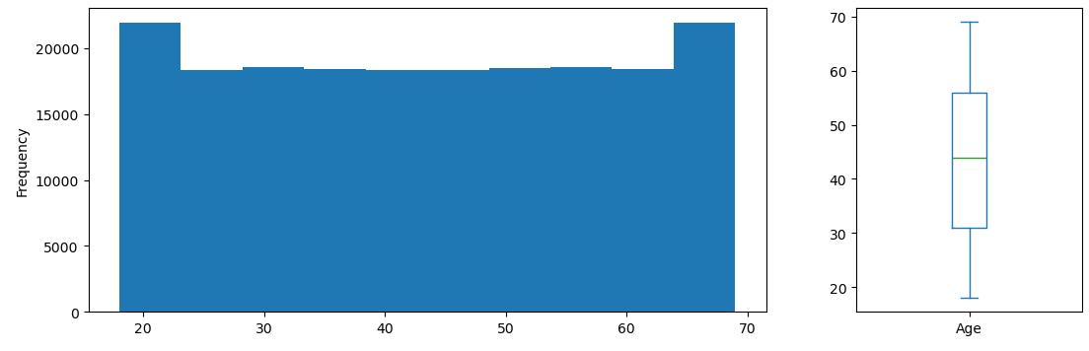

numeric_describe(df_train['Income'])

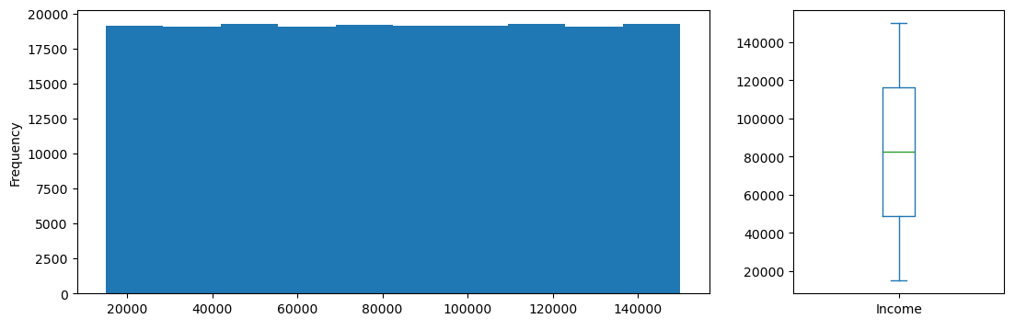

numeric_describe(df_train['LoanAmount'])
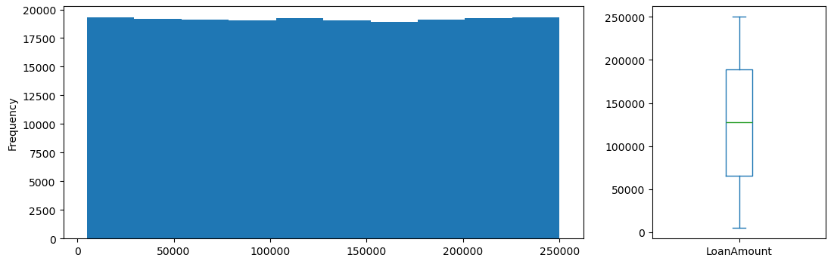

numeric_describe(df_train['CreditScore'])

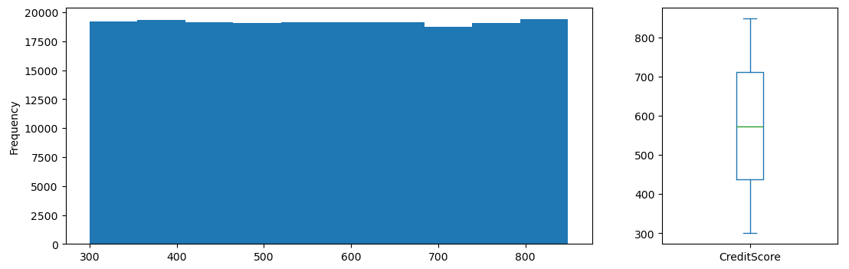
numeric_describe(df_train['MonthsEmployed'])

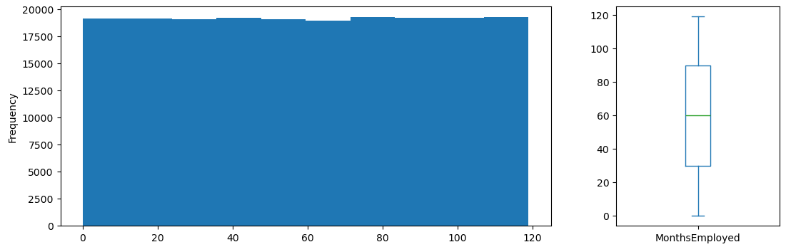

numeric_describe(df_train['NumCreditLines'])

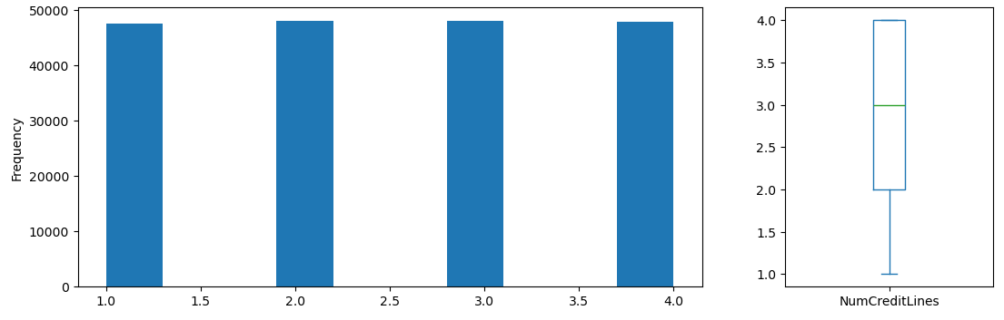

numeric_describe(df_train['InterestRate'])

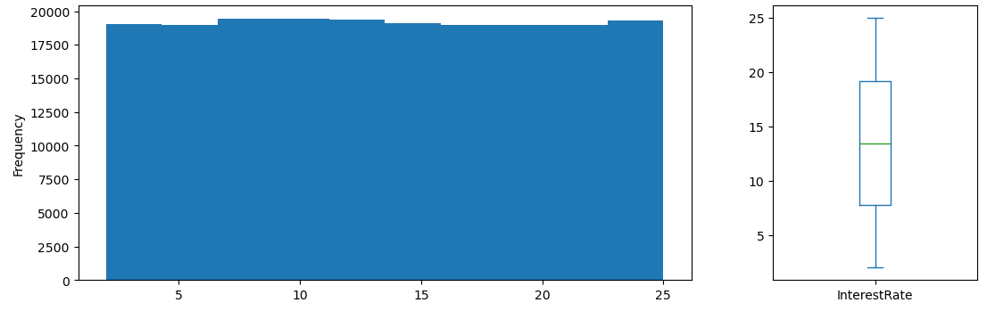

numeric_describe(df_train['LoanTerm'])

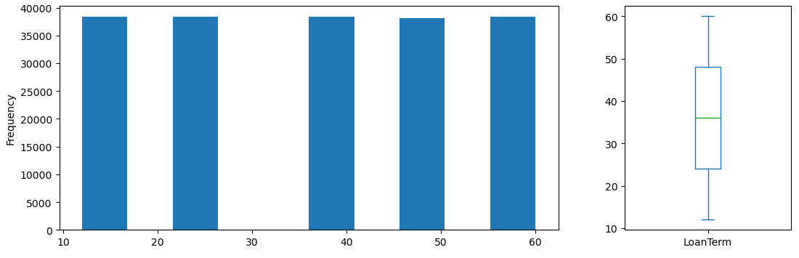

numeric_describe(df_train['DTIRatio'])

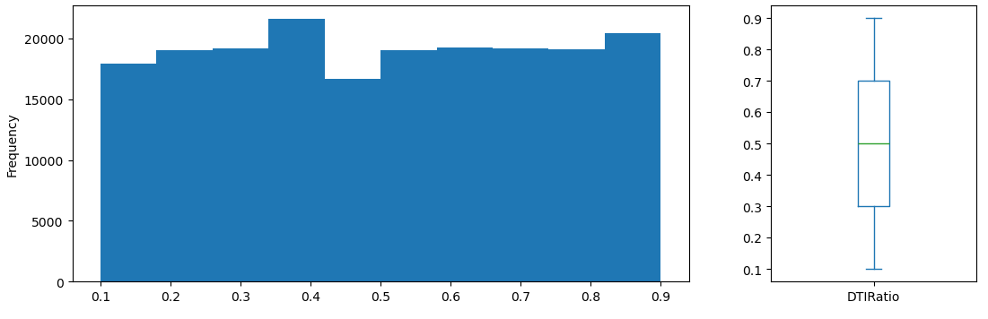

- Exploratory Data Analysis (df_train) on non-numeric features (Education, EmploymentType, MaritalStatus, HasMortgage, HasDependents, LoanPurpose, Default)

Extracting each of the above datas (i.e: Education) from the data_train to create
barchart showing the summary statistic (count and proportion) of different
Education type.

non_numeric_describe(df_train['Education'])

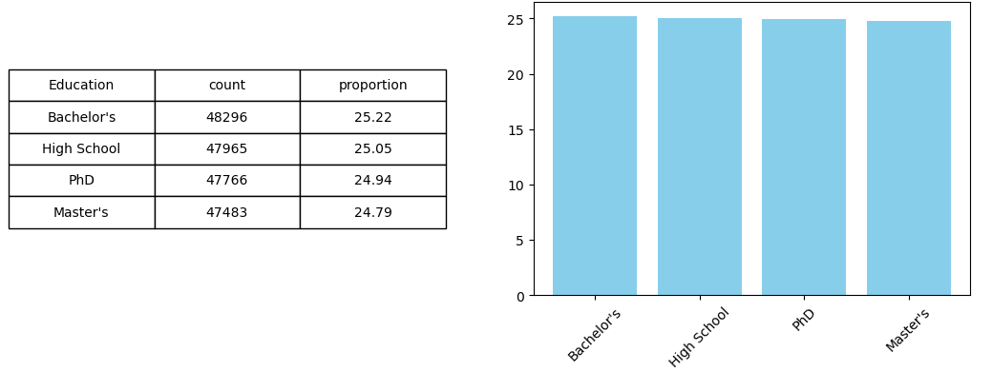

non_numeric_describe(df_train['EmploymentType'])

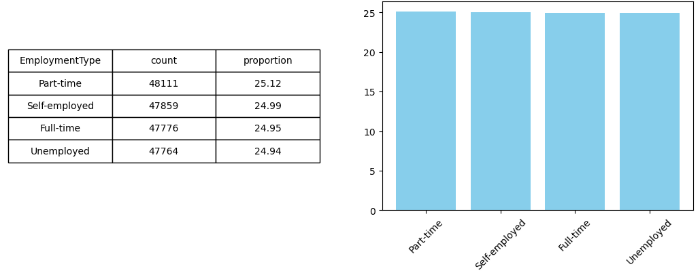

non_numeric_describe(df_train['MaritalStatus'])

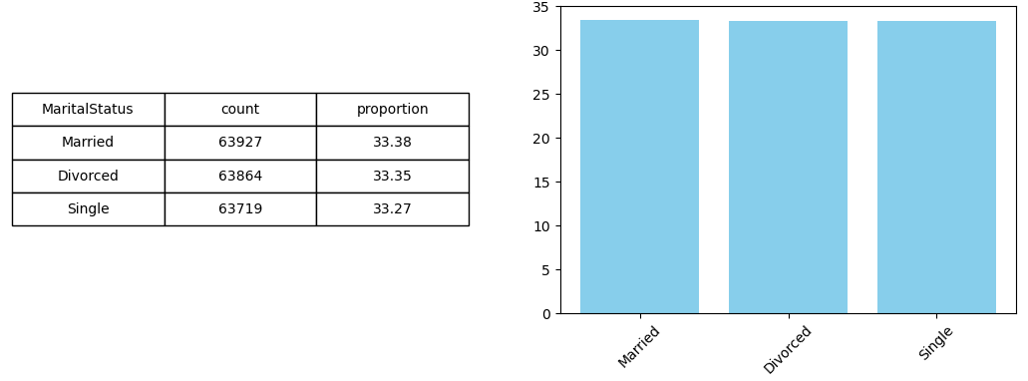

non_numeric_describe(df_train['HasMortgage'])

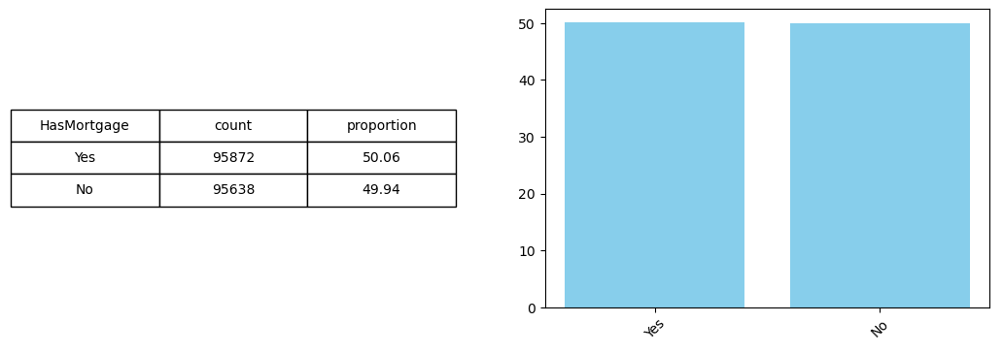

non_numeric_describe(df_train['HasDependents'])

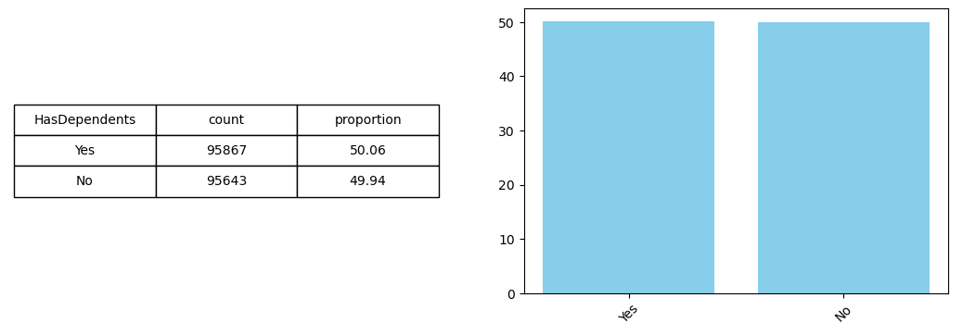

non_numeric_describe(df_train['LoanPurpose'])

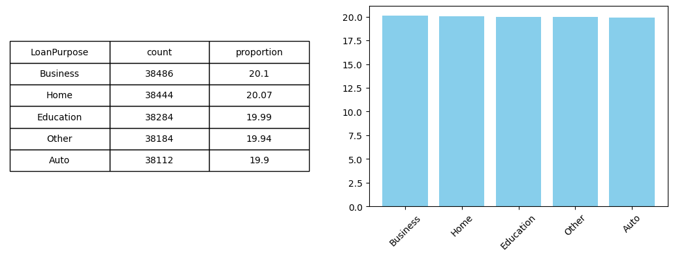

non_numeric_describe(df_train['Default'])

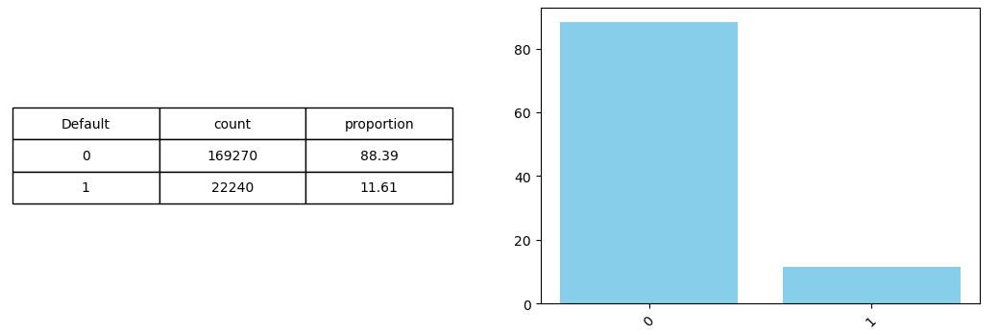

Note: Dataset has imbalanced classification:
Such condition will reflect on low Precision score (0.22) of confusion matrix.

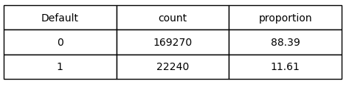

6. Part. 9.1. (df_train)
Visualize the correlation between the numeric features ( heatmap).
No strong correlation shown between the features, no possible of multicollinearity.
Therefore, no numeric features dropped.

plt.figure(figsize=(13, 6))
sns.heatmap(df_train[['Age','Income','LoanAmount','CreditScore','MonthsEmployed','NumCreditLines','InterestRate','LoanTerm','DTIRatio']].corr(), annot=True, cmap='coolwarm')
plt.show()

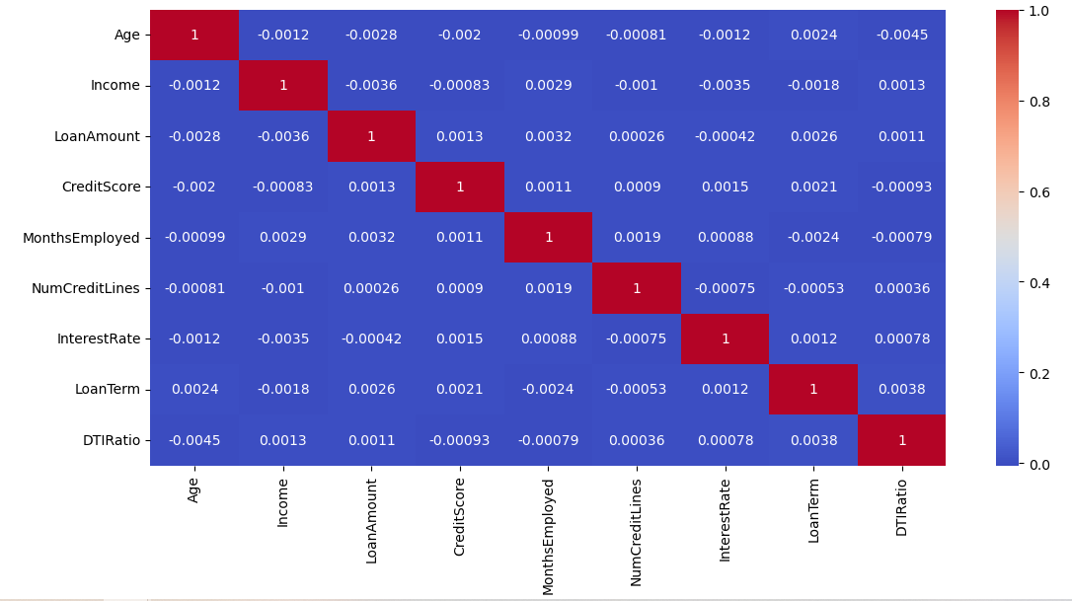

- Performing Chi-Square test of independence between categorical variables, and visualizing the p-values in a heatmap. (df_train)
No strong correlation shown between the non-numeric features, no possible of multicollinearity.
Therefore, no non-numeric features dropped.

non_numeric_columns = ['Education','EmploymentType','MaritalStatus','HasMortgage','HasDependents','LoanPurpose']
p_value_matrix = pd.DataFrame(index=non_numeric_columns, columns=non_numeric_columns)

for col_1 in non_numeric_columns:
for col_2 in non_numeric_columns:
if col_1 == col_2:
p_value_matrix.loc[col_1, col_2] = 1
else:
contingency_table = pd.crosstab(df_train[col_1], df_train[col_2])
chi2, p, dof, expected = chi2_contingency(contingency_table)
p_value_matrix.loc[col_1, col_2] = round(p, 4)

p_value_matrix = p_value_matrix.astype(float)

sns.heatmap(p_value_matrix, annot=True, cmap='coolwarm')
plt.show()

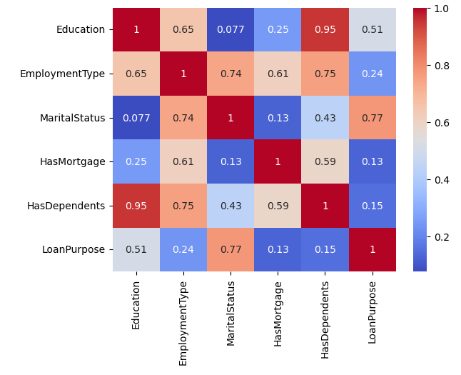

- Part 9.2 One hot encoding on (df_train)
Performing One-Hot Encoding for converting non-numeric features into numerical features, so they can be used in machine learning models.

df_train[['Education','EmploymentType','MaritalStatus','HasMortgage','HasDependents','LoanPurpose']]

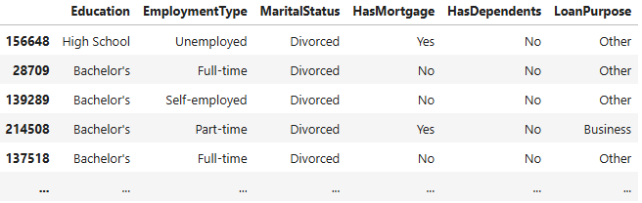
This is for non-numeric features
"""

non_numeric_columns = ['Education','EmploymentType','MaritalStatus','HasMortgage','HasDependents','LoanPurpose']
encoder_1 = OneHotEncoder(sparse_output=False, drop='first')
encoder_1_df = encoder_1.fit_transform(df_train[non_numeric_columns])
encoder_1_df = pd.DataFrame(encoder_1_df, columns=encoder_1.get_feature_names_out(non_numeric_columns))
encoder_1_df

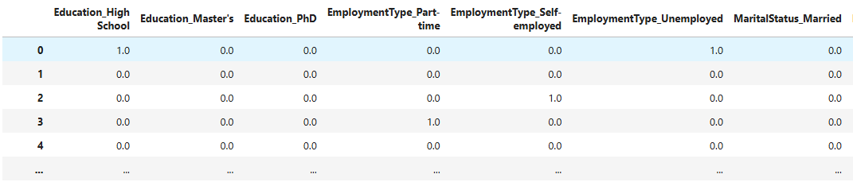

- Part 9.3 Scaling on (df_train)
Performing feature scaling for all of the numeric features. This process is essential as preprocessing step for many machine learning algorithms. Scaling ensures that all features contribute equally to the learning process by bringing them to the same numerical range, typically between 0 and 1 or standardized around mean 0, std 1.

This is for numeric features
"""

numeric_columns = ['Age','Income','LoanAmount','CreditScore','MonthsEmployed','NumCreditLines','InterestRate','LoanTerm','DTIRatio']
scaler_1 = MinMaxScaler()
scaler_1_df = scaler_1.fit_transform(df_train[numeric_columns])
scaler_1_df = pd.DataFrame(scaler_1_df, columns=df_train[['Age','Income','LoanAmount','CreditScore','MonthsEmployed','NumCreditLines','InterestRate','LoanTerm','DTIRatio']].columns)
scaler_1_df

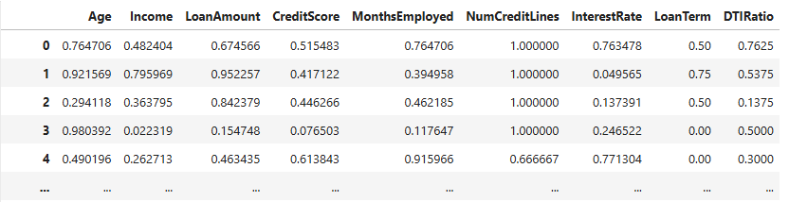

- Part 9.4 Combine into df_train_final (df_train)
Combining all cleaned, transformed and target variable features into a final training dataset.

df_train_final = pd.concat([encoder_1_df, scaler_1_df, df_train['Default'].reset_index(drop=True)], axis=1)
df_train_final

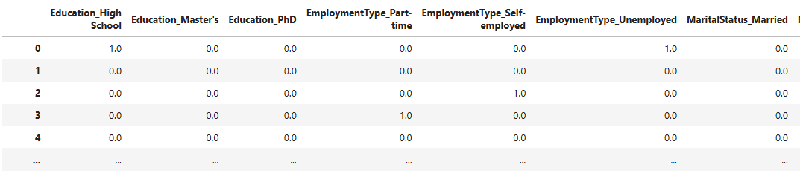

191510 rows × 24 columns

- Part 10.1 (df_train)
Model 1- Logistic Regression fit and predict on df_train_final
A linear model created to predict default or no default. Model will auto adjust for class imbalance.
My target variable Default has more 0 than 1, this code give both classes equal importance during training and sets weights inversely proportional to class frequencies.
I train the model using train dataset, predict whether each case is likely to default (0 or 1) and give the probability that each case defaults.
Evaluation the performance of logistic regression model using a confusion matrix.
The model performance result are:
- Accuracy : The proportion of all predictions that were correct
- Precision : Of all the instances predicted as default (1), how many actually were defaults.
- Recall : Of all the actual defaults (1), how many did the model correctly identify?

lr_model = LogisticRegression(class_weight='balanced')
lr_model.fit(X_train, y_train)
predicted_y_train_category = lr_model.predict(X_train)
predicted_y_train_probability = lr_model.predict_proba(X_train)[:, 1]

cm = confusion_matrix(actual_y_train_category, predicted_y_train_category)
sns.heatmap(cm, annot=True, fmt='d', cmap='Blues', xticklabels=[1,0], yticklabels=[1,0])
plt.xlabel('Predicted')
plt.ylabel('Actual')
plt.title('Confusion Matrix')
plt.show()

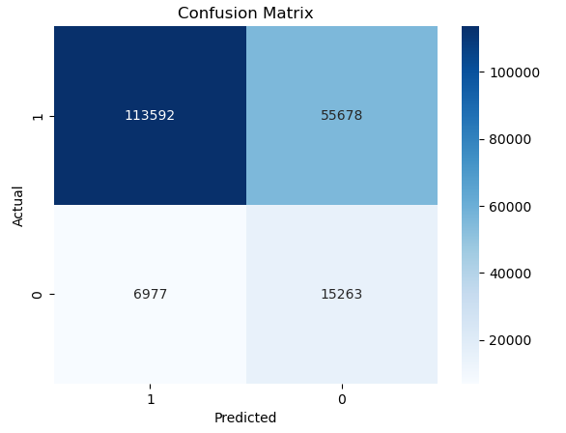
print("Accuracy :", accuracy_score(actual_y_train_category, predicted_y_train_category))
print("Precision :", precision_score(actual_y_train_category, predicted_y_train_category))
print("Recall :", recall_score(actual_y_train_category, predicted_y_train_category))

Accuracy : 0.6728369275755836
Precision : 0.2151506181192822
Recall : 0.6862859712230216

Part 10.2 (df_train)
Model 2- K nearest neighbours fit and predict on df_train_final.
This model is a popular machine learning algorithm for classification.
Parameter | Value | Meaning
n_neighbors=3 | 3 | The model will look at the 3 closest (most similar) data points in the training set when making a prediction.
weights='distance' | distance-based | Closer neighbors get more influence on the prediction than farther ones. This helps improve accuracy by reducing the influence of outliers.
knn_model = KNeighborsClassifier(n_neighbors=3, weights='distance')
knn_model.fit(X_train, y_train)

predicted_y_train_category = knn_model.predict(X_train)
predicted_y_train_probability = knn_model.predict_proba(X_train)[:, 1]

knn_model.predict_proba(X_train)

cm = confusion_matrix(actual_y_train_category, predicted_y_train_category)
sns.heatmap(cm, annot=True, fmt='d', cmap='Blues', xticklabels=[1,0], yticklabels=[1,0])
plt.xlabel('Predicted')
plt.ylabel('Actual')
plt.title('Confusion Matrix')
plt.show()

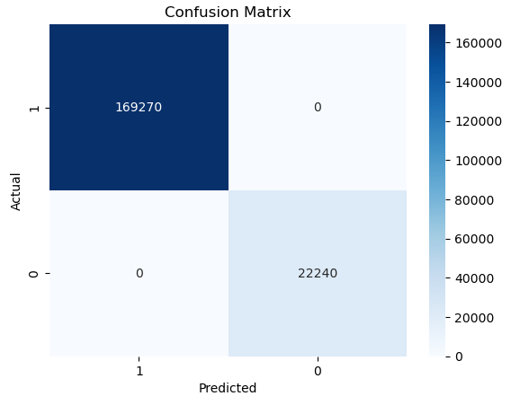

print("Accuracy :", accuracy_score(actual_y_train_category, predicted_y_train_category))
print("Precision :", precision_score(actual_y_train_category, predicted_y_train_category))
print("Recall :", recall_score(actual_y_train_category, predicted_y_train_category))

Accuracy : 1.0
Precision : 1.0
Recall : 1.0

This result might means data imbalance, too easy to predict.

DATA TEST (df_test)

12.Part 11.2. One hot encoding on (df_test)
One hot encoding on df_test for converting non-numeric features into numerical features, so they can be used in machine learning models.
This is for non-numeric features
"""

non_numeric_columns = ['Education','EmploymentType','MaritalStatus','HasMortgage','HasDependents','LoanPurpose']
encoder_2_df = encoder_1.transform(df_test[non_numeric_columns])
encoder_2_df = pd.DataFrame(encoder_2_df, columns=encoder_1.get_feature_names_out(non_numeric_columns))
encoder_2_df

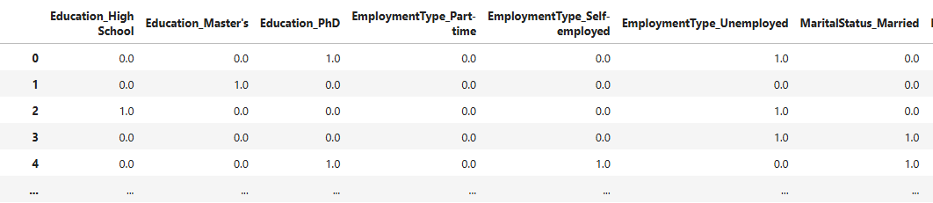
63837 rows × 14 columns
- Part 11.3. Scaling on (df_test)
Performing feature scaling for all of the numeric features. This process is essential as preprocessing step for many machine learning algorithms. Scaling ensures that all features contribute equally to the learning process by bringing them to the same numerical range, typically between 0 and 1 or standardized around mean 0, std 1.
This is for numeric features
"""

numeric_columns = ['Age','Income','LoanAmount','CreditScore','MonthsEmployed','NumCreditLines','InterestRate','LoanTerm','DTIRatio']
scaler_2_df = scaler_1.transform(df_test[numeric_columns])
scaler_2_df = pd.DataFrame(scaler_2_df, columns=df_test[['Age','Income','LoanAmount','CreditScore','MonthsEmployed','NumCreditLines','InterestRate','LoanTerm','DTIRatio']].columns)
scaler_2_df

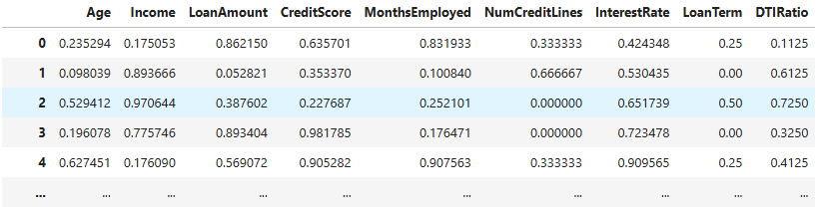
63837 rows × 9 columns

- Part 11.4. Combine into df_test_final
Combining all cleaned, transformed and target variable features into a final training dataset.
df_test_final = pd.concat([encoder_2_df, scaler_2_df, df_test['Default'].reset_index(drop=True)], axis=1)
df_test_final

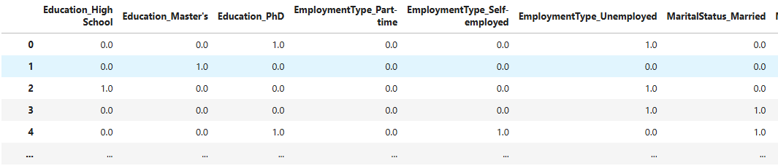
63837 rows × 24 columns

- Part12.1.
Model 1 – Logistic regression predict on df_test_final
A linear model created to predict default or no default. Model will auto adjust for class imbalance.
My target variable Default has more 0 than 1, this code give both classes equal importance during training and sets weights inversely proportional to class frequencies.
I train the model using test dataset, predict whether each case is likely to default (0 or 1) and give the probability that each case defaults.
Evaluation the performance of logistic regression model using a confusion matrix.

predicted_y_test_category = lr_model.predict(X_test)
predicted_y_test_probability = lr_model.predict_proba(X_test)[:, 1]

cm = confusion_matrix(actual_y_test_category, predicted_y_test_category)
sns.heatmap(cm, annot=True, fmt='d', cmap='Blues', xticklabels=[0, 1], yticklabels=[0, 1])
plt.xlabel('Predicted')
plt.ylabel('Actual')
plt.title('Confusion Matrix')
plt.show()

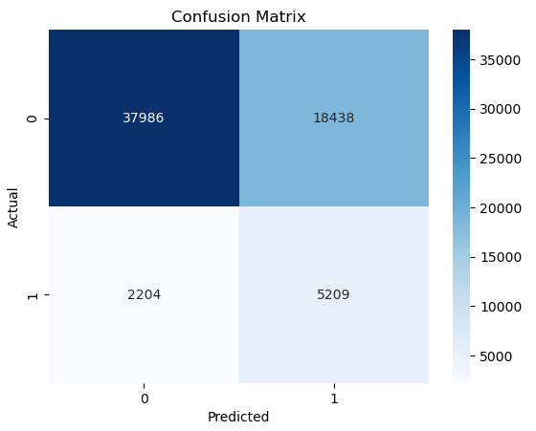
The model performance result are:
Accuracy : 0.6766452057584159
Precision : 0.220281642491648
Recall : 0.7026844732227169

- Part12.2.
Model 2 – K nearest neighbours predict on df_test_final
The model performance result are:

predicted_y_test_category = knn_model.predict(X_test)
predicted_y_test_probability = knn_model.predict_proba(X_test)[:, 1]

cm = confusion_matrix(actual_y_test_category, predicted_y_test_category)
sns.heatmap(cm, annot=True, fmt='d', cmap='Blues', xticklabels=[0, 1], yticklabels=[0, 1])
plt.xlabel('Predicted')
plt.ylabel('Actual')
plt.title('Confusion Matrix')
plt.show()

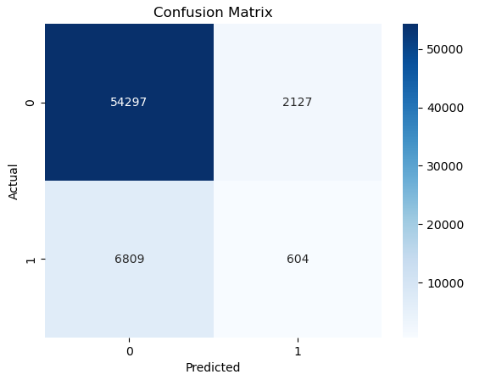

print("Accuracy :", accuracy_score(actual_y_test_category, predicted_y_test_category))
print("Precision :", precision_score(actual_y_test_category, predicted_y_test_category))
print("Recall :", recall_score(actual_y_test_category, predicted_y_test_category))
Accuracy : 0.8600184845779094
Precision : 0.22116440864152326
Recall : 0.08147848374477269

CHOSEN INITIAL MODEL : Logistic regression.
The accuracy is still acceptable (0.67). Low precision is typical for imbalance classification (0.22).
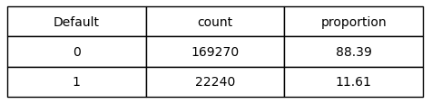
Recall value consider as high (0.70). This is necessary that the model needs to flag more potential defaulters.

Note: Accuracy : How often the model is correct ?
Precision : How frequently are the default predictions confirmed in reality ?
Recall : Finding the real defaulter.

17. SHAP (Shapley Additive exPlanations).
The code to explain how each feature contributes to model predictions. It will generate the insights on the trained model’s behaviour.
The values show:
- How each feature influences the predicted output (e.g., default or not)
- Whether each feature increased or decreased the prediction probability

Result of SHAP using Logistic Regression , for 10 sample:

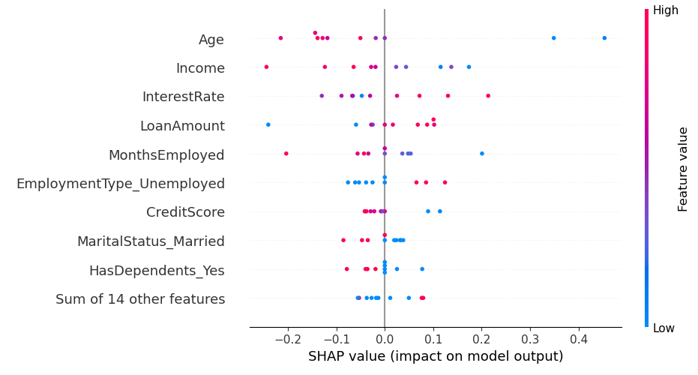

MOST IMPACTFUL FEATURES THAT INCREASE THE DEFAULT RISK:
AGE : Younger borrower priority is more to spending over loan instalments
INCOME : Lower income borrower has smaller ability to absorb unexpectable cost (i.e medical bills, rental, etc)
INTEREST RATE (*) : Higher interest will increase the burden to pay the installment for the customer.
LOAN AMOUNT(*) : Higher loan amount will increase the higher installment amount.
MONTHS EMPLOYED : Short employment is lower income stability.
EMPLOYMENT TYPE : Unemployed borrower is lack of stable income source.
CREDIT SCORE : Credit score showing the creditworthiness of the borrower.
MARITAL STATUS : Not Married borrower has likely single income source.
HAS DEPENDENTS: More dependents increase the financial support.

(*) Features which are also influenced by the bank pricing strategies, credit assessment beside the borrower.

18.How the bank officer make use of the model:
  - He needs to entry the customer’s data into the notebook
  - Run/execute.
  - Result will show :
*True Default, means true possibility of loan default.
The bank officer may deny the loan proposal.
*Else (No Default), means no possibility loan default identified.
The bank officer may proceed further.

Sample of one customer data entry and result with the probability.

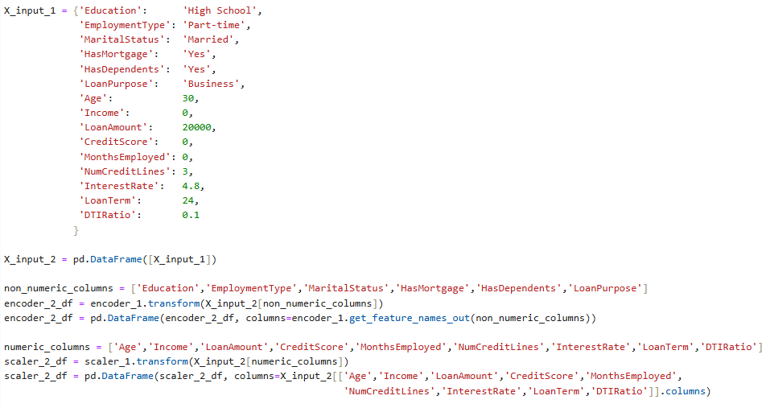
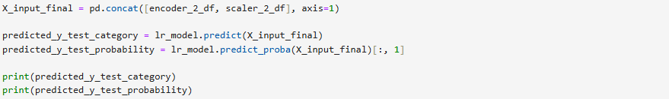

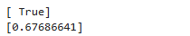

19. INSIGHT

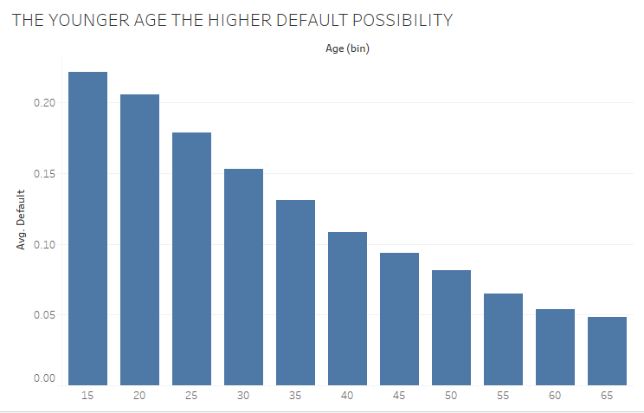

- The younger the borrower age, the higher default possibility.
Younger borrower priority is more to spending over loan instalments

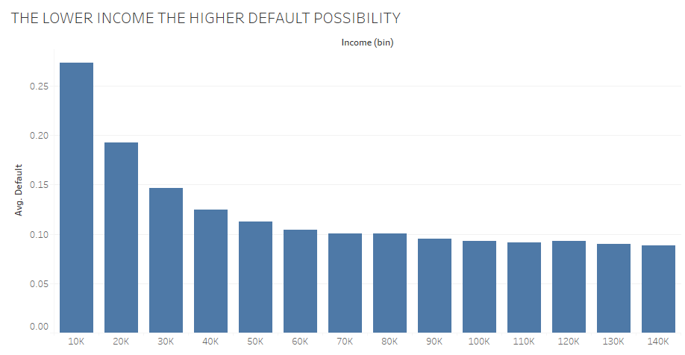

- The lower the borrower income, the higher possibility of default.
Lower income borrower has smaller ability to absorb unexpectable cost (i.e medical bills, rental, etc)

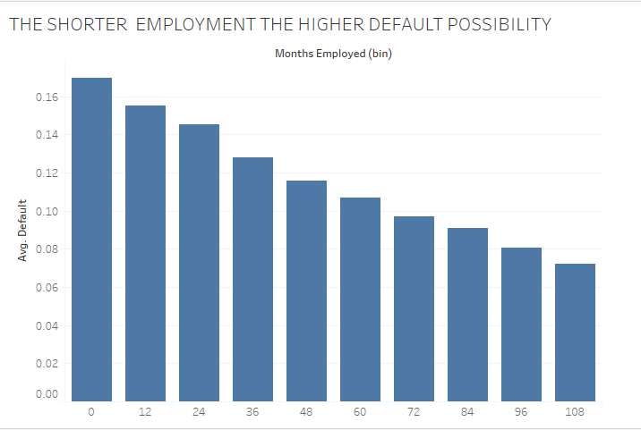

- The shorter employment the higher default possibility.
Short employment is lower income stability.

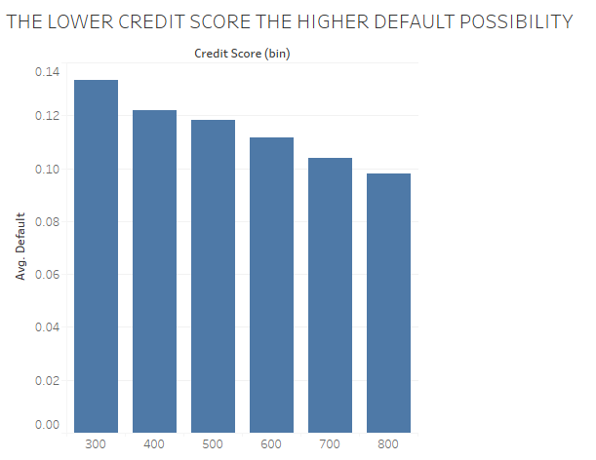

- The lower credit score the higher default possibility of the borrower.
Credit score showing the creditworthiness of the borrower.

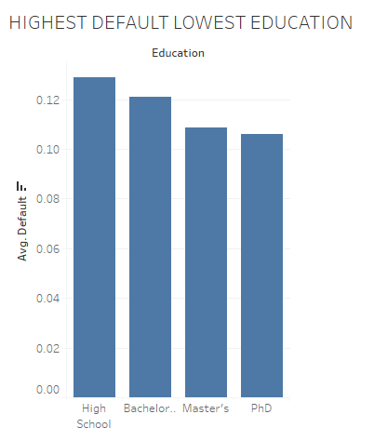
- The higher education, the lower default possibility.
Borrower with higher education, earn higher, greater ability to pay the
installment.

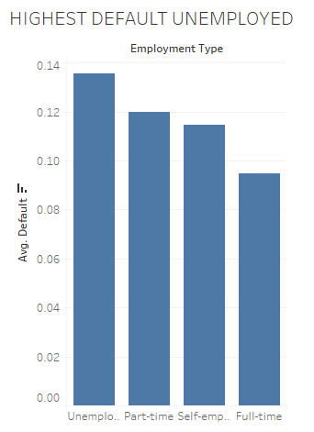

- Unemployed borrower has the most loan default possibility, whereas the fulltime has the lowest default possibility.
Unemployed borrower has very minimum to earn. Unless he has other source of fund, he is likely to default the loan.

20. CONCLUSION :

CAN BANK IDENTIFY THE POSSIBILITY OF DEFAULT AT THE POINT OF CUSTOMER ONBOARDING ?

YES, BY RUNNING THE INITIAL MODEL UPON ENTRY THE CUSTOMER INFORMATION TO CHECK THE DEFAULT POSSIBILITY.

21. RECOMMENDATION:

- SUGGEST DEVELOP A MORE ADVANCE MODEL FOR EASIER AND FASTER USE.

- ADD FEATURES OF LOAN DISBURSEMENT DATE, LOAN DEFAULT DATE FOR GETTING A FIGURE OF TOTAL LOSS IN CASE OF A LOAN DEFAULT.

ADD FEATURE OF ANY CUSTOMER’S ASSET INTO THE MODEL HELPS REFINE DEFAULT PROBABILITY ASSESSMENTS DURING CREDIT EVALUATION PROCESS.

- A RECORD OF CUSTOMER DEFAULT DETAILS AND PATTERN. WHICH DATA ARE USEFUL FOR THE BANK EARLY INTERVENSION PROCESS UPON DELINQUENCY IDENTIFICATION.

- BUIDING A SEPARATE MODEL FOR DENIED APPLICATIONS ALLOWING PROFITTABLE BUSINESS ACCEPTABLE RISK (HIGHER INTEREST, LONGER TENOR, SMALLER QUANTUM.

