**RW Mapping Methodology**

**Surabaya City, East Java**

1. Divide the region of Surabaya

The city of Surabaya was divided into 31 sub-districts (kecamatan), each containing a varying number of villages (kelurahan) within their boundaries, with a total 160. We will divide Surabaya two section, so each team get 15-16 sub districts. The map below show that divide region into **West (16 Kecamatan/Sub Districts and 79 Kelurahan/Village)** and **East (15 Kecamatan/Sub Districts and 81 Kelurahan/Village).**

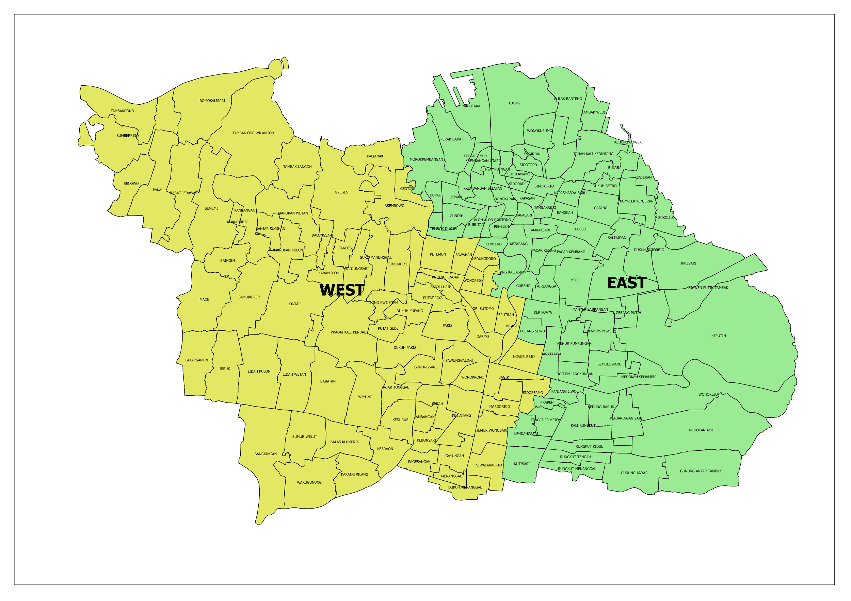

**Team Supervisor East Team Supervisor West**

|  |  |  |  |  |
| --- | --- | --- | --- | --- |
| Kecamatan | Sub District | Kelurahan | Villages |  | Kecamatan | Sub District | Kelurahan | Villages |
| **Surabaya Pusat** |  | **Surabaya Selatan** |  |
| 01. Genteng | 5 | 01. Sawahan | 6 |
| 02. Bubutan | 5 | 02. Wonokromo | 6 |
| 03. Simokerto | 5 | 03. Karangpilang | 4 |
|  |  | 04. Dukuh Pakis | 4 |
| **Surabaya Utara** |  | 05. Wiyung | 4 |
| 04. Pabean Cantian | 5 | 06. Wonocolo | 5 |
| 05. Semampir | 5 | 07. Gayungan | 4 |
| 06. Krembangan | 5 | 08. Jambangan | 4 |
| 07. Kenjeran | 4 | **Surabaya Barat** |  |
| 08. Bulak | 5 -> 4 | 09. Tandes | 6 |
| **Surabaya Timur** |  | 10. Sukomanunggal | 6 |
| 09. Tambaksari | 8 | 11. Asemrowo | 5 -> 3 |
| 10. Gubeng | 6 | 12. Benowo | 5 -> 4 |
| 11. Rungkut | 6 | 13. Lakarsantri | 6 |
| 12. Tenggilis Mejoyo | 5 -> 4 | 14. Pakal | 5 -> 4 |
| 13. Gunung Anyar | 4 | 15. Sambikerep | 4 |
| 14. Sukolilo | 7 | 16. Tegalsari (SP) | 5 |
| 15. Mulyorejo | 6 | **Total Village** | **79** |
| **Total Village** | **81** |  | |

Notes: The yellow highlight show to different data number of village BPS 2013 and 2014

**B. Team RW Mapping (data entry 16 person)**

**Team East Team West**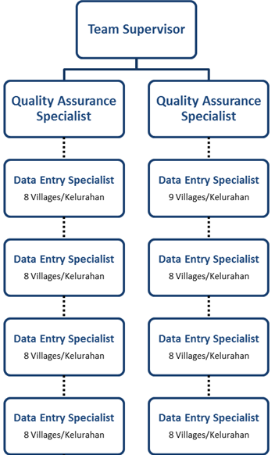

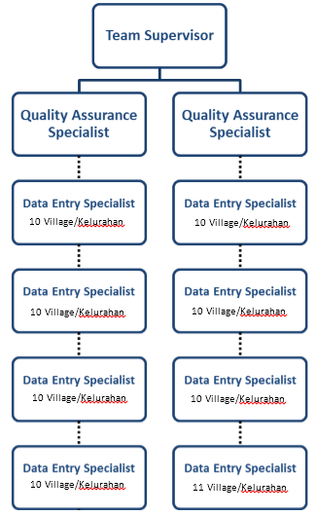 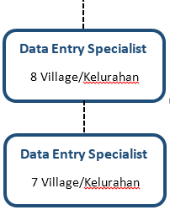

|  |  |
| --- | --- |
|  |  |
|  |  |

**C. Mapping Methodology**

**Area Survey - Sub Districts**

|  |  |  |
| --- | --- | --- |
| **Month** | **East** | **West** |
| 1 | Genteng, Bubutan, Simokerto, Krembangan = 20 villages | Tegalsari, Sawahan, Wonokromo, Sukomanunggal = 21 villages |
| 2 | Pabean Cantian, Semampir, Bulak, Kenjeran = 19 villages | Wiyung, Lakarsantri, Sambikerep, Dukuh Pakis, Sawahan (Sawunggalih, Wonokromo Village) = 20 villages |
| 3 | Tambaksari, Gubeng, Mulyorejo = 20 villages | Benowo, Pakal, Asemrowo, Tandes = 21 villages |
| 4 | Tenggilis Mejoyo, Rungkut, Gunung Anyar = 22 villages | Karang Pilang, Wonocolo, Gayungan, Jambangan = 17 villages |

Estimate = one sub districts to one team data entry for 1 month

**Peralatan**

**Alat yang dibawa setiap kelompok :**

1. Perangkat GPS (1 unit)/Smartphone
2. Baterai cadangan GPS
3. Peta A3 Citra Satelit dan OSM
4. Form survey lapangan
5. Kamera pocket/kamera handphone
6. Alat tulis (pulpen, papan jalan, map plastik)
7. ID (tanda pengenal)
8. Surat izin survey lapangan

**Mapping**

1. **RW Mapping**

* Create maps based on village boundaries in Surabaya
* Peta tersebut akan dibawa oleh Tim data entry untuk diberikan dan didiskusikan dengan aparat kelurahan. Peta tersebut dapat ditinggal dan aparat kelurahan diminta untuk menggambarkan batas RW yang akan diambil besok.
* Jika batas RW sudah digambar oleh aparat kelurahan, harap diperiksa kembali seperti: batas RW, pemberian nama RW, dan kejelasan pengambaran di peta.
* Batas RW yang sudah terkumpul akan diperiksa dan didigitasi oleh **Quality Assurance**
* The changeset comment to upload OSM data in JOSM is

**#RWMapping #Kel____ #Kec___ #PDCSurabaya**

Example : #RWMapping #Kel Sawunggalih #Kec Sawahan #PDCSurabaya

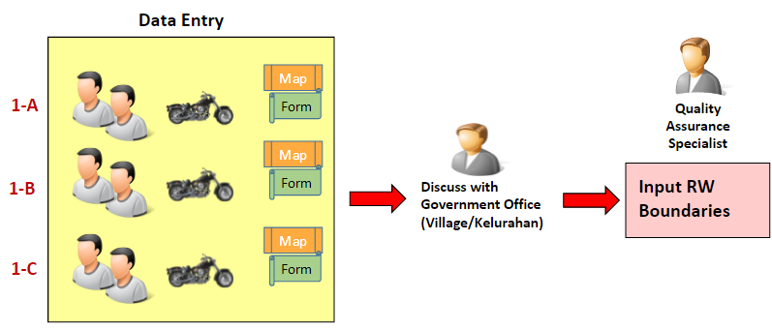

*Methodology for RW Boundaries*

1. **Infrastructure Mapping**

**Dalam survey lapangan yang harus dilakukan di lapangan adalah:**

1. Menandai letak infrastruktur dalam peta
2. Plotting lokasi tiap-tiap infrastruktur dengan menggunakan GPS
3. Mengisi form survey lapangan untuk setiap infrastruktur
4. Mengambil foto untuk setiap infrastruktur

**Catatan :**

Nomor infrastruktur pada form survey lapangan disesuaikan dengan nomor *waypoint* pada GPS

**INFRASTRUKTUR YANG DIPETAKAN :**

Dibawah ini adalah kategori-kategori infrastruktur yang akan dipetakan berdasarkan kesepakatan pada workshop sebelumnya antara lain :

**Finance**

* Banks

**Communications**

* Communication Towers

**Transportation**

* Airports
* Ferry Terminals
* Train Stations
* Bus Stations
* Roads
* Railways

**Water Supply Systems**

* Fire Hydrants
* Water Towers
* Pump House
* Reservoirs
* Water Gates
* Water well

**Electrical Power Systems**

* Generators
* Towers
* Substation
* Power Plant

**Fuel Storage**

* Gas Stations

**Public Institutions**

* Kindergarten
* Schools
* College
* Universities
* Places of Worship
* Supermarkets
* Traditional Marketplace

**Health Facilities**

* Clinics
* Hospitals

**Emergency Services**

* Police Stations
* Fire Stations

**Government Establishments**

* Offices
  + Governor Office (Kantor Gubernur)
  + Townhall (Kantor Bupati/Walikota)
  + Subdistrict Office (Kantor Kecamatan)
  + Village Office (Kantor Desa/Kelurahan)
  + Community Group Office (Kantor RW)
  + Ministry (Kementerian/Instansi Pemerintah)
* Embassies
* Administrative Boundaries
  + City/Regency (Kotamadya/Kabupaten)
  + Sub-district (Kecamatan)
  + Village (Kelurahan/Desa)
  + Sub-village (Dusun)
  + Community Group (RW*)

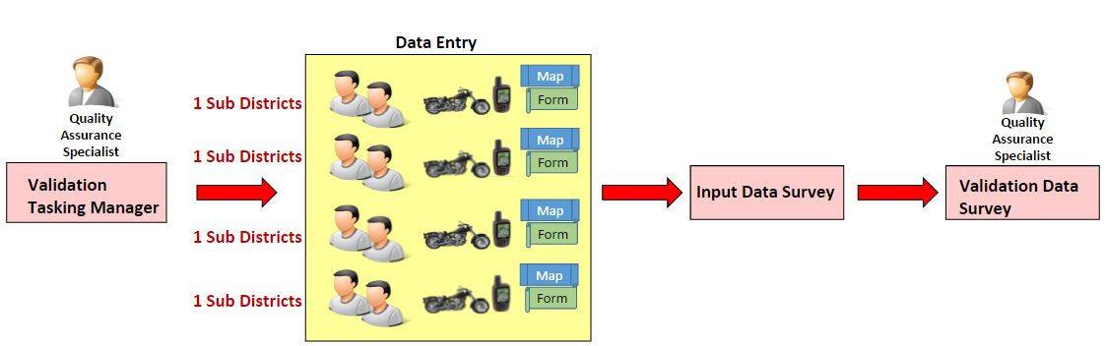

*Methodology for Infrastructures Mapping*

The changeset comment to upload OSM data in JOSM is

**#Facilities #Kel____ #Kec____ #PDCSurabaya**

Example : #Facilities #Kel Sawunggalih #Kec Sawahan #PDCSurabaya

**D. Timeline RW Mapping/day**

This is timeline after QA and data entry given the training.

|  |  |  |  |  |  |
| --- | --- | --- | --- | --- | --- |
| **Structure** | **Monday** | **Tuesday** | **Wednesday** | **Thuesday** | **Friday** |
| **Week 1** | | | | | |
| **Supervisor** | -Divide area survey and prepare before survey  **-Join to Survey** | Create village basemap to next survey based on divide area survey | Check the validation tasking manager | Check the validation tasking manager | -Validation RW boundaries  -Update statistics |
| **QA** | Validation tasking manager to next survey based on divide area survey | Validation tasking manager to next survey based on divide area survey | Create RW boundaries | Validation data entry | Validation tasking manager to next survey based on divide area survey |
| **Data Entry** | Survey | Survey | Input | Survey | Survey |
| **Week 2** | | | | | |
| **Supervisor** | validation RW boundaries and check validation from QA | Create village basemap to next survey based on divide area survey | Check the validation tasking manager | Check the validation tasking manager | -Validation RW boundaries  -Update statistics |
| **QA** | Create RW boundary | Validation data entry | Create rw boundary or **rolling survey** | Create rw boundary | Validation data entry and tasking manager, create report |
| **Data Entry** | Input | Survey | Survey | input | survey |
| **Week 3** | | | | | |
| **Supervisor** | -Divide area survey and prepare before survey  - **Join survey** | Create village basemap to next survey based on divide area survey | Check the validation tasking manager | Check the validation tasking manager | -Validation RW boundaries  -Update statistics |
| **QA** | Validation tasking manager to next survey based on divide area survey | Create RW boundary | Validation data entry and tasking | Validation data entry and tasking | Create RW boundaries |
| **Data Entry** | survey | input | survey | survey | input |
| **Week 4** | | | | | |
| **Supervisor** | -validation RW boundaries and check validation from QA | Create village basemap to next survey based on divide area survey | Check the validation tasking manager | Check the validation tasking manager | -Validation RW boundaries  -Update statistics  - create report |
| **QA** | Validation tasking manager to next survey based on divide area survey | Validation data entry, **rolling survey** | Create RW boundaries | Validation data entry and tasking, create report a month | Validation data entry |
| **Data Entry** | survey | survey | input | survey | input |

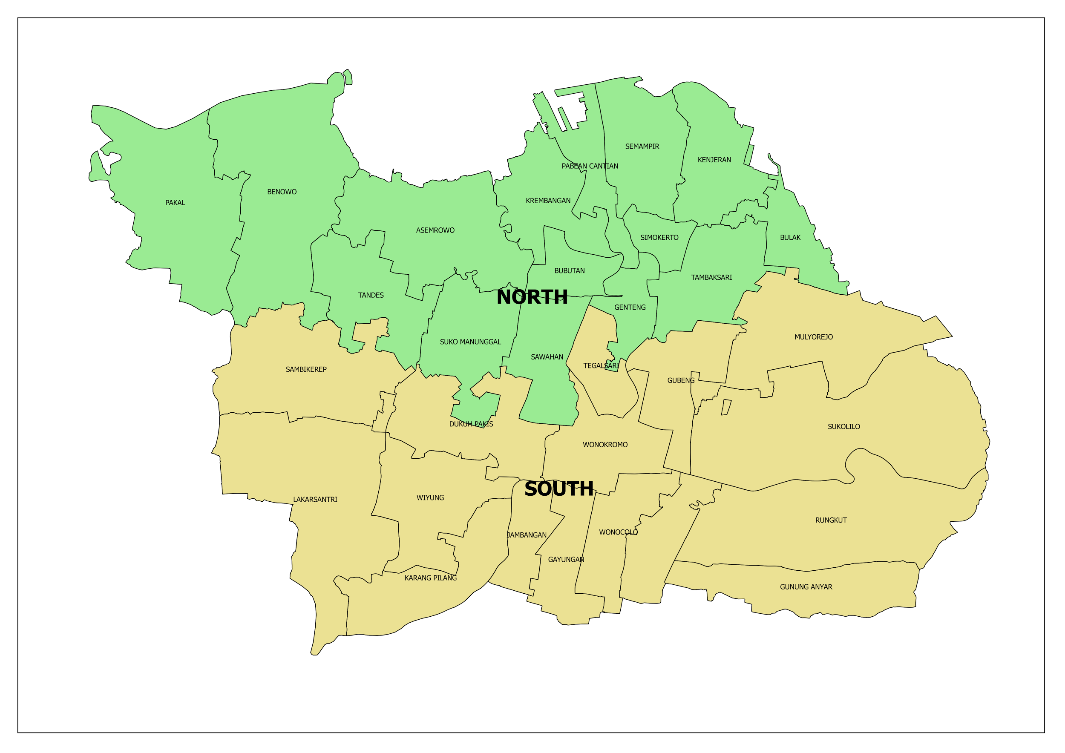

|  |  |  |  |
| --- | --- | --- | --- |
| NO | KECAMATAN | Survey | Villages |
| 1 | KARANG PILANG | South | 4 |
| 2 | JAMBANGAN | South | 4 |
| 3 | GAYUNGAN | South | 4 |
| 4 | WONOCOLO | South | 5 |
| 5 | TENGGILIS MEJOYO | South | 5 -> 4 |
| 6 | GUNUNG ANYAR | South | 4 |
| 7 | RUNGKUT | South | 7 |
| 8 | SUKOLILO | South | 7 |
| 9 | MULYOREJO | South | 6 |
| 10 | GUBENG | South | 6 |
| 11 | WONOKROMO | South | 6 |
| 12 | DUKUH PAKIS | South | 4 |
| 13 | WIYUNG | South | 4 |
| 14 | LAKARSANTRI | South | 6 |
| 15 | TEGALSARI | South | 5 |
| 16 | SAMBIKEREP | South | 4 |
|  | **Total Villages** |  | **81** |

|  |  |  |  |
| --- | --- | --- | --- |
| NO | KECAMATAN | Survey | Village |
| 1 | TANDES | North | 6 |
| 2 | SUKO MANUNGGAL | North | 6 |
| 3 | SAWAHAN | North | 6 |
| 4 | GENTENG | North | 5 |
| 5 | TAMBAKSARI | North | 8 |
| 6 | KENJERAN | North | 4 |
| 7 | BULAK | North | 5 - > 4 |
| 8 | SIMOKERTO | North | 5 |
| 9 | SEMAMPIR | North | 5 |
| 10 | PABEAN CANTIAN | North | 5 |
| 11 | BUBUTAN | North | 5 |
| 12 | KREMBANGAN | North | 5 |
| 13 | ASEMROWO | North | 5 -> 3 |
| 14 | BENOWO | North | 5 -> 4 |
| 15 | PAKAL | North | 5 -> 4 |