Setup Guide for the LaTeX Directory

# Introduction

This document describes the basic installation process for the LaTeX document processing system and the LyX editor. The process will allow the user to typeset documents using the GLIMMPSE document format, as well as document classes for variety of common statistics journals. The process involves the following steps

1. Install the LaTeX typesetting system.
2. Install the LyX editor.
3. Add the “Latex” directory to the search path for MikTex.
4. Install the LyX layout files

A nice tutorial video describing the basic installation process appears here

<http://www.youtube.com/watch?v=m4cEAVmLegg>

Note that LaTeX documents consist of two pieces: the content and the formatting information. The content is contained in a *.tex file. The content is formatted or “typeset” by compiling it against a document class file (*.cls).

# Installing LaTeX

On Windows, LaTeX is distributed in the MikTex package available here:

http://miktex.org/

Download and run the Basic MikTeX Installer for Windows (either 32 or 64 bit depending on your operating system). When running the installer, **make sure you select “yes” when asked to install missing packages on the fly.**

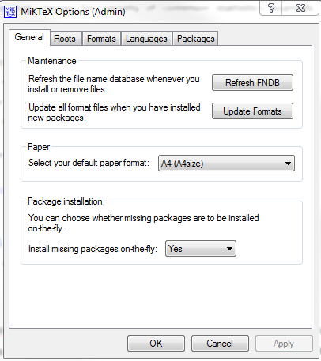

# Installing LyX

LyX is a visual editor for LaTeX. It provides real time display of formulas, integrates with BibTex and Sweave, and can export to true LaTeX. LyX can be downloaded from

<http://www.lyx.org/>.

Download and run the Windows installer. Be sure to get version 2.0.x or higher.

# Adding the “Latex” directory to the search path for MikTex

Now that you have installed LaTeX, we need to make the typesetting system aware of the GLIMMPSE and journal specific document class files. The “Roots” of the MikTeX system define the set of directories which will be scanned for class files. To add the “LaTeX” directory as a root, perform the following steps.

1. Open the MikTeX Settings tool (as admin if possible, but not necessary) from the Windows Start Menu

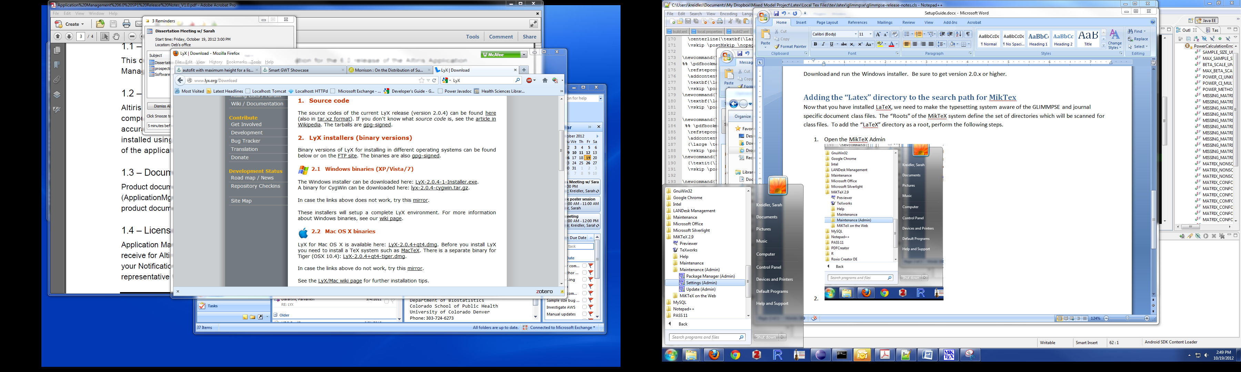

1. Go to the “Roots” tab and Click “Add”

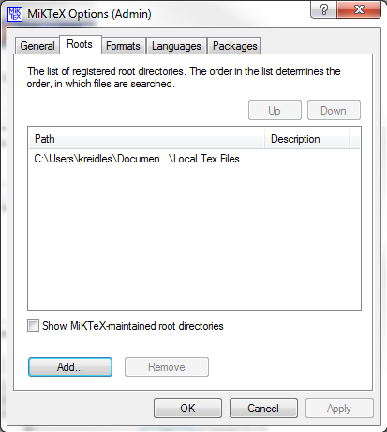

1. Browse to the “Latex” directory, highlight the “Local Tex Files” directory, and then click Ok.

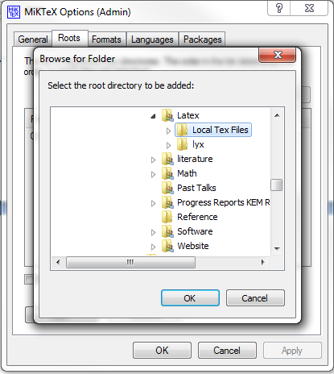

1. Click on the General Tab. Click the “Refresh FNDB.” At this point, MikTeX will be aware of our custom class files. !**You will need to refresh the FNDB whenever the class files are updated!**

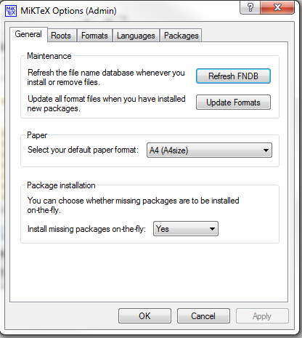

# Installing the LyX Layout Files

At this point, the underlying LaTeX system is fully configured. The LyX editor operates as a layer on top of the LaTeX system. Therefore, we need to make LyX aware of our custom classes as well. We accomplish this by installing “layout” files in the local LyX resource directory. To do so, perform the following steps.

1. Go to the “Latex\lyx\layouts” directory.
2. Select all files (Ctrl-A), right click, and select “Copy”

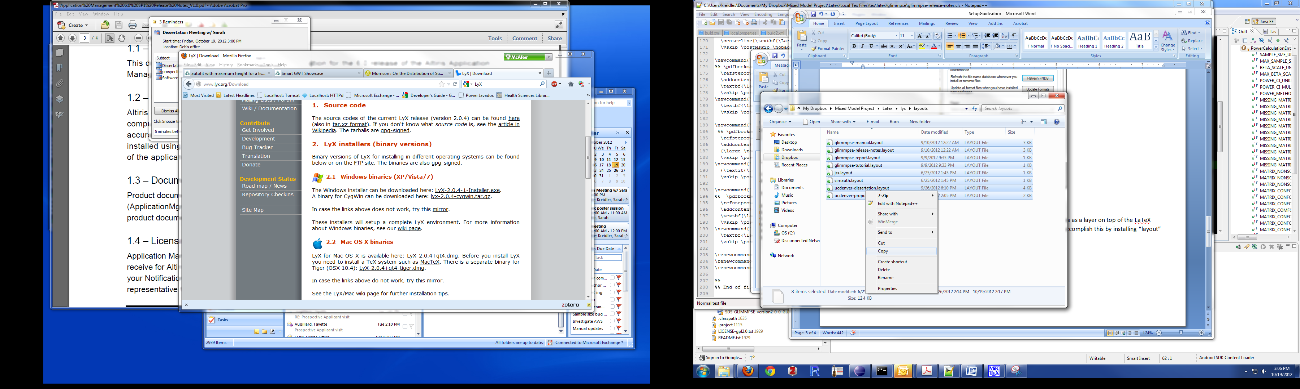

1. Browse to the local LyX layouts directory.

C:\Users*your-user-name* \AppData\Roaming\LyX2.0\layouts

Note: you may need to make “hidden” files visible in your Windows control panel in order to see the AppData directory.

1. Paste the layout files into this directory.
2. Open LyX from the Windows Start Menu.
3. Run Tools->Configure.
4. Restart Lyx.
5. Under Document->Settings->Document Class, you should now see the custom document classes.