New York City to Denver Flights in 2013

Example report

We are interested in looking at the flights from departing NYC in 2013 and arriving in Denver Colorado. For this work we will use the data provided in the R package [nycflights13](https://cran.r-project.org/package=nycflights13). (Wickham 2018)

# Fights To Denver

There were 7,266 flights from NYC to Denver during 2013. 2,859 (39.35%) of the flights originated from Newark Liberty Intl , 703 (9.68%) originated from John F Kennedy Intl , and the last 3,704 (50.98%) of flights originated from La Guardia .

## Table

A summary of the flights are provided in the table below:

|  |  |  |  |  |
| --- | --- | --- | --- | --- |
|  | flights_to_den (N = 7,266) | origin: EWR (N = 2,859) | origin: JFK (N = 703) | origin: LGA (N = 3,704) |
| **Departure Delay (minutes)** |  |  |  |  |
| minimum | -43.00 | -13.00 | -43.00 | -27.00 |
| median (IQR) | 1.00 (-3.00, 15.00) | 2.00 (-2.00, 19.00) | 1.00 (-2.50, 21.00) | 0.00 (-4.00, 11.00) |
| mean (sd) | 15.16 ± 41.83 | 16.54 ± 38.04 | 20.10 ± 43.94 | 13.15 ± 44.04 |
| maximum | 853.00 | 384.00 | 360.00 | 853.00 |
| Unknown (%) | 65/7,266 (1) | 28/2,859 (1) | 4/703 (1) | 33/3,704 (1) |
| **Arrival Delay (minutes)** |  |  |  |  |
| minimum | -67.00 | -63.00 | -66.00 | -67.00 |
| median (IQR) | -2.00 (-17.00, 17.00) | -1.00 (-15.00, 19.00) | -4.00 (-18.00, 26.00) | -4.00 (-17.00, 16.00) |
| mean (sd) | 8.61 ± 47.25 | 9.03 ± 43.40 | 10.82 ± 48.14 | 7.85 ± 49.86 |
| maximum | 834.00 | 370.00 | 335.00 | 834.00 |
| Unknown (%) | 97/7,266 (1) | 44/2,859 (2) | 6/703 (1) | 47/3,704 (1) |
| **Carrier** |  |  |  |  |
| JetBlue Airways | 338 (5) | 0 (0) | 338 (48) | 0 (0) |
| Delta Air Lines Inc. | 1,043 (14) | 0 (0) | 365 (52) | 678 (18) |
| Frontier Airlines Inc. | 685 (9) | 0 (0) | 0 (0) | 685 (18) |
| United Air Lines Inc. | 3,796 (52) | 2,170 (76) | 0 (0) | 1,626 (44) |
| Southwest Airlines CO. | 1,404 (19) | 689 (24) | 0 (0) | 715 (19) |

## Graphics

A graphic for the flight times…

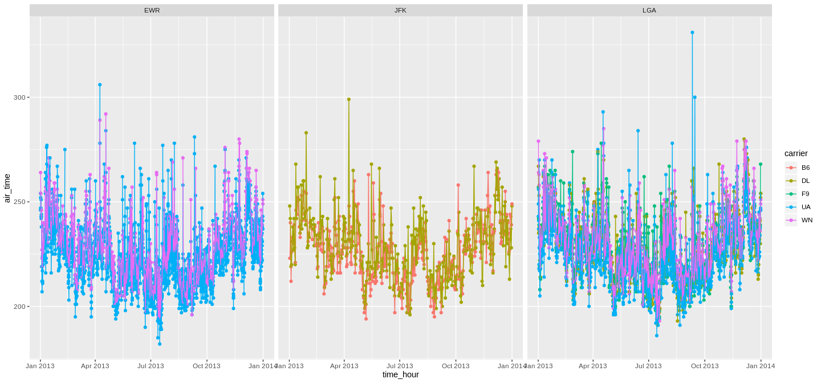

# References

Wickham, Hadley. 2018. *Nycflights13: Flights That Departed Nyc in 2013*. <https://CRAN.R-project.org/package=nycflights13>.