Important Research Paper

Clinician One, The Statistician, Clinician Two, Senior Author

# Abstract

**Purpose:** Building up a clinical research article in parts is one way to organize an your work. Some writers may find having several small files, each with a specific focus, easier to work with than one all encompassing large file. The files presented in this directory are and example of building a clinical research manuscript with knitr::spin and child documents.

**Methods:** Example files and a work flow are presented. A subset of the diamonds data set from the ggplot2 is used for the examples.

**Results:** *hightlight results here, e.g. Diamonds ranging between 1.0 and 1.5 carats in weight have a mean price of 6,513.53 (95% CI: 6,483.62, 6,543.43) US dollars.*

**Conclusions:** *hightlight conclusions*

# Introduction

The introduction section of the manuscript will likely have very little, or no analysis language, but that is okay. The process works with out without analysis language chunks.

# Methods

*< write up the clinical methods >*

Statistical methods….

Work was done in R Under development (unstable) (2019-08-23 r77062)

# Results

The original diamonds data set provides the sale price of 53,908 diamonds along with several specific physical characteristics of the diamond. This data set included carat weights ranging from 0.2 carats to 5.01 carats. For the work presented here we restricted the data to diamonds with a maximum weight of three carats. A scatter plot of the data set indicates that carat weights tend to be reported in whole or half integer values. Due to this, we have elected to discretized the report carat weight in half carat intervals. See **Table 1** for an overall summary of this data set.

## Price by carat weight

The mean price for a diamond increases with carat size, as expected. Starting with a mean price of 839.72 (95% CI: 815.85, 863.59) for diamonds with a maximum weight of 0.5 carats, the largest mean price is 15,472.90 (95% CI: 15,134.19, 15,811.62) for 2.5 to 3.0 carat weight diamonds.

The mean price of the diamonds is statistically different between each group of carat weights. This conclusion is based on all pairwise comparisons and accounting for multiple comparisons via Tukey’s Honest Significant Difference; see **Figure 3**.

# Discussion

*write the discussion section*

# References

# Table Captions

**Table 1:** Summary of the diamonds data set.

# Figure Captions

**Figure 1:** The diamonds data set: Scatter plot of price by carat weight.

**Figure 2:** The diamonds data set: Price by carat weight. Mean price for each set of diamonds is plotted as a point on the violin plot.

**Figure 3:** Tukey HSD for differeces in mean price of diamonds by carat weight groups.

# Tables

**Table 1**

|  |  |  |  |  |  |  |  |
| --- | --- | --- | --- | --- | --- | --- | --- |
|  | diamonds (N = 53,908) | carat2: (0,0.5] (N = 18,932) | carat2: (0.5,1] (N = 17,506) | carat2: (1,1.5] (N = 12,060) | carat2: (1.5,2] (N = 3,553) | carat2: (2,2.5] (N = 1,763) | carat2: (2.5,3] (N = 94) |
| **cut** |  |  |  |  |  |  |  |
| Fair | 1,600 (3) | 193 (1) | 766 (4) | 386 (3) | 148 (4) | 96 (5) | 11 (12) |
| Good | 4,903 (9) | 1,384 (7) | 1,943 (11) | 1,094 (9) | 317 (9) | 151 (9) | 14 (15) |
| Very Good | 12,080 (22) | 3,889 (21) | 4,312 (25) | 2,725 (23) | 768 (22) | 369 (21) | 17 (18) |
| Premium | 13,778 (26) | 4,315 (23) | 3,747 (21) | 3,732 (31) | 1,254 (35) | 697 (40) | 33 (35) |
| Ideal | 21,547 (40) | 9,151 (48) | 6,738 (38) | 4,123 (34) | 1,066 (30) | 450 (26) | 19 (20) |
| **color** |  |  |  |  |  |  |  |
| D | 6,774 (13) | 2,898 (15) | 2,556 (15) | 1,064 (9) | 213 (6) | 40 (2) | 3 (3) |
| E | 9,796 (18) | 4,276 (23) | 3,629 (21) | 1,476 (12) | 338 (10) | 73 (4) | 4 (4) |
| F | 9,541 (18) | 3,418 (18) | 3,523 (20) | 2,040 (17) | 440 (12) | 117 (7) | 3 (3) |
| G | 11,291 (21) | 4,147 (22) | 3,426 (20) | 2,800 (23) | 679 (19) | 228 (13) | 11 (12) |
| H | 8,298 (15) | 2,415 (13) | 2,252 (13) | 2,409 (20) | 764 (22) | 429 (24) | 29 (31) |
| I | 5,409 (10) | 1,316 (7) | 1,426 (8) | 1,436 (12) | 685 (19) | 526 (30) | 20 (21) |
| J | 2,799 (5) | 462 (2) | 694 (4) | 835 (7) | 434 (12) | 350 (20) | 24 (26) |
| **clarity** |  |  |  |  |  |  |  |
| I1 | 722 (1) | 44 (0) | 204 (1) | 300 (2) | 94 (3) | 65 (4) | 15 (16) |
| SI2 | 9,182 (17) | 1,174 (6) | 3,123 (18) | 3,127 (26) | 801 (23) | 891 (51) | 66 (70) |
| SI1 | 13,065 (24) | 3,501 (18) | 4,982 (28) | 3,134 (26) | 990 (28) | 448 (25) | 10 (11) |
| VS2 | 12,257 (23) | 4,447 (23) | 4,128 (24) | 2,536 (21) | 889 (25) | 256 (15) | 1 (1) |
| VS1 | 8,171 (15) | 3,288 (17) | 2,647 (15) | 1,603 (13) | 543 (15) | 88 (5) | 2 (2) |
| VVS2 | 5,066 (9) | 2,744 (14) | 1,346 (8) | 814 (7) | 156 (4) | 6 (0) | 0 (0) |
| VVS1 | 3,655 (7) | 2,479 (13) | 780 (4) | 339 (3) | 52 (1) | 5 (0) | 0 (0) |
| IF | 1,790 (3) | 1,255 (7) | 296 (2) | 207 (2) | 28 (1) | 4 (0) | 0 (0) |
| **price** |  |  |  |  |  |  |  |
| minimum | 326 | 326 | 806 | 1,262 | 3,105 | 5,203 | 6,512 |
| median (IQR) | 2,400.00 (949.00, 5,316.25) | 788.00 (624.00, 987.00) | 2,528.00 (1,851.00, 3,464.00) | 5,846.00 (4,764.00, 7,608.25) | 11,040 (8,975.00, 13,351.00) | 15,320 (13,209.00, 17,013.00) | 16,390.00 (14,368.50, 17,504.50) |
| mean (sd) | 3,926.09 ± 3,980.30 | 839.72 ± 310.06 | 2,811.34 ± 1,302.83 | 6,513.53 ± 2,456.44 | 11,321.77 ± 3,075.28 | 14,918.14 ± 2,678.57 | 15,472.90 ± 2,908.28 |
| maximum | 18,823 | 3,378 | 16,469 | 18,700 | 18,818 | 18,823 | 18,788 |

# Figures

**Figure 01**

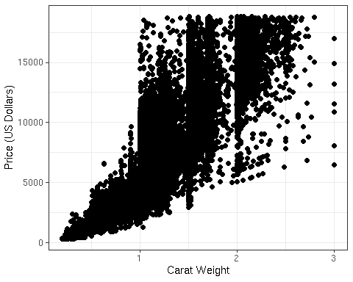

**Figure 02**

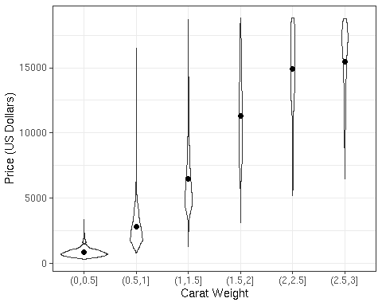

**Figure 03**

