# Data Descriptor Template

**Scope Guidelines**

**Data Descriptors** submitted to *Scientific Data* should provide detailed descriptions of valuable research datasets, including the methods used to collect the data and technical analyses supporting the quality of the measurements. Data Descriptors focus on helping others reuse data, rather than testing hypotheses, or presenting new interpretations, methods or in-depth analyses. Relevant datasets must be deposited in an appropriate public repository prior to Data Descriptor submission, and their completeness will be considered during editorial evaluation and peer review. The data must be made publicly available without restriction in the event that the Data Descriptor is accepted for publication (excepting reasonable controls related to human privacy issues or public safety).

### Title

*110 characters maximum, including spaces*

Titles should avoid the use of acronyms and abbreviations where possible. Colons and parentheses are not permitted.

### Authors

Firstname Lastname1, Firstname Lastname2

**Affiliations**

1. institution

2. institution

corresponding author(s): Firstname Lastname (email@address)

### Abstract

*170 words maximum*

The Abstract should succinctly describe the study, the assay(s) performed, the resulting data, and their reuse potential, but should not make any claims regarding new scientific findings. No references are allowed in this section.

### Background & Summary

*700 words maximum*

The Background & Summary should provide an overview of the study design, the assay(s) performed, and the data generated, including any background information needed to put this study in the context of previous work and the literature, and should reference literature as needed. The section should also briefly outline the broader goals that motivated collection of the data, as well as their potential reuse value. We also encourage authors to include a figure that provides a schematic overview of the study and assay(s) design.

### Methods

Meshblock and remoteness geography shapefiles, and meshblock details details (population, number of dwellings, and land use categorisation) and SEIFA status datasets were obtained from the ABS website (ref ref ref ref). The data was stored in the Postgres v 12 database, with the spatial database extender PostGIS installed. The shapefile were imported using the shp2pgsql utility, and stored using an ALBERS 3577 equidistant projection to facilitate distance measurements.

A centroid was calculated for each source meshblock, and buffers of 400, 1000, 2000 and 5000 metres were established around the centroid. These source buffers were then intersected with all other Australian meshblocks. Intersecting meshblocks were grouped by land use category, allowing calculation of total area, population and number of dwellings covered by the buffer for each source meshblock, land use category and buffer radius. Where a buffer partially covered a target meshblock, the population and number of dwellings were calculated proportional to the amount of coverage.

Furthermore, each meshblock was intersected against a remoteness categorisation (ref), and assigned a remoteness index, and this data was included in the meshblock level categorisation.

R v 4, with the tidyverse, Rmarkdown and sf library were used for data validation and graph production.

### Data Records

The data is stored in latrobe figshare. DOI is 10.26181/5f583219bd440 .

THe private link is <https://figshare.com/s/2b7330da75dab6a7c4a6>

The data consists of five datasets, as described in Table 1. The fields are described in The schema can be seen in Figure 1.

Table - Table level description of dataset

|  |  |
| --- | --- |
| Table Name | Description |
| meshblock_concordance | Meshblock to meshblock concordance, listing every meshblock in the neighbourhood of another meshblock. Neighbourhood of a source meshblock is defined as a meshblock that has part or all of it's area overlapped by various sized buffers from centroid of the source meshblock |
| meshblock_detail | Summary statistics of each meshblock, including the area, number of people and dwellings, the land use category, and which remoteness category and SA1 it belongs to. |
| meshblock_statistics | A summary of the neighbourhood of each source meshblock, where neighbourhood includes the details of meshblocks within a certain distance from from the centroid of the source meshblock |
| remote_detail | The description of each remoteness category |
| sa1_seifa | SEIFA statistics at the SA1 granularity. |

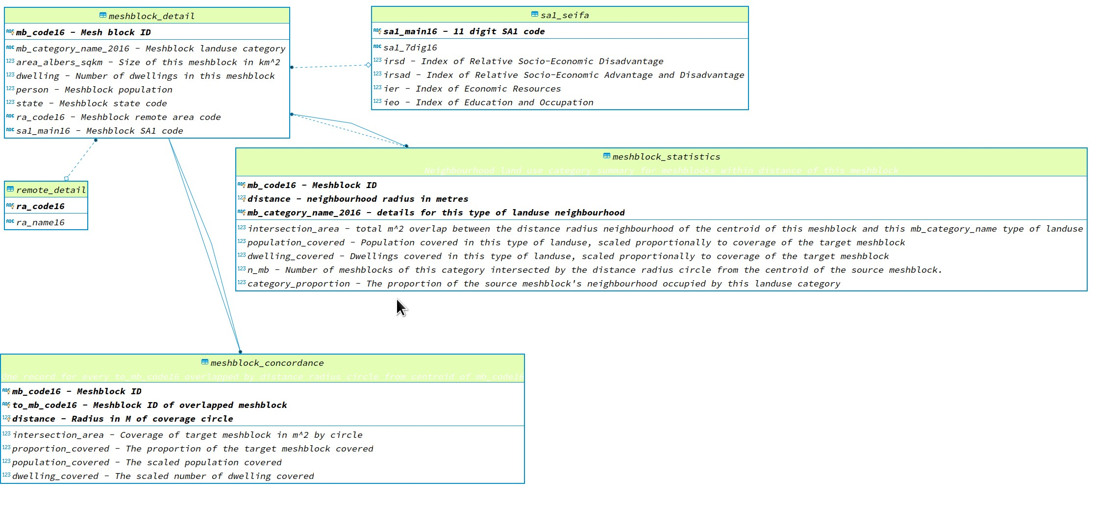

Figure - Data schema

Each table is provided in CSV format, with the

|  |  |
| --- | --- |
| Table | Number of Records |
| meshblock_concordance.csv | 524060194 |
| meshblock_detail.csv | 358122 |
| meshblock_statistics.csv | 7184849 |
| remote_detail.csv | 53 |
| sa1_seifa.csv | 57523 |

The Data Records section should be used to explain each data record associated with this work, including the repository where this information is stored, and to provide an overview of the data files and their formats. Each external data record should be cited as described below. A data citation should also be placed in the subsection of the Methods containing the data-collection or analytical procedure(s) used to derive the corresponding record.

Tables should be used to support the data records, and should clearly indicate the samples and subjects (study inputs), their provenance, and the experimental manipulations performed on each. They should also specify the data output resulting from each data-collection or analytical step, should these form part of the archived record.

### Technical Validation

Meshblocks cover the vast majority of the australian landmass. Therefore, each buffer around them meshblock centroid should interesect with a total meshblock area that is the same as the area of the circle of the target distance. For example, a 5000m target buffer should cover pi x 5000^2 sqm, or 78 sq km. The graph below shows that most meshblock buffers in total cover the appropriate area.

We examined 100 random points that did not have full coverage. In these cases, we found that the meshblock buffer covered geography contained space that was not covered by a defined meshblock. At its most extreme, this was the meshblock was a small island, and the buffer covered ocean. For example, see Figure 2. We dealt with this case by calculating the neighbourhood land use proportion based on the total buffer meshblock intersection area, rather than the area of the actual meshblock buffer.

Figure - Island meshblock where the buffer covers ocean

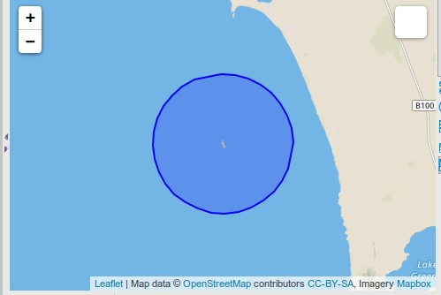

Another source of error came when the meshblock was broken up, and the centroid was not located in an actual meshblock. This occurred when the meshblock describes a set of small islands, for example. In some cases, this led to a situation where the buffer did not even include any of the original meshblock. This is a problem with using centroids in general, and we cannot see a way around it. For example, see Figure 3 and Figure 4

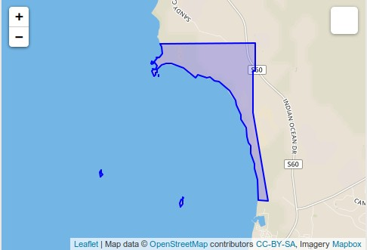

Figure - Meshblock 10977061000, which include coastline and islands.

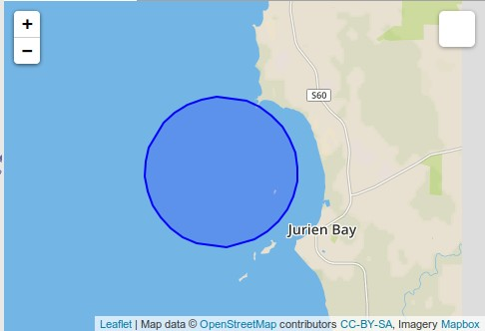

Figure - Five km buffer around meshblock 10977061000 centroid.

The Technical Validation section should present any experiments or analyses that are needed to support the technical quality of the dataset. This section may be supported by figures and tables, as needed. *This is a required section*; authors must provide information to justify the reliability of their data.

Possible content **may include:**

* experiments that support or validate the data-collection procedure(s) (e.g. negative controls, or an analysis of standards to confirm measurement linearity)
* statistical analyses of experimental error and variation
* phenotypic or genotypic assessments of biological samples (e.g. confirming disease status, cell line identity, or the success of perturbations)
* general discussions of any procedures used to ensure reliable and unbiased data production, such as blinding and randomization, sample tracking systems, etc.
* any other information needed for assessment of technical rigour by the referees

Generally, this **should not include:**

* follow-up experiments aimed at testing or supporting an interpretation of the data
* statistical hypothesis testing (e.g. tests of statistical significance, identifying differentially expressed genes, trend analysis, etc.)
* exploratory computational analyses like clustering and annotation enrichment (e.g. GO analysis).

### Usage Notes

*This section is optional*

The Usage Notes should contain brief instructions to assist other researchers with reuse of the data. This may include discussion of software packages that are suitable for analysing the assay data files, suggested downstream processing steps (e.g. normalization, etc.), or tips for integrating or comparing the data records with other datasets. Authors are encouraged to provide code, programs or data-processing workflows if they may help others understand or use the data. Please see our [code availability policy](http://www.nature.com/sdata/policies/editorial-and-publishing-policies#code-avail) for advice on supplying custom code alongside Data Descriptor manuscripts.

For studies involving privacy or safety controls on public access to the data, this section should describe in detail these controls, including how authors can apply to access the data, what criteria will be used to determine who may access the data, and any limitations on data use.

### Code Availability

The data load scripts, SQL code and R code can be found at http://github.com/dewoller/australia_neighbourhoods.

For all studies using custom code in the generation or processing of datasets, a statement must be included under the subheading "Code availability", indicating whether and how the code can be accessed, including any restrictions to access. This section should also include information on the versions of any software used, if relevant, and any specific variables or parameters used to generate, test, or process the current dataset.

### Acknowledgements

The Acknowledgements should contain text acknowledging non-author contributors. Acknowledgements should be brief, and should not include thanks to anonymous referees and editors or effusive comments. Grant or contribution numbers may be acknowledged.

### Author contributions

Each author’s contribution to the work should be described briefly, on a separate line, in the Author Contributions section.

### Competing interests

A competing interests statement is required for all papers accepted by and published in *Scientific Data*. If there is no conflict of interest, a statement declaring this must still be included in the manuscript.

### Figures

Figure images should be provided as separate files and should be referred to using a consistent numbering scheme through the entire Data Descriptor. In most cases, a Data Descriptor should not contain more than three figures, but more may be allowed when needed. We discourage the inclusion of figures in the Supplementary Information – all key figures should be included here in the main Figure section.

For initial submissions, authors may choose to supply a single PDF with embedded figures.

Authors are encouraged to consider creating a figure that outlines the experimental workflow(s) used to generate and analyse the data output(s).

### Figure Legends

### Figure legends begin with a brief title sentence summarizing the purpose of the figure as a whole, and continue with a short description of what is shown in each panel and an explanation of any symbols used. Legends must total no more than 350 words, and may contain literature references. The first sentence of the legend will be used as the title for the figure. It should contain no references of any kind, including to specific figure panels, bibliographic citations or references to other figures or panels.

### Tables

Authors are encouraged to provide one or more tables that provide basic information on the main ‘inputs’ to the study (e.g. samples, participants, or information sources) and the main data outputs of the study; also see the additional information on providing metadata on page 6. Tables in the manuscript should generally not be used to present primary data (i.e. measurements). Tables containing primary data should be submitted to an appropriate data repository.

Authors may provide tables within the Word document or as separate files (tab-delimited text or Excel files). Legends, where needed, should be included in the Word document. Generally, a Data Descriptor should have fewer than ten tables, but more may be allowed when needed. Tables may be of any size, but only tables that fit onto a single printed page will be included in the PDF version of the article (up to a maximum of three).

Due to typesetting constraints, tables that do not fit onto a single A4 page cannot be included in the PDF version of the article and will be made available in the online version only. Any such tables must be labelled in the text as ‘Online-only’ tables and numbered separately from the main table list e.g. ‘Table 1, Table 2, Online-only Table 1’ etc.

### References

Bibliographic information for any works cited in the above sections, using the standard Nature referencing style.

In line with emerging [industry-wide standards for data citation](https://www.nature.com/articles/sdata2018259), references to all datasets described or used in the manuscript should be cited in the text with a superscript number and listed in the ‘References’ section in the same manner as a conventional literature reference. See ‘Citing Data’ below for further details.

### Additional Formatting Information

**Referencing Figures, Tables, and other content**

**The Word document may reference Figures (e.g. Fig. 1), Tables (e.g. Table 1), online-only tables (e.g. Online-only Table 1) and Supplementary Information (e.g. Supplementary Table 1, or Supplementary File 2, etc.). When information from metadata documents must be referred to, it should also be included in the main manuscript as Tables, and formatted in a way that suits human readability. To refer to the ISA-Tab metadata records within the manuscript, use the phrase “see associated Metadata Record”.**

**Citation format**

All references should be numbered sequentially, first throughout the text, then in tables, followed by figures and, finally, boxes; that is, references that only appear in tables, figures or boxes should be last in the reference list. Only one publication is given for each number. Only papers that have been published or accepted by a named publication or recognized preprint server should be in the numbered list; preprints of accepted papers in the reference list should be submitted with the manuscript. Published conference abstracts, numbered patents, and archived code with an assigned DOI may be included in the reference list. Grant details and acknowledgments are not permitted as numbered references. Footnotes are not used.

Scientific Data uses standard Nature referencing style. All authors should be included in reference lists unless there are six or more, in which case only the first author should be given, followed by ‘et al.’. Authors should be listed last name first, followed by a comma and initials (followed by full stops, '.') of given names. Article titles should be in Roman text; only the first word of the title should have an initial capital and the title should be written exactly as it appears in the work cited, ending with a full stop. Book titles should be given in italics and all words in the title should have initial capitals. Journal names are italicized and abbreviated (with full stops) according to common usage. Volume numbers and the subsequent comma appear in bold. The full page range should be given where appropriate. See the examples below:

**Journal Article**:

1. Schott, D. H., Collins, R. N. & Bretscher, A. Secretory vesicle transport velocity in living cells depends on the myosin V lever arm length. *J. Cell Biol*. **156**, 35‐39 (2002).

**Book** ‐ Book titles should be given in italics and all words in the title should have initial capitals:

1. Hogan, B. *Manipulating The Mouse Embryo: A Laboratory Manual* 2nd edn (Cold Spring Harbor Laboratory Press, 1994)

**Publicly available preprint:**

1. Babichev, S. A., Ries, J. & Lvovsky, A. I. Quantum scissors: teleportation of single-mode optical states by means of nonlocal single photon. Preprint at http://arXiv.org/quant-ph/0208066 (2002).

**Code:**

1. Gallotti, R. & Barthélemy, M. Source code for: The multilayer temporal network of public transport in Great Britain. *Figshare* https://dx.doi.org/10.6084/m9.figshare.1249862.v1 (2014).

**Online material** ‐ Stable documents hosted on the web may be cited in the main reference list, using the format below. Websites or dynamic web resources should be cited by embedding the URL in the main article text:

1. Manaster, J. Sloth squeak. *Scientific American Blog Network* http://blogs.scientificamerican.com/psi-vid/2014/04/09/sloth-squeak (2014).

**Technical or government report:**

1. Akutsu, T. *Total Heart Replacement Device.* Report No. NIH-NHLI-69 2185-4 (National Institutes of Health, 1974).

## Citing Data

In line with emerging [industry-wide standards for data citation](https://www.nature.com/articles/sdata2018259), references to all datasets described or used in the manuscript should be cited in the text with a superscript number and listed in the ‘References’ section in the same manner as a conventional literature reference.

An author list (formatted as above) and title for the dataset should be included in the data citation, and should reflect the author(s) and dataset title recorded at the repository. If author or title is not recorded by the repository, these should not be included in the data citation. The name of the data-hosting repository, URL to the dataset and year the data were made available are required for all data citations. For DOI-based (e.g. figshare or Dryad) repositories the DOI URL should be used. For repositories using accessions (e.g. SRA or GEO) an [identifiers.org](https://identifiers.org/) URL should be used where available. For first submissions, authors may choose to include just the accession number. Scientific Data staff will provide further guidance after peer-review. Please refer to the following examples of data citation for guidance:

1. Zhang, Q-L., Chen, J-Y., Lin, L-B., Wang, F., Guo, J., Deng, X-Y. Characterization of ladybird Henosepilachna vigintioctopunctata transcriptomes across various life stages. figshare <https://doi.org/10.6084/m9.figshare.c.4064768.v3> (2018).
2. NCBI Sequence Read Archive <http://identifiers.org/ncbi/insdc.sra:SRP121625> (2017).
3. Barbosa, P., Usie, A. and Ramos, A. M. Quercus suber isolate HL8, whole genome shotgun sequencing project. GenBank<http://identifiers.org/ncbi/insdc:PKMF00000000> (2018).
4. DNA Data Bank of Japan <http://trace.ddbj.nig.ac.jp/DRASearch/submission?acc=DRA004814> (2016).

**Depositing your data to an appropriate repository**

Your *Scientific Data* manuscript will not be sent to review unless the dataset(s) described therein have been deposited in an appropriate public repository ([please see our list of recommended repositories](http://www.nature.com/sdata/policies/repositories)). Should a specific repository not be available for your field or data-type, or should the repository of your choice not permit confidential peer-review, you may upload your data to one of our [recommended generalist repositories](https://www.nature.com/sdata/policies/repositories#general). Integrated submission systems are available for both figshare and Dryad.