

Documentation, System Requirements, and Tutorial

* Pg 2 - System Requirements
* Pg 3 – How To: Getting to the application
* Pg 4 – How To: Open existing excel file (only Excel 2007 and newer)
* Pg 5 – How To: Picking what to export
* Pg 6 – How To: Go back to spreadsheet
* Pg 7 – How To: Save as Excel file
* Pg 8 – How To: Save as Excel file and open it
* Pg 9 – How To: Print file
* Pg 10 – Design decisions and credits
* Pg 11 – Open the code

System Requirements

This program requires a lot of system resources when processing data and exporting it. Below are the minimum system requirements.

Operation System: Windows XP or newer

Processor: Intel Dual Core or AMD Dual Core - 2.0ghz or above

Memory: 2Gb DDR3 Ram

Hard drive: 100mb+ free space (depends on file sizes)

Software: Excel 2007 or newer and Word 2007 or newer

Integrated Dev Environment: **Visual Studio 2013**

Programming Language: C#

How To: Getting to the application

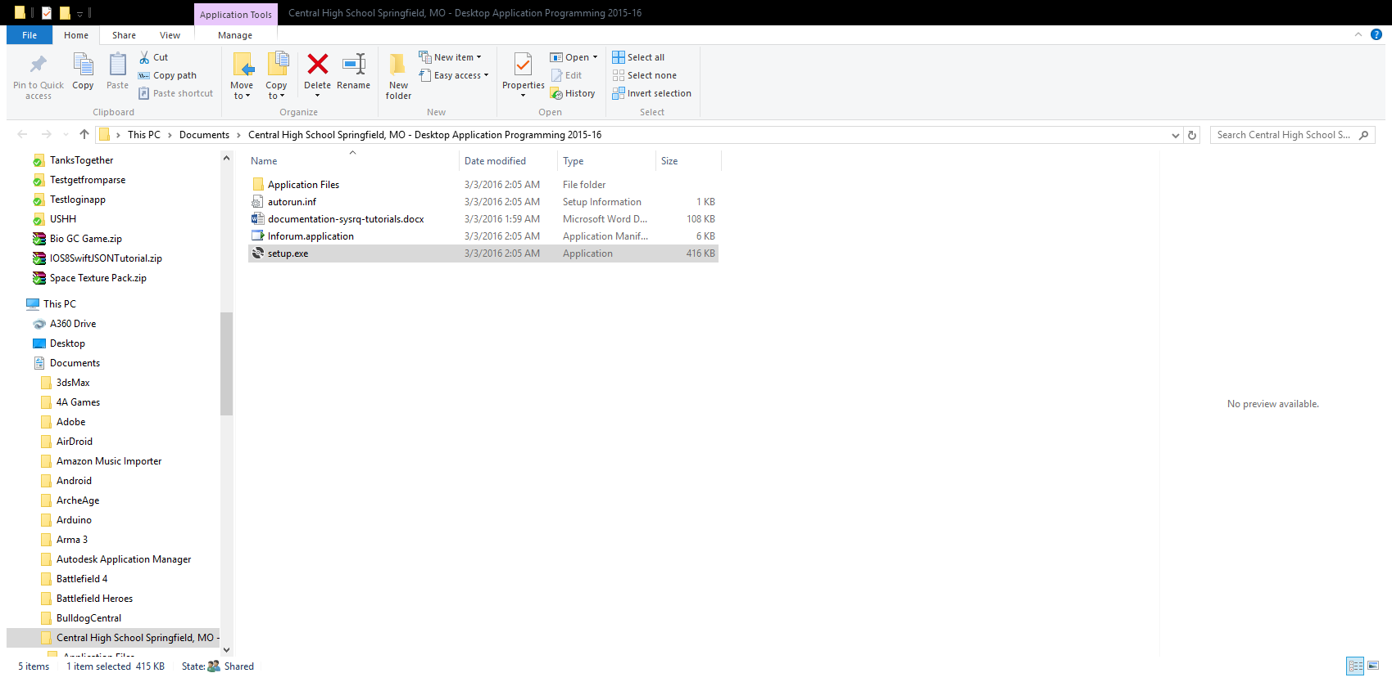

1. Run the setup.exe file located on the flash drive and go through the setup.
2. The application should open after the setup completes (if not, then just run Inforum.application)
3. Press “close…” on the loading screen of Inforum

How To: Open existing excel file (only Excel 2007 and newer)



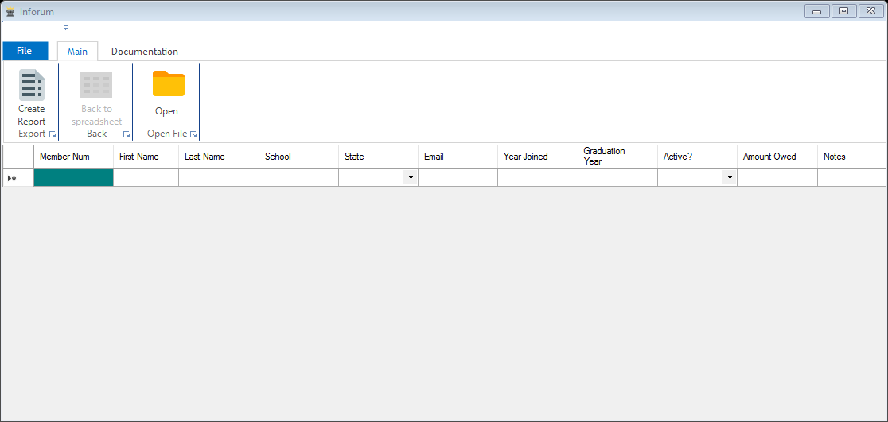



1. Press open button as shown above
2. Select Excel 2007 or newer file (.xlsx) and press Ok

How To: Picking what to export



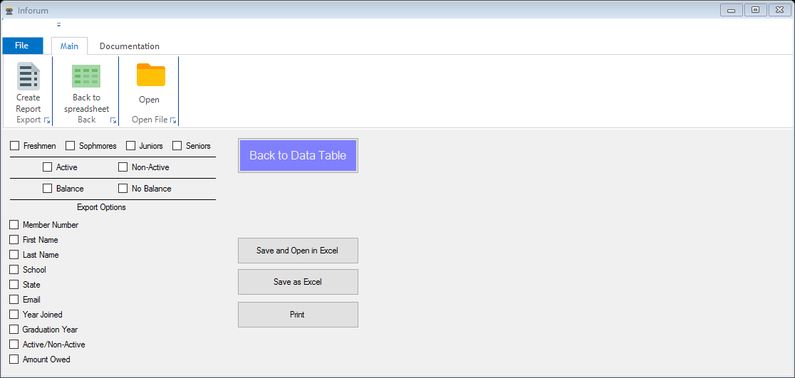



1. Click the Create Report button under the Main tab
2. Select the options that you want to export

How To: Go back to spreadsheet





1. Press either the Back to Spreadsheet button on the ribbon bar or press the Back to Data Table button

How To: Save as Excel file





1. Press Save as Excel button in the Create Report menu

How To: Save as Excel file and open it





1. In the Create Report menu press the Save and Open in Excel button

How To: Print





1. Press print button in Create Report menu

Design Decisions and Credits

In regards to programming, to reduce the size of the program and memory allocation some different methods of programming were used. Instead of using encapsulation like you would in a Java console program I opted for everything in one class and a lot of times in the same method. This means I could skip the need to deal with *this* instancing and the copying of variables. This means the code is much lighter and less memory is being used. When working with variables such as the worksheet and excel variables with data this size this could be hundreds of megabytes.

In terms of design of the program itself, I opted to go with something everyone is familiar with and that is Microsoft Office. This means people wouldn’t have to learn a new interface and simply know how to use the software already.

The logo was designed by me and the icons are from icons8.com

IDE used was Microsoft Visual Studio 2013

No external libraries were used aside from Microsoft’s excel DLLs

Open Code

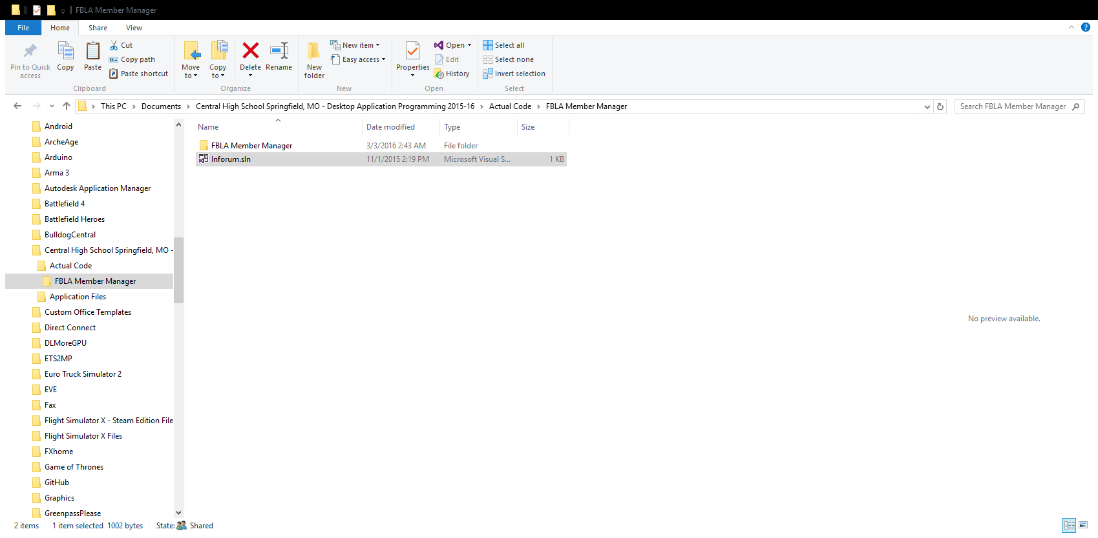

1. Open the Inforum.sln file in the Actual Code folder to open the program in Visual studio
2. (If you would like to just look at code files and nothing else, navigate to Actual Code\FBLA Member Manager\FBLA Member Manager\ and open the MainForm.cs file)