1)Turning on LED using a Microcontroller

#ifndef F_CPU

#define F_CPU 8000000UL

#endif

#include <avr/io.h>

#include <util/delay.h>

int main(void)

{

DDRB = 0xFF;

PORTB = 0xFF;

}

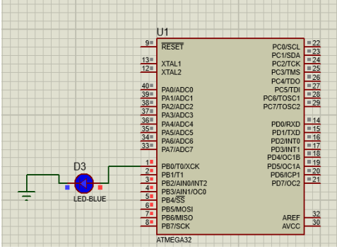

Blinking LEDs using a Microcontroller

#ifndef F_CPU

#define F_CPU 8000000UL

#endif

#include <avr/io.h>

#include <util/delay.h>

int main(void)

{

DDRB = 0xFF;

while(1)

{

PORTB = 0xFF;

_delay_ms(500);

PORTB = 0x00;

_delay_ms(500);

}

}

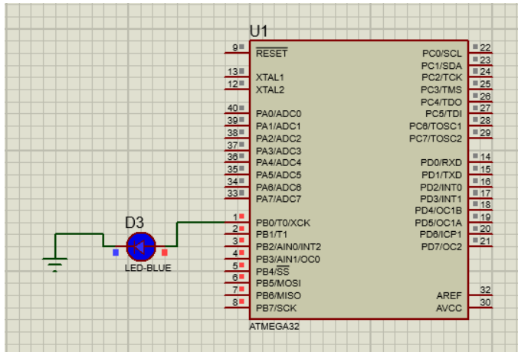

3) design and implement 7-segment led display

#include<avr/io.h>

#include<util/delay.h>

void main()

{

DDRC=0XFF;

while(1)

{

PORTC=0b00111111;

*_delay_ms*(1000);

PORTC=0b00000110;

*_delay_ms*(1000);

PORTC=0b01011011;

*_delay_ms*(1000);

PORTC=0b01001111;

*_delay_ms*(1000);

PORTC=0b01100110;

*_delay_ms*(1000);

PORTC=0b01101101;

*_delay_ms*(1000);

PORTC=0b11111101;

*_delay_ms*(1000);

PORTC=0b00000111;

*_delay_ms*(1000);

PORTC=0B01111111;

*_delay_ms*(1000);

PORTC=0b11101111;

*_delay_ms*(1000);

}

}

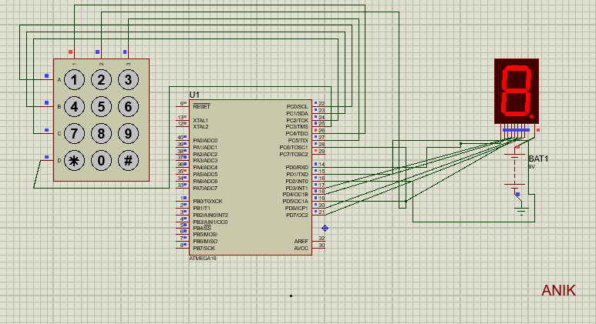

4)Design and implement 7-segment LED display with two output

#define *F_CPU* 16000000 UL

#include <avr/io.h>

#include <util/delay.h>

char database[4][4] = {

0x00,

0x01,

0x02,

0x03,

0x04,

0x05,

0x06,

0x07,

0x08,

0x09,

0x10,

0x11,

0x012,

0x13,

0x14,

0x15

};

void search();

int r1 = 0, c1 = 0;

int x = 0;

int main(void)

{

DDRC = 0xff;

PORTC = 0x00;

DDRB = 0xf0;

PORTB = 0x0f;

while (1)

{

while (1) {

x = PINB;

if (x != 0x0f) {

break;

}

}

PORTB = 0xEF;

x = PINB;

if (x != 0XEF) {

r1 = 0;

search();

}

PORTB = 0xDF;

x = PINB;

if (x != 0XDF) {

r1 = 1;

search();

}

PORTB = 0xBF;

x = PINB;

if (x != 0XBF) {

r1 = 2;

search();

}

PORTB = 0x7F;

x = PINB;

if (x != 0X7F) {

r1 = 3;

search();

}

}

}

void search() {

x = x & 0x0F;

if (x == 0x0E)

PORTC = database[r1][0];

if (x == 0x0D)

PORTC = database[r1][1];

if (x == 0x0B)

PORTC = database[r1][2];

if (x == 0x07)

PORTC = database[r1][3];

}

#include <avr/io.h>

int main(void)

{

while (1)

{

}

}

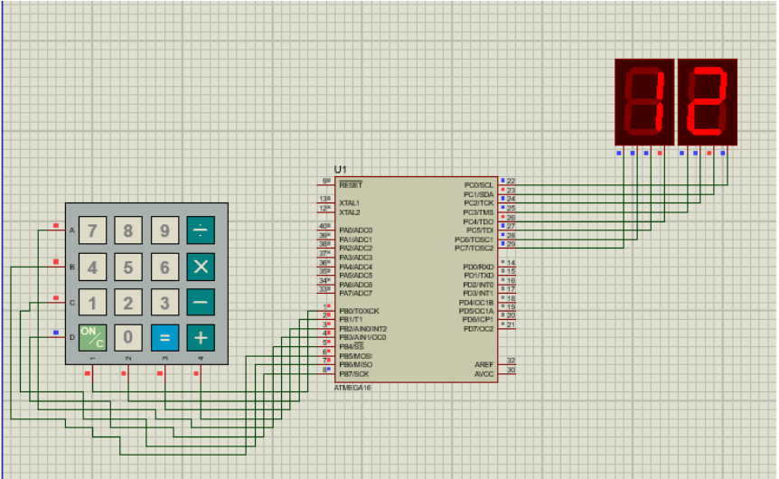

5) Implement 16*2 LCD Display to print “Welcome To Bangladesh 2.0” using Arduino simulation in proteus

#include <LiquidCrystal.h>

const int rs = 12, en = 11, d4 = 5, d5 = 4, d6 = 3, d7 = 2;

LiquidCrystal lcd(rs, en, d4, d5, d6, d7);

void setup() {

lcd.begin(16, 2);

lcd.print("Welcome To");

lcd.setCursor(1,1);

lcd.print("Bangladesh 2.0");

}

void loop() {

}

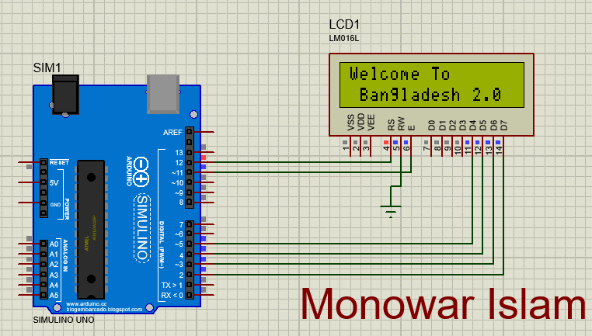

6) Implement a Servo motor rotating using Arduino simulation in proteus

#include <Servo.h>

Servo myservo;

int pos = 0;

void setup() {

myservo.attach(9);

}

void loop() {

for (pos = 0; pos <= 180; pos += 1) {

myservo.write(pos);

delay(15);

}

for (pos = 180; pos >= 0; pos -= 1) {

myservo.write(pos);

delay(15);

}

}

