Ideas:
Colour palette idea 1:
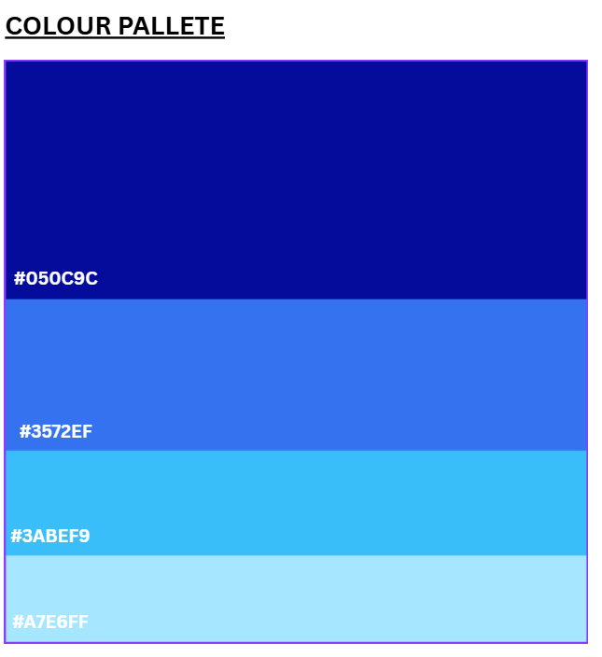
Colour palette idea 2:
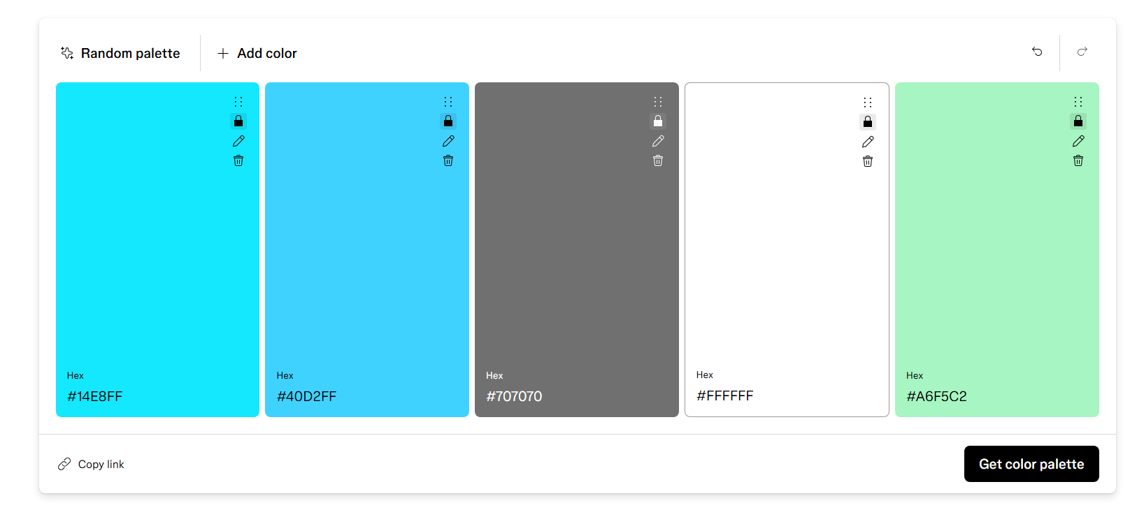
Site Map Version 1

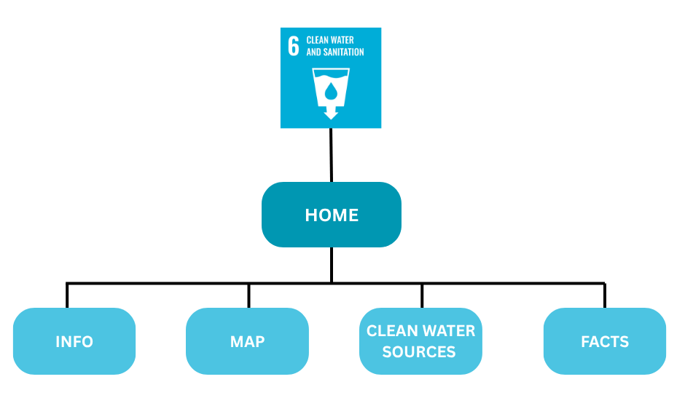
Site Map Version 2:
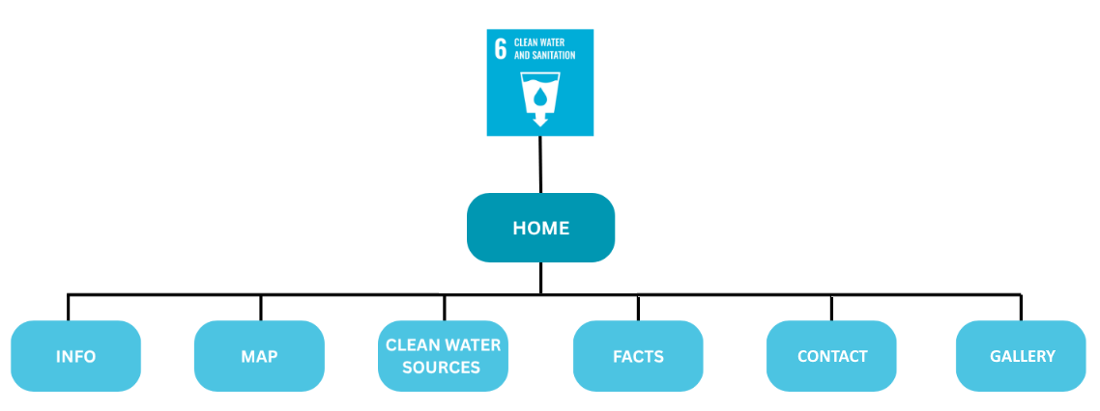

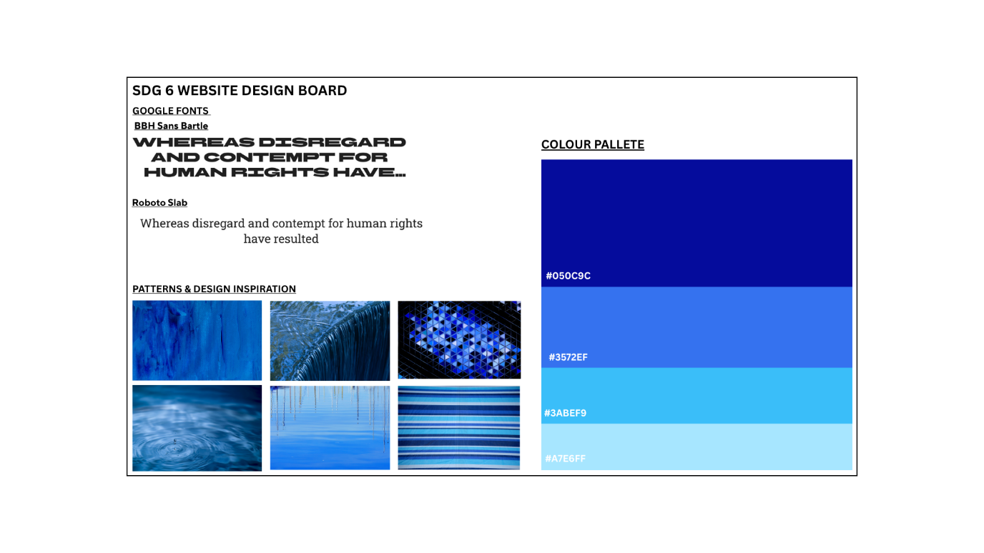
Possible visual appearance of the site (prototype):
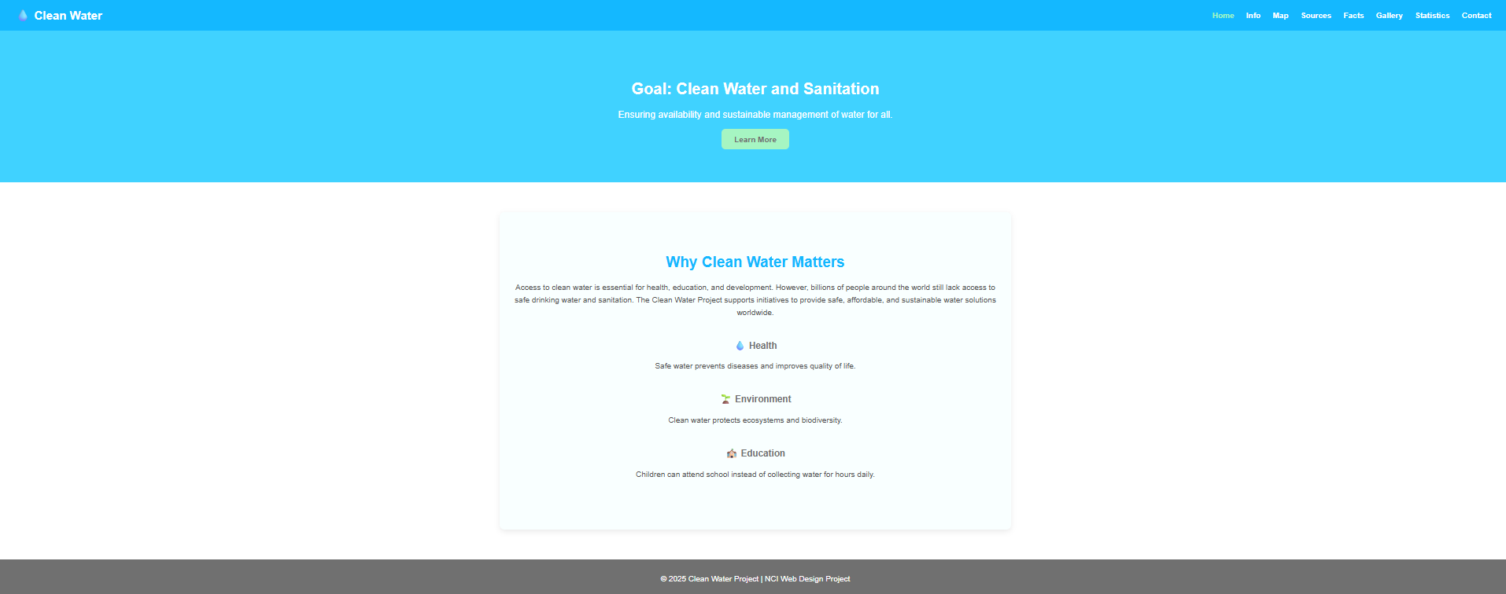

Wireframes:
Tristan
Page3.html desktop | Page3.html mobile
Page4.html desktop | Page4.html mobile

Alexander
Page5.html desktop | Page5.html mobile
Page6.html desktop | Page6.html mobile

Derek
Page7.html desktop | Page7.html mobile
Page8.html desktop | Page8.html mobile

Andrei
Index.html desktop | Index.html mobile
Page2.html dektop | Page2.html mobile

Tasks:
Andrei:
Page 1&2 :Landing page”s” (first 7 pages of pdf, broken between two pages)
Tristan:
Page 1: Info pages 8- 13 in pdf report on Irish water
Page 2: location, how to get to us address with google maps
Alexander:
Page 1: Contact us page (customer email/newsletter sign up, comment box ) ,
Page 2: info (who uses our water and for what?)
Derek:
Page 1: Report European water usage and where its needed the most
Page 2: Sources page: where all the information was gathered from

Notes:
- Everyone needs two pages no less
- One CSS file only
- Comment CSS to identify who made it
- Two wireframes per page each: desktop and mobile
- One sitemap per group
- Colour palette:

GitHub:
Derek O‘Kelly https://github.com/dex9mm/Web-Design-and-Development
Andrei Grigorita https://github.com/S1lverCr0w/wdd_group_proj
Tristan Bradley Odhiambo https://github.com/DebugT/first_website_nci
Alaxander Kirichenko https://github.com/Sasha-Clover/myfirstwebsitenci

