**Exp. 8: Programmable Digital Data Display System**

**Circuit Diagram:**

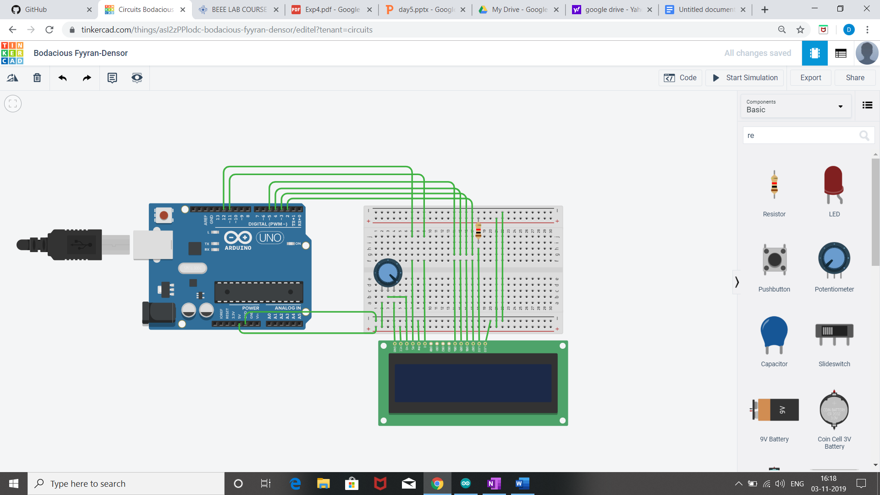

**Concept used:**

1. LCD (liquid crystal display)

a) A **register select (RS) pin-** It controls the LCD's memory in where data is being written to. It enables a user to select the instruction mode or the character mode of a **LCD**. Depending on which mode is selected, the data on the 8 data **pins** (D0-D7) is treated either as instruction or character data.

b) LCD's controller looks for instructions on what to do next.

c)A **Read/Write (R/W) pin** - It selects the reading mode or the writing mode.

d)An **Enable pin** – It enables writing.

e) Data pins 0 to 7 forms a 8-bit data line. They can be connected to Microcontroller to send 8-bit data.

These LCD’s can also operate on 4-bit mode in such case Data pin 4,5,6 and 7 will be left free.

f) Pin 15-LED+

This pin is connected to VCC and it is used for the pin 16 to set up the glow of backlight of LCD.

g) Pin 16-LED-

This pin is connected to Ground and it is used for the pin 15 to set up the glow of backlight of the LCD.

h) The potentiometer is being used for variable resistance.

2.The concept of Arduino.

**Learning and observation:**

1.The RS pin of the LCD is connected to the pin 12 of the Arduino. The LCD of R/W pin is connected to the ground. The pin 11 of the Arduino is connected to the enable signal pin of LCD module. The LCD module & Arduino module are interfaced with the 4-bit mode in this project. Hence there are four input lines which are DB4 to DB7 of the LCD.

2.The Liquid Crystal library works with all LCD displays that are compatible with the driver.

3.A digital data display will be seen “Welcome to Chandigarh University” when the circuit is turned on.

4.An in-built library named #include<LiquidCrystal.h> is used to reduce the code, as it already contains the details of connections.

**Problem and Troubleshooting:**

1.There was a slight confusion in understanding the concept and then making the required connections.

2.Some minor errors were there, which were trouble shooted by the correcting the code.

3.If we define the for printing on LED in void setup() then,we cannot able to change the cursor position,so we need to define the print statement in void loop().

**Precautions:**

1. The equipment should be working properly.

2.All the connections must be accurate.

3.The connections made on the hardware and the pins of the Arduino must coincide with the codes written.

4.Correct Port is to be selected.

5.All connections should be tight.

**Learning outcome:**

1.I have learnt the use and concepts of Liquid Crystal Display.

2.Making circuits using different equipment like Arduino, LCD etc.

3.Improvising the concepts of Arduino.