**LATENT HEAT**

The amount of energy required to change a material from one phase to another.

Q = mL

Q = energy in Joules

m = mass in kg

L = latent heat of the material

**SPECIFIC HEAT CAPACITY**

The amount of energy required to raise a kilogram of water to 1 degree Celsius (kilogram because our constants are defined with kilograms).

Q = $mcΔT$

Q = energy in Joules

m = mass in kg

c = specific heat capacity of material

$ΔT$ = change in temperature of the material (TF – TI)

**SHC AND LH OF COMMON MATERIALS**

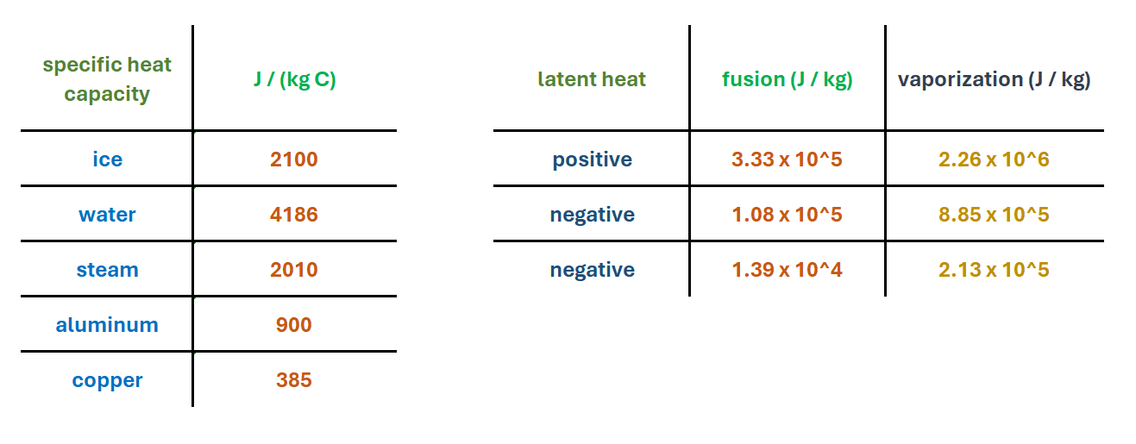

**THE HEAT CURVE**

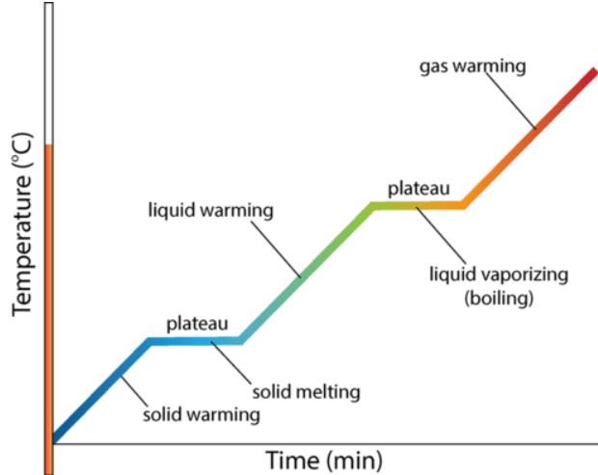

**EXAMPLES.**

1. How much energy is required to melt 790 grams of ice?

Q = mL

= (0.79 kg)(3.33 x 105 J/kg) (convert grams to kilograms)

= (0.79 kg)(3.33 x 105 J/kg)

= 263.07 kJ

1. How much heat is required to raise the temperature of 0.15kg water from 20 C to 55 C?

Q = $mcΔT$

= (0.15 kg)(4186 J/kg)(55C – 20C)

= 21.9765 kJ

1. How much energy is required to convert 3kg of ice at 0C to water at 30C?

First we need energy, Q1, to phase change ice to water, then we need energy, Q2, to raise the temperature from 0C to 30C. In total, we need to add Q1 and Q2.

Q1 = mL

= (3 kg)(3.33 x 105 J/kg)

= 999 kJ

Q2 =

= (3 kg)(4186 J/kg)(30C – 0C)

= 376.74 kJ

Qtotal = Q1 + Q2

= 999 kJ + 376.74 kJ

= 1.3754 MJ