GitHub使用教程2

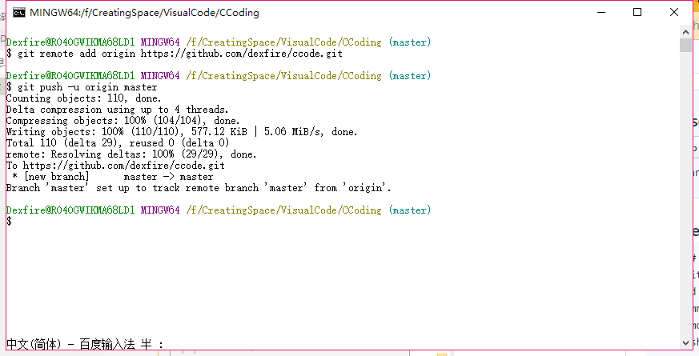

git remote add origin <url>

这句话是在本地添加一个远程仓库地址，并不会和这个地址进行交流

git push origin master 原形是 git push <target> <source branch>

**Quick setup — if you’ve done this kind of thing before**

[**Set up in Desktop**](https://desktop.github.com/)

**or**

窗体顶端

HTTPS

窗体底端

窗体顶端

SSH

窗体底端



We recommend every repository include a [README](https://github.com/dexfire/ccode/new/master?readme=1), [LICENSE](https://github.com/dexfire/ccode/new/master?filename=LICENSE.md), and [.gitignore](https://github.com/dexfire/ccode/new/master?filename=.gitignore).

**…or create a new repository on the command line**

echo "# ccode" >> README.md

git init

git add README.md

git commit -m "first commit"

git remote add origin https://github.com/dexfire/ccode.git

git push -u origin master

**…or push an existing repository from the command line**

git remote add origin https://github.com/dexfire/ccode.git

git push -u origin master

**…or import code from another repository**

You can initialize this repository with code from a Subversion, Mercurial, or TFS project.

[**Import code**](https://github.com/dexfire/ccode/import)