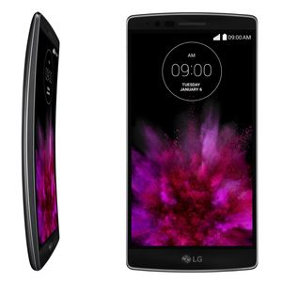

The **LG G Flex 2** is one of LG's flagship devices for 2015. Its most notable feature is the 1080p 5.5" curved display, with a 23 degree arc. It is also one of the first Android smartphones to feature the new 64-bit Qualcomm Snapdragon 810 processor, which has a clock speed of 2GHz. The G Flex 2 comes with either 2GB or 3GB of RAM and 16GB or 32GB or internal storage, depending on region. The shooter comes in at 13MP, and features laser-guided auto-focus and optical image stabilization. The G Flex 2 is powered by a non-removable 3000mAh battery. On the exterior, the device features a "self-healing" back panel coating, which is an improved version taken from the original LG G Flex.